1.Open WebStorm

2. Choose Git from Check out from Version Control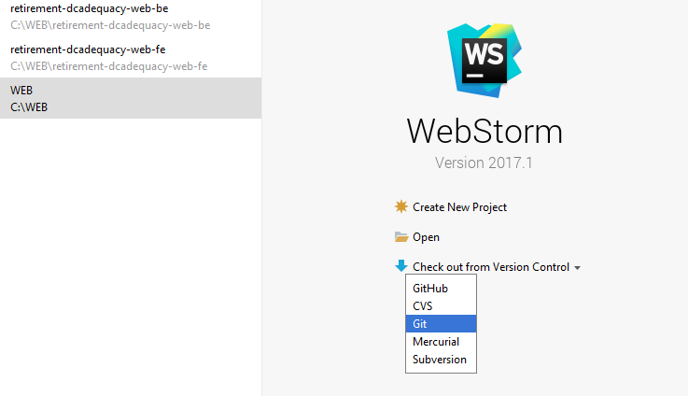

3. Enter the details of GIT Repository

Git Repository URL =

https://YOURUSERID@bitbucket.org/oliverwymantechssg/retirement-dcadequacy-engine-be.git

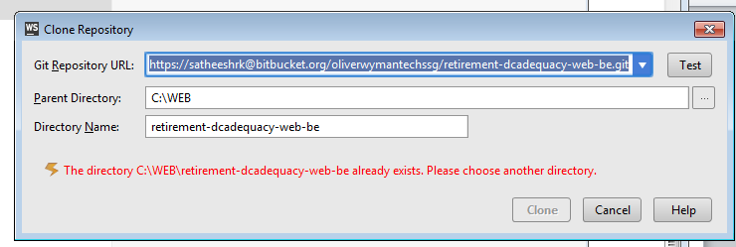

4.open the project you cloned from your local directory

5.copy the files to Test/TestCases folder

6.Right click the TestCases folder and Choose Commit Directory option

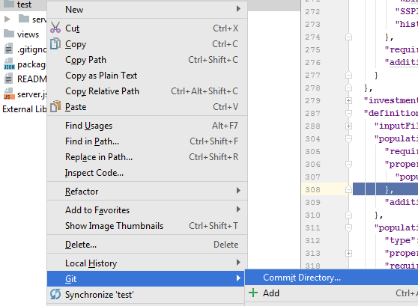

7.choose the files ,you need choose commit and push ,to push the files to the server

