

Assessment Title: Warehouse Inventory Management System

Module Name: SOFT20091 - Software Design and Implementation (SDI)

Submitted by:
Lina Belaa T0464929
Date of Submission: 28 March 2026

Table of Contents
Chapter 1: Introduction 2
1.1 Purpose of the Report 2
1.2 Aim and Objectives of the Project 2
1.3 Scope of the Project 3
Chapter 2: System Overview 3
2.1 About the Project 3
2.2 Functionality 3
Chapter 3: System Design 4
3.1 Functional and Non-Functional Requirements 4
3.2 Project Management Documentation 7
3.3 Behavioural Design Diagrams 7
3.4 Structural Design Diagrams 15
3.5 Critical Analysis 16
3.6 Implementation Explanation 17
3.7 Evaluation of Non-Functional Requirements 18
Chapter 4: Implementation 19
4.1 Overview of the Implementation Process 19
4.2 Technologies Used 19
4.3 Key Features and Implemented Functionalities 19
4.4 Screenshots of Console Interfaces 20
Chapter 5: Testing 21
5.1 User Acceptance Testing 21
5.2 Screenshots of Testing 27
Chapter 6: Documentation 42
6.1 User Manuals 42
Chapter 7: Conclusion 47
7.1 Summary of Project Outcomes 47
7.2 Challenges Encountered 47
7.3 Reflection on the Development Process 48
7.4 Potential Improvements 48
References 48
Appendices 49

Chapter 1: Introduction

1.1 Purpose of the Report

This report describes the design, implementation, and evaluation of a C++ console-based warehouse inventory system. The system gives managers the tools to manage products, employees, and orders, whilst employees can view their assigned orders, complete them, search for products, and generate their own reports. Throughout the report, software design concepts, system architecture, and the testing approach used are examined.

1.2 Aim and Objectives of the Project

1.2.1 Aim
The aim is to build a maintainable, STL-based console application that reflects a real warehouse inventory system and offers useful features for both managers and employees.

1.2.2 Objectives
- An interface needed for managers to manage the products, employees and orders.
- Managers can assign orders to employees and generate reports (inventory, completed orders, pending orders).
- Employees may view their orders assigned to them, orders they completed, search for products, and generate personal reports.
- Implement order management with status tracking (Pending, InProgress, Completed).
- Use object-oriented programming and STL containers to achieve a modular and scalable design.
- Use CSV-based data persistence for products, orders, employees, and users.

1.3 Scope of the Project
The project covers:
- Product management (adding, editing, viewing, and soft-deleting products with id, name, quantity, aisle, shelf, and price).
- Employee management (adding, editing, viewing, and soft-deleting employees).
- Order management (creating, editing, viewing, and soft-deleting orders with line items, plus status tracking).
- Order assignment to employees.
- Report generation: inventory report, completed orders report, pending orders report, and employee-specific report.
- A console-based user interface for both Manager and Employee roles.
- Data persistence using CSV files.
- User authentication with role-based access (Manager, Employee).

Chapter 2: System Overview

2.1 About the Project

The Warehouse Inventory System is a console-based app made in C++ that helps both managers and employees. Managers can do anything with products, employees, and orders. They can give employees tasks to do and make different reports. Employees, on the other hand, can see the orders that are assigned to them, finish those orders, look for products, and export their own order reports. Object-oriented programming and STL containers (map, list) were used to build the system. This keeps the code clean and simple to add to. When the app is closed, nothing is lost because all the data is stored in CSV files.

2.2 Functionality
What Managers Can Do:
- Add, edit, view, and soft-delete products (id, name, quantity, aisle, shelf, price).
- Add, edit, view, and soft-delete employees.
- Create, edit, view, and soft-delete orders with line items.
- Assign orders to employees.
- Generate an inventory report.
- Generate a completed orders report.
- Generate a pending orders report.
- Log out.
What Employees Can Do:
- View their assigned orders.
- Complete orders.
- Search for products by name or ID.
- Generate a personal report of their assigned orders.
- Log out.

Chapter 3: System Design

3.1 Functional and Non-Functional Requirements
The following table summarises the main functional requirements (FR). They are derived from the supplied requirements list and use-case stories.
ID | Priority | Requirement | Implementation Impact
FR-1.1 | Must | The Manager can register and manage employee accounts. | The system provides authenticated login and role-based access control so employee users cannot access manager-only functions.
FR-1.2 | Must | The Employee can log into the system securely. | The system hashes passwords before storage and validates all credential inputs before authentication.
FR-1.3 | Must | The system distinguishes between Manager and Employee roles. | The system routes users to role-specific menus and enforces separation of privileges.
FR-1.4 | Must | The system stores user credentials securely. | The system stores password hashes (not plain text) in users.csv and rejects invalid credential input.
FR-2.1 | Must | The Manager can add new products with ID, name, quantity, aisle, shelf, and price. | The product creation workflow validates format, range, and uniqueness before persisting to CSV.
FR-2.2 | Must | The Manager can view all products. | The system displays a formatted product table and excludes soft-deleted records from standard views.
FR-2.3 | Must | The Manager can edit existing product details. | The system applies validated updates in memory and saves changes to CSV.
FR-2.4 | Must | Each product has a unique ID, valid name, non-negative quantity, and valid location fields. | Validation rules enforce ID pattern/uniqueness, field constraints, and non-negative numeric values.
FR-2.5 | Must | The system tracks stock levels and prevents negative quantities. | Stock is deducted only on successful order completion, and completion is blocked when stock is insufficient.
FR-2.6 | Must | The Manager can soft-delete products. | The system marks isDeleted = 1 instead of removing records, blocks deletion if a product is referenced by active (Pending/InProgress) orders, and hides deleted products from standard views and searches.
FR-3.1 | Must | The Manager can add new employees with name and employee ID. | The employee workflow validates ID/name and persists records to CSV.
FR-3.2 | Must | The Manager can view all employees. | The system displays employee records with role visibility and excludes soft-deleted employees from standard views.
FR-3.3 | Must | The Manager can edit employee details. | The system validates edits and persists updated employee data to CSV.
FR-3.4 | Must | The Manager can soft-delete employees. | The system marks isDeleted = 1, blocks deletion if the employee has any assigned InProgress order, and excludes deleted employees from standard views and assignment selection.
FR-4.1 | Must | The Manager can create customer orders with unique order ID and item list. | The system validates order ID uniqueness, validates item inputs, and checks stock before creation.
FR-4.2 | Must | The Manager can edit existing orders. | The system revalidates edited order items and reverts changes if validation fails (e.g., insufficient stock).
FR-4.3 | Must | The Manager can assign orders to employees. | The system validates both order and employee IDs, records assignment, and sets status to InProgress.
FR-4.4 | Must | The system tracks order status and enforces unique order IDs. | The status lifecycle (Pending -> InProgress -> Completed) is enforced by workflow rules.
FR-4.5 | Must | The Manager can soft-delete orders under status constraints. | The system allows deletion only for Pending orders, blocks deletion for InProgress and Completed, marks deleted orders with isDeleted = 1, and hides deleted orders from standard views.
FR-5.1 | Must | The Employee can view assigned orders. | The employee view lists only orders assigned to the logged-in employee.
FR-5.2 | Must | The Employee can mark an assigned order as completed. | The system verifies ownership,status, deducts stock, and sets the order status to Completed.
FR-5.3 | Must | The system automatically deducts stock when an order is completed. | Completion applies item-level stock deduction and blocks completion if any product has insufficient stock.
FR-6.1 | Must | The system stores operational data in CSV files. | Structured CSV schemas are used for users, products, employees, orders, and order items.
FR-6.2 | Must | The system loads data on startup and saves updates during operation and on logout. | Missing CSV files are auto-created, and save operations are triggered after key state-changing actions.
FR-7.1 | Should | The Employee can search products by name or ID. | Case-insensitive partial matching returns product ID, name, quantity, and location.
FR-8.1 | Should | The Manager can generate inventory, completed-order, and pending-order reports. | The reporting module exports filtered datasets to CSV paths provided by the user.
FR-8.2 | Should | The Employee can generate a personal assigned-order report. | The system exports employee filtered order data to CSV using the logged-in employee ID.

ID | Non-Functional Requirement | Verification Approach
NFR-1.1 | Performance: Product search operations must return results within two seconds for datasets up to 100 products. | Repeated searches by product ID and name were executed on representative sample data. Results were returned within the required threshold under normal conditions.
NFR-1.2 | Performance: Order completion and inventory update operations must complete in under one second under normal load. | Representative order-completion scenarios were executed and response time was observed during normal test conditions.
NFR-2.1 | Security: Employee users must be blocked from manager-only functionality. | Employee-role logins were tested to confirm that only employee menu options were available, and manager functions were inaccessible.
NFR-2.2 | Security: Passwords must be hashed and never stored in plain text. | Stored credential values in users.csv were reviewed after account creation and confirmed to be hashed values rather than raw passwords.
NFR-2.3 | Security: The system must terminate after three consecutive failed login attempts. | Invalid credentials were entered three times consecutively and the expected termination behaviour was confirmed.
NFR-3.1 | Data Integrity: Product IDs must be unique. | Attempts to add duplicate product IDs were performed and correctly rejected with validation errors.
NFR-3.2 | Data Integrity: Inventory quantities must not become negative. | Order-completion scenarios with insufficient stock were tested and completion was correctly blocked.
NFR-3.3 | Data Integrity: Deletion must preserve history and referential consistency. | Soft-delete scenarios were validated to confirm records are flagged with isDeleted, constrained where required, and excluded from operational views.
NFR-4.1 | Reliability: Numeric input fields must reject invalid text without crashing. | Invalid text input was supplied to numeric fields and the system displayed validation messages while continuing normal execution.
NFR-4.2 | Error Handling: Missing data files must be recreated automatically on first run. | Data files were removed, and system startup behaviour was tested required CSV files were recreated successfully.
NFR-5.1 | Portability: The system is designed to be portable across Windows, Linux, and macOS using standard C++ and CMake. | Build and runtime behaviour were verified on Windows. Cross-platform portability is supported by design through standard C++ and CMake configuration. Linux/macOS execution was not validated in this submission.

3.2 Project Management Documentation
Task List:
- Requirements gathering and initial planning
- Functional and non-functional specification
- System design (use case, sequence, and class diagrams)
- Core system implementation
- Product, employee, and order workflow implementation
- Data persistence and file handling
- Report generation functionality
- Unit testing and validation including input validation
- User acceptance testing and debugging
- Report writing
- Final testing, formatting, and submission
Gantt chart:
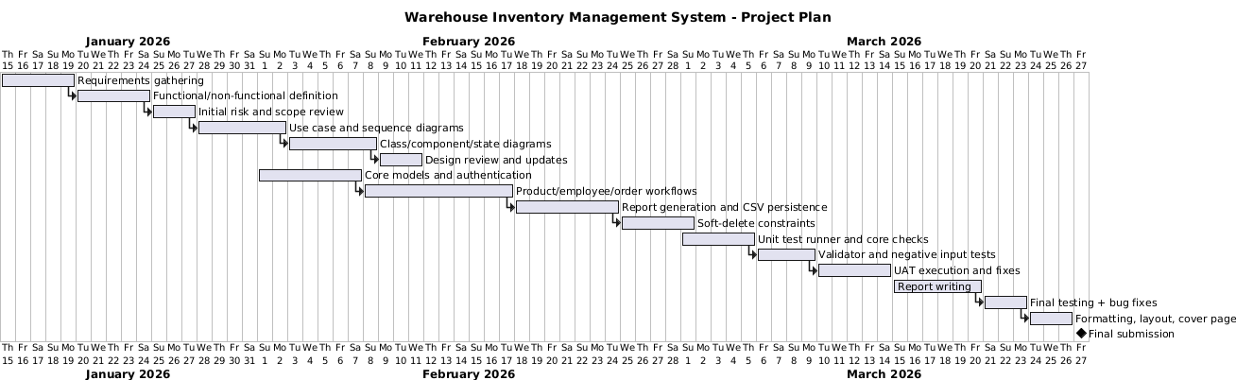

3.3 Behavioural Design Diagrams
Use Case Diagram
This use case diagram sets out how the two user roles interact with the system. The Manager handles product, employee and order administration, including assignment, reporting and controlled deletion. The Employee is limited to fulfilment tasks, such as viewing assigned orders, finding products, completing orders, and generating a personal report. This reflects the role-based access model used in the implementation.
Use Cases
- As a manager, I need to add new products so that I can keep track of what items we have.
- As a manager, I need to see all products so that I know what is in the warehouse.
- As a manager, I need to edit product details so that I can fix any mistakes.
- As a manager, I need to delete products so that I can remove items no longer in stock
- As a manager, I need to add employees so that they can use the system.
- As a manager, I need to see all employees so that I know who works here.
- As a manager, I need to delete employees so that I can remove staff who have left
- As a manager, I need to edit employee details so that the information stays correct.
- As a manager, I need to create orders so that customer requests are recorded.
- As a manager, I need to see all orders so that I can follow their progress.
- As a manager, I need to edit orders so that I can change them when needed.
- As a manager, I need to delete pending orders entered in error
- As a manager, I need to assign orders to employees so that the work gets done.
- As a manager, I need to make inventory reports so that I understand our stock levels.
- As a manager, I need to make completed order reports so that I can check finished work.
- As a manager, I need to make pending order reports so that I can see what is not done yet.
- As an employee, I need to see my assigned orders so that I know what tasks I must do.
- As an employee, I need to search for products so that I can find items quickly.
- As an employee, I need to complete orders so that the system knows the job is done.
- As an employee, I need to make my completed order report so that I can see what I finished.
- As an employee, I need to make my pending order report so that I can plan my work.

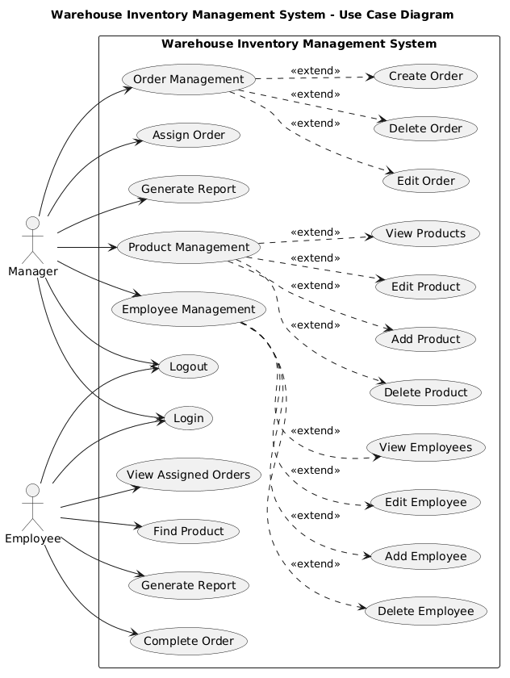

Sequence Diagram
To capture behaviour for specific scenarios, several sequence diagrams are used
Manager Creates an Order
  - Manager chooses “Order Management” → “Create order”.
  - System prompts for order ID and repeatedly for product ID and quantity.
  - canFulfillOrder() checks stock for each item.
  - If stock is sufficient, the order is stored in orders_; otherwise, an error is shown.

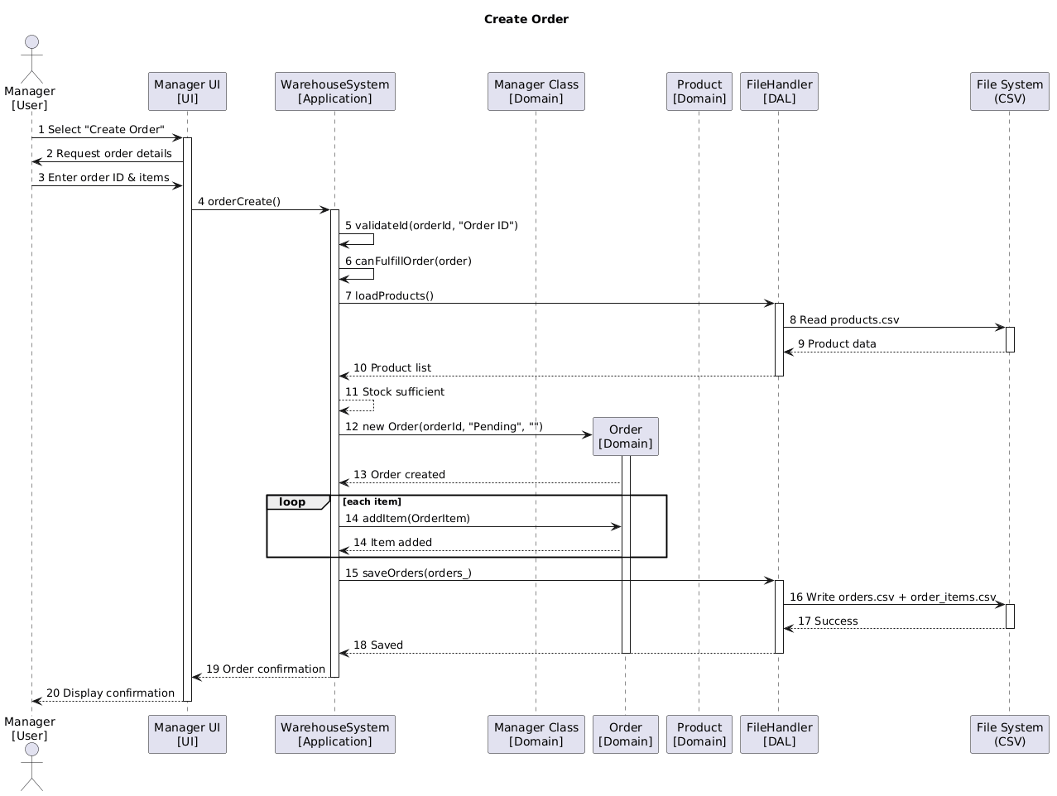
Employee Completes an Order
  - Employee chooses “Complete order”.
  - System checks that the selected order is assigned to them.
  - canFulfillOrder() is run again to avoid negative stock.
  - If OK, deductStock() is called and status is set to Completed.
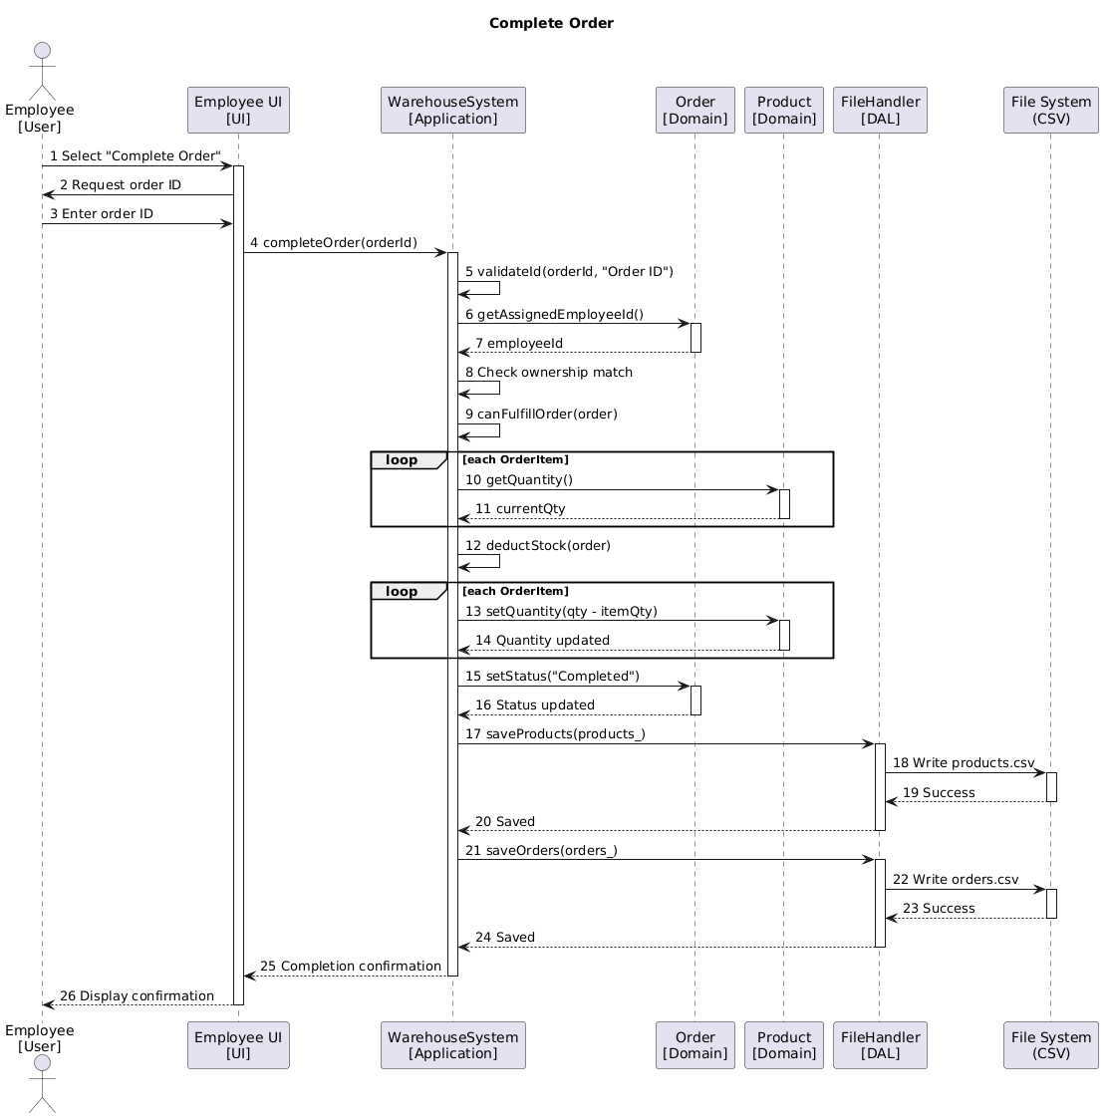
Generating Reports
  - Manager’s “Reports” menu calls appropriate ReportGenerator methods for inventory or order reports.
  - Employee’s “My report” uses generateEmployeeReport() filtered by currentUser_->getEmployeeId().
  - Reports are written to CSV at a path provided by the user.
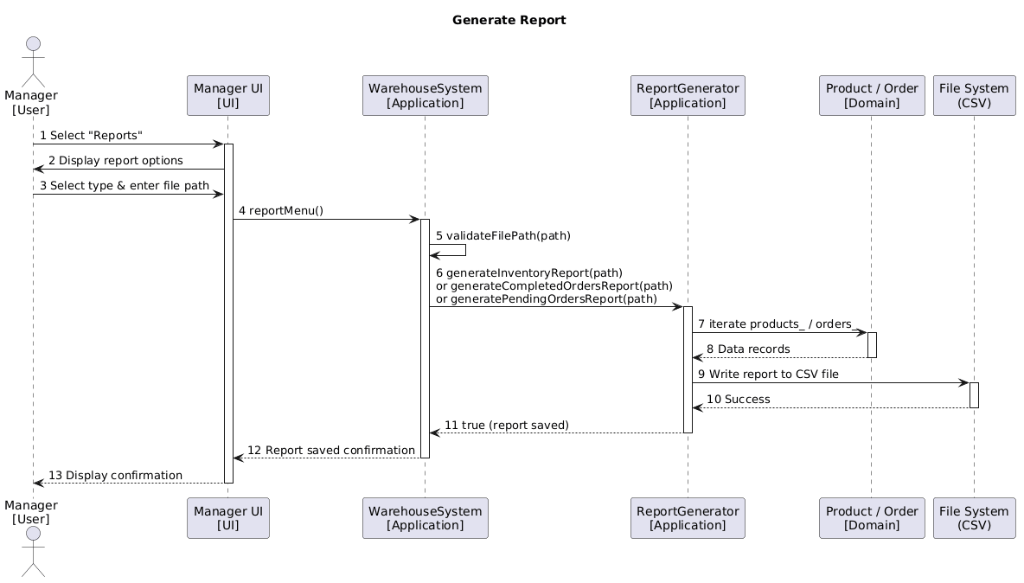
State diagram
Product state
The product state diagram models stock behaviour across InStock, LowStock, and OutOfStock, based on quantity changes. It also includes logical deletion behaviour. In this design, deleted products are removed from normal operational views, while the underlying record is retained (isDeleted) to preserve traceability.
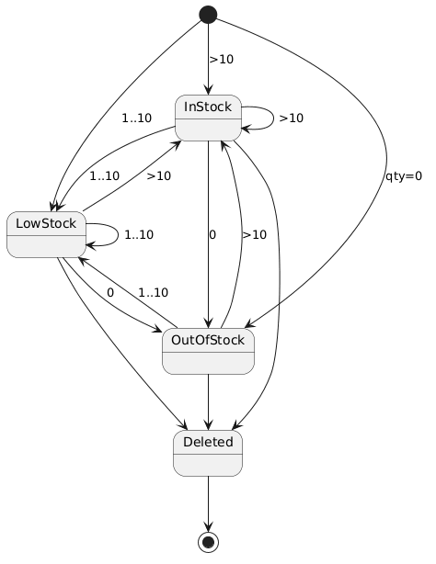
Order State
This state diagram captures the order lifecycle from Pending to InProgress and then Completed, alongside deletion constraints. It aligns with the implemented rules: only Pending orders can be deleted, while InProgress and Completed orders are protected to maintain operational consistency and historical accuracy.
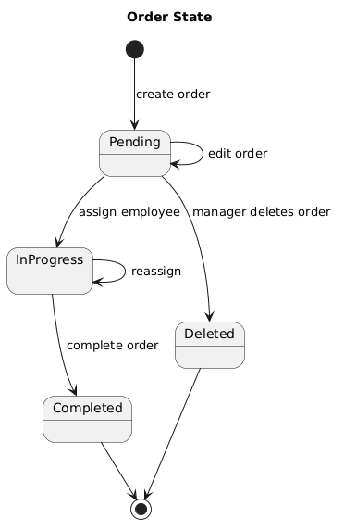

3.4 Structural Design Diagrams
Class diagram
The class diagram presents the structural design of the system:
- User is an abstract base class, with Manager and Employee as subclasses for role separation.
- Product, EmployeeRecord, OrderItem, and Order represent the core warehouse domain data.
- AuthManager handles authentication and manages the user map.
- FileHandler is responsible for loading and saving entities to CSV files.
- ReportGenerator reads in-memory collections and generates CSV reports.
- WarehouseSystem contains the main maps, holds references to AuthManager and ReportGenerator, and coordinates UI flow and business logic.
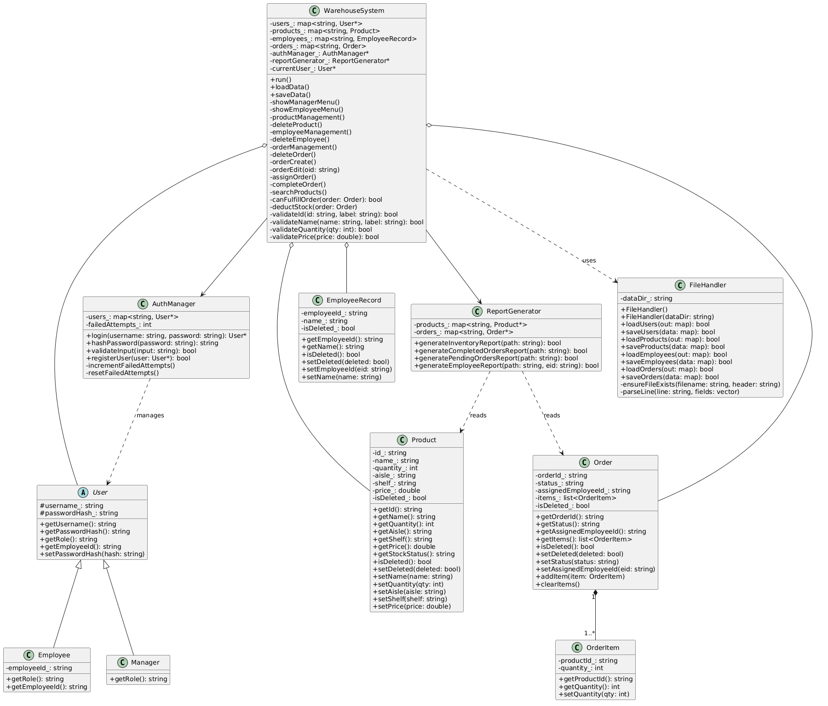
Component diagram
The component diagram outlines the high-level architecture: user interface, application control, domain model, persistence, and reporting. CSV files form the persistence boundary. This structure supports maintainability by keeping responsibilities separated and reducing coupling between modules.
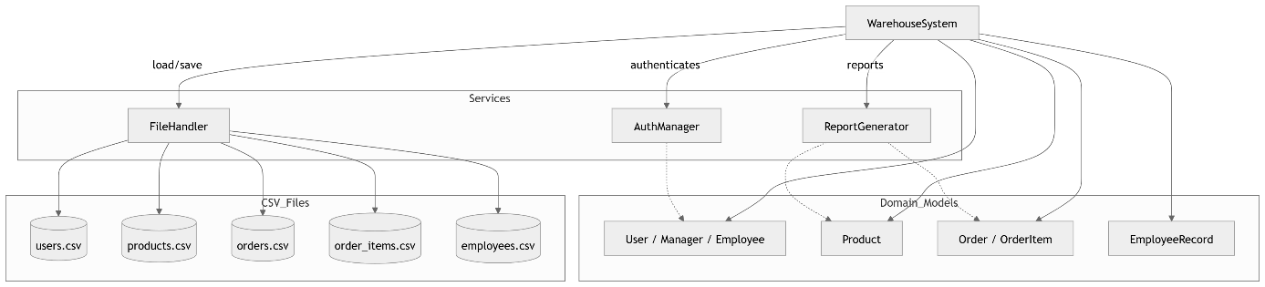

3.5 Critical Analysis
Software Architecture Analysis
The system uses a layered architecture that keeps the user interface (menus), core business logic (WarehouseSystem), and data persistence (FileHandler) separate. Users interact through the console menus, whilst the main work is done by WarehouseSystem. File reading and writing is handled by FileHandler, and ReportGenerator takes care of producing reports. This separation makes the system easier to understand, maintain, and extend.
Design Principles Analysis
- Encapsulation: Classes like Product, Order, and OrderItem use private attributes with getter and setter methods.
- Inheritance: Manager and Employee both inherit from the abstract User class.
- Polymorphism: The user’s role determines which menu is shown (showManagerMenu vs showEmployeeMenu).
- Separation of Concerns: Each class has a clear job AuthManager handles authentication, FileHandler handles I/O, and ReportGenerator handles reports.
- Deletion Strategy Analysis: A soft delete approach was adopted to preserve fulfilment history and referential integrity. Deleting a record sets an isDeleted flag rather than removing it, keeping flagged entries invisible to users whilst the data remains intact. Deletion constraints apply: products and employees cannot be deleted if linked to active or Inprogress orders, and only Pending orders may be deleted.

3.6 Implementation Explanation
Key Data Structures:
- std::map<string, Product>: Products indexed by product ID.
- std::map<string, Order>: Orders indexed by order ID.
- std::map<string, EmployeeRecord>: Employees indexed by employee ID.
- std::map<string, User*>: Users indexed by username.
- std::list<OrderItem>: line items inside each Order.
Classes
WarehouseSystem:
- Manages products, orders, employees, users.
- Provides product management, employee management, order management, order assignment.
- Contains ReportGenerator for report generation.
- Handles input validation and menu navigation.
AuthManager:
- Handles user authentication.
- Verifies login credentials and user roles.
FileHandler:
- Loads and saves products, orders, order items, employees, users to CSV files.
- Ensures data persistence across sessions.
ReportGenerator:
- Generates inventory report (id, name, quantity, aisle, shelf, price).
- Generates completed orders report.
- Generates pending orders report.
- Generates employee-specific report.
Product:
- Stores product data: id, name, quantity, aisle, shelf, price.
- getStockStatus() returns InStock, LowStock, or OutOfStock based on quantity.
Order:
- Stores orderId, status, assignedEmployeeId, list of OrderItem.
- Status: Pending, InProgress, Completed.

3.7 Evaluation of Non-Functional Requirements
NFR 1.1 — Performance (search): Product search returns results near-instantly in testing, well within the 2-second threshold for datasets of up to 100 products.
NFR 1.2 — Performance (order completion): Order completion and inventory updates execute in under 1 second under normal load, meeting the requirement.
NFR 2.1 — Security (access control): Role-based access control is enforced at runtime; employee accounts are blocked from all manager-only menu options.
NFR 2.2 — Security (password storage): Passwords are hashed prior to storage and are never written to file in plain text.
NFR 2.3 — Security (login attempts): The system tracks consecutive failed login attempts and terminates the session after three failures.
NFR 3.1 — Data integrity (unique IDs): Duplicate product ID checks are performed on insertion, any conflict is rejected with a descriptive error message.
NFR 3.2 — Data integrity (stock levels): Order completion is blocked if available stock is insufficient, ensuring inventory quantities never fall below zero.
NFR 4.1 — Reliability (input validation): All numeric input fields are validated, invalid entries display an error and prompt re-entry without crashing the application.
NFR 4.2 — Error handling (missing files): On first run, any missing CSV data files are created automatically, allowing the system to initialise without error.
NFR 5.1 — Portability: The system uses standard C++17 with no platform-specific dependencies and has been verified to compile and run on Windows

Chapter 4: Implementation

4.1 Overview of the Implementation Process
From Design to Code
- The WarehouseSystem class handles all management functions and coordinates the menus.
- FileHandler takes care of loading and saving data to CSV files.
- ReportGenerator produces the various CSV reports.
- AuthManager handles login and role verification.
- Product, Order, OrderItem, and EmployeeRecord model the domain entities.
Data Structures Used
- std::map for products, orders, employees, and users.
- std::list for order items within each order.
Object-Oriented Programming Concepts Used
- Encapsulation: Private members with public getters and setters.
- Inheritance: Manager and Employee extend User.
- Polymorphism: The menu displayed depends on the user’s role.
- Composition: WarehouseSystem holds products, orders, employees, ReportGenerator, and AuthManager.

4.2 Technologies Used
- Programming Language: C++20
- Build System: CMake
- IDE: CLion
- Standard Library: <map>, <list>, <string>, <fstream>, <algorithm>

4.3 Key Features and Implemented Functionalities
Manager Console Features:
- Product Management: Add, view, edit, and soft-delete products.
- Employee Management: Add, view, edit, and soft-delete employees.
- Order Management: Create, view, edit, and soft-delete orders with line items.
- Assign Order: Assign orders to employees.
- Reports: Inventory report, completed orders report, pending orders report.
- Logout.
Employee Console Features:
- My Orders: View assigned orders.
- Complete Order: Mark order as Completed.
- Search Products: Search by name or ID.
- My Report: Export assigned orders to CSV.
- Logout.

4.4 Screenshots of Console Interfaces
Login console Interface
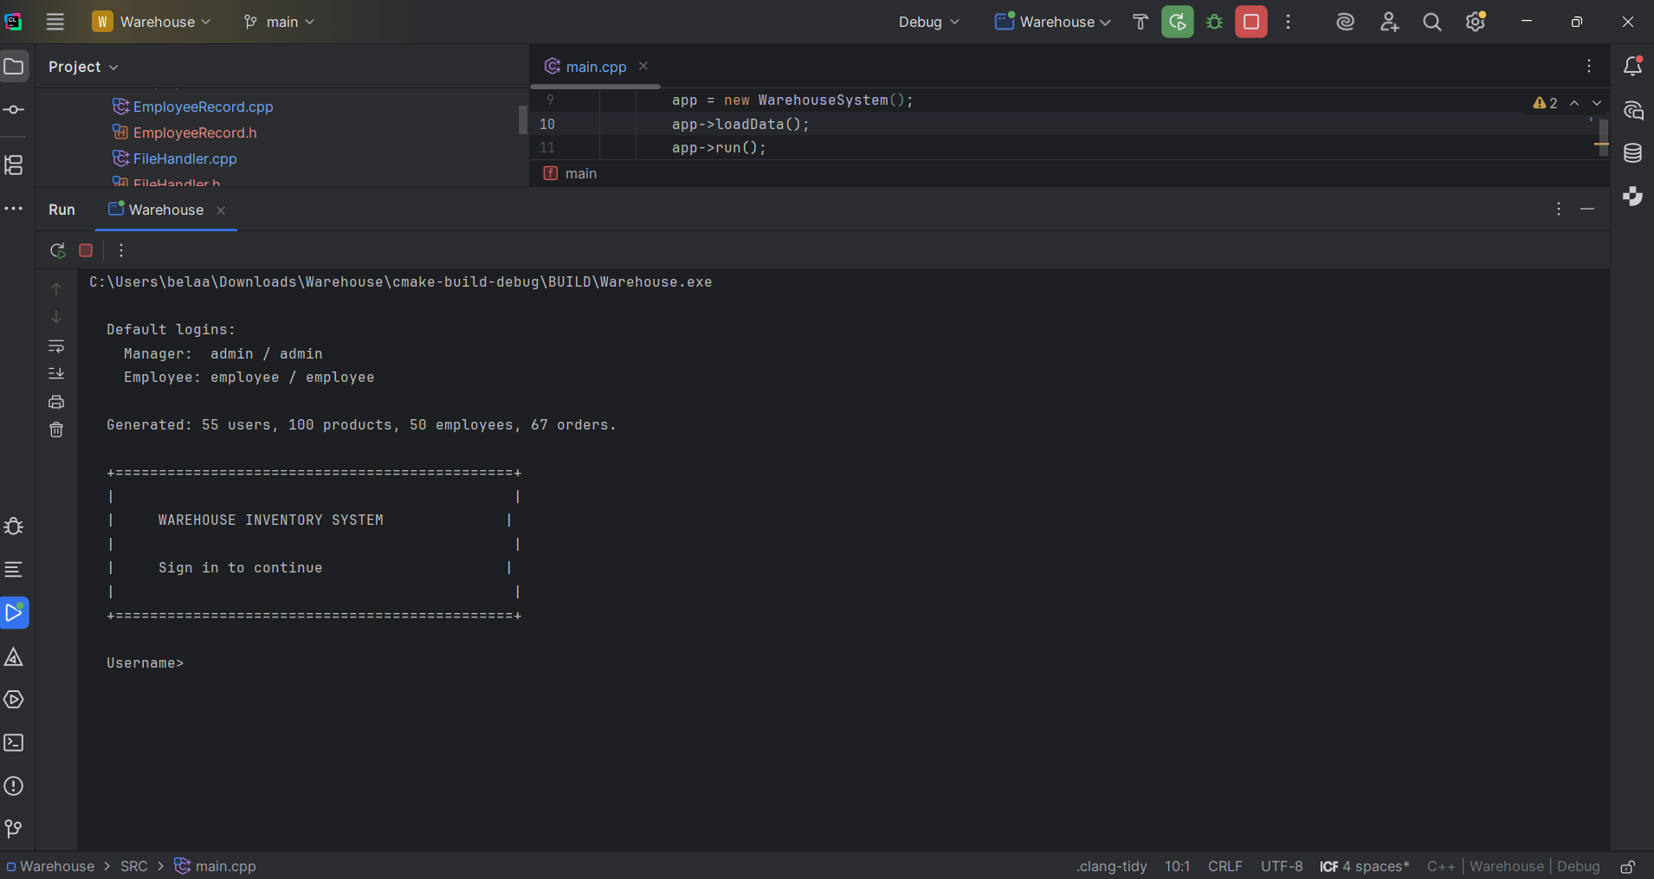

Manager console Interface
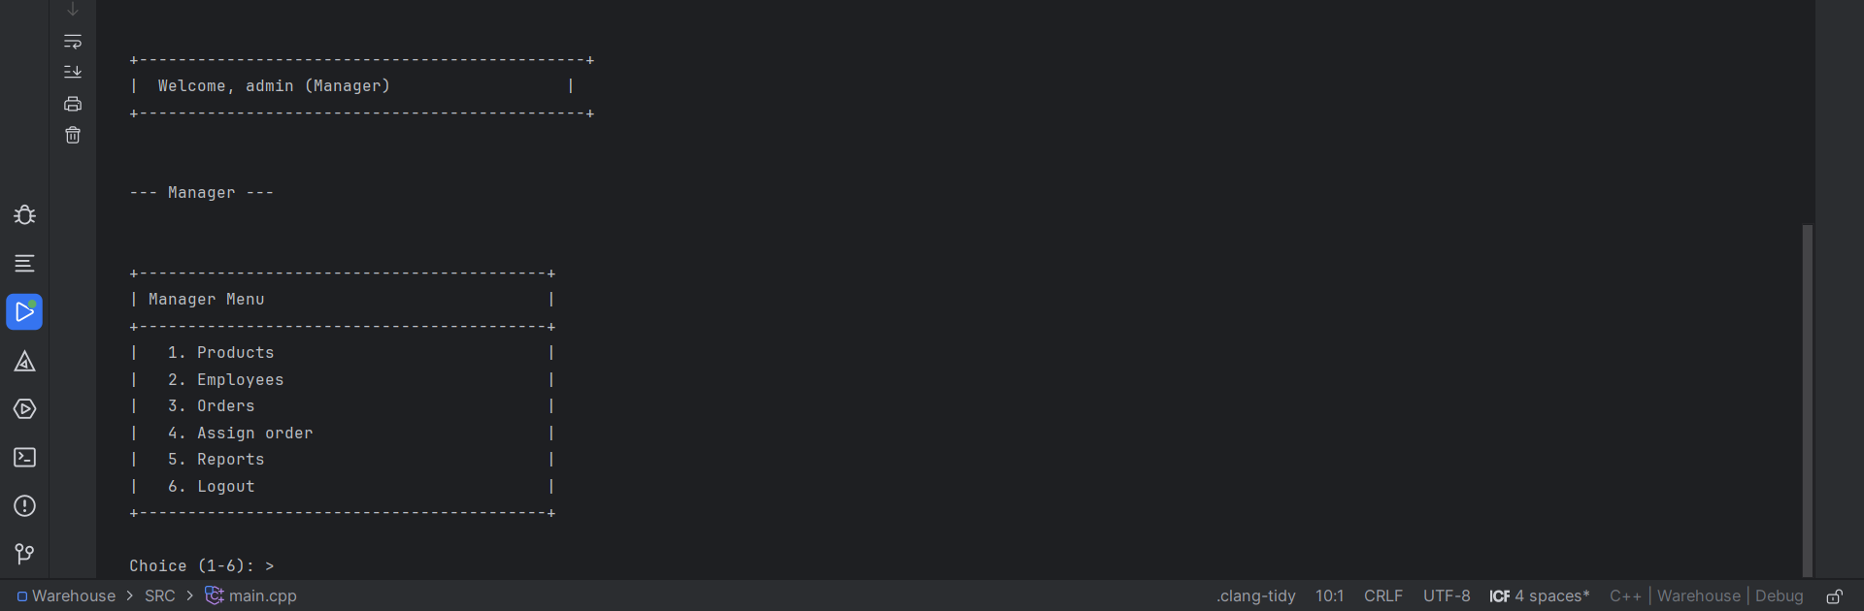

Employee console Interface
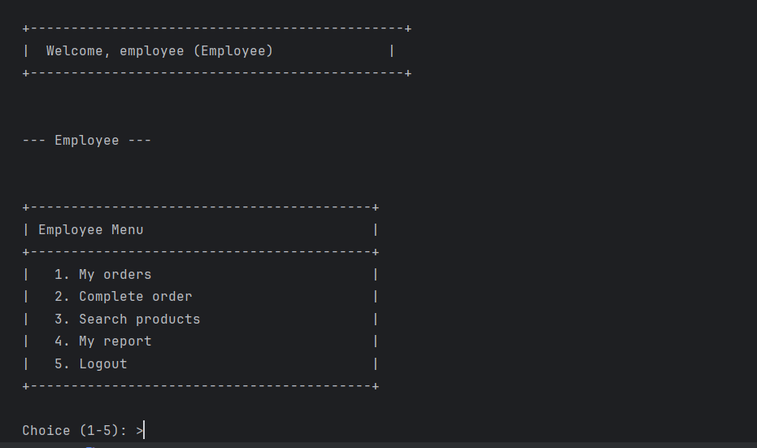
Logout Interface
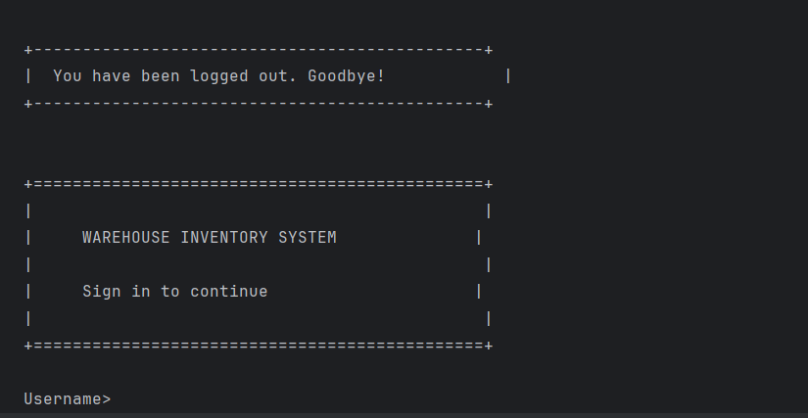

Chapter 5: Testing

5.1 User Acceptance Testing
Authentication Tests
Test ID | User Role | Scenario | Expected | Actual
1 | Manager | Login with valid Manager credentials | Welcome to Manager menu | Pass
2 | Employee | Login with valid Employee credentials | Welcome to Employee menu | Pass
3 | Both | Login with invalid username | Error message | Pass
4 | Both | Login with invalid password | Error message | Pass
5 | Both | Login with empty username | Error or prompt again | Pass
6 | Both | Login with empty password | Error or prompt again | Pass
7 | Both | Logout from Manager menu | Return to login screen | Pass
8 | Both | Logout from Employee menu | Return to login screen | Pass
9 | Both | Enter invalid menu choice (e.g. 99) | Invalid choice message, prompt again | Pass

Manager – Product Management Tests
Test ID | User Role | Scenario | Expected | Actual
10 | Manager | Add product with valid data (P001, Widget, 10, A1, S2, 9.99) | Product added successfully | Pass
11 | Manager | Add product with duplicate ID | “Product with this ID already exists” error | Pass
12 | Manager | Add product with invalid ID (e.g. X1, 123) | Validation error, hint shown | Pass
13 | Manager | Add product with negative quantity | Validation error | Pass
14 | Manager | Add product with negative price | Validation error | Pass
15 | Manager | View all products when list is empty | “No products in inventory” message | Pass
16 | Manager | View all products when list has items | Table displayed with ID, Name, Qty, Location, Price | Pass
17 | Manager | Edit product with valid ID | Product updated successfully | Pass
18 | Manager | Edit product with non-existent ID | “Product not found” error | Pass
19 | Manager | Edit product, press Enter to keep name | Name unchanged | Pass
20 | Manager | Edit product, enter -1 for quantity to keep | Quantity unchanged | Pass

Manager – Employee Management Tests
Test ID | User Role | Scenario | Expected | Actual
21 | Manager | Add employee with valid data (E001, John Smith) | Employee added | Pass
22 | Manager | Add employee with duplicate ID | “Employee with this ID already exists” error | Pass
23 | Manager | Add employee and create login (y) | Login account created | Pass
24 | Manager | Add employee and skip login (n) | Only employee record created | Pass
25 | Manager | Add employee login with existing username | “Username already in use” error | Pass
26 | Manager | View all employees when empty | “No employees registered” message | Pass
27 | Manager | View all employees with data | Table with ID, Name, Role | Pass
28 | Manager | Edit employee with valid ID | Employee updated successfully | Pass
29 | Manager | Edit employee with non-existent ID | “Employee not found” error | Pass
Manager – Order Management Tests
Test ID | User Role | Scenario | Expected | Actual
30 | Manager | Create order with valid items | Order created successfully | Pass
31 | Manager | Create order with duplicate Order ID | “Order with this ID already exists” error | Pass
32 | Manager | Create order with no items (empty Product ID first) | “Order must have at least one item” error | Pass
33 | Manager | Create order with non-existent Product ID | “Product not found” error | Pass
34 | Manager | Create order with quantity exceeding stock | “Insufficient stock” error | Pass
35 | Manager | View all orders when empty | “No orders” message | Pass
36 | Manager | View all orders with data | Table with Order ID, Status, Assigned To | Pass
37 | Manager | Edit order with valid ID (Pending/InProgress) | Order updated successfully | Pass
38 | Manager | Edit completed order | “Cannot edit a completed order” error | Pass
39 | Manager | Edit order with non-existent ID | “Order not found” error | Pass
40 | Manager | Edit order, revert due to insufficient stock | “Insufficient stock. Order reverted” | Pass
Manager – Assign Order Tests
Test ID | User Role | Scenario | Expected | Actual
41 | Manager | Assign order to valid employee | “Order X assigned to Y” confirmation | Pass
42 | Manager | Assign non-existent order | “Order not found” error | Pass
43 | Manager | Assign completed order | “Cannot reassign a completed order” error | Pass
44 | Manager | Assign order to non-existent employee | “Employee not found” error | Pass
Manager – Reports Tests
Test ID | User Role | Scenario | Expected | Actual
45 | Manager | Generate inventory report to valid path | “Report saved to [path]” | Pass
46 | Manager | Generate completed orders report | Report saved | Pass
47 | Manager | Generate pending orders report | Report saved | Pass
48 | Manager | Select Back (4) in Reports menu | Return to Manager Menu | Pass
49 | Manager | Enter invalid file path for report | Validation error or “Failed to save report” | Pass

Employee Tests
Test ID | User Role | Scenario | Expected | Actual
50 | Employee | View assigned orders when none | “You have no assigned orders” message | Pass
51 | Employee | View assigned orders when some exist | Table with Order ID, Status | Pass
52 | Employee | Complete order assigned to self | “Order completed successfully” | Pass
53 | Employee | Complete order not assigned to self | “This order is not assigned to you” error | Pass
54 | Employee | Complete already completed order | “Order is already completed” error | Pass
55 | Employee | Complete order with insufficient stock | “Insufficient stock” error | Pass
56 | Employee | Complete non-existent order | “Order not found” error | Pass
57 | Employee | Search products by ID (e.g. P001) | Matching product(s) displayed | Pass
58 | Employee | Search products by partial name | Matching product(s) displayed | Pass
59 | Employee | Search with no matches | “No products match your search” message | Pass
60 | Employee | Generate my report with custom path | “Report saved to [path]” | Pass
61 | Employee | Generate my report with empty path | Default path used (my_orders_E001.csv) | Pass
Edge Cases and Error Handling
Test ID | User Role | Scenario | Expected | Actual
62 | Both | Enter invalid choice 3 times in a row | “Too many invalid attempts. Returning to menu” | Pass
63 | Manager | Create order with invalid Order ID format | Validation error, hint shown | Pass
64 | Manager | Add product with empty name | Validation error | Pass
65 | Employee | Generate report when no employee ID | “No employee ID for this account” error | Pass

Manager — Delete Tests

Test ID | User Role | Scenario | Expected | Actual
66 | Manager | Delete product with valid ID that has no active orders | Product deleted successfully | Pass
67 | Manager | Delete product that is part of an active Pending order | Cannot delete: product is part of active order ORD001 | Pass
68 | Manager | Delete product with non-existent ID | Product not found | Pass
69 | Manager | Delete product, enter n at confirmation | Deletion cancelled | Pass
70 | Manager | Delete employee with valid ID who has no InProgress orders | Employee deleted successfully | Pass
71 | Manager | Delete employee who has an InProgress order assigned | Cannot delete employee has active order ORD002 InProgress | Pass
72 | Manager | Delete employee with non-existent ID | Employee not found | Pass
73 | Manager | Delete employee, enter n at confirmation | Deletion cancelled | Pass
74 | Manager | Delete Pending order with valid ID | Order deleted successfully | Pass
75 | Manager | Delete InProgress order | Cannot delete an order that is InProgress | Pass
76 | Manager | Delete Completed order | Cannot delete a completed order history must be preserved | Pass
77 | Manager | Delete order with non-existent ID | Order not found | Pass
78 | Manager | Attempt to view deleted product in View All Products | Deleted product does not appear in list | Pass
79 | Manager | Attempt to view deleted employee in View All Employees | Deleted employee does not appear in list | Pass
80 | Manager | Attempt to view deleted order in View All Orders | Deleted order does not appear in list | Pass
81 | Manager | Attempt to edit a soft-deleted product | Product not found | Pass
82 | Manager | Attempt to assign order to soft-deleted employee | Employee not found | Pass
83 | Manager | Deleted product does not appear in employee product search | Search returns no result for deleted product ID | Pass

5.2 Screenshots of Testing
Automated tests — WarehouseTests
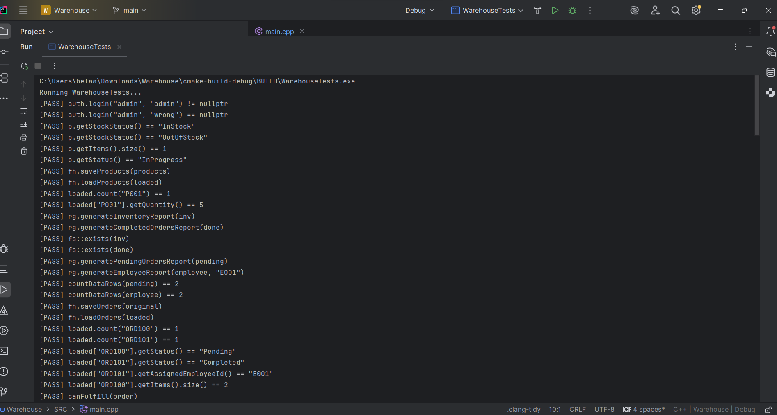
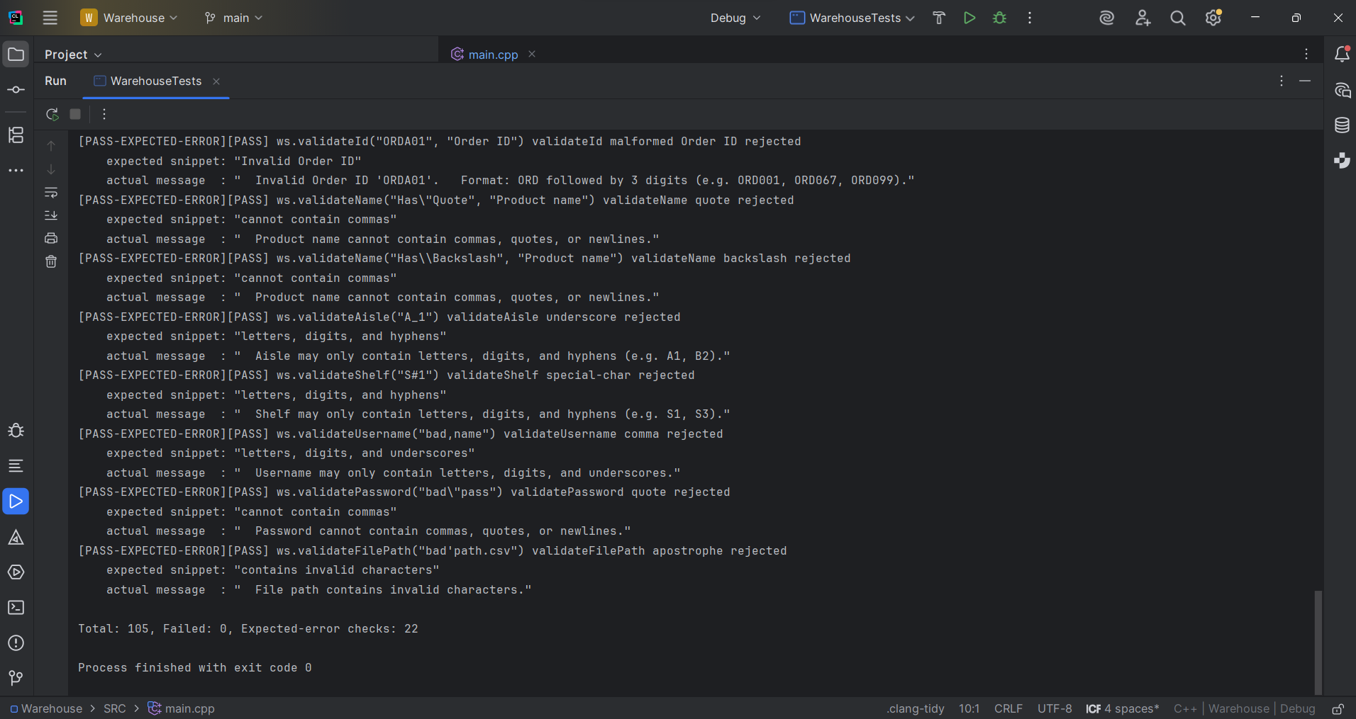

UAT-1 — Manager login: valid credentials → manager menu
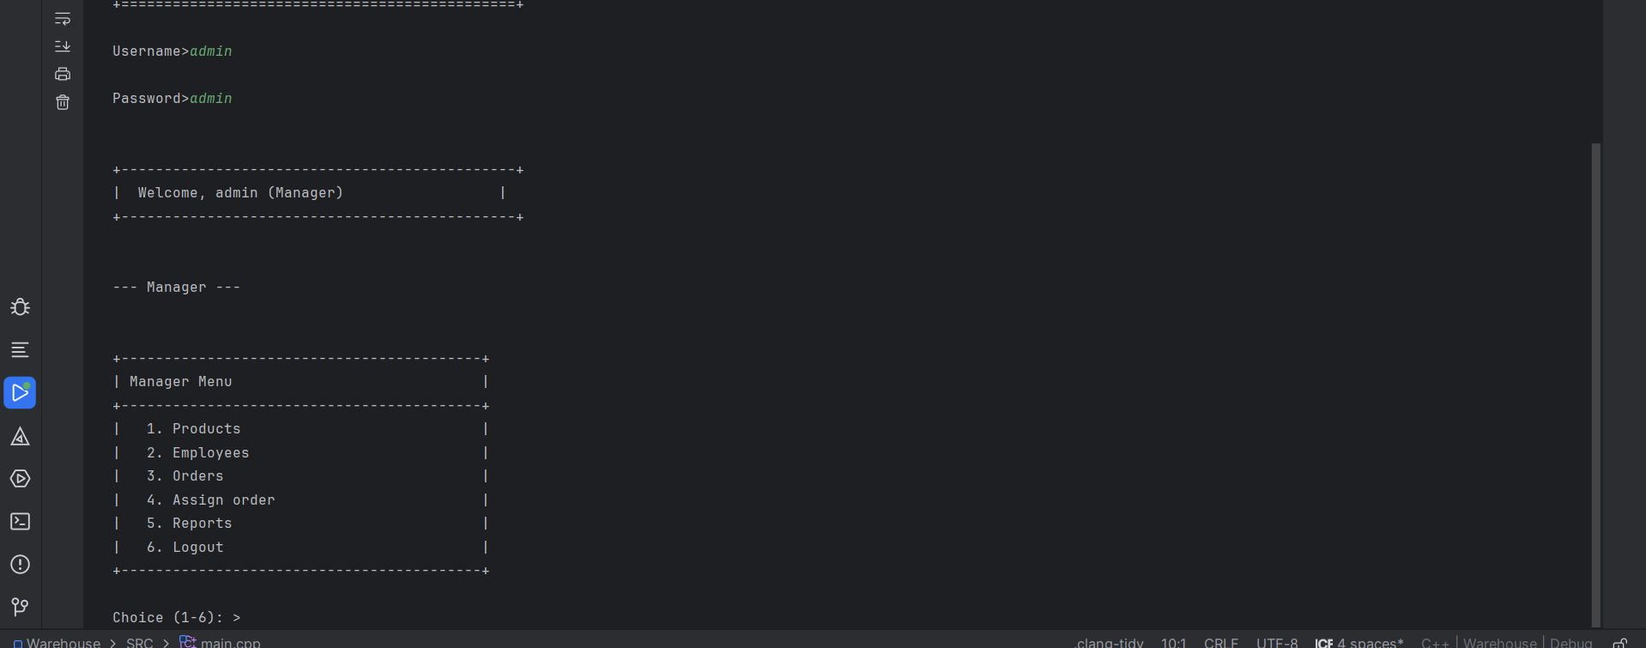
UAT-2 — Employee login: valid credentials → employee menu
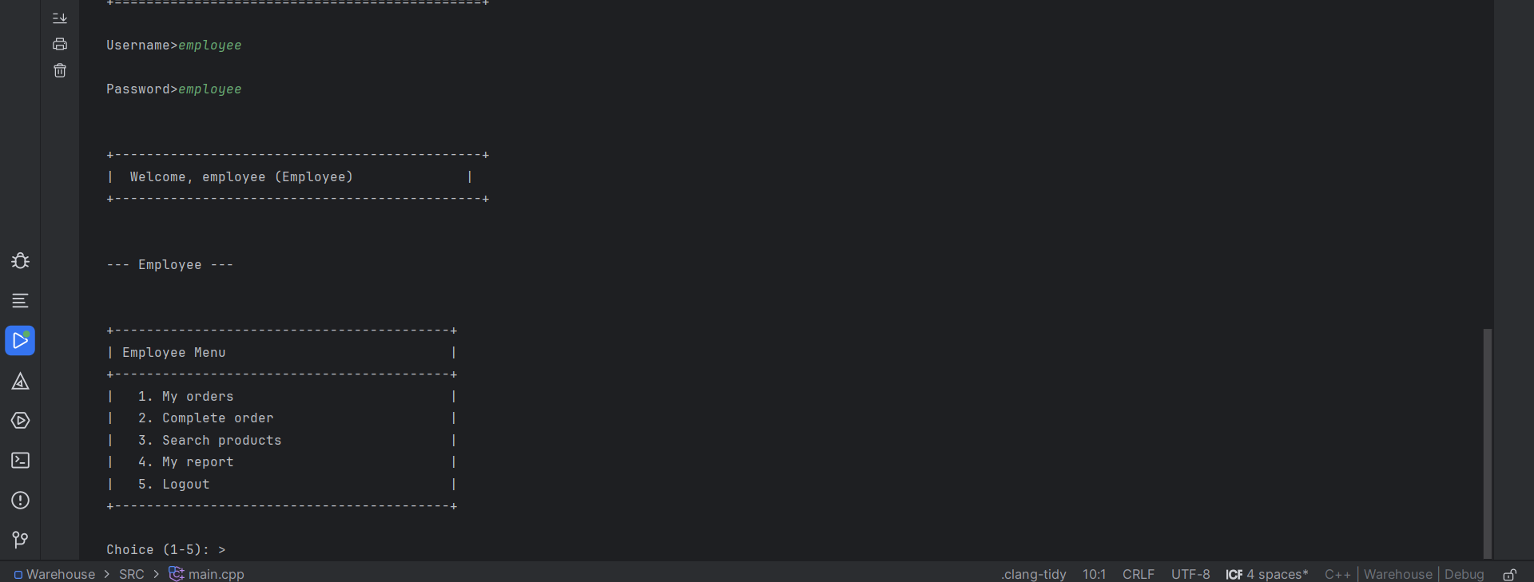
UAT-3/4 — Login failure: invalid username or password
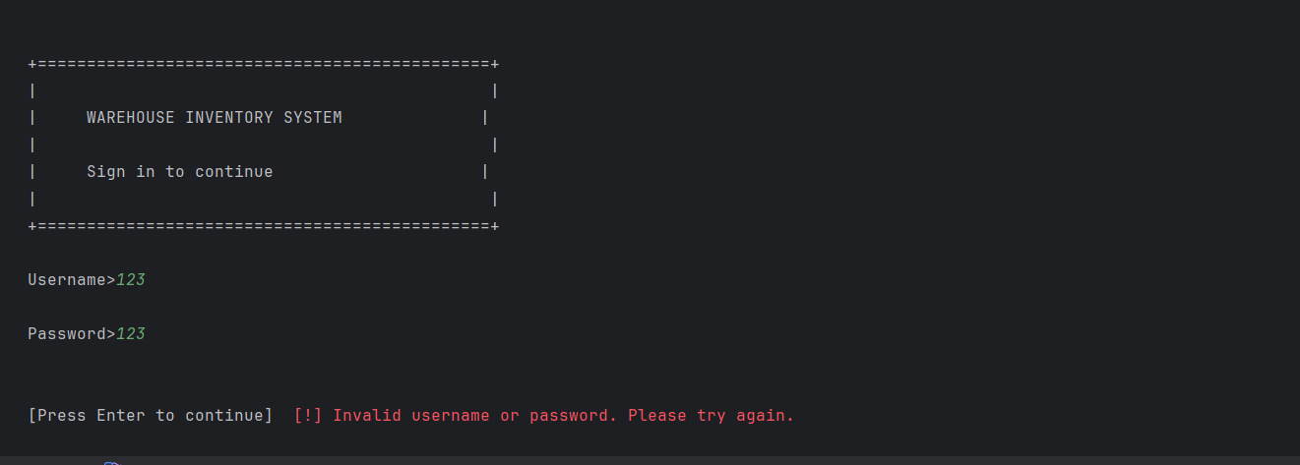

UAT-10/11 — Add product: success and duplicate ID error
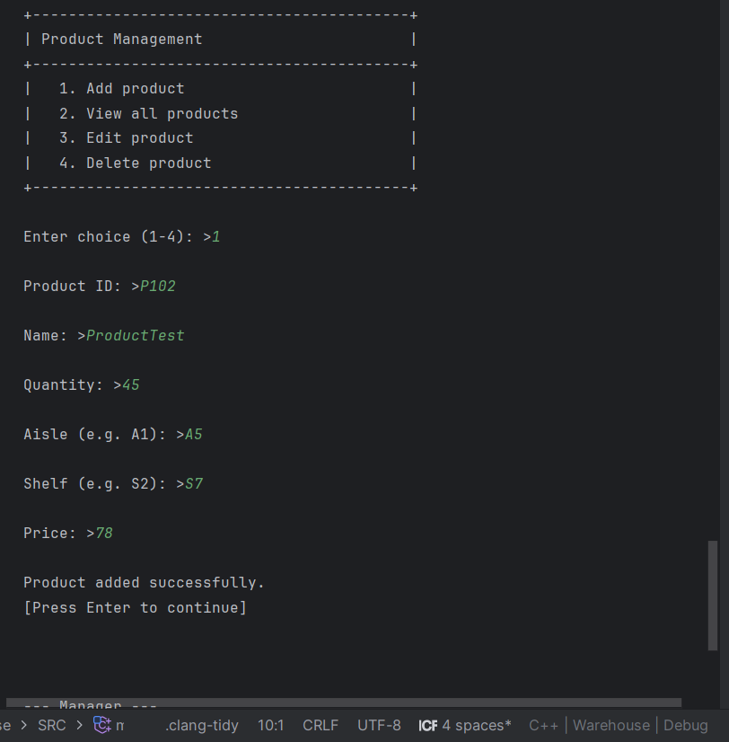
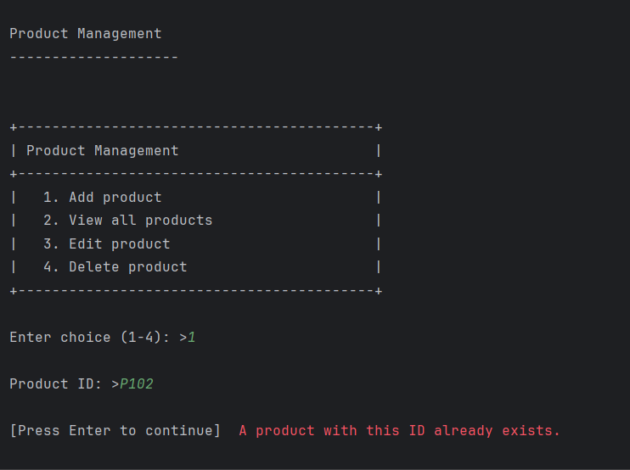

UAT-12/13 — Add product: validation error
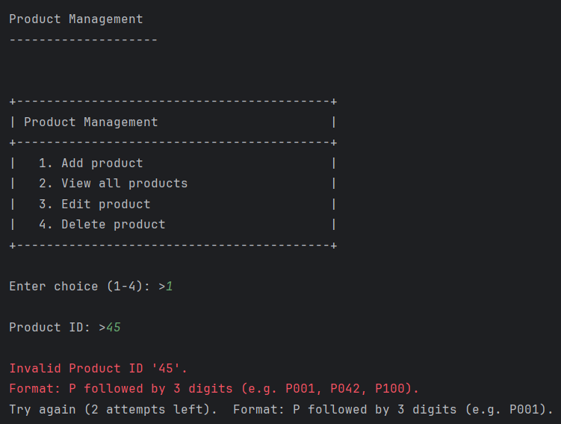

UAT-16 — View all products: table listing
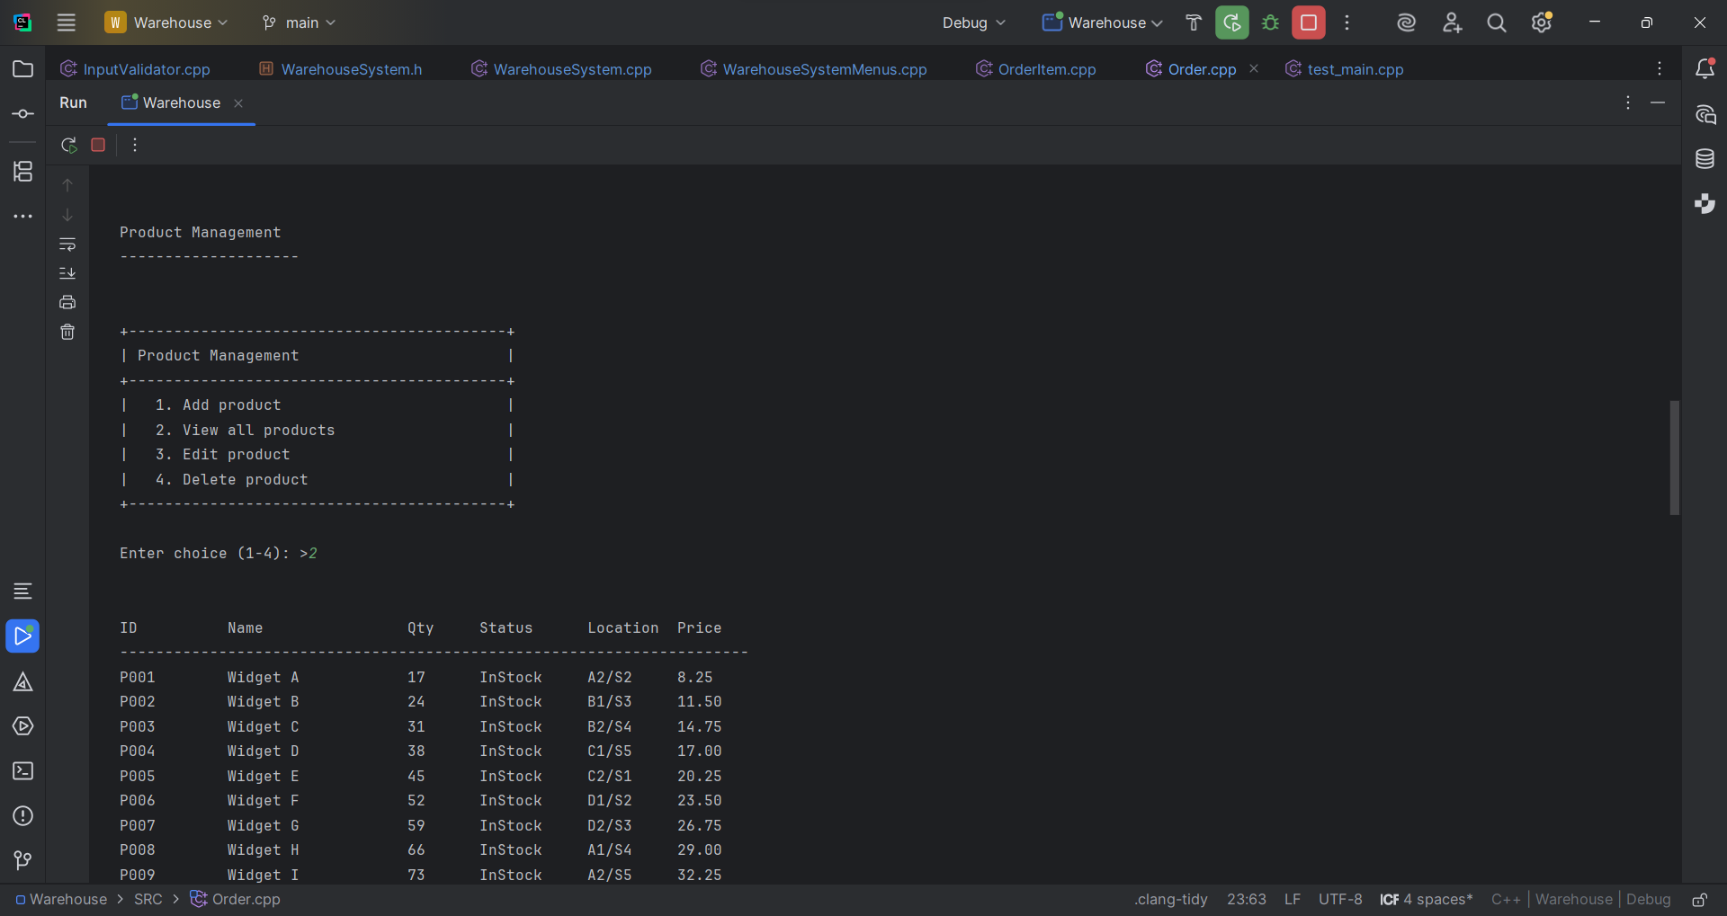

UAT-21/22 — Add employee: success and duplicate ID error
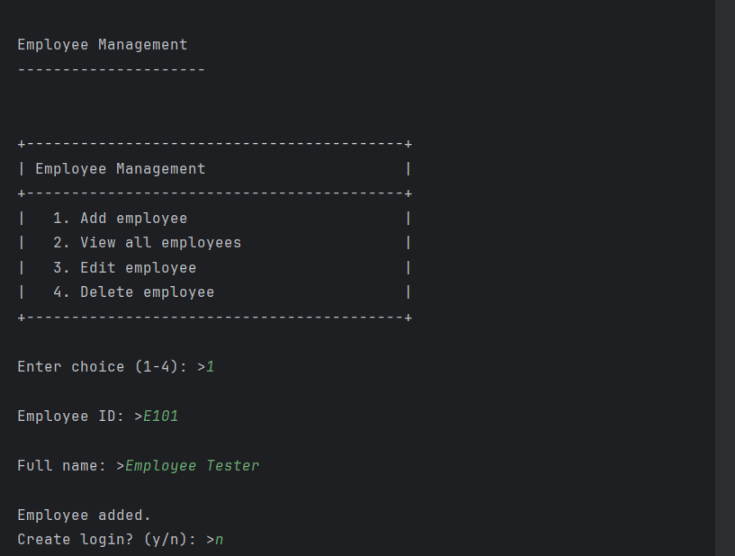

UAT-30/34 — Create order: success and insufficient stock error
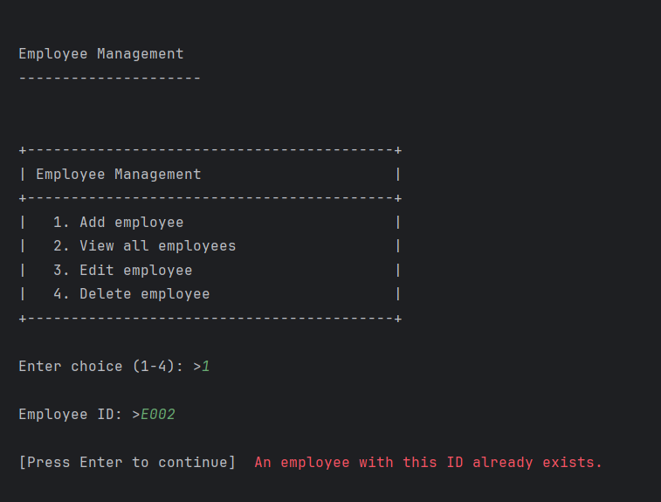

UAT-36 — View all orders: table listing
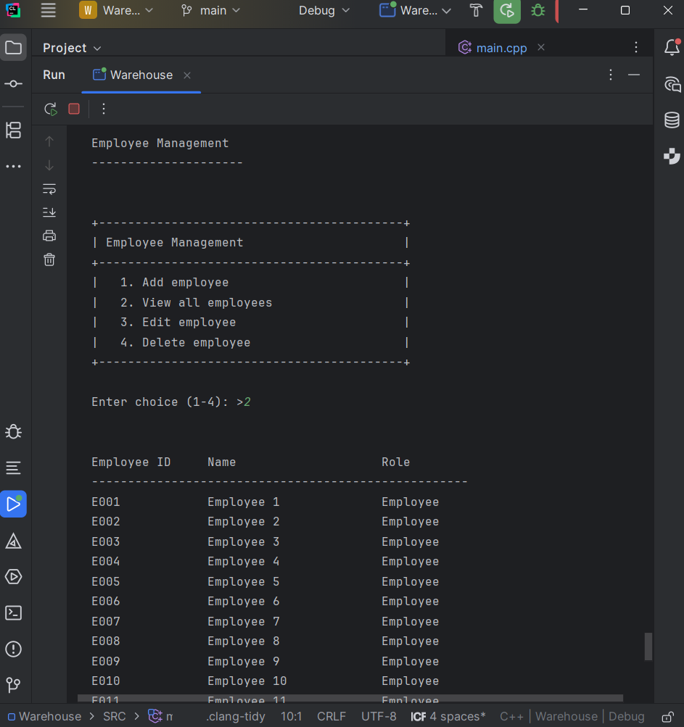

UAT-41 — Assign order: confirmation message
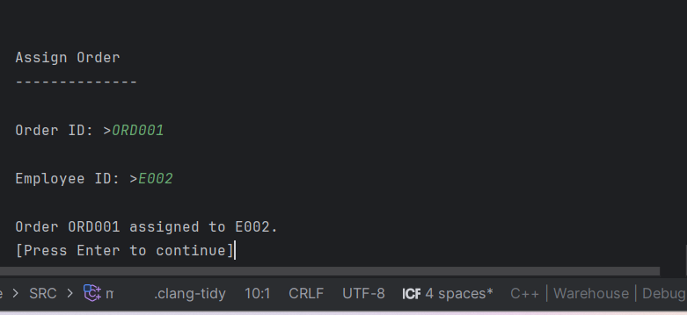
UAT-45 — Inventory report: saved confirmation
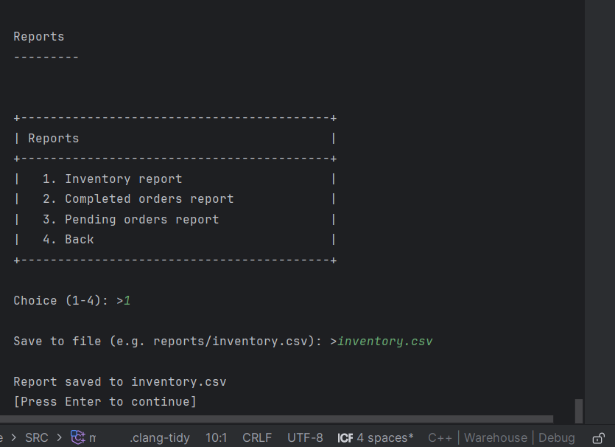

UAT-51/52 — Employee: assigned orders list and complete order success
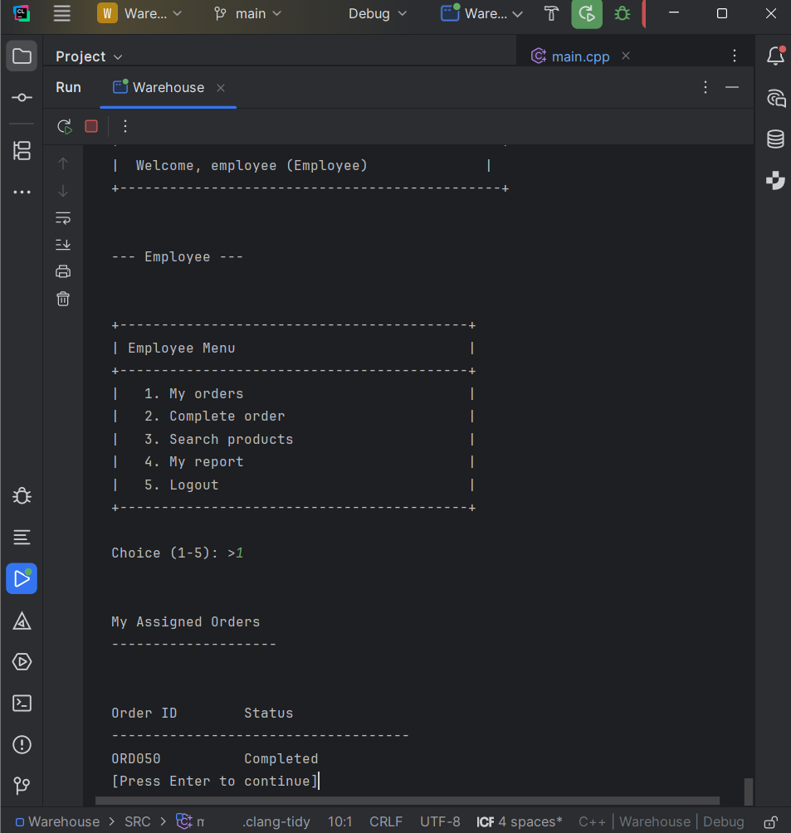

UAT-57/59 — Employee: product search match and no matches
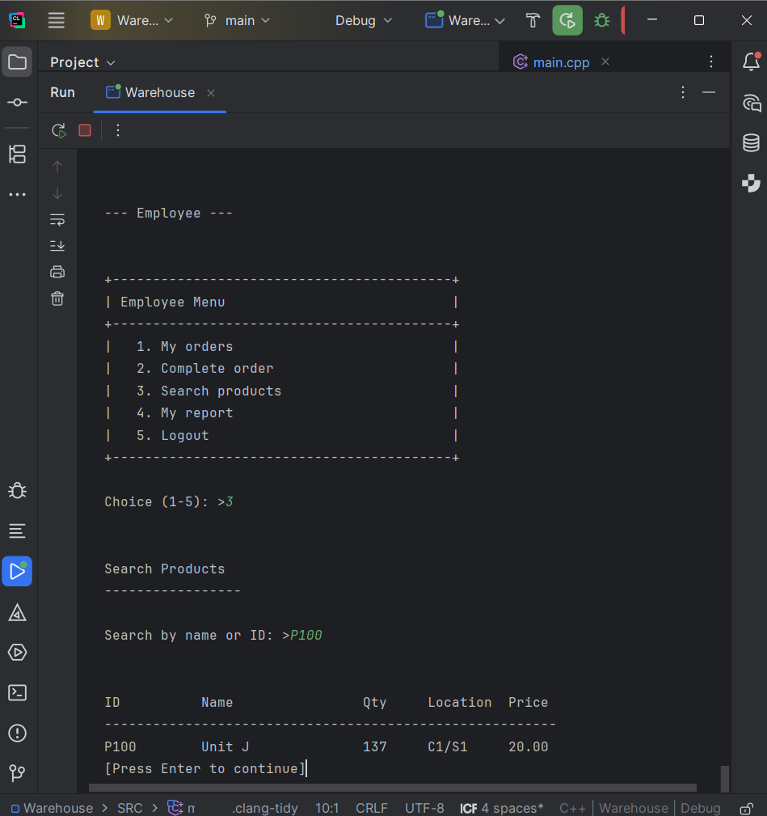

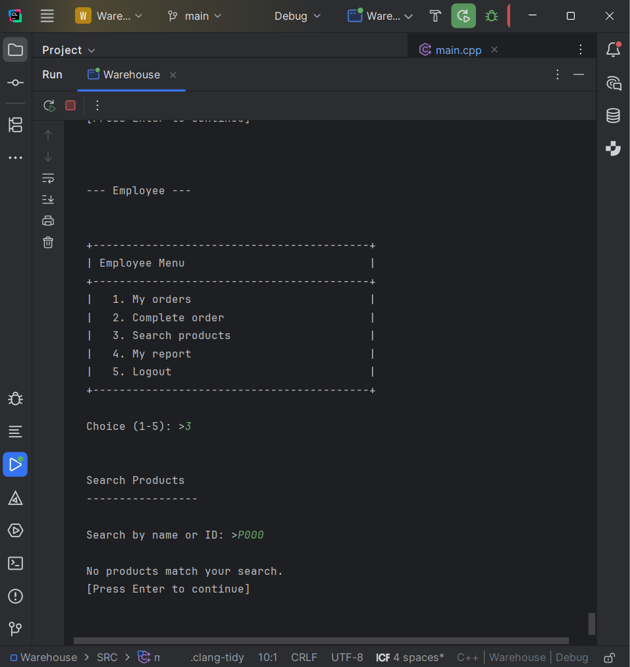

UAT-62 — Menu input: repeated invalid attempts → return to menu
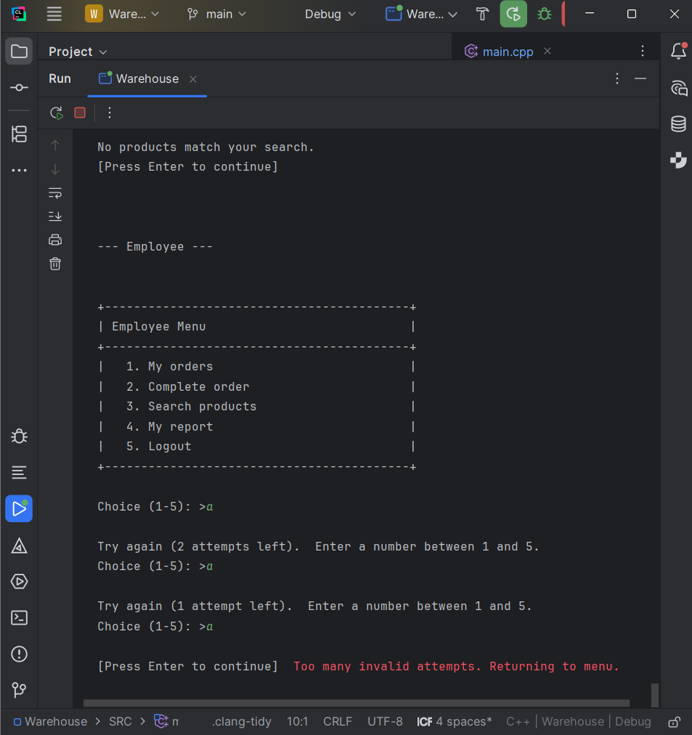

UAT-66/67 — Delete product: success
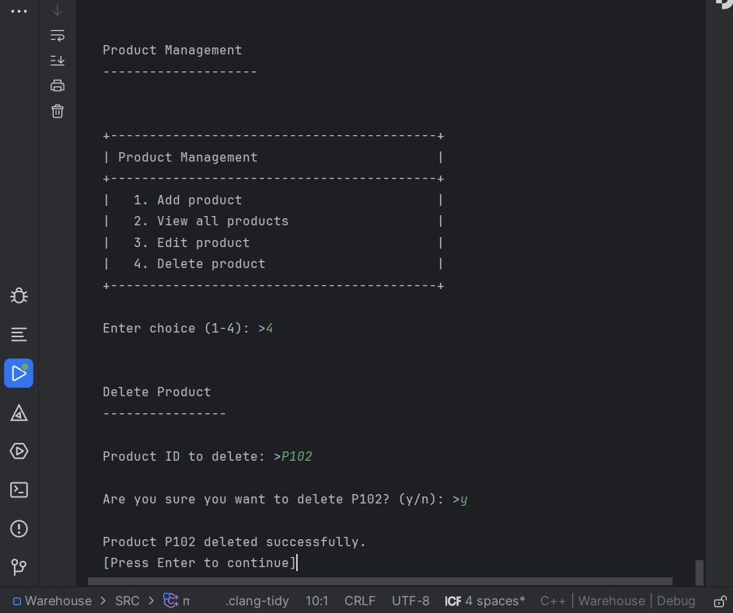

Chapter 6: Documentation

6.1 User Manuals

Manager User Manual
This manual details all Manager functions available within the Warehouse Inventory System.
1. Logging In
- Upon launching the application, the login prompt will be displayed.
- Enter your username and password when prompted.
- If incorrect credentials are provided, an error message will be displayed. A maximum of three attempts is permitted before the system returns to the main menu.
- Upon successful authentication, the Manager Menu will appear with options 1–6.
2. Product Management (Menu Option 1)
2.1 Add Product
- Select option 1 (Add product) from the Product Management menu.
- Product ID: Enter an ID in the format P followed by 3 digits (e.g. P001, P123). Incorrectly formatted or duplicate IDs will be rejected with an error message.
- Name: Enter between 1 and 60 characters. Commas and quotation marks are not permitted.
- Quantity: Enter a whole number of zero or greater.
- Aisle: Alphanumeric characters only, up to 10 characters (e.g. A1, B2).
- Shelf: Same format as Aisle (e.g. S1, S3).
- Price: Enter a numerical value of zero or greater (e.g. 9.99).
- Upon successful validation, the product will be saved and a confirmation message will be displayed.
2.2 View All Products
- Select option 2 (View all products).
- A table will be displayed showing: ID, Name, Quantity, Location (Aisle/Shelf), and Price.
- If no products exist, an appropriate message will be displayed.
- Press Enter to return to the menu.
2.3 Edit Product
- Select option 3 (Edit product).
- Enter the ID of the product to be modified (e.g. P001). If the product does not exist, an error message will be displayed.
- For each field (Name, Quantity, Aisle, Shelf, Price), press Enter to retain the current value. For Quantity or Price, enter -1 to leave the existing value unchanged.
- Only the fields requiring modification need to be updated.
- A confirmation message will be displayed once the record has been updated.
2.4 Delete Product
- Select option 4 (Delete product) from the Product Management menu.
- Enter the Product ID to be deleted (e.g. P001). If it does not exist, an error message will be displayed.
- If the product is referenced by an active Pending or InProgress order, deletion will be blocked and the relevant order ID will be shown.
- A confirmation prompt will be displayed enter y to proceed or n to cancel.
- Upon deletion, the product will no longer appear in any views or searches. The record is retained in the CSV file with isDeleted = 1.
3. Employee Management (Menu Option 2)
3.1 Add Employee
- Select option 1 (Add employee).
- Employee ID: Enter E followed by 3 digits (e.g. E001). Duplicate IDs won’t be accepted.
- Full name: Enter 1–60 characters, no commas or quotes.
- When asked “Create login? (y/n):”:
  - y: A username (3–30 characters, letters/digits/underscores) and password (4–50 characters) will be required. The employee will then be able to log in to the system.
  - n: Only the employee record is created, no login account is set up.

3.2 View All Employees
- Select option 2 (View all employees).
- A table shows Employee ID, Name, and Role (Manager, Employee, or - if they don’t have a login).
- Press Enter to go back.
3.3 Edit Employee
- Select option 3 (Edit employee).
- Enter the Employee ID you want to edit.
- Enter the new name (or press Enter to keep the current one).
- You’ll see a confirmation when it’s done.
3.4 Delete Employee
- Select option 4 (Delete employee) from the Employee Management menu.
- Enter the Employee ID you want to delete (e.g. E001). If it does not exist, you will get an error.
- If the employee has an order currently InProgress, deletion will be blocked and you will see an error message showing the order ID.
- You will be asked to confirm: type y to proceed or n to cancel.
- On success, the employee is marked as deleted and will no longer appear in the employee list. The record is preserved in the CSV file with isDeleted = 1.

4. Order Management (Menu Option 3)
4.1 Create Order
- Select option 1 (Create order).
- Order ID: Enter ORD followed by 3 digits (e.g. ORD001). Duplicate IDs won’t be accepted.
- Add items: For each line item:
  - Enter the Product ID (e.g. P001). Leave it empty when you’re done.
  - If the product isn’t found, you’ll see an error and can try again.
  - Enter the Quantity (whole number greater than 0).
- The order must have at least one item.
- The system checks stock. If there isn’t enough stock for any item, the order will be rejected.
- On success, you’ll see a confirmation message.
4.2 View All Orders
- Select option 2 (View all orders).
- A table shows Order ID, Status (Pending/InProgress/Completed), and Assigned To (employee ID or -).
- Press Enter to go back.

4.3 Edit Order
- Select option 3 (Edit order).
- Enter the Order ID you want to edit.
- Completed orders cannot be edited, you will see an error if you try.
- Re-add all the line items (Product ID and Quantity). Leave Product ID empty when you are done.
- Stock is checked again. If there is not enough stock or you did not add any items, the order is reverted.
- A confirmation message will be displayed upon success.
4.4 Delete Order
- Select option 4 (Delete order) from the Order Management menu.
- Enter the Order ID you want to delete (e.g. ORD001). If it does not exist, you will get an error.
- Only Pending orders can be deleted. If the order is InProgress you will see "Cannot delete an order that is InProgress." If it is Completed you will see "Cannot delete a completed order history must be preserved."
- You will be asked to confirm: type y to proceed or n to cancel.
- On success, the order is marked as deleted and will no longer appear in any views. The record is preserved in the CSV file with isDeleted = 1.

5. Assign Order (Menu Option 4)
- Enter the Order ID you want to assign.
- If the order doesn’t exist or is already Completed, you’ll see an error.
- Enter the Employee ID (e.g. E001). The employee must already exist in the system.
- The order status is set to InProgress and the employee is assigned.
- A confirmation message will be displayed once the update is saved.
6. Reports (Menu Option 5)
- Select the required report type: 1 for Inventory, 2 for Completed orders, 3 for Pending orders, or 4 to return to the Manager Menu.
- Enter the file path to which the CSV report should be saved (e.g. inventory.csv). Quotation marks and newline characters are not permitted in the path.
- Upon success, the message "Report saved to [path]" will be displayed. If the file cannot be saved, "Failed to save report." will be displayed.
7. Log Out (Menu Option 6)
- Choose option 6 to log out return to the login screen.

Employee User Manual
This manual explains how to use all the Employee functions.
1. Logging In
- Run the application and enter your username and password.
- Your account must be linked to an employee ID (this is set up when a Manager adds you and chooses “Create login? y”).
- Once logged in, the Employee Menu appears with options 1–5.
2. My Orders (Menu Option 1)
- select option 1 (My orders).
- A table lists all orders assigned to you, with Order ID and Status.
- If you do not have any assigned orders, a message will tell you.
- Press Enter to go back to the menu.
3. Complete Order (Menu Option 2)
- select option 2 (Complete order).
- Enter the Order ID you want to complete (e.g. ORD001).
- The system checks that:
  - The order exists
  - The order is assigned to you
  - The order isn’t already completed
  - There’s enough stock for all items
- If any of these fail, you’ll see an error message.
- On success, stock is deducted and the order status is set to Completed.
- You’ll see a confirmation message.
4. Search Products (Menu Option 3)
- select option 3 (Search products).
- Enter a product name (partial match works) or product ID (e.g. P001 or “Widget”).
- Results appear in a table: ID, Name, Quantity, Location (Aisle/Shelf), and Price.
- If nothing matches, a message will tell you.
- Press Enter to go back.
5. My Report (Menu Option 4)
- select option 4 (My report).
- Enter the file path where you want to save your assigned orders report (e.g. my_orders_E001.csv).
- If you press Enter without typing a path, the default “my_orders_[yourEmployeeId].csv” is used.
- On success: “Report saved to [path]”. On failure: “Failed to save report.”
6. Log Out (Menu Option 5)
- Choose option 5 to log out and return to the login screen.

Input Validation
Field | Format
Product ID | P + 3 digits (e.g. P001)
Employee ID | E + 3 digits (e.g. E001)
Order ID | ORD + 3 digits (e.g. ORD001)
Name | 1–60 chars, no commas or quotes
Username | 3–30 chars, letters/digits/underscores
Password | 4–50 chars, no commas or quotes
Quantity | Whole number ≥ 0 (or > 0 for order items)
Price | Number ≥ 0
Aisle/Shelf | Letters and digits only, up to 10 chars

Chapter 7: Conclusion

7.1 Summary of Project Outcomes

The Warehouse Inventory System was successfully made as a console application in C++. Managers can handle orders, employees, and products, give employees tasks, and make reports. Employees can check their assigned orders, finish them, search for products, and make their own reports. Using object-oriented principles and STL data structures, role-based access is added, CSV durability, and the ability to make reports.

7.2 Challenges Encountered
- Keeping data consistent across products, orders, and employees.
- Making sure order fulfilment checks stock availability before an order can be completed.
- Handling file I/O for multiple CSV files whilst maintaining data integrity.

7.3 Reflection on the Development Process
Using object-oriented programming helped keep the system modular. Classes such as WarehouseSystem, FileHandler, ReportGenerator, and AuthManager each have a clear responsibility. STL containers (map, list) made data handling straightforward, and separating menus, business logic, and persistence made development and testing easier.

7.4 Potential Improvements
- Add a graphical user interface
- Replace CSV storage with a database
- Add more report types
- Replace the current djb2 password hashing algorithm with a stronger, salted algorithm such as bcrypt or Argon2 for improved security.
- Add date and time tracking for orders.
- Extend soft delete functionality to support record restoration, allowing managers to reactivate previously deleted products, employees, or orders.

References
ACM, IEEE Computer Society and AAAI (2024). Computer science curricula 2023: final report. [PDF] Available at: https://ieeecs-media.computer.org/media/education/reports/CS2023.pdf [Accessed 9 March 2026].
cppreference.com contributors (2026). cppreference.com: C++ language and standard library reference. [online] Available at: https://en.cppreference.com/w/ [Accessed 5 March 2026].
cppreference.com contributors (n.d.). cppreference.com: filesystem library (std::filesystem). [online] Available at: https://en.cppreference.com/w/cpp/header/filesystem [Accessed 9 March 2026].
cppreference.com contributors (n.d.). cppreference.com: std::cerr, std::clog, std::cout. [online] Available at: https://en.cppreference.com/w/cpp/io/cerr [Accessed 9 March 2026].
Fowler, M. (2018). The practical test pyramid. [online] Available at: https://martinfowler.com/articles/practical-test-pyramid.html [Accessed 9 March 2026].
GeeksforGeeks (n.d.). GeeksforGeeks. [online] Available at: https://www.geeksforgeeks.org/ [Accessed 19 January 2026].
JetBrains (n.d.). CLion – cross-platform IDE for C and C++. [online] Available at: https://www.jetbrains.com/clion/ [Accessed 15 January 2026].
Kitware Inc. (n.d.). CMake: add_executable. [online] Available at: https://cmake.org/cmake/help/latest/command/add_executable.html [Accessed 9 March 2026].
National Institute of Standards and Technology (NIST) (2020). NIST password guidelines (SP 800-63B). [online] Available at: https://pages.nist.gov/800-63-3/sp800-63b.html [Accessed 2 March 2026].
Object Management Group (OMG) (2017). OMG unified modeling language (OMG UML), version 2.5.1. [online] Available at: https://www.omg.org/spec/UML/2.5.1/ [Accessed 22 February 2026].
PlantUML (2026). PlantUML language reference guide. [online] Available at: https://plantuml.com/guide [Accessed 27 February 2026].
PlantUML (2026). PlantUML official documentation. [online] Available at: https://plantuml.com/ [Accessed 25 February 2026].
Visual Paradigm (2026). What is a UML class diagram? [online] Available at: https://www.visual-paradigm.com/guide/uml-unified-modeling-language/what-is-class-diagram/ [Accessed 27 February 2026].
Visual Paradigm (2026). What is a UML sequence diagram? [online] Available at: https://www.visual-paradigm.com/guide/uml-unified-modeling-language/what-is-sequence-diagram/ [Accessed 27 February 2026].
W3Schools (n.d.). W3Schools online web tutorials. [online] Available at: https://www.w3schools.com/ [Accessed 19 January 2026].

Appendices
Main.cpp :
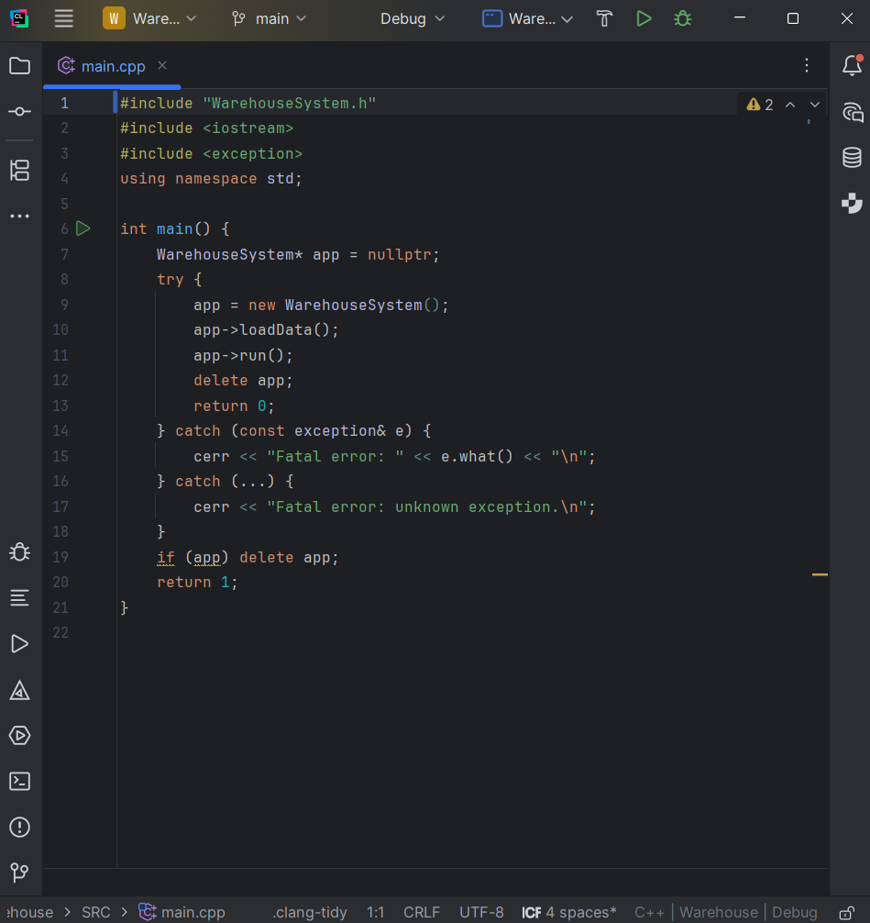

AuthManager.h:
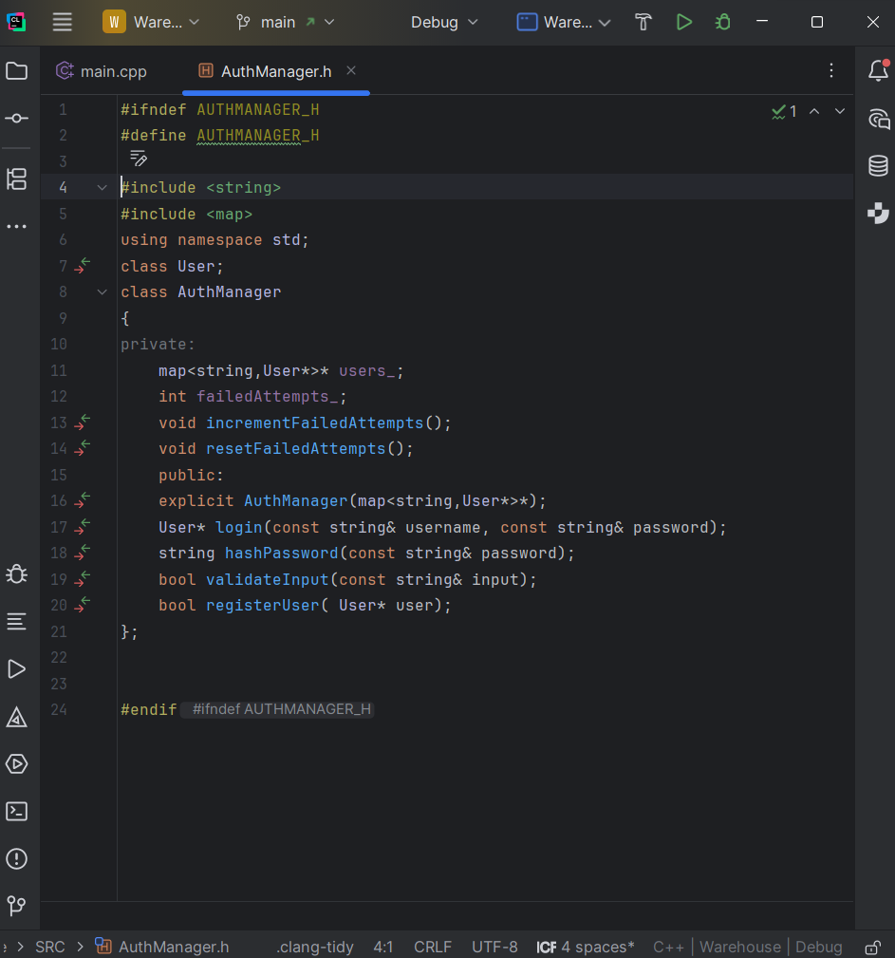

AuthManager.cpp:
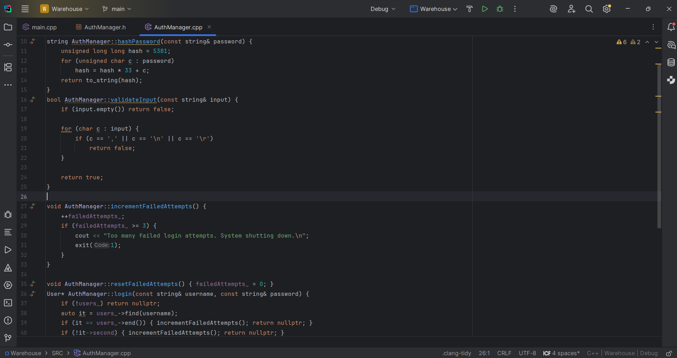

Employee.cpp:
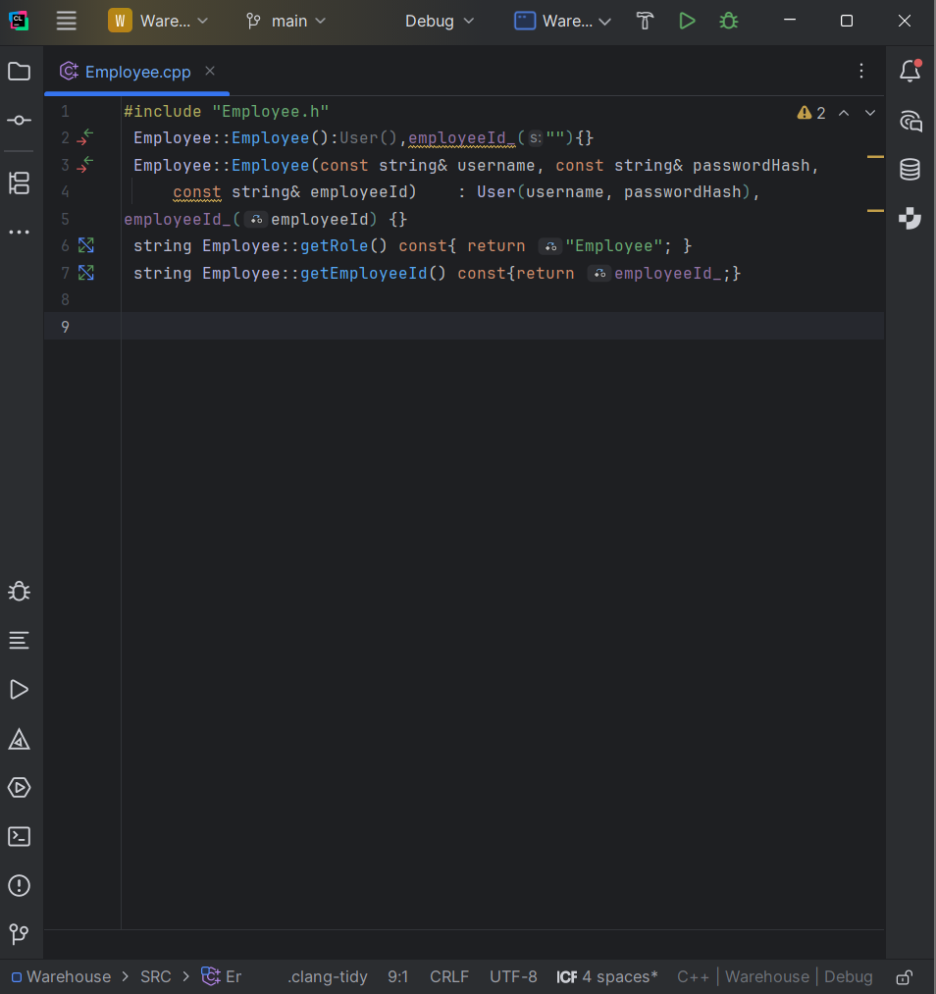

Employee.h:
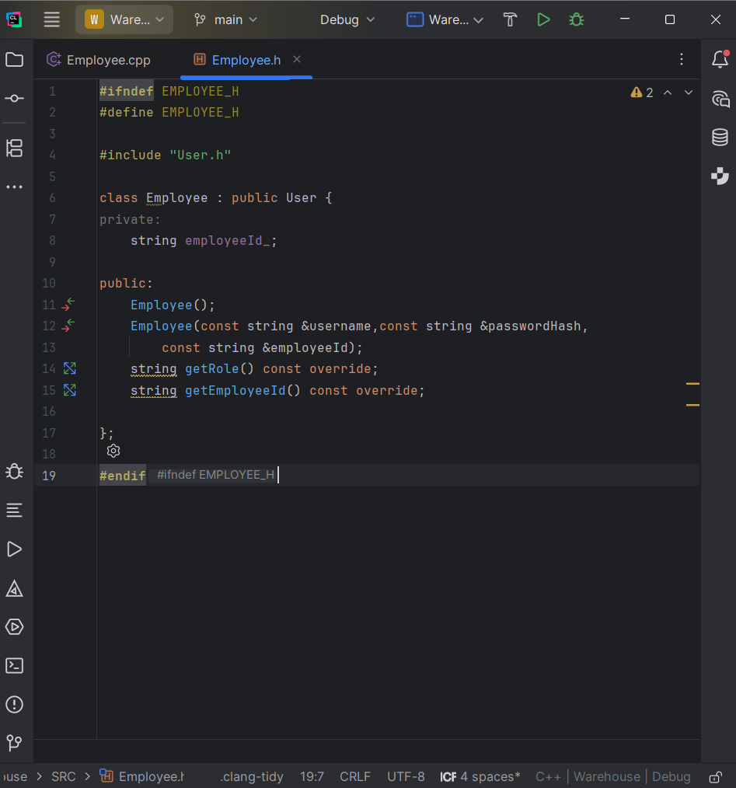

EmployeeRecord.cpp:
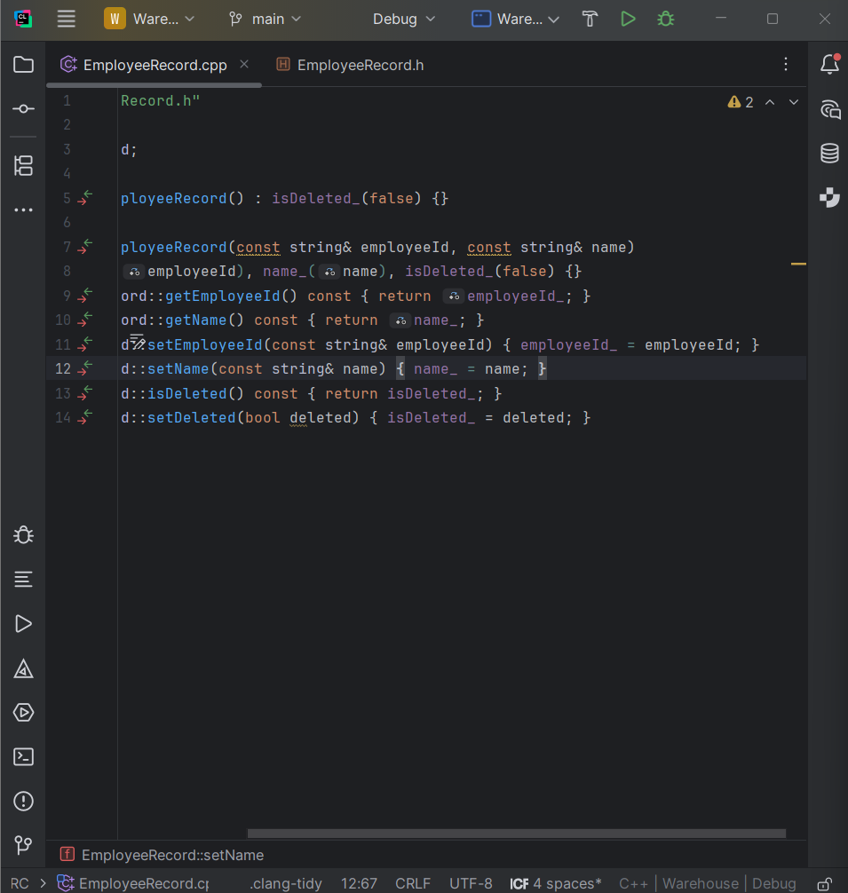

EmplyeeRecord.h:
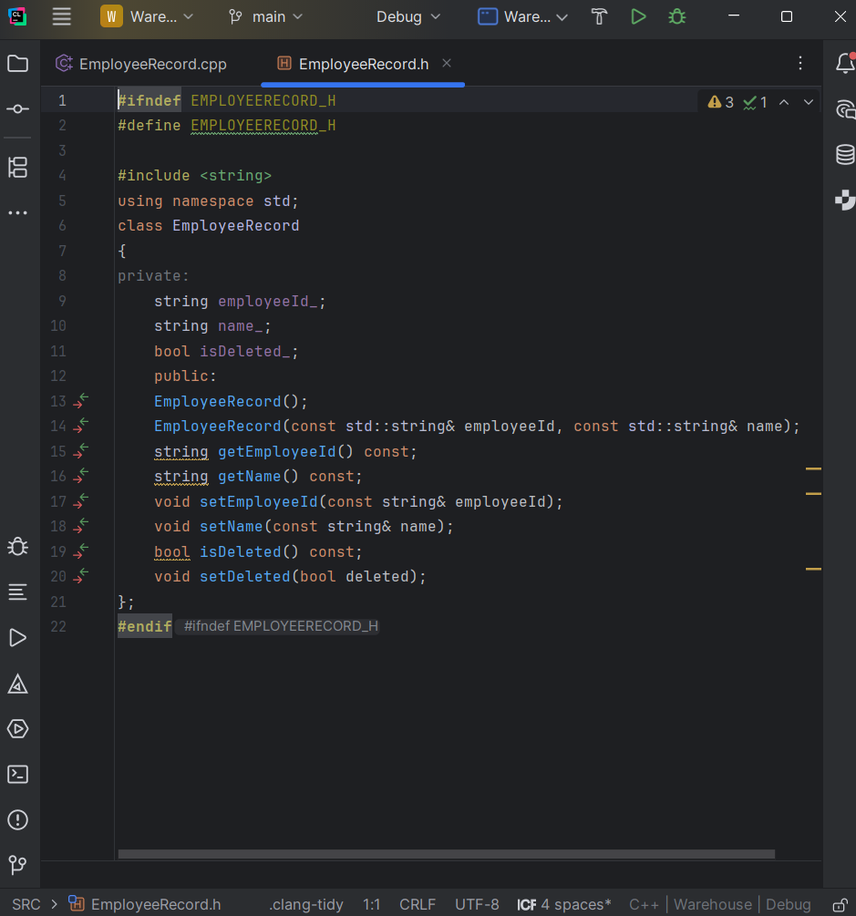

FileHandler.cpp:
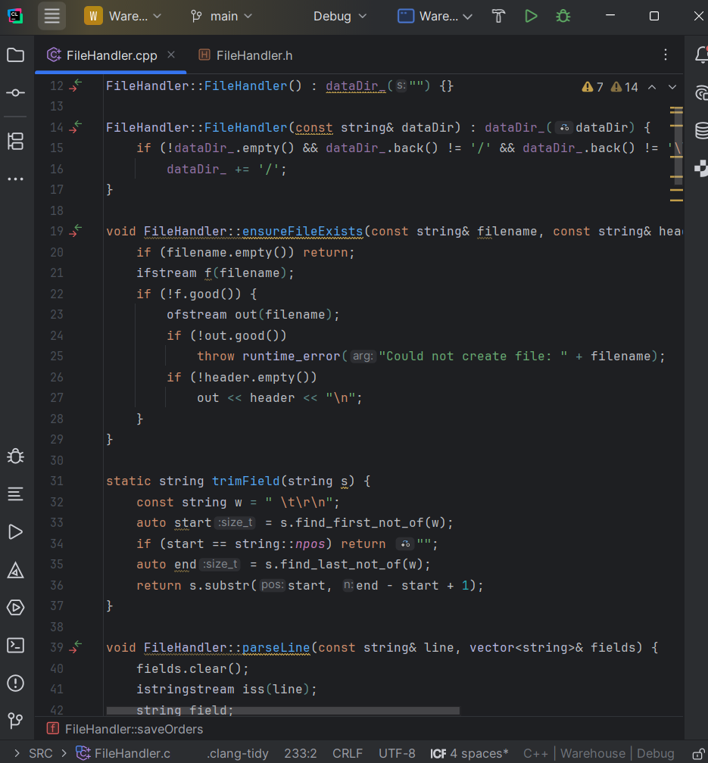
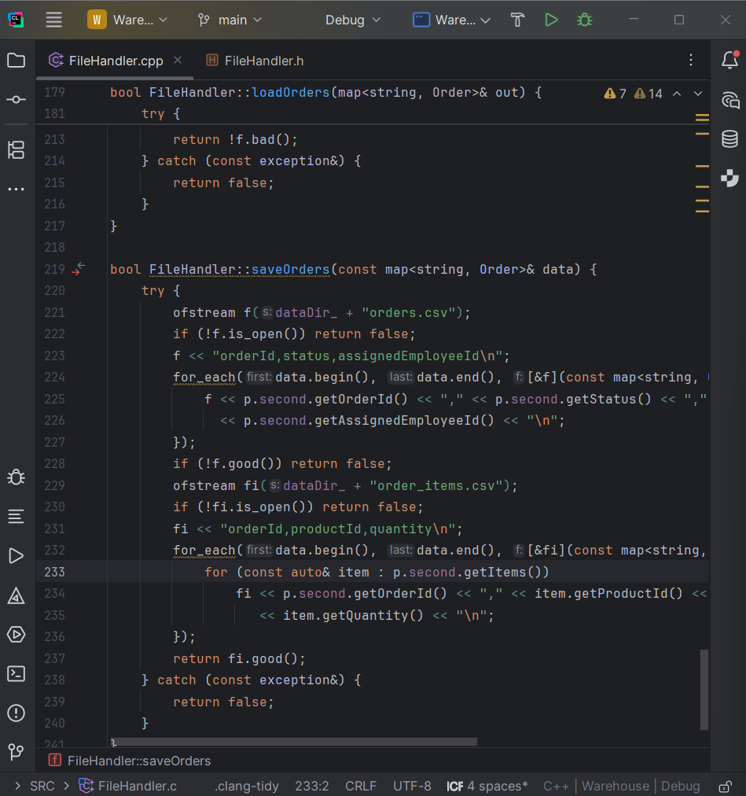

FileHandler.h:
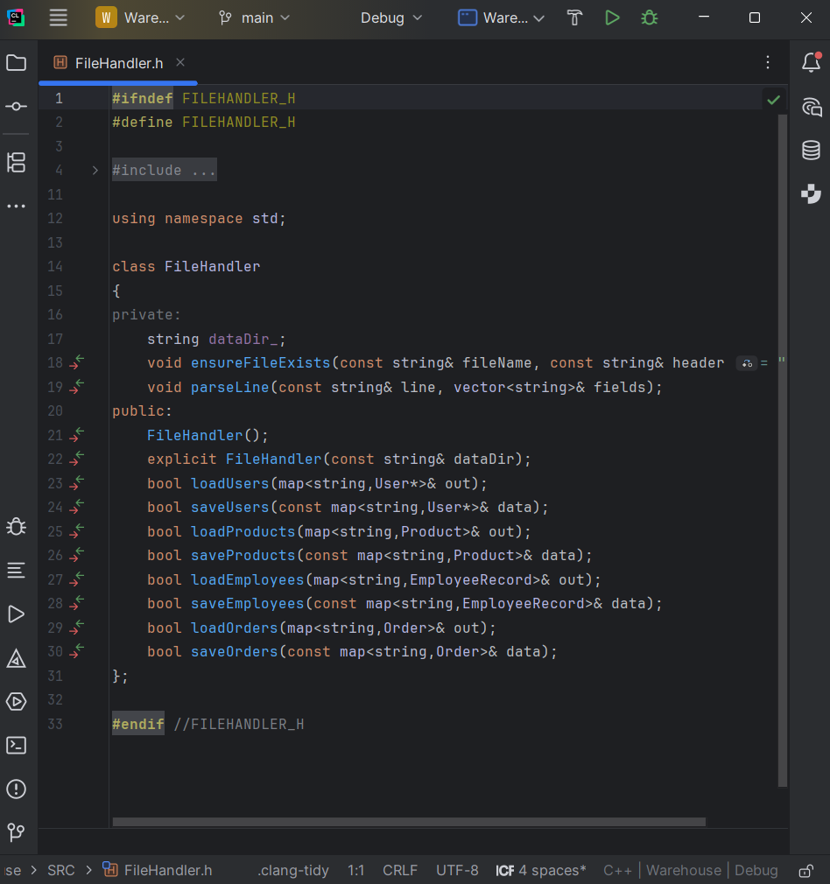

Manager.cpp:
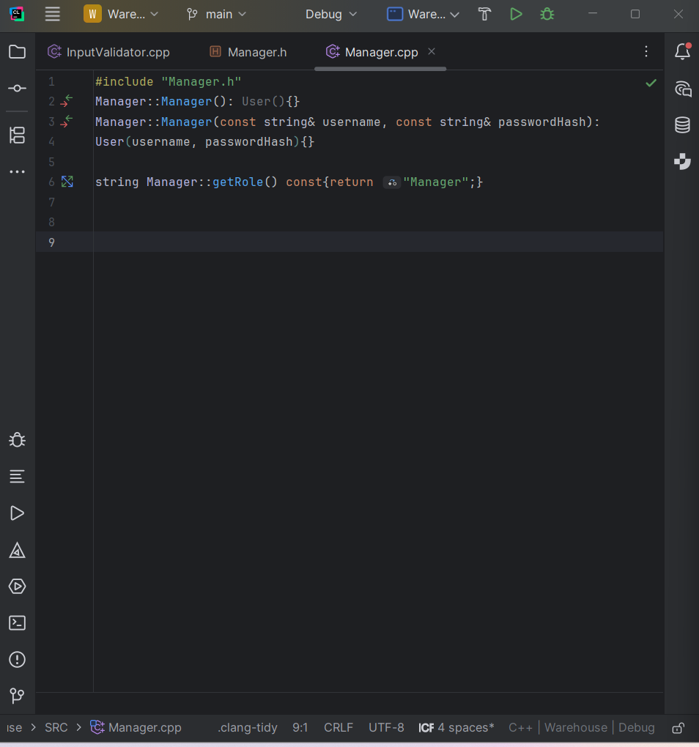

Manager.h:
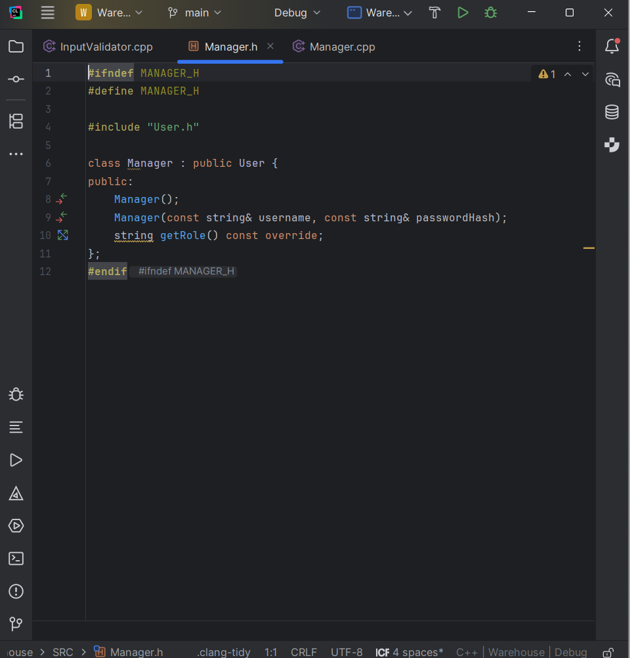

Order.cpp:
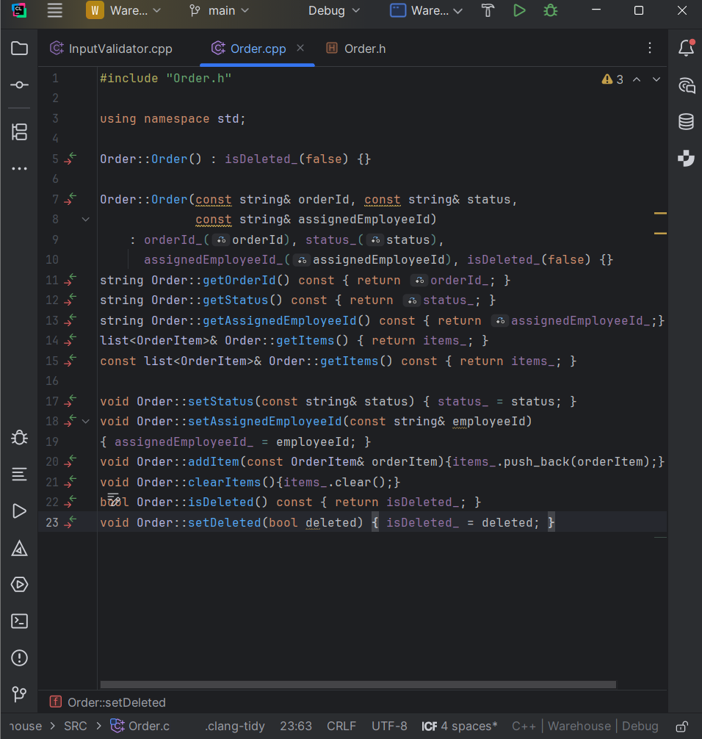

Order.h:
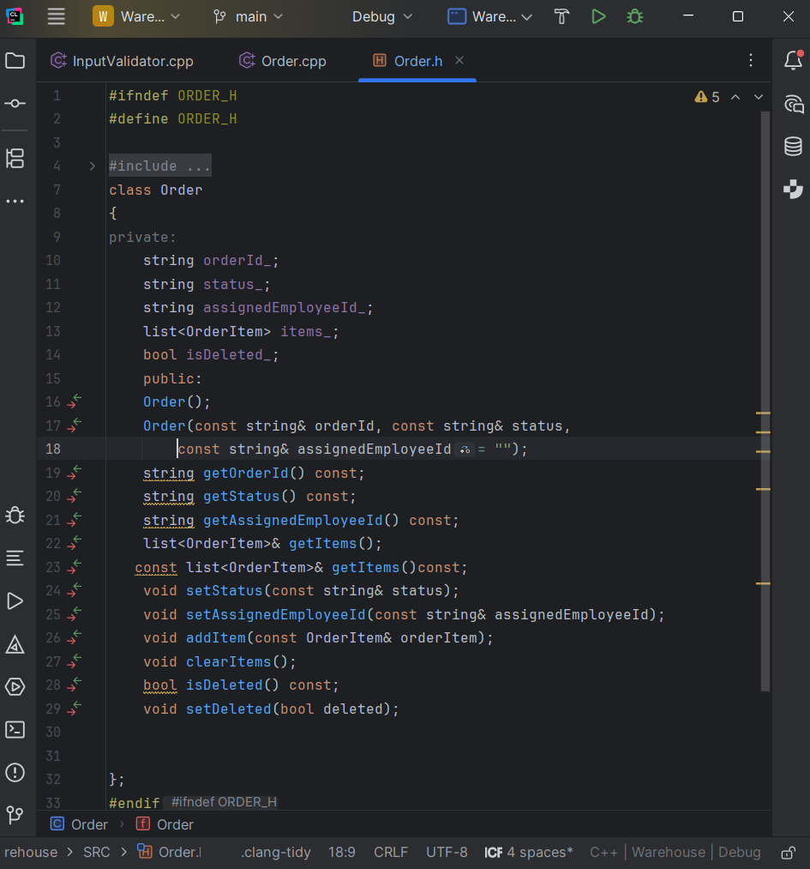
OrderItem.cpp:
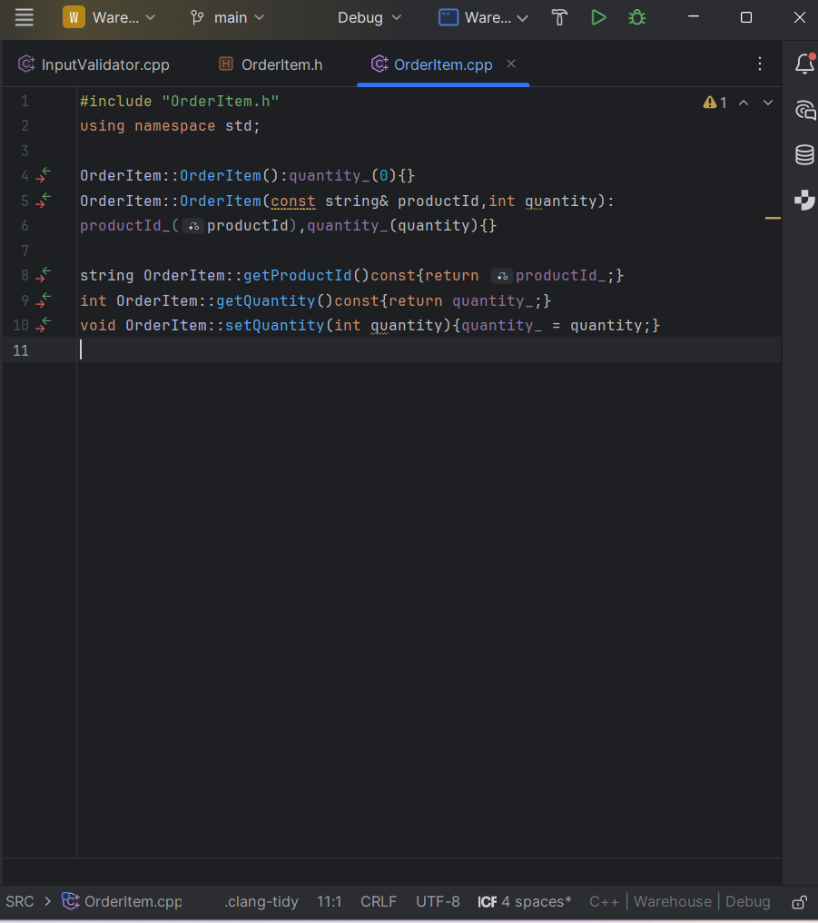
OrderItem.h:
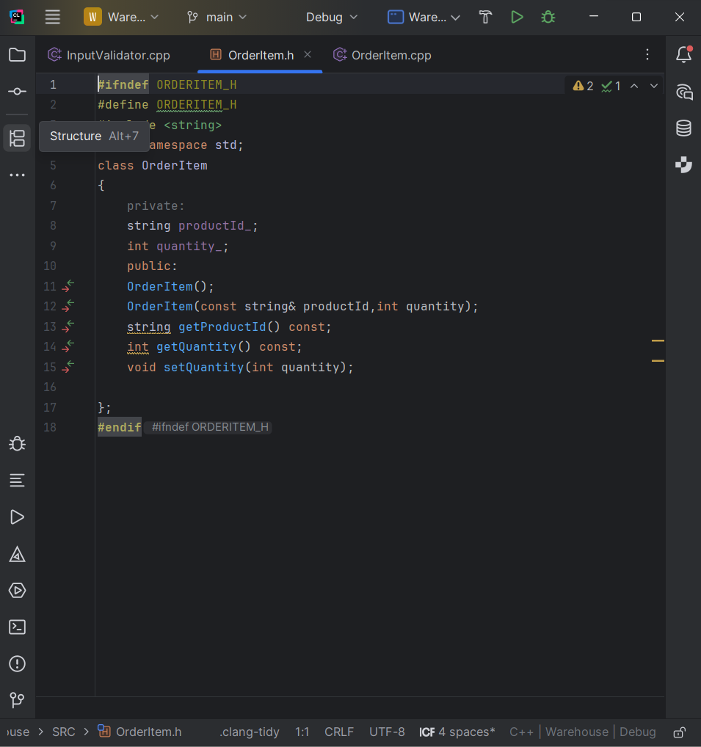
Product.cpp:
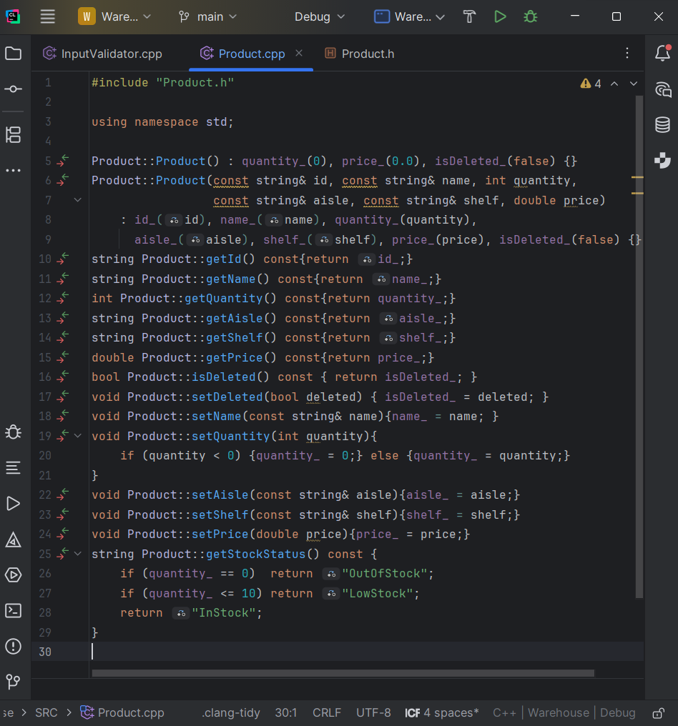
Product.h:
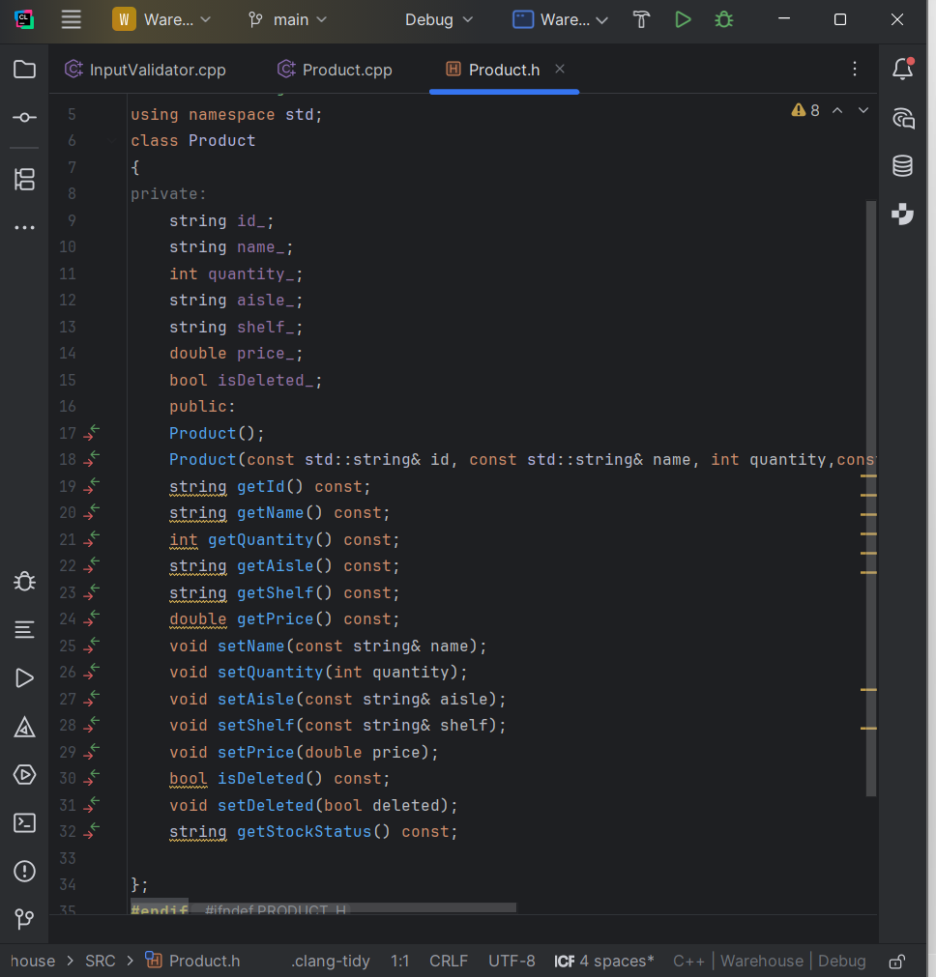
User.cpp:
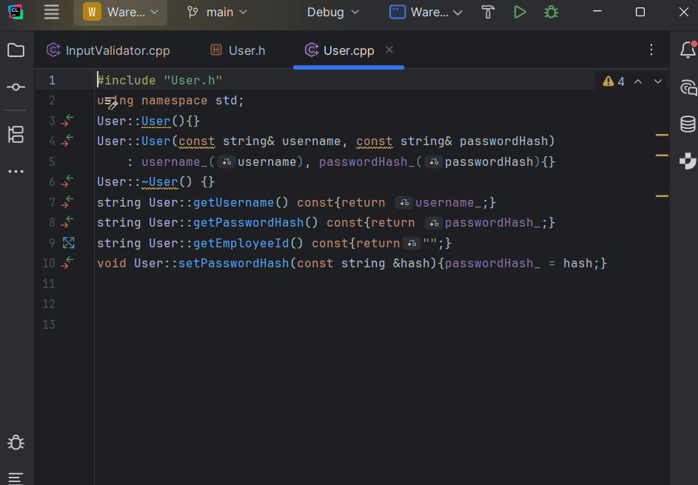
User.h:
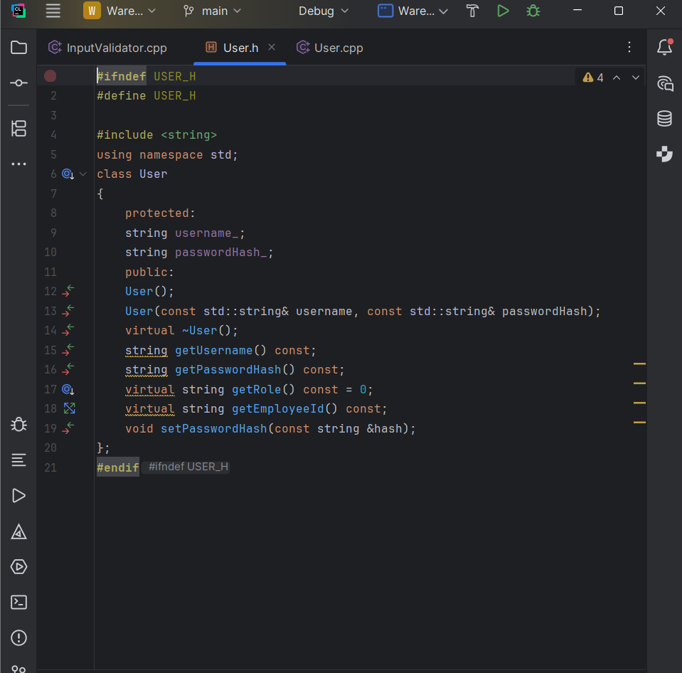
ReportGenerator.cpp:
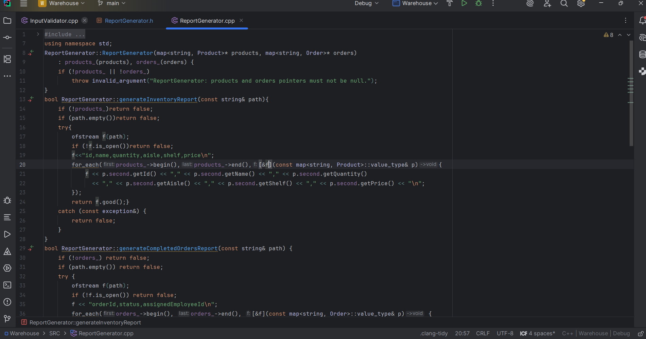
ReportGenerator.h:
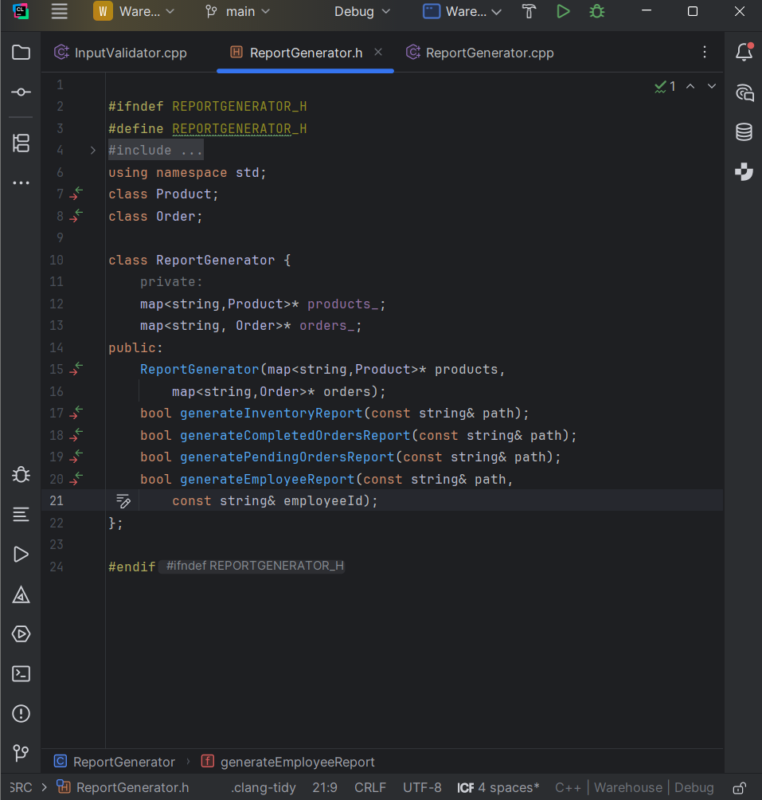
InputValidator.cpp:
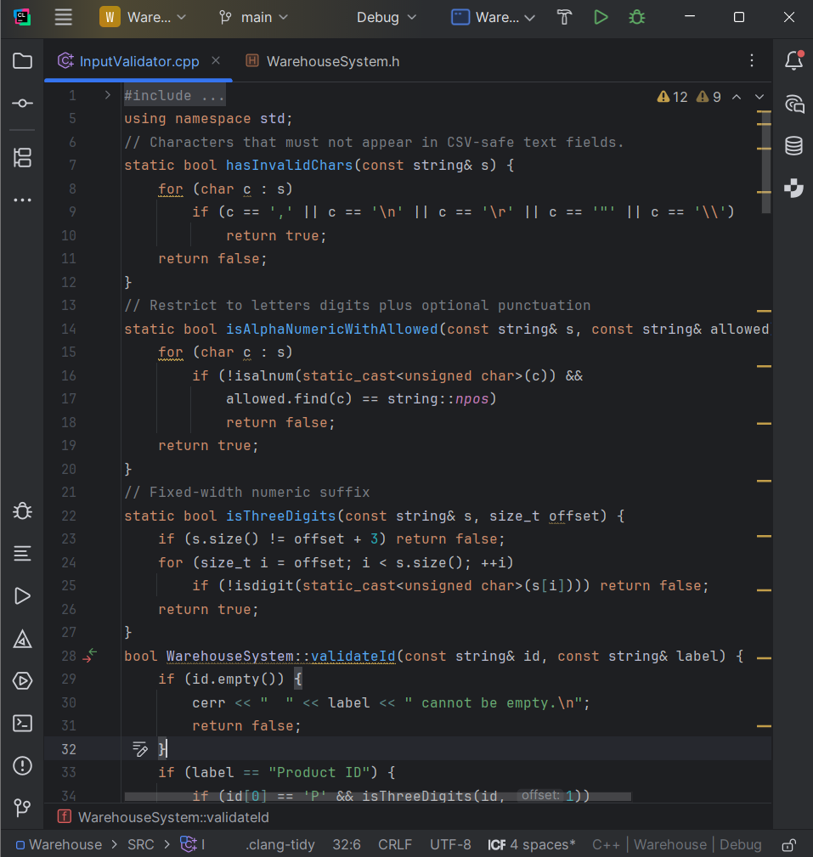
WarehouseSystem.cpp:
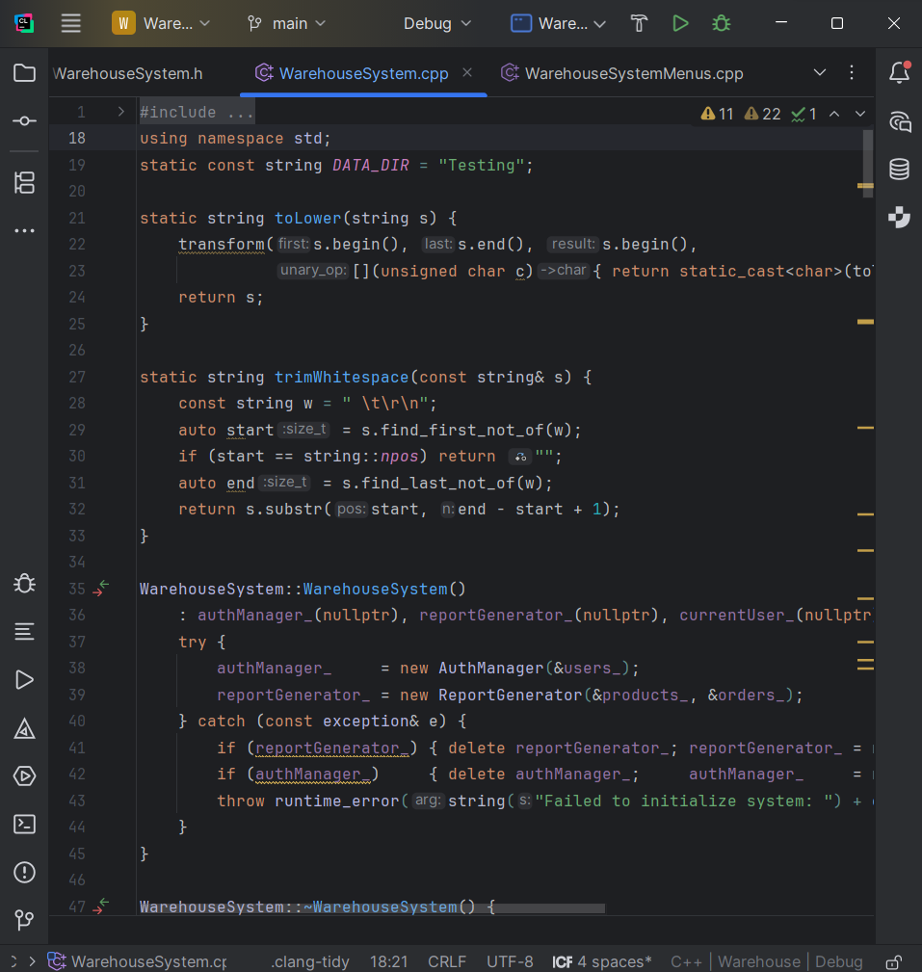
WarehouseSystem.h:
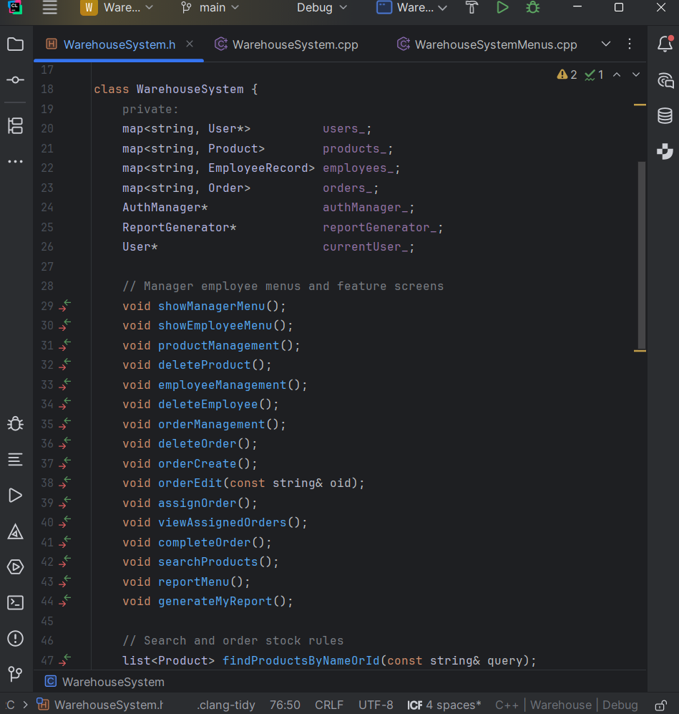
WarehouseSystemMenus.cpp:
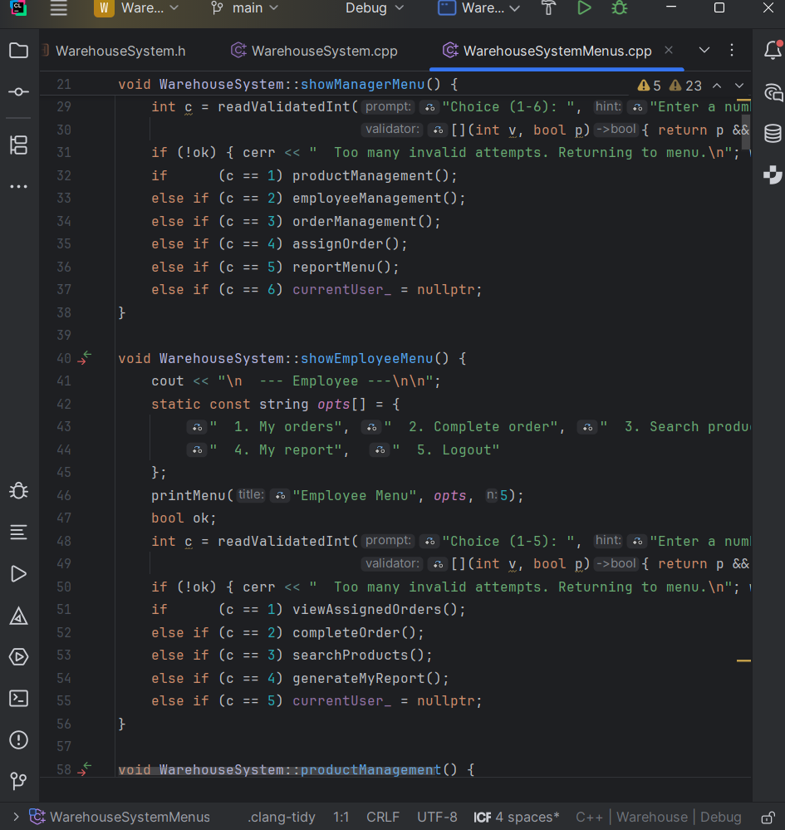
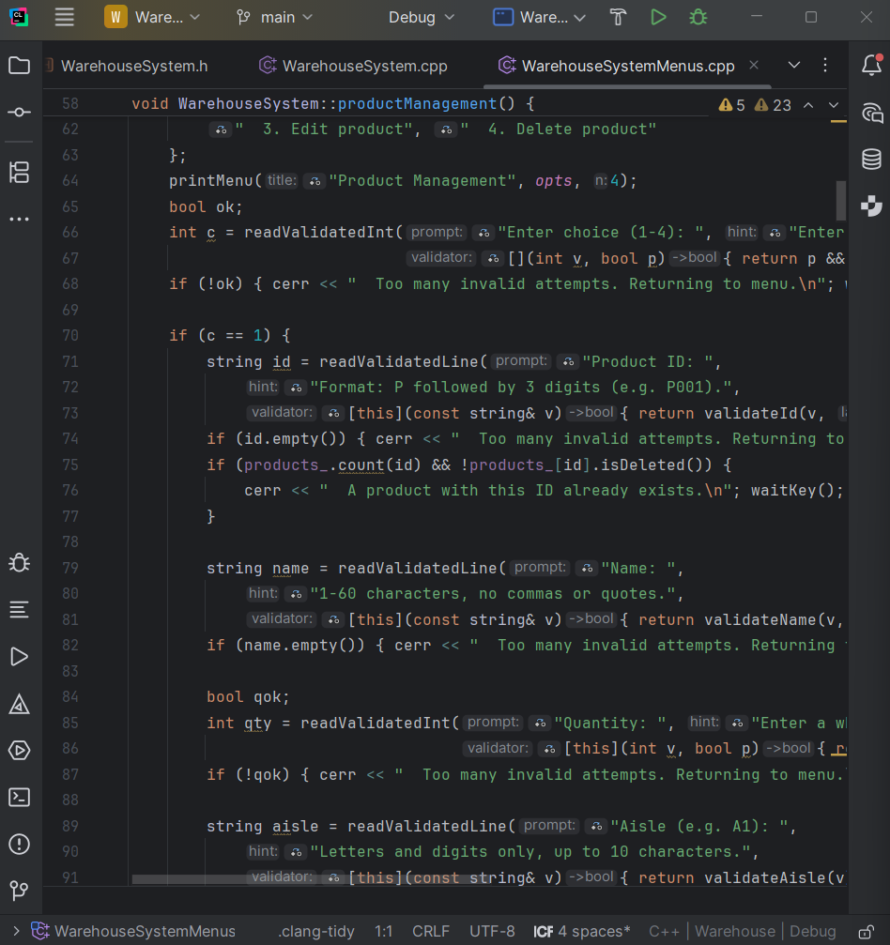
Test_main.cpp:
