Map App – Lina Ghanim – 11/22/2020

1. Open the App

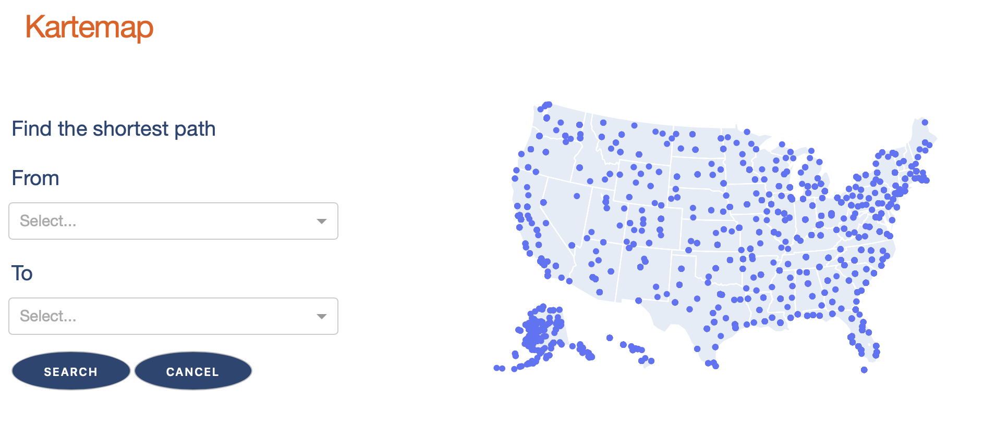

1. Choose From and To cities

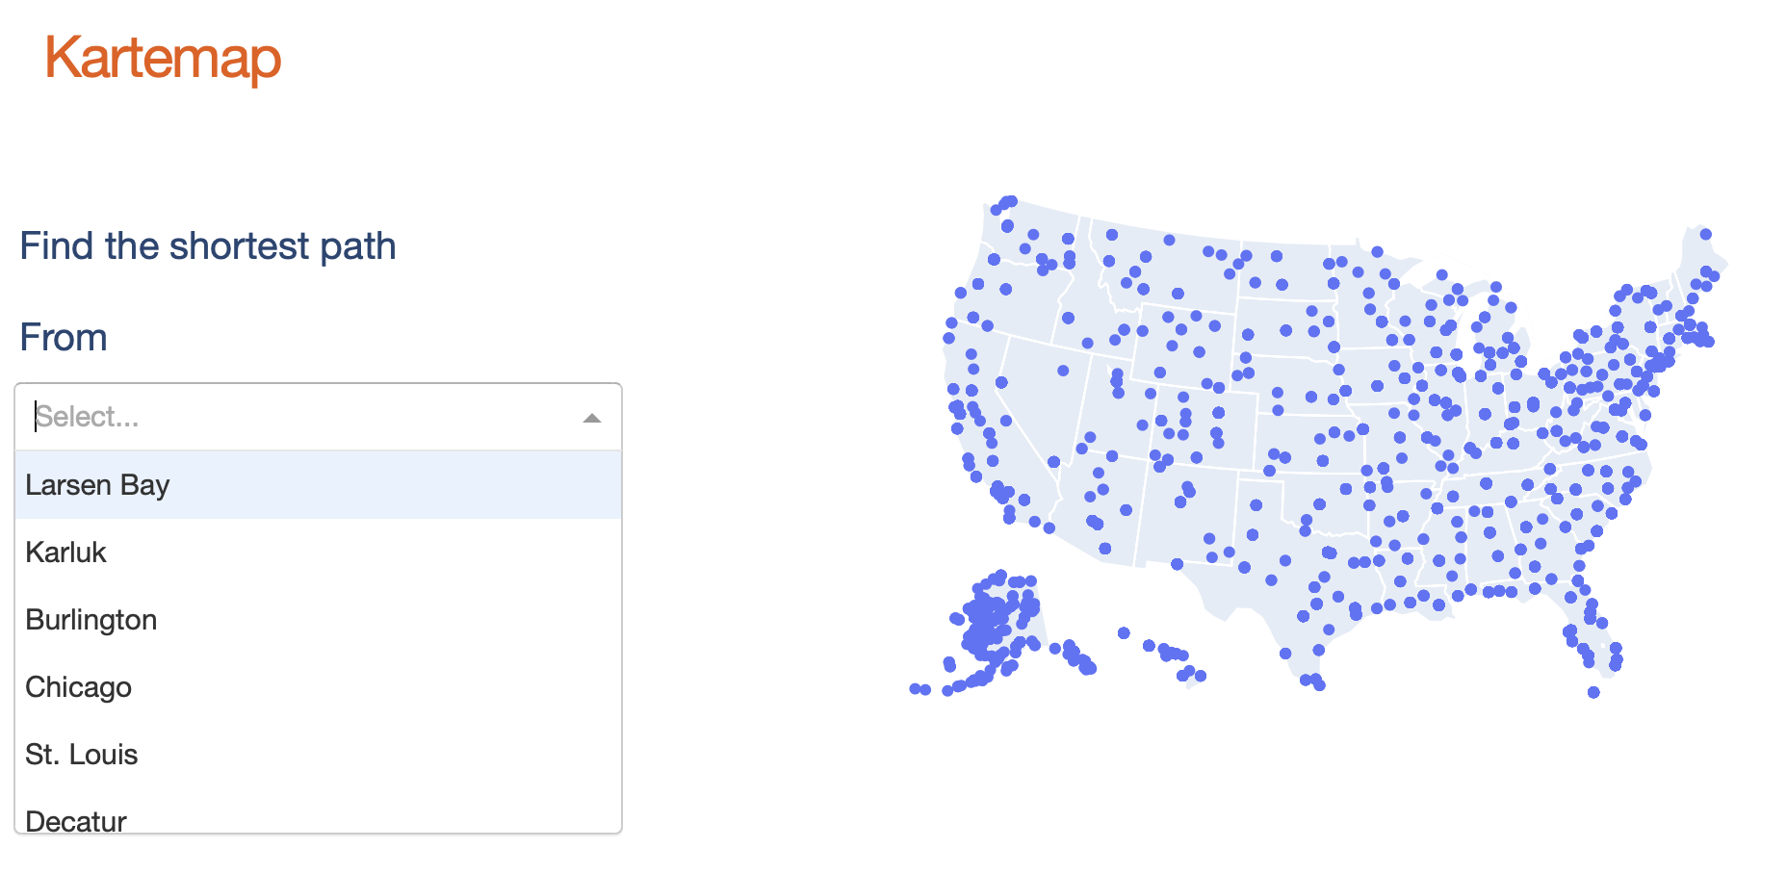

1. Get the path

