Documentation for installation and development of open data module

Content :
1, Introduction.
2, Installation.
3, Explanation.
4, Development direction

1 , Introduction

In the world of technology, data is the most important resource. Therefore processing and statistical data becomes more important than ever. There are a lot of software, web sites for processing and statistical data (excel, google sheet ...) but most are closed source products and some are not good enough to meet completely needs analysis and statistics of user data. Creating an open source product capable of processing and statistically superior data over existing products is the goal of linagora to create Open Data.
Open Data is now a module of Open-Paas for the purpose of processing and statistical data through charts. Open Data has two main parts, Chart and Map running on the core of the Open-Paas system. Now that the new linagora has developed a section of the Chart section, this tutorial will guide you on what has been developed so far.

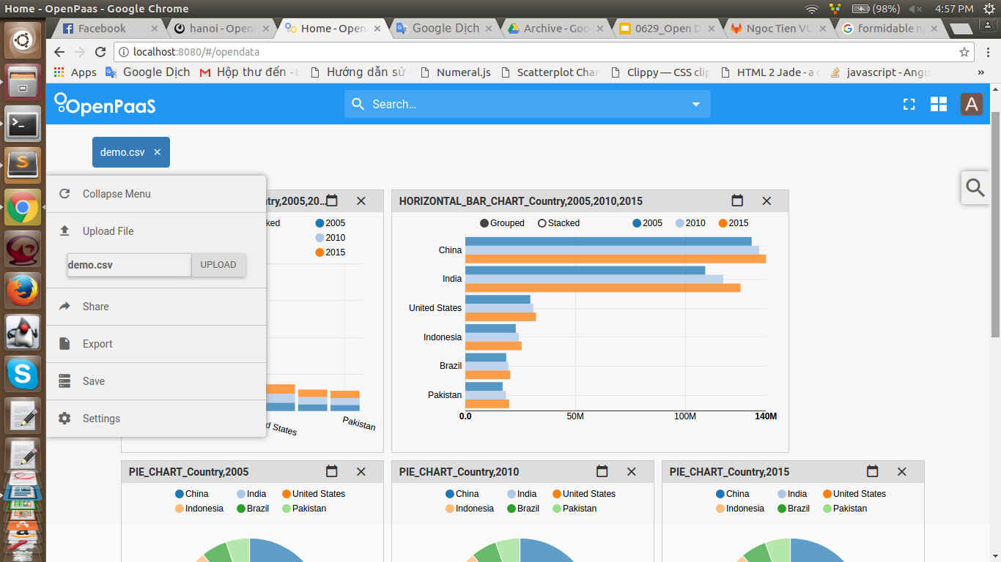

2 , Installation

After you successfully install Open-Paas
Step 1 : git clone https://ci.linagora.com/ntvu/linagora.esn.opendata to folder rse/node_modules
Step 2 : Declare the Open Data module by adding the line "linagora.esn.opendata" to the array of modules in the file rse / config / default.json.

Step 3 : You need to download some libraries for this module. Sorry but now i can’t add all there libraries to the core of Open-Paas, so if you can , hope you do it and edit this document.
The library: "d3" (requires ver <4.0), "angular-gridster", "nvd3", "numeral", "select-2", "angular-ui-select2".
Download and copy to the rse / frontend / components directory

Library: "numeral", "formidable". Download and copy to rse/node_modules directory

(if you know, you can add these libraries to rse / bower.json and rse / package.json and use terminal to download it)

Note: It is possible that the select-2 library will crash when down, so bower will destroy your entire download package → can not run. In that case you just delete the dependency of select-2 in bower and then clone directly on git later.

Step 4 : into the file rse / frontend / views / esn / index.pug add the downloaded libraries (remember to order the library when added). You should add background libraries such as angularjs or jquery, and before the general file style of the system as styles.css (only for css).
The libraries are added with the following syntax:

link(rel='stylesheet', href='/components/angular-gridster/dist/angular-gridster.min.css')
link(rel='stylesheet', href='/components/nvd3/build/nv.d3.min.css')

script(src='/components/select2/dist/js/select2.js')
script(src='/components/angular-gridster/dist/angular-gridster.min.js')
script(src='/components/numeral/min/numeral.min.js')
script(src='/components/d3/d3.min.js')
script(src='/components/nvd3/build/nv.d3.min.js')
script(src='/components/angular-ui-select2/src/select2.js')

Step 5 : Run Open Paas and access the url : http://localhost:8080/#/opendata

3 , Explanation

3.1 : Idea

Details of the idea team leader project will be present to you, In this document I will just say the main idea serves the purpose of directing the design of the project source code.

As you know, we have so many types of data stored from large database to small files. We realize that only have three main types of data:
Text
Number
TIme
And of course different individuals, groups will have different data on different files and they need to statistic them in different ways. So the first feature that this project must have is the ability to process user uploaded files.
For example, the input is a CSV file with fields separated by a ',' as follows :
Country,2005,2010,2015
China,1302285,1336681,1367486
India,1090974,1173109,1251696
United States,295517,309348,321369
Indonesia,229245,243423,255994
Brazil,186021,195835,204260
Pakistan,169279,184405,199086

When we present it in table form , it will be :
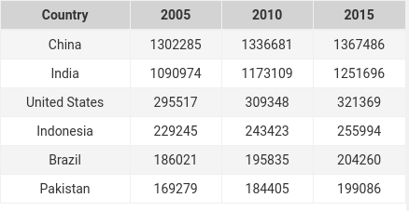

As you can see, the first column will be the text data type, the second column has the numeric type and it also with other two columns. And the special thing is that the title of the numeric columns is also the number, but it is actually the time data type.
Therefore, the first task when receiving input files will be to identify each data shell and render it into the data table as above and from there draw statistical chart to display it for users (specifically More, this identification is still a lot of complexity, I will speak more clearly in the code explanation guide)

Looking at the data above, we can classify data columns into two types:
Object type: Include text data type and time data type.
Display type: includes numeric data type.

When you draw a chart, the “display type” data will be mapped to the “object type” data and shown on the chart as follows:
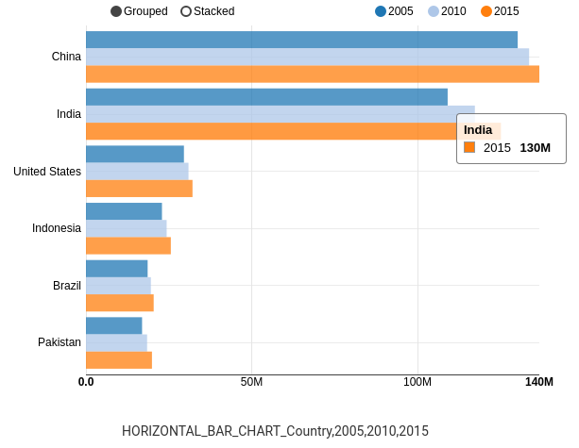

From this we can see that with a graph you will need at least 1 column of "object type", so with the above data you will have to identify where is the column of the “object type”, where is the column of the number, from that we will build a data structure to graph.

3.2 : Analysis and explain source code

The project will consist of two parts: the frontend and backend, the source of the backend will be in the directory rse/node_modules/linagora.esn.opendata/backend/webserver/api/opendata,
and the source code of the frontend will be in the directory rse/node_modules/linagora.esn.opendata/frontend/app

In /backend/webserver/api/opendata you can see some code files and 2 directories are “analysis” and “file-upload”. The “file-upload” directory is the place to store the files successfully uploaded by the user, the “analysis” folder is the directory that supports the analysis of the data in the file, it will include 4 directories as “base”, “datetime”, “number” and “string”, each directory will contain corresponding files that support the analysis of the corresponding data types, with the “base” directory it will support the detecting of data attributes (eg repetition repeat) . File analysis-data.js will have the task of adding these folders, and other files that interact with files in any of the four directories will interact via the analysis-data.js file.

Back in the /backend/webserver/api/opendata directory, you can see five files:
router.js: receive and route requests to processing files
middleware.js: intermediate processing (almost like a proxy)
index.js: you may not care about this file
core.js: analyzes and identifies user data into the appropriate data structure containing information for the frontend to process and graph the data.
controller.js: receive file, save file returned core.js processed data for frontend.

The rest of the backend you can read at the link: http://docs.open-paas.org/.
The structure of the frontend is divided by UI, each part of the UI is a separate module, has its own component and is processed separately, these modules interact with each other through the rootscope of the angularjs. The main UI of the Open Data is divided into three part are “subheaders”, “sidebar” and “dashboard”, corresponding to the three directories “subheaders”, “sidebar” and “dashboard”, and also other directories such as “console”, “data-table”, This will be for other UI that are part of the Open Data chart, but not programmed yet, you can skip.

Each of these directories has a file system that includes:
file.module.js: declare module
file.component.js: Declare the components of that module
file.controller.js: event handlers for the components of that module
file.service.js: services, factory, provider processing data for the controller (this file may not be available)
file.pug: file UI, this file will be build to html file when you run Open-Paas
file.less: corresponding to the css file

And all of the above modules must be injected into the aggregate module in the file app.module.js in the / frontend / app directory.
File app.pug will be the main Open Data UI file, it will bring together the components of the modules there.
File app.less will be the total style file, which will define the most common css for both the Open Data module, and it will include the less files of the child modules within the Open Data.
In addition, there is a very important file is app.route.js file, this file will declare the url used within the Open data. You can see the code:
$ stateProvider
.state ('opendata', {
url: '/ opendata',
templateUrl: '/opendata/app/app.html',
})
Every time you want a new interface you have to declare more here, you can learn more about how to implement the state url in other modules such as admin, calender.
The current purpose of the frontend is to draw charts based on the data sent from the backend, so if we analyze by feature we will have one part to paint and one part to translate from raw data to chart data so I will put all these part in a core folder. By that division, the current core will consist of two directories are "draw" for drawing and "chart-valid" for the purpose of identifying graph types that can be drawn with each data and transformed into Data of the corresponding graph type.
Now Open Data can draw up to six types of graphs, as you can see in each draw or "chart-valid" folder. There are six subdirectories corresponding to six types of graphs. Synthesize the sub services of each chart type, then the core.service.js file will merge the services in the draw and chart-valid directories so that when accessed, you only need to access through the service core. In addition to the two directories listed above, the core directory also has another base directory, the base directory that contains the base.service.js file, which will contain common handlers for the entire Open Data module. Any function related to data processing you can find here.

In the Open data UI, the dashboard is the main part, so there are a lot of things to do here, you can see that there are two directories: "filter" and "statistic", "statistic" are small services that support the dashboard service in statistics data, the filter will be a part of the UI but it belongs to the dashboard so I still leave it in the dashboard.

And that is the basic structure of Open Data, now I will go into explaining the source code.To explain the source code I would go from the user's request. When users have access to the main page of the Open Data they will select the file and upload to the server. You will see in the sidebar.pug file the input(type = "file" name = "fileupload" file-model = "$ ctrl.file"). Here I create an directive "file-model", you will see that directive in the sidebar.component.js file as follows:

.directive('fileModel', ['$parse', function ($parse) {
return {
restrict: 'A',
bindings: {},
transclude: true,
require : "^?opendataSidebar",
link: function(scope, element, attrs , opendataSidebar) {
var model = $parse(attrs.fileModel);
var modelSetter = model.assign;

element.bind('change', function(){
scope.$apply(function(){
modelSetter(scope, element[0].files[0]);
opendataSidebar.filename = element[0].files[0].name;
});
});
}
};

Here when the user clicks on the file in the interface, the directive file-model will run the 'change' function, which will set the scope variable "file" to a value corresponding to element [0] .files [0] or the user file upload. Also, when you look at the sidebar.controller.js file that controller for the component "sidebar", you can see the variable:
this.filename = "Click here to select file !";
When looking at the UI sidebar you can clearly see what this variable do :
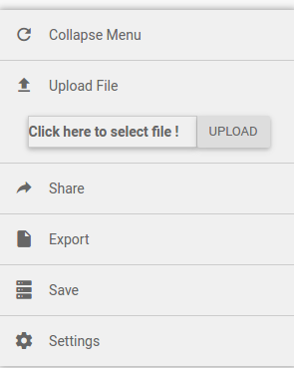

As you can see, this variable displays the file name of the user, so the line opendataSidebar.filename = element[0].files[0].name; It has the mission to changing the filename variable in the controller to the name of the file the user will upload. We can change variables in the component sidebar controller in the directive file-model cause this directive required the component sidebar: require: "^ opendataSidebar".

After the user has selected the file, they will proceed to upload the file selected. Then I'll catch the event that occurs when the user clicks the upload button:
button.btn.btn-susscess (ng-click = "$ ctrl.uploadFile ()") Upload

Then you can see the event handler function when the user click the upload button in the controller:
this.uploadFile = function(){
var f = this.file;
var fd = new FormData();
fd.append('file', f);

$http.post("/opendata/fileupload" , fd ,{
transformRequest: angular.identity,
headers: {'Content-Type': undefined}
})

.success(function(response){ })

.error(function(){});
}

Here I will take the file what the directive file-model set into the scope, and send it to the backend with an ajax request.
By the way, I'm going to talk about the sidebar.controller.js file before continue explain how the file will be handled at the backend.

this.collapse = false;
this.collapse_menu = function(){
var x = angular.element(document.getElementById("opendata-sidebar"));
self.collapse == true ? x.width("300px") : x.width("40px");
if(!self.collapse){
if (!self.hide) {
self.hide_submenu();
}
}
self.collapse == true ? self.collapse = false : self.collapse = true;

}
this.collapse_item = function(){
if(self.collapse == true)
self.collapse_menu();
}

The "collapse" variable controls the change of the menu. When this variable is false, the menu is displayed and vice versa.

The "collapse_menu" function checks the "collapse" variable, if collapse = true means that the menu is in the hidden state, then we will resize the menu to the show state and show the menu items and then change the collapse state to false and vice versa when collapse = false.

The collapse_menu function is written specifically for item "collapse" on the menu, cause this is the only item that when pressed will have to change the menu from hidden to show and vice versa. For other items, each item will perform its own functions in the future so when the menu is in the show state that you press it will not collapse the menu but when the menu is in the hidden state, when you press Any item has to be moved to the show state. That's why we have the collapse_item function. This function handles the event when you click on any item on the menu and its function is described above.
Some of the other code in this file has the same functionality as the code I just explained, so I will not explain it anymore.

And now, back to the processing of the upload file at the backend. The file will be sent to url: / opendata / fileupload. As mentioned above, the route.js file on the backend will receive this request:
router.post ('/ fileupload', middleware.passThrough, controller.upload);

It will put into the middleware process, exactly is the passThrough function in the middleware, you can preprocess the request here before putting it into the controller, in here I do not process anything so after passing through the middleware, request will go straight to the controller's upload function.

var file_pattern = /[0-9a-z]+\.+csv$/i;
var PATH_UPLOAD = path.normalize(__dirname+'/file-upload/');

function upload(req, res) {
var form = new formidable.IncomingForm();
form.parse(req, function (err, fields, files) {

if(!file_pattern.test(files.file.name)){
res.json(200,{status : 0 , error : "Sorry , we only accept .csv files !!!!"});
return;
}
var content = fs.readFileSync(files.file.path).toString();
fs.writeFileSync(PATH_UPLOAD+files.file.name, content);
content = fs.readFileSync(PATH_UPLOAD+files.file.name).toString();
res.json(200,{status : 1 , data : core.detectData(content)});
});
}

The upload function will receive the form data that we sent from the frontend, firstly it will check the file name, because we only process the csv file now, so we will check if the file name is true for the pattern, otherwise we will send error back to the user.

I will explain the variable file_pattern = /[0-9a-z]+\.+csv$/i; .
Here [0-9a-z] means that in the filename can appear any character from 0-9 or a-z, the "+" sign will have to appear at least once.
The "\. +" symbol means that the file name must appear at least once the ".".
The "csv $" symbol means that the file name must end with "csv"
The "i" at the last means no case-sensitive in filename.
You can learn more about regular expressions

After make sure the filename is correct, we will read the file. The readFileSync function reads the file in synchronous mode. After reading, we will save the file to the file-upload directory. Then we will process the contents of the file in the core.js and send it back to the user.

Detect data :

function detectData(data){
var t1 = cutRow(data);
var t2 = cutData(t1);
var t3 = classifyData(t2);

return t3;
}

You can see the steps for identifying data through this function. The output of this step will be the input of the next step. We will go step by step.
The first is the cutRow (data) function, as example in the "idea" section, the data will be expressed in lines. Therefore, the mission of this function is to cut off the following lines of data:
function cutRow(data){
var cut = [];
var sub = "";
for(var i=0;i<data.length;i++){
if(data.charAt(i) != '\n'){
sub+=data.charAt(i);
}else{
if(((i+1) <= data.length) && (data.charAt(i+1) == '\n')){
continue;
}else{
cut.push(sub);
sub = "";
}
}
}
cut.push(sub);
return cut;
}

This function is very easy to understand, so I will not explain much, there is only 1 place when data.charAt (i) = '\ n', then we have to check the user case down two or more consecutive lines, will have to remove extra lines:

if(((i+1) <= data.length) && (data.charAt(i+1) == '\n')) continue;

Next we will cut each record in each line with the cutData () function:

function cutData(data){
var char =[];
data = stringAnalysis.clearData(data);

for(var i=0;i<data.length;i++){
char[i] = data[i].split(",");
}
return char;
}

The input here is the array of lines after passing the cutRow () function. This function will split each data by ",".
According to the standard of the .csv file, the data inside the file will be split by "," also, use ";". This is an uncluttered place in Open Data, as you further develop this module, please add a separator symbol function so that no matter which symbol you are using, you will be able to recognize it.
Before we cut each data by the "," we will have to filter and correct all the data that itself has "," (example: "hello, how are you?", This is a sentence but itself it has "," sign).
Filtering and editing will be performed by clearData () function in analysis-string.js file. You can find the clearData () function in the /analysis/string/analysis-string.js file.
function clearData(data){
for (var i = 0; i < data.length; i++) {
data[i] = clearString(data[i]);
}
return data;
}
function clearString(str){
str = str.replace(/, /g,";");
str = str.replace(/ ,/g,";");
str = str.replace(/\r/g,"");
return str;
}

The clearData function input is the lines of the file and processes it with the clearString() function. According to the document current standard , after the "," will have a space, so when we identify a string is ",/s" in the line we replace it with a ";" for avoid mistake when cutting. Otherwise we will add some other handlers similar to "/s," in addition you will have to handle special characters like "/r".
So after going through the cutData () function we have each record cut out clearly and saved in an array.
The array will have the following structure:
var a = [
[a, b, c, d]
[x, y, z, v],
...
];
Once you have each of the data shells explicit, you will place them in each column corresponding to the classifyData () function.
function classifyData(char){
var cl = [];

var labels = [];
for(var i=0;i<char.length;i++){
var flag = true;
for(var j=0;j<char[i].length;j++){
if(numberAnalysis.isNumeric(char[i][j])){
if(!timeAnalysis.isYear(char[i][j])){
flag = false;
break;
}
}
}
if(!flag){
continue; // if not found headerRow yet -> continue
}else{
labels = char[i];
for(var k=0;k<char[i].length;k++){
var obj = {};
obj["title"] = char[i][k];
obj['data'] = [];
obj['type'] = 0;
cl.push(obj);
}
char.splice(i, 1);
break;
}
}

for(var x=0;x<char.length;x++){ //move data item to their column
for(var y=0;y<char[x].length;y++){
cl[y]['data'].push(char[x][y]);
}
}

// cut to min lenght of all column
cutMinData(cl,minLenghtData(cl));

cl = isValidData(cl);
cl = detectTypeData(cl);
cl = base.detectCategory(cl);
cl = analysis.number(cl);
cl = setLabelsCol(cl);
cl = setLabel(cl);

return cl;
}

This function is very long, so I will talk part by part. First I would declare a variable is "cl" to store the output value of this function.
With example in the "idea" section we can see that every data file has a row of column titles, the first mission of data identification is to identify that row, of course
it maybe have some data file only has the data but not show the data about what, then we have to have a mechanism that identifies each data record as to what the column is talking about and automatically set a title for that column, but that is very complicated and with a new project like Open Data we will temporarily develop those things later.
Going back to recognizing the title line, I'll just call that line is “headerRow”, so I'll create an array of var labels = []; to save each record of “headerRow”.
for(var i=0;i<char.length;i++){
var flag = true;
for(var j=0;j<char[i].length;j++){
if(numberAnalysis.isNumeric(char[i][j])){
if(!timeAnalysis.isYear(char[i][j])){
flag = false;
break;
}
}
}
if(!flag){
continue; // if not found headerRow yet -> continue
}else{ // do something }

The idea is very simple, you will loop through each sub arrays of input array, with each of these arrays you will use a variable flag, a line is headerRow when all its records are type "text" or "time", so when it detects any record in the line is "number", flag = false, thus identifying whether the stream is headerRow or not.
Please note, not always the first line is headerRow because they can be exported from the Database or elsewhere, or they simply want to test the Open Data identity, so we do not default the first line is always the headerRow and we must try to handle the maximum possible cases.
Here, I check each data in the sub arrays, if it is numeric, I will continue to check that it is a "time" form (example: 2005, 1995, ...) otherwise. then the data is completely numeric and so the line will not be a headerRow and vice versa, if it is not numeric then it will be "text".
Note: My argument here is not very strict because if it is not numeric it can still be "time" (example: 01/01/1995) so when you develop this module, Hope you can fix this for me.
Currently my thoughts are not really right, but the results will still run properly because I am using numeral js library. For better understanding, let's look at the isNumeric () function in the /analysis/number/analysis-number.js file:
function isNumeric(input){
var RE = /^-{0,1}\d*\.{0,1}\d+$/;
var result = (RE.test(numeral(input.replace(" ", "")).value()));
return result;
}

Here I have a pattern that checks for a string that is a number, and I use numeral (input.replace ("", "")). Value () to filter the numeric data of the input,if the input contains any number the numeral js library that will be filtered out and checked by my pattern, so that the input data will be recognized as "number" data, and actually it is a "number" or otherwise the next identification process will continue to clarify this.

Going back to defining the headerRow, if a line has of all data in the type "text" or "time" then that would be defined as headerRow, so the flag would remain true, and after that we have the processing code in else {// do something}:
for(var k=0;k<char[i].length;k++){
var obj = {};
obj["title"] = char[i][k];
obj['data'] = [];
obj['type'] = 0; //undefine
cl.push(obj);
}
char.splice(i, 1); //cut this line from data array
break;

When identified the headerRow as the "i" element in the input array, I will loop through each of the elements in the headerRow. You can see that each element in headerRow will be the title representing a column. The data structure that I intend to define will be column by column, each column will have itself title, type of column, and an array containing that column's data. So for each element in headerRow I would create such a data structure with title as the k element of the headerRow then add that structure to the "cl" output array.

After creating a column-based structure from headerRow, I will cut away the headerRow line from the input array so that the input array is now completely filled with the data of the columns. So you can see now I will have an output data structure as follows:
var cl = [
{
title : headerRow[0],
type : 0,
data : []
},
{
title : headerRow[1],
type : 0,
data : []
},
….
];

The "type" field here defines the data type of this column:
data ['type']: 0: undefine, 1: string, 2: time, 3: number, 4: invalid

And so you can easily understand the following code that used to put the data of each column into its "data" array:
for(var x=0;x<char.length;x++){ //move data item to their column
for(var y=0;y<char[x].length;y++){
cl[y]['data'].push(char[x][y]);
}
}

The columns of data not only has those components, we must also define many of their properties. Examples with data as follows:
Country,Year,Population
China,2005,13102285K
India,2005,1090974K
US,2005,295517K
Indonesia,2005,229245K
Brazil,2005,169279K
Pakistan,2005,169279K
China,2010,1336681K
India,2010,1173109K
US,2010,309348K
Indonesia,2010,243423K
Brazil,2010,195835K
Pakistan,2010,184405K
China,2015,1367486K
India,2015,1251696K
US,2015,321369K
Indonesia,2015,255994K
Brazil,2015,204260K
Pakistan,2015,199086K

You may notice that the first two columns of data are repeated continuously, the third column outside the dataset may even contain units. So when analyzing a data we do not just put each data in its place but we also have to analyze each record and its relationship with other records to derive the properties. of that data, thereby giving out the outstanding features of the product.

For that reason, before putting the data back into the frontend we will have to analyze to show some of its characteristics :
cutMinData(cl,minLenghtData(cl));
cl = isValidData(cl);
cl = detectTypeData(cl);
cl = base.detectCategory(cl);
cl = analysis.number(cl);
cl = setLabelsCol(cl);
cl = setLabel(cl);

First of all, in order to avoid the uneven amount of data between columns, we cut to the smallest column:
function cutMinData(data,min){ // cut data to min lenght
for (var i = 0; i < data.length; i++) {
if(data[i]['data'].length > min){
while((data[i]['data'].length - min) > 0){
data[i]['data'].pop();
}
}
}
}

Once you have ensured the amount of data evenly between the columns, you will analyze the contents of the data columns. Start with isValidData() function. This is a function for validation of the data, which checks for empty data in a column, if any, then the column is identified as "type" = invalid.

After making sure the data columns are valid, we will identify the data types of those columns with the detectTypeData() function:
function detectTypeData(data){
for (var i = 0; i < data.length; i++) {
if(data[i]['type'] == 0){
if(timeAnalysis.isTimeData(data[i]))
data[i]['type'] = 2;
}
}

for (var i = 0; i < data.length; i++) {
if(data[i]['type'] == 0){
if(numberAnalysis.isNumbericData(data[i]['data'])){
data[i]['type'] = 3;
}else{
data[i]['type'] = 1;
}
}
}

return data;
}

This function will recognize the "type" columns as defined above. First it checks whether the column is a "time" type, if it is, then set column type = 2, otherwise it will continue to check whether the column data is "number" or not. Set column type = 3, if not both, can only be text and assign column type = 1.
Cause the "time" data validation with the isTimeData() function in the /analysis/datetime/datetime-analysis.js file has some unreasonable and complex places so i'll say later, now I'm going to talk about testing the "number" data with the isNumbericData() function in the /analysis/number/number-analysis.js file. First if you go into the code files you can see I always have two functions to test a data is isSomething() and isSomethingData () (or isSomethingCol ()), isSomething () will check for a data about somenthing and returns true or false, isSomethingData () (or isSomethingCol ()) will invoke isSomething () and check each data for an array and return true or false.

So when you go to the /analysis/number/number-analysis.js file you will see that all of the functions inside are structured like that, and isNumbericData() is no exception, it will call isNumeric( ) and check each data whether it is digital data.

Returning to the isTimeData() function, it does not fully follow the above rules, so I will explain this function in detail:
function isTimeData(data){
if (isYearsData(data['data'])) {
data['format'] = "YYYY";
return true
}else if(isDataDatetime(data['data'])){
for (var i = 0; i < data['data'].length; i++) {
data['data'][i] = clearDate(data['data'][i]);
}

var format = findDateFormat(data['data']);
data['year'] = findYear(data['data'],format);
data['month'] = findMonth(data['data'],format);
data['data'] = formatAllDate(format,data['data']);
data['format'] = "YYYY/MM/DD";

return true;
}

return false;
}

Cause th time data refers to dates of countries and different regions have different date format formats (eg in Europe mm/dd/yyyy, but in southeast Asia it is dd/mm/yyyy). Therefore, in order to response all the users, we must find the standard format for their "time" data.
So columns with "type" = 2 will have the property "format". First we will check the data inside the column is the year or not with the function isYearsData(), if the data is exactly the year form (ex: 1995,2005,2017, ...) we will set "format" = YYYY and return true. If it is not a year, we will check if it is a date format (ex: 20/10/1998, ...) otherwise this is not a "time" data type but if this data is the kind of "date" we will have to find its common format.
The first mission we will have to put all the data in the same general form, why? Suppose you have two data as follows: 12/1/1995 and 12/10/1995, we can see right away that the length of these two strings is not equal, leading to the subsequent string processing will be difficult due to That would change 1/12/1995 → 01/12/1995. And the clearDate() function will handle that.

After putting all the data into a general form, i will find the general format of all that data with the findDateFormat() function, which will loop through all the data in the array and with each data it will find the full set of possible formats of the data (ex: 01/01/2000 will be in two formats, dd / mm / yyyy and mm / dd / yyyy) and put in an array. After obtaining the array of formatting of the data I will proceed to find the generic format for all the data. The problem will be finding the intersection of N arrays, then we just need to find the intersection of array[0] with array[1] called I, taking I to intersection with array[2] → I2, and array [3] → I3 ... .., and finally I will find the intersection of those arrays as the possible format types of data in the column. Then I would take the first format of the type found to use. (This is not necessarily true when all the date data in the column can be formatted in many types and the type that is actually true for the user might be type[1] while I would always take the type[0] in the intersection type array. Find out, more data make this algorithm is more accurate).

With data type is "date", statistically that data over months and years is very significant, so separating months and years into a property of "type" = 2 column is necessary.

Based on the format you just found, we will use the moment js library to separate the months and years into separate arrays. In addition, the current data we analyze is not the data we will show to the user, is also through many other processing steps, so reformatting the whole data in a convenient way for programming is what should be do, so then format the whole data in yyyy/mm/dd format for the most convenience for programming.
So I have finished explaining the functions isTimeData() and detectTypeData().

Next, we will determine the iteration of the "type" columns = 1 or 2 via the detectCategory() function in the /analysis/base/base.js file. To do this is simple, you just use the "Set" collection in javascript is absolutely able to identify quickly.
Next, analysis.number() will be a unit identifier for "number" columns, so its code is easy to understand so I will not explain much.

Typically, user data will not only contain one column, in which the columns will have an id form (all the data in the column are different from each other), the remaining "text" or "time" columns usually are descriptive columns or will have repetitive data properties.
So we will have a column as the main column, I will call it "label", so the column will be column type = "1" or "2" and not a "category". If there are many columns of the same nature, we will get the first column, the remaining columns will give it a tag called "description" and the setLabelsCol() function will do the above.
In case you can not find the label column after passing setLabelsCol(), I will always get the first column labeled with setLabel().

So I've analyzed the relative ok of the user's data. Suppose a user's upload data is as follows:
a,b,c,d,e,f
1992,2,3,6,3,03/01/1992
1990,3,6,7,8,12/10/1990
2000,4,5,6,7,02/10/2000
1994,2,4,4,4,11/07/1994
1995,2,1,3,7,03/12/1995

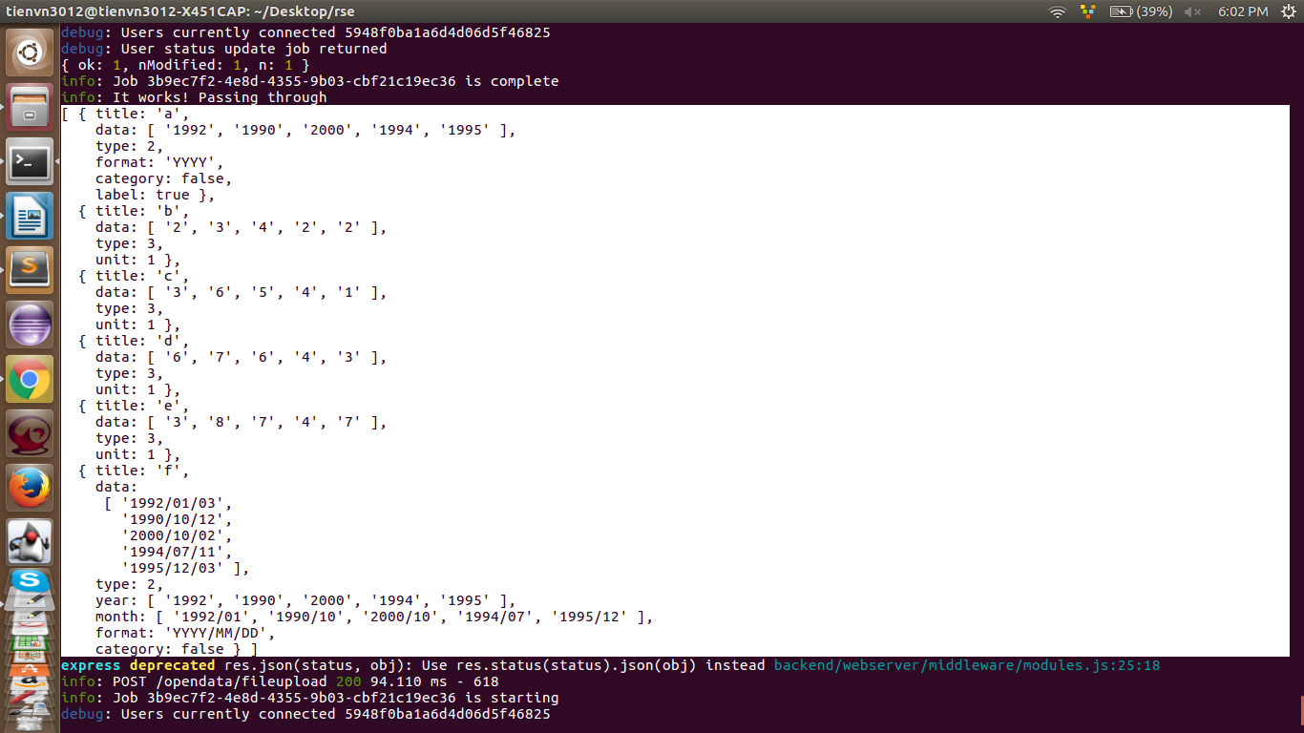
The Open Data Backend will analyze the data structure as follows:

Thus, this data will be sent back to the ajax request of the frontend at sidebar.controller.js.
As you have seen we have analyzed a user's data file, but that's not enough, we will have to respond not just a file, we must to respond many files of the same user put up cause they might want to compare data between files through charts, or want to statistically map multiple files at once. For that reason, we will have to build a data structure per file every time a user uploads a file and receives the analyzed data of that file at the frontend.
.success(function(response){
if(response['status']){
allData.push({
data : response['data'],
file_index : count,
filename : self.filename
});

allChartTable.push({
file_index : count,
filename : self.filename,
data : []
});

$rootScope.drawData();

self.collapse_menu(); // collapse menu when user upload file success

$rootScope.addFile(self.filename);
count+=1;
}else{
alert(response['error']);
}
})

Data sent back from the backend I will save it to a global variable is "allData". You can see the global variables I define in the app.module.js file. Looking at the above code you can see the data structure of the allData variable very well. I have set a property "file_index" = count. "count" is a global variable, each time a user uploads a file, count increments one unit.

Also, I will add a new object to the "allChartTable" variable. This variable exists to save the columns used to draw of each graph. Imagine a data of 10 columns but with up to 9 "text" columns, then you would have to draw about 9 graphs to indicate the relationship between each "text" column and the remaining "number" column. This allChartTable will store the "text" and "number" columns that each graph represents.

Once the data has been sent back, we will draw the graph and show it in the dashboard. The dashboard is another module not related to the sidebar, so they will interact with each other via $rootScope, so we will use the returned data and call the dashboard's drawing function via $rootScope.
Also, as you can see we have the filebar in the dashboard, so we will call the addFile() function of the dashboard to add a new tab to the fileBar.


We will talk about the drawData() function of dashboard.controller.js. Multiply speaking about the dashboard controller, there is a variable you need to note that this.gridsterOpts variable; . In the dashboard I am using the angular-gridster library to resize and drag items as in the demo clips that the team leader will show you. This variable will be used to configure the parameters of the angular-gridster and for better understanding read the angular-gridster document at: https://github.com/ManifestWebDesign/angular-gridster.

The drawData() function is a composite of many functions, so I will explain each code of this function. First line :
var items = dashboardService.renderItems(allData[allData.length-1]['data']);

As above, the file.service.js will be the data processing files for the controller. In the future, when you develop a web page for Open Data you will need a data that can be customized by the user, and the columns selected are displayed or not so from the data that the backend analyzes, we will need a more consistent data structure with that. So the renderItems() function handles the data returned by the backend and converts it to data consistent with the frontend.
Note, you can fully process and render a data structure consistent with the frontend from the backend, but that is not the good thing to do because the frontend is always going to change constantly so it may be time to structure You will then have to revise the data structure to fit in the new UI, and then not only have the frontend but the backend you will have to revise as well. To avoid having to make too much of a change, the backend should public a general data structure and frontend will handle it.

The input of the renderItems() function is the user's newly uploaded file data sent from the backend. Now this function will render the properties to an object, and it will assign an "active" property to each object. With the "active" property when the user wants to define the columns to be draw, we will change the "active" of each column according to the user's intent, so only the columns are "active" = true can be draw.
In addition, this function has another special function: render the data "month", "year" of the "type" column = 2 (time) to a new column that has properties like the other columns. Building such virtual columns will help us a lot in drawing our own charts later.
for (var i = 0; i < data.length; i++) {
if((data[i]['type'] == 2) && (data[i]['format'] != "YYYY")){
var month = {};
var year = {};

month['index'] = index;
month['type'] = 2;
month['title'] ="month of "+data[i]['title'];
month['label'] = false;
month['data'] = data[i]['month'];
month['category'] = data[i]['category'];
month['format'] = "YYYY/MM";
month['month_label'] = true;

items.push(month);
index++;

year['index'] = index;
year['type'] = 2;
year['title'] = "year of "+data[i]['title'];
year['label'] = false;
year['data'] = data[i]['year'];
year['category'] = data[i]['category'];
year['format'] = "YYYY";

items.push(year);
index++;
}
}

Also, to distinguish these columns we will need its own flags: month ['month_label'] = true;
And after processing, you will have the output data structure as follows:
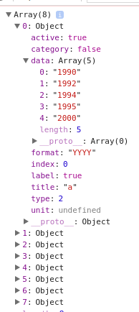

This data will be input of the next function:
var obj = dashboardService.parseToChartData(items,[]);

This function will have 2 input param, param 1 will be the previous data rendered by the render function, the second param will be for the filter, in this time we are currently just upload files so param 2 will be empty array.
First, there are cases where you have to treat the "label" column separately, so separate the "lable" column and the "data" columns(the column have "type"=3) before putting it into processing to graph data is the thing to do :
for (var i = 0; i < data.length; i++) {
if((data[i]['type'] == 1) || (data[i]['type'] == 2)){
if(data[i]['label']){
labels = data[i];
continue;
}
data_labels.push(data[i]);
}else{
datas.push(data[i]);
}
}

And then you will see the line :
var valid = coreService.baseService.delete_item(filter,coreService.chartValid.chartValid,'id');

Now you do not need to care about that because we have not filtered anything. The work now is to process the input data into the data corresponding to each type of graph:
for (var i = 0; i < coreService.chartValid.chartValid.length; i++) {
chart_data = [];
chart_id = 0;
if(coreService.chartValid.chartValid[i].name(labels,data_labels,datas)){
chart_id = coreService.chartValid.chartValid[i].id;
chart_data =coreService.chartValid.chartValid[i].data(labels,data_labels,datas);

all_chart_data.push({
chart : chart_id,
data : chart_data
});
}
}

Take a look at /core/chart-valid/chart-valid.service.js. As mentioned at the beginning, each graph type will have different conditions to determine whether the drawing with the input data can draw that graph ? That is why we will have valid files corresponding to each graph type and variable this.chartValid = []; This will be the set of all basic functions of the graph types we have.
this.chartValid = [
{
name :”function check could this graph can be draw with input data uploaded by the uploader”,
data : “This function will translate from input data to data of this graph type if it is possible to draw”
id : “id of this graph type”
},
...
];

Currently we have 6 graphs type with id in turn:
0 : Vertical Bar Chart
1 : Horizontal Bar Chart
2 : Pie Chart
3 : Line Chart
4 : Area Chart
5 : Bubble Chart
6 : Combo Bar and Line Chart

So we will loop through this array, each array element will represent a type of graph, when determine this type can draw we will proceed with the input data to output the data to draw with that type of graph. Each graph type can have multiple graphs representing different data, each with their own data, but all of them will share the same graph type. So we will save all the data of each graph belonging to the same graph type into a variable called all_chart_data and return it to the controller.
And the data returned will be of the form:
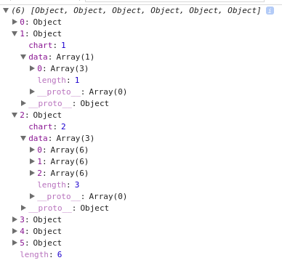

And now we will go into the analysis of each type of chart data.
As said at the top, "chart-valid" folder in the core will be the place to analyze and translate data of each chart type. Currently, Open Data is drawing 6 types of charts, so in this folder will have 6 folders corresponding to each type of chart, each chart will have a service to perform the above mission.
These services are designed based on a common principle, as it is implementing an interface (rather, it extends an abstract class just like in java if you know it), so each service of a graph type will mandatory contains two functions (function name is not mandatory to follow any standard but the mission of that function must completely follow what has been set). These two functions are "valid" and "parseToData". The mission of these two functions is very simple, the "valid" function accepts data, analyzes whether or not the data can be drawn and returns true or false. The "parseToData" function will be called when the "valid" function returns true, the function of which is from the input data, with a magic that turns it into data for the corresponding graph type and returns the result is an data array where each element is the data of a graph of that type.
To expand on the many types of graphs I will say at the end, I will now delve into the analysis of each type of graph.
One more thing, as said, each graph has a different data structure and it will also depend on the library you use to graph the graph. I am currently using the nvd3 library to draw graphs, so you can refer to the data structure of each graph type at the url: http://nvd3.org/examples.

Bar chart:
Here we have two types of bar graphs are horizontal and vertical columns. Notice that either column or column is still a column chart and all data can be represented as a column graph, so the "valid" function of these two graphs will always return true. And these two graphs will have the same input data, so we just need a "parseToData" function for both of them, and this function will be responsible for distinguishing what the return data is from.
Specifically, that will be done in the parseToBarData (labels, data_labels, datas, type) function in bar-chart.service.js and each valid file of these two graphs will call this function and pass on the parameter. "Type" to distinguish.
Also the remaining parameters:
labels: columns have the property "label" = true
data_labels: columns with "type" = 1 and 2 left (text or time)
datas: columns with "type" = 3 (number)

Cause this function is very lengthy so I can not explain one pass, I will go into each code.
var unitData = baseService.splitByProperty(datas,'unit');

As mentioned in the backend, numeric columns may have different units, so drawing two columns different from one in the same column graph may cause a "lost column" phenomenon. For clarity, imagine a unit column of it % → the maximum value that the column will reach is 100, so if it draws the same column as the population, population of a region was able to reach hundreds of millions and when performing on graphs 100 is much smaller than hundreds of millions → almost impossible to see the % column on the graph. So to avoid that situation we will have to separate each group of "number" columns that have the same unit. And when drawing we will draw for each type of unit.
And so splitByProperty() in base.service.js will do that. It will cut the "number" columns by whatever property we want and return the array of data with different units. Specific output will be as follows:
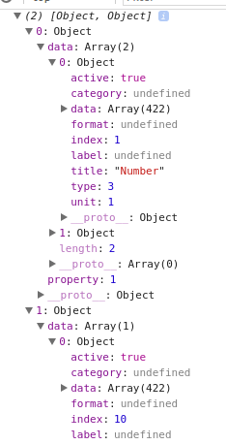

With 3 columns "number" in which two regular columns and one column % splitByProperty() function will split the data as above.
Also, when parsing data for a column chart there are some other issues:
- We can not let a graph of 10 objects, each of which has up to 10 columns, so here I will extract as many as 3 columns an object in a graph. You can see in the loop of the function there are paragraphs:
index = j;
j + 3> unitData [x] ['date']. length? (offset = unitData [x] ['data']. length - j): offset = 3;
Those are the paragraphs where I cut 3 columns of data immediately.
- We can not let a graph have only one object that has three columns, but we have to split it into three objects and each object has one column. To solve it I will have two functions, parseAllowRow() and parseAllowCol(). With input data I will treat it to draw which direction is best and parse the data that way.
- The columns "type" = 2 (time) should not be drawn by bar charts, so I ignored all the "time" columns when drawing the bar chart.
- There will be columns where the data is repetitive as mentioned above, with the columns that we will have to total statistics of the same data and plot its graph and it is processed in parseCategoryData() function
- Apart from the column with the "label" = true property, with large 500-line data there will be lots of graphs that have too many columns, and that's not okay, so whether the column is repeated or not, If the number of columns (objects) is too large we will ignore it, here I limit the number of objects <25.

These are the current issues that have been dealt, cause i don't have much time so I will only write the issues dealt in the code.
The condition for each graph to draw (except the line chart) I have commented above the "valid" function in the code.
Before going into the problems of the most complex graph type - "line chart" I will say a bit about the "pie chart".

Pie chart:
You may have seen the chart you need with a bar chart, but with the same data, the corresponding pie chart will give you a completely different view. Pie chart will calculate the % of that data in the total data, and each pie chart is usually made up of two columns, a "number" column and a "text" column. But there will be special cases where the pie chart is made up of only one "text" column, to explain this I would like the following:
You have a list of students in the whole school, including a "gender" column so you only need that gender column to know how many % male, female, The pie chart is made up of that column.That is the biggest problem that the pie chart has solved.

Line chart:
The key to this type of chart is "time", so the condition for drawing a line graph is to have less than one "time" column. Not only that, like the example in the "idea" section, you can see that the title of a column can also be a "time" type, when not only the data in the same column, you have to draw the chart can represent the data of multiple columns interacting with each other. Because a straight line is made up of at least 2 points, if the number of "number" columns has a title of "time"> 1, then we will draw a line chart.

You can see that for each type of chart we only draw with certain types of columns, the reason is simple, if you draw all the things you can draw, so with a data only 500 lines, you can draw hundreds of charts and users will not like it at all. So limiting a chart of expertise to drawing one or more data that is best expressed is essential. You can not show 1000 graphs and then roll them over several hundred column charts when they really need line charts.

Like bar chart I will explain the problems that the line chart solves:
- Split the "number" by unit, and plot the chart with that type of unit.
- Just get "labels" as "time" columns, sort the time and the corresponding data to draw a standard chart (because nvd3 will not sort the input data for you)
- The "year" or "month" columns, which are drawn as normal columns, have been transformed into a virtual one.
- In addition, the line chart will be able to draw statistical charts on a monthly basis each year:
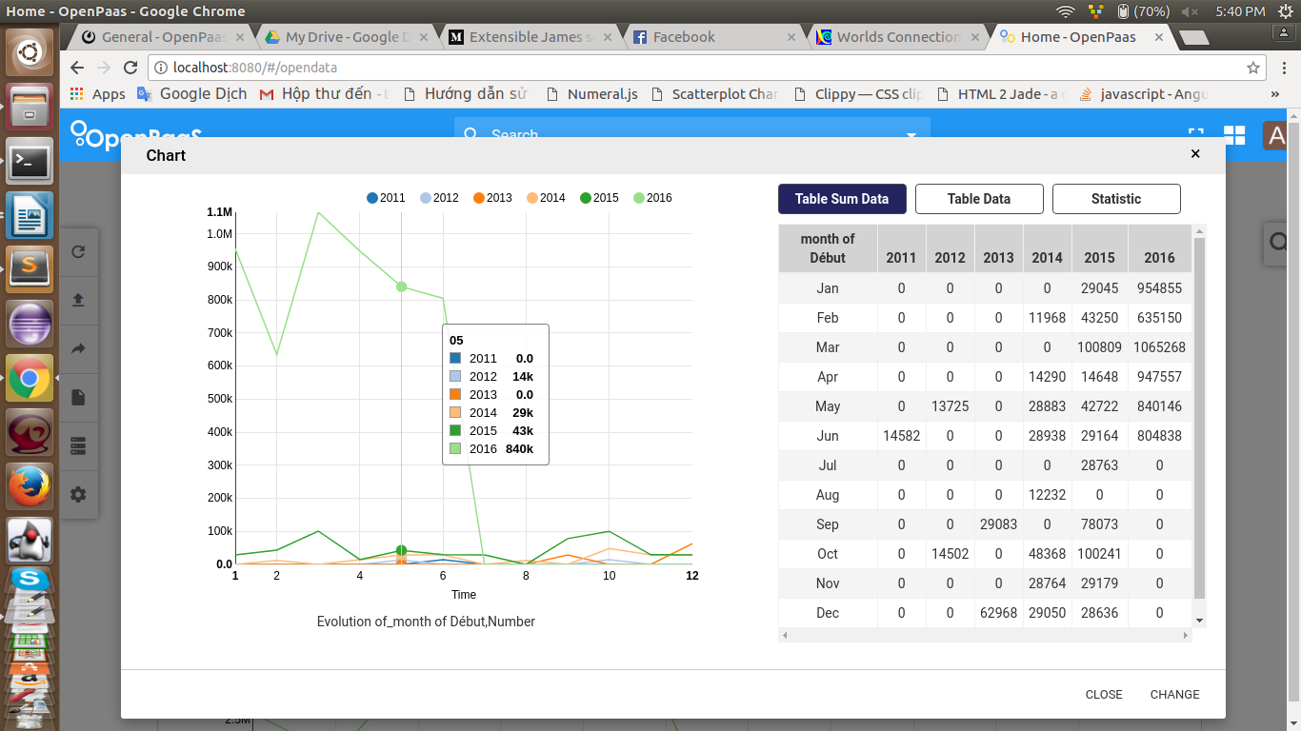
The monthByYear () function in line-valid.service.js will do this mission, the input data will be the virtual month column we created above, first we will use a "Set" to determine how many year in array of years.
var monthDataByYear = [];
var years = baseService.getYearOfData(labels[i]);
var set = new Set(years);
var yearArray = Array.from(set);

For each year we will set up a 12-element data array corresponding to 12 months:
for (var x = 0; x < yearArray.length; x++) {
monthDataByYear.push({
year : yearArray[x],
month : []
});
for (var y = 1; y <= 12; y++) {
monthDataByYear[x]['month'].push({
month : y < 10 ? "0"+y : y+"",
data : 0
});
}
}

The remaining mission is very simple, that is to sum the data for each month of each year, this is completely loop to calculate the total needed, I will not explain thoroughly.

Back to dashboard.controller, after obtaining the data of the charts, we will proceed to build the data structure and display to the user.
As mentioned before, users can upload multiple files and each file will not have many charts, so a logical structure will consist of an array of files, each of which have an array of graph data.
And to avoid problem that the index in the array changed when the user deletes a file, we will use a static index as the "count" variable or the lenght property of the "allData" variable.

So the array of files will have struct :
self.dashboardFile.push({
file_index : file_index,
filename : allData[allData.length-1]['filename'],
dashboardItems : dashboardItems // mảng các box chứa đồ thị
});

The idea here is that when we get the number of graphs we need, we will calculate the height and width needed for the graph to be presented in the most beautiful way, then with the number of data graph, the length and width of each graph we will use "angular-gridster" library to display the corresponding boxes on the UI dashboard. Then we will use nvd3 to draw the graph corresponding to each box.
So dashboardItems will be the array that contains the boxes of that file.
for (var i = 0; i < obj.length; i++) {
for (var j = 0; j < obj[i]['data'].length; j++) {
dashboardItems.push({
title : dashboardService.autoChartTitle(obj[i]['chart'],coreService.baseService.getDataByFileIndex(file_index,allChartTable)[i]['data'][j]),
id : "chart-"+file_index+"-"+obj[i]['chart']+"-"+i+"-"+j,
type : obj[i]['chart'],
file : file_index,
sizeX : coreService.drawService.classifySizeX(obj[i]['chart'],obj[i]['data'][j]),
sizeY : coreService.drawService.classifySizeY(obj[i]['chart'],obj[i]['data'][j]),
active : {
type_flag : true,
labels_flag : true,
category_flag : true
},
temp : false,
data : obj[i]['data'][j],
table : coreService.baseService.getDataByFileIndex(file_index,allChartTable)[i]['data'][j]
});
}
}

Each box will display the title of that chart, and the title will show which chart shows the fields in the data. We will write a function to handle that, autoChartTitle(). This function takes the input as the graph and data of that graph, which returns a sequence of graph names. That string has the form "graph type + lable column + data columns".
The next property of a box is "id", which is the most important property, we will rely on it to determine which box will graph with what data. As you know, the current "obj" variable is saving all graph data, so we will use the order of elements inside it to type "id" for the boxes. So an "id" of a box will be in the form "file_index + chart type + i + j" because "obj" is a 2 dimensional array.

Each chart has a different amount of data, based on that, calculating the length, width for the box. Length and width information are calculating by the draw.service and stored in the "sizeX" and "sizeY" properties. ".

And then you can see :
active : {
type_flag : true,
labels_flag : true,
category_flag : true
},

This part is for the filter, when the user filter maybe they will want to filter by graph type, fields in the graph or other parameters.
Here each filter corresponds to a flag, when the whole flag = true, this box will be displayed, for example, if you filter the pie chart, then all of the remaining type flags will be false except for the pie chart. Therefore only the pie chart can be displayed.

temp: false,
This is an attribute that determines whether this box is an intermediate box. Why are there intermediate boxes? Consider an example:
Country,Year,Population
China,2005,13102285K
India,2005,1090974K
US,2005,295517K
Indonesia,2005,229245K
Brazil,2005,169279K
Pakistan,2005,169279K
China,2010,1336681K
India,2010,1173109K
US,2010,309348K
Indonesia,2010,243423K
Brazil,2010,195835K
Pakistan,2010,184405K
China,2015,1367486K
India,2015,1251696K
US,2015,321369K
Indonesia,2015,255994K
Brazil,2015,204260K
Pakistan,2015,199086K

As you can see the first column is a "category" column, so when the user filters that column according to the data is "china" then what you need to do is turn that data into:
Country,Year,Population
China,2005,13102285K
China,2010,1336681K
China,2015,1367486K

And then draw the chart with the new data just obtained. Then those graphs are not the original graphs of the data, these graphs analyzed by code, which are temporary graphs, and the "temp" property determines whether a box is temporary or not.

The remaining properties are "data" and "table" used to store the data of that graph and the table data of that graph.
And then you can see the line :
$rootScope.setFiltersCategory(file_index);

Each file uploaded by different users has different data, so you will have to filter according to different data. The function of this function is to render all the data needed to filter the selects for the user to select.
Because the filter is not fully functional so I will talk about this function later.

After you have rendered all the boxes to the dashboard, now it is time to graph the boxes. This will be a service "draw" in the core implementation:
coreService.drawService.drawAll(obj,file_index);

You can see in the /core/draw folder that 6 directories corresponding to the six types of graphs that we can draw up to now. The functions in these sub services are purely the graphing functions of the "nvd3" library.
Looking at the draw.service.js file, you can see that the functions automatically calculate the length and width of each graph depending on the amount of data they contain. These functions are easy to understand so I will not say more about it. I will focus on the function that we are considering as the drawAll() function.
As mentioned above, the parameters needed to define a box containing graphs include the index ning tof the data in the array contaihe data, the index file and the chart type, in addition to a parameter. Here I not only draw the graph in the box i will draw graph in the popup too, this popup will display the graph and specific data of it graph in tabular format for easy comparison. So we have to distinguish between graphs in the dashboard and graphs in the popup. So the last parameter I will use is a string for easy identification. When the string is "chart," the graph needs to draw a graph in the boxes, when the string is "modal", the graph needs to draw a graph in the popup.

The drawAll() function calls the classifyDraw() function, the input of the classifyDraw() function takes on the string to distinguish where we draw the chart, The drawAll() function is only for drawing boxes in the dashboard. Therefore, this function will be passed to the "chart" function to recognize the graphing of the boxes in the dashboard.
Also you can see a small function above the drawShow() function:
classifyDraw("modal",0,type,0,0,data);

This function is a function for the popup, so it will call the classifyDraw() function and pass it to the "modal" string so that the classifyDraw() function recognizes graphing in the popup. In essence, the transmission of such strings is to select the id of the boxes needed to draw.
The rest of the classifyDraw() function is just a call to drawing services for graph types.
function classifyDraw(name_id,file_index,id,obj_id,data_id,data){
var chart_id = "";
if("modal" == name_id){
chart_id = "#chart_modal svg";
d3.select(chart_id + " *").remove();
}else{
chart_id = "#"+name_id+"-"+file_index+"-"+id+"-"+obj_id+"-"+data_id+" svg"
}
switch(id){
case 0 : drawBarChartService.draw(chart_id,data,0);
break;
case 1 : drawBarChartService.draw(chart_id,data,1);
break;
case 2 : drawPieChartService.draw(chart_id,data);
break;
case 3 : drawLineChartService.draw(chart_id,data);
break;
case 4 : drawAreaChartService.draw(chart_id,data);
break;
case 5 : drawBubbleChartService.draw(chart_id,data);
break;
case 6 : drawComboChartService.draw(chart_id,data);
break;
default : return;
}
};

So after this step we have the graph displayed on the dashboard.

Now we are going to go into the last-talking function of Open Data, the function that does popup information:

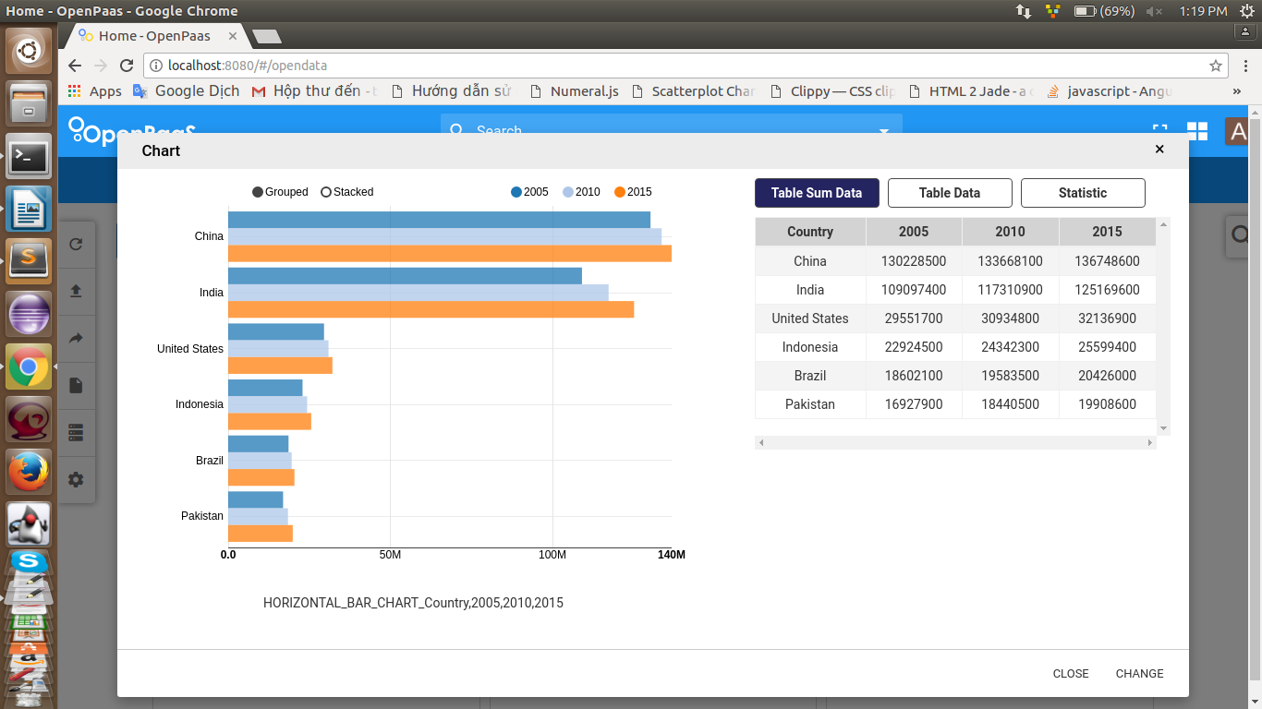
When you click on the show info section of a graph, the popup will display and the show() function inside the controller will be triggered.
var e = angular.element(event.currentTarget).parents("li").find("div[type]");
//e -> id = "chart-0-1-2-3" <=> "chart-file_index-chart_type-obj_index-data_index"
var position = coreService.baseService.detectChartId(e[0]['id']);
//posiition = [file_index,chart_type,obj_index,data_index]

The first thing to do when popup is displayed is to know what popup will display for which graph. We will determine that graph by their id. When the user clicks on the show info button on a dashboad graph box, it will be from the element that the user has just clicked to find the div containing the id of the graph that the user just clicked.

With that id, we will analysis thought the way that we have created that id. The detectChartId() function will reverse that id to the required parameters including file_index, type, index.

And as you know all graph data is stored in the "allChartData" variable, so with the above parameters we can completely get the data of the graph we need and then redraw that graph to the popup by calling the drawShow() function in the draw service mentioned above.
var index = 0;
var flag = false;
for (var i = 0; i < allChartData.length; i++) {
if(allChartData[i]['file_index'] == parseInt(position[0])){
index = i;
flag = true;
break;
}
}

coreService.drawService.drawShow(parseInt(position[1]),
allChartData[index]['data'][parseInt(position[2])]['data'][parseInt(position[3])]);

The id after being parsed will return an array whose order is described in the comment code above.
self.table = dashboardService.parseToDataTable(
allChartTable[index]['data'][parseInt(position[2])]['data'][parseInt(position[3])]);

self.sum_table = dashboardService.parseToStatisticTable(parseInt(position[1]),
allChartData[index]['data'][parseInt(position[2])]['data'][parseInt(position[3])],
allChartTable[index]['data'][parseInt(position[2])]['data'][parseInt(position[3])]);

self.statistic = dashboardService.parseToStatistic(parseInt(position[1]),
allChartTable[index]['data'][parseInt(position[2])]['data'][parseInt(position[3])]);

Then we process the data table section into the statistics beside. All the data of the columns drawn on each graph are stored in the "allChartTable" variable, so to display the columns we will use the parameters from the parsed id to retrieve the corresponding data and represent it. table.
With a total table for repetitive data, iterative columns are summed, so it is best to use the processed data of the graph inside the "allChartData" variable to easily to handle.
Because each type of graph has different input data so the synthesis is different, so with this table each graph will have its own way of getting the same data structure. Each graph must be processed separately in parseToStatisticTable() function.
this.parseToStatisticTable = function(type,data,table){
var data_table = {
labels: [],
data : []
};

(table['data']).unshift(table['labels']); // add to render title
for (var i = 0; i < table['data'].length; i++) {
data_table['labels'].push(table['data'][i]['title']);
}
(table['data']).shift(); //before render → remove

switch(type){
case 0 :
var t = statisticTable.statisticBarChartTable(data);
data_table['data'] = t;
break;
case 1 :
var t = statisticTable.statisticBarChartTable(data);
data_table['data'] = t;
break;
case 2 :
var t = statisticTable.statisticPieChartTable(data);
data_table['data'] = t;
break;
case 3 :
var t = statisticTable.statisticLineChartTable(data);
if(!Array.isArray(t)){
(t['label_return']).unshift(data_table['labels'][0]);
data_table['labels'] = t['label_return'];
data_table['data'] = t['data_return'];
}else{
data_table['data'] = t;
}
break;
case 4 :
var t = statisticTable.statisticAreaChartTable(data);
data_table['data'] = t;
break;
case 5 :
var t = statisticTable.statisticBubbleChartTable(data);
data_table['data'] = t;
break;
case 6 :
var t = statisticTable.statisticComboChartTable(data);
data_table['data'] = t;
break;
default :
var t = statisticTable.statisticBarChartTable(data);
data_table['data'] = t;
break;
};
return data_table;
}

We will use a switch case to determine the handling of the input data, with the line chart being a bit special as it will have to record the data in each month every year and so we will have to deal with it alone.

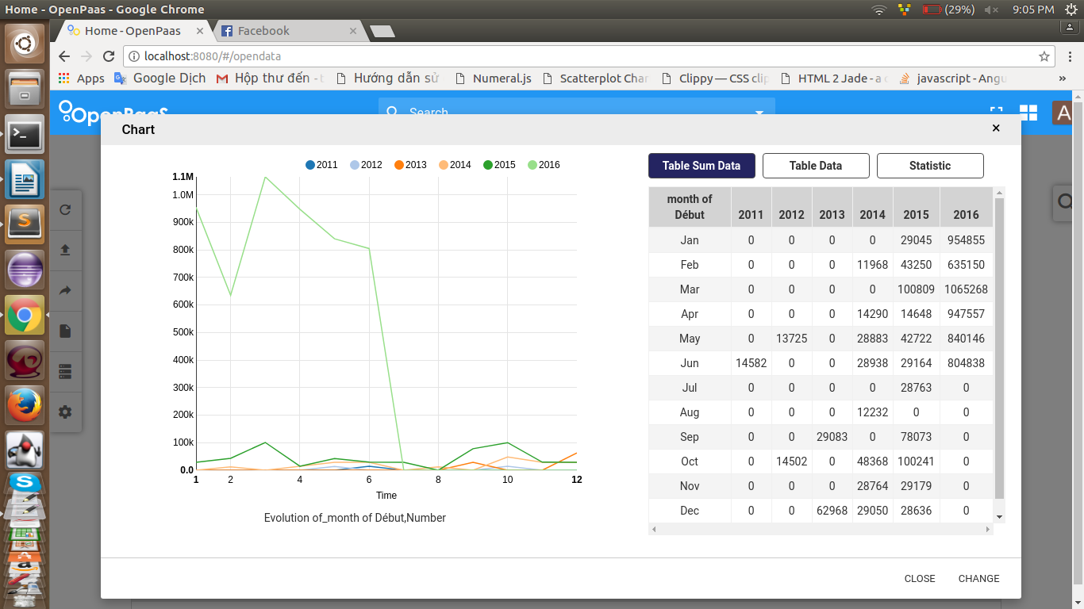
You can find the render functions from graph data to display data in the dashboard-statistic-table.service.js file.

In addition, this popup also statistics some data for users such as maximum value, smallest, average, …

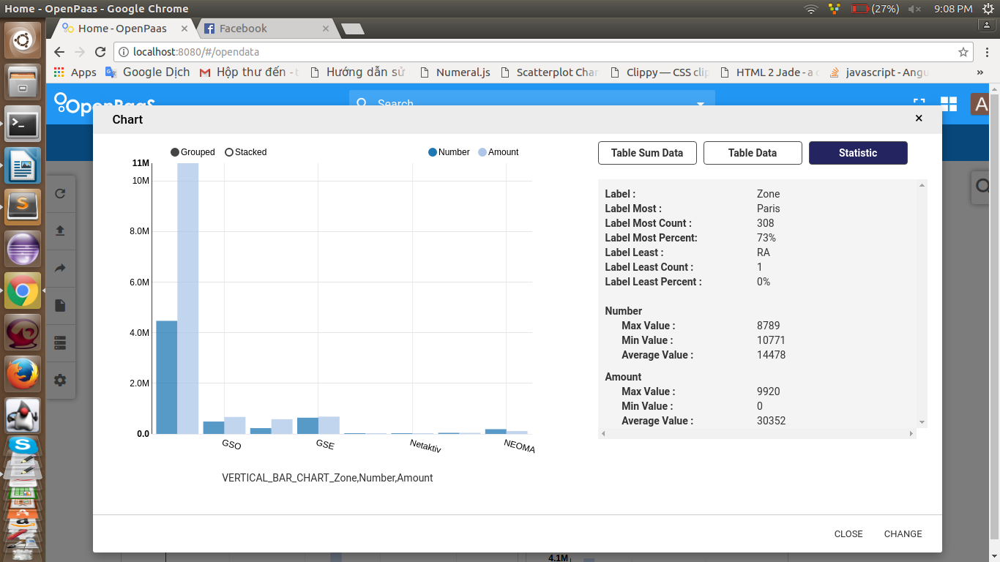

You can see the way to statistics inside the dashboard-statistic.service.js file, it's very simple so I will not explain anymore.
So I explained the show() function and almost anything in this module. Although there are still many unexplained things but that is all you can easily understand, so I will not waste time explaining.

Things are unreasonable and need to be changed

1) The first thing unreasonable is that the "file-model" directive is in the sidebar.component.js file. You should write it to another file instead of just like the current one.
2) The second thing unreasonable thing is that the ajax request sends the file backend that is currently in sidebar.controller.js. This is not because the main purpose of the controller is to interact with the UI and distribute the data, so a data handling function should not be left at the controller, so hopefully you can get the ajax request to the sidebar. service.js. You can read the angular tutorial to know how to fix this problem.
3) The third thing unreasonable is that the draw service is currently drawing directly into the DOM. Hope you look for a way to have only the controller interact with the DOM, the service should be the data processing part. You can replace the use of "nvd3" by using "angular-nvd3" to do this, but me and Project manager have agreed that "nvd3" looks better than "angular-nvd3" so temporarily we still decided to use "nvd3".
4) The fourth thing unreasonable is that this project is still not good control of the asynchronous javascript, so there are still some UI errors. Hope you can modify this.
5) The fifth thing unreasonable is that the backend has not processed the non-csv file and the csv file pattern check pattern still has some exceptions, so hopefully you will fix this part.
6) The sixth thing unreasonable is the "number check" function above, so you can write down the best possible test function.
7) The Seventh thing unreasonable is that some pattern check unit data may have errors, please check again.
8) The eighth thing unreasonable is the filter. Currently the filter is not running (you download select-2 for the error), the select-2 library I use has some errors to use in this system, so please find out which library That's more appropriate. Code part filter I will still keep in this, if needed you can refer and rewrite.

4, Development direction

1) Add new chart types:
When adding a new chart type you will need the following:
Create a new folder named of that type in the /core/chart-valid folder
- Create a valid service file of the graph type (eg radar.service.js).
- In the valid file you need to write at least two functions as "valid" and "parseData" with input data similar like other graph types. The "valid" function will have a mission that analyze input data whether or not to draw your graph and return either true or false. The "parseData" function will have a mission that if the "valid" function returns true, it will be from the input constructing the data structure that your chart requires. That's at least of what you need to do in this file.
- The next step is to inject the service into "chartValidService". As you said you have seen an array of "chartValid" within this service, each object within the array represents a graph type with properties:
+ "Name": the "valid" function of that graph
+ "Data": The "parseData" function of that graph type
+ "Id": id of the new graph type, when creating a new type you can auto-assign an id that does not overlap with the previous id.
- Similar to chart-valid, you need to create a directory corresponding to your new graph type for draw your graph with data and id, and then you must save your graph object in the "allChart" variable so that when we need it we will update the entire graph.
- After created, you must inject your service into the drawService. You can see inside the drawService that there are functions that define the box size for your graph on the dashboard (the max width is 6), so write a function that defines the length and width of your graph with the input data of the graph.
- Then rely on the id of the graph you just created to add the corresponding case switches for your graph in the drawService functions.
- Also, you will have to declare your graph name in the classifyChartId function of the dashboardService to serve the purpose of setting the title of the graph.
- As mentioned above, each type of graph has a different way to statistic data so you have to add the sum of your graph type in dashboard-statistic-table.service.js and add the case to parseToStatisticTable( ) of the dashboardService.

That is how to create a new graph type, looks the steps seem very long but the reality is very simple, hope you can succeed with this direction.

2) Read files other than csv:
- You can see the input stream as file backend and analysis. So to intervene in this you have to write an input file sort function when receiving the file in the controller.
- After classifying files, you write detectables for each file type, but return the same data structure from which the data structure is built into the data-detecting functions in the core. Thus, the current analysis flow will be completely unaffected.

3) More types of units that can be identified:
- You can see a lot of patterns in the backend analysis-number.js file, when you want to identify new units you write your patterns here.
- Like with the frontend, these patterns have a function call to match and each new unit type gives it an id that does not coincide with the old unit.
- This file is easy to understand and just read through the code you can understand right away so I will not explain much.

4) Insert options into the graph type drawing function:
Currently the input of the graphs has only id and data, so when you want to configure a color chart or other things we will not intervene. So a task for you is to insert the option to make the graph look better. This would be an unfortunate part of having Open Data built into this case, so when you do this you will probably have to make some changes to the parseData() .

5) User data storage:
Open Data is currently using the core of Open-Paas, so you may have to write your database access functions inside the Open-Paas core.
In the future, Open Data will evolve into a dedicated web portal, so you can talk to a team leader about building not only a database but also a backend with the technology you want (for example, java, php, ...) and you can do dozens of different frontends from your phone to the web and all are referred to your backend including the current frontend in Open-Paas. So you will not need to depend on the core of Open-paas anymore.

6) Building machine learning model:
Although above I wrote that it is impossible to show thousands of graphs to users, so now every kind of graph is drawing only the data that it can show best but if you want to build the machine learning model for this module you can do the following:
- Build every graph that can draw with one data.
- Hides most of the graphs away from displaying it to the user, graphs showing the user are the graphs that are most likely to perform best with that data.
- Build a database to classify each type of user data
- Statistics the number of clicks on the "info" and click on "delete" of each type of chart for each type of data, so that you can see for which user they tend to prefer to see what type of chart represents the data type. Anyhow, from then on the performance graphs were hidden at the user's discretion.
- With regular machine learning models you should have a certain number of records for high accuracy. (In probability theory, the more probability of the occurrence of the test, the more likely it is to appear. For example, somehow you figure out that 60% of people like to view line charts with time-based data, but 10 people are not sure exactly 6 people like that. With 1000 people, even 100,000 people, the number of people like that will come close to the 60% you can count on). So when building a machine learning model let it run for a while. Put to use it can serve well immediately.
- I know there are still a lot of things to build such a machine learning model, but the general idea is so that you can consult and build successfully.

7) Build pages for users to manually build the graphs they want from their data:
No matter how good the dashboads are, they can not produce the perfect graphs at the user's discretion, so building a site for users to build their own graphs with the fields they want is essential.
This page will have to be called a "console" so that the user can use the command set to draw what fields and from how many lines to how many of the data. This is intended for users who are already familiar with this system.
For that reason you will have to build a set of instructions for the user. Specific PM will introduce you.

8) Build shared dashboard between users:
Refer to this feature of team calender, users can share the dashboard they have edited and agreed to other users they want.

9) Statistics and data management of the dashboad:
The site manager and user built self-built graphs page have been designed before, PM will guide you specifically on this.

10) Add features to share graphs on social networks.
11) Unit identifier in headerRow records (for example, country, 2005 (%), 2010 (%), 2015 (%))

That's almost things about Open Data. This is a new project and is still developing in the long run, so it needs a strong data structure and algorithm. Due to the limited experience and limited ability of myself, there are still many unreasonable points in the process of working. I apologize and hope you can repair and develop Open Data as a useful tool for every user.
Hope you success with this project. Thank you !

Author: tienvn3012
If you have any questions regarding this code or document you can contact me directly:
Facebook: https://www.facebook.com/tien.orion
Gmail: tienvn3012@gmail.com

