**Group:** Eco Buddies Again!

**Members:** Lina Clifford, Jessica Martinez, Laura Haynes, Elizabeth Clark, Olivia Dinkelacker

**Q1 (3 pts.): Upload a single pair plot of selected columns in the habitat data.**

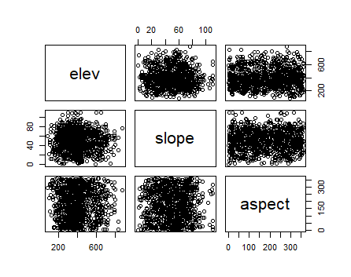

**(1 pt.) Qualitatively describe what kinds of patterns you see in the pair plot.**

Elevation and slope seem to have data more concentrated towards the center of the graph, while the other graphs show

**(1 pt.) Do any of the variables seem to be associated? Why or why not?**

None of the variables appear to be associated. All pair plots seem to have a random distribution, because the if you tried to fit a line of best fit, it would show no slope in any plot.

**(1 pt.) Include the R-code you used to create the plot.**

pairs(dat_hab[,c("elev","slope","aspect")])

**Q2 (3 pts.): Upload a histogram of counts for one of the bird species.**

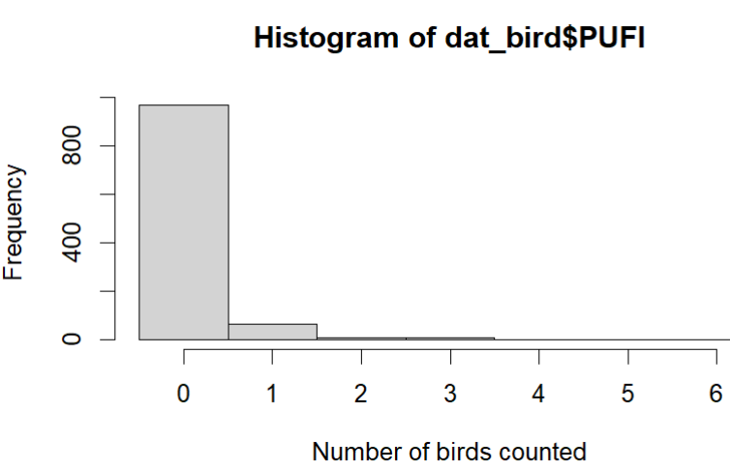

**(2 pts.) Qualitatively describe two insights you can learn from the histogram. Consider, for example**

**Is the distribution of counts skewed?**

The distribution of the bird counts is skewed left, for which frequency of observations is higher to the left, where number of birds counted is lower.

**Are there lots of sites with zero observations?**

Yes, except for zero

**Are the bird counts best described in terms of presence/absence, or abundance?**

Presence/absence

**(1 pt.) Include the R-code you used to create the plot.**

hist(dat_bird$PUFI ,xlab = "Number of birds counted", breaks = 0:7 - 0.5)