**Group:** Eco Buddies 3.0

**In Class Data Reading Assignment**

**Names:** Lina Clifford, Laura Haynes, Olivia Dinkelacker, Liz Clark, Nicole Yunes Perez

9/22/2022

We had difficulties with loading packages and calling csv files.

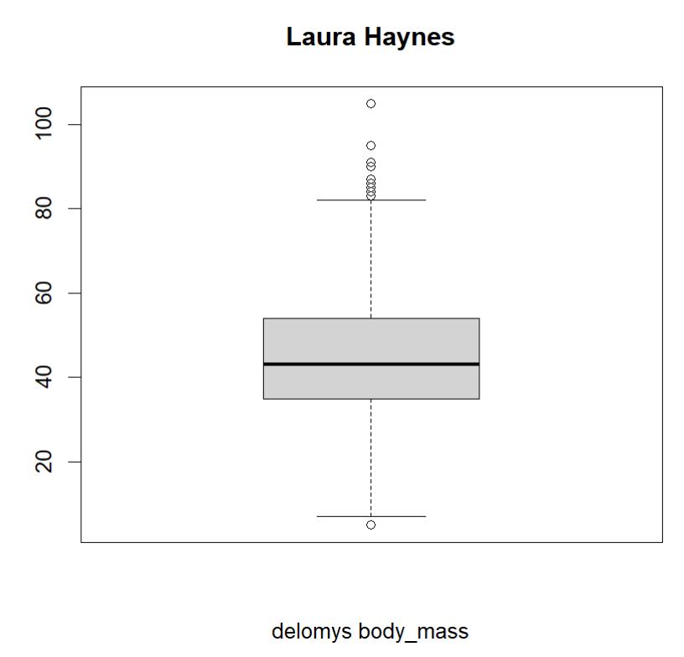

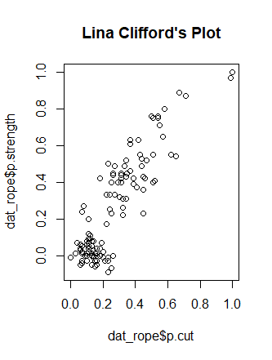

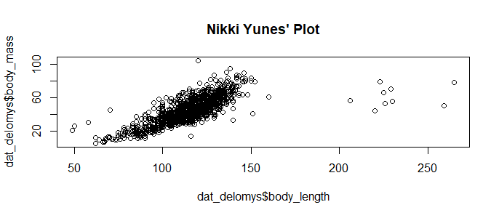

Code Used:

#install here package

install.packages("here")

#load in Here package

require(here)

#see working directory

getwd()

#load in csv file into environment

dat_catrate = read.csv(here("data", "catrate.csv"))

dat_delmoys = read.csv(here("data", "delomys.csv"))

dat_rope = read.csv(here("data", "rope.csv"))

#see if dataframe or matrix

class(dat_catrate)

class(dat_delmoys)

class(dat_rope)

#see first few lines

head(dat_catrate)

head(dat_delmoys)

head(dat_rope)

#create plot with name

plot(dat_rope$p.cut, dat_rope$p.strength, main="Lina Clifford's Plot")

