Eco Buddies: Lina Clifford, Liz Clark, Laura Haynes, Jessica Martinez, Olivia Dinkelacker

In Class Probability 3

10/11/2022

* **Q1 (1 pt.): If I wanted to use a binomial distribution to model my six forest plots, what values should I use for the two parameters of a binomial distribution?**
  + You would need n, or number of trials, and P which is probability of success for each trial.
* **Q2 (1 pt.):** **Use dbinom to calculate the probability of observing birds in *exactly* four of the six patches. Include your R-code in your answer.**
  + dbinom(x=4, size = 6, prob = 2/3, log = FALSE)
  + 0.3290219
* **Q3 (1 pt.):** **Now, suppose I did a survey and observed no birds in my plots. Use dbinom to calculate the probability of observing no presences.**
  + dbinom(x=0, size=7, prob=2/3, log=FALSE)
  + 0.0004572474
* **Q4 (1 pt.): Back to the binomial scenario (bird presence/absence in 6 forest plots).** 
  + **Now use pbinom to calculate the probability of observing *four or fewer* presences in the 6 plots. Show your R code?**
  + 0.648834
  + pbinom(q = 4, size = 6, prob = 2/3, lower.tail = TRUE, log.p = FALSE)
* **Q5 (1 pt.):** **Now use pbinom and the law of total probability to calculate the probability of observing *four or more* presences in the 6 plots. Show your R code?**
  + pbinom(q = 4, size = 6, prob = 2/3, lower.tail = FALSE, log.p = FALSE)
  + 0.351166
* **Q6 (1 pt.):** **Are you more *likely* to observe a value of 1.0 or 2.0?**
  + You are more likely to observe a value of 1.0.
* **Q7 (1 pt.): What is the *probability* of observing a value of 1.0 or less? Show the R code you used to find your answer.**
  + 0.8413447
  + pnorm(q=1,mean=0,sd=1, lower.tail=TRUE, log.p=FALSE)
* **Q8 (1 pt.):** **What is the *probability* of observing a value between 1.0 and 2.0? Show the R code you used to find your answer.**
  + pnorm(q=1:2,mean=0,sd=1, lower.tail=TRUE, log.p=FALSE)
  + 0. 1359052
* **Q9 (2 pts.):** **Show the complete R-code you used to create your plot. Make sure you include all the code to recreate your plot in a fresh R session.**

y_2 = dnorm(x, mean = 0, sd = 2)

y2 = dnorm(x, mean = -2, sd= 1)

plot(y ~ x, type = "l", ylab = "Probability Density")

points(y_2 ~ x, type = "l", lty = 2)

points(y2 ~ x, type = "l", ylab = "Probability Density", lty = 2)

y_cdf_1 = pnorm(x, mean = 0, sd = 1)

plot(y_cdf_1 ~ x, type = "l", ylab = "cumulative density")

y_cdf3 = pnorm(x, mean= -2, sd=1)

y_cdf_2 = pnorm(x, mean = 0, sd = 2)

plot(y_cdf_1 ~ x, type = "l", ylab = "Cumulative Density")

points(y_cdf3 ~ x, type = "l", lty = 2)

plot()

* **Q10 (1 pt.): Include a figure of your plot.**

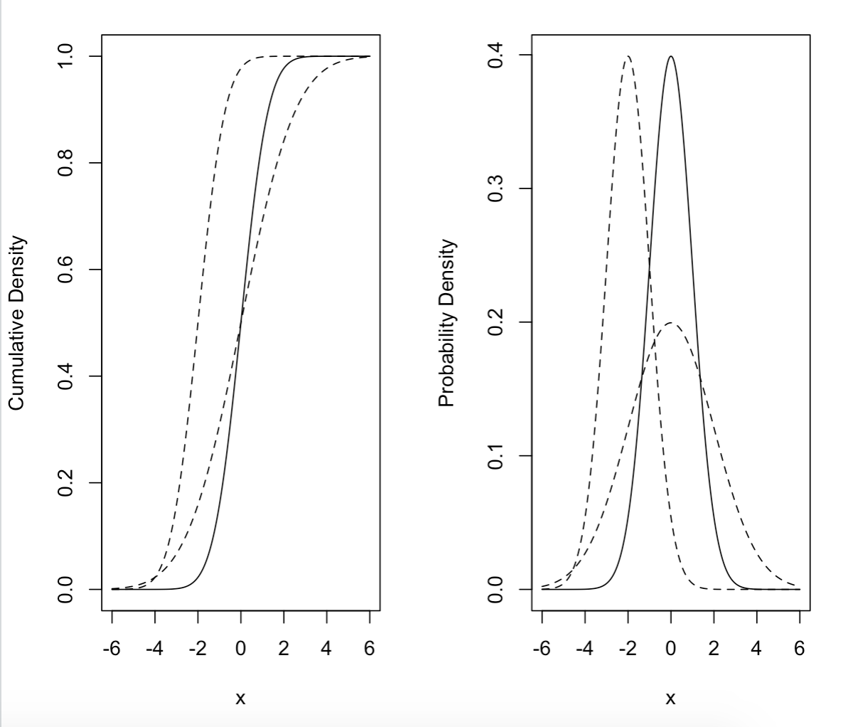

* **Q11 (2 pts.):** **Show the complete R-code you used to create your plot. Make sure you include all the code to recreate your plot in a fresh R session.**

x_bin = 0:5

y_bin_2 = dbinom(x_bin, size = 6, prob = 2/3)

barplot(

height = y_bin_2,

names.arg = x_bin,

space = 0,

ylab = "Pr(x)",

main = "Binomial: n = 6, p = 2/3")

* **Q12 (1 pt.)**: **Include a figure of your plot.**

