Eco Buddies: Elizabeth Clark, Olivia Dinkelacker, Laura Haynes, Jessica Martinez, Lina Clifford

In Class Models 1 (t tests)

**Q1 (2 pts.): Create separate boxplots of body mass for male and female Adelie penguins. Your boxplots do not have to be in the same panel like mine. Show the R-code you used to make the plots.**

dat_ade = droplevels(subset(penguins, species == "Adelie"))

dat_ade$sex <- as.factor(dat_ade$sex)

levels(dat_ade$sex) <- c("F","M")

boxplot(dat_ade$body_mass_g ~ dat_ade$sex,

main = "Boxplots of Penguin Body Mass by Sex",

ylab = "Body mass (g)",

xlab = "Sex")

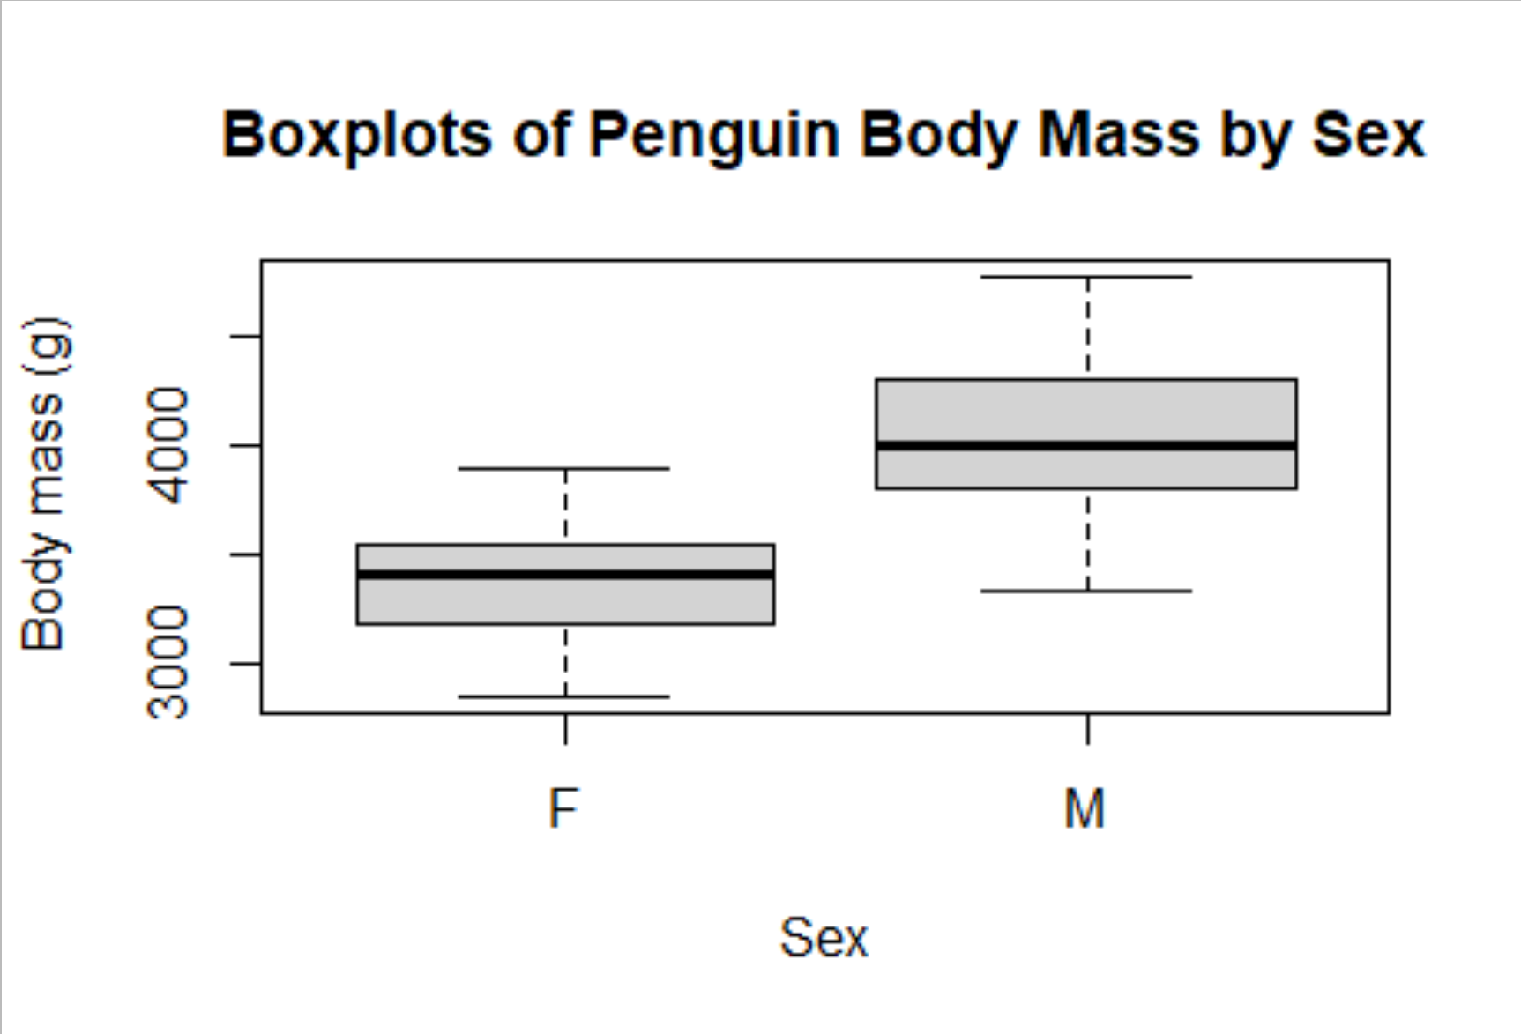

**Q2 (2 pts.): Perform a one-sample t-test of the alternative hypothesis that female Adelie penguins have a body mass different from zero grams. Note that this is a very silly alternative hypothesis. Is this a one- or two-tailed test? Show your R-code. You’ll need to do some subsetting. Check the help entry for t.test(). Specifically, check out the mu and alternative arguments.**

Technically this is a two sided t-test because you want to know if body mass is different from 0, greater than or less than. However, since body mass logically cannot be less than 0, we can treat this as a one sided t-test.

femalepen=subset(dat_ade,sex== "F" )

t.test(femalepen$body_mass_g, y = NULL, alternative = "greater", mu = 0, paired = FALSE, var.equal = FALSE)

**Q3 (1 pt.): Describe your conclusions based on the p-value of the t-test.**

Based on the p-value of the test, the null hypothesis can be rejected, and we can accept the alternative hypothesis that female Adelie penguins have a body mass different from 0 grams. The p-value from running the t-test was less than 2.2e-16, since it is less than 0.05, there is a significant difference.

**Q4 (2 pts.): Now, conduct a slightly less silly test: perform a one-sample t-test of the alternative hypothesis that male Adelie penguins have a mean body mass greater than 4000 grams. Is this a one- or two-tailed test?**

This would be a one-sided t-test because we’re only looking at greater than 4000, not greater than or less than 4000.

malepen=subset(dat_ade,sex== "M" )

t.test(malepen$body_mass_g, y = NULL, alternative = "greater", mu = 4000, paired = FALSE, var.equal = FALSE)

**Q5 (1 pt.): Describe your conclusions based on the p-value of the t-test.**

Based on the p-value of the test, we fail to reject the null hypothesis which means male Adelie penguins do not have a mean body mass greater than 4000 as the p-value is 0.1438.

**Q6 (2 pts.): Conduct a two-sample t-test of the alternative hypothesis that male and female Adelie penguins have different mean body masses. Show your r-code.**

t.test(femalepen$body_mass_g, malepen$body_mass_g)

**Q7 (1 pt.): Describe your conclusions based on the p-value of the t-test.**

Based on the p-value, we are able to reject the null hypothesis and accept the alternative hypothesis that there is a significant difference in body mass between male and female Adelie penguins.

**Q8 (2 pts.): Conduct a two-sample (one-tailed) t-test of the *directional* alternative hypothesis that male Adelie penguins are heavier than females.**

t.test(malepen$body_mass_g, femalepen$body_mass_g, alternative = "greater", paired = TRUE, var.equal = FALSE)

P = -2.2e-16

**Q9 (2 pts.): Conduct a two-sample (one-tailed) t-test of the *directional* alternative hypothesis that male Adelie penguins are lighter than females.**

t.test(malepen$body_mass_g, femalepen$body_mass_g, alternative = "less", paired = TRUE, var.equal = FALSE)

P = 1

**Q10 (2 pts.): Explain why the p-values are so drastically different in the two directions.**

There is such a drastic difference between the two directions because in Question 8, there was a indication that male Adelie penguins are heavier than females because the p-value was extremely low(2.2-16), meaning that the likelihood of this occurring by chance is low. In Question 9, there was no indication, and it was solely up to chance that male penguins were lighter than females, this was shown through a p-value of 1, meaning that the likelihood of this happening because of chance is VERY high.