Lina Clifford

ECO 602 – Analysis of Environmental Data

Using Models 2 Assignment

Due 12/4/2022

**Q1 (4 pts.): Re-create the conditional boxplot of penguin body mass conditioned on sex and species. Include your boxplot as a figure in your report.**

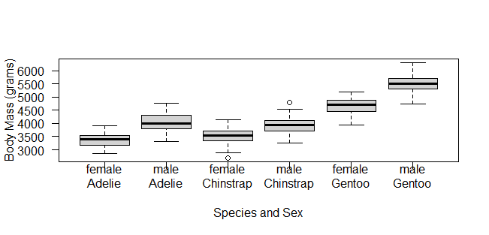

**Q2 (2 pts.): Based on the boxplots, do you think male penguins are significantly heavier than female penguins of the same species? Explain your reasoning, and be sure to explain why you think any observed differences are significant or not.**

Based on the boxplots, I think that male penguins are significantly heavier than female penguins of the same species. The median body mass of male Adelie, Chinstrap, and Gentoo penguins is very close to, if not exceeds, the fourth quartile of body mass for Adelie, Chinstrap, and Gentoo female penguins, respectively.

**Q3 (2 pts.): Do you think adding sex to a model that already includes species will improve the model fit? Make sure you justify your answer based on the boxplots and not results of a statistical test.**

Yes, I think adding sex to a model that already includes species will improve the model fit. The boxplots of the model including sex and species are shorter and have less variability than the boxplots of the model of only species. Without including sex, the boxplots for Adelie and Chinstrap species look almost identical. Adding sex helps to account for more of the data’s variability.

**Q4 (2 pts.): Show the R-code you used to build fit_both. Hint: You only need one line of code to do this!**

fit_both = lm(body_mass_g ~ sex * species, data = penguins)

**Q5 (2 pts.): What is the base case for the two-way model that includes sex and species?**

The base case for the two-way model that includes sex and species is “sexfemale.”

**Q6 (2 pts.): What are the names of the two coefficients (from the first column of the coefficient table) that you need to calculate the average mass of female Chinstrap penguins?**

The names of the two coefficients from the first column of the coefficient table that you need to calculate the average mass of female Chinstrap penguins are “speciesChinstrap” and “(Intercept)” which is the base case, “sexfemale.”

**Q7 (2 pts.): What is the predicted average mass of female Chinstrap penguins in the interactive model?**

3368.836 + 158.370 = 3527.206

**Q8 (2 pts.): What is the observed average mass of female Chinstrap penguins, calculated from the penguins data? Hint: You’ll need to do some logical subsetting to get the answer!**

3527.206