Lina Clifford

ECO 602 Analysis of Environmental Data

Lecture Assignment: Data Exploration and Deterministic Functions

Due 10/9/2022

Q1: Terrain Histograms

1. Create histograms for the three terrain variables: elevation, slope, and aspect.
2. Plot all three histograms in one figure and include it in your report.

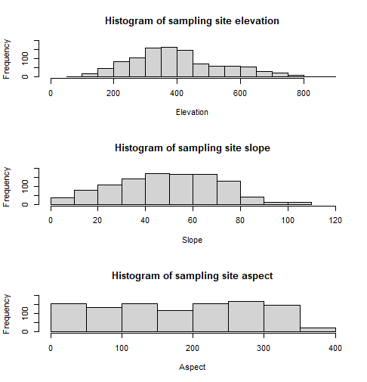

Q2: Elevation Histogram Interpretation

The elevations of the bird census sampling sites are unevenly distributed in that different elevation levels are not evenly represented in the sampling sites. Rather, most sampling sites have elevations between 300 and 400. There are more low-elevation sampling sites than high-elevation sampling sites.

Q3: Slope Units

The units of slope in this dataset is percent slope which is numeric and ranges from 0 to 110 percent.

Q4: Slope Histogram Interpretation

Most of the slopes of the bird census sample sites range from 30 to 80 percent slope. Most sample sites, therefore, are not flat and do have some slope. There are more relatively flat sites than sites with more extreme slopes.

Q5: Aspect

Aspect is the compass direction that a slope faces. Aspect is measured in degrees and range from 0 to 360 degrees.

Q6: Aspect Histogram Interpretation

The aspect of the bird census sample sites is fairly evenly distributed, meaning that a variety of aspects were evenly used. There does appear to be slightly more samples with aspects between 250 and 300, which are northwest facing slopes.

Q7: Terrain/Basal Area Linear Models

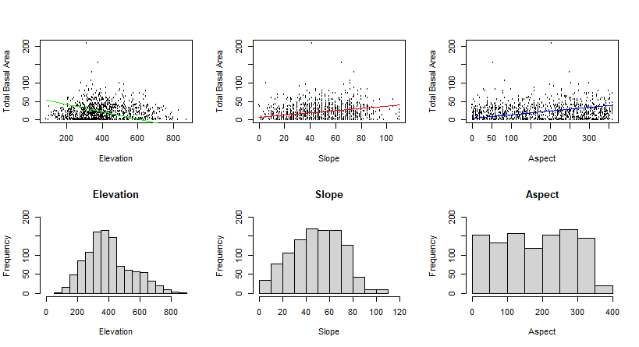

Q8: Terrain/Basal Model Interpretation

There appears to be a very weak relationship between total basal area and elevation. It seems that total basal area increases as elevation increases until about 500 feet of elevation, then total basal area decreases as elevation continues to increase. This is not a linear relationship; therefore, my linear model is not a good fit for the data.

Similarly, there does not appear to be a strong relationship between total basal area and slope. Visually, one might guess there is a very, very weak positive relationship though. I choose a positive low slope for this model. I do not think my linear model is a great fit for this data, but I think it fits slightly better than my model for elevation and total basal area.

Lastly, there looks to be a very weak positive relationship between aspect and total basal area. As with the model of slope and total basal area, I think my model for these variables is not very fitting but is better than my first model between elevation and total basal area. I think my linear model fits better for these variables because as aspect increases, the “outlier” points of the scatterplot increase. The main clump of the data stays concentrated between 0 and 75 meters squared per hectare total basal area.