Eco Buddies (Liz Clark, Laura Haynes, Lina Clifford, Jessica Martinez, Olivia Dinkelacker)

In Class Likelihood

**Q1 (1 pt.): What value for λ did you select?**

We chose a Lambda value of 4.0

**Q2 (1 pt.): How did you choose a value?**

Guessing and checking! Lambda of 3.9 and 4.1 both had higher likelihood values than 4.0

**Q3 (1 pt.): Include your histogram into your report.**

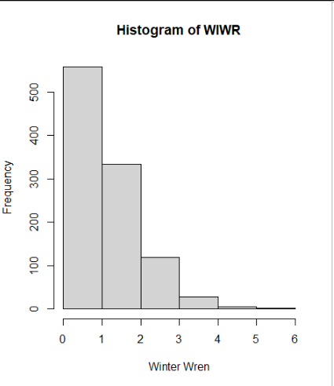

**Q4 (1 pt.): What value for λ did you select?**

1.5

**Q5 (2 pts.): Show the R code you used to calculate the Poisson log-likelihood for the vector of Winter Wren census counts.**

sum(log(dpois(x = dat_all$WIWR, lambda = 1.46))

**Q6 (1 pt.): What are the two parameters for a binomial distribution and what do they represent?**

N = number of trials, and p = probability of success.

**Q7 (2 pts.): What were the parameter values you selected?**

N = 6, and p = 0.5

**Q8 (1 pt.): How did you choose a value for n?**

We chose 6 as a value of n because there are 6 plots you can observe birds in.

**Q9 (2 pts.): Show R code you used to calculate the binomial log-likelihood for the vector of Winter Wren census counts.**

wiwr_counts = c(2, 6)

dbinom(x = wiwr_counts, size= 6, prob = 0.5)

0.234375 0.015625

**Q10 (1 pt.): Considering a Maximum Likelihood criterion, which model better fit the data?**

The binomial distribution model better fit the data.

**Q11 (2 pts.): Considering what you know about the Binomial and Poisson distributions, which model is more appropriate for census count data?**

Poisson

**Q12 (1 pt.): Create the vector (make sure you set seed to 1) and calculate the log likelihood that it came from a standard normal distribution.**

The log likelihood that it came from a standard normal distribution is –12.01869.

**Q13 (2 pts.): Show the R code you used to make the calculation**

set.seed(1)

vec_rnorm = rnorm(n = 10, mean = 0, sd = 1)

sum(log(dnorm(vec_rnorm, mean=0, sd=1)))

**Q14 (2 pts.): Use the guess and check method to find the maximum likelihood optimal values for mean and standard deviation (to 2 significant figures) of the numbers in the vector.**

**set.seed(1)**

**vec_rnorm = rnorm(n = 10, mean = 0, sd = 0.5)**

**sum(log(dnorm(vec_rnorm, mean=0,sd=0.5)))**

**-5.087216**

**Q15 (1 pt.): How did you choose your starting guess values for mean and standard deviation?**

**We chose these values based on our previous values for mean and standard deviation, and then guessed and checked from there**