**Name: Lina Lau**

**C339 Data Analysis Project - Project Summary**

**Date: March 27, 2023.**

Introduction

Overweight and obesity are growing in epidemic proportions. Since 1975, the number of overweight people has almost tripled. In 2016, 39% of adults (aged ≥ 18 years) were overweight. Of these, 13% were obese. A majority of the world’s population reside in countries where overweight and obesity kills more people than underweight.

According to the World Health Organisation, overweight and obesity are defined as abnormal or excessive fat accumulation that may impair health. Body mass index (BMI) is a simple metric that is commonly used to classify overweight and obesity in adults.

BMI = Weight (kg) / Height (m)^2

In adults, a BMI of ≥ 25 mg/m2 indicates overweight while a BMI of ≥ 30 kg/m2 indicates obesity.

Project goals

This particular topic was chosen as it is of personal interest as someone with an epidemiological background. Visualising health trajectories are important to understand where society is heading and to uncover details that could be previously unknown.

This project utilises data from the World Health Organisation (WHO) from 1975 to 2016 available [here](https://www.who.int/data/gho/data/themes/topics/topic-details/GHO/body-mass-index). There are a few goals of this project:

1. The goal of the project is to visualise BMI prevalence from 1975 to 2016 using an interactive dashboard.
2. BMI prevalence trajectories are then plotted by country income, as defined by the World Bank. The groups considered are High-income, upper-middle, lower-middle, and low-income countries.
3. Using various analysis methodologies that were taught by the instructor, namely Azure, Python, and also to improve programming and analytical skills.

Extract, Transform, and Load (ETL) script

The schematic diagram below (Figure 1) illustrates the steps and overarching processes involv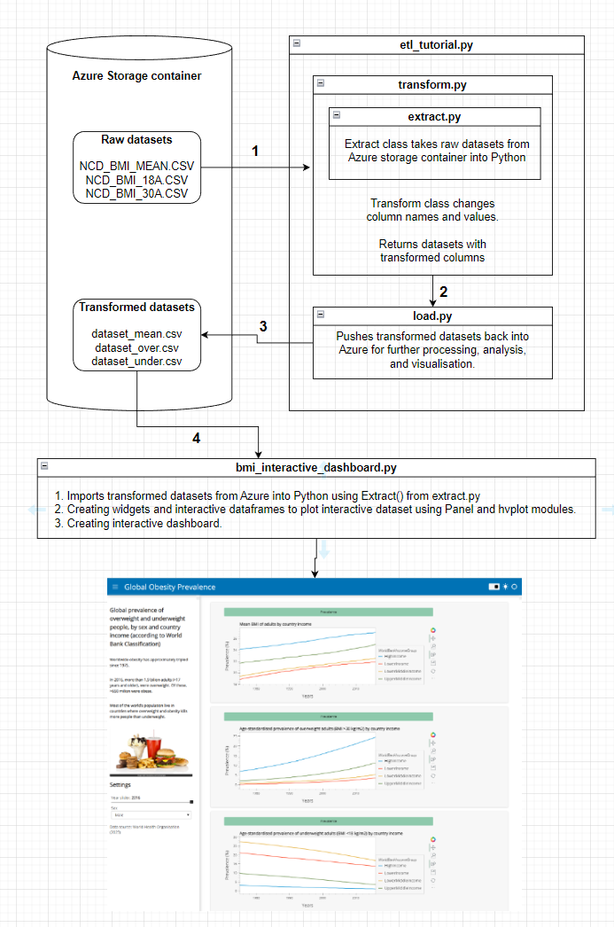ed in this data analysis project.

Visualisations and interpretations

From Figure 2, mean BMI increases regardless of country income. However, people from high income countries have the highest mean BMI. This is followed by upper middle-income, lower-middle income countries, then lower income countries. Mean BMI of adults from lower-middle and lower income countries are similar.

The rate of mean BMI increase by country income is in Table 1 below. When the rates of BMI increase are compared, the rate is greater in countries where income is lower than those of higher income countries. This may mean that nutrient-dense food is more easily accessible with time. The impact of globalisation also meant that fast-food chains are available in these countries. People from lower income countries generally work longer hours for less wages so more often than not, fast-food is a cheaper and quicker option than fresh fruit and vegetables.

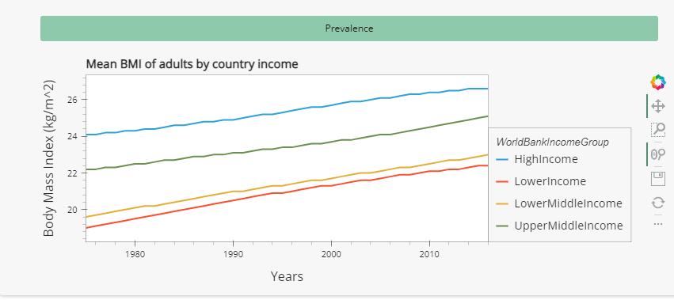

Figure 2 - Mean BMI of adults by country income

| **Country income group** | **Income per capita (USD) in 2016 (**[**Source**](https://blogs.worldbank.org/opendata/new-country-classifications-2016#:~:text=As%20of%201%20July%202016,a%20GNI%20per%20capita%20between)**)** | **Rate of BMI increase** |
| --- | --- | --- |
| Lower income | < 1025 | 0.08 kg/m^2/year |
| Lower middle income | 1026 - 4035 | 0.08 kg/m^2/year |
| Upper middle income | 4036 - 12475 | 0.07 kg/m^2/year |
| High income | >12476 | 0.06 kg/m^2/year |

Table 1 - Rate of BMI increase by country income.

From Figure 3, the proportion of overweight adults increases the most in high-income countries. Again, the trend follows that of Figure 1 where the greatest increase is seen in high-income countries, followed by upper-middle income, lower-middle, and lower income countries.

High-income countries have the highest rate of increase in obesity - growing at 0.39% per year. The rates of both lower-middle and lower income countries are similar at 0.13% and 0.14% per year, respectively.

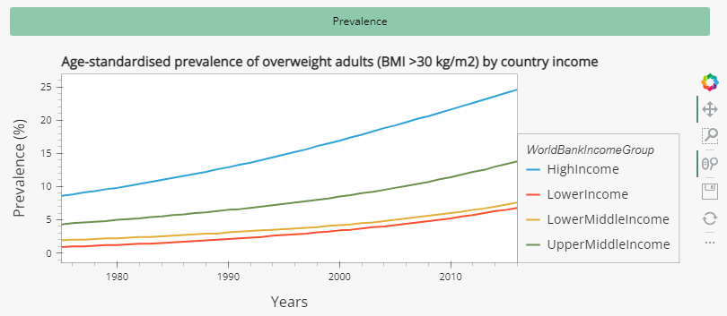

Figure 3 - Age-standardised prevalence of overweight adults by country income.

| **Country income group** | **Income per capita (USD) in 2016 (**[**Source**](https://blogs.worldbank.org/opendata/new-country-classifications-2016#:~:text=As%20of%201%20July%202016,a%20GNI%20per%20capita%20between)**)** | **Rate of increase in obesity** |
| --- | --- | --- |
| Lower income | < 1025 | 0.14%/year |
| Lower middle income | 1026 - 4035 | 0.13%/year |
| Upper middle income | 4036 - 12475 | 0.23%/year |
| High income | >12476 | 0.39%/year |

Table 2 - Increase in obesity rates by country income.

From Figure 4, the number of underweight people are generally decreasing across all income groups. This is consistent to the increase of obese people. The trends are slightly different with underweight adults, with lower-middle income countries having the highest amount ot underweight adults. The decreasing proportion of underweight people in high-income countries remains relatively stable over the years at -0.05% per year - the least decrease among all countries.

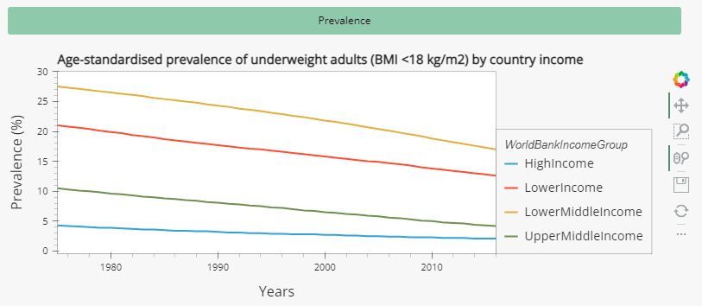

Figure 4 - Age-standardised prevalence of underweight adults by country income.

| **Country income group** | **Income per capita (USD) in 2016 (**[**Source**](https://blogs.worldbank.org/opendata/new-country-classifications-2016#:~:text=As%20of%201%20July%202016,a%20GNI%20per%20capita%20between)**)** | **Rate of decrease in underweight** |
| --- | --- | --- |
| Lower middle | 1026 - 4035 | -0.25%/year |
| Lower income | < 1025 | -0.20%/year |
| Upper middle income | 4036 - 12475 | -0.14%/year |
| High income | >12476 | -0.05%/year |

Table 3 - Rate of decrease in underweight persons by country income.

In conclusion, the proportion of obese persons regardless of country income is increasing, while the opposite is observed for underweight adults (except high-income countries, where the trend remains stable). If no appropriate measures are taken, obesity and its associated diseases will burden healthcare systems and decrease quality of life.