
MINISTRY OF EDUCATION, CULTURE AND RESEARCH
OF THE REPUBLIC OF MOLDOVA
Technical University of Moldova
Faculty of Computers, Informatics and Microelectronics
Department of Software Engineering and Automation

Report
Laboratory Work No.4
Operating Systems
Topic: The xv6 Shell from the Outside

Done by:
st. gr. FAF-243 Felicia Ojog

Checked by:
Patricia Reițman,
university assistant

Chișinău - 2026

INTRODUCTION 3
1 PURPOSE OF THE REPORT 4
2 THEORETICAL BACKGROUND 5
3 DEVELOPMENT ENVIRONMENT 6
4 PRACTICAL WORK AND RESULTS 7
4.1 Fix sleep for the Current xv6 7
4.2 Bash versus the xv6 Shell 9
4.3 Who Expands *? A Program that Prints argv 12
4.4 Reading the xv6 Shell 15
CONCLUSION 18
REFERENCES 20

INTRODUCTION
A command shell is the main textual interface between a user and an operating system. It reads commands, interprets special syntax, starts programs, connects their input and output streams, and controls how processes are executed. Modern shells such as Bash provide many conveniences, including variable expansion, pathname globbing, command history, completion, job control, quoting rules, and a search path for executable programs.
xv6 provides a deliberately small Unix-like shell implemented in user/sh.c. Because its implementation is compact, it is possible to compare its behavior directly with Bash and connect visible command-line behavior to the source code that implements it. This makes xv6 useful for understanding which functions belong to the shell itself and which are provided by the operating-system kernel or by ordinary user programs.
Laboratory Work 4 compares Bash and the xv6 shell experimentally, verifies the sleep program from the previous laboratory on the current xv6 revision, implements a small args program that exposes the exact argument vector received by a process, and inspects the xv6 shell source code. The practical work therefore links command-line behavior with process creation, redirection, pipes, argument parsing, and shell implementation.

1 PURPOSE OF THE REPORT
The purpose of this report is to document Laboratory Work 4 for the Operating Systems course and to study the xv6 shell from the outside by comparing it with Bash on Linux. The work focuses on identifying which shell features are common to both environments and which conveniences are provided only by Bash.
A second objective is to verify that the sleep user program created in Laboratory Work 2 remains compatible with the current xv6 source tree, where the user-visible delay system call may be named pause(). The laboratory also introduces a small args program for xv6 and Linux so that command-line arguments can be inspected directly and the role of the shell in wildcard expansion and quote removal can be demonstrated.
The final objective is to inspect user/sh.c and relate the observed shell behavior to its implementation. The report is structured according to the four laboratory parts and includes the required comparison table, command listings, Observe answers, source-code fragments, and conclusions. Screenshot figures will be inserted after the practical execution is completed.

2 THEORETICAL BACKGROUND
A shell is an ordinary user-space program that repeatedly reads a command line, parses it, and starts one or more processes. The kernel provides mechanisms such as fork, exec, pipes, file descriptors, and process waiting, while the shell combines these mechanisms according to command-line syntax. Redirection changes the file descriptors used as standard input or output, a pipe connects the output of one process to the input of another, and background execution allows the shell to continue without waiting for a command to finish.
Bash adds substantial processing before a program is started. It performs parameter expansion such as $HOME, pathname expansion such as *.c, quote processing, command history, interactive completion, and executable lookup through PATH. These transformations occur in the shell before exec is called, so the program normally receives only the final argument strings rather than the original command-line syntax.
The xv6 shell intentionally implements a much smaller subset of Unix shell behavior. Its source code represents parsed commands using a small number of command structures and executes them by creating processes, connecting pipes, applying redirections, and calling exec. The built-in cd command requires special handling because changing directory must modify the working directory of the shell process itself; performing cd only in a child process would not change the parent shell directory.
The argc and argv parameters of a C program reveal exactly what arguments were passed to it. argc is the number of argument strings, including the program name, while argv is an array containing those strings. By printing argv in both Bash and xv6, the laboratory can determine whether wildcard expansion, variable expansion, and quote removal occurred before the program started.

3 DEVELOPMENT ENVIRONMENT
Laboratory Work 4 was completed in Ubuntu 26.04.1 LTS running inside Oracle VirtualBox, using the same virtual machine and xv6 source tree as the previous Operating Systems laboratories. The xv6 source directory was /home/lina/xv6-riscv and QEMU was used to run the RISC-V xv6 system.
Before starting the practical tasks, the course setup was checked with bash os2026-setup.sh --check. The script confirmed Git, make, GCC, Bash, grep, sed, awk, the RISC-V cross compiler, and QEMU 10.2, and it also successfully built and booted xv6.
The laboratory uses two command environments side by side: Bash in Ubuntu and the xv6 shell running under QEMU. The Linux-side experiments use a temporary directory such as /home/lina/shtest, while the xv6-side commands are executed at the xv6 $ prompt. Source-code inspection and editing are performed from Ubuntu in the xv6-riscv directory.
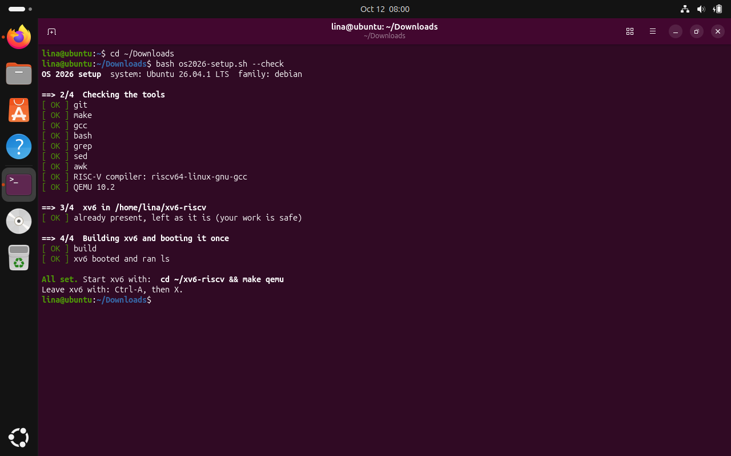
Figure 3.1 Development environment and successful setup check
The screenshot shows the course setup check completing successfully in Ubuntu. The required development tools were available, and xv6 was built and booted correctly before starting the laboratory tasks.

4 PRACTICAL WORK AND RESULTS
The practical work is divided into four parts. The first updates and verifies the sleep program from Laboratory Work 2. The second compares Bash and the xv6 shell using the same command lines. The third uses an argument-printing program to determine which component expands wildcards and removes quotes. The fourth examines user/sh.c and connects the observed behavior to the implementation of the xv6 shell.

4.1 Fix sleep for the Current xv6
Task: Verify which delay system call is declared by the current xv6 tree, update user/sleep.c if necessary, and test the sleep command inside xv6.
Commands used:
cd ~/xv6-riscv
grep -n "pause\|sleep" user/user.h
grep -n "_sleep" Makefile
make qemu
$ sleep 20
$ sleep
Program used:
#include "kernel/types.h"
#include "user/user.h"

int
main(int argc, char *argv[])
{
if(argc != 2){
fprintf(2, "usage: sleep <ticks>\n");
exit(1);
}
pause(atoi(argv[1]));
exit(0);
}
Results and observations:
The current xv6 tree declares int pause(int); in user/user.h at line 25. The existing user/sleep.c already used pause(atoi(argv[1])) and therefore required no code change. The Makefile also already contained the $U/_sleep\ entry in UPROGS.
After rebuilding with make qemu, sleep 20 paused briefly and returned to the xv6 prompt. Running sleep without an argument printed usage: sleep <ticks>, confirming that both the normal and validation paths worked correctly.

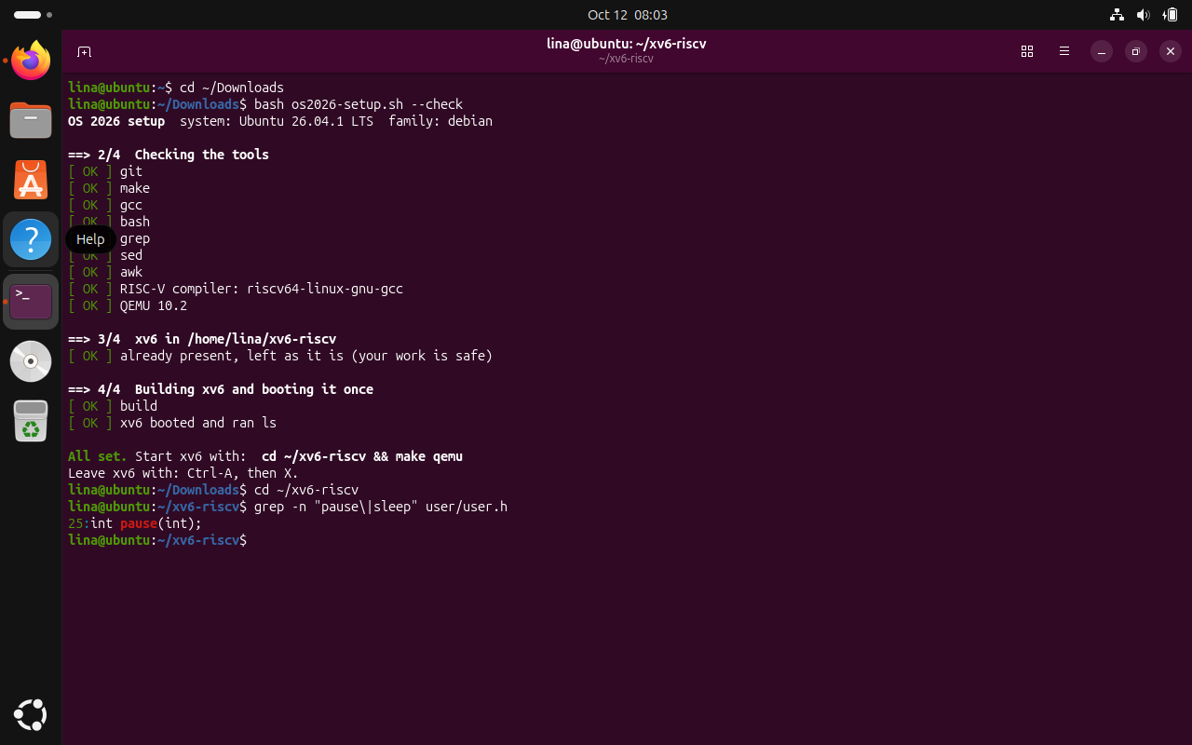
Figure 4.1 The pause declaration in user/user.h
The output confirms that the current xv6 source tree declares pause(int) in user/user.h. This verifies that the sleep program must call pause() rather than the older sleep() system-call name.

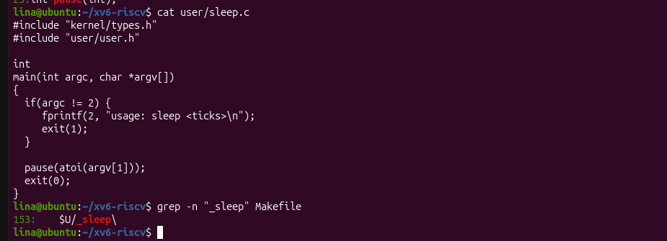
Figure 4.2 Current sleep.c implementation
The displayed sleep.c validates that exactly one tick argument is provided, prints a usage message for invalid input, and calls pause(atoi(argv[1])) for the requested delay.

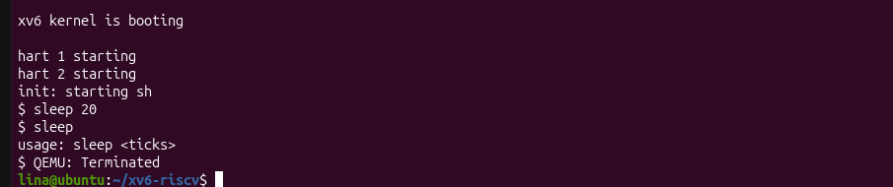
Figure 4.3 sleep running in xv6 with and without an argument
The xv6 test shows the normal and error cases of the sleep command. The valid sleep 20 invocation returns after the requested delay, while running sleep without a tick value prints the expected usage message.

4.2 Bash versus the xv6 Shell
Task: Execute the same command lines in Bash and in the xv6 shell, compare the results, and identify which shell features are implemented in each environment.
Linux test setup:
mkdir -p ~/shtest && cd ~/shtest
touch README
Commands tested in both shells:
Table 4.1 – Comparison of Bash and xv6 Shell Features
Command | Tests | Bash output | xv6 output | Explanation / observation
echo hello > f ; cat < f | redirection | hello | hello | Both shells support input/output redirection.
ls | grep READ | pipe | README | README line from xv6 ls output | Both shells support pipes; xv6 ls includes metadata columns.
(echo a; echo b) | wc | grouping, list | 2 2 4 | 2 2 4 | Both shells support grouping/list syntax used here and piping into wc.
echo one ; echo two | sequence | one / two | one / two | Both shells support sequential commands separated by ;.
echo bg & | background | background job started; bg printed | bg printed and prompt returned | Both shells support background execution with &.
ls * | globbing | README f | ls: cannot open * | Bash expands * before ls runs; xv6 passes * literally.
echo $HOME | variables | /home/lina | $HOME | Bash expands shell variables; xv6 does not.
echo "a b" | quotes | a b | "a b" | Bash removes quotes while preserving the space; xv6 prints the quotes literally.
mkdir d ; cd d ; ls .. | PATH / executable lookup | README d f | parent directory listing | Both can change directory and access .., but xv6 has no PATH search.
arrow up, Tab, Ctrl+R | history and completion | history/completion/search work | not supported | These interactive editing features are Bash features, not implemented by the xv6 shell.
Observe answers to complete after execution:
1. Both shells supported basic command execution, redirection, pipes, semicolon-separated command sequences, background execution, and cd. Bash additionally provided pathname globbing, variable expansion, quote processing, command history, Tab completion, and Ctrl+R reverse search.
2. In xv6, ls stopped working after cd d because xv6 does not search a PATH for executable programs. The user programs such as ls are stored in the parent/root directory of the xv6 filesystem. From inside d, running ../ls explicitly names the executable and works correctly.
3. The missing feature I would miss most in daily work is command history and interactive completion because they greatly reduce repeated typing. A small command-history mechanism would likely be one of the easier improvements because it could be implemented inside the shell without changing the kernel.

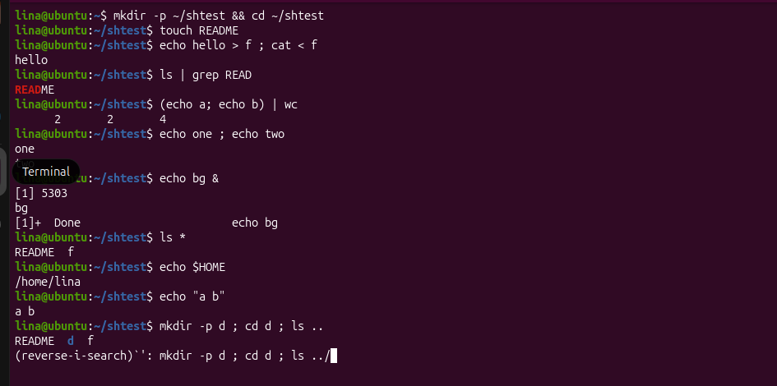
Figure 4.4 Commands executed in Bash
The Bash session demonstrates redirection, pipes, grouped commands, command sequencing, background execution, globbing, variable expansion, quoting, directory changes, and interactive history features in the Linux shell.

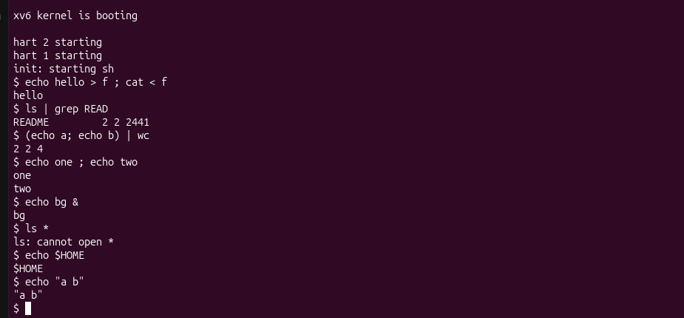
Figure 4.5 The same command tests in xv6
The same tests were repeated at the xv6 shell prompt. Core mechanisms such as redirection, pipes, sequencing, and background execution work, while higher-level Bash features such as glob expansion and variable expansion are absent.
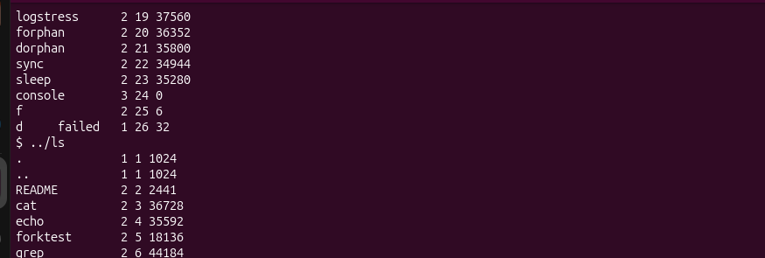
Figure 4.6 ls failing after cd d and the working ../ls alternative
The screenshot records the xv6 directory test and the working ../ls alternative. After entering the subdirectory, a program name such as ls is not found automatically because xv6 does not provide Bash-style PATH searching. Invoking ../ls gives an explicit path to the program stored in the parent directory and successfully lists that directory
.

4.3 Who Expands *? A Program that Prints argv
Task: Implement equivalent argument-printing programs for xv6 and Linux, run the same command lines in both shells, and inspect argc and argv.
xv6 program user/args.c:
#include "kernel/types.h"
#include "user/user.h"

int
main(int argc, char *argv[])
{
printf("argc = %d\n", argc);
for(int i = 0; i < argc; i++)
printf("argv[%d] = [%s]\n", i, argv[i]);
exit(0);
}
The xv6 Makefile must also contain a $U/_args\ entry in UPROGS.
Linux program args_linux.c:
#include <stdio.h>

int
main(int argc, char *argv[])
{
printf("argc = %d\n", argc);
for(int i = 0; i < argc; i++)
printf("argv[%d] = [%s]\n", i, argv[i]);
return 0;
}
Linux compilation:
gcc -o args args_linux.c
Commands to run in both shells:
args one two three
args *.c "x y"
args $HOME
args 'single quoted'
Results and observations:
For args *.c "x y", xv6 reported argc = 4 and passed [*.c], ["x], and [y"] as separate argument strings after argv[0]. Bash reported argc = 5 because *.c expanded to args_linux.c, one.c, and two.c, while "x y" became one argument without the quote characters.
The experiment shows that the shell, not the user program and not the kernel, performs pathname expansion and quote processing. Bash transformed *.c into matching file names, expanded $HOME to /home/lina, and removed quotes before the program started. The xv6 shell performed none of these transformations.
Whitespace between unquoted words acts as an argument separator. Extra separator spaces are not preserved as part of an argument; they only separate words before exec receives the argv array.

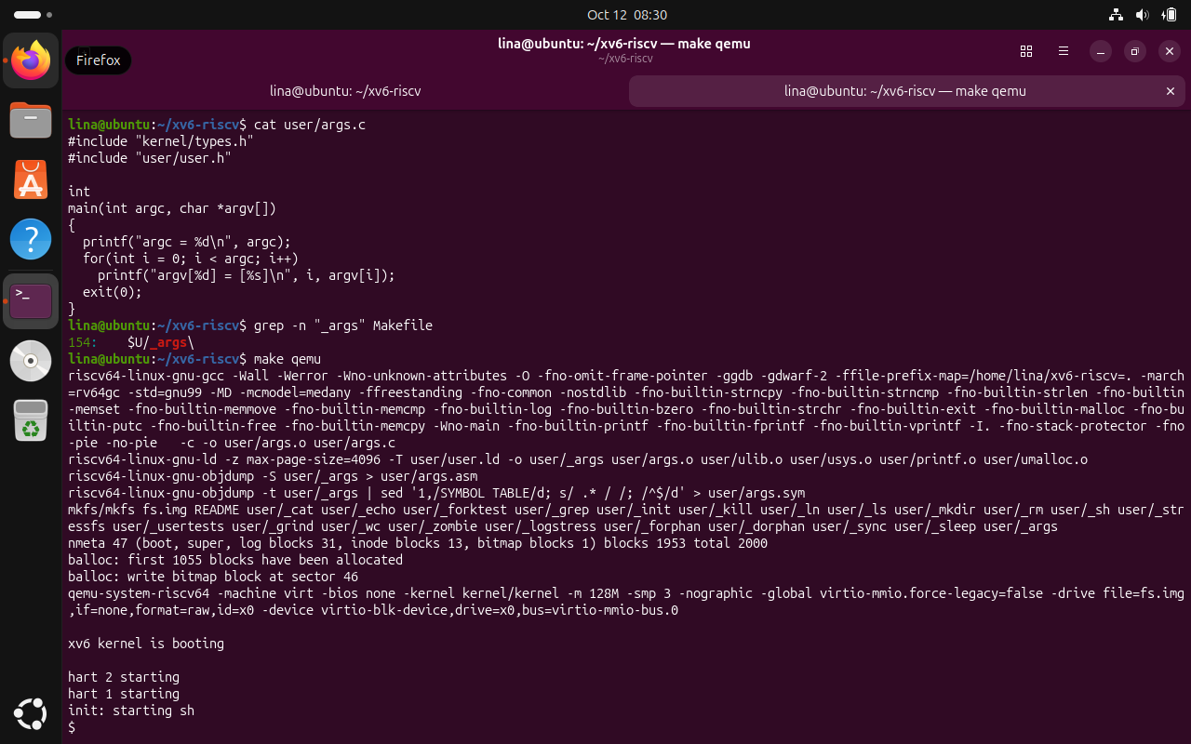
Figure 4.7 args.c and the UPROGS entry
The screenshot shows the xv6 args program that prints argc and every argv element, together with the Makefile entry that includes _args in UPROGS so that the executable is placed in the xv6 file-system image.
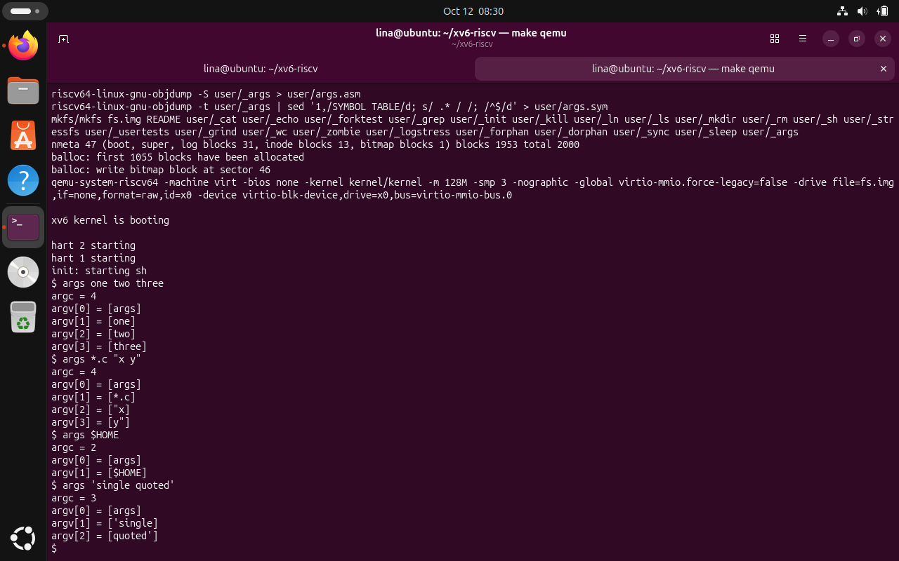
Figure 4.8 Argument handling in the xv6 shell
The xv6 output shows that *.c and $HOME are passed literally and that quoted text is not combined in the same way as in Bash. The argument list therefore exposes the limited preprocessing performed by the xv6 shell.

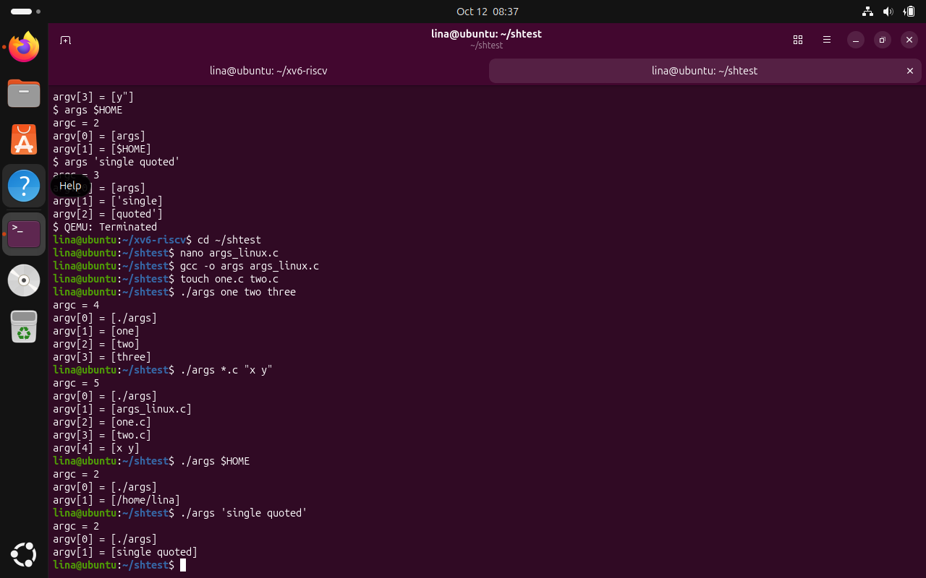
Figure 4.9 Argument handling in Bash
The Linux output shows Bash preprocessing the command line before the program starts: wildcard patterns become matching filenames, $HOME is expanded, and quoted text is delivered as one argument without the quote characters.

4.4 Reading the xv6 Shell
Task: Inspect user/sh.c to identify the command structures understood by the xv6 shell and the code that executes them.
Commands used:
cd ~/xv6-riscv
wc -l user/sh.c
grep -n "#define" user/sh.c
grep -n "case " user/sh.c
grep -n "cd" user/sh.c | head
Observe answers to complete after source inspection:
1. user/sh.c defines five command kinds: EXEC for ordinary command execution, REDIR for < and > redirection, PIPE for |, LIST for ;, and BACK for & background execution.
2. The grep output shows cd handling around line 170 in user/sh.c. cd is handled directly by the shell process because the current working directory is process state. If cd were executed in a child process, only the child directory would change and the shell would remain in its previous directory.
3. Searching user/sh.c found no pathname-globbing logic for * and no variable-expansion logic for $. The only $ match was the code that prints the shell prompt. This explains why xv6 left *.c and $HOME unchanged in Parts 2 and 3.

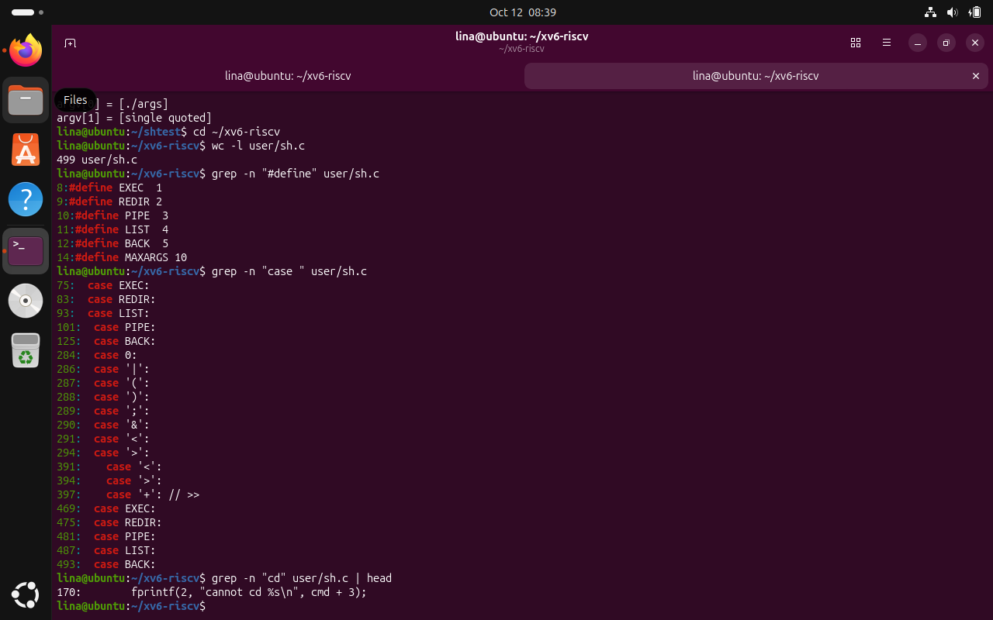
Figure 4.10 Command kinds, execution cases, and cd reference in sh.c
The source inspection identifies the five command structures used by xv6—EXEC, REDIR, PIPE, LIST, and BACK—and the corresponding execution cases. The search for cd also shows that directory changes are handled specially by the shell.

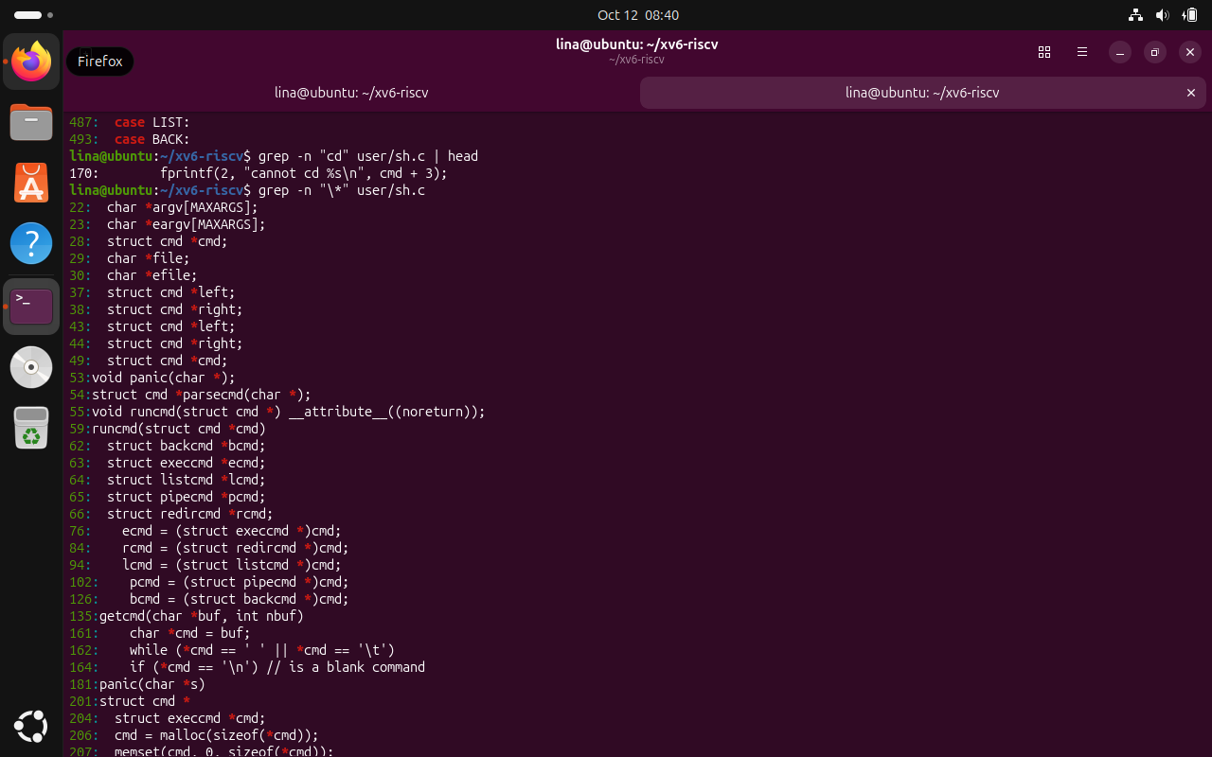
Figure 4.11 Search for * in sh.c
The search finds many asterisks used as C pointer syntax, but no pathname-expansion implementation. This supports the experimental result that xv6 does not expand patterns such as *.c into matching filenames.
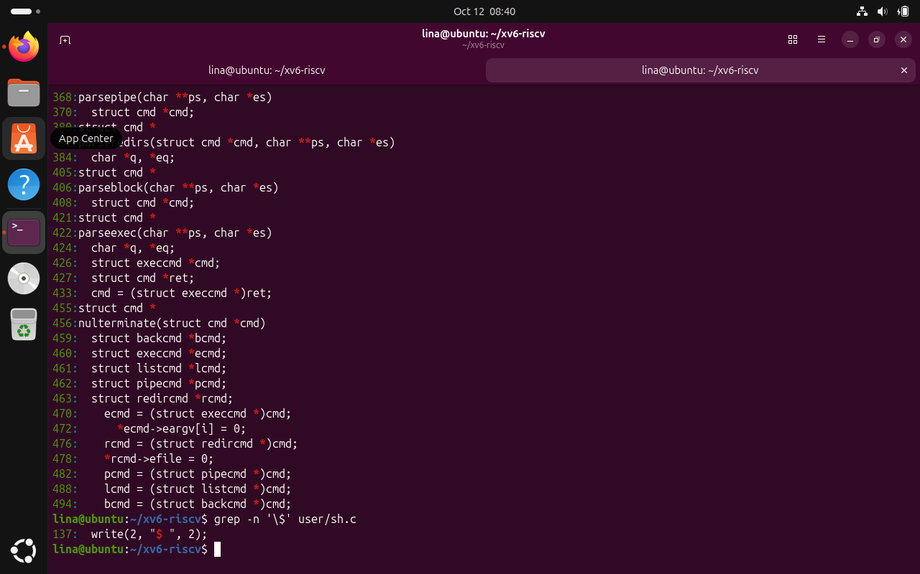
Figure 4.12 Search for $ in sh.c
The dollar-sign search finds the code that prints the shell prompt but no variable-expansion logic. This explains why $HOME remains a literal argument in the xv6 shell.

CONCLUSION
Laboratory Work 4 provided a practical comparison between Bash and the xv6 shell and showed how much processing a shell performs before a user program begins execution. By running the same commands in both environments, it became possible to separate fundamental Unix shell mechanisms from the additional conveniences offered by a modern interactive shell. Both environments supported the essential operations needed to execute programs, redirect input and output, connect commands with pipes, run command sequences, launch background jobs, and change directories.
The first part connected the current work with Laboratory Work 2 by verifying the previously implemented sleep command against the present xv6 source tree. The header user/user.h declared pause(int), the existing sleep.c correctly called pause(atoi(argv[1])), and the Makefile already included the _sleep program. Testing inside xv6 showed that sleep 20 completed normally, while an invocation without the required argument produced the expected usage message. This confirmed both compatibility with the renamed system call and correct input validation.
The Bash-versus-xv6 comparison made the difference between a minimal teaching shell and a full production shell especially clear. Redirection, pipes, grouped execution, sequencing, and background execution demonstrate the core process-control responsibilities of a shell. Bash additionally provided pathname expansion, environment-variable expansion, quote processing, command history, completion, and reverse search. These features are not required for a shell to launch programs, but they significantly improve usability during everyday command-line work.
The directory-change experiment also illustrated an important design detail. In xv6, ls stopped working after cd d because the shell does not perform PATH-based executable lookup. Supplying ../ls worked because it identified the program explicitly relative to the current directory. At the same time, cd itself must be handled by the shell rather than by a separate child process; otherwise only the child would change its working directory and the interactive shell would remain in the original location.
The argument-printing programs provided the clearest evidence of where command-line transformations occur. In Bash, *.c was expanded into the matching source filenames, $HOME was replaced by /home/lina, and quoted text was passed as one argument with the quote characters removed. In xv6, the corresponding strings were passed almost literally, and quoted text was split differently. Since the Linux and xv6 programs simply printed the argv array they received, the experiment demonstrates that globbing, variable expansion, and quote handling are shell responsibilities rather than services performed by the kernel or by the executed program.
Reading user/sh.c connected all of the experimental results to the shell implementation itself. The five command kinds—EXEC, REDIR, PIPE, LIST, and BACK—correspond directly to the basic operations observed during testing, and cd is handled specially because it must modify the shell process rather than a child. At the same time, the absence of globbing and variable-expansion code explains the literal treatment of *.c and $HOME. Overall, the laboratory showed that a compact shell can implement the essential Unix process-control model with relatively little code, while Bash adds a large layer of parsing and interactive functionality that makes command-line work faster and more convenient.

REFERENCES
[1] GitHub Repository. Laboratory Work 3. Available at: https://github.com/linalinalina1/os-2026-FeliciaOjog/tree/main/lab4
[2] Operating Systems, FCIM / FAF, UTM. Lab 4 - The xv6 Shell from the Outside, 2026-2027.
[3] MIT PDOS. xv6: a simple, Unix-like teaching operating system for RISC-V.
[4] MIT PDOS. xv6-riscv source repository. Available at: https://github.com/mit-pdos/xv6-riscv

