MINISTRY OF EDUCATION, CULTURE AND RESEARCH
OF THE REPUBLIC OF MOLDOVA
Technical University of Moldova
Faculty of Computers, Informatics and Microelectronics
Department of Software Engineering and Automation

Report
Laboratory Work No.6
Operating Systems
Topic: Inside the xv6 File System

Done by:
st. gr. FAF-243 Felicia Ojog

Checked by:
Patricia Reițman,
university assistant

Chișinău - 2026
INTRODUCTION 3
1 PURPOSE OF THE REPORT 4
2 THEORETICAL BACKGROUND 5
3 DEVELOPMENT ENVIRONMENT 6
4 PRACTICAL WORK AND RESULTS 7
4.1 Read What xv6 Shows 7
4.2 Write mystat 7
4.3 Measure the Limits 12
4.4 Write find 14
4.5 Optional Exercise: Find with Inode Numbers 17
CONCLUSION 21
REFERENCES 22

INTRODUCTION
File systems transform persistent disk blocks into named files and directories. Although modern operating systems provide elaborate implementations, the underlying mechanisms involve inodes, directory entries, block addressing, hard links, and carefully defined system calls. The xv6 teaching operating system offers a compact implementation in which these mechanisms can be observed directly in both source code and running programs.
Laboratory Work 6 investigates the xv6 file system through four connected exercises: examining the directory listing and file types, implementing a custom mystat utility, inspecting file-system limits and disk layout, and creating a recursive find utility. The work combines observation inside the xv6 shell with C programming, Makefile integration, and inspection of kernel headers and system-call implementation.
The report documents the actual commands, results and source-code changes, answers the Observe questions from the laboratory instructions, and provides evidence captured from Ubuntu and QEMU. The final analysis emphasizes the relationship between user programs and filesystem metadata.

1 PURPOSE OF THE REPORT
The purpose of this report is to document the implementation and examination of xv6 file-system functionality in Laboratory Work 6. The objectives include interpreting directory entries and inode types, using stat() to inspect metadata, demonstrating hard-link behavior, understanding the layout and limits described in kernel/fs.h, and implementing a directory traversal utility.
The results are supported by screenshots of the setup, programs, kernel code, build process, and program executions. Each exercise also includes the relevant interpretation of observed behavior and responses required by the laboratory instructions.

2 THEORETICAL BACKGROUND
An inode represents a file-system object and stores its metadata independently of its directory name. In xv6, a directory consists of fixed-size dirent records containing an inode number and a name. File-type constants identify directories, ordinary files and device entries, while the stat structure exposes the device identifier, inode number, file type, number of links and size.
A hard link adds a directory entry referencing an existing inode. Both names identify the same underlying data and share the same inode number. Removing one name decreases the inode link count but does not remove data while another link remains. xv6 implements these operations using system calls such as link and unlink, together with inode reference and allocation management.
Disk data is organized into fixed-size blocks. Filesystem constants define block size, direct and indirect block addressing and maximum directory-name length. Metadata blocks store information needed to locate and manage data. The xv6 filesystem image also reserves space for its log, inode blocks and allocation bitmap. Recursive traversal examines each directory entry, constructs child paths, skips unused and self-referential entries and closes opened descriptors.

3 DEVELOPMENT ENVIRONMENT
Laboratory Work 6 was carried out in Ubuntu running in Oracle VirtualBox. The xv6-riscv source tree was stored under /home/lina/xv6-riscv. The course setup script, launched from Downloads using bash os2026-setup.sh --check, verified the required development tools, the RISC-V cross-compiler, QEMU and an xv6 build-and-boot check. The host shell was used for source editing and compilation, while QEMU provided the xv6 user shell for testing.
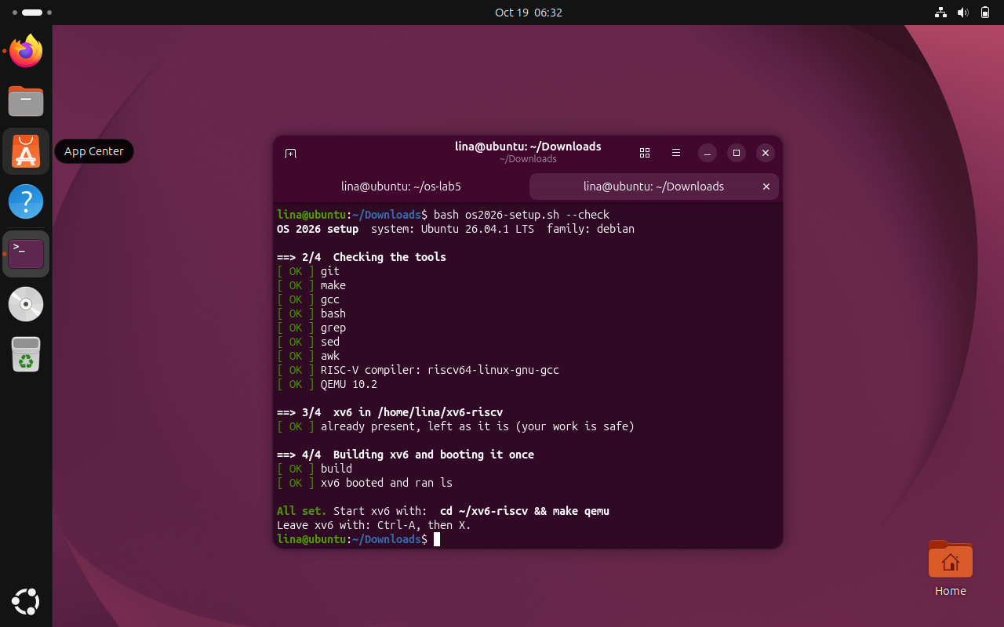
Figure 3.1 Course setup and development tool check
The setup output shows the course toolchain checks and confirms that the existing xv6 working tree and QEMU environment were usable for the laboratory.

4 PRACTICAL WORK AND RESULTS
The practical work was completed in four stages. Commands entered in the Ubuntu shell are distinguished from the operations executed in the xv6 shell, and screenshots document representative outputs for each stage.

4.1 Read What xv6 Shows
Task: Inspect the root directory using the built-in ls utility, then create directory a and inspect its entries. The printed columns are the name, type, inode number and file size.
$ ls
$ mkdir a
$ ls a
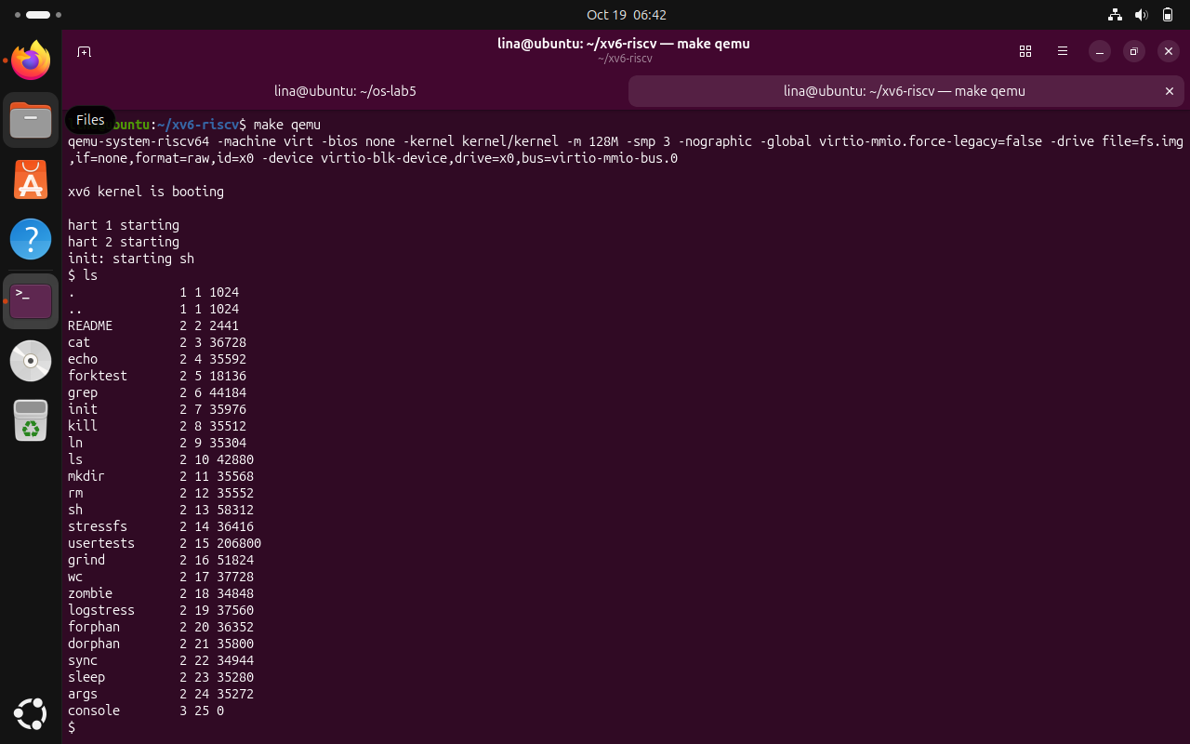
Figure 4.1 xv6 directory contents and an empty directory
The root listing includes the current and parent directory entries and standard user programs. The newly created directory a contains the entries . and .., with a total size of 32 bytes.
Observe (1): In kernel/stat.h, type 1 (T_DIR) denotes a directory, type 2 (T_FILE) denotes a regular file, and type 3 (T_DEVICE) denotes a device. Observe (2): The root inode is 1. Both . and .. refer to inode 1 because the root is its own parent. Observe (3): The size of a is 32 bytes and it contains exactly two entries, . and ... Therefore each directory entry occupies 16 bytes.

4.2 Write mystat
Task: Create user/mystat.c, add the executable to UPROGS in the Makefile, and test how stat() reports the metadata of regular files, directories and devices. The typename helper maps T_DIR, T_FILE and T_DEVICE to readable strings. Error handling prints a message to descriptor 2 and continues with other arguments.
nano user/mystat.c
nano Makefile
make qemu
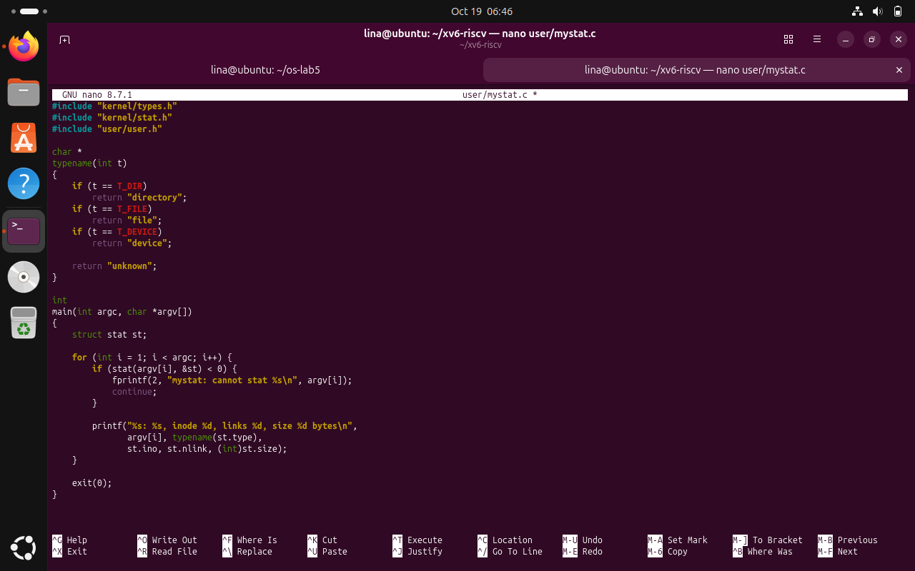
Figure 4.2 Custom mystat source code
The new user program calls stat() on each requested pathname and formats the type, inode number, link count and size. Unreadable or missing paths are handled without ending the whole argument loop.

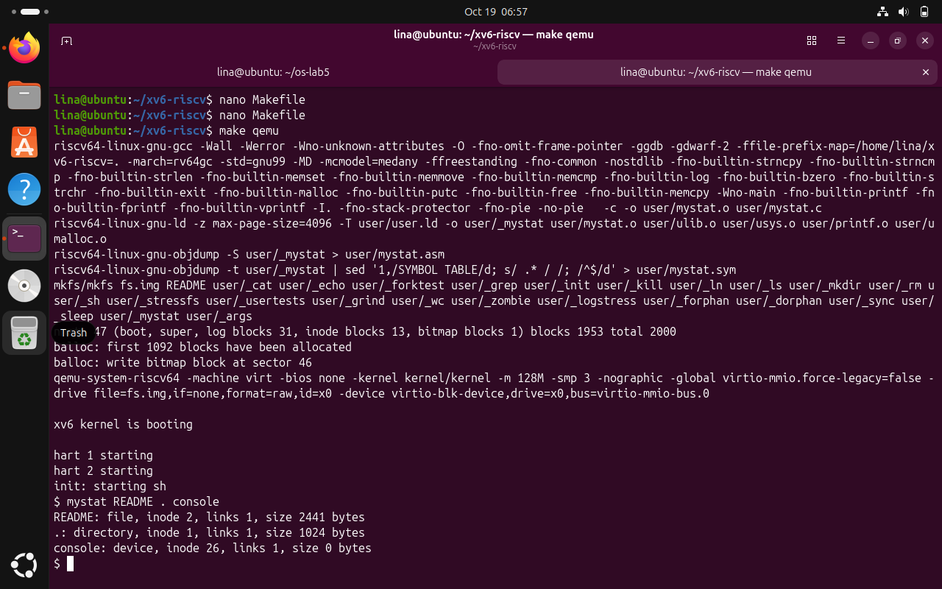
Figure 4.3 Makefile registration and mystat build
The Makefile UPROGS section includes the _mystat program. The subsequent build compiles and makes the utility available inside the xv6 filesystem image.

$ mystat README . console
$ ln README r2
$ mystat README r2
$ rm README
$ mystat r2
$ cat r2 | wc
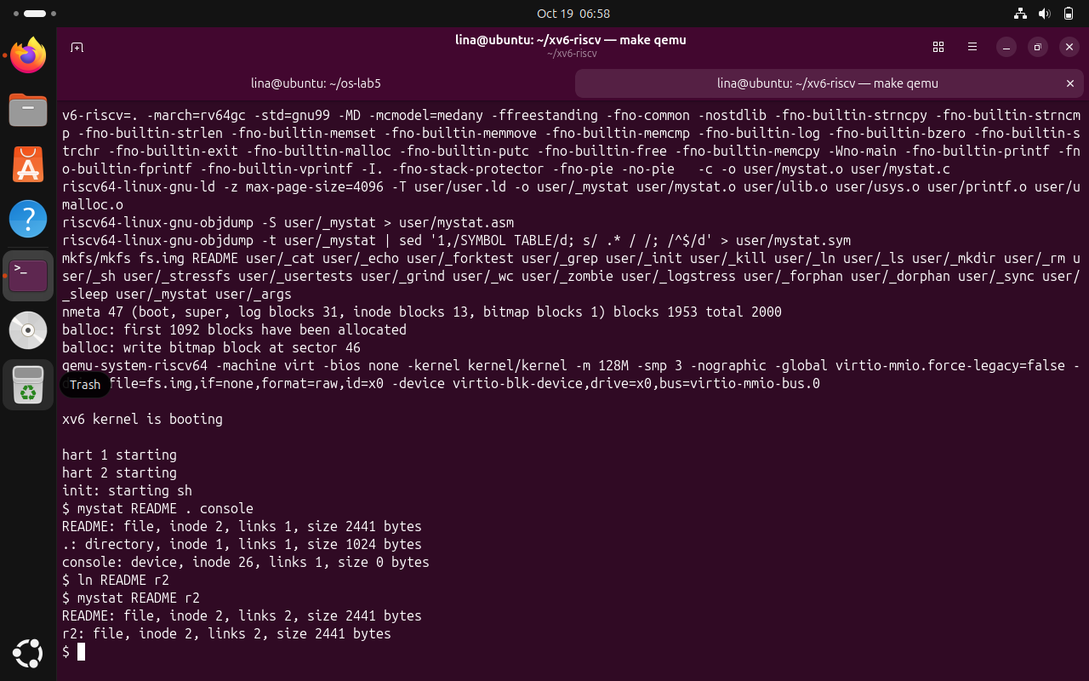
Figure 4.4 File types and metadata reported by mystat
The program identifies README as a file, . as a directory and console as a device; the displayed inode and size values match the xv6 metadata for each object.

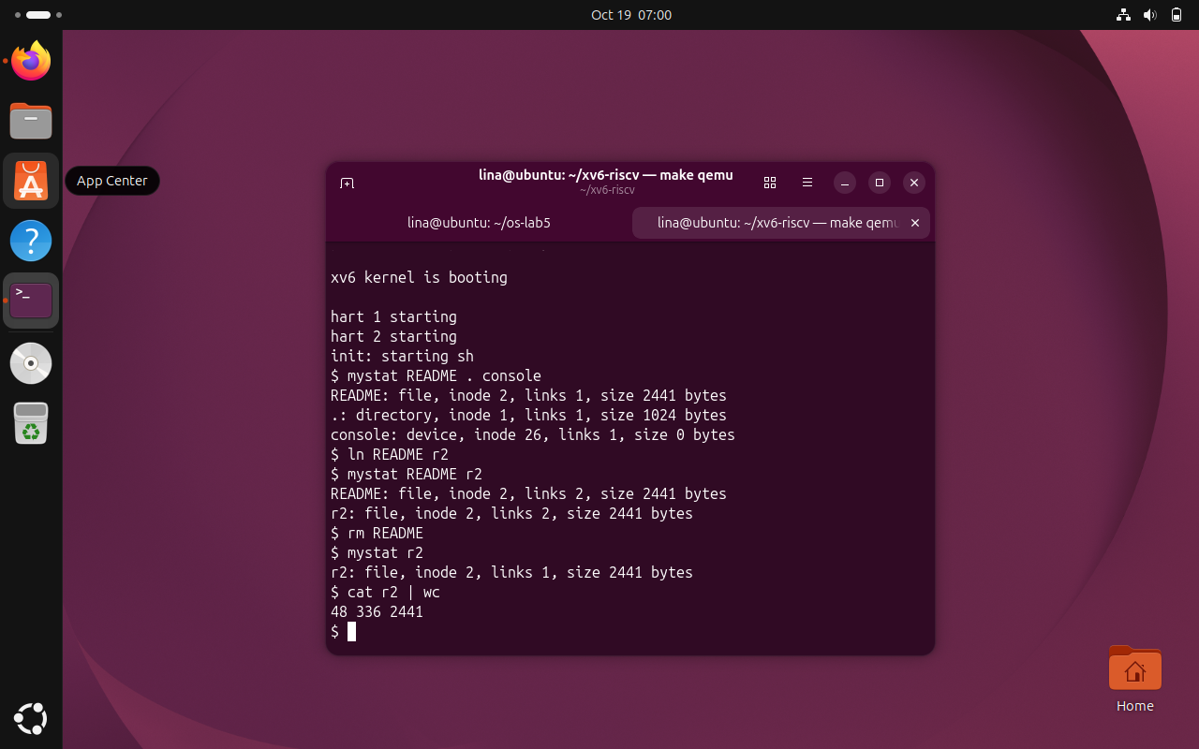
Figure 4.5 Hard-link creation preserves the inode
After ln README r2, README and r2 share inode 2 and both report two links. Their content and size remain unchanged because the operation adds a directory entry instead of copying the file.

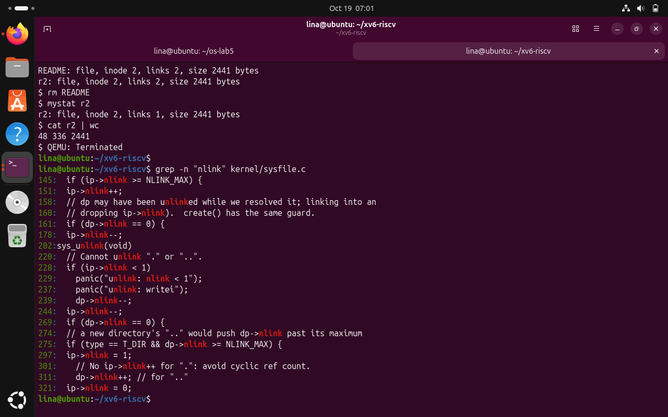
Figure 4.6 Link count after removing README
Removing README leaves r2 accessible with the same inode and file size, while its link count decreases from two to one. The subsequent cat and wc output confirms that the remaining name still accesses the data.
Observe (1): The hard-link experiment changed the number of directory names and the inode link count, but not the inode identifier or file data. Before unlinking there were two names and nlink = 2; after rm README, r2 remained and nlink = 1. Observe (2): In kernel/sysfile.c, sys_unlink decrements ip->nlink and updates the inode after removing the directory entry. File blocks are freed when the inode has no links and its last active reference is released, through inode cleanup. Observe (3): struct dinode in kernel/fs.h contains type, major, minor, nlink, size and addrs (block addresses).
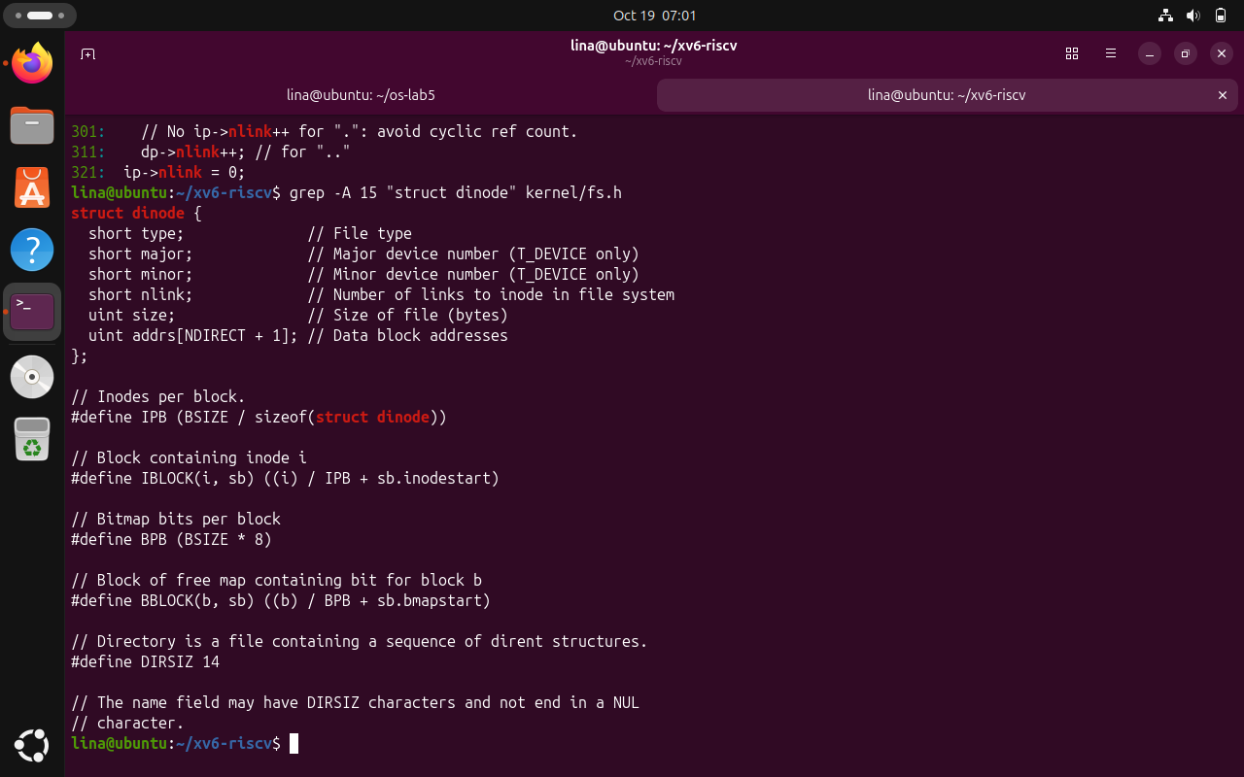
Figure 4.7 Kernel unlink logic examined in sysfile.c
Inspection of sys_unlink identifies the management of inode link counts and directory entries, providing source-level evidence for the hard-link behavior observed in xv6.

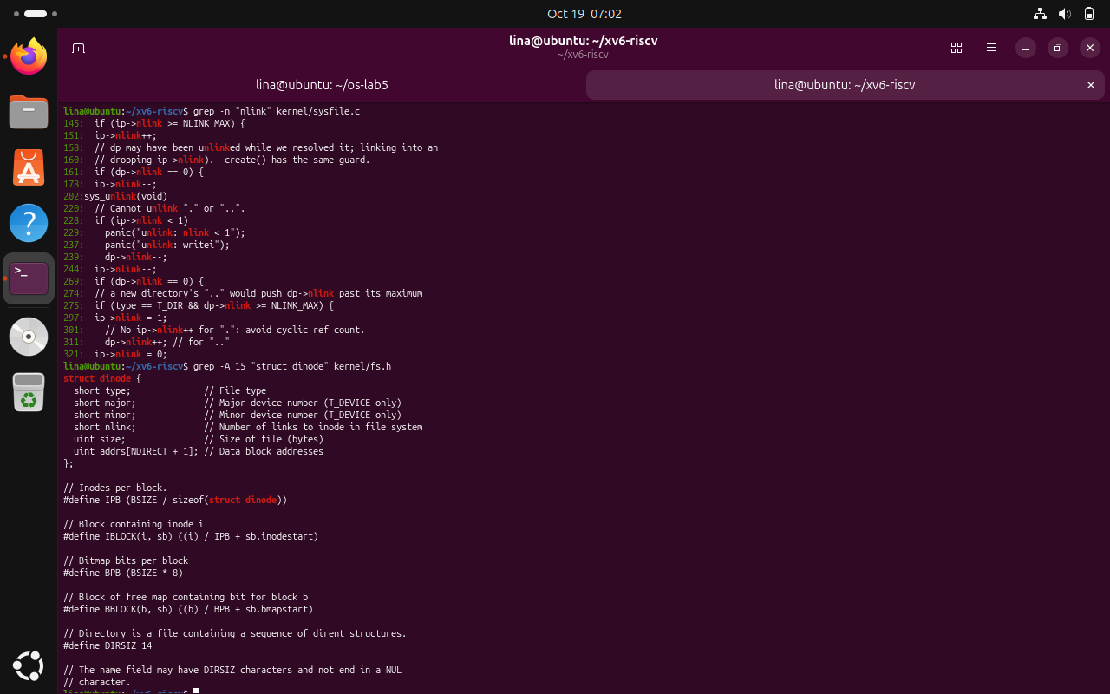
Figure 4.8 On-disk inode structure in kernel/fs.h
The displayed dinode declaration shows the stored file type, device identifiers, number of links, file size and block-address array used by the xv6 file system.

4.3 Measure the Limits
Task: Read the filesystem constants, rebuild the filesystem image to inspect metadata allocation, and test a directory name longer than the xv6 limit.
grep -n "define BSIZE\|define NDIRECT\|define NINDIRECT\|define DIRSIZ" kernel/fs.h
make clean
make fs.img 2>&1 | grep nmeta
make qemu
$ mkdir averyveryverylongname
$ ls
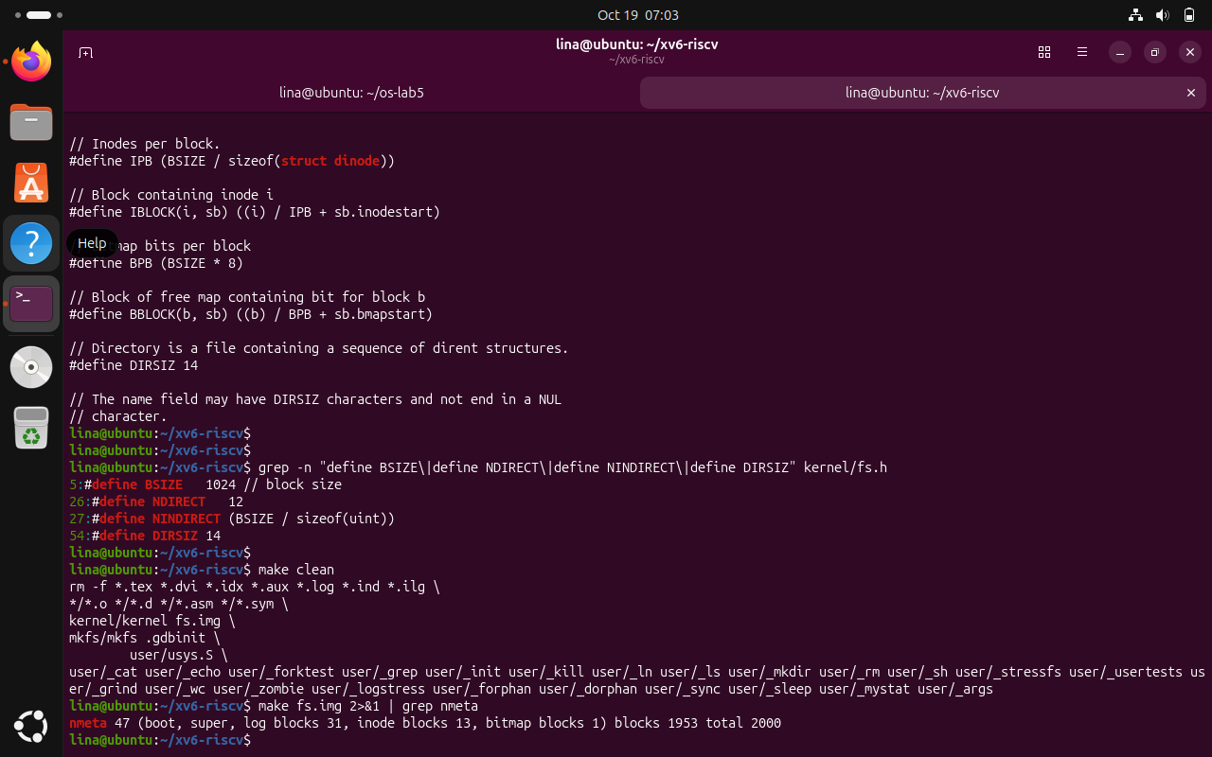
Figure 4.9 Filesystem constants and block addressing
The header reports BSIZE = 1024 bytes, NDIRECT = 12, NINDIRECT = BSIZE / sizeof(uint) and DIRSIZ = 14. These values govern file addressing and the maximum name stored in a directory entry.

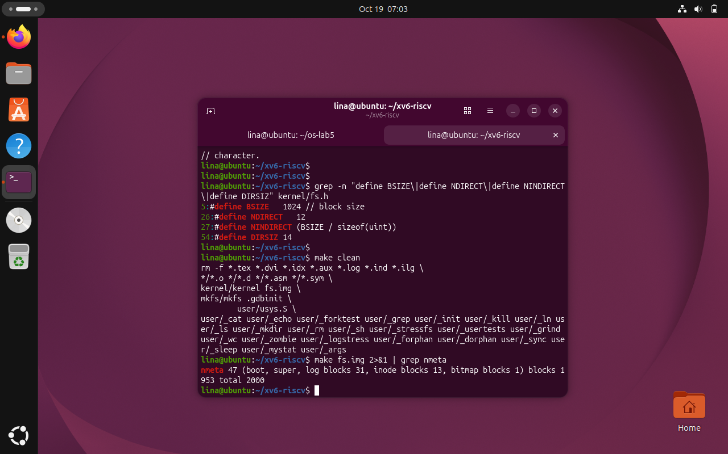
Figure 4.10 Filesystem image allocation summary
The build output reports nmeta 47, including 31 log blocks, 13 inode blocks and one bitmap block, with 1953 data blocks and 2000 total blocks. These values describe the generated xv6 disk image.

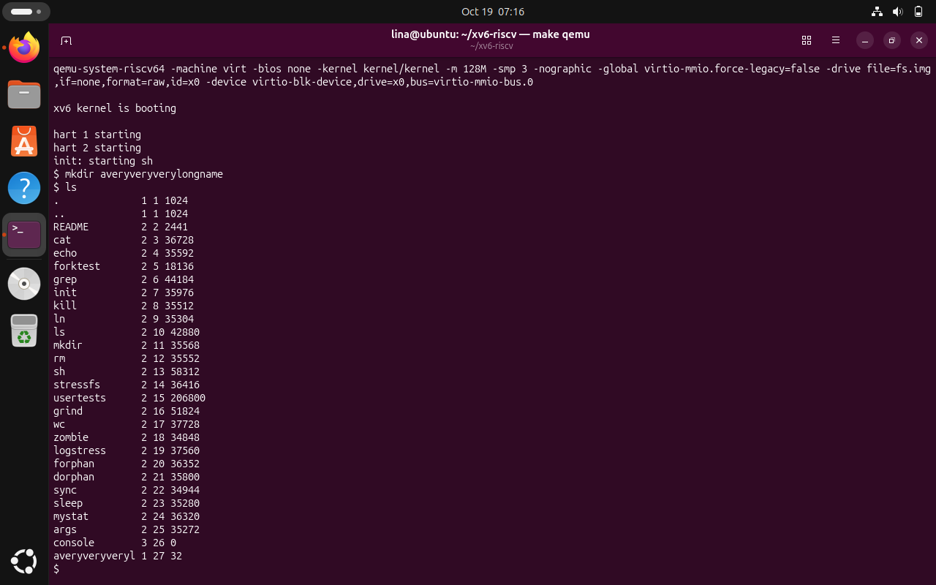
Figure 4.11 Directory-name truncation in xv6
The attempted name averyveryverylongname is displayed in shortened form by ls. Its truncation follows DIRSIZ = 14, which reserves fourteen bytes for a directory-entry name.
Observe (1): The long name is shown as averyveryverylo, the first fourteen characters; DIRSIZ = 14 explains this limit. Observe (2): The laboratory asks for twelve direct blocks and one single-indirect block. With block size 1024 bytes and 4-byte addresses, the indirect block stores 1024 / 4 = 256 addresses; the maximum size is (12 + 256) × 1024 = 274432 bytes (268 KiB). This is the exercise calculation and depends on the stated one-indirect-block arrangement.
Observe (3): The generated image has 2000 blocks total, of which 47 are metadata blocks and 1953 are data blocks. The metadata summary explicitly lists 31 log blocks, 13 inode blocks and one bitmap block; the remaining two metadata blocks are for boot and superblock information.

4.4 Write find
Task: Implement user/find.c to traverse a directory tree recursively and print paths whose final component matches the requested target name. The program uses open, read, stat, strcmp and close, skips unused dirent entries and excludes . and .. to avoid cycles.
nano user/find.c
nano Makefile
make clean
make qemu
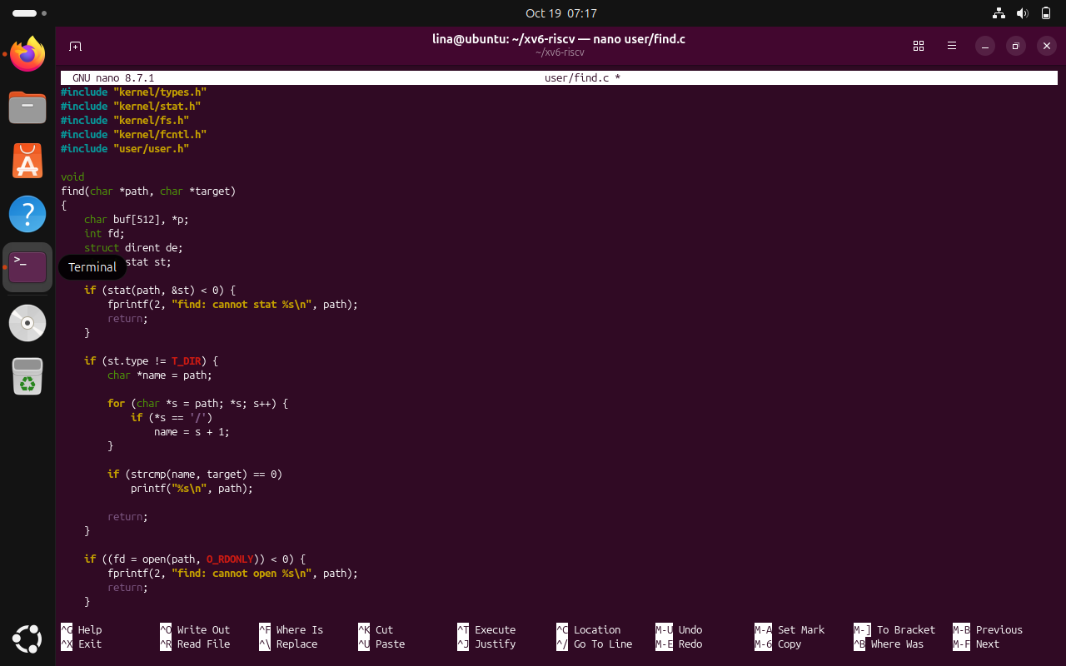
Figure 4.12 Recursive find implementation, first section
The program checks its starting path with stat(), handles invalid paths and non-directory targets, and opens directories for traversal. These checks establish the base cases for recursion.
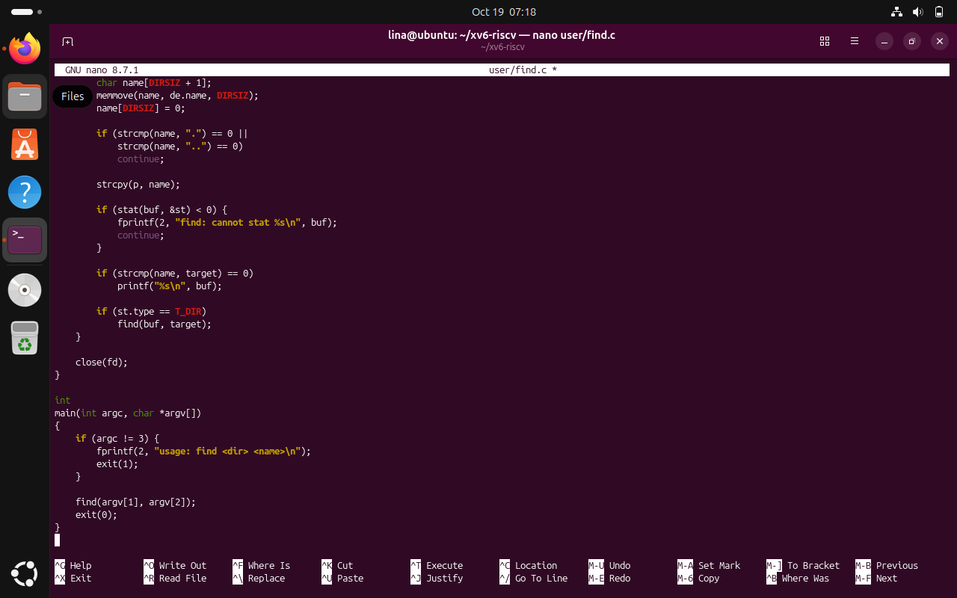
Figure 4.13 Recursive traversal and argument checking
The remaining implementation reads dirent records, skips . and .., constructs complete paths, prints matching names, descends into child directories and closes descriptors. The main function validates the command arguments.

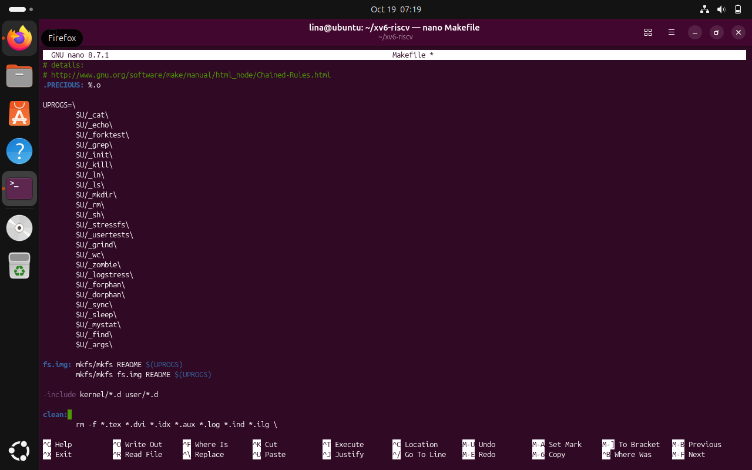
Figure 4.14 Both new programs registered in the Makefile
The UPROGS section includes both _mystat and _find, allowing make to build the utilities into the xv6 image.
$ mkdir a
$ mkdir a/b
$ echo x > a/b/r2
$ echo y > a/r2
$ ln cat r2
$ find . r2
$ find a b
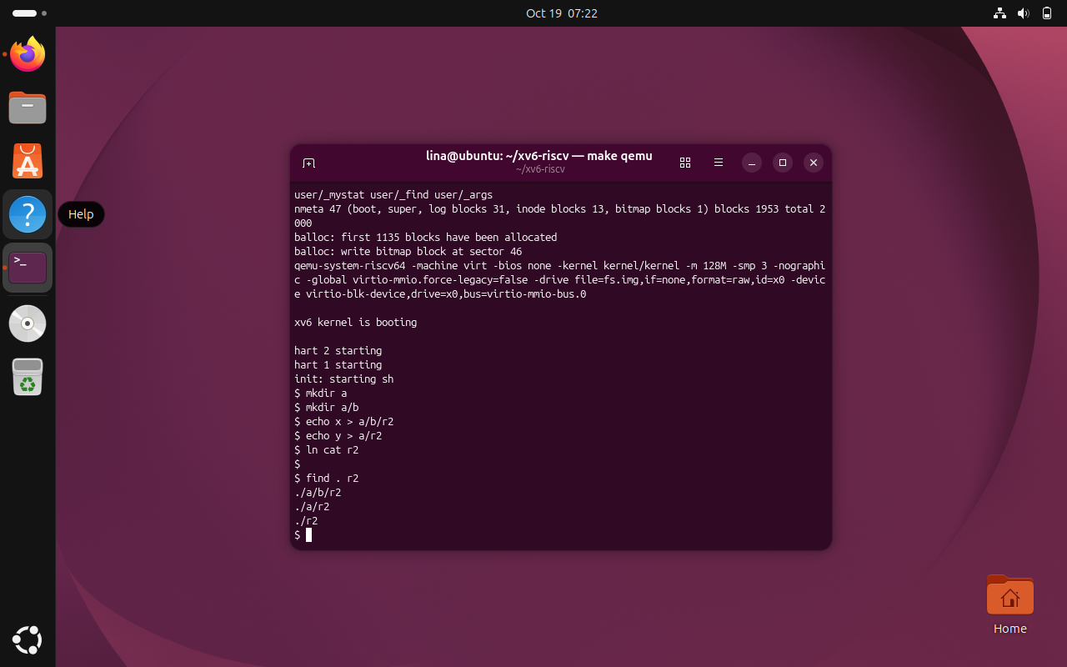
Figure 4.15 Test directory structure and sample files
The xv6 shell creates nested directory a/b and two files named r2, then adds a hard link with the same name in the root. This provides three matching paths at different tree levels.
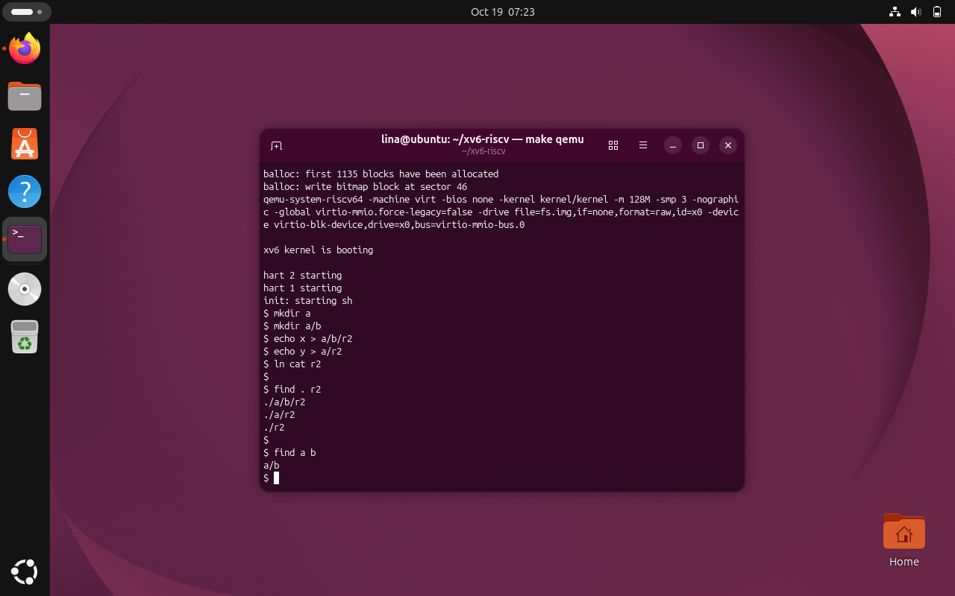
Figure 4.16 Successful recursive find queries
The first query prints ./a/b/r2, ./a/r2 and ./r2; the second query finds a/b. This confirms that the utility searches nested directories and compares path components correctly.
The completed find program identifies matching entries at more than one directory depth. Testing on a freshly rebuilt filesystem reduces interference from previous experiments. The listing order is not significant because directory iteration determines the sequence of matches.

4.5 Optional Exercise: Find with Inode Numbers
Task: Extend the recursive user/find.c utility with an optional -n argument so that each matching path is printed together with its inode number, while preserving the original search behavior.
Commands used:
nano user/find.c
make qemu
$ find . r2
$ find . r2 -n
$ mystat cat r2 a/r2 a/b/r2
$ find
$ find . r2 -x
Results and observations:
The existing find routine was extended with a show_inode parameter. The program accepts either two positional arguments or an additional -n flag. When this flag is present, the output includes the inode number obtained using stat(). The flag is passed into recursive calls so that all matching paths are handled consistently, regardless of their directory depth.
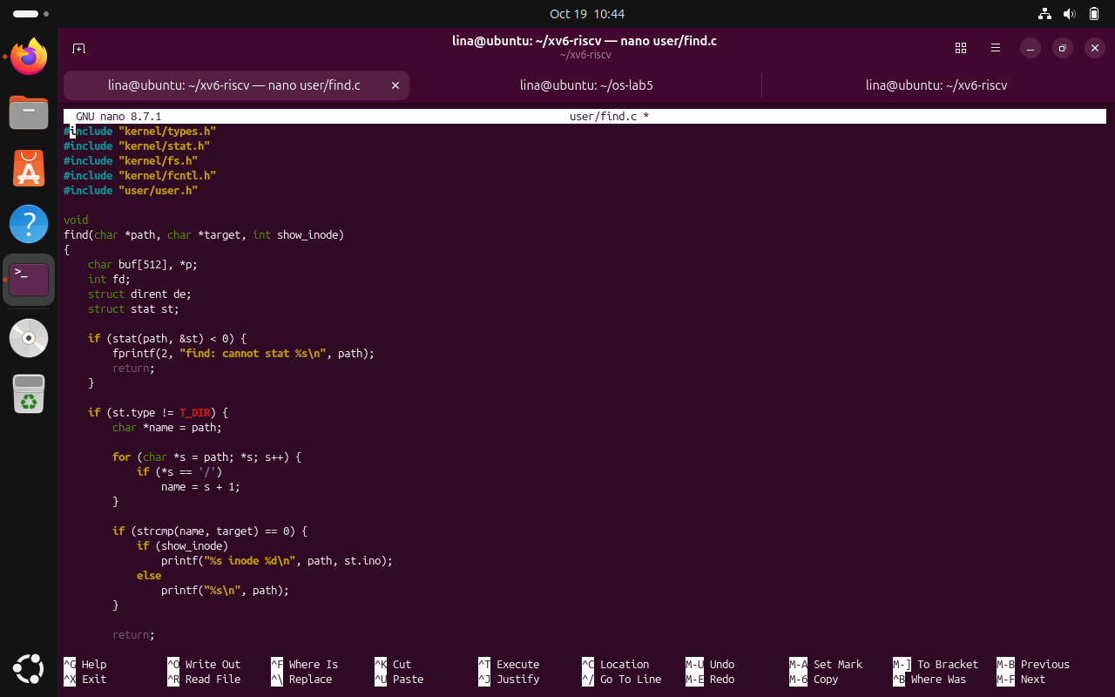
Figure 4.17 Modified find source code with the inode option
The function signature includes the show_inode flag and the matching-path output can optionally display the inode number.
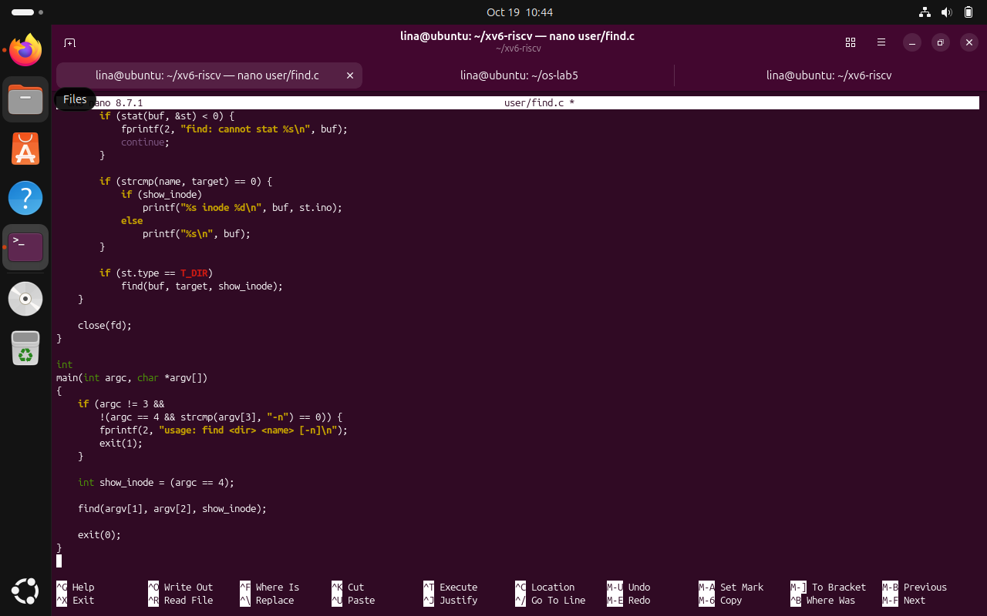
Figure 4.18 Recursive flag propagation and argument validation
The program passes the option through recursive calls and validates the optional -n argument in main.
After rebuilding xv6, the test directory tree was recreated where necessary. The original find . r2 command continued to print three matching paths. Running find . r2 -n printed the same matches together with their inode numbers, demonstrating that the optional enhancement did not replace the required behavior.
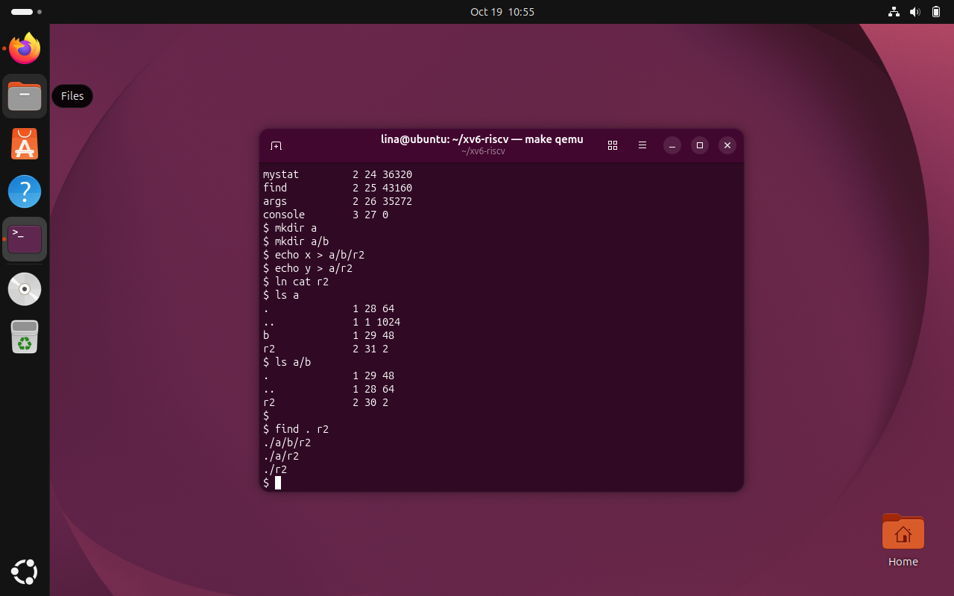
Figure 4.19 Existing recursive find search still works
The original command lists three files named r2 at different levels of the directory tree.
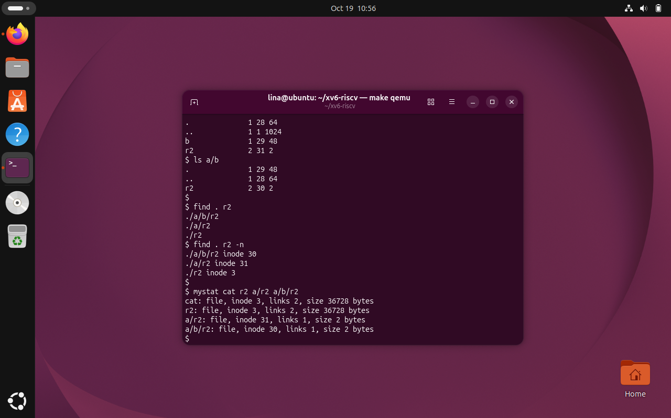
Figure 4.20 Matching paths and inode numbers verified with mystat
The enhanced search displays inode numbers, and mystat confirms that root-level r2 and cat share an inode while the nested r2 files have different inodes.
The inode comparison identifies the top-level ./r2 as the same underlying file as cat because it was created using ln cat r2. The paths ./a/r2 and ./a/b/r2 identify distinct files. These results verify that the tool reports inode identity rather than merely comparing names.
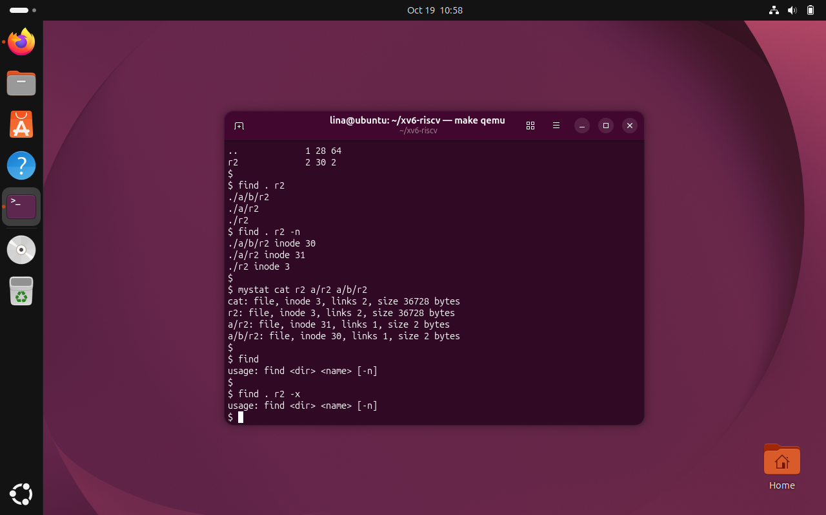
Figure 4.21 Rejection of missing and unsupported find arguments
Calling find without its required arguments or with -x displays the expected usage message rather than attempting a search.
Bonus observation: Of the three entries named r2, only the root-level ./r2 is a hard link to cat and therefore shares its inode number. The optional -n output provides direct evidence of this relationship. The error-handling tests also verify that unsupported command-line arguments are rejected.

CONCLUSION
Laboratory Work 6 provided a detailed practical understanding of the xv6 file system by linking visible shell results with the data structures and system calls responsible for them. Unlike a high-level examination of files in a complete Linux system, the xv6 exercises made it possible to examine a small implementation directly and to verify how a name in a directory connects to metadata stored in an inode. The initial inspection established the meaning of the file-type codes, the root directory inode and the fixed-size records used to represent directory entries.
Implementing mystat strengthened the connection between low-level metadata and user-facing utilities. The program used stat() to report the kind, inode number, link count and size of different filesystem objects, while handling invalid paths through an explicit error branch. The hard-link experiment was particularly important because it showed that two directory names can refer to the same inode without duplicating the data. Removing README affected the link count, but r2 continued to access the same content. Inspection of sys_unlink and the on-disk inode structure explained why data remains available until its remaining references have been released.
The filesystem-limit exercise demonstrated that small implementation constants have observable consequences. A fourteen-byte name field explains the truncated directory name; block size and indirect addressing determine the maximum file capacity. The image-builder output further exposed the distinction between metadata and usable data space, including the boot and superblock, log, inode, bitmap and data regions. These results clarified that a filesystem is not simply a collection of files, but an organized on-disk structure with reserved management information.
The implementation of find added an algorithmic perspective to the laboratory. Recursive directory traversal required correct interpretation of dirent records, path construction, file-type checks and disciplined closure of file descriptors. Skipping empty entries and the special names . and .. prevented invalid traversal and recursive cycles. Tests with identically named files at different depths confirmed that the program searched the directory tree rather than only one directory, and that it produced usable pathnames for each match.
Overall, the laboratory reinforced important systems-programming practices: consulting header definitions before writing code, registering new programs correctly in the build system, distinguishing Ubuntu commands from xv6 commands, rebuilding the filesystem image when required, validating behavior with controlled tests, and interpreting results rather than assuming them. The completed exercises show how filesystem interfaces, metadata, storage layout and recursive algorithms work together, providing a foundation for understanding more advanced operating-system filesystem implementations.

REFERENCES
[1] GitHub Repository. Laboratory Work 3. Available at: https://github.com/linalinalina1/os-2026-FeliciaOjog/tree/main/lab6
[2] Technical University of Moldova, Operating Systems, “Inside the xv6 File System,” Laboratory Work 6, 2026–2027.

