
MINISTRY OF EDUCATION, CULTURE AND RESEARCH
OF THE REPUBLIC OF MOLDOVA
Technical University of Moldova
Faculty of Computers, Informatics and Microelectronics
Department of Software Engineering and Automation

Report
Laboratory Work No.3
Operating Systems
Topic: The Command Line: Shell, Pipes and Text Filters

Done by:
st. gr. FAF-243 Felicia Ojog

Checked by:
Patricia Reițman,
university assistant

Chișinău - 2026
INTRODUCTION 3
1 PURPOSE OF THE REPORT 4
2 THEORETICAL BACKGROUND 5
3 DEVELOPMENT ENVIRONMENT 6
4 PRACTICAL WORK AND RESULTS 7
4.1 Move Fast, Find Help 7
4.2 What the Shell Does to Your Line 9
4.3 Redirection, Chaining and Jobs 12
4.4 Answer Questions with One-Liners 13
4.5 Your First Script 17
CONCLUSION 21
REFERENCES 23

INTRODUCTION
The command line is one of the most direct interfaces to an operating system. A shell reads command lines, performs expansions and redirections, starts programs, connects processes with pipes, and reports exit status. These mechanisms make it possible to combine small utilities into compact commands that solve practical text-processing and system-administration tasks.
Laboratory Work 3 studies the Linux shell from the outside. The work begins with navigation, command discovery, history, and built-in help, then examines globbing, quoting, variables, arithmetic expansion, command substitution, redirection, conditional chaining, and background jobs. The laboratory then applies filters such as grep, cut, sort, uniq, wc, head, tail, and tr to an artificial access log.
The final part turns the one-line commands into reusable shell scripts. The laboratory therefore connects interactive command-line use with basic automation and demonstrates how standard Unix tools can be composed to answer questions about data with short pipelines.

1 PURPOSE OF THE REPORT
The purpose of this report is to document the practical work performed in Laboratory Work 3 for the Operating Systems course. The main objectives were to understand how Bash interprets a command line, distinguish shell built-ins from external programs, use command history and help facilities, control standard input and output streams, and combine commands through pipes and shell operators.
A second objective was to practice text processing with one-line pipelines. A generated access.log file containing 500 requests was analysed to count failures, pages, users, and login shells. The resulting commands were saved in oneliners.sh. Finally, report.sh was created to summarize request failures and to demonstrate argument handling, validation, exit codes, executable permissions, and scheduled execution with cron.
The report records the commands, predictions, observed outputs, answers to all Observe questions, required screenshots, bonus tasks, and the conclusions obtained during the work.

2 THEORETICAL BACKGROUND
Bash is both an interactive command interpreter and a scripting language. Before executing a command, the shell may perform several transformations, including parameter expansion, command substitution, arithmetic expansion, brace expansion, word splitting, pathname expansion (globbing), and quote removal. These transformations explain why a simple command such as echo *.c can print file names even though echo itself does not search the file system.
Every process has standard input, standard output, and standard error streams. Bash redirection operators can connect these streams to files or to other file descriptors. The order of redirections is significant because each redirection is applied from left to right. Pipes connect the standard output of one command to the standard input of another, allowing small filters to be combined into larger processing pipelines.
Shell operators also control execution. A semicolon executes commands sequentially regardless of success, && executes the next command only if the previous one succeeds, and || executes the next command only if the previous one fails. An ampersand starts a command as a background job. Exit status values communicate success or failure; by convention, zero indicates success while non-zero values indicate an error or other exceptional condition.
Utilities such as grep, cut, sort, uniq, wc, head, tail, and tr follow the Unix philosophy of performing one focused task and communicating through text streams. Shell scripts make these command sequences reusable. A shebang such as #!/bin/bash specifies the interpreter, executable permission permits direct execution, and cron can run a command automatically according to a schedule.

3 DEVELOPMENT ENVIRONMENT
Laboratory Work 3 was completed in Ubuntu 26.04.1 LTS running in Oracle VirtualBox. The same virtual machine used for the previous Operating Systems laboratories was reused. Before starting, the course setup script was checked with bash os2026-setup.sh --check. The check confirmed the presence of Git, make, GCC, Bash, grep, sed, awk, the RISC-V cross compiler, and QEMU, and it also verified that xv6 still built and booted correctly.
The Lab 3 working directory was /home/lina/os-lab3. The artificial access log was generated with the loop supplied in the laboratory instructions. The command wc -l access.log confirmed that the file contained exactly 500 lines, which was the expected data set size.
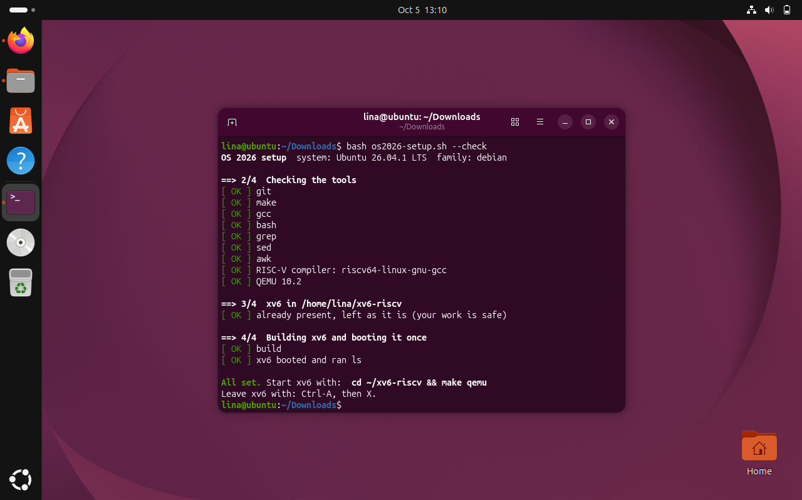
Figure 3.1 Development environment and successful course setup check
The setup check reported all required command-line tools as available and successfully built and booted xv6. This confirmed that the Ubuntu virtual machine was prepared before the Lab 3 work began.

4 PRACTICAL WORK AND RESULTS
The laboratory was carried out in five parts. Each part focused on a different aspect of command-line operation: shell navigation and help, command-line expansion, redirection and jobs, text-filter one-liners, and shell scripting.

4.1 Move Fast, Find Help
Task: Practice command completion and history, distinguish built-in and external commands, inspect PATH, observe exit codes, and use built-in documentation.
Commands used:
ls /usr/sh (Tab twice)
cd /et (Tab once)
Ctrl+R
type cd ; type ls ; type echo ; which ls
echo $PATH
echo $PATH | tr ':' '\n'
nosuchprog ; echo "exit code: $?"
man ls
ls --help | head
man -k "list directory"
help cd

Results and observations:
Tab completion expanded an unambiguous prefix automatically and displayed alternatives when many paths matched. Reverse history search with Ctrl+R located a previous command without retyping it. The type command reported cd and echo as shell built-ins. The ls command was configured as an alias for coloured output, while which ls identified the external program at /usr/bin/ls.
The PATH contained ten directory entries in the observed shell, including /usr/local/sbin, /usr/local/bin, /usr/sbin, /usr/bin, /sbin, /bin, /usr/games, /usr/local/games, and /snap/bin. The executable ls is located in /usr/bin. Running a nonexistent command returned exit code 127.
The cd command must be a shell built-in because changing directory has to modify the working directory of the current shell process. If cd were executed as a separate external process, only that child process could change its own working directory and the interactive shell would remain in the original directory. The ls manual showed that option -t sorts entries by modification time.
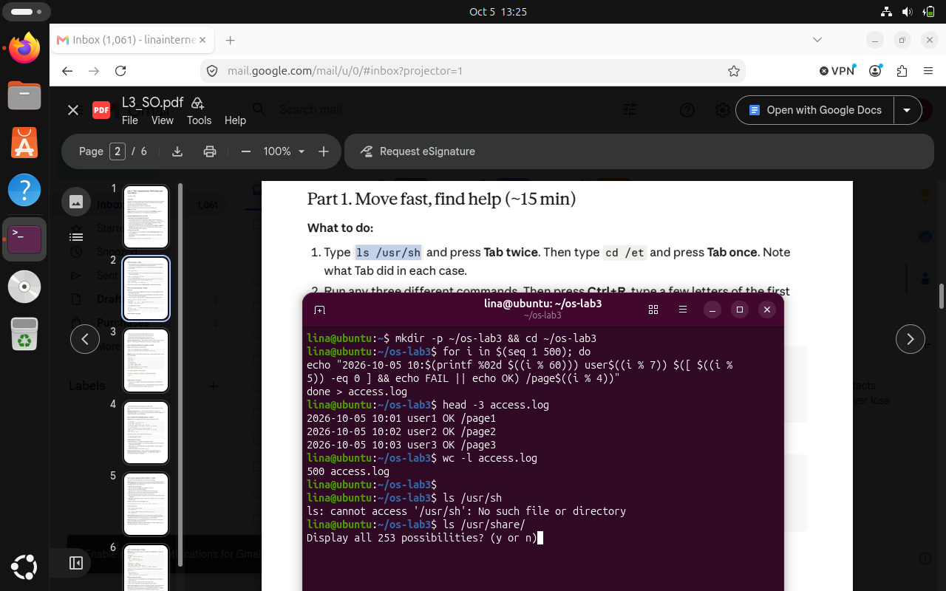
Figure 4.1 Tab completion
The shell expanded /usr/sh to /usr/share/ and displayed the available completions after Tab was pressed twice, demonstrating interactive pathname completion.

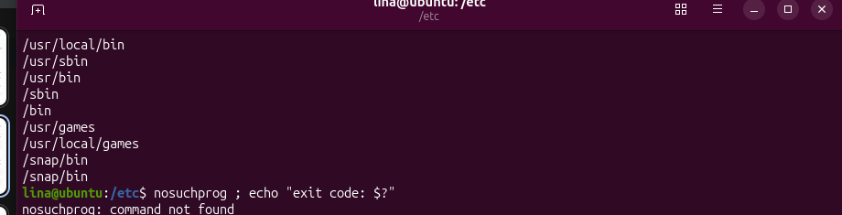
Figure 4.2 Output of type and which
The output distinguishes shell built-ins from the external ls executable and shows /usr/bin/ls as the program found by which.

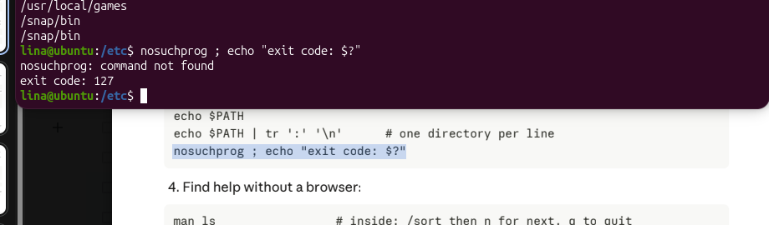
Figure 4.3 Directories in PATH
The PATH value was split at colon characters so that each search directory was displayed on a separate line.

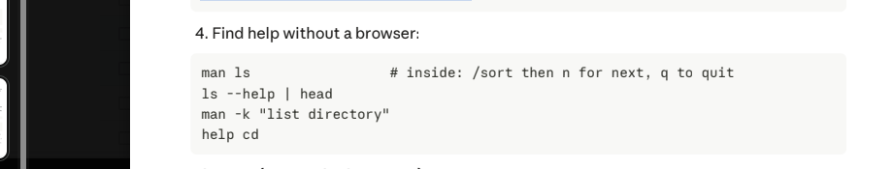
Figure 4.4 Exit code of a missing command
The intentionally nonexistent command nosuchprog produced command not found and exit code 127.

4.2 What the Shell Does to Your Line
Task: Predict and observe pathname expansion, quoting, variable expansion, brace expansion, arithmetic expansion, and command substitution.
Setup commands:
mkdir -p ~/os-lab3/play && cd ~/os-lab3/play
touch a.c b.c file1.txt file2.txt notes.txt "alfa beta.txt"
ls

Prediction and result table:
Table 4.1 – Prediction and Results of Shell Expansion Commands
Command | My prediction | Real output | Explanation
echo *.c | a.c b.c | a.c b.c | Matched all .c files.
echo file?.txt | file1.txt file2.txt | file1.txt file2.txt | ? matched one character.
echo [a-b]* | a.c, alfa beta.txt, b.c | a.c alfa beta.txt b.c | Character class matched names starting with a or b.
echo *.xyz | No matching files | *.xyz | With no match, Bash kept the pattern unchanged.
ls alfa beta.txt | Expected the spaced name | Errors for alfa and beta.txt | Without quotes, the shell created two arguments.
ls "alfa beta.txt" | alfa beta.txt | alfa beta.txt | Quotes preserved the space inside one argument.
echo '$HOME' "$HOME" \$HOME | $HOME /home/lina $HOME | $HOME /home/lina $HOME | Single quotes and backslash suppress expansion; double quotes allow it.
echo {1..5}; echo $((7 * 6)) | 1 2 3 4 5 and 42 | 1 2 3 4 5 and 42 | Brace and arithmetic expansion worked as predicted.
echo "today is $(date +%A), I am $(whoami)" | Current day and user | today is Monday, I am lina | Command substitution inserted command output.
touch log{1..3}.txt && ls log* | log1.txt log2.txt log3.txt | log1.txt log2.txt log3.txt | Brace expansion created three files; globbing listed them.

Observe answers:
The wildcard expansions were produced by the shell before echo executed. echo itself received the expanded file names as arguments. The unquoted command ls alfa beta.txt failed because the shell split it into two arguments. Two valid fixes are ls "alfa beta.txt" and ls alfa\ beta.txt.
Single quotes preserve text literally and suppress parameter and command expansion. Double quotes preserve spaces while still allowing parameter, command, and arithmetic expansion. A backslash quotes the following character. When ls displays a file name containing a space, it may show the name in quotes to make the output unambiguous and reusable as shell input.
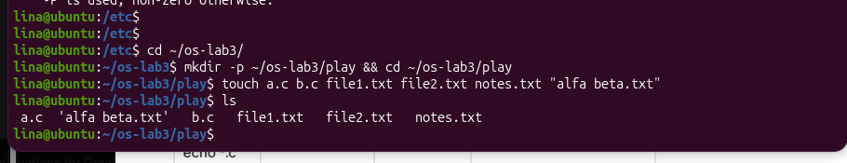
Figure 4.5 Files created in the play directory
The required test files were created successfully, including the file alfa beta.txt whose name contains a space.

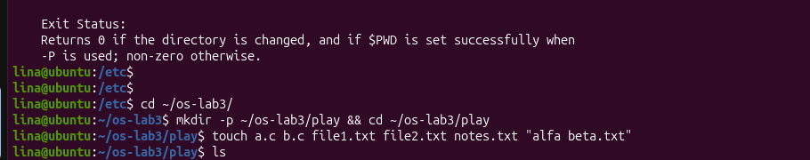
Figure 4.6 Globbing results
The outputs demonstrate *, ?, character-class matching, and the behavior of an unmatched *.xyz pattern.

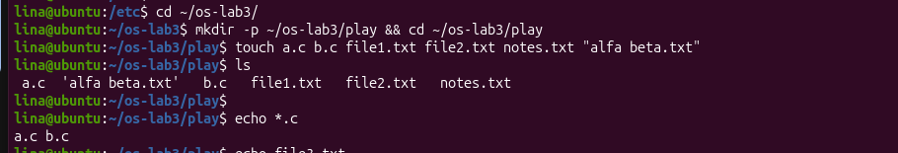
Figure 4.7 Error on a name with a space and the quoted fix
The unquoted file name was split into two arguments, while the quoted form was passed as one argument and worked correctly.

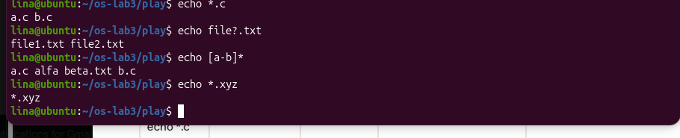
Figure 4.8 Single quotes, double quotes and backslash
The output shows that single quotes and a backslash preserve the literal string $HOME, whereas double quotes allow the variable to expand to /home/lina.

4.3 Redirection, Chaining and Jobs
Task: Separate standard output and standard error, compare redirection order, use command-control operators, and manage a background job.
Commands used:
ls /etc /nope > out.txt 2> err.txt
wc -l out.txt ; cat err.txt
ls /etc /nope > all.txt 2>&1 ; tail -2 all.txt
echo first > notes.md ; echo second >> notes.md ; cat notes.md
wc -l < access.log
ls /nope 2> /dev/null || echo "failed with code $?"
mkdir -p tmp && cd tmp && echo "I am in $(pwd)" ; cd ~/os-lab3
sleep 100 &
jobs ; kill %1 ; jobs
ls /etc /nope > all.txt 2>&1
ls /etc /nope 2>&1 > all.txt

Results and observations:
The normal directory listing from ls was written to out.txt, while the diagnostic for the nonexistent /nope path was written to err.txt. This demonstrates the separation between file descriptor 1 (stdout) and file descriptor 2 (stderr).
The two combined-redirection forms produced different results because redirections are processed from left to right. In > all.txt 2>&1, stdout is redirected first and stderr is then made a copy of the redirected stdout, so both streams go to the file. In 2>&1 > all.txt, stderr is first connected to the original terminal stdout, and only afterward stdout is redirected to the file; therefore the error remains visible in the terminal.
The command wc -l < access.log printed only the number because wc read from standard input and did not receive a filename argument. By contrast, wc -l access.log also prints the filename. The semicolon operator executes the next command unconditionally, && executes it only after success, and || executes it only after failure.
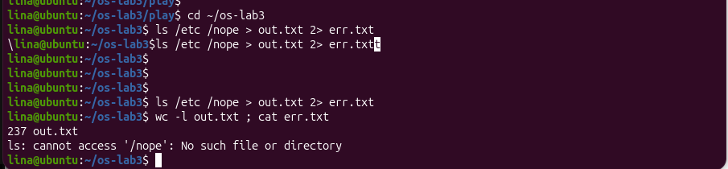
Figure 4.9 stdout and stderr in separate files
The /etc listing was redirected to out.txt and the /nope error to err.txt. Reading err.txt displayed the expected diagnostic.

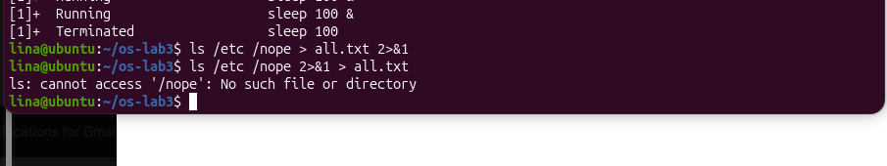
Figure 4.10 Comparing the order of redirections
The second redirection order left the error visible in the terminal, demonstrating that shell redirections are applied from left to right.
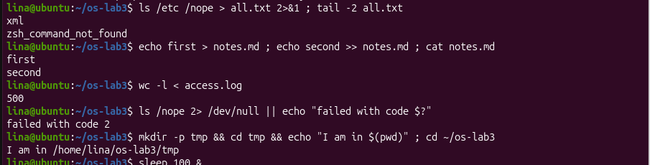
Figure 4.11 The ;, && and || operators
The commands demonstrate unconditional sequencing with ;, conditional success chaining with &&, and failure handling with ||.

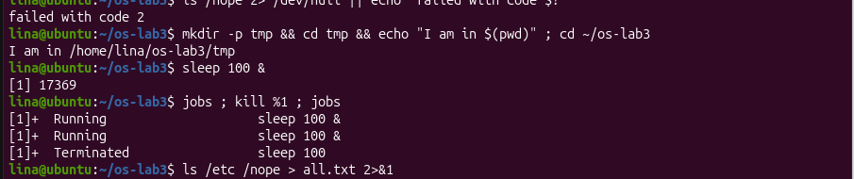
Figure 4.12 Running a background job and stopping it
sleep 100 was launched as a background job, displayed by jobs, and terminated using kill %1.

4.4 Answer Questions with One-Liners
Task: Use one command line per question to analyse access.log and /etc/passwd. Save the commands in oneliners.sh.
Q1. How many requests failed?
grep FAIL access.log | wc -l
Result: 100
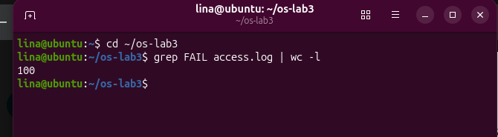
Figure 4.13 Number of failed requests
Q2. How many different pages were requested, and which?
cut -d' ' -f5 access.log | sort -u ; echo "count: $(cut -d' ' -f5 access.log | sort -u | wc -l)"
Result: /page0, /page1, /page2, /page3; count = 4
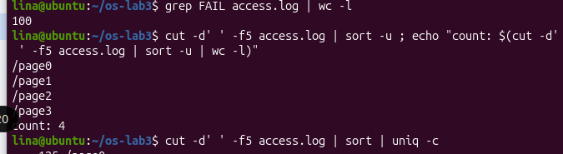
Figure 4.14 Different requested pages
Q3. How many requests did each page get?
cut -d' ' -f5 access.log | sort | uniq -c
Result: 125 requests for each of /page0, /page1, /page2, and /page3
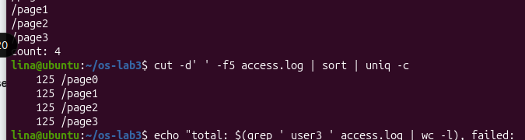
Figure 4.15 Request count per page
Q4. Which user or users have the most failed requests, and how many?
grep FAIL access.log | cut -d' ' -f3 | sort | uniq -c | sort -rn
Result: user5 and user3, with 15 failed requests each
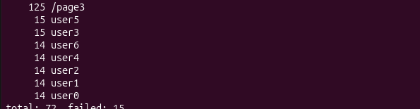
Figure 4.16 Users with the most failed requests
Q5. How many requests did user3 make, and how many failed?
echo "total: $(grep ' user3 ' access.log | wc -l), failed: $(grep ' user3 ' access.log | grep -c FAIL)"
Result: 72 total requests; 15 failed
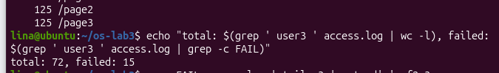
Figure 4.17 user3 total and failed requests
Q6. Print the last 3 failed requests, showing only time and user.
grep FAIL access.log | tail -3 | cut -d' ' -f2,3
Result: 10:10 user0; 10:15 user5; 10:20 user3
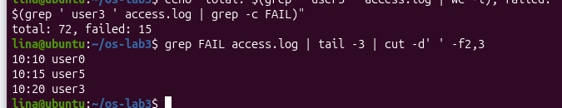
Figure 4.18 Last three failed requests
Q7. Which login shells appear in /etc/passwd, and how many accounts use each?
cut -d':' -f7 /etc/passwd | sort | uniq -c | sort -rn
Result: 40 /usr/sbin/nologin; 5 /bin/false; 2 /bin/bash; 1 /bin/sync
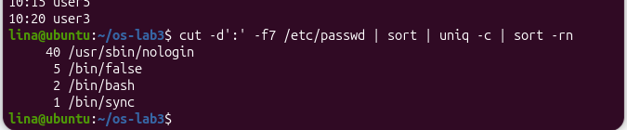
Figure 4.19 Login shells in /etc/passwd
Q8. Why do ls /etc | wc -l and ls -l /etc | wc -l differ by exactly one?
ls /etc | wc -l ; ls -l /etc | wc -l
Result: 236 and 237. The long listing adds a leading total line.
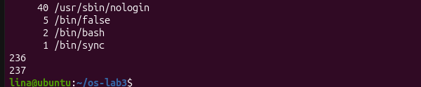
Figure 4.20 Comparison of ls and ls -l line counts
For Q8, the prediction was that ls -l /etc | wc -l would be exactly one larger. The observed values were 236 and 237. The difference comes from the additional total line printed by the long-listing format before the individual directory entries.
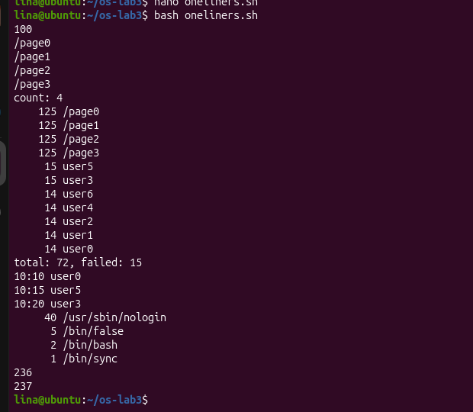
Figure 4.21 Full run of oneliners.sh
The script executed all eight saved one-liners in sequence and reproduced the expected counts and outputs.

Bonus (+1):
grep -E '10:[0-5]0 .* FAIL ' access.log
grep -E '10:[0-5]0 .* FAIL ' access.log | wc -l
The regular expression selected failed requests whose minute ended in 0. The final count was 50 matching requests.
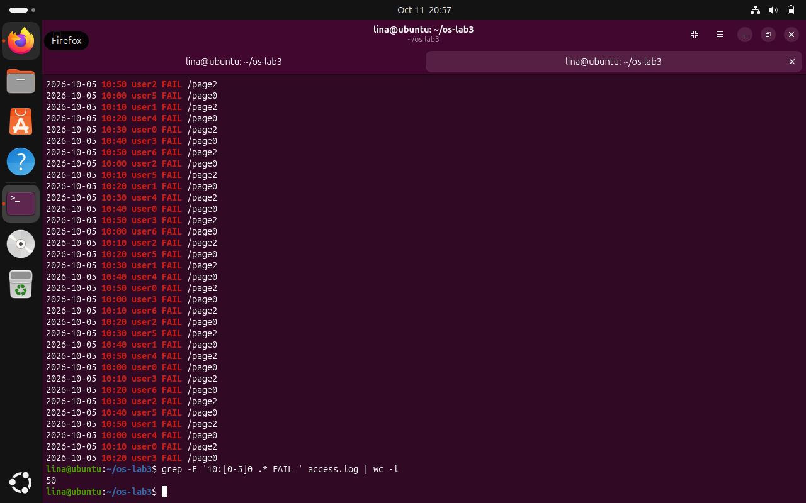
Figure 4.22 Bonus grep -E result and count
The bonus command selected the requested 10:00, 10:10, 10:20, 10:30, 10:40, and 10:50 failure records and counted 50 matches.

4.5 Your First Script
Task: Create report.sh, validate its input file, summarize failures, print per-user failure counts, and test error handling.
Script content:
#!/bin/bash
# usage: ./report.sh access.log
log=$1
if [ ! -f "$log" ]; then
echo "no such file: $log" >&2
exit 1
fi
total=$(wc -l < "$log")
fails=$(grep -c FAIL "$log")
echo "$total requests, $fails failed"
for user in user0 user1 user2 user3 user4 user5 user6; do
count=$(grep " $user " "$log" | grep -c FAIL)
echo "$user: $count failures"
done

Commands used:
chmod +x report.sh
./report.sh access.log
./report.sh nope.log ; echo "exit code: $?"

Results and observations:
The shebang #!/bin/bash tells the operating system to use /bin/bash as the interpreter when the script is executed directly. Before chmod +x, direct execution with ./report.sh would fail because the file does not have executable permission, although it could still be run explicitly with bash report.sh.
The prefix ./ is necessary because the current directory is normally not included in PATH. Therefore typing only report.sh does not normally locate the script, while ./report.sh gives an explicit path to it. The validation error is written with >&2 so that diagnostics use standard error instead of normal output, and exit 1 communicates failure to the calling shell.
Running the script on access.log reported 500 requests and 100 failures. The per-user counts were 14 failures for user0, user1, user2, user4, and user6, and 15 failures for user3 and user5. Running it with nope.log printed a clear error and returned exit code 1.
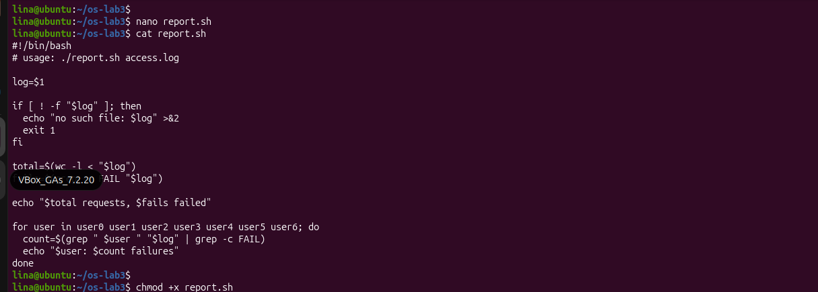
Figure 4.23 Contents of report.sh
The script checks that its argument names an existing file, counts total and failed requests, and loops over user0 through user6 to print per-user failure counts.

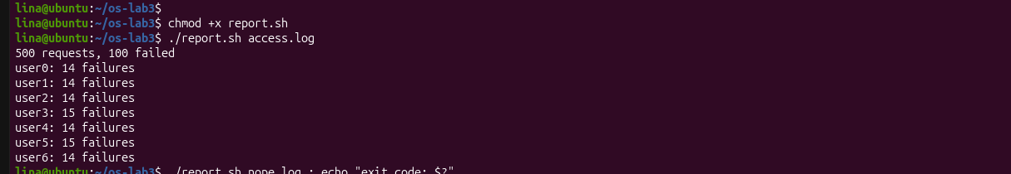
Figure 4.24 Running report.sh on access.log
The successful run reported 500 requests, 100 failures, and the expected per-user failure distribution.

Figure 4.25 Error handling for a missing file
The missing-file test printed no such file: nope.log to standard error and returned exit code 1.

Bonus (+1): scheduled execution with cron
* * * * * /home/lina/os-lab3/report.sh /home/lina/os-lab3/access.log >> /home/lina/os-lab3/report.log 2>&1
The crontab entry executed report.sh every minute and appended both standard output and standard error to report.log. After waiting more than two minutes, the log contained repeated report output, confirming that cron executed the script automatically. The temporary cron entry was then removed, and crontab -l showed no active report.sh entry.
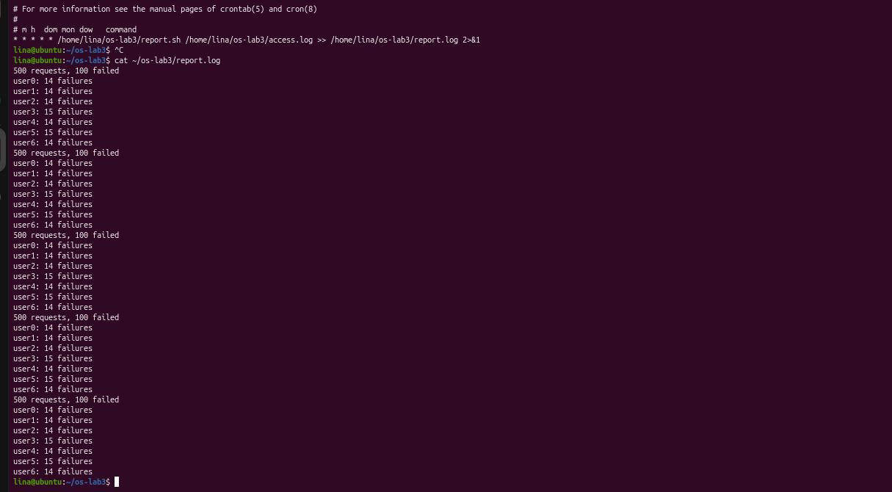
Figure 4.26 Cron bonus and generated report.log
The screenshot shows the every-minute crontab entry and the repeated report output appended to report.log.
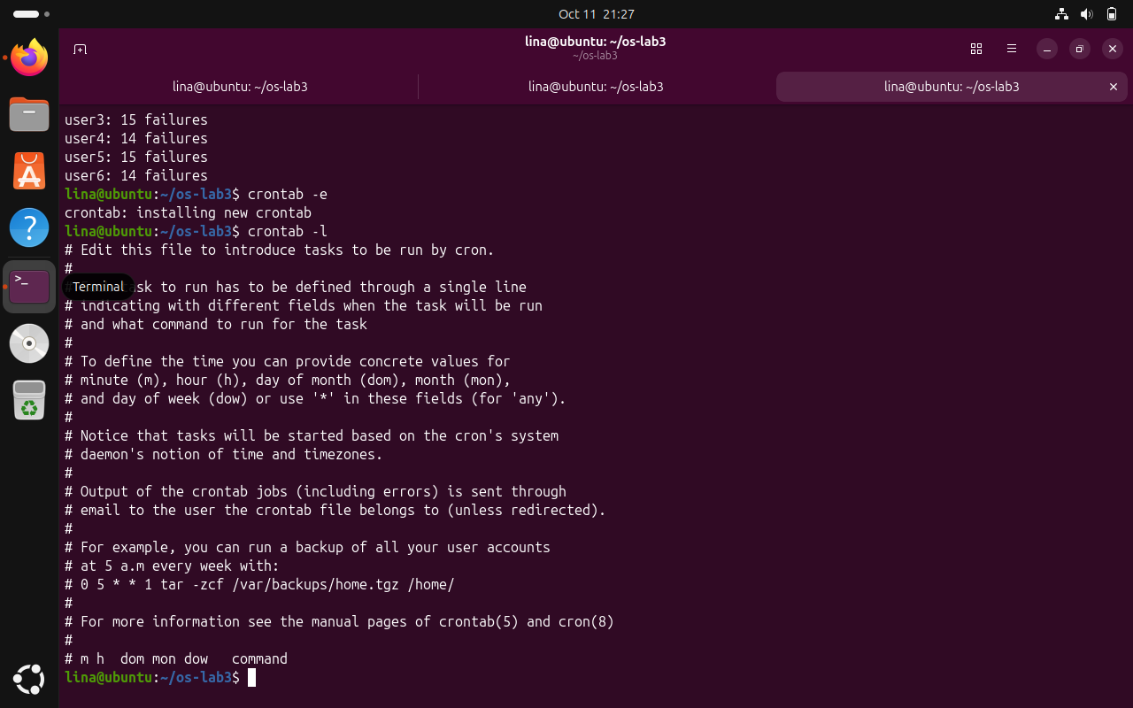
Figure 4.27 Cron entry removed after the bonus
After the demonstration, crontab -l contained only comments and no active report.sh job, confirming that the temporary scheduled task had been removed.

CONCLUSION
Laboratory Work 3 provided a practical understanding of how the Linux command line processes commands, manages input and output, and combines small utilities to solve larger tasks. The work began with basic shell interaction, including tab completion, command history, built-in and external commands, the PATH environment variable, exit codes, and several forms of built-in help. These exercises showed how the shell simplifies command execution and how users can inspect the environment without relying on graphical tools.
The second part demonstrated how the shell interprets a command before it is executed. Globbing patterns such as *.c, file?.txt, and [a-b]* were expanded by the shell into matching filenames, while unmatched patterns remained unchanged. Quoting also proved important: single quotes preserve text literally, double quotes allow variable and command expansion, and the backslash can escape special characters. The experiment with the filename alfa beta.txt illustrated why spaces must be quoted or escaped when they are part of a single argument.
The third part focused on redirection, command chaining, and background jobs. Standard output and standard error were redirected separately and together, showing that they are independent streams. The order of redirections was also important because > all.txt 2>&1 and 2>&1 > all.txt do not produce the same result. The operators ;, &&, and || demonstrated different ways to control the execution of commands depending on the success or failure of previous commands. Background execution with &, together with jobs and kill, showed how the shell can manage processes interactively.
Part 4 demonstrated the power of pipelines and text-processing utilities. Commands such as grep, cut, sort, uniq, wc, head, and tail were combined to analyze the generated access log and answer practical questions using one-line commands. The tasks included counting failed requests, identifying requested pages, finding the users with the most failures, filtering requests for a specific user, extracting selected fields, and analyzing login shells from /etc/passwd. The bonus task using grep -E also showed how regular expressions can be used for more precise filtering.
In the final part, the one-line commands were extended into an executable Bash script. The report.sh script accepted a log file as an argument, validated the input, calculated totals and failures, used a loop to print failure counts for each user, and returned an appropriate error code when the input file did not exist. Making the script executable with chmod +x demonstrated the role of file permissions, while the shebang line specified the interpreter used to execute the script. The cron bonus further demonstrated how command-line scripts can be automated to run periodically and redirect their output into a log file.
Overall, this laboratory work connected several important shell concepts into one practical workflow. It demonstrated that Bash is not only a command launcher but also a powerful environment for filename expansion, quoting, redirection, process control, text processing, scripting, and automation. The exercises also emphasized the Unix philosophy of combining small tools through pipes, where each command performs a simple task and larger solutions are built by connecting them together. As a result, the laboratory improved both practical command-line skills and the understanding of how the shell interacts with programs, files, processes, and the operating system.

REFERENCES
[1] GitHub Repository. Laboratory Work 3. Available at: https://github.com/linalinalina1/os-2026-FeliciaOjog/tree/main/lab3
[2] Operating Systems, FCIM / FAF, UTM. Lab 3 - The Command Line: Shell, Pipes and Text Filters, 2026-2027.
[3] GNU Project. Bash Reference Manual. Available at: https://www.gnu.org/software/bash/manual/
[4] GNU Project. GNU Coreutils Manual. Available at: https://www.gnu.org/software/coreutils/manual/.
[5] Linux man-pages project. Linux Manual Pages. Available at: https://man7.org/linux/man-pages/

