
MINISTRY OF EDUCATION, CULTURE AND RESEARCH
OF THE REPUBLIC OF MOLDOVA
Technical University of Moldova
Faculty of Computers, Informatics and Microelectronics
Department of Software Engineering and Automation

Report
Laboratory Work No.7
Operating Systems
Topic: Three Small Programs: Processes, Redirection, a Pipe

Done by:
st. gr. FAF-243 Felicia Ojog

Checked by:
Patricia Reițman,
university assistant

Chișinău - 2026
INTRODUCTION 3
1 PURPOSE OF THE REPORT 4
2 THEORETICAL BACKGROUND 5
3 DEVELOPMENT ENVIRONMENT 6
4 PRACTICAL WORK AND RESULTS 7
4.1 fork + exec + wait 7
4.2 A zombie, on purpose 9
4.3 Redirection: ls -l > out.txt 11
4.4 A pipe: ls /etc | wc -l 12
4.5 Optional: three-stage pipeline 14
CONCLUSION 15
REFERENCES 16

INTRODUCTION
Laboratory Work 7 investigates how Linux creates and manages processes and how ordinary programs cooperate through file descriptors. The experiments demonstrate the relationship between the commands typed in a shell and the operating-system mechanisms used to execute them. A small program first creates a child process, replaces its program image with another executable, and waits for its completion. Additional experiments examine a temporarily unreaped child process, redirect the output of a command into a file, and connect multiple commands through pipes. The optional three-stage pipeline extends the same approach to three cooperating programs. Together, these practical tasks help explain process execution, synchronization, and interprocess communication through directly observable terminal behavior.

1 PURPOSE OF THE REPORT
The purpose of this report is to document Laboratory Work 7 and examine how Linux processes are started, coordinated, and connected using standard system calls. The first objective is to apply fork(), execlp(), and waitpid() to execute a command in a child process and distinguish successful execution from a failed attempt to start a nonexistent executable. The second objective is to observe the temporary zombie state created when a child exits before the parent collects its termination status. Another objective is to demonstrate how file descriptors control output redirection and how pipes transport data between programs without changing those programs. Finally, the practical work compares manually implemented pipelines with equivalent Linux shell commands and includes the optional three-stage pipeline. The report records the available terminal results, addresses every Observe question, and explains the behavior illustrated by the experiments.

2 THEORETICAL BACKGROUND
A process is an executing program with its own process identifier (PID) and associated resources, including open file descriptors. The fork() system call creates a child process, which initially continues from the same point as its parent. In the child, an exec-family call such as execlp() loads a different program; if this succeeds, the original child program does not resume after the call. The parent can use waitpid() to collect the child’s termination status. If the child exits before this happens, it temporarily remains as a zombie until its parent reaps it. Linux processes ordinarily use descriptor 0 for standard input, descriptor 1 for standard output, and descriptor 2 for standard error. Closing a descriptor and opening a file can redirect subsequent output, while dup() allows another open descriptor to take the lowest available descriptor number. A pipe provides a byte stream between processes: one end is used for reading and the other for writing. Unused pipe ends must be closed so that readers can detect end-of-file when all writers have finished. These mechanisms explain the behavior of the redirection and pipeline programs in this laboratory.

3 DEVELOPMENT ENVIRONMENT
The practical work was performed in Ubuntu Linux using the Bash terminal and the GCC C compiler. The working directory was ~/os-lab7, and the recorded terminal prompts identify the user as lina on the ubuntu host. The C files were compiled with the options -Wall and -Wextra to enable additional compiler diagnostics. The exercises used standard Linux commands, including ls, date, ps, head, grep, and wc, alongside executable programs compiled from the laboratory source files. The results discussed in the practical section come from terminal outputs shared during the work, including process identifiers, file listings, and command counts. These transcripts are distinguished from screenshots because the report should not present reconstructed terminal images as evidence of execution.
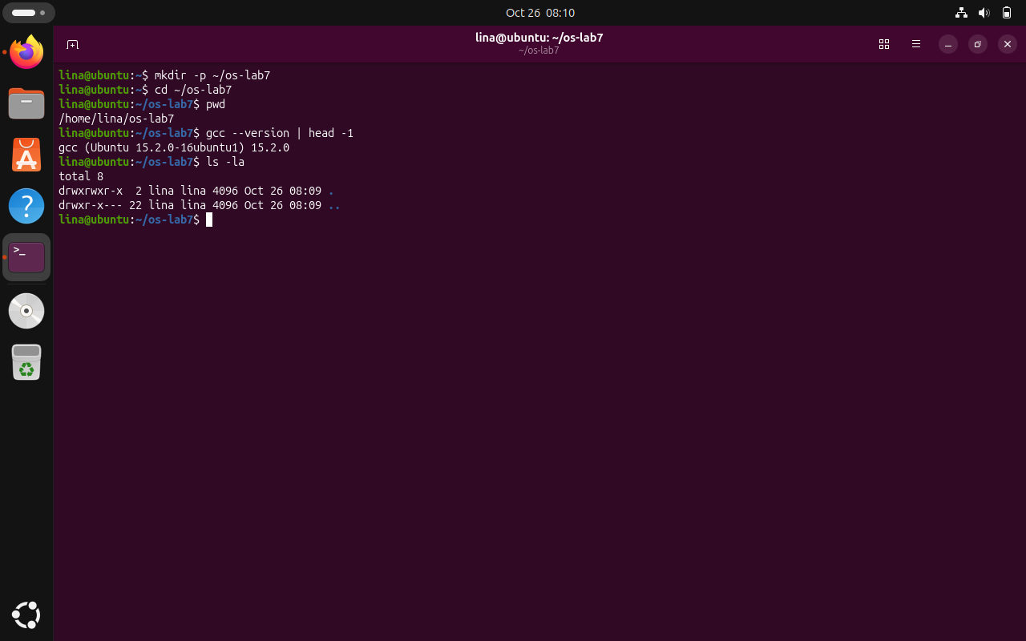
Figure 3.1 - Ubuntu development environment
The screenshot documents the Ubuntu working directory used for Lab 7 and confirms the Linux development environment before compilation.

4 PRACTICAL WORK AND RESULTS

4.1 fork + exec + wait
The run.c program uses fork(), execlp() and waitpid(). The original ls -l version succeeded, the date variation was prepared, and the nonexistent-program variation was tested. The final submission must retain the working ls version.
Commands used:
cd ~/os-lab7
gcc -Wall -Wextra -o run run.c && ./run
Change execlp to date; rebuild and run
Change execlp to nosuchprog; rebuild and run
Restore execlp("ls", "ls", "-l", (char *)NULL);
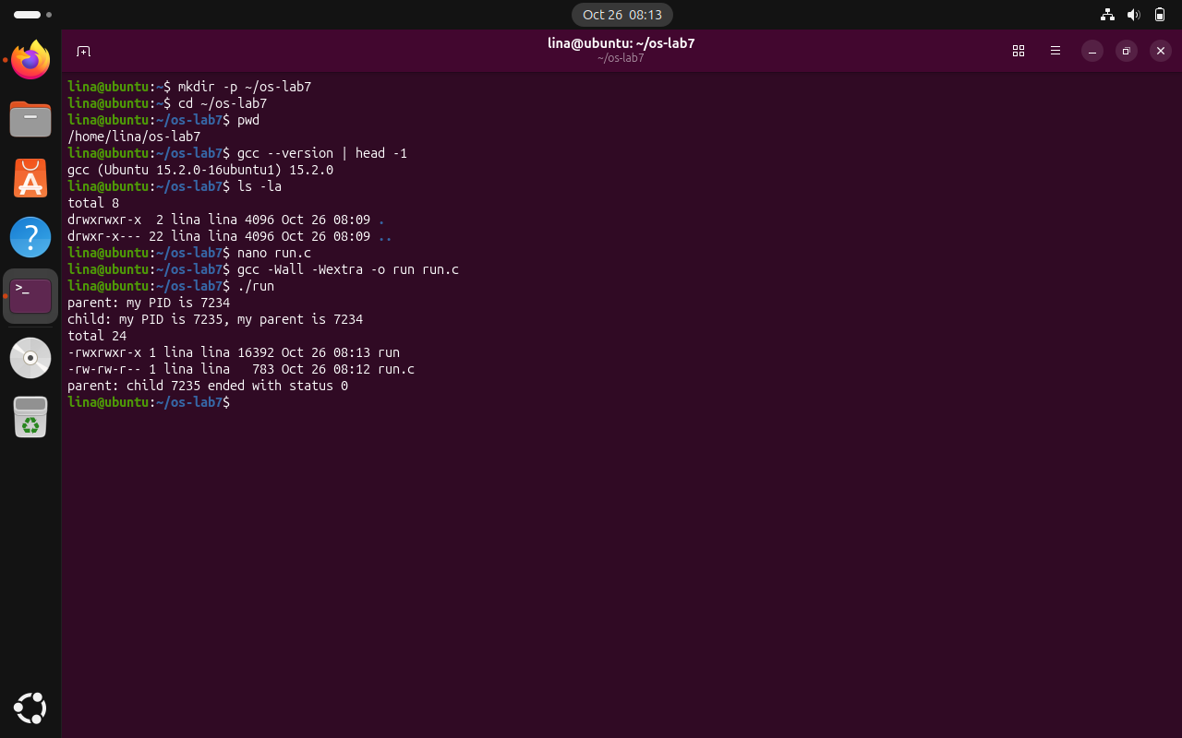
Figure 4.1 - Successful execution of run.c with ls
The parent and child PIDs demonstrate process creation; the child executes ls -l and the parent receives exit status 0.
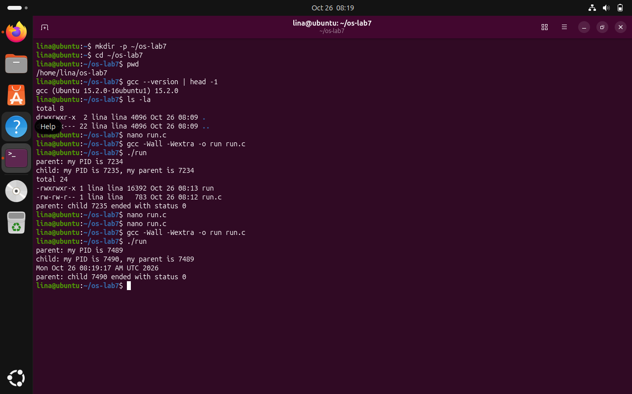
Figure 4.2 - Executing date in the child process
The date variant shows that changing the executable in the child leaves the fork-and-wait structure unchanged and finishes with status 0.
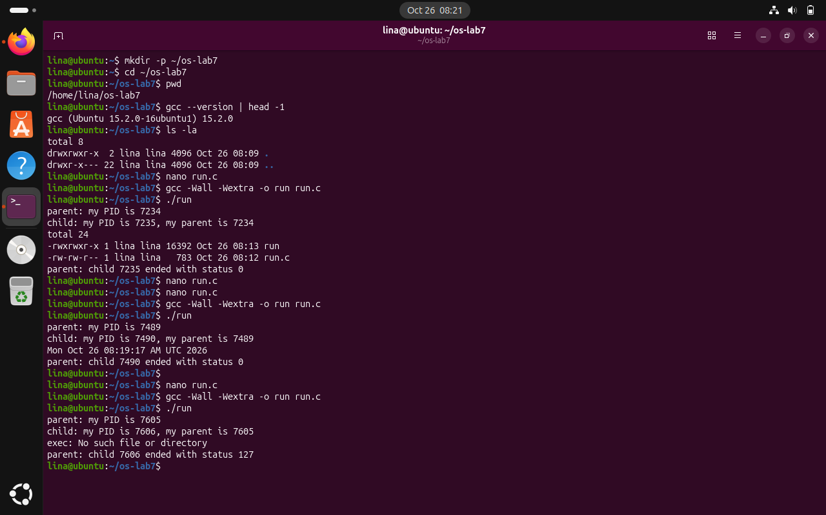
Figure 4.3 - Failed execution of nosuchprog
The missing program causes execlp to return an error, and the child then exits with status 127.

Observe questions and answers:
1. Why is perror("exec") printed only for nosuchprog?
In the successful ls and date experiments, execlp() replaces the child process image with the requested executable. A successful call does not return, so the following perror("exec") line is never reached. For the nonexistent nosuchprog command, execlp() returns -1 and sets errno. The child therefore executes perror(), which produces the observed "No such file or directory" message, and then calls exit(127).
2. Which number is printed as "my parent"?
The value displayed as "my parent" comes from getppid() executed by the child. It identifies the PID of the original run process that called fork(), not the child PID or the shell PID. For example, the successful ls test showed parent PID 7234 and child PID 7235, while the child identified 7234 as its parent. This demonstrates that fork() created a separate child linked to the original process.
3. What are the exit statuses for ls and nosuchprog?
For the successful ls version, the parent reported exit status 0, indicating that the command completed successfully. The displayed Linux test had parent PID 7234 and child PID 7235. In the nosuchprog test, the parent received exit status 127 because the child deliberately calls exit(127) after the failed execlp(). The failure output showed child PID 7606 and parent PID 7605. The difference in statuses reflects the two execution paths, and WEXITSTATUS(status) extracts the child exit code from the status collected by waitpid().

4.2 A zombie, on purpose
In zombie.c, sleep(20) delays the parent before waitpid(), temporarily leaving the finished ls child in the process table.
Commands used:
gcc -Wall -Wextra -o zombie zombie.c
./zombie > /dev/null &
sleep 2; ps -o pid,ppid,stat,cmd
After 20 seconds: ps -o pid,ppid,stat,cmd
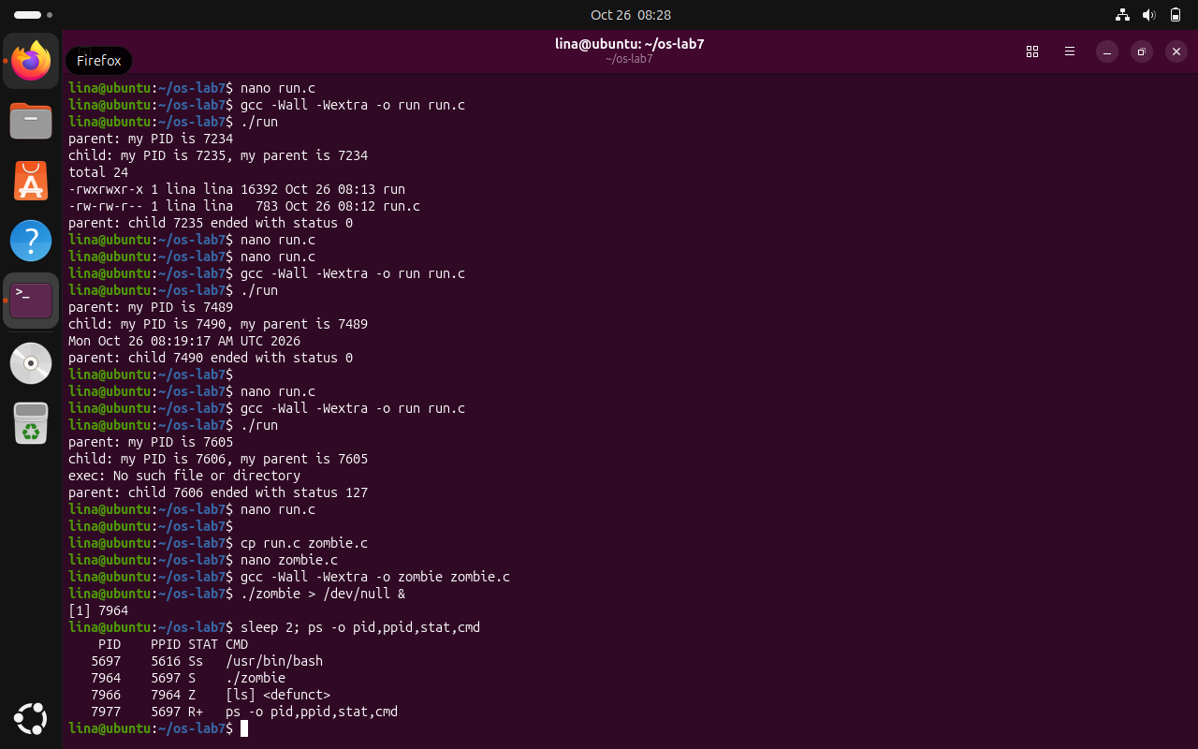
Figure 4.4 - Zombie process present in the process table
The process table displays the ls child in state Z (defunct) while the parent is sleeping before waitpid.

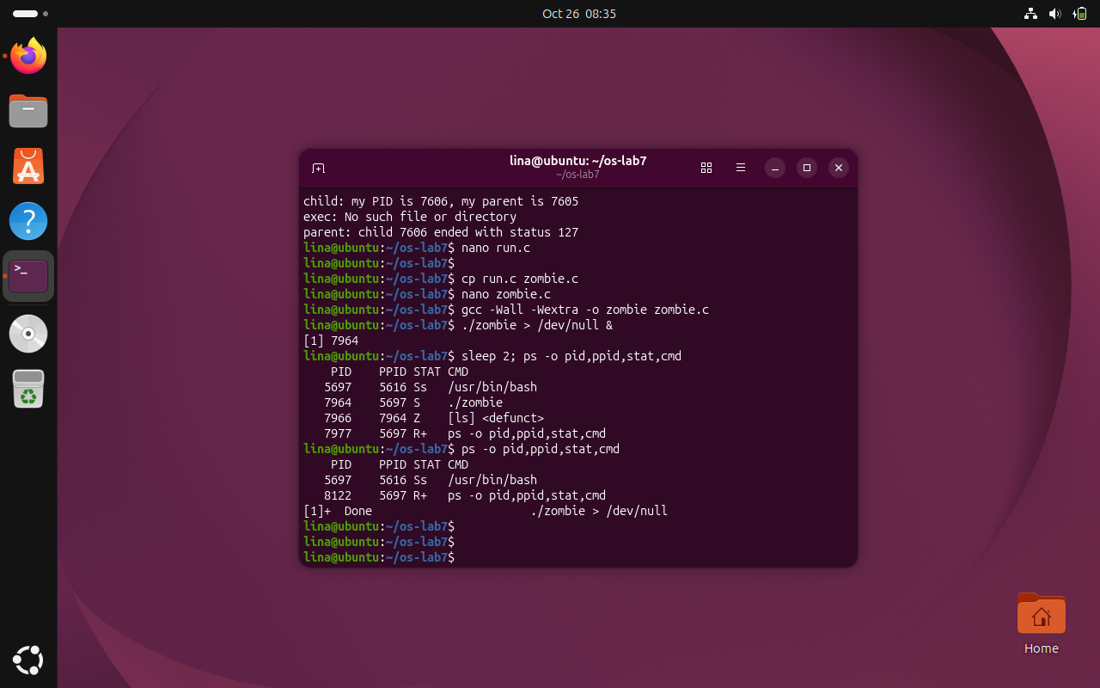
Figure 4.5 - Process table after collecting the child
The subsequent process table no longer lists the defunct ls child, showing that the parent collected its termination status.

Observe questions and answers:
1. What letter appears for ls, and what does it mean?
The ls child appears with the letter Z in the STAT column, together with the label [ls] <defunct>. Z means the program has already exited, but the parent has not yet retrieved its termination status. In the recorded process table, ls had PID 7966 and PPID 7964, so its parent was the still-running ./zombie process. The child remained temporarily listed because the parent was executing sleep(20) before waitpid().
2. Does the defunct line remain after 20 seconds? Which line removes it?
No. After the parent finished its 20-second delay, the second ps output did not list [ls] <defunct>, and Bash displayed the background job as Done. The exact line responsible for removing the zombie state is waitpid(pid, &status, 0): it collects the terminated child's status so that the kernel can release its remaining process-table entry. sleep(20) only creates the observation interval; it does not remove the zombie.

4.3 Redirection: ls -l > out.txt
redirect.c closes standard output before creating out.txt and running ls. The output is stored in the file rather than printed to the terminal.
Commands used:
gcc -Wall -Wextra -o redirect redirect.c && ./redirect
head -3 out.txt
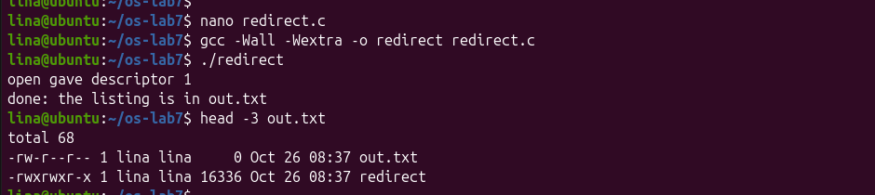
Figure 4.6 - Output redirected into out.txt
The output confirms descriptor 1 was reused for out.txt; the first lines of that file contain the ls directory listing.

Observe questions and answers:
1. What descriptor does open() return, and why?
The observed output was "open gave descriptor 1". In the child, close(1) first releases descriptor 1, which is normally standard output (stdout). When the program opens out.txt, the operating system allocates the lowest available file descriptor, now 1. This makes out.txt the child's standard output destination. The use of O_CREAT and O_TRUNC also creates the file if necessary and replaces its previous contents.
2. Why does the ls listing not appear on screen?
The ls program is unchanged and continues writing its directory listing to standard output, file descriptor 1. However, the child has reassigned descriptor 1 to out.txt before calling execlp(), and the new executable inherits that open descriptor. Consequently, the directory listing appears in the file instead of in the terminal. The diagnostic "open gave descriptor 1" still appears on screen because it is written using stderr, descriptor 2, which was not redirected.
3. Which descriptor should be closed to redirect errors?
To redirect errors as in 2> err.txt, the program should close descriptor 2, which represents standard error (stderr), before opening the error file. Since open() selects the lowest free descriptor, it would then receive descriptor 2, assuming descriptors 0 and 1 remain open. The new program would inherit this destination, and error messages written to stderr would be stored in err.txt instead of appearing on the screen.

4.4 A pipe: ls /etc | wc -l
pipeline.c creates a pipe and two children, wiring the output of ls to the input of wc. The deliberately broken version leaves the parent write end open; the final source must retain the close call.
Commands used:
gcc -Wall -Wextra -o pipeline pipeline.c && ./pipeline
ls /etc | wc -l
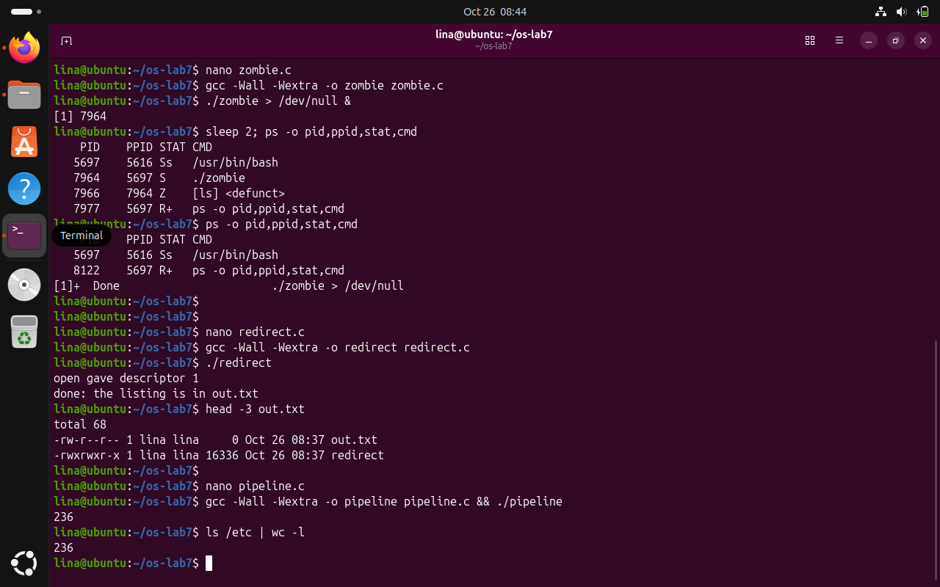
Figure 4.7 - Matching output of pipeline.c and the shell pipeline
The compiled pipeline and the Bash command ls /etc | wc -l both returned 236 entries in this environment.
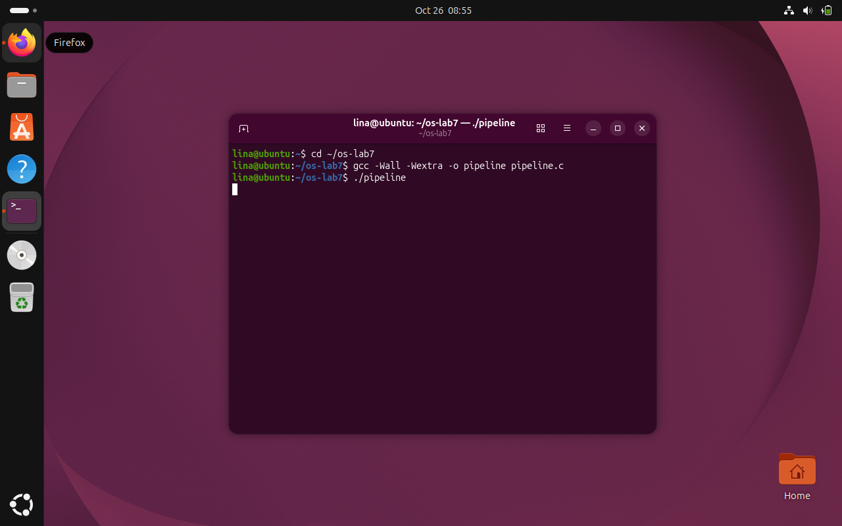
Figure 4.8 - Deliberately unclosed pipe write descriptor
The screenshot shows that ./pipeline remains active without returning to the shell prompt. With the parent holding p[1] open, wc waits for EOF and cannot finish normally.
Observe questions and answers:
1. Should the two commands print the same number?
Yes. The recorded execution of ./pipeline printed 236, and running the equivalent Bash command ls /etc | wc -l also printed 236. Both commands count the lines in the ls /etc output: the C version explicitly creates the pipe and connects file descriptors, while Bash constructs an equivalent pipeline automatically. Equal results support that the pipe was connected correctly in the successful version.
2. Which child does not end after the deliberate change?
The wc child is the process that does not terminate normally after the parent's close(p[1]) call is commented out. The screenshot of the deliberately modified ./pipeline shows that the terminal does not return to the shell prompt. The code explains the specific reason: ls can finish writing and exit, but the parent still holds an open write end, preventing wc from observing the end of the input stream. The observation and the source-code explanation support the same conclusion.
3. What is wc waiting for?
wc is waiting for an end-of-file (EOF) indication on its standard input, which is connected to the pipe's read end. A pipe reports EOF only after all its writing descriptors have been closed and its buffered data has been consumed. By commenting out the parent's close(p[1]), at least one writer stays open, so the read operation in wc keeps waiting. Restoring close(p[1]) in the final code allows EOF to propagate and the pipeline to terminate normally.

4.5 Optional: three-stage pipeline
The optional program uses two pipes and three children for ls /usr/bin | grep x | wc -l. The actual program output was 224, equal to the shell comparison output of 224.
Commands used:
gcc -Wall -Wextra -o pipeline3 pipeline3.c && ./pipeline3
ls /usr/bin | grep x | wc -l
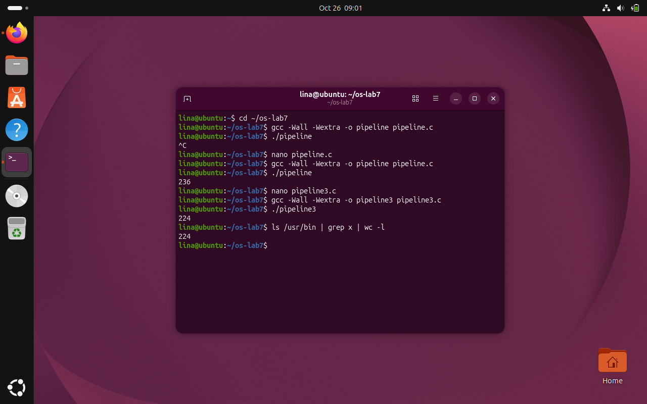
Figure 4.9 - Three-stage pipeline bonus
The optional two-pipe, three-process implementation and the equivalent shell command both returned 224 matching lines.

CONCLUSION
Laboratory Work 7 connected familiar Linux shell commands with the operating-system mechanisms that make them possible. The process-creation exercise showed how fork() creates a child while the parent retains control, how execlp() replaces the child program, and how waitpid() retrieves the termination result. The recorded execution of run.c showed parent PID 7234 and child PID 7235, followed by a successful ls listing and exit status 0. The date variation demonstrated that the same structure can launch another executable without changing the process-management logic.
The failure test provided an important contrast to successful program replacement. When the child attempted to execute nosuchprog, execlp() failed and returned to the existing program. The error message was displayed and exit(127) determined the status observed by the parent. This distinction clarified why code after a successful exec call is not normally executed, and why an explicit failure path must still be provided.
The zombie experiment made process termination and resource collection visible in the Linux process table. While the parent process with PID 7964 was sleeping, the terminated ls child appeared as PID 7966 with state Z and the label <defunct>. After the parent called waitpid(), the entry disappeared. This demonstrated that a process can finish running before its parent retrieves its exit status, and that waiting is necessary to release the child process information maintained by the operating system.
The redirection and pipeline exercises highlighted the central role of file descriptors. Closing standard output before opening out.txt caused open() to reuse descriptor 1, redirecting the ls listing into the file without modifying ls. In the pipeline experiment, two children were connected using a pipe, and the C program and Bash command both returned 236 lines for /etc. The experiment with an unclosed writing end explained why a reader can remain blocked waiting for end-of-file when a write descriptor is still open.
The optional three-stage pipeline extended these ideas to ls, grep and wc connected by two pipes. Its output of 224 lines matched the corresponding Bash command, supporting the correctness of the descriptor connections and the closing of unused pipe ends. Overall, the laboratory strengthened the practical understanding of how process creation, synchronization, redirection and inter-process communication work together. It also demonstrated the importance of testing each modification, keeping genuine command evidence, and restoring the functional source after deliberately introducing an error.

REFERENCES
[1] GitHub Repository. Laboratory Work 4. Available at: https://github.com/linalinalina1/os-2026-FeliciaOjog/tree/main/lab7
[2] Operating Systems, Laboratory Work 7, FCIM / FAF, UTM, 2026-2027.
[3] Linux manual pages / xv6-riscv source code, as applicable to the laboratory.

