
MINISTRY OF EDUCATION, CULTURE AND RESEARCH
OF THE REPUBLIC OF MOLDOVA
Technical University of Moldova
Faculty of Computers, Informatics and Microelectronics
Department of Software Engineering and Automation

Report
Laboratory Work No.10
Operating Systems
Topic: Add Your Own System Call: trace

Done by:
st. gr. FAF-243 Felicia Ojog

Checked by:
Patricia Reițman,
university assistant

Chișinău - 2026
INTRODUCTION 3
1 PURPOSE OF THE REPORT 4
2 THEORETICAL BACKGROUND 5
3 DEVELOPMENT ENVIRONMENT 6
4 PRACTICAL WORK AND RESULTS 7
4.1 The Number and the User Side 7
4.2 The Kernel Side 9
4.3 Play with the Mask 11
4.4 Observe Questions and Answers 14
CONCLUSION 15
REFERENCES 18

INTRODUCTION
An operating system exposes kernel services through system calls. Each call connects a user-level request with a specific implementation in the kernel, allowing applications to obtain services without directly modifying protected kernel state. The xv6 teaching operating system makes this connection especially clear because its code is compact enough to examine and modify.
Laboratory Work 10 extends xv6 by introducing a trace system call. Unlike the preceding Linux laboratory, where strace observes system calls from outside a program, this task adds tracing logic to the operating system itself. The experiment therefore follows a call from its user declaration and assembly stub through the system-call dispatcher to a kernel handler.
The implementation uses the course-specific xv6 source tree, in which system-call number 22 already belongs to sync and trace must use number 23. The kernel uses printk rather than the printf function described in some older tutorials. The report organizes the required edits and tests into the three parts of the handout, includes the Observe answers and documents the completed experiments using the included screenshots.

1 PURPOSE OF THE REPORT
The purpose of Laboratory Work 10 is to implement and verify a new system call in xv6. The first objective is to register trace as system-call number 23, provide the declaration and user stub, create the trace command, and include the new program in the xv6 filesystem image.
The second objective is to extend the kernel so that every process can store its own trace mask. This requires a handler that reads the requested mask, registration in the system-call table, a readable name table, conditional printing after each selected call, and inheritance of the mask when a process forks.
The final objective is to test different masks, explain the significance of individual bits and connect observed output with process behavior. The report also answers the four Observe questions from the handout, including why only certain calls appear, how forked children are traced and which mask combines open and close.

2 THEORETICAL BACKGROUND
In xv6, system calls are assigned integer constants in kernel/syscall.h. A user program calls a wrapper declared in user/user.h; the generated user stub places the number in the appropriate register and executes ecall. The kernel dispatcher then selects the corresponding handler from its system-call table and returns the result to the caller.
The trace system call stores an integer bit mask in the process structure. Each bit corresponds to a system-call number: if bit N is enabled, the kernel reports call N when the process makes it. For example, the mask 32 equals 2 to the power of 5 and selects read, which is system-call number 5 in the laboratory source tree.
The kernel prints a trace record after executing a selected call so that the displayed line includes the returned value. The dispatcher also uses a table of system-call names to display readable names instead of numeric identifiers. This mechanism shows how instrumentation can be incorporated into a central operating-system component.
Process lifetime is essential to tracing behavior. The trace command sets a mask and then uses exec to replace its program image, leaving the process and its mask in place. When fork creates a child process, explicitly copying the trace mask ensures that the new process inherits the same tracing selection. These mechanisms explain the output of the required tests.

3 DEVELOPMENT ENVIRONMENT
The laboratory uses the existing xv6-riscv source tree in Ubuntu Linux running under Oracle VirtualBox. The RISC-V cross-compiler and build tools produce the xv6 kernel and user programs, and QEMU runs the resulting operating system for the tests.
Before editing the source files, the laboratory instructions require checking that make qemu builds and boots the current tree. After changing the user-side files, xv6 is rebuilt to verify that the new system-call number reaches the kernel. Subsequent edits add the kernel handler and tracing logic, followed by another rebuild.
The practical tests were executed at the xv6 shell prompt. The commands exercised the read-only, all-calls, fork-only and write-only masks. Screenshots document the source-code modifications and successful terminal tests, including the recorded process IDs and system-call return values.

4 PRACTICAL WORK AND RESULTS
The practical work follows the three parts of the laboratory handout: establishing the user-side interface, implementing kernel support and testing trace masks. Code fragments, verified terminal results and numbered screenshots document the completed implementation and experiments.

4.1 The Number and the User Side
Task: Register the new system-call number, declare its user interface, generate its assembly stub, create a trace user utility and add that utility to UPROGS.
// kernel/syscall.h (after SYS_sync 22)
#define SYS_trace 23

// user/user.h (after int sync(void);)
int trace(int);

// user/usys.pl
entry("trace");

// Makefile UPROGS
$U/_trace\
The user program accepts a bit mask followed by a command. It calls trace(mask) and then exec(command, args) to replace its program image while retaining the tracing configuration.
The user-side changes form a complete path from the command line to the system-call interface. The numeric constant identifies the request, the declaration exposes trace to C programs, and the generated stub performs ecall. Adding the utility to UPROGS ensures that the trace command is available inside the xv6 filesystem. The first check deliberately runs before the kernel handler exists, so the unknown-call message verifies the interface without claiming that tracing already works.
// user/trace.c
#include "kernel/types.h"
#include "kernel/stat.h"
#include "user/user.h"
int main(int argc, char *argv[]) {
if (argc < 3) {
fprintf(2, "usage: trace mask command [args...]\n");
exit(1);
}
if (trace(atoi(argv[1])) < 0) {
fprintf(2, "trace: failed\n");
exit(1);
}
exec(argv[2], argv + 2);
fprintf(2, "trace: exec %s failed\n", argv[2]);
exit(1);
}
Observed Check 1: before installing the kernel handler, trace 32 grep hello README printed “3 trace: unknown sys call 23” followed by “trace: failed”. This confirmed the user-side request reached the kernel with number 23.
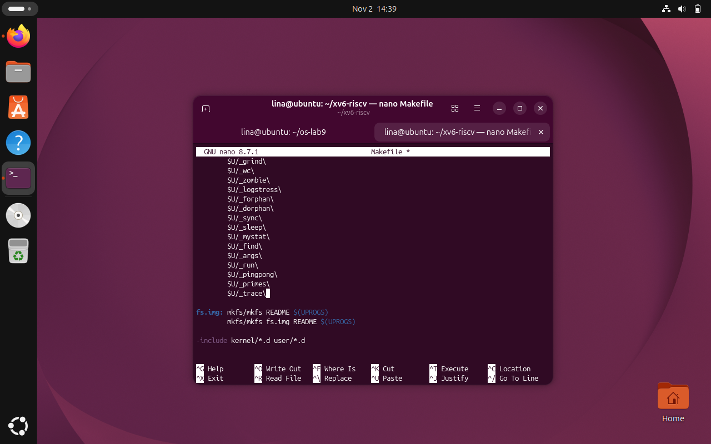
Figure 4.1 User-side declarations, trace utility and Makefile
The screenshots document the user-side implementation, including system-call number 23, the user declaration, stub, trace.c program and Makefile registration.

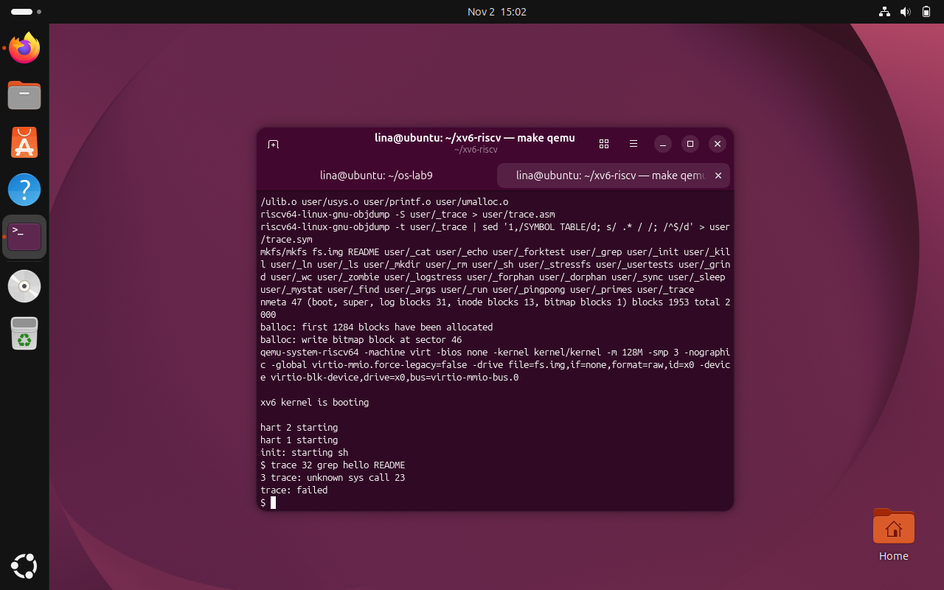
Figure 4.2 Check 1: unknown system call 23
The first xv6 check reports unknown sys call 23 and trace: failed. This expected intermediate result confirms that the call reached the kernel before its handler was registered.

4.2 The Kernel Side
Task: Store a tracing mask for each process, implement the handler, register it in the dispatch table, print selected calls and ensure that child processes inherit tracing.
// kernel/proc.h, in struct proc
int trace_mask;

// kernel/sysproc.c
uint64 sys_trace(void) {
int mask;
argint(0, &mask);
myproc()->trace_mask = mask;
return 0;
}

// kernel/syscall.c, declaration and dispatch table
extern uint64 sys_trace(void);
[SYS_trace] = sys_trace,

// kernel/proc.c, in fork() after copying name
np->trace_mask = p->trace_mask;
A table mapping system-call numbers to names is added above syscall() in kernel/syscall.c. It includes all calls listed in the lab sheet, including sync and trace. After dispatching a valid call and storing its return value in a0, the kernel checks the corresponding mask bit.
p->trapframe->a0 = syscalls[num]();
if ((p->trace_mask >> num) & 1)
printk("%d: syscall %s -> %ld\n",
p->pid, syscallnames[num], p->trapframe->a0);
The name array maps SYS_fork, SYS_exit, SYS_wait, SYS_pipe, SYS_read, SYS_kill, SYS_exec, SYS_fstat, SYS_chdir, SYS_dup, SYS_getpid, SYS_sbrk, SYS_pause, SYS_uptime, SYS_open, SYS_write, SYS_mknod, SYS_unlink, SYS_link, SYS_mkdir, SYS_close, SYS_sync and SYS_trace to their printed names. The table must be declared above syscall(), and the output uses printk in this particular xv6 revision.
The dispatcher prints a record only after the selected system call has executed and its return value has been saved in the trapframe. This placement explains why the output reports both the call name and its result. Keeping trace_mask in struct proc makes tracing process-specific, while copying it during fork allows children to retain the parent tracing selection. The read-only check then verifies the complete implementation by printing the four recorded read return values.
make qemu
# In xv6:
trace 32 grep hello README
Observed Check 2: trace 32 grep hello README produced four read traces from PID 3 with return values 1023, 965, 453 and 0. The first three reads total 2441 bytes and the final zero denotes end of file.
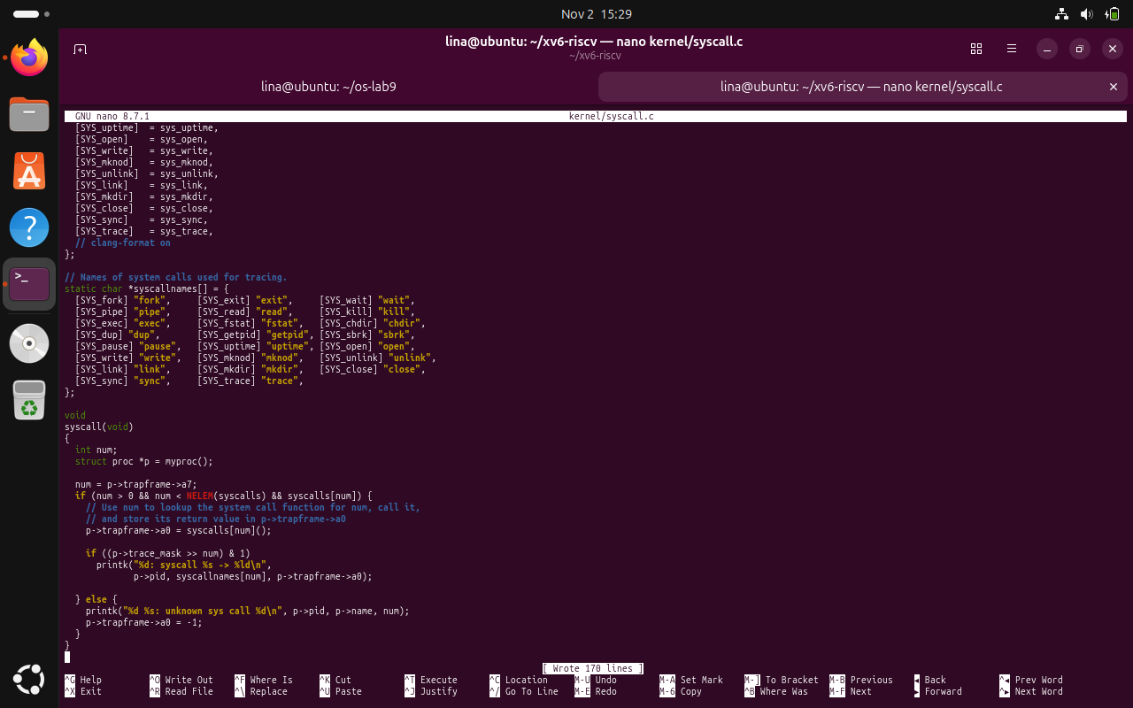
Figure 4.3 Kernel implementation and dispatch table
The screenshots show the kernel-side changes to process state, syscall dispatch, tracing output and inheritance across fork().

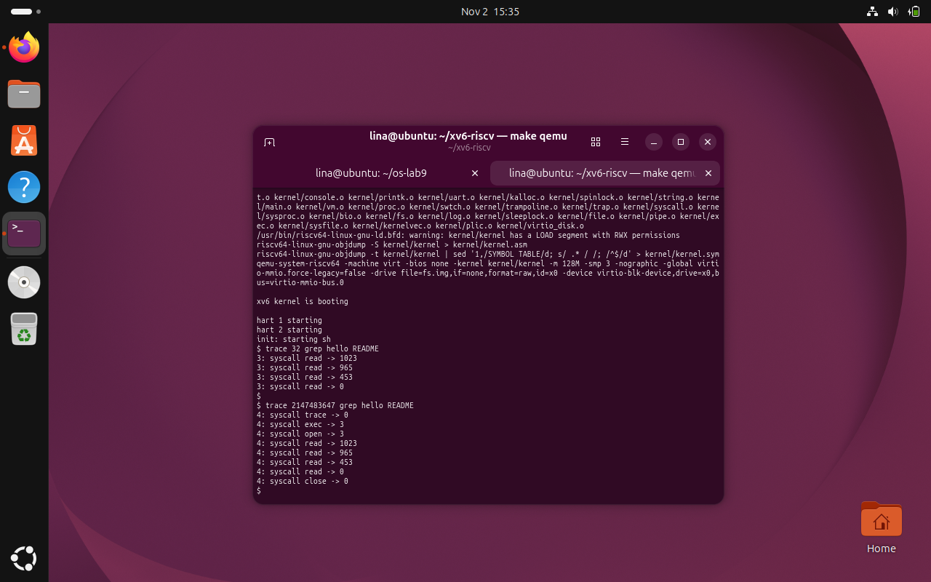
Figure 4.4 Check 2: tracing read calls
After implementing the kernel handler, trace 32 grep hello README displays read return values 1023, 965, 453 and 0, as recorded in the xv6 terminal.

4.3 Play with the Mask
Task: Run the three prescribed tests to compare tracing all selected calls, only fork and only write.
trace 2147483647 grep hello README
trace 2 usertests forkforkfork
trace 65536 echo hi
Observed results: mask 2147483647 traced trace, exec, open, four read calls and close for PID 4. With mask 2, the forkforkfork test traced child-process forks, including successful creation up to PID 66 and failed fork returns of -1, and ended with “OK” and “ALL TESTS PASSED”. With mask 65536, PID 67 printed two write traces returning 2 and 1, with the first trace appearing directly after “hi”.
These tests demonstrate three different mask configurations. The value 2147483647 enables bits 0 through 30, so it shows the sequence of calls made by grep. The value 2 selects only fork and makes it possible to observe tracing in several processes. The value 65536 selects only write, making the separate two-byte text output and one-byte newline visible. The different masks change what is reported, not whether the unselected system calls execute.
The recorded fork test ends after a successful fork returning PID 66 and subsequent failed fork calls returning -1. The example in the handout reaches PID 67, but process identifiers can differ between runs and are not the success criterion. The important evidence is that child processes generate trace lines and the test concludes with OK and ALL TESTS PASSED. Similarly, the write trace appearing immediately after hi is explained by kernel logging between two separate write calls.
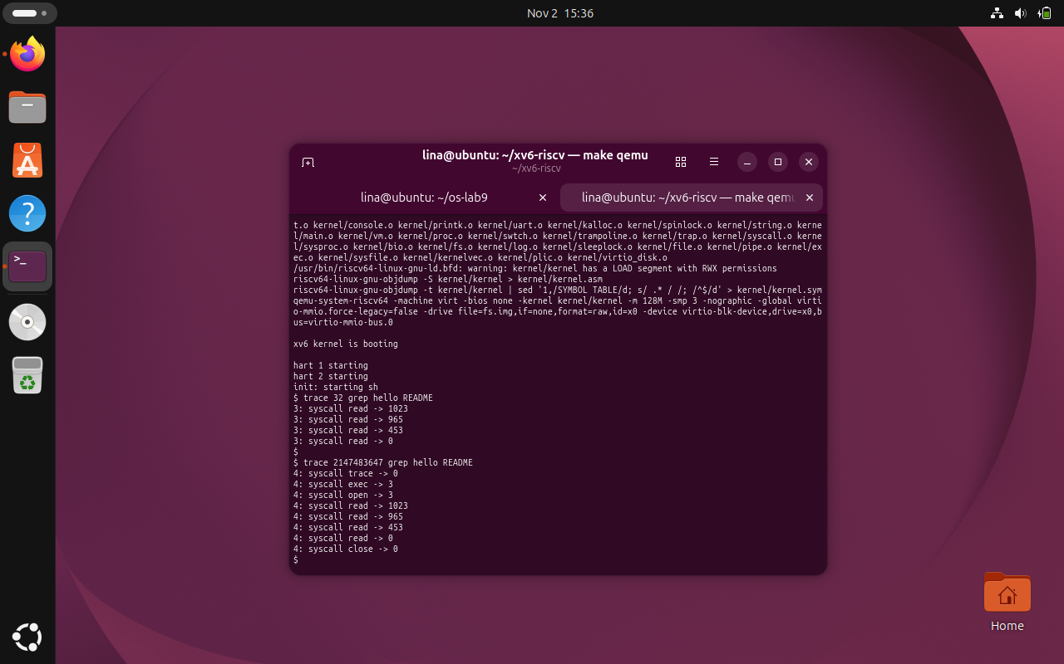
Figure 4.5 All-calls mask with grep
The all-calls mask 2147483647 records trace, exec, open, read and close operations for the grep command.

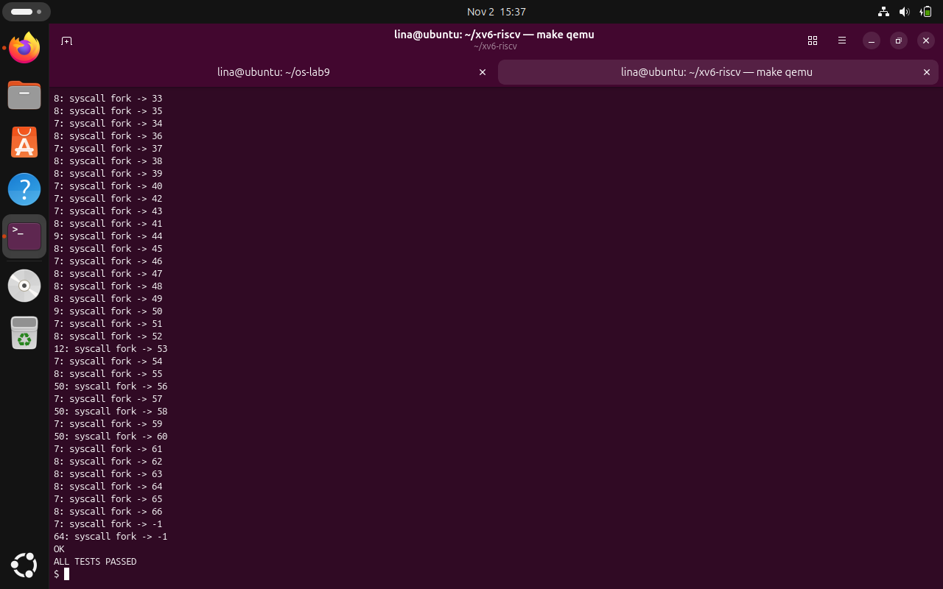
Figure 4.6 Fork-only mask and inherited tracing
The fork-only mask 2 produces traces from several process IDs. The observed test reaches PID 66 and ends with OK and ALL TESTS PASSED.
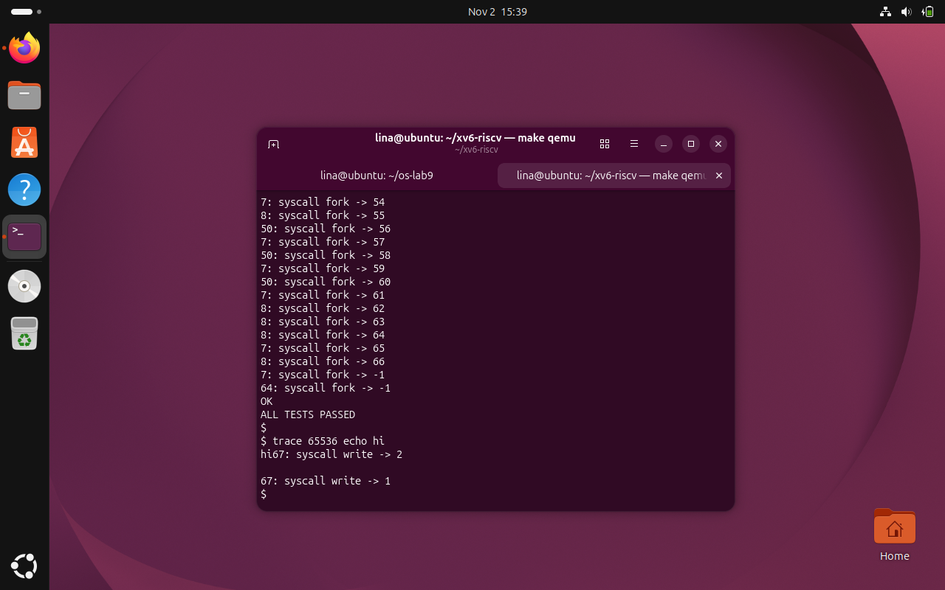
Figure 4.7 Write-only mask with echo
The write-only mask 65536 traces two write operations from echo hi, returning 2 and 1. The first trace starts immediately after hi because the newline is written separately.

4.4 Observe Questions and Answers
1. In trace 32 grep hello README, why does the output contain read but not open or close?
Answer: The mask 32 equals 2^5, setting only bit 5. Since SYS_read is number 5, the kernel prints read calls and filters out other calls such as open (15) and close (21). Those system calls can still execute; they are simply not displayed by the trace mechanism.
2. In forkforkfork, why can several different PIDs print trace lines? Which code makes it possible?
Answer: fork creates child processes with different PIDs. The line np->trace_mask = p->trace_mask; in kernel/proc.c copies the parent mask into each child. Therefore, when a child also forks, its own calls are traced, resulting in output from multiple process IDs.
3. Why does the write trace appear between “hi” and the following newline? How many times does echo call write?
Answer: The echo program in this xv6 version performs separate write operations for the text and its terminating newline. When the write of “hi” completes, the kernel immediately prints the trace entry before the next write outputs the newline. The recorded experiment confirms two write calls, transferring 2 bytes and 1 byte respectively.
4. Which mask traces open (15) and close (21), and no other calls?
Answer: Set bit 15 and bit 21: (1 << 15) | (1 << 21) = 32768 + 2097152 = 2129920. Therefore, the mask is 2129920.

CONCLUSION
Laboratory Work 10 provided practical experience in extending the xv6 operating system by implementing the trace system call directly in its kernel. Unlike observing system calls from outside the operating system, as in the previous laboratory, this task required modifying both the user-space interface and the kernel implementation. The work demonstrated that a new system call is not introduced through a single function: several interconnected components must cooperate to transfer a request from a user program to the appropriate kernel handler and return the result safely. This process made the relationship between system-call numbers, interface declarations, process structures, and the central dispatch mechanism easier to understand.
The first part established the user-side interface for trace by assigning the unique system-call number 23, declaring the function in user/user.h, adding the generated system-call stub through user/usys.pl, implementing the trace user program, and updating the Makefile. The program accepts a tracing mask and the command to be executed, then calls trace before replacing itself with the target command using exec. The initial verification produced the message 'unknown sys call 23', followed by 'trace: failed'. Although this was an error, it was the intended result at that stage: it confirmed that the user-level program and stub were correctly forwarding system-call number 23 to the kernel before the corresponding handler existed.
The second part demonstrated how a system call is registered and processed inside the kernel. Adding trace_mask to struct proc provided a separate tracing configuration for each process, while sys_trace retrieved the integer argument and stored it in the current process. The dispatch table in kernel/syscall.c was then extended to associate SYS_trace with its handler. A table of system-call names made the output understandable, and a conditional printk statement displayed the process identifier, the system-call name, and the return value only when the corresponding mask bit was enabled. Because this condition is evaluated after the system call completes, the displayed return value represents the result of the actual operation.
The successful read-only test was an important confirmation that the full interface was working. The command 'trace 32 grep hello README' produced four read entries with return values 1023, 965, 453 and 0. The first three values represent the number of bytes returned by successive read calls, totaling 2441 bytes, while the final zero indicates the end of the file. Only read operations appeared because mask 32 enables bit 5, corresponding to SYS_read. This established that the mask controls what is displayed rather than preventing other system calls, such as open and close, from executing.
Further experimentation showed how different tracing masks change the amount of observable information. Using mask 2147483647 displayed the trace, exec, open, read and close calls performed by the grep command, allowing their execution sequence to be followed. In contrast, mask 65536 enabled tracing only for write, and the command 'trace 65536 echo hi' showed one write returning 2 bytes and a second write returning 1 byte. The placement of the tracing message directly after 'hi' was explained by echo issuing separate write calls for the text and the newline. These experiments demonstrated that bit masks provide a compact and flexible way to select specific system-call categories.
The forkforkfork experiment was particularly useful for understanding process creation and inheritance. With mask 2, the output displayed fork calls associated with multiple process identifiers, demonstrating that tracing continued in processes created during the test. This behavior was enabled by adding 'np->trace_mask = p->trace_mask;' in the fork implementation, which explicitly transfers the parent's tracing configuration to its child. The last successful fork in the recorded execution returned PID 66, followed by failed fork attempts returning -1, and the test concluded with 'OK' and 'ALL TESTS PASSED'. The difference between PID 66 in the observed run and PID 67 in the example is not a functional error, because process numbering depends on execution history and scheduling.
The laboratory also clarified the different effects of exec and fork on process state. exec replaces the program executed by an existing process, so the tracing mask stored in that process remains available to the newly loaded command. fork, on the other hand, creates another process, making explicit inheritance of trace_mask necessary for tracing to continue in children. Comparing these two mechanisms showed why system-call tracing is tied to process state and why a kernel extension must account for process lifecycle operations, not only its own immediate handler.
An additional practical lesson was the importance of using the correct version of xv6 and following its existing conventions. The course source tree already assigns number 22 to sync, so trace must use 23. Likewise, its kernel diagnostic routine is printk rather than the printf shown in some older online instructions. Verifying file locations, declarations, Makefile entries, and the order of kernel modifications reduced the risk of confusing a build error with an implementation error. The successful compilation and repeated tests confirmed that the changes were integrated into the course-specific source tree without disrupting the demonstrated behavior of existing programs.
Overall, Laboratory Work 10 achieved its objective of adding and verifying a functioning trace system call in xv6. The implementation linked the user-side invocation, kernel dispatch, process-specific mask storage, conditional output, and inheritance across child processes. The observed tests provide concrete evidence of each required behavior, from the initial deliberate unknown-call message to selective read and write tracing and successful fork inheritance. The laboratory strengthened understanding of the user-kernel boundary, system-call registration, bitwise operations, and process management. These concepts provide a useful foundation for future work involving operating-system debugging, process inspection, and the design of additional kernel services.

REFERENCES
[1] GitHub Repository. Laboratory Work 4. Available at: https://github.com/linalinalina1/os-2026-FeliciaOjog/tree/main/lab10
[2] Technical University of Moldova, “OS 2026 - Lab 10 - Add a System Call, trace (xv6),” course laboratory sheet, 2026.
[3] MIT xv6 RISC-V source tree: kernel/syscall.c, kernel/sysproc.c, kernel/proc.c, kernel/proc.h, user/usys.pl.

