
MINISTRY OF EDUCATION, CULTURE AND RESEARCH
OF THE REPUBLIC OF MOLDOVA
Technical University of Moldova
Faculty of Computers, Informatics and Microelectronics
Department of Software Engineering and Automation

Report
Laboratory Work No.8
Operating Systems
Topic: The Same Calls, Inside Your Own OS

Done by:
st. gr. FAF-243 Felicia Ojog

Checked by:
Patricia Reițman,
university assistant

Chișinău - 2026
INTRODUCTION 3
1 PURPOSE OF THE REPORT 4
2 THEORETICAL BACKGROUND 5
3 DEVELOPMENT ENVIRONMENT 6
4 PRACTICAL WORK AND RESULTS 7
4.1 run inside xv6 7
4.2 pingpong 9
4.3 Optional: primes 10
CONCLUSION 12
REFERENCES 13

INTRODUCTION
Laboratory Work 8 continues the study of Unix process management by reproducing the main process operations from Linux inside the xv6 teaching operating system. The exercises use a small RISC-V operating system built from source, making the relationship between a user program, the system-call interface, and the kernel easier to observe. In the first part, a parent creates a child, replaces the child with another program, and collects its termination status. The experiment then tests both successful execution and failure when the requested executable is absent. In the second part, two pipes are used to pass a byte between parent and child in both directions. The optional primes exercise extends the same techniques to a chain of communicating processes.

1 PURPOSE OF THE REPORT
The purpose of this laboratory is to implement and test process creation, execution, synchronization, and interprocess communication in xv6. It aims to compare fork(), exec(), and wait() in xv6 with the corresponding Linux experiment from Laboratory Work 7, including the different exit codes explicitly chosen after failed exec calls. Another objective is to use two unidirectional pipes to exchange a message between processes, identify which read() call blocks for a reply, and correctly close unused file descriptors. The optional exercise demonstrates multiple cooperating processes by filtering prime numbers from 2 through 35. The work also requires registering new programs in Makefile, compiling them with the RISC-V toolchain, and verifying their execution under QEMU.

2 THEORETICAL BACKGROUND
The fork() system call creates a new child process that continues from the point of the call. In the child, exec() replaces the program image with a requested executable; when exec() succeeds, it does not return to the old program. The parent can use wait() to collect the child’s termination status. The same general model applies on Linux, although this laboratory uses xv6-specific user headers and exec()/wait() interfaces rather than execlp()/waitpid(). When exec() fails, the program continues after the call, and the exit status depends on the explicit exit() instruction. Pipes allow byte streams to flow between processes: pipe() supplies a read end and a write end, read() blocks when data are not yet available, and close() releases unused descriptors. A pipe is used in one direction in this experiment, so two pipes provide a request and reply path. In the prime-number sieve, each process reads its first surviving value, prints it as a prime, and passes the remaining nonmultiples to the next stage.

3 DEVELOPMENT ENVIRONMENT
The practical work was performed from an Ubuntu terminal in /home/lina/xv6-riscv, using the xv6-riscv source tree, RISC-V cross-compiler, Makefile, and QEMU. The project contains kernel/ and user/ directories, where the new user programs are placed under user/. Every added executable must also appear in Makefile under UPROGS, with the required line continuation. The user verified that xv6 booted into its shell, displaying the messages “xv6 kernel is booting” and “init: starting sh”. The experiments were executed at the xv6 $ prompt and their actual outputs were recorded during the practical work. No Linux shell commands were run inside xv6.
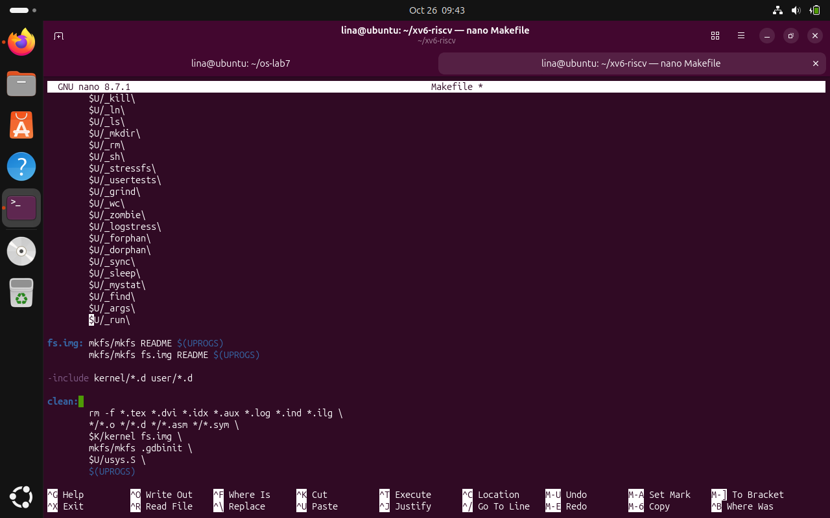
Figure 3.1 - xv6 project and successful execution
The screenshots show the xv6 source environment, Makefile registration, and successful QEMU startup.

4 PRACTICAL WORK AND RESULTS

4.1 run inside xv6
The program user/run.c was first built with the child executing echo and printing a message. The tested parent had PID 3 and child PID 4, and the program exited successfully. Next, exec() was changed to ls and the program printed the xv6 root directory listing. Finally, exec("nosuchprog", args) intentionally failed; the child reported the failure and exited with status 1. After the experiment, the required final version was restored to execute echo. The recorded tests demonstrate successful and failed program replacement, as well as the different exit statuses chosen by the xv6 and Linux implementations.
Commands used:
cd ~/xv6-riscv
Add user/run.c and a TAB-indented $U/_run\ entry to Makefile
make qemu
Inside xv6: run
Exit xv6: Ctrl-A then X; change exec to ls; make qemu; run
Exit xv6; change exec to nosuchprog; make qemu; run
Restore exec("echo", args) and correct echo arguments; rebuild
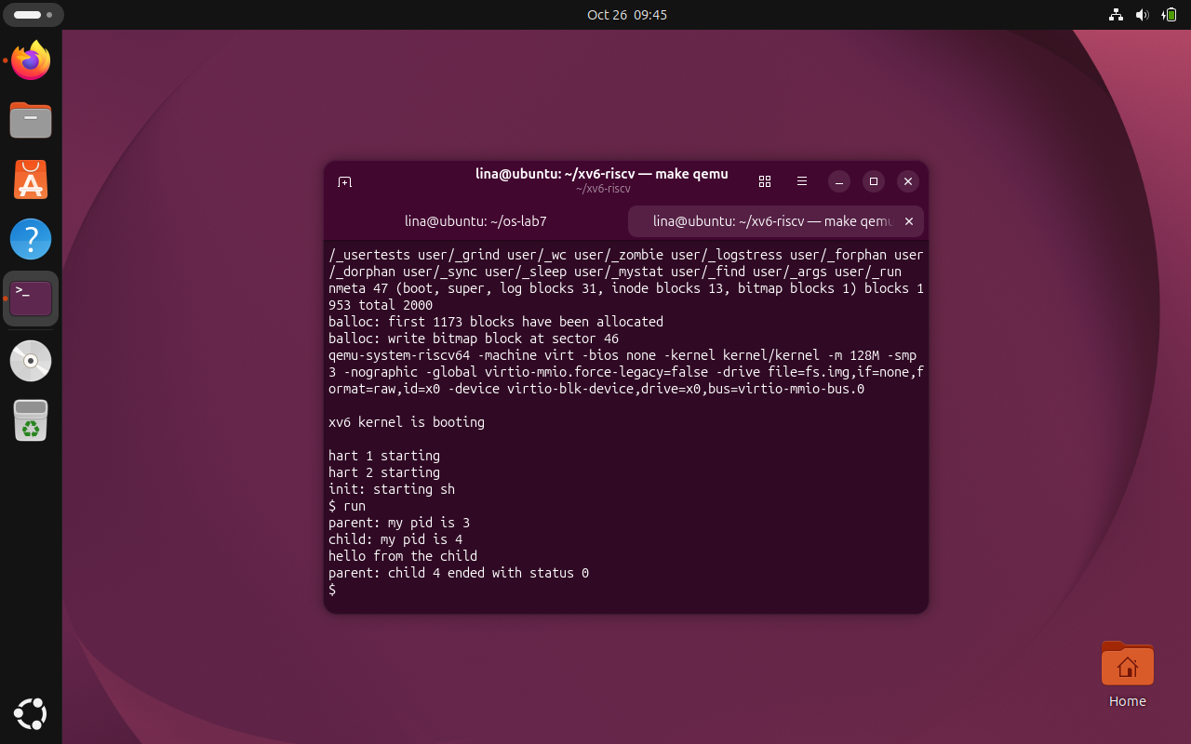
Figure 4.1 - run executes echo successfully in xv6
The child executes echo and prints the requested message; parent PID 3 receives status 0 from child PID 4.
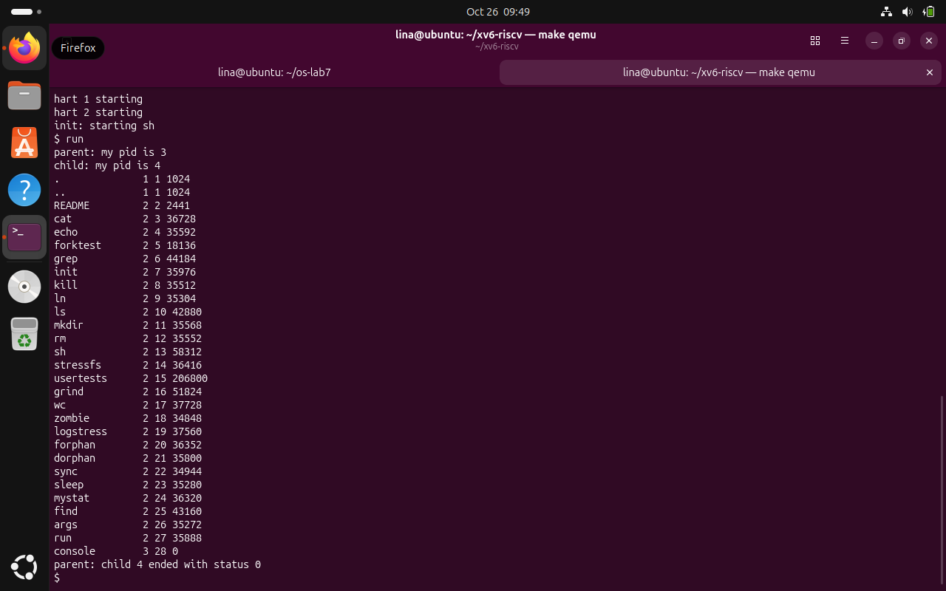
Figure 4.2 - run executes ls in xv6
After replacing echo with ls, the child lists files inside xv6 and terminates with exit status 0.

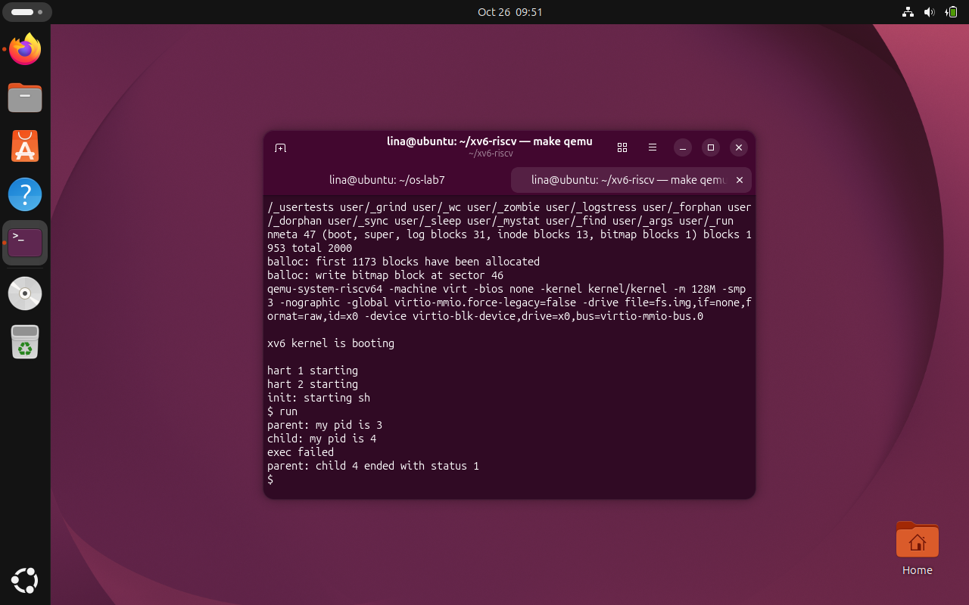
Figure 4.3 - Unsuccessful exec in xv6
Executing the nonexistent program fails; the child prints exec failed and the parent observes exit status 1.

Observe questions and answers:
1. What three calls are used in Linux and xv6? What is the same?
On Linux, run.c calls fork(), execlp() and waitpid(); the xv6 version calls fork(), exec() and wait(). Both programs follow the same three-stage pattern: create a child process, replace the child's code with another executable, and wait for that child to finish. The exact function interfaces differ because Linux supplies execlp() and waitpid() through its user-space libraries, while this xv6 exercise uses the simpler exec() and wait() interfaces provided by xv6. The successful tests show the same overall process behavior on both systems.
2. Who prints "hello from the child"?
The message "hello from the child" is printed by the echo program, not by a printf() statement in run.c. The child first prints its PID, then successfully calls exec("echo", args). That call replaces the child's executable image with echo, which reads the argument strings and writes the requested message. The parent only prints its own PID and the final exit-status line after wait() returns. The xv6 screenshot shows parent PID 3, child PID 4, and status 0.
3. Why is the failure status 1 in xv6, but 127 on Linux?
The different failure statuses come from the instructions written in the two user programs, not from an automatic Linux-versus-xv6 rule. When xv6 exec("nosuchprog", args) fails, run.c prints "exec failed" and explicitly calls exit(1), so wait(&status) reports 1. When Linux execlp() fails, the Lab 7 program calls exit(127), so its parent extracts 127 using WEXITSTATUS(). Both calls return only on failure; changing the explicit exit values would change the observed statuses.

4.2 pingpong
The program user/pingpong.c uses a parent-to-child pipe and a child-to-parent pipe. The parent sends a single byte through the first pipe; the child reads it, prints that it received ping, and sends a byte back through the second pipe. The parent blocks while reading the reply and then prints that it received pong. The recorded execution showed “4: received ping” followed by “3: received pong”, and returned to the xv6 shell. Closing unused pipe ends prevents unintended readers or writers from keeping the communication channels open.
Commands used:
Add user/pingpong.c and $U/_pingpong\ to Makefile UPROGS
make qemu
Inside xv6: pingpong
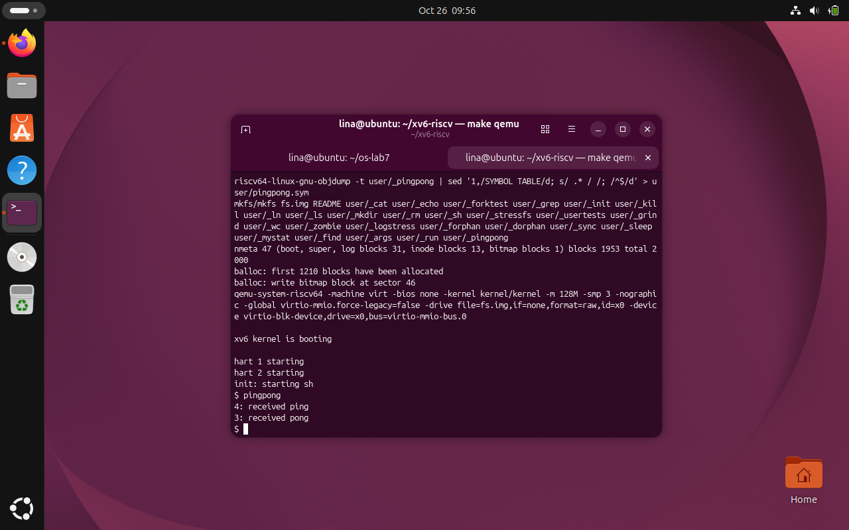
Figure 4.4 - Pingpong communication between xv6 processes
The child (PID 4) prints received ping before the parent (PID 3) prints received pong, verifying the two-way pipe exchange
.
Observe questions and answers:
1. Why are two pipes needed?
The program uses two separate pipes so that each communication direction has its own read and write endpoints. The p2c pipe carries the initial byte from the parent to the child, while c2p carries the reply from the child to the parent. With only one shared pipe, the processes could compete to read data in the same channel and might consume their own messages. Separate channels make the order of the exchange clear: the child receives ping first, and the parent receives pong afterward.
2. Which call makes the parent wait for a reply?
The synchronization point for the reply is read(c2p[0], &b, 1) in the parent. This read blocks while the child has not yet written its response into c2p[1], so the parent cannot print "received pong" too early. The screenshot shows "4: received ping" before "3: received pong", consistent with that ordering. The later wait(0) serves a different purpose: it waits for and reaps the terminated child after the reply has already been received.

4.3 Optional: primes
The optional user/primes.c program uses a chain of processes connected by pipes to generate prime numbers between 2 and 35. The initial recursive implementation caused the RISC-V compiler to flag infinite recursion as an error because compilation uses -Werror. The program was revised to an iterative process-chain implementation without disabling warnings. In the successful xv6 execution it printed prime 2, 3, 5, 7, 11, 13, 17, 19, 23, 29, and 31, then returned to the shell prompt. This confirms all eleven primes in the requested range were reported.
Commands used:
Add user/primes.c and $U/_primes\ to Makefile UPROGS
make qemu
Inside xv6: primes
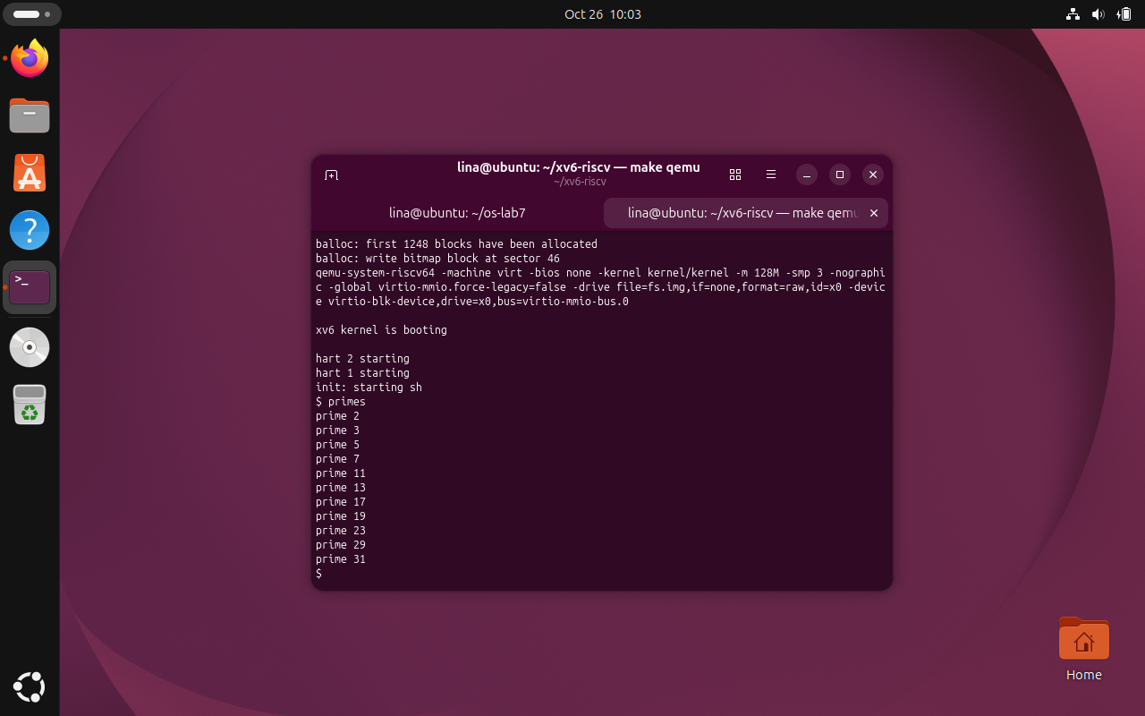
Figure 4.5 - Prime number sieve in xv6
The optional sieve prints all eleven prime numbers from 2 through 35, then returns to the xv6 shell prompt.

CONCLUSION
Laboratory Work 8 demonstrated that the process-management operations previously studied in Linux remain recognizable inside xv6. The initial run program used fork(), exec() and wait() to create a child, replace its code with echo and collect its termination status. In the recorded execution, parent PID 3 created child PID 4, and the child printed "hello from the child" before the parent reported status 0. The experiment showed that a compact teaching operating system can expose the same essential mechanisms as a full Linux environment.
Replacing echo with ls produced the xv6 directory listing and another successful status 0, confirming that exec() replaces the executing program when the requested executable exists. Attempting to execute nosuchprog instead printed "exec failed" and ended with status 1. The contrast with the Linux experiment, which used status 127 on failure, showed that the observed exit value is determined by the failure-handling code rather than by a universal status automatically assigned by exec().
The pingpong exercise developed the idea of communication between processes using two separate pipes. One pipe carried a byte from the parent to the child, while the other carried a response back. The real output showed "4: received ping" followed by "3: received pong". This order was enforced by the blocking read() operations rather than by a fixed execution schedule. Closing the unnecessary pipe ends and then calling wait() also illustrated the difference between waiting for data and collecting a terminated child.
The optional primes exercise extended pipe communication from one parent-child pair to a chain of filtering processes. Each stage identified a prime and forwarded values not divisible by it to the next stage. An initial recursive implementation failed to compile because the compiler reported possible infinite recursion and xv6 treated the warning as an error. Replacing that approach with an iterative process chain resolved the build issue without disabling compiler checks. The final program printed all 11 primes between 2 and 35 and returned to the xv6 prompt.
Together, these experiments provided a closer understanding of the relationship between user programs and the kernel services that support them. They reinforced the importance of correct argument vectors, explicit exit status handling, blocking I/O, descriptor closure and correct Makefile registration of user programs. The completed work also demonstrated the need to leave user/run.c in its original echo configuration and retain working pingpong.c and primes.c implementations for a reproducible final build.

REFERENCES
[1] GitHub Repository. Laboratory Work 4. Available at: https://github.com/linalinalina1/os-2026-FeliciaOjog/tree/main/lab8
[2] Operating Systems, Laboratory Work 8, FCIM / FAF, UTM, 2026-2027.
[3] Linux manual pages / xv6-riscv source code, as applicable to the laboratory.

