
MINISTRY OF EDUCATION, CULTURE AND RESEARCH
OF THE REPUBLIC OF MOLDOVA
Technical University of Moldova
Faculty of Computers, Informatics and Microelectronics
Department of Software Engineering and Automation

Report
Laboratory Work No.9
Operating Systems
Topic: Watching System Calls with strace

Done by:
st. gr. FAF-243 Felicia Ojog

Checked by:
Patricia Reițman,
university assistant

Chișinău - 2026
INTRODUCTION 3
1 PURPOSE OF THE REPORT 4
2 THEORETICAL BACKGROUND 5
3 DEVELOPMENT ENVIRONMENT 6
4 PRACTICAL WORK AND RESULTS 7
4.1 See the Calls of a Real Command 7
4.2 A Program That Calls the Kernel Directly 9
4.3 Count One Kind of Call 11
CONCLUSION 12
REFERENCES 14

INTRODUCTION
A system call is the controlled interface through which a program requests services from the operating-system kernel. Operations such as opening a file, transferring bytes, and closing an open resource involve kernel-managed objects and cannot be understood only by looking at a program’s visible output. Observing these requests makes it possible to connect C functions with the activity performed by the operating system.
On Linux, strace records the system calls issued by a process, together with their arguments and return values. Filtering its output makes routine operations easier to interpret and demonstrates the difference between user-level function calls and kernel interfaces. A command as familiar as ls can therefore serve as an example of how an ordinary application uses the operating system.
Laboratory Work 9 investigates a real command with strace, creates a small C application that performs file operations, and examines the corresponding system-call sequence. The report documents the commands, actual terminal outputs and Observe answers, supported by screenshots of the completed experiments. The counting example is identified separately because the provided sheet does not give detailed instructions for its third part.

1 PURPOSE OF THE REPORT
The purpose of Laboratory Work 9 is to understand how Linux applications interact with the kernel through system calls and to practice interpreting their execution traces. The first objective is to run ls with a restricted strace filter and recognize the calls associated with file access and terminal output.
A second objective is to implement and compile syscalls.c, a small C program that opens a text file, writes a message, closes the file, opens it again and reads its contents. Comparing normal output with the recorded calls helps explain file descriptors, access flags, byte counts and return values.
The final objective is to consolidate the observations in a structured report, including explicit answers to the questions in the laboratory instructions. The report uses the recorded terminal results and supporting screenshots, while distinguishing the supplementary counting exercise from the instructions explicitly supplied in the handout.

2 THEORETICAL BACKGROUND
A system call transfers control from an application to the kernel to request a service protected or managed by the operating system. For file operations, the program normally passes a descriptor, buffer address, length or access flags, and receives a return value describing the outcome. The kernel maintains the underlying open-file state and validates the request before performing it.
File descriptors are small nonnegative numbers that identify resources within a process. By convention, descriptor 0 represents standard input, 1 standard output and 2 standard error. Newly opened files commonly receive descriptor 3 when the first three descriptors are already in use. The descriptor returned by open can then be passed to write, read and close.
The open function obtains a descriptor for a specified path. Flags such as O_CREAT, O_WRONLY and O_TRUNC request file creation, writing and truncation, while O_RDONLY requests reading. The write call returns the number of bytes written, and read returns the number of bytes obtained; a return of zero indicates end of file in the usual regular-file case.
The strace utility shows the system-call name, supplied arguments and return value. On Linux, a C call to open may appear as openat in the trace because of how the C library implements the interface. Filtering for openat, read, write and close makes it easier to isolate the relevant events from initialization and library activity.

3 DEVELOPMENT ENVIRONMENT
The laboratory was completed in Ubuntu Linux running in a VirtualBox environment, as in the previous Operating Systems laboratories. The installed strace version was 6.19, as verified in the Ubuntu terminal. GCC was used to compile the C application, and a terminal was used to inspect its interactions with the Linux kernel.
The availability of strace was confirmed using strace --version, which reported version 6.19. The custom program was compiled using gcc -Wall -Wextra -o syscalls syscalls.c, with warnings enabled. Compilation and subsequent execution succeeded, as shown by the recorded terminal output.
The practical work used the commands ls -l, ./syscalls and filtered strace invocations. The program created note.txt in its working directory and read its contents back. Screenshots document the observed output, including successful file operations and the supplementary system-call summary.

4 PRACTICAL WORK AND RESULTS
The following subsections follow the supplied laboratory instructions in order. Each part states the task, presents the relevant commands or code, explains the actual execution results and includes numbered screenshots with captions and observations.

4.1 See the Calls of a Real Command
Task: Run the ls command under strace, restricting output to file-opening, reading, writing and closing operations. Follow any child processes with -f.
strace -f -e trace=openat,read,write,close ls -l
Observed result: the filtered trace showed file-opening, reading and closing operations, followed by write(1, ..., 745) = 745 for the displayed directory listing. The ls command terminated normally with exit status 0.
The sequence also shows that the directory listing is not produced by a single isolated operation. Before displaying the results, ls opens and reads supporting system files and shared libraries, then releases the associated descriptors. The filtered command deliberately excludes other calls, so the trace is not a complete record of every operation performed by ls. The final write to descriptor 1 is the visible connection between these preceding operations and the text printed in the terminal.
Observe question: Which system call does ls use to print to the screen? To which descriptor does it write?
Answer: ls uses write() to output its listing, normally with file descriptor 1, which represents standard output. A write(1, ..., n) entry shows that n bytes were requested for output. Diagnostic messages generally use descriptor 2 instead.
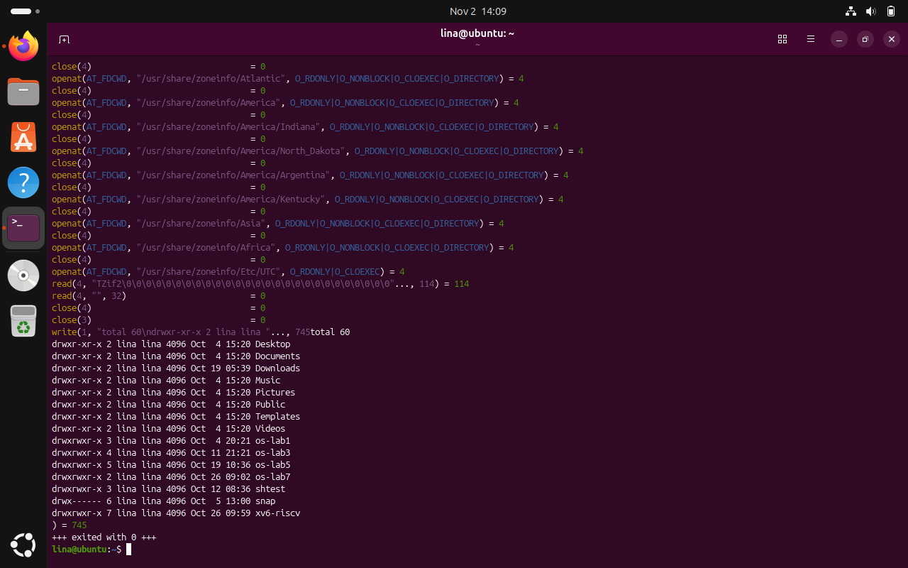
Figure 4.1 Tracing ls with selected system calls
The terminal screenshots show the filtered ls trace. In the recorded output, write(1, ..., 745) = 745 confirms that the directory listing was sent to standard output through file descriptor 1.

4.2 A Program That Calls the Kernel Directly
Task: Create syscalls.c following the laboratory sheet, compile it with the requested GCC warnings enabled, run it normally and inspect it with strace.
#include <fcntl.h>
#include <unistd.h>
#include <string.h>
#include <stdio.h>

int main(void) {
const char *msg = "hello, kernel\n";
int fd = open("note.txt", O_CREAT | O_WRONLY | O_TRUNC, 0644);
if (fd < 0) { perror("open"); return 1; }
printf("open returned descriptor %d\n", fd);
ssize_t n = write(fd, msg, strlen(msg));
printf("write sent %zd bytes\n", n);
close(fd);
fd = open("note.txt", O_RDONLY);
char buf[64];
n = read(fd, buf, sizeof(buf) - 1);
buf[n] = '\0';
printf("read got %zd bytes: %s", n, buf);
close(fd);
return 0;
}
gcc -Wall -Wextra -o syscalls syscalls.c
./syscalls
strace -e trace=openat,write,read,close ./syscalls
Observed output: open returned descriptor 3; write sent 14 bytes; read got 14 bytes: hello, kernel. The filtered trace confirmed openat on note.txt, write(3, ..., 14) = 14, read(3, ..., 63) = 14 and successful close calls. Separate write calls to descriptor 1 produced the diagnostic text.
The program creates or truncates note.txt using O_CREAT, O_WRONLY and O_TRUNC, with mode 0644 specifying the permissions used when a new file is created, subject to the process umask. After writing the message, it closes descriptor 3 and opens the same path again with O_RDONLY. The subsequent read uses a buffer of 64 bytes while requesting at most 63, leaving room for the terminating null character. The trace confirms that descriptor 3 was reused and that the 14 bytes read matched the message originally written.
Observe question: Why does the first openat return descriptor 3 rather than 0, 1 or 2?
Answer: Descriptors 0, 1 and 2 are normally already allocated to standard input (stdin), standard output (stdout) and standard error (stderr). The kernel therefore assigns the next available descriptor, commonly 3, to note.txt. A specific program can have different descriptor allocation if descriptors have been closed or redirected.
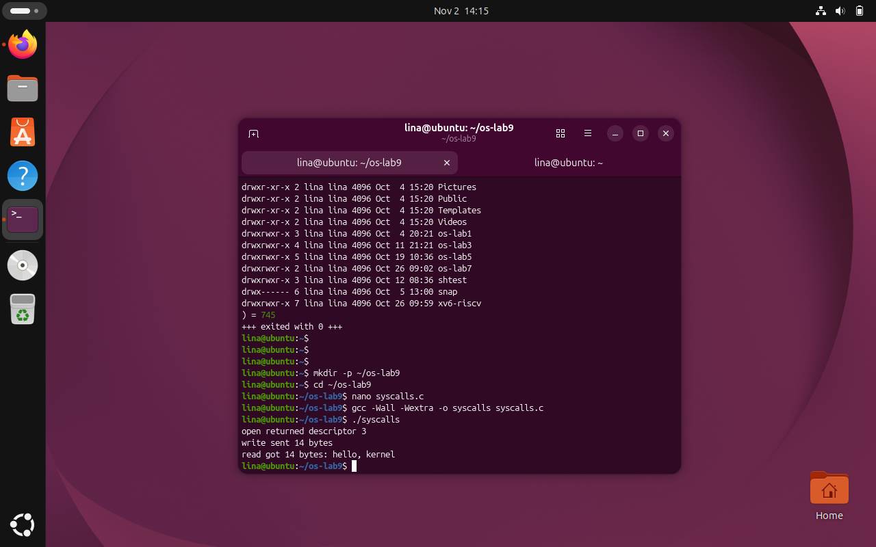
Figure 4.2 Compilation and normal execution of syscalls.c
The screenshots show compilation of syscalls.c and its successful execution. The program opened note.txt using descriptor 3, wrote 14 bytes and read back the same 14-byte message.

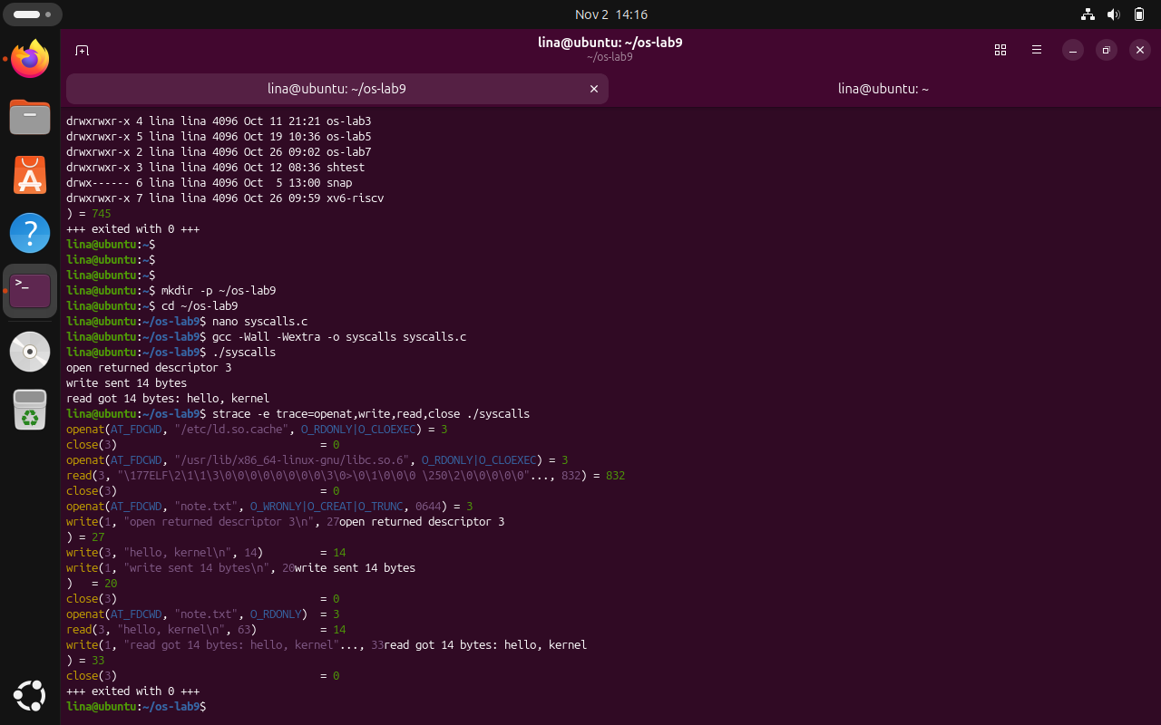
Figure 4.3 Filtered strace of the custom C program
The filtered trace shows openat, write, read and close calls associated with note.txt, as well as initialization calls for the dynamic loader and C library. The file operations return the expected values.

4.3 Count One Kind of Call
The supplied Lab 9 PDF lists Part 3 as “Count one kind of call” but provides no detailed commands for that section. As a supplementary experiment, strace was run in summary mode to measure the frequency of the four file-related calls already examined.
strace -c -e trace=openat,read,write,close ./syscalls
Observed summary: openat = 4 calls, read = 2 calls, write = 4 calls and close = 4 calls, for 14 calls in total. The four write calls include three output messages written to standard output and one 14-byte file write. The timing data depend on the execution environment.
The summary includes calls made during application startup as well as those written explicitly in syscalls.c. Two openat operations access the loader cache and C library, while the other two open note.txt. The four write calls include three lines of program output and one file write. The percentage-time and microseconds-per-call columns describe this particular execution and can vary between runs; the stable observation here is the number and type of monitored calls.
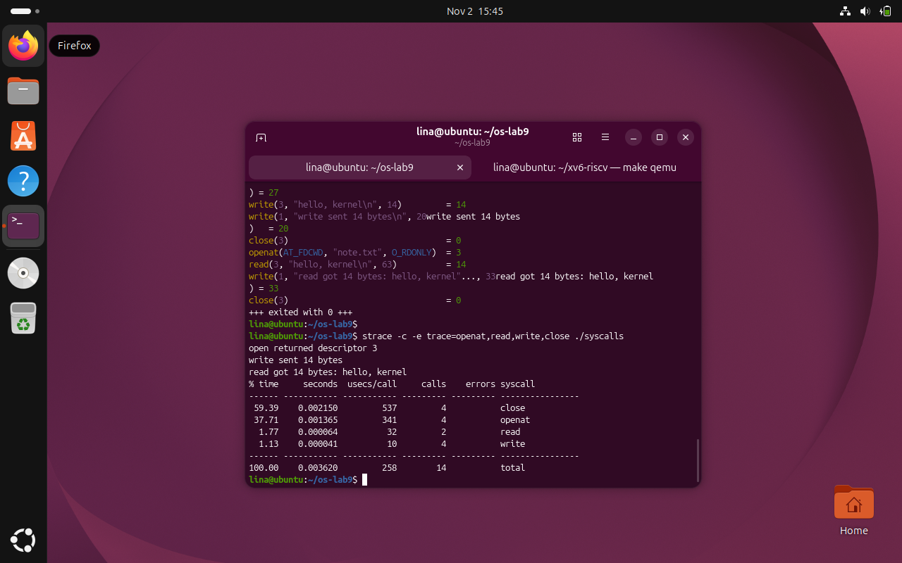
Figure 4.4 Counting file-related system calls using strace summary mode
The summary records 14 monitored calls: four openat, two read, four write and four close. This supplementary experiment uses the actual strace -c output.

CONCLUSION
Laboratory Work 9 provided practical experience in observing and analyzing the interaction between user-space applications and the Linux operating system kernel. By using the strace utility, the laboratory demonstrated how ordinary program operations are translated into system calls responsible for accessing files, transferring data, and managing system resources. The experiments helped establish a clearer understanding of the system-call interface and its importance in the execution of Linux applications.
The first part of the laboratory focused on monitoring the execution of the ls -l command using strace. By filtering the output to include openat, read, write, and close, it was possible to identify the system calls involved in accessing files and producing the directory listing. The experiment demonstrated that even a simple command performs numerous interactions with the operating system before displaying its results. In particular, the recorded write(1, ..., 745) = 745 call confirmed that the directory listing was written to standard output through file descriptor 1.
The second part involved developing a C program that performed file operations using open(), write(), read(), and close(). The program successfully created note.txt, wrote the message hello, kernel followed by a newline, and read the same content back. The observed output confirmed that the first file-opening operation returned descriptor 3 and that 14 bytes were successfully written and subsequently read. These results demonstrated the correct use of file descriptors, access flags, and return values when communicating with the Linux kernel.
An important observation was the relationship between the functions used in the C source code and the system calls displayed by strace. Although the program called open(), the trace recorded the corresponding operations as openat(). This distinction demonstrated that library functions may use different underlying system calls to provide the requested functionality. The experiment also showed that file descriptors can be reused after being closed, since descriptor 3 was assigned both when opening the file for writing and when reopening it for reading.
The supplementary counting experiment provided additional information about the frequency of system calls during program execution. Using strace in summary mode, the recorded results showed 14 monitored system calls, consisting of four openat(), two read(), four write(), and four close() operations. This demonstrated that the execution of a relatively small C program involves additional operations associated with program initialization and library loading. The experiment also highlighted the usefulness of statistical tracing for identifying frequently executed system calls and examining their execution costs.
Another significant aspect of the laboratory was understanding the role of standard file descriptors. The experiments confirmed that descriptors 0, 1, and 2 are normally assigned to standard input, standard output, and standard error, respectively. Consequently, the first newly opened file received descriptor 3. Understanding this convention is essential for interpreting system-call traces, implementing file operations, and working with input/output redirection in Linux programs.
Overall, Laboratory Work 9 successfully demonstrated how system-call tracing can be used to investigate program behavior at the boundary between user space and kernel space. All experiments were completed successfully, and the observed results were consistent with the expected behavior of the implemented operations. The laboratory strengthened practical knowledge of Linux file handling, system-call arguments, return values, descriptor management, and execution tracing. These concepts provide a foundation for understanding operating-system mechanisms and for using diagnostic tools to analyze and troubleshoot application behavior.

REFERENCES
[1] GitHub Repository. Laboratory Work 4. Available at: https://github.com/linalinalina1/os-2026-FeliciaOjog/tree/main/lab9
[2] Technical University of Moldova, “OS 2026 - Lab 9 - Watching System Calls (Linux),” course laboratory sheet, 2026.
[3] Linux manual pages: strace(1), open(2), read(2), write(2), close(2).

