
MINISTRY OF EDUCATION, CULTURE AND RESEARCH
OF THE REPUBLIC OF MOLDOVA
Technical University of Moldova
Faculty of Computers, Informatics and Microelectronics
Department of Software Engineering and Automation

Report
Laboratory Work No.1 and No.2
Operating Systems
Lab 1: The OS as a Resource Manager
Lab 2: Meet the OS You Will Build (xv6)

Done by:
st. gr. FAF-243, Ojog Felicia

Checked by:
Reițman Patricia,
university assistant

Chișinău - 2026
INTRODUCTION 3
1 PURPOSE OF THE REPORT 4
2 THEORETICAL BACKGROUND 5
3 DEVELOPMENT ENVIRONMENT 6
4 LABORATORY WORK 1 - THE OS AS A RESOURCE MANAGER 7
4.1 Files and Directories 7
4.2 Processes 8
4.3 Memory 11
4.4 Devices and Storage 12
5 LABORATORY WORK 2 - MEET THE OS YOU WILL BUILD 14
5.1 Building and Booting xv6 14
5.2 Using xv6 15
5.3 Source Code Analysis 16
5.4 Implementing the sleep Program 17
CONCLUSION 23
REFERENCES 25

INTRODUCTION
An operating system is the software layer that manages hardware resources and provides services to programs. It coordinates files, running processes, memory, and input/output devices while presenting applications with consistent interfaces. Linux exposes many of these mechanisms directly through terminal commands and pseudo-filesystems, which makes it possible to observe the operating system as a resource manager.
The second laboratory work approaches the operating system from the opposite direction. Instead of only observing a complete Linux system, xv6 is built from source and executed as a small Unix-like teaching operating system. Because xv6 is compact, its user programs, system-call interface, and kernel implementation can be inspected directly.
These two laboratory works therefore complement each other. The first work examines the behavior of a real Linux system from the outside, while the second work studies the structure of an operating system from the inside by compiling xv6, running its user programs, inspecting source code, and implementing a new user-space command.

1 PURPOSE OF THE REPORT
The purpose of this report is to document the practical work performed in Laboratory Work 1 and Laboratory Work 2 for the Operating Systems course. Laboratory Work 1 focuses on observing how Linux manages four fundamental resources: files, processes, memory, and devices. The observations were obtained directly from the Ubuntu terminal using standard Linux commands and the /proc and /dev interfaces.
Laboratory Work 2 focuses on the xv6 teaching operating system. The objectives were to build and boot xv6 under the QEMU emulator, use its shell and standard user programs, inspect the relationship between user-space code and kernel system-call handlers, and implement a small sleep user program. The program was then rebuilt and tested inside xv6.
The report records the commands, relevant outputs, practical observations, screenshots, and conclusions obtained during both laboratory works.

2 THEORETICAL BACKGROUND
An operating system manages resources on behalf of programs. File management organizes persistent data into a hierarchical namespace and applies ownership and permission rules. Process management creates, schedules, isolates, and terminates running programs. Memory management distributes physical RAM among processes while giving each process its own virtual address space. Device and input/output management provides uniform interfaces for storage devices, terminals, and other hardware.
Linux exposes system information through both commands and special files. The /proc pseudo-filesystem contains process and kernel information generated dynamically by the operating system, while /dev contains file-like representations of devices. Commands such as ps, top, free, df, lsblk, and mount provide convenient views of the corresponding kernel-managed resources.
xv6 is a small Unix-like operating system used for teaching operating-system concepts. It separates privileged kernel code in kernel/ from ordinary user programs in user/. User programs request services from the kernel through system calls such as read(), write(), open(), close(), and process-related calls. Pipes demonstrate inter-process communication because one process can write data that another process reads through kernel-managed file descriptors.
The xv6 version used in this work is the current RISC-V repository revision. In this revision, the user-visible delay system call that older course material refers to as sleep() has been renamed to pause(). For this reason, the required user command remains named sleep, but its implementation calls pause() with the requested number of ticks.

3 DEVELOPMENT ENVIRONMENT
The laboratory works were completed in Ubuntu 26.04.1 LTS running as a virtual machine in Oracle VirtualBox. The virtual machine was configured with 4 GB of RAM, two virtual processors, and a 25 GB virtual disk. The terminal was used for all Linux and xv6 commands.
Laboratory Work 1 required only the standard Linux utilities already available in Ubuntu. Laboratory Work 2 additionally required Git, the RISC-V cross-compilation toolchain, and QEMU. The xv6 source code was cloned from the MIT PDOS xv6-riscv repository into /home/lina/xv6-riscv. Because the current Ubuntu package split provides the RISC-V emulator separately, qemu-system-riscv was installed in addition to the other required packages.
The same Ubuntu virtual machine was used for both laboratories. xv6 was compiled from source inside Ubuntu and then executed under QEMU, resulting in the hierarchy Windows -> VirtualBox -> Ubuntu -> QEMU -> xv6.
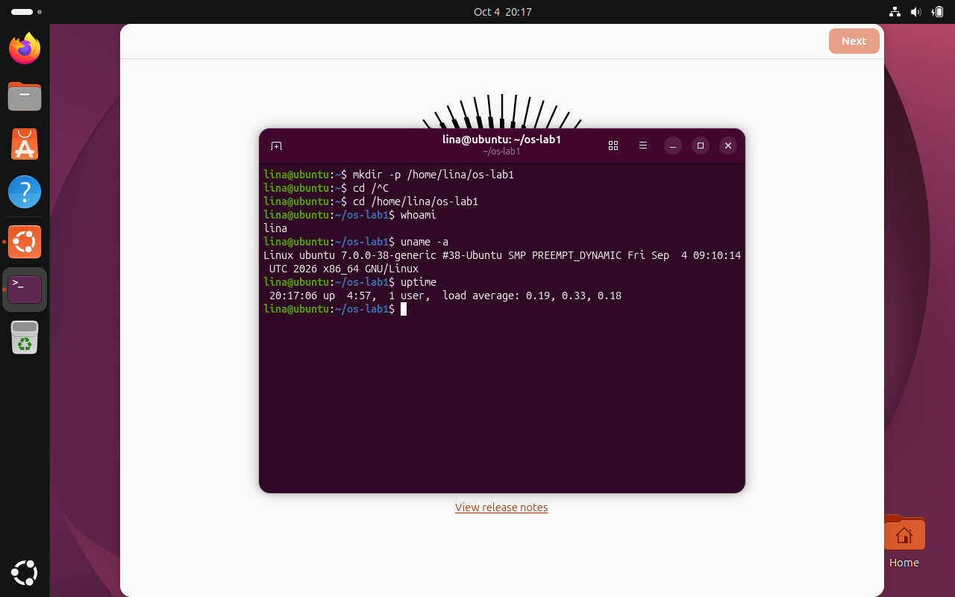
Figure 3.1 Ubuntu terminal and initial Lab 1 environment
The screenshot shows the Ubuntu desktop running inside Oracle VirtualBox with a terminal opened for the first laboratory work. The prompt confirms that the active user is lina and that the working directory is /home/lina/os-lab1. This screen establishes the Linux environment in which the commands for both laboratory works were executed.

4 LABORATORY WORK 1 - THE OS AS A RESOURCE MANAGER
Laboratory Work 1 was performed in the directory /home/lina/os-lab1. The initial commands whoami, uname -a, and uptime were used to identify the current user, kernel, and system uptime. The user was lina, and the system was running an Ubuntu Linux kernel. The following sections document the four required resource-management areas.

4.1 Files and Directories
Task: Explore the Linux file-system tree, create and manipulate files, and observe ownership and permissions.
Commands used:
pwd
ls -la /
ls -la /home/lina
cd /etc
ls | head
cd /home/lina/os-lab1
mkdir demo
cd demo
echo "hello operating systems" > note.txt
cp note.txt copy.txt
mv copy.txt renamed.txt
ls -l
rm renamed.txt
ls -l note.txt
chmod 600 note.txt
ls -l note.txt
chmod 644 note.txt
Results and observations:
The files created in the demo directory were owned by user lina and group lina. After chmod 600 note.txt, the permission string became -rw-------. The first character indicates a regular file, rw- gives the owner read and write permission, and the remaining two groups of --- indicate that the group and other users have no permissions. The permissions were then restored with chmod 644 note.txt.
Two examples of directories directly under the root directory are /etc, which contains system-wide configuration files, and /home, which contains the home directories of users.
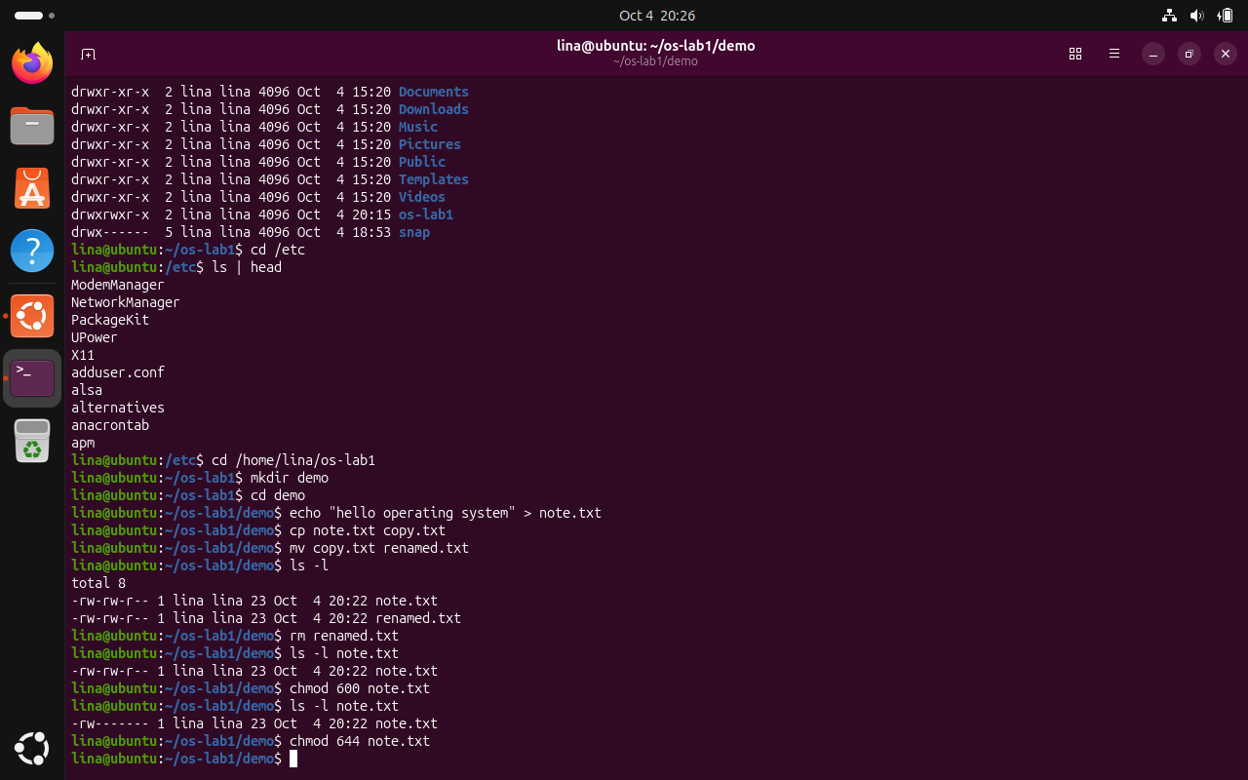
Figure 4.1 File creation, manipulation, ownership, and permissions
The screenshot documents the file-system operations performed in the demo directory. It shows the creation of note.txt, copying and renaming of the file, removal of renamed.txt, and the use of ls -l to inspect ownership and permissions. The output also demonstrates the effect of chmod 600, where note.txt becomes readable and writable only by the owner, followed by chmod 644 to restore normal read permissions for the group and other users.

4.2 Processes
Task: Inspect running processes, start a background process, identify it, terminate it, and inspect its /proc information.
Commands used:
ps aux | head
ps aux | wc -l
top
sleep 300 &
jobs
ps -ef | grep sleep
kill 9039
sleep 300 &
PID=$!
ls /proc/$PID/
cat /proc/$PID/status | head -20
kill $PID
Results and observations:
The idle virtual machine had approximately 203 processes. Process ID 1 was systemd, the init and system manager process for the Ubuntu system. The first background sleep process received PID 9039, and a later process used for /proc inspection received PID 9072.
The State line in /proc/9072/status was S (sleeping). This is the expected state because the sleep program is waiting for time to pass rather than actively using the processor.
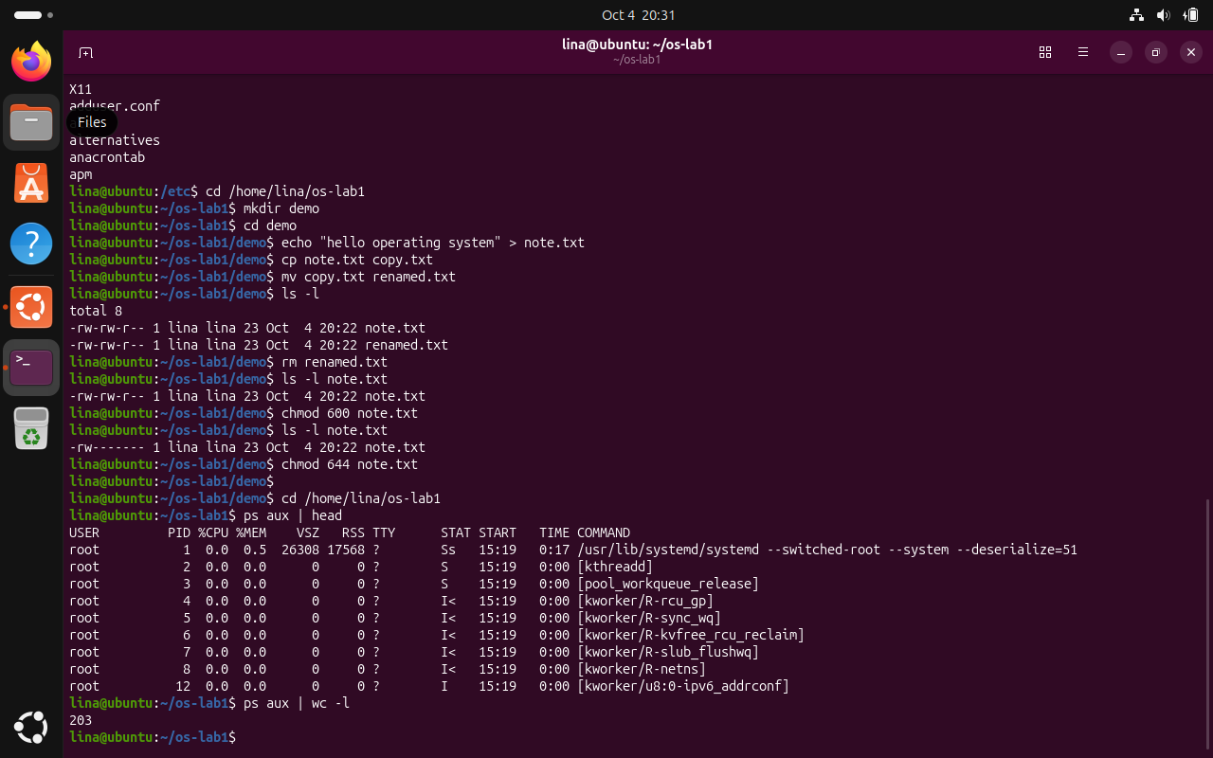
Figure 4.2 Process count on the idle Ubuntu virtual machine
The screenshot shows the command ps aux | wc -l being used to estimate the number of active processes in the Ubuntu virtual machine. The result is 203, which provides a snapshot of the process population before creating additional test processes. The preceding ps aux | head output also shows systemd as PID 1 and several kernel processes managed by the operating system.
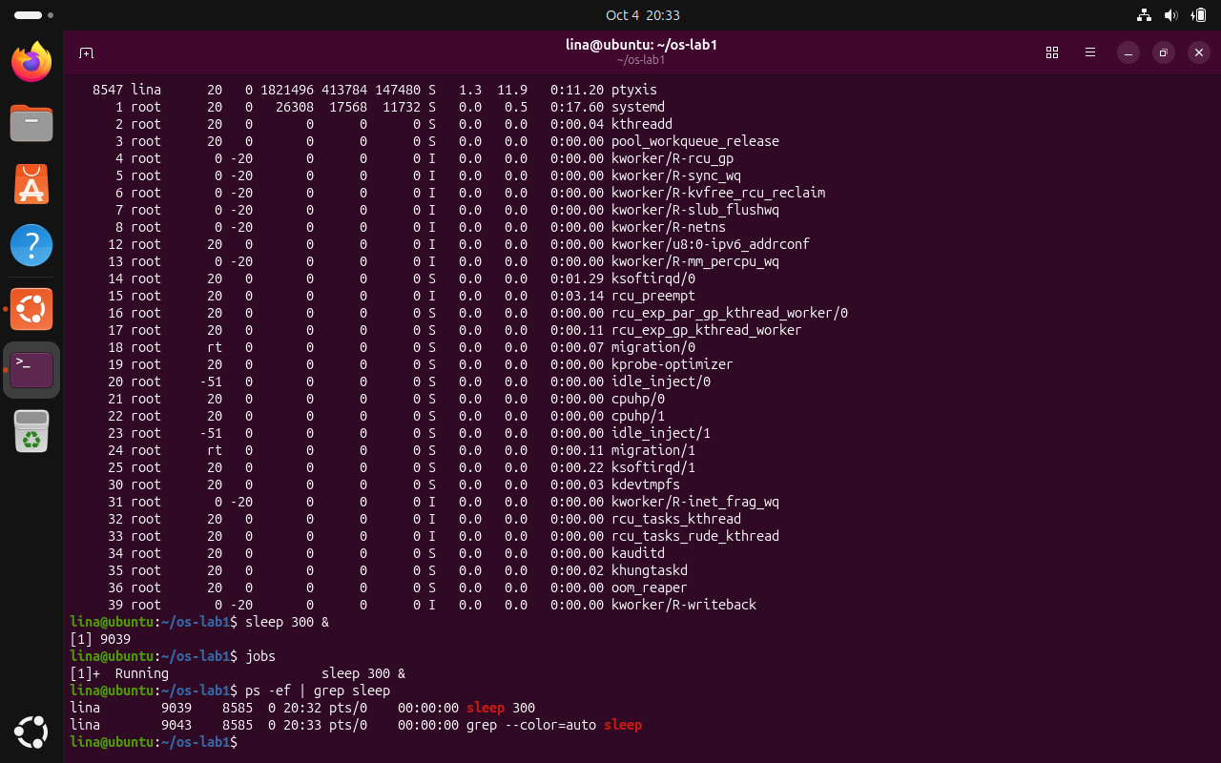
Figure 4.3 Background sleep process, jobs, and process search
The screenshot shows a sleep 300 process launched in the background and assigned PID 9039. The jobs command confirms that the process is running as a background job, while ps -ef | grep sleep locates the process in the system process table. The process is then terminated with kill, demonstrating basic process creation, identification, monitoring, and termination.
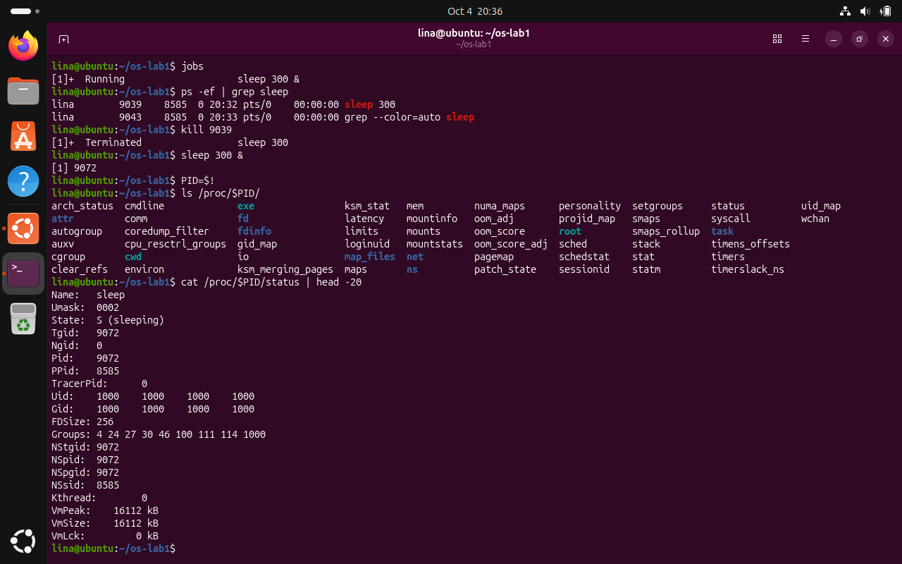
Figure 4.4 Process information exposed through /proc
The screenshot illustrates how Linux exposes process information through the /proc pseudo-filesystem. A second sleep process is started, its PID is saved in the shell variable PID, and the directory /proc/$PID is inspected. The status file shows State: S (sleeping), confirming that the process is waiting rather than actively executing on the CPU, together with identifiers, memory information, and other process metadata.

4.3 Memory
Task: Observe physical memory and swap usage and inspect the resident memory of a simple process.
Commands used:
free -h
cat /proc/meminfo | head -6
sleep 300 &
PID=$!
grep VmRSS /proc/$PID/status
kill $PID
Results and observations:
The free -h output reported approximately 3.3 GiB of total RAM, 1.5 GiB used, 190 MiB free, and approximately 1.8 GiB available at the moment of measurement. No swap space was configured, as the Swap row reported 0 B.
The resident set size of the test sleep process was VmRSS = 7700 kB. This value is small compared with the total memory of the virtual machine, which is expected because sleep performs almost no active computation and requires only a small process image and runtime state.
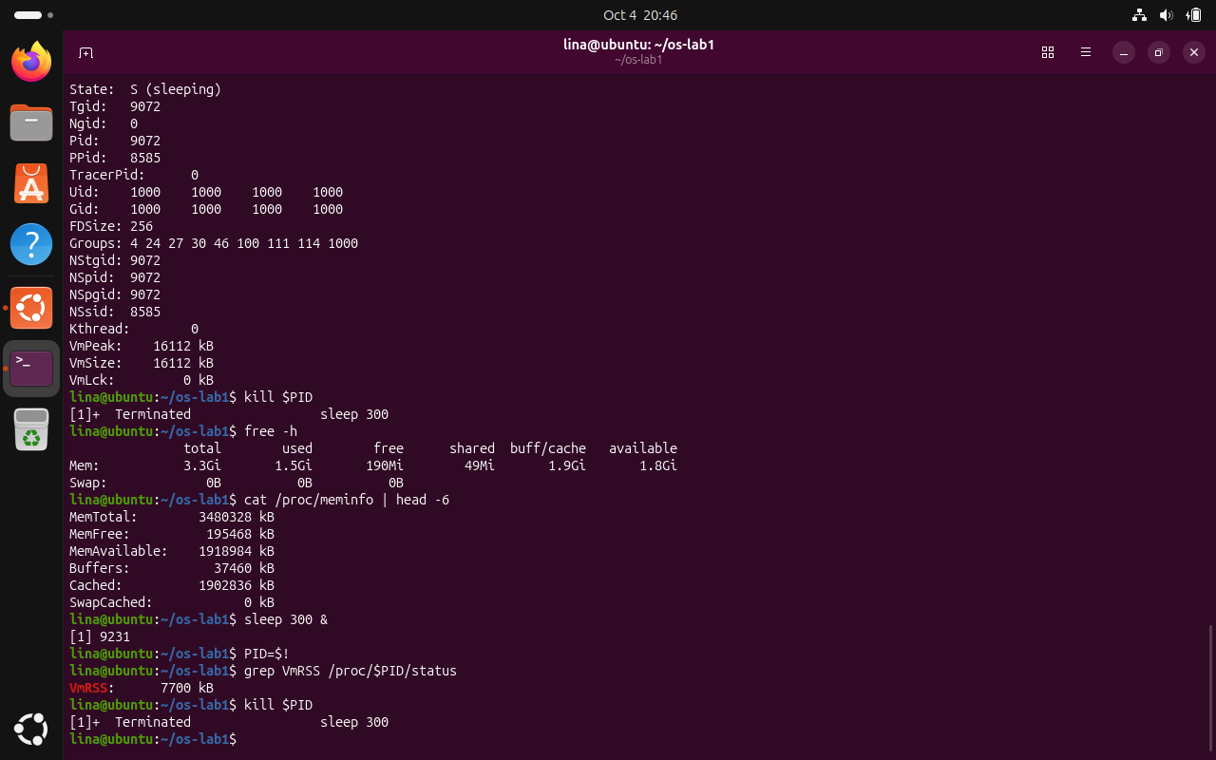
Figure 4.5 Physical memory, swap, and VmRSS measurements
The screenshot presents the memory measurements collected with free -h, /proc/meminfo, and the VmRSS field of a test process. At the moment of measurement, the virtual machine had approximately 3.3 GiB of RAM, no configured swap, and about 1.8 GiB of available memory. The sleep process used approximately 7700 kB of resident memory, showing that a simple waiting process consumes only a small fraction of the available physical memory.

4.4 Devices and Storage
Task: Inspect mounted filesystems, block devices, the size of the lab directory, and device files.
Commands used:
df -h
lsblk
du -sh /home/lina/os-lab1
ls -l /dev | head
mount | head
Results and observations:
The root filesystem / was mounted from /dev/sda2 and used the ext4 filesystem. The virtual disk appeared as sda with a 25 GB partition mounted at /. The size of the os-lab1 working directory was 12K at the time of measurement.
An example device entry is /dev/cdrom, which is a symbolic link to sr0 and represents the virtual CD/DVD drive. The observation illustrates the Unix idea that “everything is a file”: hardware devices and many kernel resources are represented through file-like interfaces that can be accessed using common system operations.
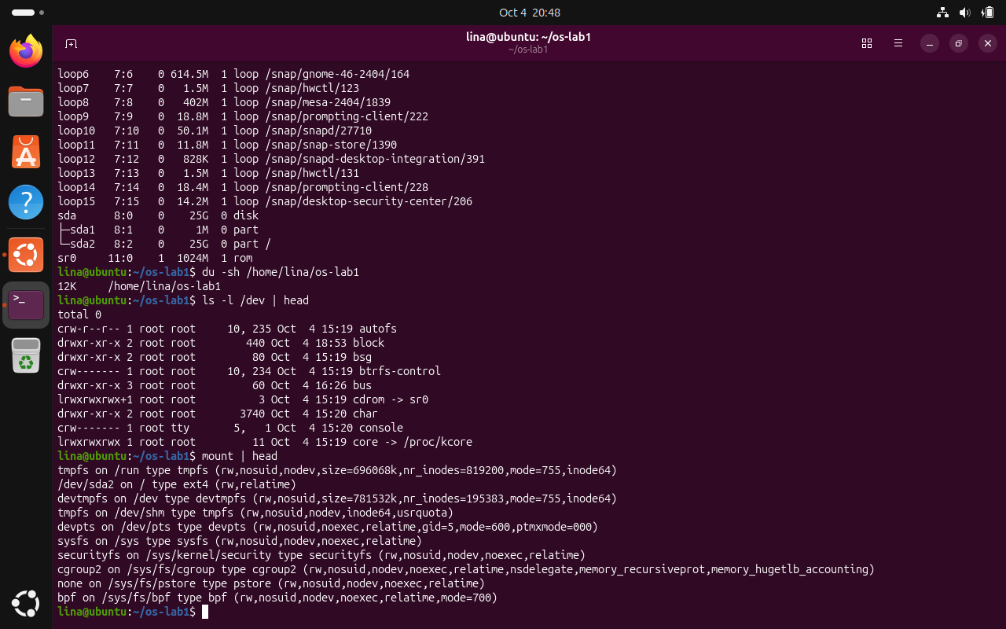
Figure 4.6 Block devices, device files, and mounted filesystems
The screenshot summarizes the storage and device observations from Lab 1. The lsblk output shows the 25 GB virtual disk and the sda2 partition mounted as the root filesystem, while du reports the size of the laboratory directory. The /dev listing includes device entries such as cdrom -> sr0, and the mount output confirms that /dev/sda2 is mounted on / using the ext4 filesystem.

5 LABORATORY WORK 2 - MEET THE OS YOU WILL BUILD
Laboratory Work 2 used the same Ubuntu virtual machine. The xv6 source tree was cloned to /home/lina/xv6-riscv and compiled using the RISC-V cross compiler. xv6 was then booted in QEMU and used through its own shell.

5.1 Building and Booting xv6
Commands used:
cd /home/lina
git clone https://github.com/mit-pdos/xv6-riscv /home/lina/xv6-riscv
cd /home/lina/xv6-riscv
ls
make qemu
Results and observations:
The cloned source tree contained the expected Makefile, kernel/, user/, README, and related source files. The make qemu command compiled the kernel and user programs, generated the xv6 filesystem image, and started the RISC-V QEMU emulator. The successful boot ended with the messages “xv6 kernel is booting” and “init: starting sh”, followed by the xv6 $ shell prompt.
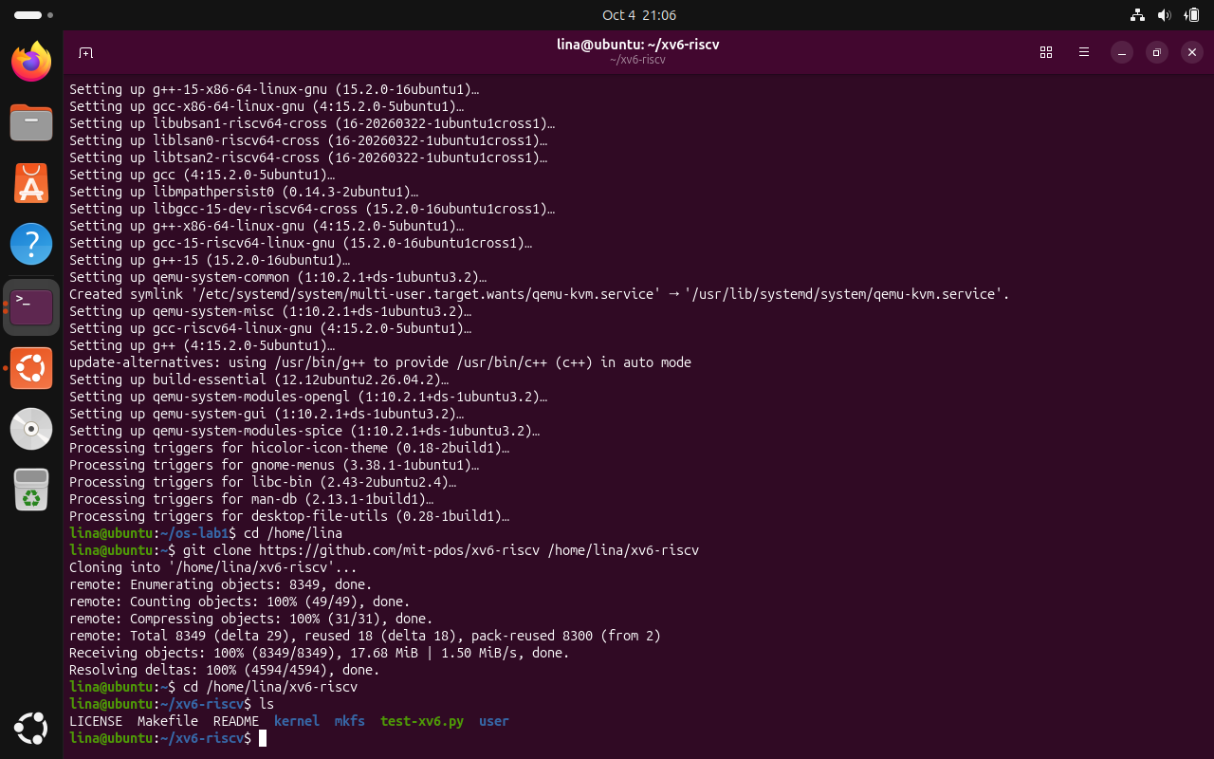
Figure 5.1 xv6 source tree after cloning the repository
The screenshot shows the successful installation of the required development packages, cloning of the xv6-riscv repository, and inspection of the source tree. The ls output confirms the presence of the main project components, including the Makefile, kernel directory, user directory, README file, and mkfs utility. This verifies that the xv6 source code was available locally and ready to be compiled.
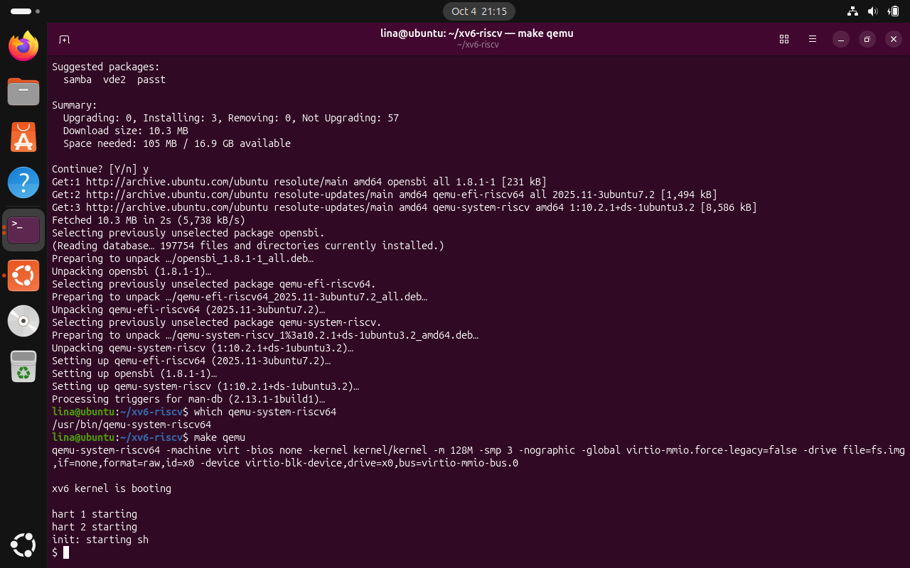
Figure 5.2 Successful xv6 build and boot in QEMU
The screenshot shows xv6 being compiled with the RISC-V cross compiler and started with QEMU. The boot messages end with “xv6 kernel is booting”, the hardware threads starting, and “init: starting sh”, after which the $ prompt appears. Reaching this prompt confirms that the kernel and user programs were built successfully and that xv6 booted into its shell.

5.2 Using xv6
Commands executed inside xv6:
ls
cat README
echo hello xv6
ls | grep c
wc README
usertests -q
Results and observations:
Three example programs provided by xv6 are ls, cat, and echo. The command ls | grep c demonstrated that pipes work in xv6. For a pipe to work, the operating system must support multiple processes and an inter-process communication mechanism that transfers data between file descriptors managed by the kernel.
The xv6 shell is similar to the Linux shell used in Laboratory Work 1 because it provides a command prompt, executes programs, supports pipes, and includes familiar Unix commands. However, the xv6 shell is intentionally much simpler and provides far fewer programs and features than a modern Linux shell.
The optional usertests -q suite was also executed. Although the suite took several minutes under QEMU inside VirtualBox, it completed successfully and reported ALL TESTS PASSED.
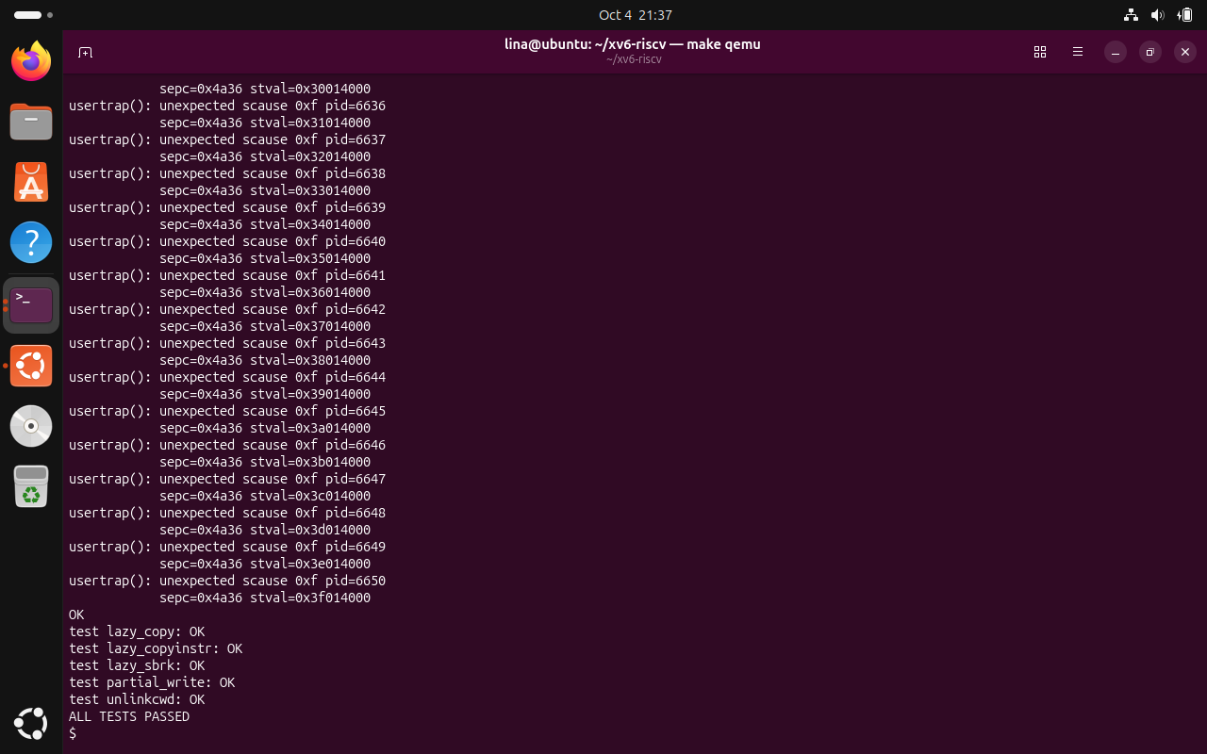
Figure 5.3 xv6 kernel test suite completed successfully
The screenshot shows the final stage of the optional usertests -q execution inside xv6. Several tests finish with OK, and the final line reports ALL TESTS PASSED. This result provides additional verification that the compiled xv6 system is functioning correctly under QEMU in the virtual-machine environment.

5.3 Source Code Analysis
Commands used after leaving QEMU:
sed -n "1,40p" user/ls.c
sed -n "1,30p" user/cat.c
cat user/user.h
grep -n "sys_read\|sys_write" kernel/sysfile.c | head
Results and observations:
The user/cat.c program relies on system-call interface functions including read() and write() to obtain bytes from a file descriptor and send bytes to an output descriptor. It also uses open(), close(), and exit() while processing file arguments. These calls cross the user/kernel boundary so that the kernel can perform protected file and device operations on behalf of the program.
In the repository revision used for the laboratory, sys_read is implemented in kernel/sysfile.c at line 69 and sys_write at line 83. The kernel/ directory contains privileged operating-system code such as scheduling, memory management, filesystems, and system-call handlers, whereas user/ contains ordinary programs that execute on top of the kernel.
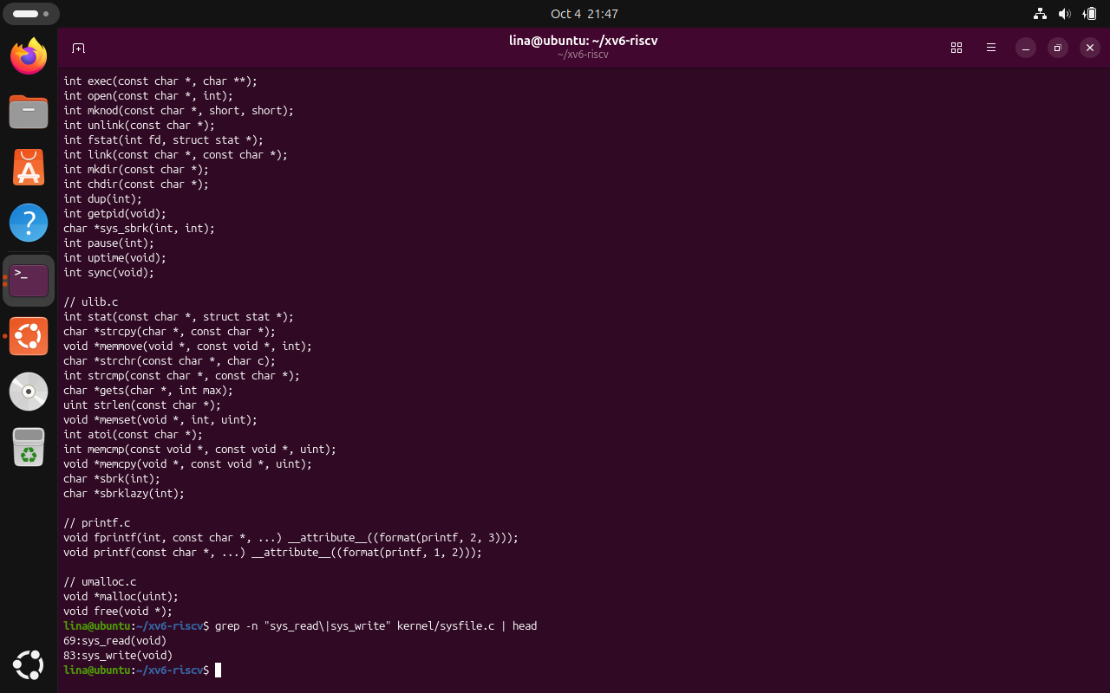
Figure 5.4 Location of sys_read and sys_write in kernel/sysfile.c
The screenshot shows source-code inspection performed after leaving QEMU. The grep command identifies sys_read at line 69 and sys_write at line 83 of kernel/sysfile.c in the repository revision used for this work. Together with the inspection of user/cat.c and user/user.h, this demonstrates the connection between user-space calls such as read() and write() and their kernel-side system-call handlers.

5.4 Implementing the sleep Program
Task: Add a new xv6 user command named sleep that pauses for the number of clock ticks supplied as its only argument.
Source Code:
#include "kernel/types.h"
#include "user/user.h"

int
main(int argc, char *argv[])
{
if(argc != 2){
fprintf(2, "usage: sleep <ticks>\n");
exit(1);
}

pause(atoi(argv[1]));
exit(0);
}
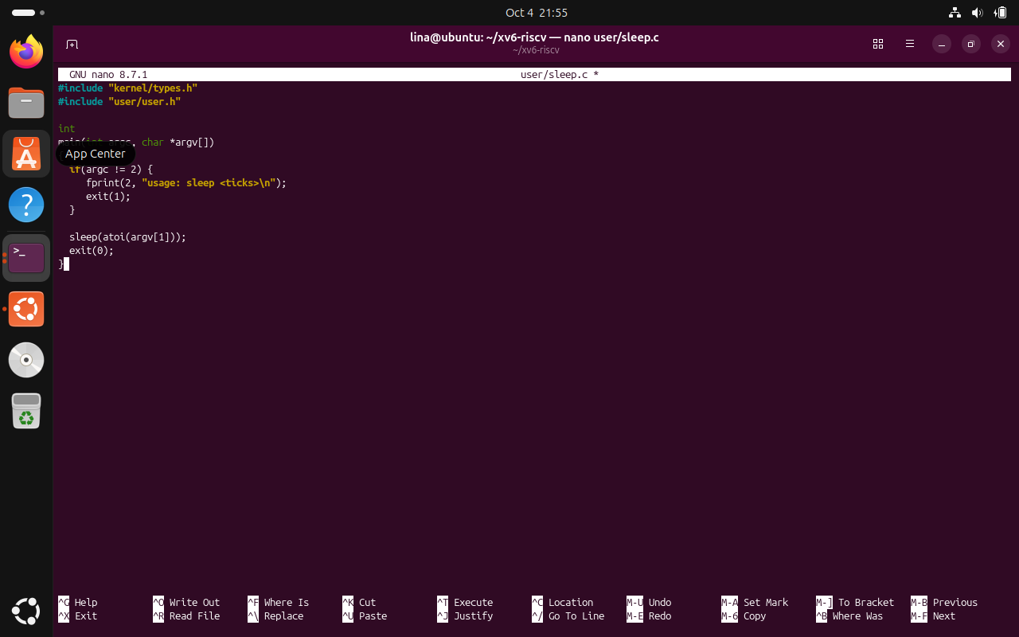
Figure 5.5 Initial sleep.c implementation written in Nano
The screenshot shows user/sleep.c being written in the Nano editor. This initial implementation followed the laboratory sheet and used the original sleep() interface. The later build and repository inspection showed that the current xv6 revision renamed this user-space interface to pause(), so the final code was updated accordingly.
The current xv6 repository revision uses pause(int) as the user-visible delay system call. The course sheet was written for an earlier revision in which this interface was named sleep(int). To preserve the required user command while remaining compatible with the current source tree, the executable is still named sleep and calls pause(atoi(argv[1])).
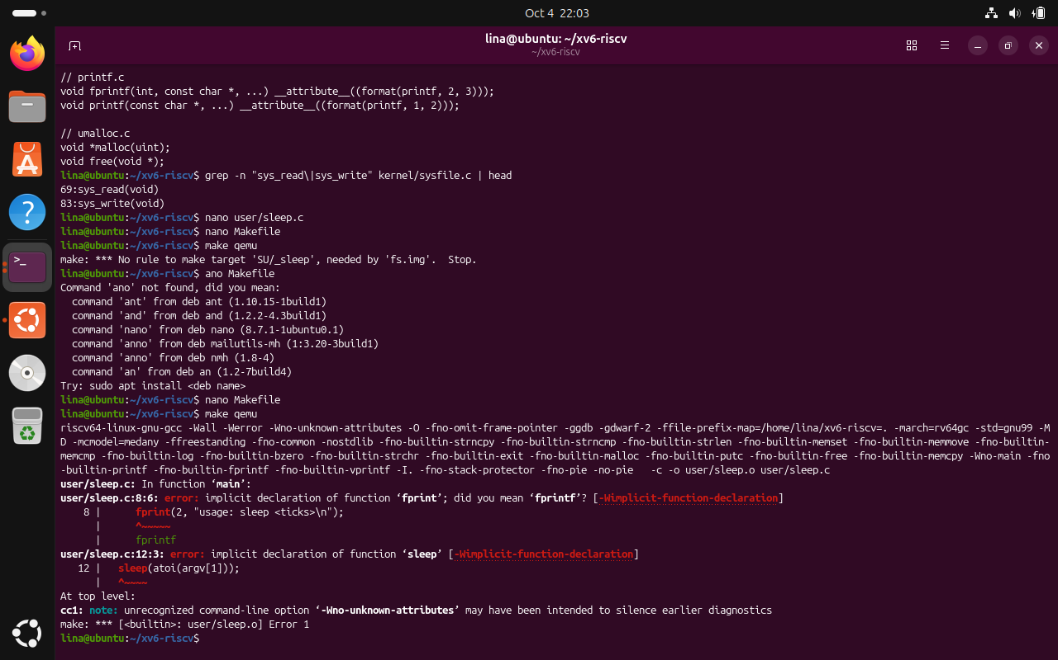
Figure 5.6 Initial build diagnostics while integrating the sleep program
The screenshot records the first build attempt after adding the new user program. The compiler exposed an initial fprintf typo and also reported that sleep() was not declared in the current user interface. These diagnostics helped identify the required corrections before rebuilding the program with fprintf() and the current pause() system-call interface.
Makefile modification:
UPROGS=\
...
$U/_sync\
$U/_sleep\
The $U/_sleep entry was added to the UPROGS list so that the new program would be compiled and included in the xv6 filesystem image.
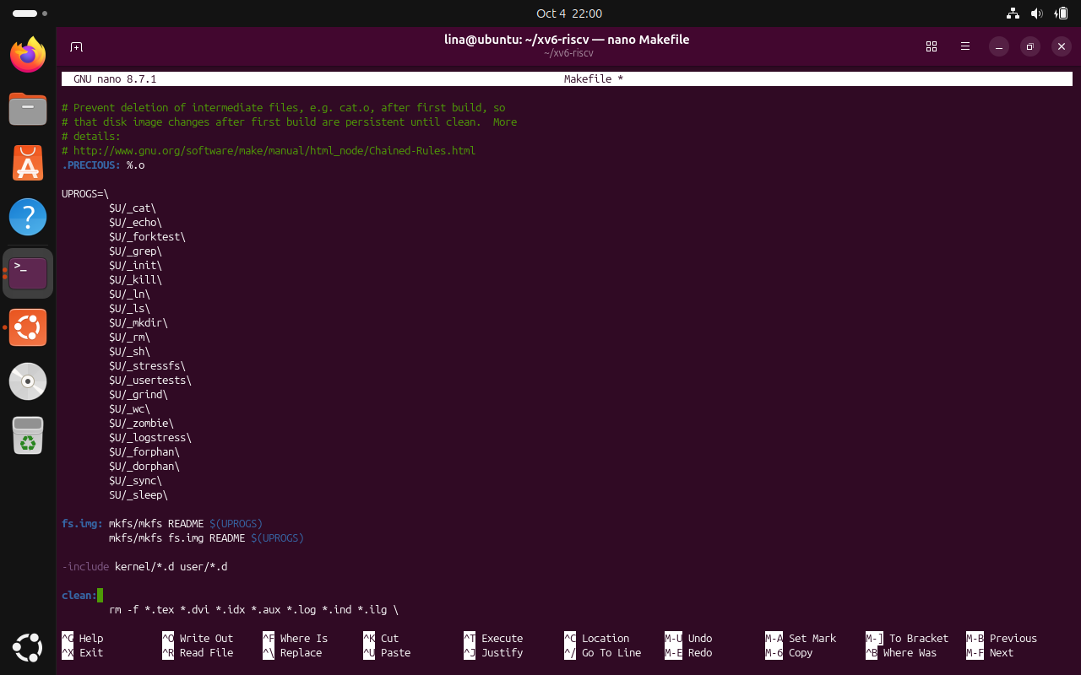
Figure 5.7 sleep program added to the xv6 UPROGS list
The screenshot shows the UPROGS section of the xv6 Makefile after adding $U/_sleep\. Entries in this list are compiled as user programs and included in the xv6 filesystem image. Adding the new line therefore ensures that the custom sleep command is built together with the standard xv6 utilities and becomes available from the xv6 shell.
The repository history confirmed that the user-space sleep() interface had been renamed to pause() in the current revision. This explains why the exact code from the course sheet did not compile without adapting the system-call name.
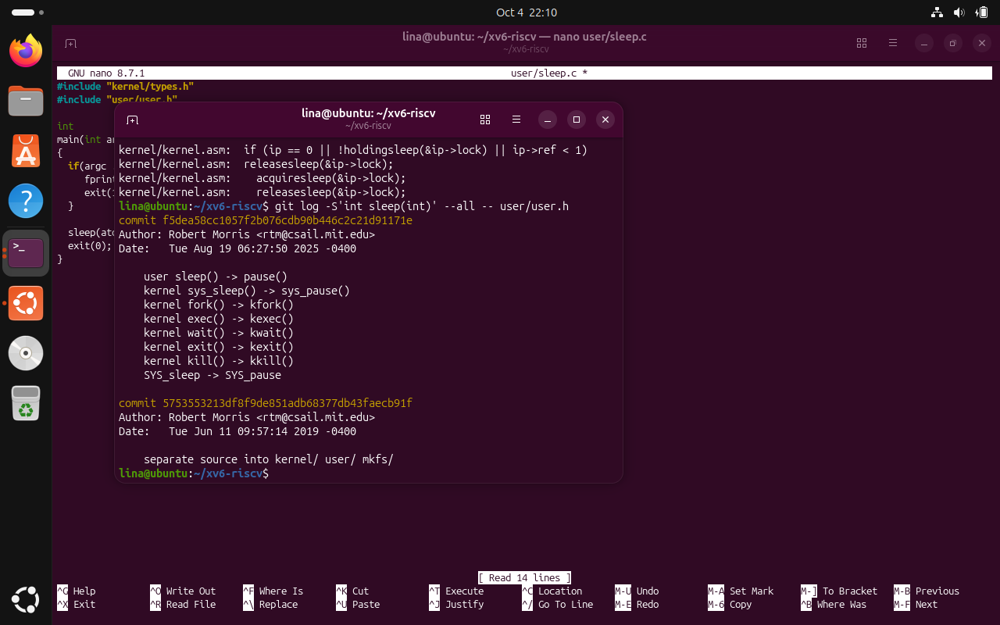
Figure 5.8 Repository history showing the sleep() to pause() rename
The screenshot records the repository-history check used to explain the difference between the laboratory instructions and the current xv6 source tree. The Git history shows a 2025 change in which the user-space sleep() interface was renamed to pause(), together with the corresponding kernel and system-call names. For this reason, the program remains named sleep as required by the task but calls pause() internally in the current repository revision.
Program Execution and Result Verification:
After correcting the user program and rebuilding with make qemu, xv6 compiled and booted successfully with the new _sleep executable included in the filesystem image. Running sleep 10 paused briefly and then returned to the shell prompt. Running sleep without an argument displayed the required usage message “usage: sleep <ticks>”. These tests confirmed the correct behavior of the program.

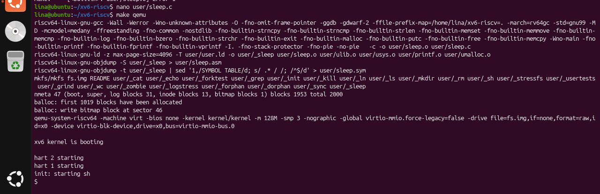
Figure 5.9 Successful rebuild and boot with the new sleep user program
The screenshot shows the successful rebuild after correcting the sleep program and adding it to the Makefile. The build output includes user/_sleep in the generated filesystem image, and xv6 then boots normally to the shell prompt. The new command was subsequently tested with sleep 10, which paused and returned to the prompt, and with sleep without an argument, which displayed the expected usage message.

CONCLUSION
The two laboratory works provided a practical and complementary understanding of operating systems by combining observation of a complete Linux environment with direct interaction with a small teaching operating system. Laboratory Work 1 focused on Linux as a resource manager, while Laboratory Work 2 moved closer to the implementation level by building, running, inspecting, and extending xv6. Together, the laboratories connected concepts that are often studied separately, such as processes, memory, files, devices, system calls, user programs, and kernel code.
In Laboratory Work 1, the Linux command line was used to observe how the operating system organizes and protects files, manages processes, allocates physical memory, and represents devices and mounted storage. File ownership and permission changes were verified directly with ls -l and chmod. Process-management commands demonstrated how a program can be started in the background, located in the process table, inspected through /proc, and terminated. The memory exercises showed the distinction between total, free, and available RAM and demonstrated that a simple sleeping process occupies only a small resident set. Storage commands showed that the root filesystem was mounted from /dev/sda2 and illustrated the Unix principle of exposing many resources through file-like interfaces.
The four main operating-system resources investigated in Laboratory Work 1 were files, processes, memory, and devices/storage. Files were observed with commands such as ls and chmod; processes were examined with ps, top, and the /proc filesystem; memory was inspected with free and /proc/meminfo; and devices and storage were analyzed with lsblk, df, /dev, and mount. This provided a direct overview of how Linux exposes and manages its principal system resources.
Laboratory Work 2 provided a more internal view of operating-system structure. The xv6 source code was successfully cloned, compiled for RISC-V, and executed under QEMU. Using the xv6 shell demonstrated that even a small teaching operating system provides familiar Unix concepts such as processes, programs, files, pipes, and a command interpreter. Programs such as ls, cat, and echo were available in xv6. A pipe such as ls | grep c demonstrated both process management and inter-process communication, since separate processes are executed and their input and output are connected through a pipe. The xv6 shell therefore provides the fundamental behavior of a Unix shell, although it is much simpler and contains fewer commands and advanced features than a modern Linux shell. The optional usertests suite completed with ALL TESTS PASSED, giving additional confidence that the built system was functioning correctly in the emulated environment.
Source-code analysis made the boundary between user space and kernel space more concrete. The user programs in user/ invoke interfaces such as read() and write(), while the corresponding kernel-side handlers are implemented in kernel/. The read() interface obtains data from a file descriptor, while write() sends data to a file descriptor such as standard output. In the repository revision used for this laboratory, sys_read and sys_write were located in kernel/sysfile.c at lines 69 and 83. The user/ directory contains ordinary user-space programs, whereas the kernel/ directory contains privileged operating-system functionality. This inspection demonstrated how a user program requests a service without directly accessing privileged kernel functionality, which is a central operating-system protection mechanism.
The final xv6 task extended the system with a new user command named sleep. The program validated its argument, converted the number of ticks, invoked the available delay system-call interface, and exited normally. Because the current xv6 repository renamed the older user-space sleep() interface to pause(), the implementation was adapted to call pause() internally while preserving the required sleep command and behavior. The program was added to UPROGS, rebuilt successfully, and verified with both a valid invocation and the missing-argument case.
Overall, the work demonstrated both how an operating system can be examined from the outside and how its internal implementation can be explored and modified. Linux provided a realistic environment for observing resource management, while xv6 exposed the underlying mechanisms in a source tree small enough to study directly. The combination of command-line experimentation, source-code inspection, compilation, emulation, and implementation strengthened the connection between theoretical operating-system concepts and their concrete behavior in real and educational systems.

REFERENCES
[1] GitHub Repository. Laboratory Work 1. Available at: https://github.com/linalinalina1/os-2026-FeliciaOjog/tree/main/lab1
[2] GitHub Repository. Laboratory Work 2. Available at: https://github.com/linalinalina1/os-2026-FeliciaOjog/tree/main/lab2
[3] Operating Systems 2026-2027, Laboratory Work 1: “The OS as a Resource Manager (Linux)”, FCIM / FAF / Technical University of Moldova.
[4] Operating Systems 2026-2027, Laboratory Work 2: “Meet the OS You Will Build (xv6)”, FCIM / FAF / Technical University of Moldova.
[5] MIT PDOS. xv6-riscv source repository. Available at: https://github.com/mit-pdos/xv6-riscv

