
MINISTRY OF EDUCATION, CULTURE AND RESEARCH
OF THE REPUBLIC OF MOLDOVA
Technical University of Moldova
Faculty of Computers, Informatics and Microelectronics
Department of Software Engineering and Automation

Report
Laboratory Work No.5
Operating Systems
Topic: The File System with Your Own Hands

Done by:
st. gr. FAF-243 Felicia Ojog

Checked by:
Patricia Reițman,
university assistant

Chișinău - 2026
1 PURPOSE OF THE REPORT 4
2 THEORETICAL BACKGROUND 5
3 DEVELOPMENT ENVIRONMENT 6
4 PRACTICAL WORK AND RESULTS 7
4.1 The Tree and File Types 7
4.2 Inodes and Links 8
4.3 Permissions 12
4.4 Disks and the Kernel as Files 16
4.5 Optional Exercises: Magic Numbers and Setuid Programs 19
CONCLUSION 23
REFERENCES 24

INTRODUCTION
A file system organizes persistent information into files and directories while controlling how users and processes access it. Linux exposes this structure through a single directory tree, where regular files, links, devices and virtual kernel interfaces can all be inspected using standard commands. File names identify directory entries, but the underlying data and metadata are maintained separately through inodes.
Laboratory Work 5 examines the Linux file system experimentally. The exercises explore the directory hierarchy and file types, inode numbers and hard links, symbolic links, file allocation, Unix permissions, default permission masks, special permission bits, mounted disks, and the /proc interface. Commands were executed as a normal user so that the permission checks could be observed correctly.
The report presents the commands and actual observations supported by screenshots and answers every required Observe question from the laboratory instructions. Particular attention is given to the distinction between names and inodes, the difference between file size and allocated storage, and the behavior of directory permissions.

1 PURPOSE OF THE REPORT
The purpose of Laboratory Work 5 is to investigate how Linux represents and protects files by examining the system directly. The objectives are to identify file and device types; observe how directory entries refer to inodes; compare hard and symbolic links; measure file sizes and disk allocation; experiment with file and directory permissions; and examine disk mounts and kernel-generated process information.
Practical work was organized into four parts. Terminal outputs, including deliberately unsuccessful permission checks and access through dangling symbolic links, were collected as evidence. The report explains these outputs, provides the answers to all four groups of Observe questions, and summarizes the conclusions reached.

2 THEORETICAL BACKGROUND
The Linux file system begins at / and contains directories such as /etc, /usr, /dev, /tmp and /proc. In the long format produced by ls -l, the first character identifies the kind of entry: - denotes a regular file, d a directory, l a symbolic link, c a character device and b a block device. A symbolic link contains a pathname, whereas a hard link is another directory entry referring to the same inode as an existing file.
An inode holds file metadata, including ownership, permissions, link count, size and pointers to storage. Removing one hard-link name does not delete the file while another hard link remains. By contrast, a symbolic link can remain present when its target is removed, creating a dangling link. The apparent length of a file is also distinct from allocated disk space: a sparse file can have a large logical size without allocating corresponding data blocks.
Linux permissions are separated into owner, group and others, each with read, write and execute bits. For directories, read permits listing names and execute permits traversal of known paths. A umask removes default permission bits when new files or directories are created. Special bits include setuid, which can run a program with the file owner’s effective identity, and the sticky bit, which restricts deletion of entries in shared writable directories.
The lsblk, df and mount utilities expose block devices, space usage and mounted file systems. The /proc virtual file system exposes kernel and process information, including CPU data, memory statistics, process status and open file descriptors. The entries displayed by these utilities reflect the virtual machine rather than necessarily the physical host computer.

3 DEVELOPMENT ENVIRONMENT
Laboratory Work 5 was performed in Ubuntu running inside Oracle VirtualBox, using the normal account lina. The existing virtual machine from earlier Operating Systems laboratory work was reused. The commands were executed in the Terminal, without switching to the root account.
The working directory was created at /home/lina/os-lab5 with mkdir -p ~/os-lab5 && cd ~/os-lab5. All example files and directories for the inode, link and permission experiments were created there. The supplied screenshots document the terminal commands and observed responses.
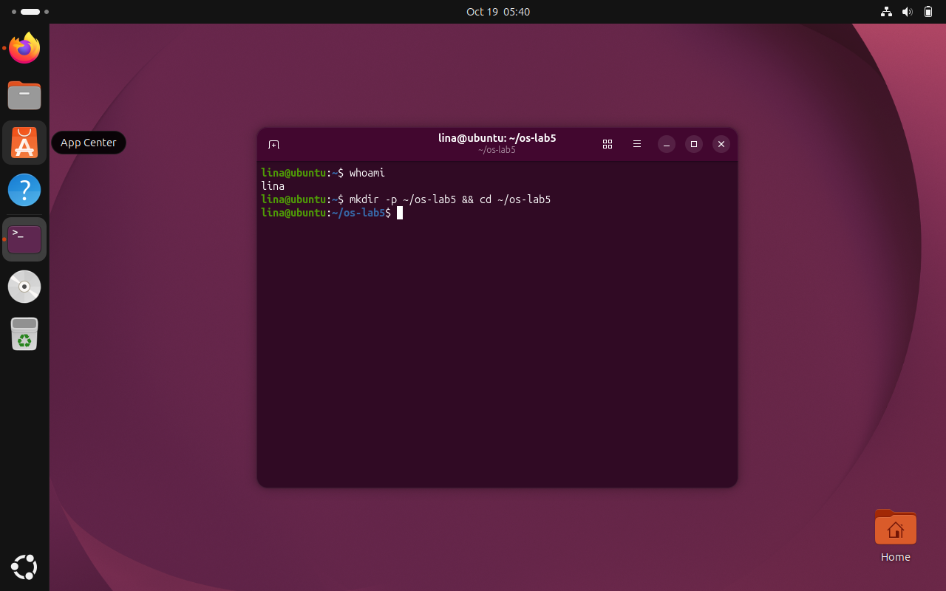
Figure 3.1 Verification of the working directory /home/lina/os-lab5
The terminal confirms that the laboratory was performed by the regular Ubuntu user lina in the isolated /home/lina/os-lab5 working directory.

4 PRACTICAL WORK AND RESULTS
The practical work was divided into four parts: file types and directories, inodes and links, permissions, and mounted disks together with kernel interfaces. The results below follow the sequence of the laboratory worksheet and include the required observations.

4.1 The Tree and File Types
Task: Inspect the root directory, classify file types, identify devices and compare directory sizes.
Commands used:
ls /
ls -ld /etc /etc/passwd /bin /dev/null /tmp
ls -l /dev | head
file /usr/bin/ls /etc/passwd /bin
du -sh /var/log 2>/dev/null
du -sh /usr 2>/dev/null
Results and observations:
The root listing showed the standard Linux hierarchy. The ls -ld output classified /etc and /tmp as directories (d), /etc/passwd as a regular file (-), /bin as a symbolic link (l), and /dev/null as a character device (c). The link /bin pointed to usr/bin, corresponding to /usr/bin. Thus, all five file types requested in the first Observe question were determined directly from the first character of the permission string.
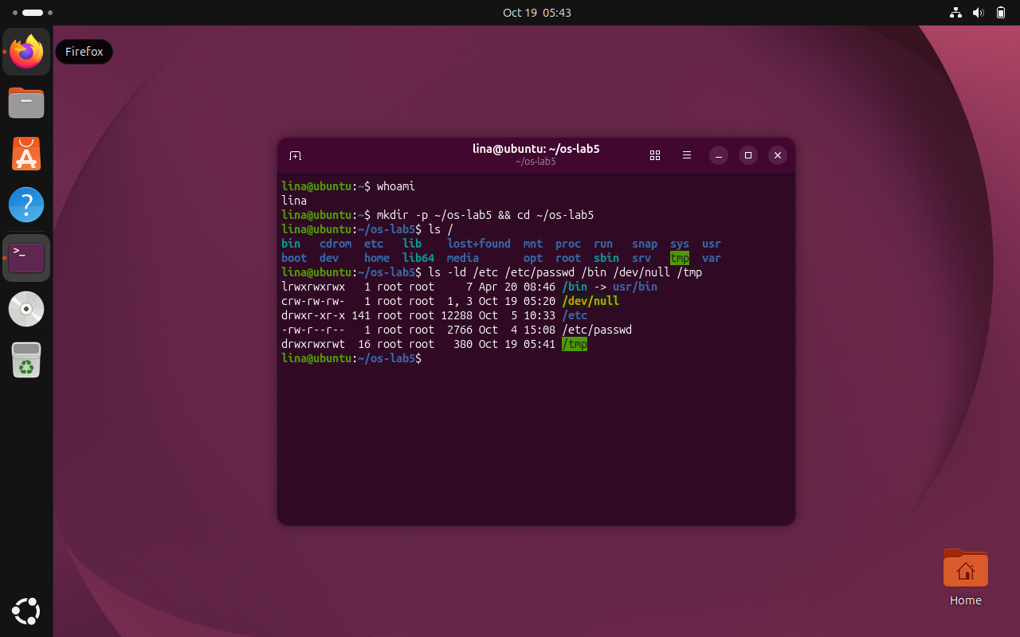
Figure 4.1 File-type information for the selected system paths
The listing distinguishes regular files, directories, character devices and symbolic links by their first permission character. In this system /bin points to usr/bin.
The /dev listing included character-device entries such as autofs and console, as well as a block-device directory. The character device /dev/null was independently identified by its c prefix. A block device is represented by an entry whose type begins with b; the later lsblk output identified the virtual disk and its partitions. The file utility recognized /usr/bin/ls as an executable, /etc/passwd as text and /bin as a link.
The du -sh comparison indicated that /usr consumed substantially more disk space than /var/log (several gigabytes versus a much smaller log directory). This is expected because /usr holds installed programs and shared system data. The screenshots contain the actual size measurements; they should be used rather than substituting figures from another computer.
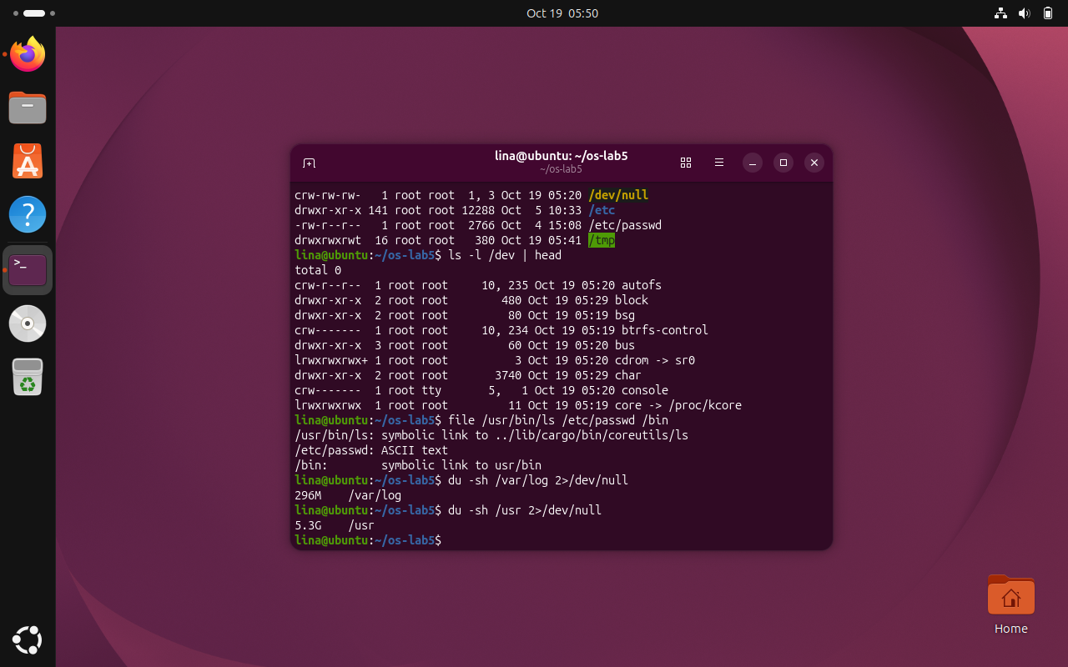
Figure 4.2 File identification and disk-usage comparison
The file utility identifies the executable, text file and symbolic link, while du shows the storage used by /var/log and /usr on the virtual machine.
Observe (1): The first character of ls -l identifies the type: /etc and /tmp are directories (d), /etc/passwd is a regular file (-), /bin is a symbolic link (l), and /dev/null is a character device (c). Observe (2): /bin points to usr/bin, resolving to /usr/bin. Observe (3): /dev/autofs and /dev/null are character devices; the virtual disk /dev/sda is a block device, as confirmed by the disk listing. Observe (4): /usr uses substantially more disk space than /var/log, as shown by the recorded du outputs.

4.2 Inodes and Links
Task: Examine inode metadata, hard links, symbolic links, directory link counts and sparse file storage.
Commands used:
echo hello > notes.txt; stat notes.txt; ls -li notes.txt
ln notes.txt hard.txt; ls -li notes.txt hard.txt
rm notes.txt; cat hard.txt; ls -li hard.txt
ln -s hard.txt soft.txt; ls -li hard.txt soft.txt
cat soft.txt; rm hard.txt; cat soft.txt; ls -l soft.txt
mkdir d; ls -ld d; mkdir d/x d/y; ls -ld d
echo x > one.txt; ls -l one.txt; du -h one.txt
truncate -s 1G big.img; ls -lh big.img; du -h big.img
rm big.img
Results and observations:
The stat output for notes.txt included an Inode field and a Links field. The inode number identifies the underlying file object, while the link count gives the number of hard-link directory entries referring to that inode. Initially, the link count was 1. After ln notes.txt hard.txt, both names displayed the same inode number and a count of 2. Removing notes.txt deleted only that directory entry; hard.txt still displayed hello and the count decreased to 1.
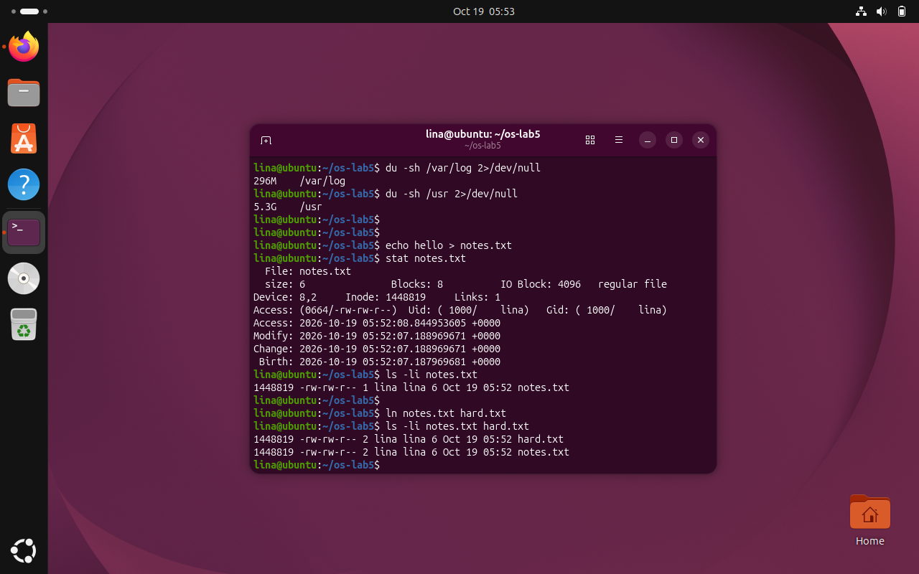
Figure 4.3 Inode metadata and the inode number of notes.txt
The stat command displays the inode number and the initial link count of notes.txt. Both stat and ls -li refer to the same underlying file metadata.
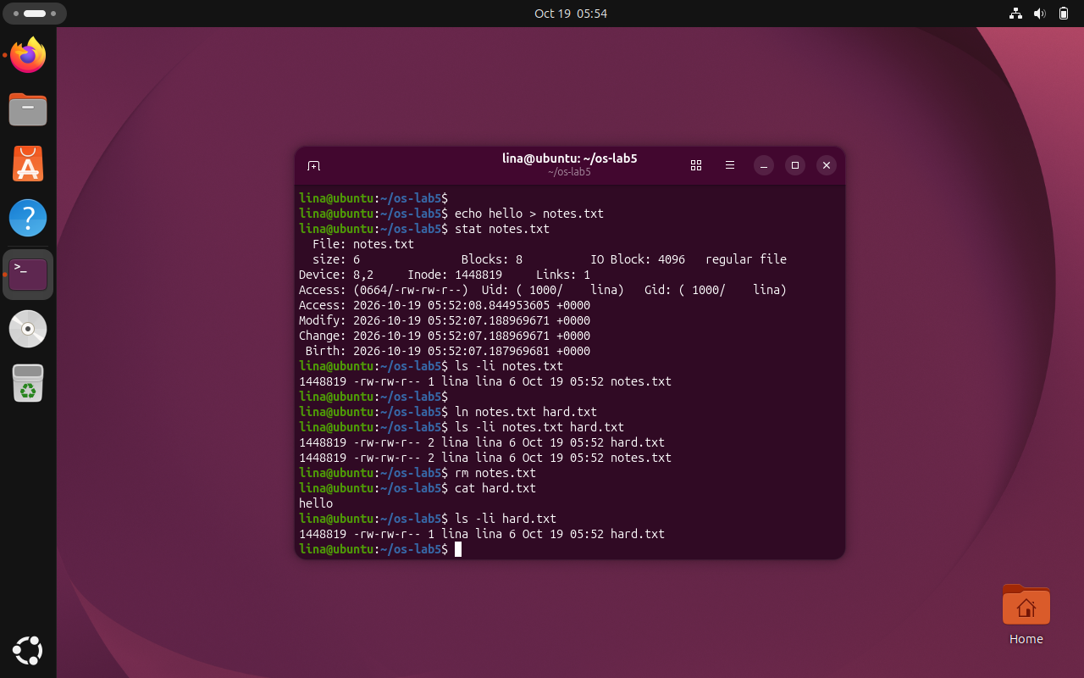
Figure 4.4 Hard-link experiment and preservation of file contents
Both names use the same inode after creation of the hard link. Removing notes.txt does not remove the data, and hard.txt remains readable.
The command ln -s hard.txt soft.txt created a separate symbolic-link inode whose contents identify the target name hard.txt. The name hard.txt is eight bytes long, explaining the symbolic link’s size of 8 bytes. Once hard.txt was removed, soft.txt remained in the directory, but cat soft.txt failed with No such file or directory because its target path no longer existed.
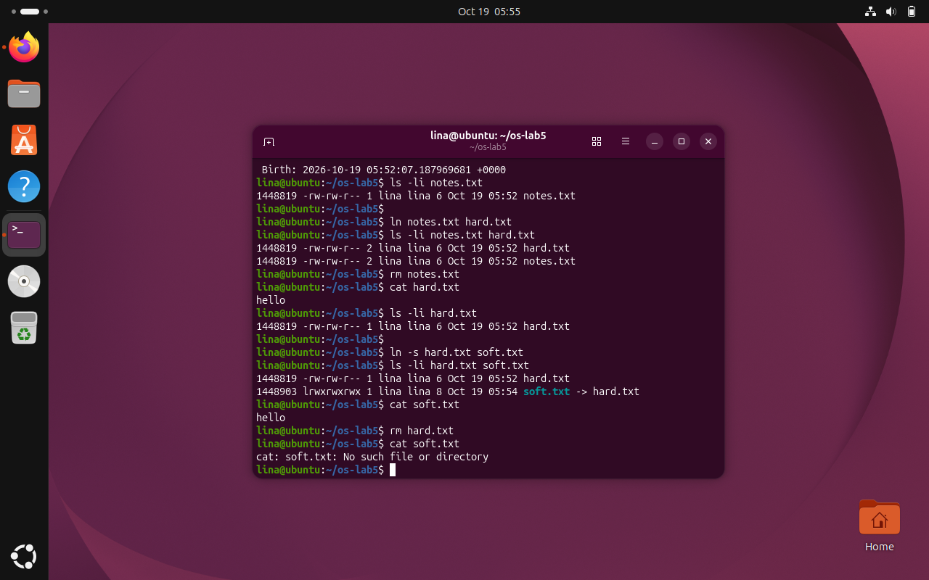
Figure 4.5 Symbolic link after deletion of its target
The symbolic link records the target pathname hard.txt. After that target is removed, soft.txt remains visible but attempting to open it produces the expected missing-file error.
A newly created directory d had a link count of 2, reflecting the name by which its parent references it and its own . entry. Each newly created subdirectory contributes one .. reference back to d. Therefore, creating d/x and d/y increased the count to 4. The size experiment showed that echo x creates a 2-byte file (the character and a newline), while du commonly reports one 4.0K allocated filesystem block. The sparse file big.img had an apparent size of 1.0G but du displayed 0 allocated space because truncate changed the logical length without writing data blocks.
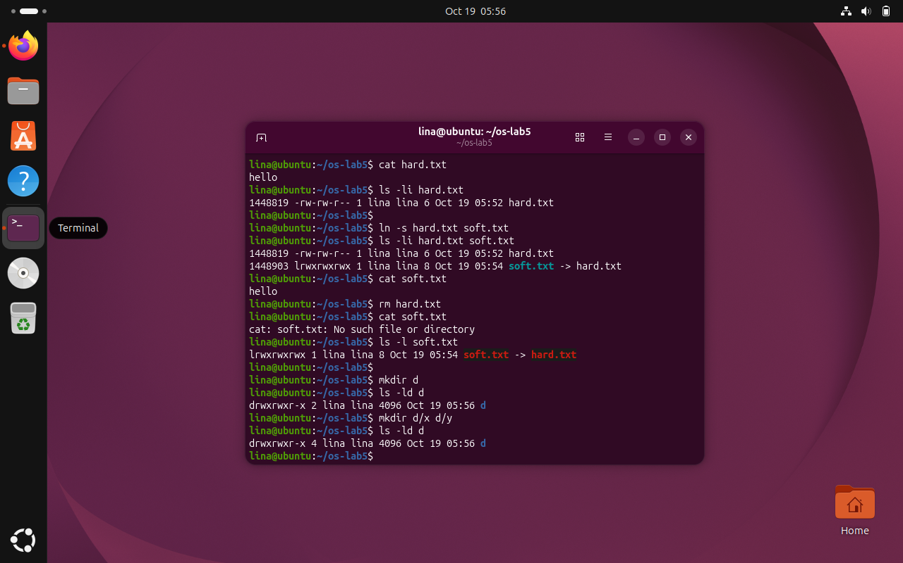
Figure 4.6 Directory link counts before and after adding subdirectories
The directory link count increases from two to four after creating the x and y subdirectories, each of which contains a parent reference.
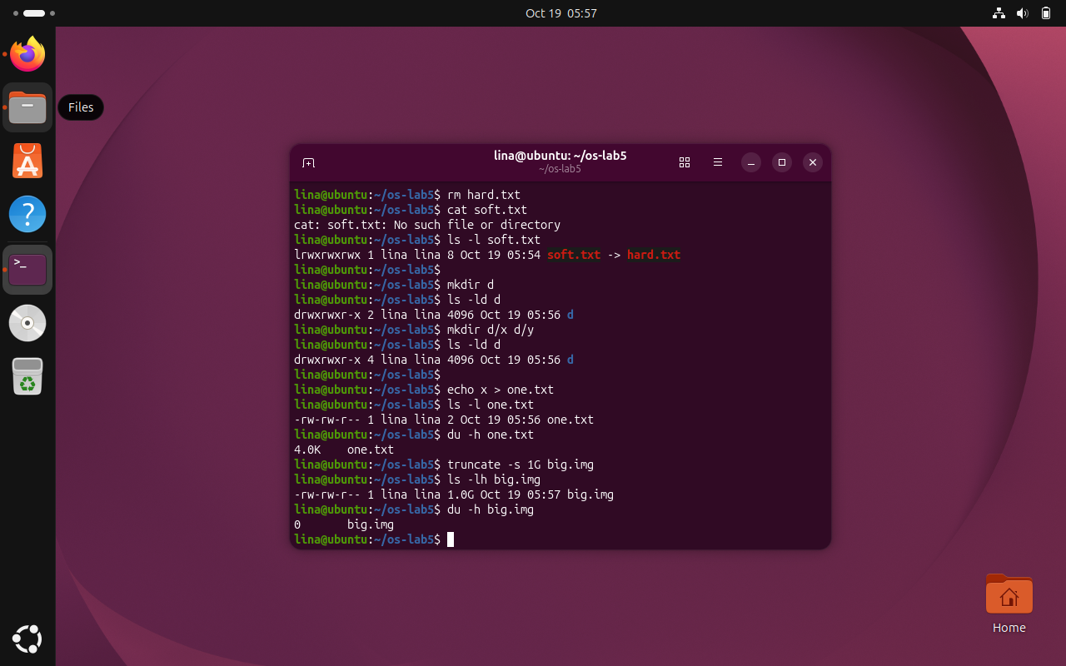
Figure 4.7 Apparent file size compared with allocated disk space
The small text file occupies a full allocation block, while the sparse 1 GB image reports no allocated blocks because it has not been filled with data.

Observe (1): The Inode field in stat is the inode number, while Links is the hard-link count. Observe (2): hard.txt remains readable after removing notes.txt because the names refer to the same inode; rm unlinks a directory entry. Observe (3): soft.txt becomes a dangling symbolic link after its target is removed. Its size is 8 bytes because the target string hard.txt has eight characters. Observe (4): Directory d initially has two links, one from its parent and its own . entry; each child directory adds a .. link, giving four. Observe (5): The two-byte one.txt uses an allocated filesystem block (typically 4.0K), whereas the sparse 1 GB big.img has no allocated data blocks.

4.3 Permissions
Task: Examine numeric permissions, umask, directory traversal, setuid, sticky bits and restricted files.
Commands used:
echo secret > s.txt
chmod 600 s.txt; ls -l s.txt
chmod 000 s.txt; cat s.txt
chmod u+r s.txt; cat s.txt
umask; touch new.txt; mkdir newdir; ls -ld new.txt newdir
mkdir box; echo hi > box/f
chmod u=r,go= box; ls box; cat box/f
chmod u=x,go= box; ls box; cat box/f
chmod 755 box
ls -l /usr/bin/passwd; ls -ld /tmp
cat /etc/shadow; ls -l /etc/shadow
Results and observations:
The permission modes can be written as follows: 600 = rw------- (private file), 644 = rw-r--r-- (ordinary readable document), 755 = rwxr-xr-x (executable program or public directory), and 700 = rwx------ (private directory). The chmod 600 command made s.txt accessible only to its owner for reading and writing. After chmod 000, cat reported Permission denied despite the file still being owned by the same user. Ownership identifies which permission class applies; it does not automatically override missing permission bits. The command chmod u+r restored reading and cat printed secret.
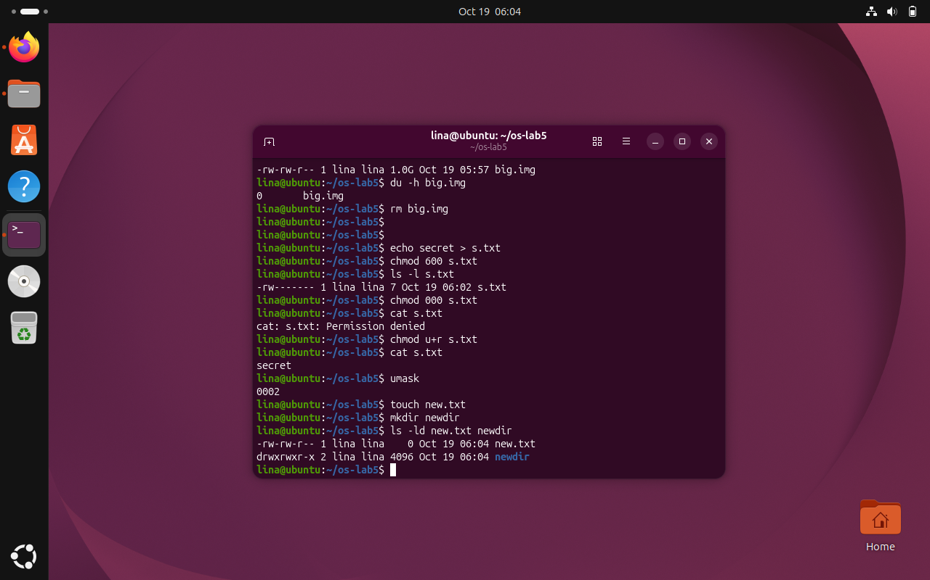
Figure 4.8 File permissions changed from 600 to 000 and restored
Changing s.txt to mode 000 produces the expected Permission denied message. Adding owner read permission restores the ability to display secret.
The actual umask was 0002. Consequently, new.txt was created with permissions -rw-rw-r-- (664), and newdir with drwxrwxr-x (775), obtained from the usual base modes 666 and 777 by excluding the masked write bit for others. This differs from systems using umask 0022 and must be reported using the observed value rather than the default example.
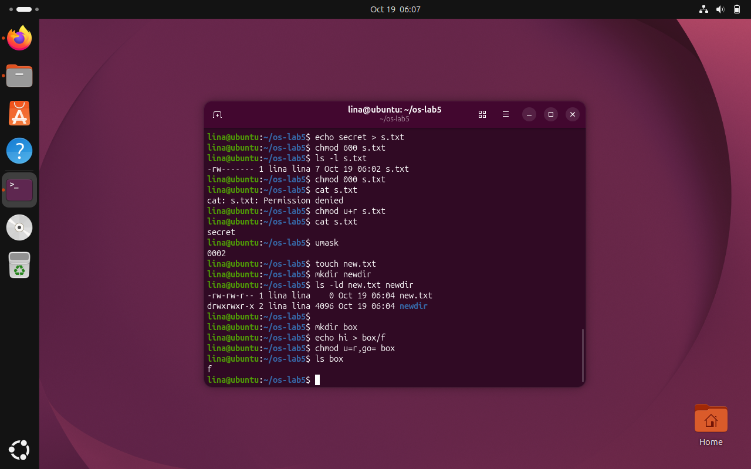
Figure 4.9 Observed umask 0002 and resulting default permissions
The observed umask is 0002, so the created file has mode 664 and the new directory has mode 775 rather than the values of the 0022 example.
The box experiment distinguished read from execute permissions on a directory. With chmod u=r,go= box, ls box could list the entry f but cat box/f could not traverse the directory and failed with Permission denied. With chmod u=x,go= box, ls box was denied because names could not be listed, while cat box/f succeeded because the known filename could be traversed. The final chmod 755 box restored ordinary directory access.
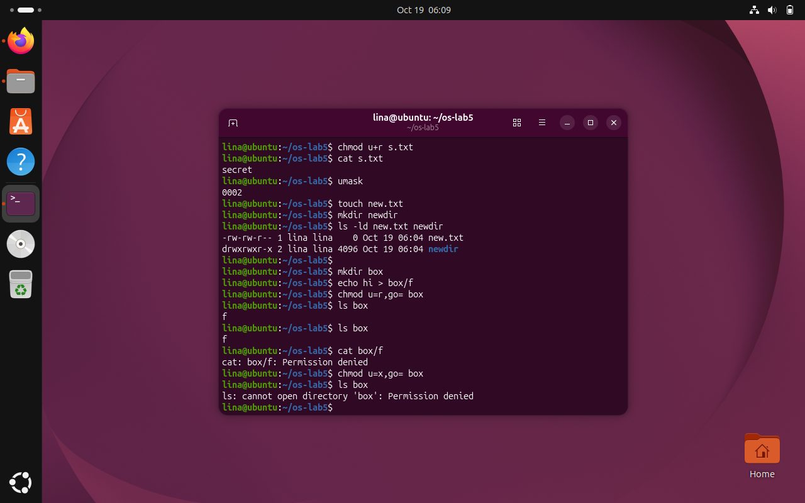
Figure 4.10 Read-only directory allows listing but denies file access
With directory read permission but no execute permission, the file name can be listed but the file cannot be accessed through that directory.

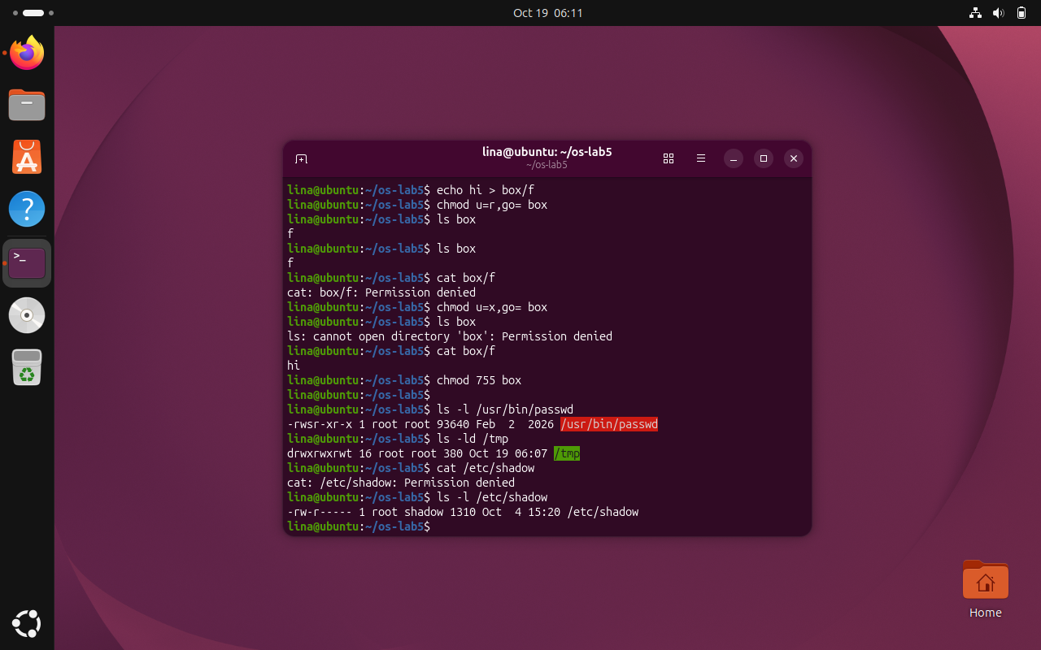
Figure 4.11 Execute-only directory permits traversal of a known file
With execute-only access, the directory cannot be listed, but an already-known filename can be traversed and its contents read.
The /usr/bin/passwd listing contained an s in the owner execute position, indicating setuid. This allows passwd to perform protected password updates with the privileges required by the system. The /tmp listing ended in t, indicating the sticky bit: in a shared writable directory, users generally cannot delete or rename other users’ entries. Reading /etc/shadow directly as an ordinary user returned Permission denied, confirming the restrictions on sensitive account data.
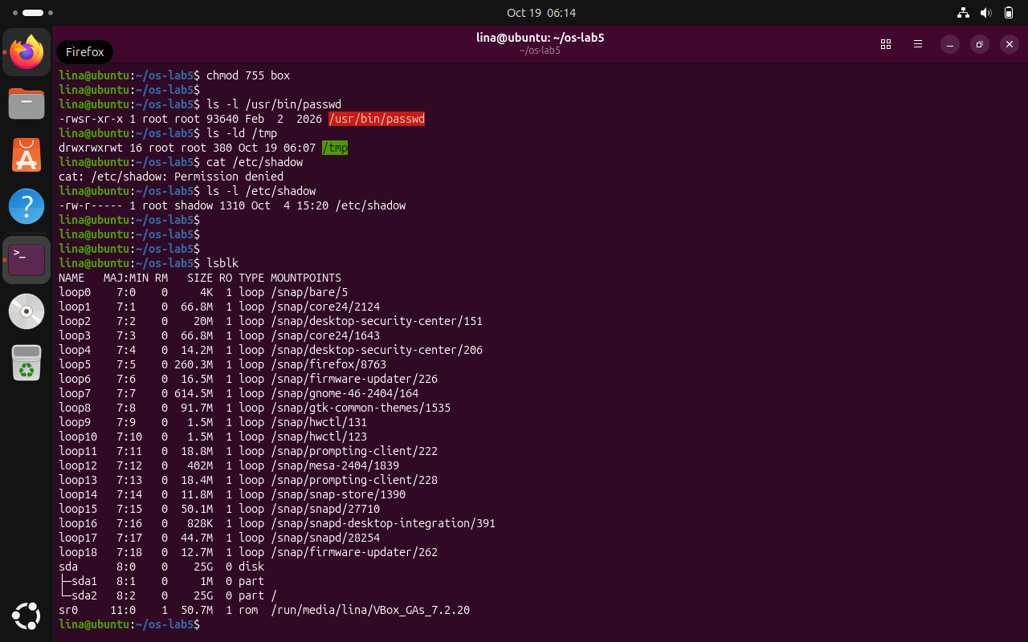
Figure 4.12 Setuid, sticky bit and protected shadow file
The setuid bit appears in the permissions of passwd and the sticky bit appears on /tmp. Access to /etc/shadow is denied for the ordinary user.

Observe (1): 600 corresponds to rw------- (private file), 644 to rw-r--r-- (readable document), 755 to rwxr-xr-x (executable or shared directory), and 700 to rwx------ (private directory). Observe (2): Ownership does not bypass permission-bit checks; chmod 000 removes the owner’s access too. Observe (3): The actual umask was 0002, resulting in 664 for new.txt and 775 for newdir. Observe (4): Directory read permission allows listing names, while execute permission allows searching or traversing a known entry. Observe (5): The s in /usr/bin/passwd indicates setuid, permitting the utility to update protected password information; the t in /tmp is the sticky bit, limiting who can remove entries in the shared directory.

4.4 Disks and the Kernel as Files
Task: Inspect virtual disks, root filesystem usage, CPU and RAM statistics, and process file descriptors.
Commands used:
lsblk
df -h
mount | grep " / "
grep -c processor /proc/cpuinfo
head -3 /proc/meminfo
head -5 /proc/self/status
ls -l /proc/self/fd
Results and observations:
The `lsblk` output identified the virtual disk `/dev/sda` with a total capacity of 25G, containing `/dev/sda1` (1M) and `/dev/sda2` (25G). The `mount` output confirmed that `/dev/sda2` was mounted at `/` using the ext4 file system. The `df -h` output showed that the root file system had a total capacity of 25G, with 8.3G used, 15G available, and 36% utilization. These values describe the storage configuration of the Ubuntu virtual machine.
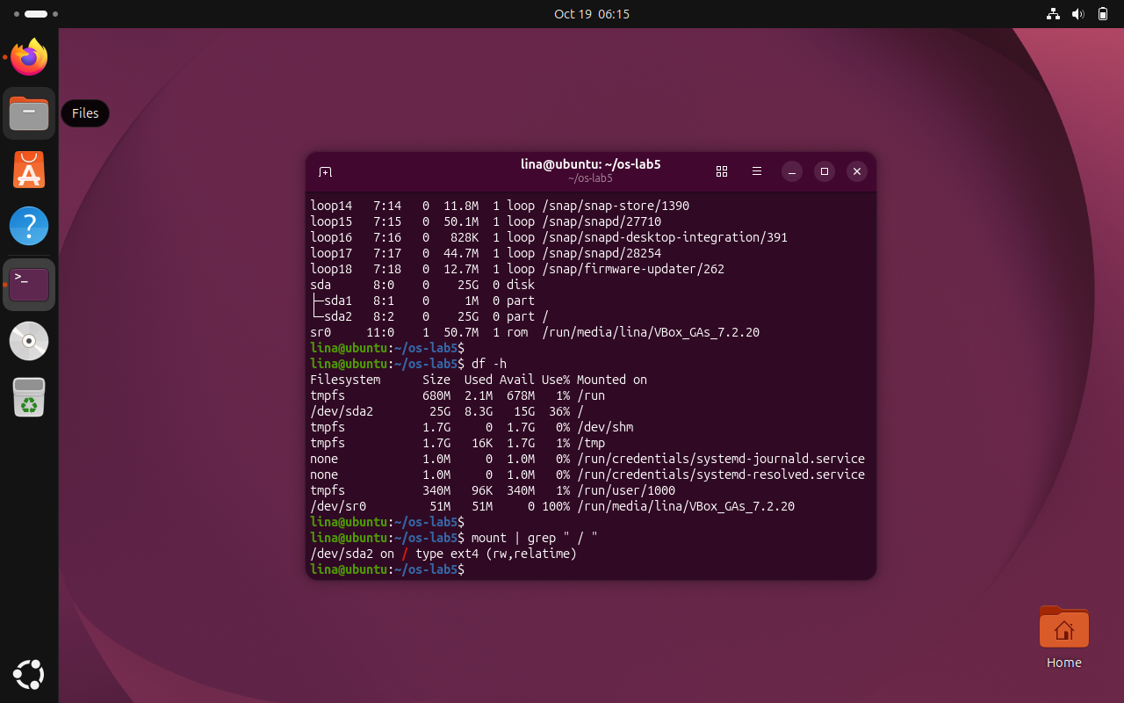
Figure 4.13 Block-device layout and filesystem capacity
The disk listing reveals the virtual disk and its partitions, while df reports the capacity and current usage of mounted filesystems.

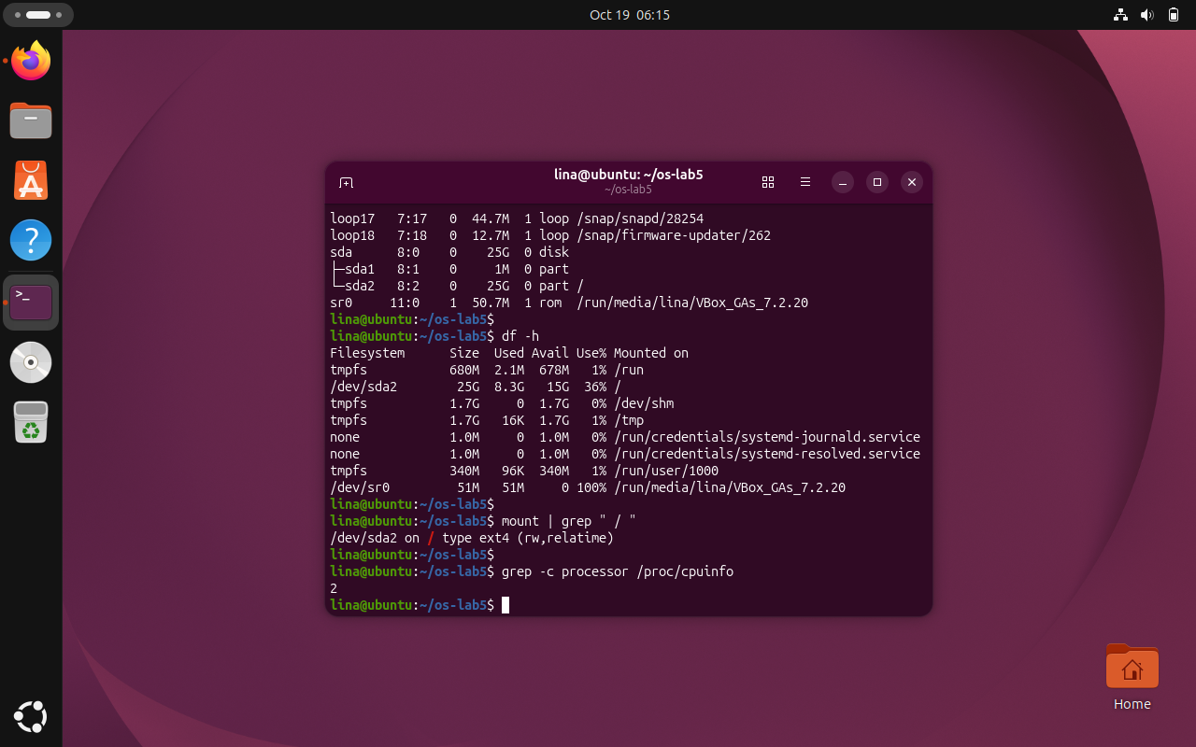
Figure 4.14 Mounted root partition and filesystem type
The mount output identifies /dev/sda2 as the ext4 partition mounted at /, providing the root filesystem for Ubuntu.

The `/proc/cpuinfo` output reported 2 logical processors available to the Ubuntu virtual machine. The `/proc/meminfo` output showed `MemTotal: 3480328 kB`, corresponding to approximately 3.32 GiB of RAM. At the time of measurement, `MemFree` was 171616 kB and `MemAvailable` was 682868 kB. These values represent the resources available to the virtual machine rather than the physical host computer.
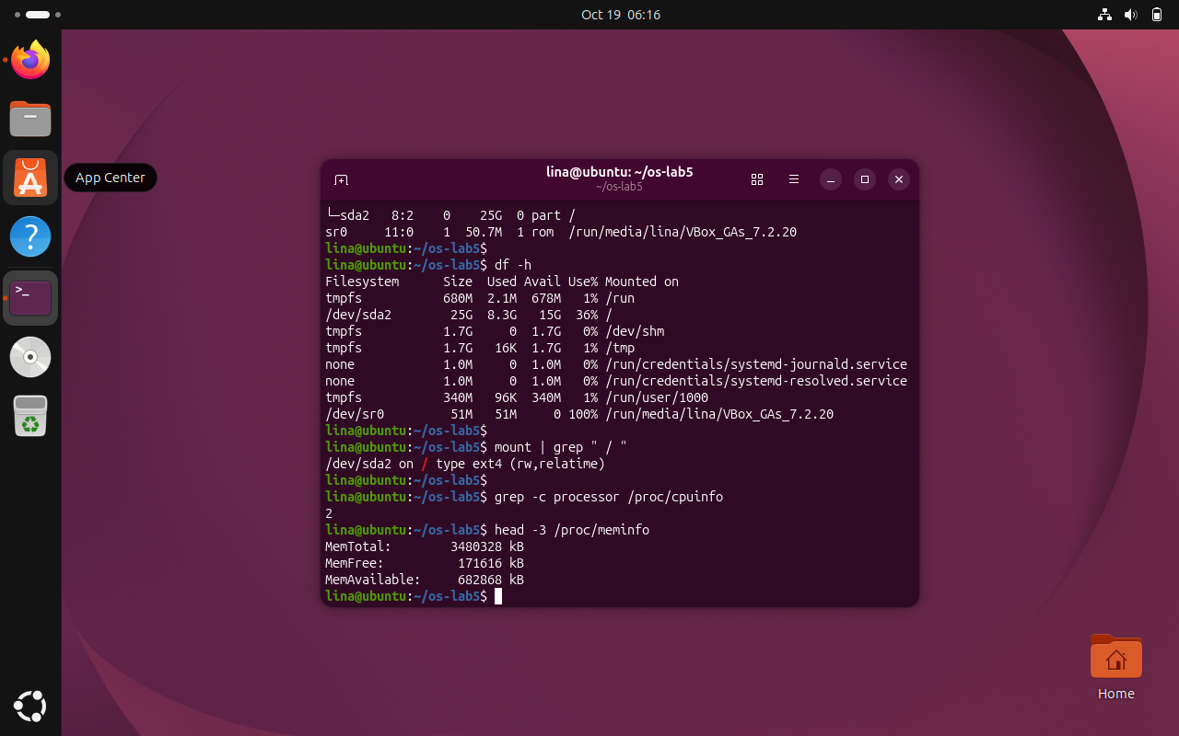
Figure 4.15 Processor count and memory statistics from /proc
The /proc outputs show the logical processor count and the virtual machine memory totals reported by the running Linux kernel.

The first line of /proc/self/status named head, because /proc/self refers to whichever process accesses it: in the command head -5 /proc/self/status, the reader is head itself. The directory /proc/self/fd exposed numbered symbolic links corresponding to the process’s open descriptors, including standard input (0), standard output (1), and standard error (2).
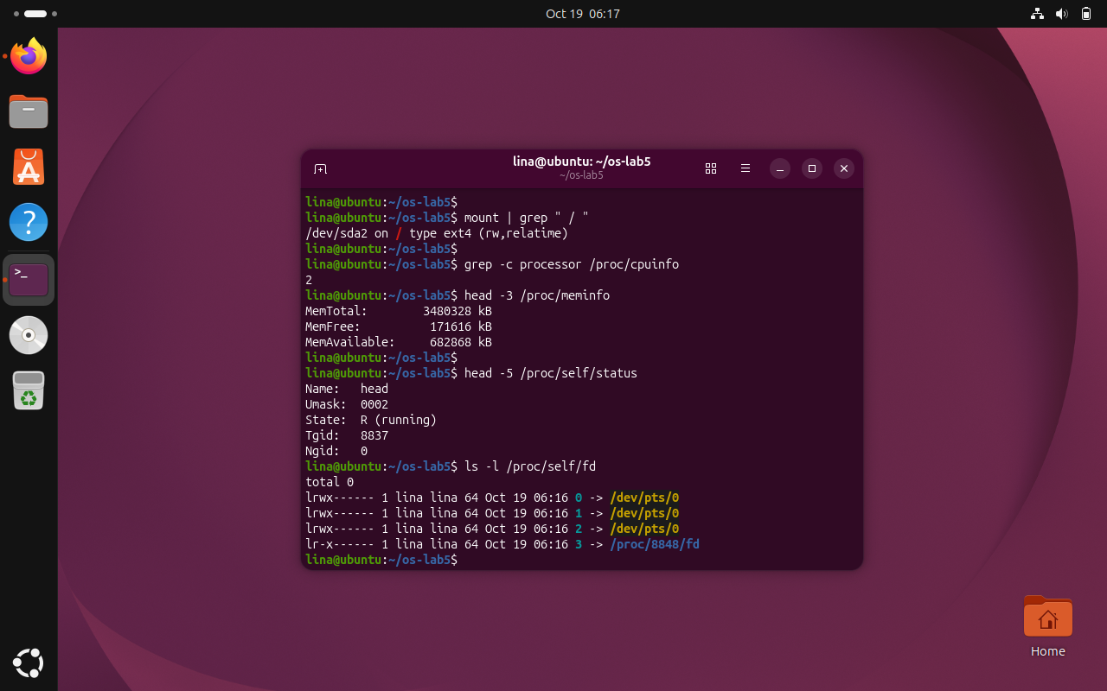
Figure 4.16 Process status and open file descriptors
The name head appears in /proc/self/status because it is the process reading the file. The fd directory lists links corresponding to that process’s open descriptors.
Observe (1): The virtual disk was /dev/sda (25G), containing /dev/sda1 (1M) and /dev/sda2 (25G). The root file system / was located on /dev/sda2 and used ext4.
Observe (2): The root file system had a total capacity of 25G, with 8.3G used, 15G available, and 36% utilization.
Observe (3): The Ubuntu virtual machine had 2 logical processors and approximately 3.32 GiB of RAM, according to /proc/cpuinfo and /proc/meminfo.
Observe (4): The process name displayed by /proc/self/status was head, because /proc/self refers to the process accessing it. In this experiment, the head command was reading its own process information.

4.5 Optional Exercises: Magic Numbers and Setuid Programs
Task: Complete two optional filesystem investigations by identifying compressed data from its signature and locating setuid executable files.
Commands used:
cd ~/os-lab5
gzip -c /etc/passwd > notes.txt
file notes.txt
xxd notes.txt | head -1
find / -xdev -perm -4000 -type f 2>/dev/null
ls -l /usr/bin/passwd
Results and observations:
The first optional experiment compressed /etc/passwd into a file called notes.txt. Although the extension remained .txt, the file utility identified the file as gzip-compressed data. Inspecting its first bytes with xxd revealed the gzip signature 1f 8b, followed by compression-method byte 08. The test demonstrates that file contents and header signatures can establish a format independently of a filename extension.
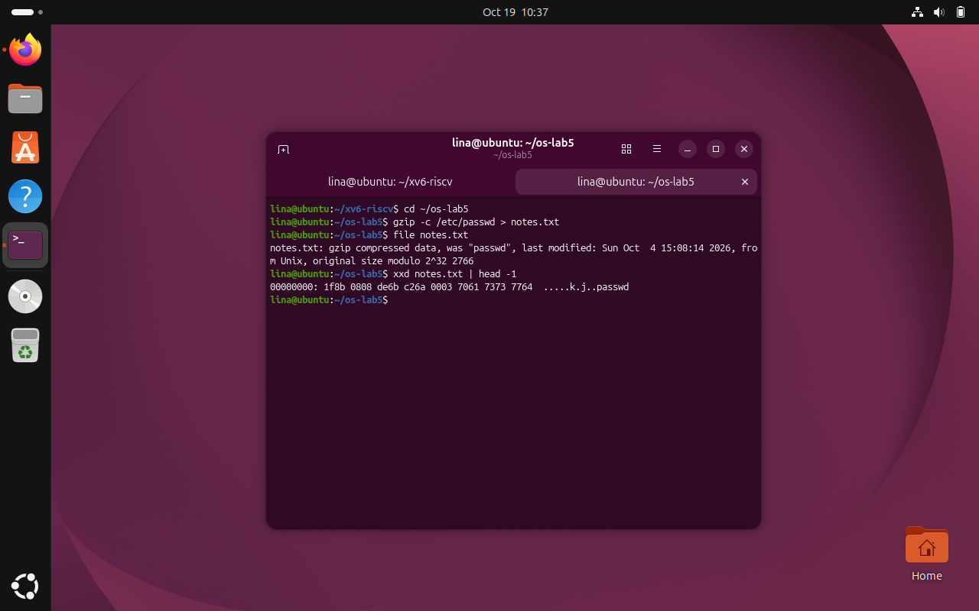
Figure 4.17 Identification of compressed contents despite the .txt extension
The file command recognizes gzip data in notes.txt even though the file has a text-file extension.
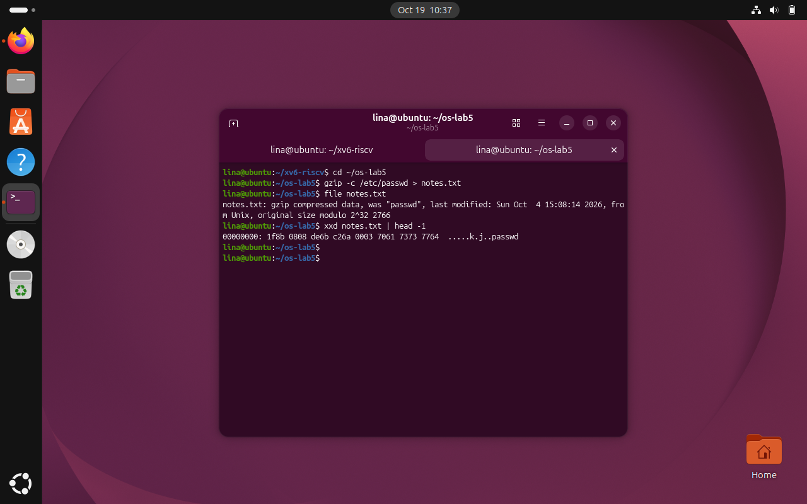
Figure 4.18 Gzip file signature examined with xxd
The hexadecimal dump begins with 1f 8b 08, confirming the gzip format and its compression method.

The second optional experiment searched the root filesystem for regular files with the setuid bit enabled, omitting access errors. The results included privileged utilities within /usr/bin. Inspecting /usr/bin/passwd showed an s in the owner-execute permission position, indicating that the executable can run with its file owner’s effective user identity. The installed utilities can vary by Ubuntu version, so the screenshot records the list present in this virtual machine.
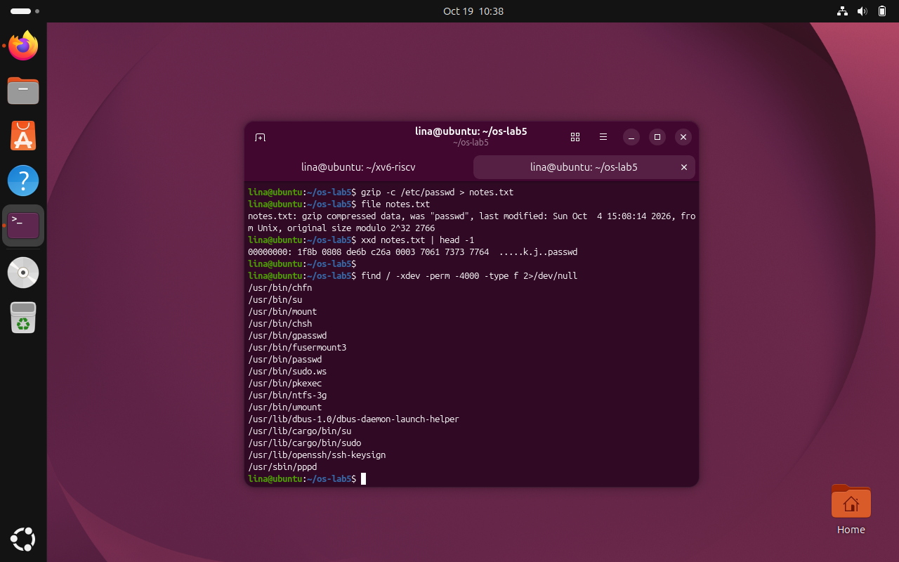
Figure 4.19 Search results for setuid executables
The search lists regular files with the setuid permission bit on the scanned root filesystem.
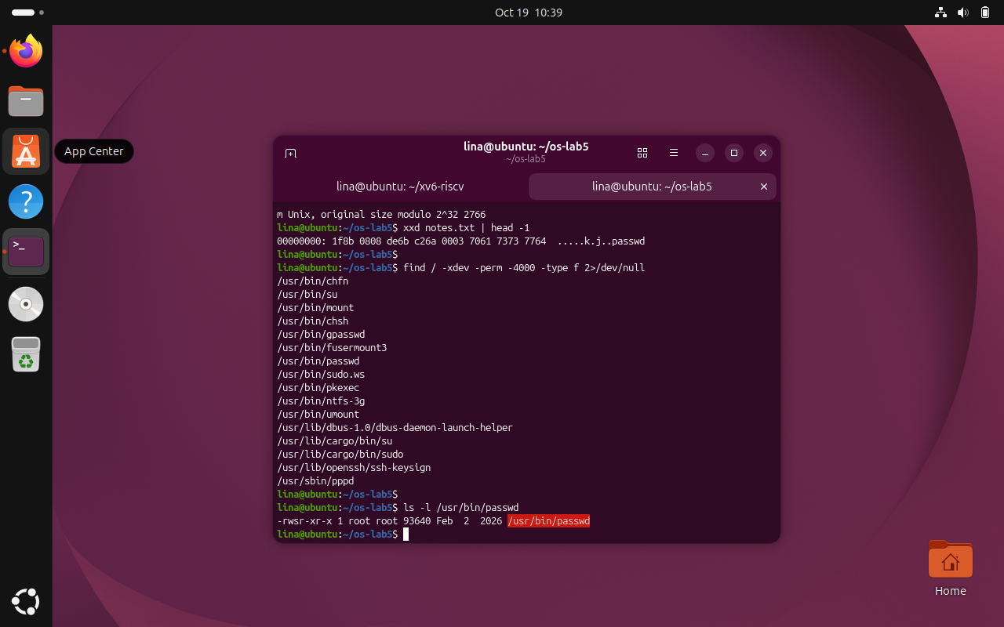
Figure 4.20 Setuid permissions of the passwd utility
The permissions displayed for /usr/bin/passwd contain the setuid indicator in the owner execution field.

Bonus observations: The gzip magic number is 1f 8b; file detects the actual compressed format even when its extension is misleading. The setuid search identifies executable files allowed to run with the effective identity of their owner; /usr/bin/passwd is an example. Which additional results differ from lecture examples depends on the exact lecture list, which was not provided with the screenshots.

CONCLUSION
Laboratory Work 5 demonstrated that the Linux filesystem provides a unified directory hierarchy while representing multiple kinds of objects: ordinary files, directories, links and devices. Inspection of actual system paths showed how file type is encoded in listing output, how a symbolic system directory such as /bin redirects to /usr/bin, and how device files appear inside /dev.
The inode experiments established that file names and underlying file objects are distinct. Hard links shared inode metadata and survived the removal of one name, whereas a symbolic link became unusable after its target was removed. Directory link counts and sparse-file measurements further illustrated that names, link counts, apparent sizes and allocated storage capture different aspects of the filesystem.
Permission tests confirmed that file ownership does not bypass access bits and that the read and execute permissions of a directory have different effects. The observed umask 0002 produced modes 664 and 775 for newly created files and directories. The special bits in passwd and /tmp, together with the restricted /etc/shadow file, demonstrated mechanisms used to manage privileged operations and shared spaces securely.
Finally, block-device and mount information connected the directory tree with the underlying virtual disk, while /proc exposed CPU, memory, process and descriptor information through file-like interfaces. Taken together, the experiments strengthened practical understanding of Linux file storage, metadata, permissions and virtual kernel interfaces.
The practical comparisons also demonstrated why interpreting a command output requires attention to its context. For example, a symbolic link can remain present even though its target has disappeared, an empty sparse image can display a large logical length with no allocated disk blocks, and a directory may allow known-file traversal without allowing its contents to be listed. These results cannot be inferred from filenames alone; they depend on the underlying metadata and permissions.
The laboratory also reinforced the importance of conducting permission experiments as a normal user and preserving actual system output. The observed umask, filesystem type and storage layout belonged to the Ubuntu virtual machine and therefore may differ from another installation. Overall, the tasks connected theoretical concepts of filesystems with practical evidence and provided a foundation for examining how the same ideas are implemented inside xv6 in Laboratory Work 6.

REFERENCES
[1] GitHub Repository. Laboratory Work 3. Available at: https://github.com/linalinalina1/os-2026-FeliciaOjog/tree/main/lab5
[2] Technical University of Moldova, Operating Systems, “Lab 5: The File System with Your Own Hands,” academic year 2026–2027.
[3] Linux manual pages: ls(1), stat(1), ln(1), chmod(1), umask(2), du(1), lsblk(8), df(1), mount(8), proc(5).

