**About Us**

Fix&Demo is a construction consulting company that provides services of assessing condition of a property. If the condition of the property satisfies certain requirements, Fix&Demo will recommend that it be repaired. If the condition of the property does not meet the requirements, Fix&Demo will recommend that it be torn down.

Fix&Demo makes a recommendation, not a final decision. It is up to the property owner in the end, and not in the hands of Fix&Demo.

Upon request, Fix&Demo can mediate sessions with the property owners, the mortgage holders, tenants if any, any other creditors and any government office providing requirements.

Fix&Demo will be available to obtain and recommend a short list of contractors and assist with the procurement of the contractor and monitor the remediation project if:

* The recommendation is to demolish and the property owner accepts it
* The recommendation is to fix, regardless of whether the property owner accepts or not

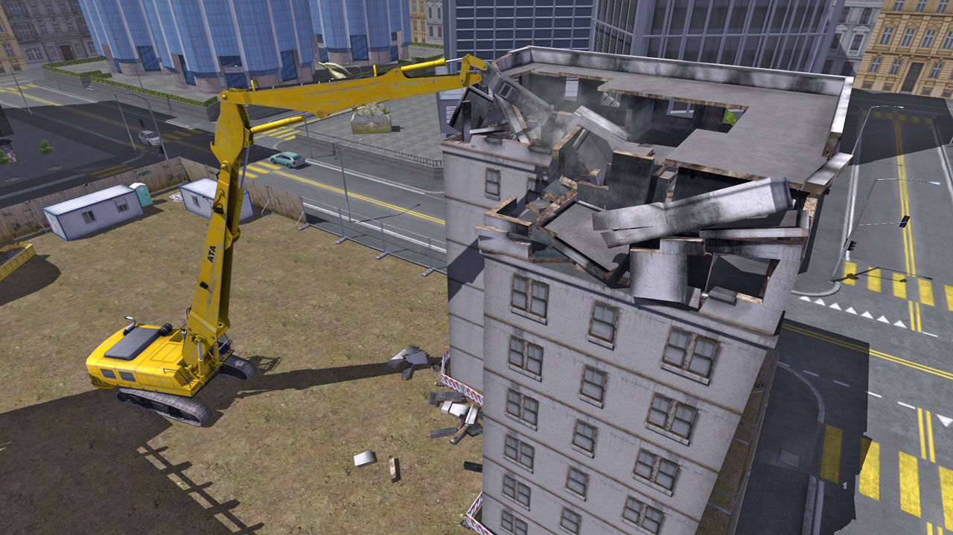We are currently devoting more resources to provide assistance to those that have suffered from Hurricane Sandy. For submitting applications, please register and create an application which will be reviewed by us as soon as possible. If there are any questions, feel free to contact us through the site.

**Services**

Fix&Demo requires that you register before applying for our services. Fix&Demo provides services of assessing the condition of a property. An application will have to be filled out, and upon assessment, Fix&Demo will come up with a decision of whether we can provide repair of a property or if it needs to be demolished.

**Home Page**

Fix&Demo is a construction consulting company that provides services of assessing condition of a property. If the condition of the property satisfies certain requirements, Fix&Demo will recommend that it be repaired. If the condition of the property does not meet the requirements, Fix&Demo will recommend that it be torn down.



If you need assistance after Hurricane Sandy, we are willing to help. All it takes is a few minutes to fill out our application and we will get back to you as quickly as we can. Any questions will be promptly answered through emails.

