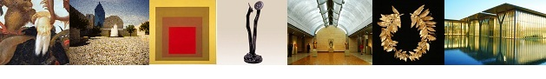

DFW Art History Network Newsletter
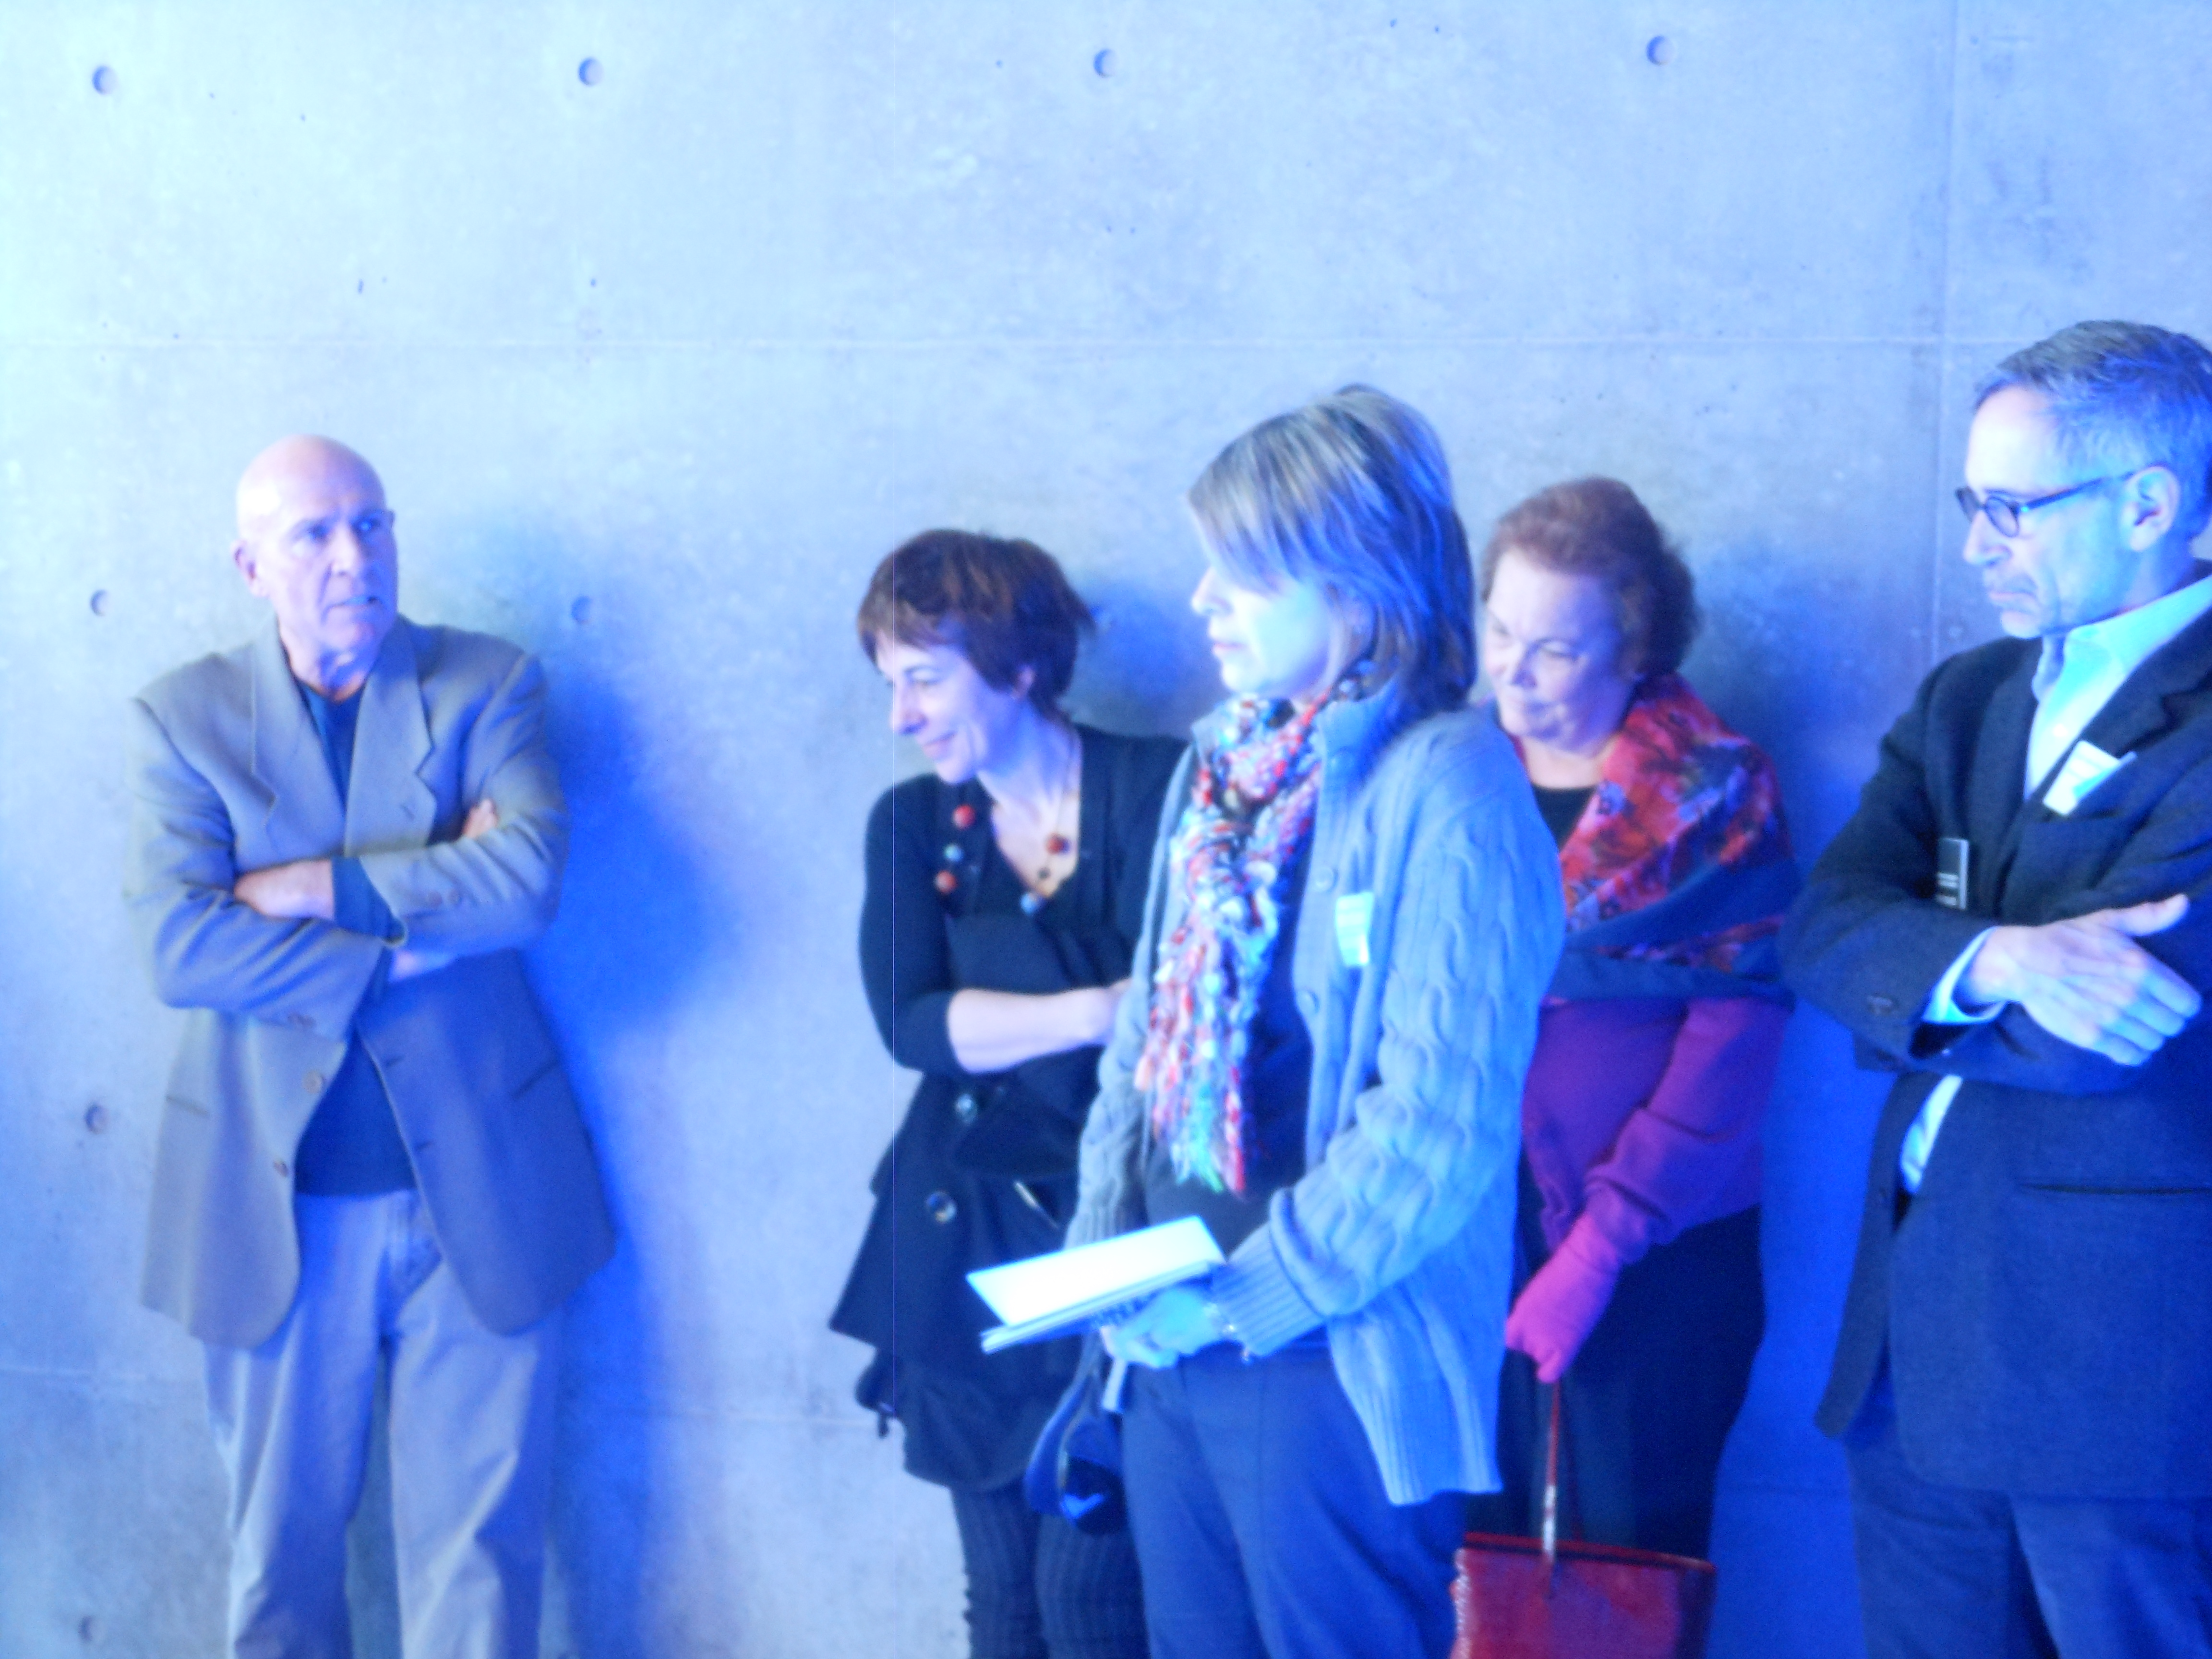
Dear Art Historians,

Thank you to the attendees of our brunch at the Fort Worth Modern this month.

For those who missed the fun, the picture here was taken in a gallery by the water, next to the work of Jenny Holzer (b. 1950) titled Kind of Blue – 2012. This work was a special commission by the museum to celebrate its 10th Anniversary. In the picture are, from left to right: Michael Auping (Modern Art Museum of Fort Worth), Sylvie Penichon (Amon Carter Museum of American Art), Mary Vaccarro (The University of Texas at Arlington), Bonnie Pitman (The University of Texas at Dallas), Ed Marquand (Marquand Press).

SAVE THE DATE
Bernini symposium at the Kimbell
February 2-3, 2013
On Saturday, February 2, 2013, the Kimbell will be hosting a symposium on the theme of Gian Lorenzo Bernini and his preparatory models. This promises to be a most stimulating day of discussions.
The occasion is the opening of the exhibition Bernini: Sculpting in Clay, of which the Kimbell Art Museum is the joint organizer with the Metropolitan Museum of Art. The exhibition will be on view at the Kimbell from February 3 through April 14, 2013.
On Sunday, February 3, from 9 a.m. until noon, you are also invited to attend a study day in the galleries. This is an opportunity to tour the exhibition with the curators and to engage in discussion with them and colleagues.
In order to reserve your place at both events, please e-mail Samantha Sizemore (ssizemore@kimbellmuseum.org) by January 18, 2013.

Upcoming Lectures

Wednesday January 23, 12:15 pm
Alexandra Vargo, McDermott Education Intern An Artistic Affair: Peter Hujar's "David Wojnarowicz" at the DMA

Wednesday January 30, 12:15 pm
Shannon Karol, Manager of Docent and Teacher Programs Provocative Comparisons at the DMA

Thursday January 31, 6:00 pm
INsights & OUTlooks: John Bramblitt, Guest Artist at the Meadows. Registration required.

Fridays February 1, 8, 15, 22, 10:30 am
Luis Martin, SMU Professor Emeritus of History Nation Building: The Search for National Identity in Latin America at the Meadows. Registration required.

Saturday February 2, 10:00 am - 12:30 pm; 2:00 pm - 4:30 pm
Bernini: Sculpting in Clay at the Kimbell

Wednesday February 6, 12:15 pm
Kevin W. Tucker, The Margot B. Perot Curator of Decorative Arts and Design American Furniture at the DMA

Tuesday February 7, 7:00 pm
Tuesday Evenings at the Modern Popular series of lectures and presentations by artists, scholars, and critics, free and open to the public

Wednesday February 13, 12:15 pm
Pilar Wong, McDermott Education Intern Rufino Tamayo: Decreasing Color, Increasing Possibilities at the DMA

Wednesday February 20, 12:15 pm
Olivier Meslay, Associate Director of Curatorial Affairs and The Barbara Thomas Lemmon Curator of European Art Chagall: Beyond Color at the DMA

Wednesday February 27, 12:15 pm
Dr. Anne Bromberg, The Cecil and Ida Green Curator of Ancient and Asian Art The South Asian Collection at the DMA

Thursday February 28, 6:00 pm
Sinclair Bell, Associate Professor of Art History, Northern Illinois University Fans, Fame and the Roman Circus at the Meadows Bob and Jean Smith Auditorium

Meet this month's highlight

Charissa Terranova

Charissa N. Terranova is Assistant
Professor of Aesthetic Studies at UTD
where she teaches the history of
contemporary art and modern architecture
and new media theory.

For the last six years, her work has been focused on the interstices of conceptual art, the landscape, and technology. Forthcoming from UT Press, her book Automotive Prosthetic: Technological Mediation and the Car in Conceptual Art combines critical theory and new media theory to form the first philosophical analysis of the car within works of conceptual art. These works are broadly defined to encompass a wide range of creative expressions, particularly in car-based conceptual art by both older, established artists and younger, emerging artists including Ed Ruscha, Martha Rosler, Richard Prince, Sylvie Fleury, Yael Bartana, Jeremy Deller, and Jonathan Schipper.
Terranova’s current research both plays on the surface and digs deeper into new perceptions gained while researching Automotive Prosthetic. The first project, The Conceptual Turn is a small book on the periodicity of conceptual art. Here she rereads the history of conceptualism as a broader technologically inflected continuum of tendencies, choices, and attitudes among artists that began in the 1950s and continues into the present. The second project, Haptic Unconscious: A Prehistory of the Digital Image in Art, 1937-1972 traces a unique cognitive paradigm present in the development of new media art, from kinetic and light art to early computer and digital art. This book traces a philosophy of bodily knowing through art from Laszlo Moholy-Nagy and Gyorgy Kepes to Jack Burnham and E.A.T.
Terranova was the conceptual innovator and the founding Director of UTD's artist residency, which she dubbed CentralTRAK. Having taken a hiatus from journalism and curating, Terranova writes fiction in her spare time and his working her way to a novel, having started with 300-word short stories.
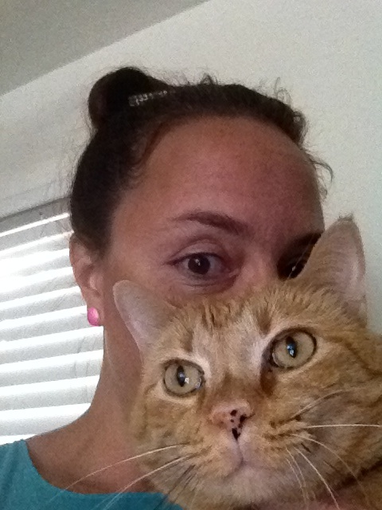

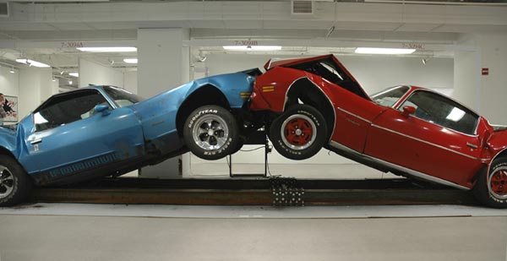

Jonathan Schipper, SLOW INEVITABLE DEATH OF AMERICAN MUSCLE SLOW MOTION CAR CRASH, 2008

Show Openings

Mountain View College Faculty Exhibit at Mountain View College Cliff Gallery Jan 22 through Feb 08, Reception Feb 06 at 1:00 pm

League For Innovation Student Art Competition at Mountain View College Kiva Gallery Jan 22 through Feb 22, Reception Feb 07 at 7:00 pm

C4: Christine Bisetto, Colette Copeland, Clayton Hurt & Chancellor Page 500X Gallery OPENED Jan 12 7:00 – 10:00 pm

William Bailey - The Imaginary Still Life at Talley Dunn Gallery OPENED Jan 12

Ex Libris at Talley Dunn Gallery OPENED Jan 12

DZINE Victory at the Dallas Contemporary OPENING Jan 19 9:00 pm - midnight

Michael Miller: Out of Commerce, with Trenton Doyle Hancock, Daniel Kurt, Lawrence Lee, Robyn O’Neil, Jeff Parrott and Jasmyne Graybill: Flourish at the MAC OPENING Fri Jan 18 6:00 - 8:00 pm

Collections, Cultures, and Collaborations: The Joy Losee Collection: Art and Dress Along the Silk Road at UNT Art Gallery OPENED Jan 15

FOCUS: Gary Simmons at the Fort Worth Modern OPENED Jan 13

FOCUS: Yinka Shonibare MBE at the Fort Worth Modern OPENED Jan 13

Gail Peter Borden at Galleri Urbane Dallas OPENED Jan 12 5:00 - 8:30 pm

Ed Ruscha: Made in California at the Amon Carter OPENED Jan 15

Bernini: Sculpting in Clay at the Kimbell OPENS Feb 03

Flight Deck: Public Art at DFW and Love Field at UTA Gallery Jan 14 through Feb 16, Reception Jan 25 at 5:30 pm, gallery talk at 6:30 pm

CADD Bus Tour Saturday Jan 19th, starts at PDNB Gallery 10:30 AM

Randy Twaddle, Casey Williams at Holly Johnson Gallery OPENED Jan 12

CLOTHESLINE: Photographs by John Albok at PDNB Gallery OPENED Jan 12

Rosalyn Bodycomb, Robert Jessup at Conduit Gallery OPENED Jan 12

Meadows Museum Acquires Five Early 20th-Century Spanish Paintings

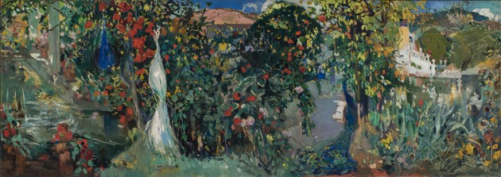
Allegory by Joaquím Mir Trinxet, 1904 (photo by Dimitris Skliris)
The Meadows Museum has acquired five early 20th-century Spanish paintings through a purchase and partial gift from Mr. and Mrs. Alan B. Coleman (former dean of SMU's Cox School of Business), whose collection of early 20th-century Spanish paintings is one of the finest in the U.S. Included in the gift are Moulin Rouge, Exit to the Box Seats (Moulin Rouge, salida a los palcos), c. 1902, by Hermenegildo Anglada-Camarasa (1871-1959); Segovia, from Perogordo Road (Segovia desde el camino de Perogordo), c. 1908, by Aureliano de Beruete y Moret (1845-1912); Allegory (Alegoría), c. 1903, by Joaquim Mir Trinxet (1873-1940); Snow and Thaw (Nieve y deshielo), c. 1900, by Darío de Regoyos y Valdés (1857-1913); and Farm-House, Alcira (Alquería de Alcira), c. 1903, by Joaquín Sorolla y Bastida (1863-1923).
The Colemans had previously lent four of these works to the Meadows for its 2005-2006 exhibition Prelude to Spanish Modernism: Fortuny to Picasso.
Read the story on dallasartnews.com →

Amon Carter Launches Art Conservation Blog
The Amon Carter Museum of American Art has launched a blog to highlight projects in their Art Conservation Lab, a 1,200 ft2 space complete with ultraviolet light analytical equipment and a spectrophotometer for monitoring any changes in color and density potentially experienced by works of art. The blog will continually be updated as the Amon Carter's conservationists work on projects for the 2013 exhibition schedule and on the permanent collection.
Continue reading →

Raul Cordero and Michel “El Pollo” Pérez: Painting of all Excuses at CentralTrak OPENS Sat Jan 19

Alfredo Salazar-Caro at Oliver Francis Gallery One night only: Fri Jan 18

Reframing Documentary: Creative PhD in Progress at UTD Art Gallery OPENS Jan 25

Red/Yellow: Kathy Lovas & Susan Sponsler Exhibit at Mountain View College Cliff Gallery OPENS Feb 19

Kenda North, Krista Harris and Kevin Box at Craighead Green Gallery OPENED Sat Jan 12

Gail Norfleet and Hadar Sobol at Valley House Gallery; Gail Norfleet artist talk Jan 26, 11:00 am

SCOTTIE PARSONS at the William Campbell Contemporary OPENED Jan 12

Trey Egan – Be Still with Me (MFA Thesis Exhibition) at Cris Worley Fine Arts OPENED Jan 12

Current Exhibitions

Tenth Anniversary Acquisitions at the Fort Worth Modern ongoing

Difference? at the DMA through March 17

Karla Black: Concentrations 55 at the DMA through March 17

CHAMP! New works by Ricardo Paniagua at RE Gallery through Feb 01

Young Masters 2013 at the DMA through Feb 17

Du Chau: The Color of My Memory at Kirk Hopper Fine Art through Feb 9

Bryan Adams: Exposed at Goss-Michael Foundation through Feb 8

New International Arts Management Master's Degree and SMU Meadows Professors Featured in Canada's The Globe and Mail
SMU's new International Arts Management program was a recently featured article in Canadian news. The new 12-month degree will allow 25 students to study for four months each at SMU, HEC in Montreal and Bocconi School of Management in Milan, Italy. The three universities' advisory board includes Cirque du Soleil chief executive officer Daniel Lamarre, former New York Philharmonic president Zarin Mehta and Glenn Lowry, director of New York’s Museum of Modern Art, to give feedback on the program and provide internships and other support for students.
Read the full article →

Ruth Carter Stevenson, President of the Amon Carter Museum, Passes Away at 89

Ruth Carter Stevenson with a picture of her father, Amon G. Carter. Photo: Paul Moseley / Star-Telegram archives
Read the article at Glasstire →

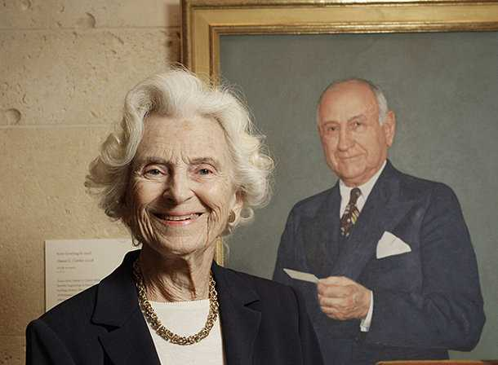

CLOSING SOON

Sightings: Eva Rothschild at the Nasher CLOSES Jan 20

Industrial Monuments: Photographs and Works on Paper from the Machine Age at Amon Carter CLOSES Jan 20

9th Annual High School Art Exhibition at Tyler Museum of Art CLOSES Jan 20

Posters of Paris: Toulouse-Lautrec and His Contemporaries at the DMA CLOSES Jan 20

Variations on Theme: Contemporary Art 1950s–Present at the DMA CLOSES Jan 27

Linder at Goss-Michael Foundation CLOSES Jan 31

Cross Talk at Circuit 12 Contemporary CLOSES Feb 12

Upcoming Musical Performances

2tone: Featuring Cindy Horstman on harp and Michael Medina on bass at the Kimbell Friday Jan 18, 5:30 - 7:30 pm

Cliburn at the Modern at the Fort Worth Modern Saturday Jan 19, 2:00 pm

Tom Reynolds and Paul Unger: Standards, ballads, bassa novas, and blues at the Kimbell Friday Jan 25, 5:30 - 7:30 pm

Tom Reynolds and Paul Unger: Standards, ballads, bassa novas, and blues at the Kimbell Friday Jan 25, 5:30 - 7:30 pm

Schola Cantorum of Texas: Made in America at the Fort Worth Modern Thursday Feb 7, 7:30 pm

Chamber Music Society of Ft. Worth: The Amernet String Quartet at the Fort Worth Modern Saturday Feb 9, 2:00 pm

National Theatre Live - The Magistrate at the Fort Worth Modern Wednesday Feb 13, 2:00 pm; 7:00 pm

Larry Palmer, Professor of Harpsichord and Organ, SMU, and music students from the Meadows School of the Arts on the Museum’s Oldovini organ at the Meadows Thursday Feb 14, 5:30 - 6:30 pm

Upcoming Films

Gregory Crewdson: Brief Encounters at the Fort Worth Modern Jan 18,19, 20

West of Memphis at the Fort Worth Modern Jan 25, 26, 27

Amour at the Fort Worth Modern Feb 1, 2, 3

Harlan Jacobson's Talk Cinema: sneak previews of highly acclaimed foreign and independent films at the Fort Worth Modern Feb 17, 11:00 am

5 Broken Cameras at the Fort Worth Modern Feb 16, 2:00 pm

Oscar Night at the Modern at the Fort Worth Modern Feb 24, 6:00 pm

