# Newsletter Banner revised

**DFW Art History Network Newsletter**

**SAVE THE DATE**

**DFWAHN GATHERING**

**Sunday March 24 at 4:00 pm**

**The Warehouse**

**14105 Inwood Road, Dallas, Texas 75225**

***RSVP to Pierrette by March 15***

The Warehouse is a new art space developed by two collecting couples - the Faulconers and the Rachofskys. The building contains about 18,000 square feet of exhibition space, divided into 16 galleries, and will show works from both the Rachofsky and Faulconer collections. The first installation at The Warehouse features work by Sigmar Polke, Gerhard Richter, Marlene Dumas, Lucio Fontana, Piero Manzoni, Alberto Burri, Jim Hodges, Kara Walker, Carroll Dunham, Vija Celmins, Robert Irwin, Ricci Albenda, Mario Merz, and Gabriel Orozco, among others.

2013 Amon Carter Fellowships

The Amon Carter Museum of American Art invites applications for the 2013 Davidson Family Fellowship. Established in 1996 by a generous gift from the Davidson Family Charitable Foundation, the fellowship provides support for scholars working toward the PhD or at the postdoctoral level to either begin or continue work on research projects in the history of American art that directly relate to objects in the museum’s permanent collection of paintings, sculpture, works on paper, photographs, and rare books.  
  
The stipend rate is $3,000 per month for a minimum one month and maximum four month, full-time research period at the museum. The application deadline is April 15, 2013, for a fellowship period to start on or after September 1, 2013. The museum will announce awards by May 31, 2013.  
  
Please consult the full fellowship description, including application instructions at:  
  
<http://www.cartermuseum.org/library/davidson-family-fellowship>

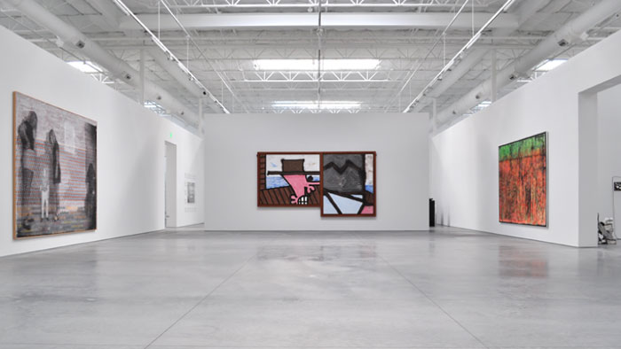

March/April 2013 Issue 007



Spotlight on…

Myra Walker

Professor and Director of the

Texas Fashion Collection at the

University of North Texas

Professor Walker is a “museum person” through

and through. She started her museum career at

the University of Southern Illinois with Evert

Jonson in the early 80’s, after art training at

Louisiana State University. From Carbondale,

Illinois, she found her way to New York City to

work side by side with Diana Vreeland. Walker

was tapped by UNT to be Director of the TFC in 1987. This enormous and internationally important collection had its roots in the fashion collection of Neiman Marcus and was given as a block to UNT to serve as inspiration for art students.

When Prof. Walker arrived, it lacked professional care, curation, and shape, and she has provided all of that in the intervening decades. The collection has grown with gifts from legendary Texas women such as Mrs. Mercedes T. Bass. Prof. Walker has curated, published, and lectured widely on subjects that range from 18th century French fashion to Rock and Roll “fashion” to Balenciaga and has done exhibitions locally at the Kimbell Art Museum and the Meadows Museum as well as at UNT’s “branch” in downtown Dallas *Fashion on Main*.

Thanks to Professor Walker, an entire generation of young curator/scholars in the history of fashion has been trained in Denton—both with the kind of hands-on experience the makes a great curator and with rigorous bibliographical and intellectual underpinnings. 2013—marks Prof. Walker’s 25th anniversary at the Texas Fashion Collection. A dream come true would be to convince the powers-that-be to change its name to the International Fashion Collection IN Texas!

- Rick Brettell

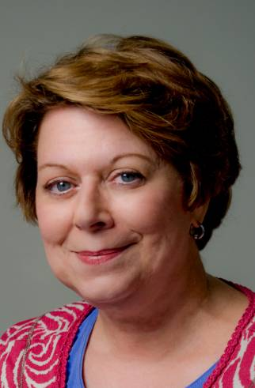

**Upcoming Lectures**

**Saturday** March 09, 11:00 am

[*James Surls, Carbondale, CO*](https://www.kimbellart.org/learn/lectures-discussions) at the Kimbell

**Tuesday** March 12, 7:00 pm

[*Richard Phillips*](http://www.themodern.org/programs/lectures)at the Modern

**Wednesday** March 13, 12:15 pm

Hannah Fullgraf, McDermott Graduate Curatorial Intern for European Art [*Linear Possibilities in Modern European Prints*](http://www.dallasmuseumofart.org/Events/GalleryTalksTours/index.htm) at the DMA

**Friday** March 15, 12:15 pm

Gallery talk [*Martín Rico and His Circle*](http://smu.edu/meadowsmuseum/public_programs.htm#thu) at the Meadows

**Saturday** March 16, 2:00 pm

[*360: Artist, Critics, Curators - Heather Cook*](http://www.nashersculpturecenter.org/360-Artists-Critics-Curators/Heather-Cook) at the Nasher

**Tuesday** March 19, 7:00 pm

[*Matthew Collings*](http://www.themodern.org/programs/lectures)at the Modern

**Wednesday** March 20, 12:15 pm

Dr. Carol Reynolds [*Chagall: Beyond Color*](http://www.dallasmuseumofart.org/Events/GalleryTalksTours/index.htm) at the DMA

**Wednesday** March 20, 12:30 pm

Paola D’Agostino, the Met [*Bernini and Bronze*](https://www.kimbellart.org/learn/lectures-discussions) at the Kimbell

**Thursday** March 21, 6:00 pm

[*Artist Talk: Dornith Doherty and Misty Keasler*](http://www.cartermuseum.org/calendar/public-programs/artist-talk-dornith-doherty-and-misty-keasler) at the Amon Carter

**Thursday** March 21, 7:00 pm

[*Dallas Architecture Forum Presents: Kenneth Frampton*](http://dallasmuseumofart.org/Events/Lectures/index.htm#State_of_the_Arts) at the DMA

**Thursday** March 21, 7:00 pm

[*360: Artist, Critics, Curators - Matthew Collings*](http://www.nashersculpturecenter.org/360-Artists-Critics-Curators/Heather-Cook) at the Nasher

**Friday** March 22, 10:30 am

Luis Martin, Professor Emeritus of History, SMU [*Nation Building: The Search for National Identity in Latin America*](http://smu.edu/meadowsmuseum/public_programs.htm#thu) at the Meadows. Friday morning lecture series (all dates: Apr 5, 12, 19, 26)

**Friday** March 22, 12:15 pm

Gallery talk [*Jaume Plensa: Light and the Human Form*](http://smu.edu/meadowsmuseum/public_programs.htm#thu) at the Meadows

**Wednesday** March 27, 12:15 pm

Gabriel Ritter, The Time and Nancy Hanley Assistant Curator of Contemporary Art [*Cindy Sherman*](http://www.dallasmuseumofart.org/Events/GalleryTalksTours/index.htm)at the DMA

**Tuesday** April 02, 7:00 pm

[*Trenton Doyle Hancock*](http://www.themodern.org/programs/lectures)at the Modern

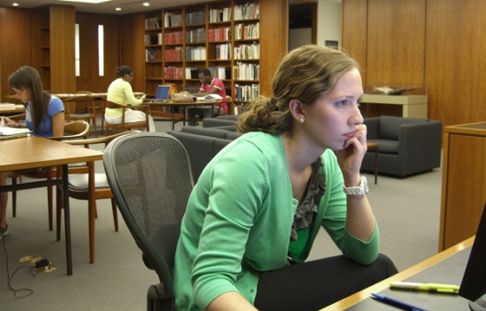

**New Amon Carter Library Hours**

Wednesday: 11 a.m.–4 p.m.  
Thursday: 11 a.m.–7 p.m.  
Friday: 11 a.m.–4 p.m.

BEGINNING SATURDAY MARCH 2  
Saturday: 11 a.m.–4 p.m., September through May

*Other times by appointment*

Starting March 2 the Amon Carter Museum of American Art research library will offer Saturday hours, 11 a.m.-4 p.m., September through May.

Complementing the museum’s art collection, the library offers an extensive range of materials on American art, photography, and history from the early nineteenth century to the present. The library provides support to researchers at all levels interested in deepening their understanding of the country’s artistic heritage.

Photocopies, digital scanning, public computers, and Wi-Fi available.

Library materials may not be checked out.

**Wednesday** April 03, 12:15 pm

Emily Schiller, McDermott Graduate Curatorial Intern for American and Decorative Art [*The Rise of the Machine in Interwar American Art*](http://www.dallasmuseumofart.org/Events/GalleryTalksTours/index.htm)at the DMA

**Thursday** April 04, 5:30 pm

Curator Nicole Atzbach [*Cava Club: Martín Rico's Rio San Trovaso, Venice (c. 1900)*](http://smu.edu/meadowsmuseum/public_programs.htm#thu) at the Meadows

**Thursday** April 04, 6:30 pm

Myra Walker, UNT, Director of Texas Fashion Collection[*The Art of Fashion*](http://smu.edu/meadowsmuseum/public_programs.htm#thu) at the Meadows

**Thursday** April 04, 7:30 pm

Gabriel Ritter, Dr. Agatha Beins (TWU), Tracy Achor Hayes (Neiman Marcus), Dr. Mary Celeste Kearney (UT), Claudia Stephens (SMU) [*Multiple Perspectives/Multiple Personalities—A Discussion on Cindy Sherman*](http://dallasmuseumofart.org/Events/Lectures/index.htm#State_of_the_Arts) at the DMA

**Friday** April 05, 6:00 pm

George T.M. Shackelford [*Degas in Perspective*](https://www.kimbellart.org/event/degas-perspective) at the Kimbell

**Tuesday** April 09, 7:00 pm

[*Panel discussion with representatives of Triple Canopy, Cabinet, and Pastelegram*](http://www.themodern.org/programs/lectures)at the Modern

**Thursday** April 11, 7:30 pm

Richard R. Brettell Lectures Series presents Dr. Paul Galvez, Wildenstein Institute, Paris [*Hunting High and Low: Gustave Courbet's Fox in the Snow*](http://dallasmuseumofart.org/Events/Lectures/index.htm#State_of_the_Arts) at the DMA

**Friday** April 12, 12:15 pm

Scott Winterrowd, Curator of Education [*Martín Rico and Plein-Air Painting in Spain*](http://smu.edu/meadowsmuseum/public_programs.htm#thu)  at the Meadows

**Saturday** April 13, 2:00 pm

[*Nathan Mabry*](http://www.nashersculpturecenter.org/360-Artists-Critics-Curators/Heather-Cook) at the Nasher

**Tuesday** April 16, 7:00 pm

[*Robyn O'Neil*](http://www.themodern.org/programs/lectures)at the Modern

**Wednesday** April 15, 12:30 pm

Jennifer Casler Price, curator for Asian and non-Western art [*Fashioned from the Earth: Asian Traditions in Clay*](https://www.kimbellart.org) at the Kimbell

**Thursday** April 18, 6:00 pm

George Shackelford, Deputy Director, Kimbell [*Mad on Color: Impressionism in Venice*](http://smu.edu/meadowsmuseum/public_programs.htm#thu) at the Meadows

**Tuesday** April 23, 7:00 pm

[*Barry McGee*](http://www.themodern.org/programs/lectures)at the Modern

**Wednesday** April 24, 6:30 pm

[*Dallas Architecture Forum Presents: William Pedersen, FAIA*](http://dallasmuseumofart.org/Events/Lectures/index.htm#State_of_the_Arts) at the DMA

Dallas Museum of Art Discovers George Inness Painting in the Collection

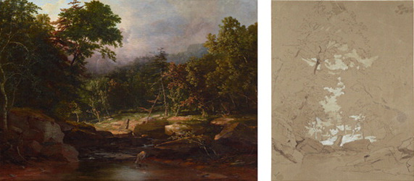

In October 2013, the Dallas Museum of Art announced the reattribution of a painting to the artist George Inness, widely admired as one of America’s greatest landscape painters. The work of art has been in the Museum’s collection for eighty years, entering in 1931 as part of a bequest by Cecil A. Keating. At the time of the painting’s acquisition, the unsigned work carried the title of In the Woods and was believed to be by the hand of Asher B. Durand, a leading figure of the first generation of the Hudson River school painters in the mid-19th century.

At some point during the next forty years, doubts as to the authorship of the painting were raised and the attribution was downgraded to possibly being by Durand, which held until August of this year. Sue Canterbury, The Pauline Gill Sullivan Associate Curator of American Art, viewed the painting in the Museum’s art storage area and was intrigued by its strong composition and competent execution, as well as by the questions surrounding its authorship. After an examination of the spatial organization and the techniques used in the painting, a number of artists, including Durand, were eliminated as possible creators of the work. Close scrutiny of the early works of Inness yielded the greatest degree of parity in matters of execution. Canterbury’s suspicions of Inness’s authorship were clinched, however, when she suddenly came across a pen and ink drawing from the Princeton University Art Museum that contained the key compositional elements of the Dallas work. Of these similarities, the most eye-catching is the pointing trapezoidal rock that appears in the center of both drawing and painting.

Stream in the Mountains is on view in the DMA’s American Art galleries on Level 4, alongside Asher B. Durand’s Wooded Landscape, which is presently on loan to the DMA from the Jean and Graham Devoe Williford Charitable Trust.

.

Images: George Inness, Stream in the Mountains (formerly: In the Woods), c. 1850, oil on canvas, Dallas Museum of Art, bequest of Cecil A. Keating, 1931.6; George Inness, Woodland Scene, 1845–55, pen and brown-black ink, brush, and brown wash heightened with white gouache over traces of graphite on brown wove paper, Princeton University Art Museum. Gift of Frank Jewett Mather Jr. x1943-27

**Thursday** April 25, 7:30 pm

Olivier Meslay, Associate Director of Curatorial Affairs and Rabbi David Stern, Senior Rabbi of Temple Emanu-El of Dallas [*Chagall: Art and Religion*](http://dallasmuseumofart.org/Events/Lectures/index.htm#State_of_the_Arts) at the DMA

**Wednesday** May 01

**Thursday** May 02

International symposium *From the Other Shore: Narratives and Perspectives on Spanish & Latin American Art*  at the Meadows

**Thursday** May 02, 09, 16, 23

Nancy Cohen Israel *Martín Rico and His Place in the 19th-century Landscape Tradition* at the Meadows ($40 for four-part series)

**Thursday** May 09, 7:30 pm

Gabriel Ritter [*Cindy Sherman: Artist as Model*](http://dallasmuseumofart.org/Events/Lectures/index.htm#State_of_the_Arts) at the DMA

**Friday** May 10, 6:00 pm

Xavier Ray, curator of paintings at the Musée d'Orsay, Paris [*The New Musée d'Orsay*](https://www.kimbellart.org/) at the Kimbell

**Saturday** May 11, 11:00 am

Moderated by Nancy E. Edwards, curator of European art [*Gary Cunningham, FAIA, Dallas*](https://www.kimbellart.org/) at the Kimbell

**Saturday** May 18, 2:00 pm

[*360: Artist, Critics, Curators: Liz Larner*](http://www.nashersculpturecenter.org) at the Nasher

**Show Openings**

[***groundwork: Kelly Kroener***](http://regallerystudio.com/)**at RE Gallery OPENING** Fri Mar 08 6:00 pm

**Artist Talk** Sun Mar 24 6:00 pm

**Closing Reception** Fri Apr 05 6:00 pm

[***Nate Glaspie, Shelby David Meir & Shayne Murphy***](http://www.500x.org/)**500X Gallery Mar 09 – Apr 7; OPENING** Sat Mar 09, 7:00 pm

[***Don Sahli***](http://www.swgallery.com/)**at Southwest Gallery OPENING** Sat Mar 09 1:00 pm

[***Peter Ligon and Corbett Sparks***](http://www.yelp.com/biz/gray-matters-art-gallry-dallas)**Road Agent at Gray Metters**

**OPENING** Sat Mar 09, 7:00 pm

[***Failing Flat: Sculptural Tendencies in Painting curated by Nathan Green***](http://www.centraltrak.net/)**at CentralTrak** **Mar 09 – Apr 27**

**OPENING** Sat Mar 09

[***Impressions of Europe: Nineteenth-Century Vistas by Martín Rico***](http://smu.edu/meadowsmuseum/about_Rico.htm)**at the Meadows** **Mar 10 - Jul 07**

**OPENS** Sun Mar 10

#### A Closer Look at Pierre Bonnard’s The Street in Winter

[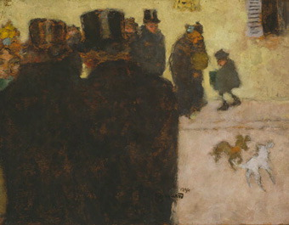](http://dallasmuseumofart.org:9090/emuseum/view/objects/asitem/2154/102/title-desc?t:state:flow=89c14b6c-db02-4412-bc12-79a48b6456a7)

Pierre Bonnard’s painting The Street in Winter of 1894 entered the Dallas Museum of Art’s collection in 1985 as part of The Wendy and Emery Reves Collection. Earlier this year, Associate Director of Curatorial Affairs Olivier Meslay chose to highlight this masterwork of European art in a new installation within the Museum’s replica of the Villa La Pausa on Level 3. In this petite yet impressive painting, Bonnard captures a moment of everyday life in the streets of Paris.

Pierre Bonnard was a member of the Nabis (Hebrew for “prophet”), a group of predominantly French artists active in Paris around 1888 to 1900. Founded by Paul Sérusier, the circle included many influential artists such as Maurice Denis, Paul Ranson, Henri-Gabriel Ibels, Edouard Vuillard, Félix Vallotton, and Aristide Maillol. The Nabis followed the synthetist precedent set by Paul Gauguin, which explored the ways in which feeling and thought could be integrated with the appearance of natural forms.   
  
The provenance history of The Street in Winter begins with two art critics who had collections of works from various art movements that originated in France, including the Nabis group.The painting first belonged to Thadée Natanson, an important French critic and collector who strongly supported the Nabi movement. In 1891 Thadée, along with his brother Alexandre, founded the Revue Blanche, a journal that promoted Bonnard and his contemporaries and celebrated their innovative aesthetic. In 1908, when Natanson sold his collection of art, The Street in Winter came into the possession of the influential dealer, art critic, and collector Félix Fénéon. Like Natanson, Fénéon was active in the literary community of Paris. He contributed to numerous magazines and co-founded his own journal, Revue Indépendante, in 1884.

**NASHER XCHANGE: 10 YEARS. 10 ARTISTS. 10 SITES.**

Commemorating its 10th anniversary, the Nasher Sculpture Center will present *Nasher XChange*, a dynamic public art exhibition consisting of 10 commissioned works by 10 renowned artists at 10 diverse sites throughout the city of Dallas.

[**Read more →**](http://www.nashersculpturecenter.org/Exhibitions/Nasher-Xchange)

[***Maximum Overdrive***](http://www.utdallas.edu/calendar/event.php?id=1220269951)**at UTD Gallery OPENING** Sat Mar 22 6:30 pm

[***Michael Bise: Life and Death Frank Rodick: Selections from the exhibition Labyrinth of Desire Wael Shawky: Cabaret Crusades Shannon Novak: Tonnetz***](http://the-mac.org/)**at the MAC Mar 23 – May 11 OPENING**  Sat Mar 23 6:00 - 8:00 pm

[***Lucas Martell Exhibit***](http://www.mountainviewcollege.edu/Academics/acaddivisions/Ahss/arts/Pages/artgallery.aspx)**at Mountain View College Cliff Gallery Mar 26 – Apr 12 Reception** Apr 12, 7:00 pm

[***modzone: Works by Bill Parker***](http://www.banksfineart.com/)**at Banks Fine Mar 28 – May 23**

[***FOCUS: Barry McGee***](http://www.themodern.org/exhibitions/upcoming)**at the Fort Worth Modern** **Mar 31 – Jun 02**

[***Art Appreciation Photography/Art Show***](http://www.mountainviewcollege.edu/Academics/acaddivisions/Ahss/arts/Pages/artgallery.aspx)**at Mountain View College Kiva Gallery Apr 09 – Apr 19**

**Reception** Apr 19, 7:00 pm

[***Dan Rees***](http://www.gossmichaelfoundation.org/)**at Goss-Michael Foundation OPENS Apr 12**

[***John Pomara, Walter Van Beirendonck, Soner***](http://www.dallascontemporary.org/)**at Dallas Contemporary OPENING Apr 12**, 9:00 pm

[***Sightings: Nathan Mabry***](http://www.nashersculpturecenter.org/Exhibitions/Sightings/Nathan-Mabry)**at the Nasher April 13 – July 07**

**Current Exhibitions**

[***Ted Kincaid - The Beautiful Lie/The Terrible Truth***](http://www.talleydunn.com/)**at Talley Dunn Gallery** Mar 02 – Apr 13

[***Raven's Riddle: Bill and Hans Haveron***](http://www.kirkhopperfineart.com/) **at Kirk Hopper Fine Art** Mar 02 – Apr 13

[***Brent Kollock: The Eccentric Center***](http://www.norwoodflynngallery.com/)**at Norwood Flynn Gallery**

OpenedMar 02

[***Bernini: Sculpting in Clay***](https://www.kimbellart.org/exhibitions)**at the Kimbell** through April 14

[***Big Pictures***](http://www.cartermuseum.org/exhibitions)**at the Amon Carter** through Apr 21

[***Night: Prints and Drawings from the Collection***](http://www.cartermuseum.org/exhibitions)**at the Amon Carter** through Apr 28

[***Jasper Johns - Circles and Squares***](http://www.talleydunn.com/)**at Talley Dunn Gallery** Mar 02 – May 04

[***China Through the Lens of John Thomson 1868-1872***](http://crowcollection.org/)**at Crow Collection** Feb 16 – May 05

[***BUNNY YEAGER***](http://www.pdnbgallery.com/Site/HOME.html)**at PDNB Gallery** Feb 23 – May 11

[***Ken Price Sculpture: A Retrospective***](http://www.nashersculpturecenter.org/Exhibitions/Sightings/Nathan-Mabry)**at the Nasher** Feb 09 – May 12

#### [New Collections Handbook Highlights Recent Acquisitions across Museum’s Encyclopedic Collection and Showcases DMA’s Transformative Growth Since Its Founding in 1903](http://www.dallasmuseumofart.org/PressRoom/dma_441496)

The Dallas Museum of Art celebrates more than

one hundred years of benefaction from its major

donors with the release of a new collection hand-

book, documenting the Museum’s transformative

growth since its founding in 1903. The 368-page,

full-color publication provides an overview of the

quality, breadth, and depth of the Museum’s

encyclopedic collection and emphasizes the

tremendous impact of the Museum’s longtime

patrons, who enabled the Museum to grow from

a regional resource into one of the nation’s

leading arts institutions. With an introduction by

former Museum director Bonnie Pitman, the

guide highlights more than four hundred works of art with new photography and scholarship, and showcases in particular recent gifts and major acquisitions from the past fifteen years. *Dallas Museum of Art: A Guide to the Collection* is available in the Museum Store and online at shopDMA.org.

#### The Quality Instinct: Seeing Art Through a Museum Director’s Eye by  Maxwell L. Anderson Provides Readers with Insights and Anecdotes on How to See and Judge Art

Maxwell L. Anderson, the newly named Eugene McDermott Director of the Dallas Museum of Art and former director of the Whitney Museum of American Art in New York, enters the fray with The Quality Instinct: Seeing Art Through a Museum Director’s Eye.

Part personal memoir, part thinking person’s guide to the museum, The Quality Instinct is filled with wit, humor, anecdotes, and insights from the author’s thirty years in the highly competitive, often contentious art world. Anderson takes us on a grand tour of ancient and contemporary art, sharing five simple metrics of quality that help us increase our “visual literacy” as we learn to see, not simply look—and yes, to judge.

*All proceeds from the sales will go directly to the Dallas Museum of Art.*

[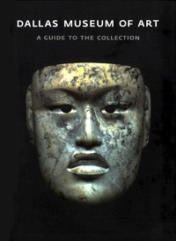](http://store.shopdma.org/damuofartgup.html)

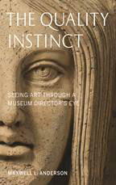

**Upcoming Musical Performances**

[***Counterpoint and Invention: Jay Campbell, cello and piccolo cello, Conor Hanick, piano and harpsichord, David Fulmer, Composer, and Wei-Chieh Lin, Composer***](http://www.nashersculpturecenter.org/Events-Calendar/Soundings--New-Music-at-the-Nasher/Performances)**at the Nasher**

Friday March 08, 7:30 pm

[***Tom Reynolds and Paul Unger: Standards, ballads, bassa novas, and blues***](https://www.kimbellart.org/learn/music-performances)**at the Kimbell**

Friday March 08, 5:30 - 7:30 pm

[***Chamber Music Society of Fort Worth***](http://www.themodern.org/performances)**at the Fort Worth Modern**

Saturday March 09, 2:00 pm

[***Fort Worth Classic Guitar Society***](http://www.themodern.org/performances)**at the Fort Worth Modern**

Thursday March 14, 7:30 pm

[***Texas Camerata***](http://www.themodern.org/performances)**at the Fort Worth Modern**

Saturday March 16, 2:00 pm

[***Larry Palmer, Professor of Harpsichord and Organ, SMU, and music students from the Meadows School of the Arts on the Museum’s Oldovini organ***](http://smu.edu/meadowsmuseum/public_programs.htm#thu)**at the Meadows**

Thursday March 21, 5:30 - 6:30 pm

[***Chamber Music Society of Fort Worth: Alexander Shtarkman***](http://www.themodern.org/performances)**at the Fort Worth Modern**

Saturday March 30, 2:00 pm

[***National Theatre Live - People***](http://www.themodern.org/performances) **at the Fort Worth Modern**

Wednesday April 03, 2:00 pm; 7:00 pm

[***Cliburn at the Modern: Christopher Theofanidis, composer***](http://www.themodern.org/performances)**at the Fort Worth Modern**

Saturday April 06, 2:00 pm

[***Fort Worth Classic Guitar Society: Ian Watt***](http://www.themodern.org/performances)**at the Fort Worth Modern** Thursday April 11, 7:30 pm

[***Ives’ Concord Sonata and the Poetry of E.E. Cummings***](http://www.nashersculpturecenter.org/Events-Calendar/Soundings--New-Music-at-the-Nasher/Performances)**at the Nasher**

Friday April 26, 7:30 pm

[***Marie Cosindas: Instant Color***](http://www.cartermuseum.org/exhibitions)**at the Amon Carter** through May 26

[***Texas Impressionism: Branding with Brushstroke and Color, 1885-1935***](http://www.tylermuseum.org/)**at Tyler Museum of Art** through May 26

[***Chagall: Beyond Color***](http://dma.org/View/CurrentExhibitions/index.htm)**at the DMA** through May 26

[***Loren Mozley: Structural Integrity***](http://dma.org/View/CurrentExhibitions/index.htm)**at the DMA** through June 30

[***Ed Ruscha: Made in California***](http://www.cartermuseum.org/exhibitions)**at the Amon Carter** through July 21

[***Tenth Anniversary Acquisitions***](http://www.themodern.org/exhibitions/upcoming)**at the Fort Worth Modern** through Aug 11

[***Gold on Black: Japanese Lacquer from the Jacqueline Avant Collection***](http://crowcollection.org/)**at Crow Collection** Mar 02 – Sep 15

**CLOSING SOON**

[***Red/Yellow: Kathy Lovas & Susan Sponsler Exhibit***](http://www.mountainviewcollege.edu/Academics/acaddivisions/Ahss/arts/Pages/artgallery.aspx)**at Mountain View College Cliff Gallery CLOSES Mar 08 Reception March 08, 7:00 pm**

[***Focus Exhibition—African Influences on Modern Art***](http://dma.org/View/CurrentExhibitions/index.htm)**at the DMA CLOSES Mar 10**

[***FOCUS: Gary Simmons***](http://www.themodern.org/exhibition/upcoming/focus-gary-simmons/1442)**at the Fort Worth Modern** **CLOSES Mar 14**

[***Lana Paninchul: This Makes Me Sad***](http://www.oliverfrancisgallery.com/)**at Oliver Francis Gallery** **CLOSES Mar 14**

[***David A. Dreyer: Resonance of Place and Philip John Evett: Sculpture and Drawings***](http://www.valleyhouse.com/)**at Valley House Gallery CLOSES Mar 16**

[***JAMES R. BLAKE***](http://www.williamcampbellcontemporaryart.com/)**at the William Campbell Contemporary** **CLOSES Mar 16**

[***Difference?***](http://dma.org/View/CurrentExhibitions/index.htm)**at the DMA CLOSES Mar 17**

[***Karla Black: Concentrations 55***](http://dma.org/View/CurrentExhibitions/index.htm)**at the DMA CLOSES Mar 17**

[***CLOTHESLINE: Photographs by John Albok***](http://www.pdnbgallery.com/Site/HOME.html)**at PDNB Gallery** **CLOSES Mar 20**

**For information to be included in the May/June issue,  please provide to Pierrette Lacour at pierret@utdallas.edu before Saturday, April 20**

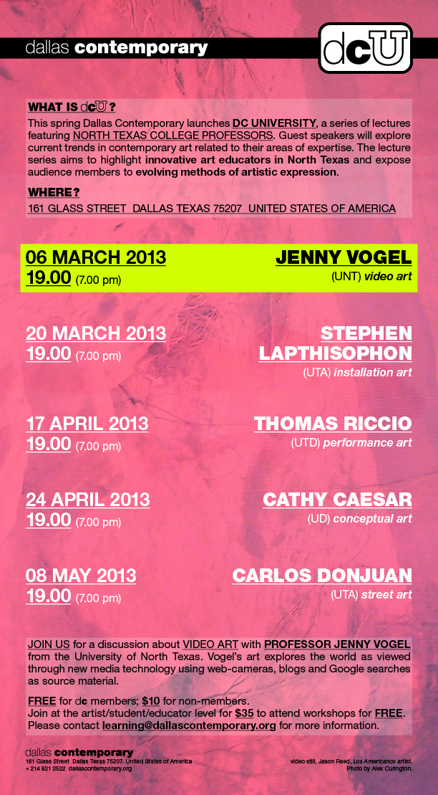

[***FOCUS: Yinka Shonibare MBE***](http://www.themodern.org/exhibitions/upcoming)**at the Fort Worth Modern** **CLOSES Mar 24**

[***Young American Talent***](http://www.elcentrocollege.edu/artgallery)**at El Centro H. Paxton Moore Fine Art Gallery CLOSES Mar 24** closing reception and award ceremony Wed Mar 27 6:00 pm

[***Cross Currents: Tradition and Innovation in Contemporary Art of the Islamic World***](http://gallery.unt.edu/exhibitions)**at UNT Art Gallery CLOSES Mar 30**

[***Raymond Saa, Michelle O'Michael and Peter Burega***](http://www.craigheadgreen.com/)**at Craighead Green Gallery** **CLOSES Mar 30**

[***Paul Booker ‘Meander’***](http://www.crisworley.com/)**at Cris Worley Fine Arts** **CLOSES Mar 30**

[***Roberto Munguia, Michael Tole, Jason Flowers***](http://www.conduitgallery.com/)**at Conduit Gallery** **CLOSES Mar 30**

[***Dzine: Victory***](http://dallascontemporary.org/)**at the Dallas Contemporary CLOSES Mar 30**

[***Selected works on exhibit in the Lounge in Marfa***](http://www.galleriurbane.com/upcoming-dallas-exhibits.html)**at Galleri Urbane Dallas** **CLOSES Mar 30**

[***Randy Twaddle***](http://www.hollyjohnsongallery.com/)**at Holly Johnson Gallery CLOSES Mar 30**

[***The Sacred in the Everyday: John Cobb's Chapel Series***](http://www.tylermuseum.org/)**at Tyler Museum of Art CLOSES Mar 30**

[***Land Ho***](http://www.circuit12.com/) **at Circuit 12 Contemporary** **CLOSES Mar 30**

**NOTICE:**

***PDNB Gallery Director Burt Finger deaccessioning notice:*** [***30 YEARS OF COLLECTING***](http://www.pdnbgallery.com/Site/HOME.html)

**Upcoming Films**

[***A Place at the Table***](http://www.themodern.org/films/category/Magnolia-at-the-Modern/87) **at the Fort Worth Modern**

Mar 08 – Mar 10

[***JOHN ALBOK’S NEW YORK***](http://www.pdnbgallery.com/Site/HOME.html) **at PDNB Gallery**

Mar 9, 1:00 & 3:00 pm

[***Roman Holiday***](https://www.kimbellart.org/learn/films) **at the Kimbell** Mar 10

[***American Choral Directors Association 2013 Film Festival***](http://www.dallasmuseumofart.org/Events/Films/index.htm)**at the DMA**

Mar 13 – 16, selected times (Screenings will include question-and-answer sessions with film directors, composers, and VIP guests)

[***The Gatekeepers***](http://www.themodern.org/films/category/Magnolia-at-the-Modern/87) **at the Fort Worth Modern**

Mar 15 – Mar 17

[***Tom and Jerry & The Wizard of Oz (2011)***](http://www.dallasmuseumofart.org/Events/Films/index.htm)**at the DMA**

Mar 15, 6:00 pm

[***56 Up***](http://www.themodern.org/films/category/Magnolia-at-the-Modern/87) **at the Fort Worth Modern** Mar 22 – Mar 24

[***Great Performances: Tosca from Rome***](https://www.kimbellart.org/learn/films) **at the Kimbell**

Mar 24

[***NO***](http://www.themodern.org/films/category/Magnolia-at-the-Modern/87) **at the Fort Worth Modern** Mar 29 – Mar 31

[***Lore***](http://www.themodern.org/films/category/Magnolia-at-the-Modern/87) **at the Fort Worth Modern** Apr 05 - 07

[***La Dolce Vita***](https://www.kimbellart.org/learn/films) **at the Kimbell** Apr 07

[***Beyond the Hills***](http://www.themodern.org/films/category/Magnolia-at-the-Modern/87) **at the Fort Worth Modern** Apr 12 - 14

[***A Gift of History: Quin Mathews Films and Art Matters Archives***](http://dallasmuseumofart.org/Events/Lectures/index.htm#State_of_the_Arts) **at the DMA** Apr 18 (screening of highlights and commentary, followed by reception)

[***To the Wonder***](http://www.themodern.org/films/category/Magnolia-at-the-Modern/87) **at the Fort Worth Modern** Apr 19 - 21

[***The Company You Keep***](http://www.themodern.org/films/category/Magnolia-at-the-Modern/87) **at the Fort Worth Modern**

Apr 26 - 29

[***The Private Life of a Masterpiece: Michelangelo, David***](http://www.kimbell.org) **at the Kimbell** Apr 28