# Newsletter Banner revised

May/June 2013 Issue V

# Distinguished Endowed Chair of Art History Roberto Tejada Awarded Fellowship at The Clark

## *Award given to scholar whose work takes an interdisciplinary approach to the visual*

Meadows Distinguished Endowed Chair of Art HistoryRoberto Tejada has been named the recipient of a fellowship from The Sterling and Francine Clark Art Institute (in conjunction with the Oakley Center for the Humanities and Social Sciences) at Williams College in Williamstown, Massachusetts. This recognition - The Clark's most distinguished - is awarded to a scholar in the humanities whose work takes an interdisciplinary approach to some aspect of the visual.  Along with the Center for Advanced Study in the Visual Arts at the National Gallery of Art and the Getty Research Center, the Clark’s fellowship program is recognized as one of the most crucial centers for the cultivation of original thinking in the visual arts in the United States. Tejada joins a line of esteemed thinkers, critics and historians who have been Clark recipients, including such scholars as W.J.T. Mitchell, Kobena Mercer, Griselda Pollock, Serge Guilbaut, Lowery Sims and others.

[*Read more...*](https://www.smu.edu/Meadows/NewsAndEvents/News/2013/130226-TejadaFellowship)

**DFW Art History Network Newsletter**

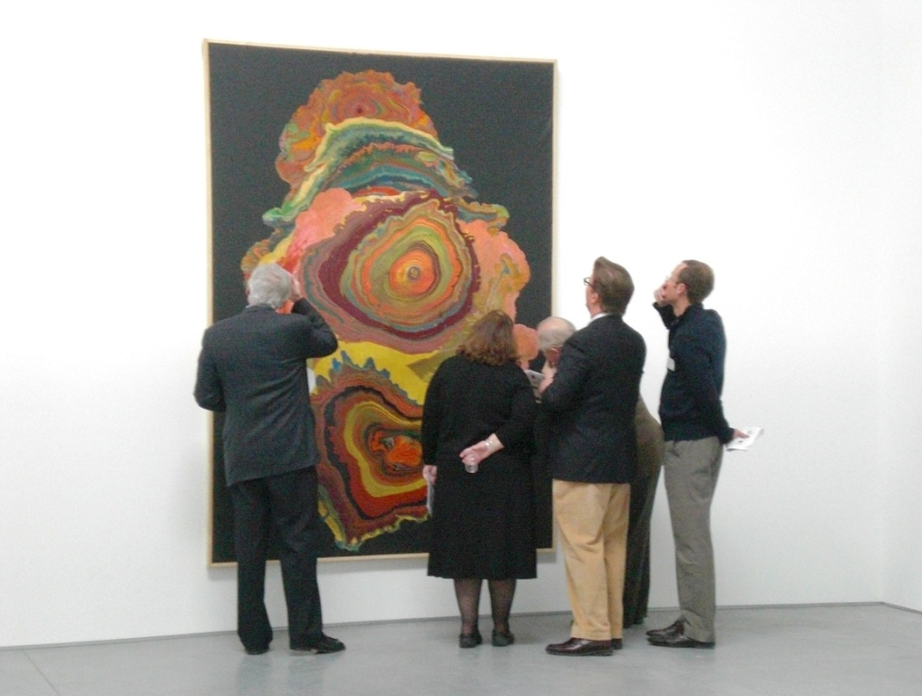

**THANK YOU TO ATTENDEES OF SPRING DFWAHN GATHERING AT THE WAREHOUSE**

Many thanks to those who attended the DFWAHN gathering at the Warehouse Sunday, March 24th in Dallas. The event was graciously hosted by Thomas Feulmer whose tour of this exciting new exhibition space was pure delight. Especially memorable were the Gutai works such as the ---- pictured here.



Spotlight on…

**Douglas Klahr**

School of Architecture

The University of Texas at Arlington

One of the greatest pleasures of DFWAHN for

me, one of its founders, is meeting fellow art

historians who I would never otherwise have

met and finding mutual interests. That is the

case with Douglas Klahr at UTA and me. We

have each been active in university teaching in

Dallas since 1998 and 2005 respectively and

are both interested in 19th century architecture

and the history of photography and we live within

a mile of each other. Yet, somehow, our paths

never crossed until the first DFWAHN meeting at the Barrett’s home. There, we happily prattled on about German 19th century architecture, Douglas’s field, and about the history of photography, his new field.

Douglas Klahr teaches in the School of Architecture at UTA, which, like most such professional schools, has architectural historians trained in art and architecture history programs. His life and career are fascinating. Trained as an undergraduate at Brown in art and architectural history, Douglas entered the corporate world in luxury retailing when fresh out of college, working for such important global retail bands as Chanel, La Prairie, I. Magnin, and Goldpfeil Ludwig Krumm AG, before realizing that his true vocation was art and architectural history. He returned to his first love, architectural history, obtaining his master’s degree from the University of Virginia’s Architecture School (with its Jeffersonian classical tradition) and then returning to Brown University’s Art and Architectural History Department for his Ph.D.

With fluency in German, Douglas was attracted to the field of German 19th century architecture and urbanism, a field that is overshadowed in the United States by French, English, Italian, and American architectural history. His master’s thesis and dissertation were both devoted to the architecture and urbanism of Berlin during the reign of German Emperor Wilhelm II, a field also neglected in favor of the earlier architecture of Schinkel and Klenze and the later of the German modernists. Writing about over-the-top Neo-Baroque was not exactly “fashionable,” but Douglas has willingly bucked trends for most of his scholarly career.

He has published in such prestigious journals as the Oxford Journal of Art, Zeitschrift für Kunstgeschichte, The Journal of the Society of Architectural Historians, and German History and has lectured widely in the United States and Europe. His work on the photographic representation of cities is fascinating, and his two most recent articles are entitled **“Stereoscopic Photography Encounters the Staircase: Traversing Thresholds, Borders and Passages”** (in press), **“The Radically Subversive Narrative of Stereoscopic Photography,”** along with the book chapter **“The Elusive Challenge of Photographing Urban Spaces: Nineteenth Century Berlin as Exemplar”** in *Documenting History, Charting Progress, and Exploring the World: Architecture in Nineteenth Century Photographs*, edited by Micheline Nilsen (London: Ashgate Press, 2013).

- Rick Brettell

*Learn more about Douglas Klahr's at UTA* [*profile*](http://www.uta.edu/architecture/faculty-staff/douglas-klahr.php)*.*

**Upcoming Lectures**

**Tuesday** May 14, 7:00 pm

Author Robert Edsel[*Saving Italy: The Monuments Men, Nazis, and War*](https://18637a.blackbaudhosting.com/18637A/An-Evening-with-Robert-Edsel) at the Nasher

**Thursdays** May 16, 6:00 pm

Nancy Cohen Israel, Art Historian [*Martín Rico and His Place in the 19th-century Landscape Tradition*](http://smu.edu/meadowsmuseum/public_programs.htm#thu) at the Meadows. Thursday evening lecture series (all dates: May 2, 9,16, 23)

**Thursday** May 16, 6:00 pm

[*Guest Artist John Bramblitt*](http://smu.edu/meadowsmuseum/public_programs.htm#thu) at the Meadows.

**Friday** May 17, 6:00 pm

Author Gary Edsel[*Saving Italy: The Race to Rescue a Nation's Treasures from the Nazis*](https://www.kimbellart.org/learn/lectures-discussions) at the Kimbell

**Saturday** May 18, 2:00 pm

[*Liz Larner*](http://www.nashersculpturecenter.org/) at the Nasher

**Wednesday** May 22, 12:30 pm

Willard Spiegelman, Dwain Hughes, Jr.[*Why Poussin Matters*](https://www.kimbellart.org/learn/lectures-discussions) at the Kimbell

**Wednesday** May 15, 12:15 pm

Holly York, McDermott Graduate Curatorial Intern for Family Programs [*Evolution of Painting: A Conversation on Henri Matisse & Hans Hoffman*](http://www.dallasmuseumofart.org/Events/GalleryTalksTours/index.htm) at the DMA

**Wednesday** May 15, 7:30 pm

ARTS&LETTERSLIVE [Artful Musings: Characteristics in Color: A Serenade to Chagall](http://www.dallasmuseumofart.org/Events/GalleryTalksTours/index.htm) at the DMA

**Thursday** May 16, 2:00 pm

Dr. Herbert Traxl [Former Ambassador to India](http://www.crowcollection.org) at the Crow

**Wednesday** May 22, 12:15 pm

Sarah Foltz, independent scholar, [*Loren Mozley: Structural Integrity*](http://www.dallasmuseumofart.org/Events/GalleryTalksTours/index.htm) at the DMA

**Wednesday** May 29, 12:15 pm

Deborah Hunter, Associate Professor of Photography, SMU [*Cindy Sherman*](http://www.dallasmuseumofart.org/Events/GalleryTalksTours/index.htm)at the DMA

**Friday** May 31, 7:30 pm

ARTS&LETTERSLIVE [Distinguished Writers: Margaret Atwood](http://www.dallasmuseumofart.org/Events/GalleryTalksTours/index.htm) at the DMA

**Tuesday** June 04, 7:30 pm

ARTS&LETTERSLIVE [Distinguished Writers: Revolution! Joseph J. Ellis and Tom Reiss](http://www.dallasmuseumofart.org/Events/GalleryTalksTours/index.htm) at the DMA

[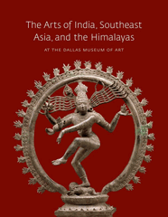](http://ep.yimg.com/ca/I/dallasmuseumofart_2257_3758290)

**Dallas Museum of Art Publishes Its First**

**Catalogue of South & Southeast Asian Art**

*The Arts of India, Southeast Asia,and the Himalayas*

Surveys the Cultural and Artistic Significance of

1700 Years of Visual Art Over the Museum’s Nearly Sixty Years of Collecting

The Dallas Museum of Art announced the publication of the first catalogue dedicated to exploring the Museum’s collection of over 450 works of South and Southeast Asian art. The richly illustrated 264-page book was written by Dr. Anne R. Bromberg, Ph.D., the DMA’s Cecil and Ida Green Curator of Ancient and Asian Art, with contributions by scholars Catherine B. Asher, Frederick M. Asher, Robert Warren Clark, and Nancy Tingley.

Interest in Asian art at the Dallas Museum of Art has centered on special exhibitions for much of its history, beginning in 1938 with *Chinese Ancestral Portraits and Japanese Landscape Prints.* The DMA has collected and continued to build its important collection of the arts of South and Southeast Asia since the acquisition of the Tibetan Manjushri sculpture in 1955. In 1962 the groundbreaking exhibition *Arts of Man* led to a significant expansion of the DMA’s Asian art holdings.

You can purchase the book at: <http://shopdma.org/arofinsoasan.html>

**Swartz Brothers Chronicled Early Life in Fort Worth**

Exhibition at Central Fort Worth Library on view in May



The best-known photograph shows the five members of the “Wild Bunch” (aka, the “Fort Worth Five”) posed in John’s studio in 1900. It is the basis of the downtown development known as “Sundance Square.” The Brothers’ cumulative work provides a stunning visual chronicle of late 19th- and early 20th-century Fort Worth as well as a window into American life during that era. On display in the West Wing of the [Central Library](http://fortworthtexas.gov/library/branches/central/) from May 1 - 30.

[*More info…*](http://fortworthtexas.gov/library/info/default.aspx?id=107860)

**NASHER XCHANGE: 10 YEARS. 10 ARTISTS. 10 SITES.**

Commemorating its 10th anniversary, the Nasher Sculpture Center will present *Nasher XChange*, a dynamic public art exhibition consisting of 10 commissioned works by 10 renowned artists at 10 diverse sites throughout the city of Dallas.

[*Updates…*](http://www.nashersculpturecenter.org/Exhibitions/Nasher-Xchange)

**Wednesday** June 05, 12:15 pm

Dr. Lyle Novinski, Professor Emeritus, UD [*Body Beautiful in Ancient Greece: Masterworks from the British Museum*](http://www.dallasmuseumofart.org/Events/GalleryTalksTours/index.htm)at the DMA

**Thursday** June 06, 6:00 pm

Director Mark Roglan[*Collecting Rico in America*](http://smu.edu/meadowsmuseum/public_programs.htm#thu) at the Meadows.

**Wednesday** June 12, 12:15 pm

Steven Alpert [The Indonesian Collection](http://www.dallasmuseumofart.org/Events/GalleryTalksTours/index.htm) at the DMA

**Saturday** June 15, 10:00 am

[*Wari: Lords of the Ancient Andes*](https://www.kimbellart.org/learn/lectures-discussions) at the Kimbell

**Wednesday** June 19, 12:15 pm

Leigh Arnold, DMA Research Project Coordinator [*DallasSITES: Charting Contemporary Art,1930 to Present*](http://www.dallasmuseumofart.org/Events/GalleryTalksTours/index.htm)at the DMA

**Monday** June 24, 7:30 pm

ARTS&LETTERSLIVE [Neil Gaiman](http://www.dallasmuseumofart.org/Events/GalleryTalksTours/index.htm) at the DMA

**Wednesday** June 26, 12:15 pm

Olivier Meslay, Associate Director of Curatorial Affairs and The Barbara Thomas Lemmon Curator of European Art [*Hotel Texas: An Art Exhibition for President and Mrs. John F. Kennedy*](http://www.dallasmuseumofart.org/Events/GalleryTalksTours/index.htm)at the DMA

**Wednesday** June 26, 7:00 pm

**Thursday** June 27, 7:00 pm

Maxwell Anderson [*The Body Beautiful in Ancient Greece*](http://www.dallasmuseumofart.org/Events/GalleryTalksTours/index.htm) at the DMA

**Show Openings**

[***The Best of Moldova***](http://www.swgallery.com/)**at Southwest Gallery OPENS** Sat May 11

[***The Color Black: A Conversation In Three Parts***](http://www.500x.org/)**500X Gallery** May 11 - June 02

[***That Mortal Coil: Rebuking the Ideal in Contemporary Figurative Art***](http://www.utdallas.edu/ah/events/index.php)**at CentralTrak** May 11 - June 29

[***Sedrick Huckaby: Hidden in Plain Site***](http://www.cartermuseum.org/)**at the Amon Carter** May 14 - Oct 31

[***Romare Bearden: A Black Odyssey***](http://www.cartermuseum.org/)**at the Amon Carter** May 18 - Aug 11

[***Heather Gorham, Danna Ruth Harvey, Joey Brock***](http://www.craigheadgreen.com/)**at Craighead Green Gallery** May 18 – June 22

**OPENING** Sat May 18 5:00 PM

The Swartz brothers – David, John and Charles – were three Virginia farm boys who ventured west, arriving in Fort Worth in the mid-1880s. Over the next 30 years, they observed the city through the lens of a camera, snapping pictures of people, events and architecture – leaving a priceless legacy. Hundreds of those images have survived.

**Art Historian Dr. Lisa Owen**

**Awarded Fulbright Grant**

[*UNT*](http://www.unt.edu/) *professor of Art History received Fulbright-Nehru Research Award to conduct fieldwork on medieval rock-cut temples in India*

[***Susan O'Malley***](http://www.galleriurbane.com/upcoming-dallas-exhibits.html)**at Galleri Urbane Dallas** **OPENS** Sat May 18

[***Beyond Abstraction: Recent Works by Six North Texas Artists***](http://the-mac.org/)

**at the MAC** May 18 – June 29

**OPENING** Sat May 18 5:30 PM

[***Andrew Douglas Underwood: The Fall of Bonnie and Clyde***](http://the-mac.org/)

**at the MAC** May 18 – June 29

**OPENING** Sat May 18 5:30 PM

[***Robin Ragin: Homage to a Mentor***](http://the-mac.org/)

**at the MAC** May 18 – June 29

**OPENING** Sat May 18 5:30 PM

[***JD Miller Live Painting Event***](http://www.dallasartdealers.org/events/live-painting-event-jd-miller/)**at Samuel Lynne Galleries** May 18 6:00 pm

[***Ruben Nieto “Shadow Paintings”***](http://www.crisworley.com/)**at Cris Worley Fine Arts** May 18 - June 22

**OPENING** Sat May 18 6:00 pm

[***CVAD MFA Showcase***](http://gallery.unt.edu/)**at UNT Art Gallery** May 21 - June 29

**OPENING** May 23, 5:00 pm

[***Katharina Grosse: Wunderblock***](http://www.nashersculturecenter.org)**at the Nasher** June 01 - Sept 01

[***We the People: Picturing American Identity***](http://www.cartermuseum.org/)**at the Amon Carter** June 15 - Sept 08

[***Wari: Lords of the Ancient Andes***](http://www.kimbellart.org)**at the Kimbell** June 16 - Sept 08

[***Leonard Baskin: Indian Portraits***](http://www.cartermuseum.org/)**at the Amon Carter** June 22 - Sept 01

[***ART: Winter, Spring, Summer, Fall***](http://www.banksfineart.com/exhibition/63)**Banks Fine Art** June 27 - Sept 28

[***Selections from the Permanent Collection***](http://www.themodern.org)**at the Fort Worth Modern** July 01 - Aug 11

[***June Wayne: The Tamarind Decade***](http://www.cartermuseum.org/)**at the Amon Carter** July 23 - 2014

[***México Inside Out: Themes in Art Since 1990***](http://www.themodern.org/) **at the Fort Worth Modern** Sept 15

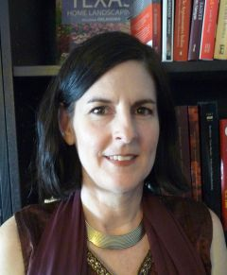

The Fulbright-Nehru award is a highly competitive grant open to all disciplines in the study of India. For 2013-14, approximately 25 grants were awarded strictly for research.  Owen, a faculty member with the [College of Visual Arts and Design](http://art.unt.edu/), received one of five serial grants from this pool of research grantees that funds multiple trips to India.

[*Read more…*](http://news.unt.edu/news-releases/art-history-professor-awarded-fulbright-grant)

**UTA Student Receives UT System Regents Award**

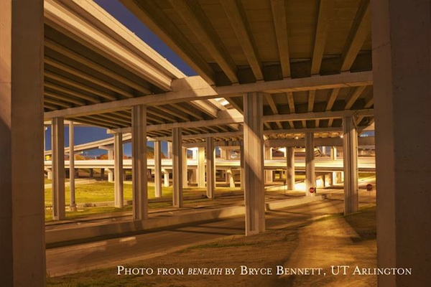

University of Texas at Arlington Photography student Bryce Bennett has received The University of Texas System Board of Regents’ Outstanding Student Award in Arts and Humanities for his exceptional work in the visual arts.

Bennett was recognized for outstanding two-dimensional work for his photographic series, *Beneath* and *Inside Out* which gives the viewer a unique perspective of the highway overpass underworld that is rarely experienced by driver or pedestrian.

[*Read more…*](http://www.uta.edu/news/releases/2013/05/UTRegents-award-ArtStudent.php)

**DMA Announces** **New $17 Million Marguerite and Robert Hoffman Fund** **for European Art Before 1700**

*Museum to Have One of the Nation’s Largest Endowed Funds for Acquisitions and Care of Old Master Paintings and European Sculpture*

Dallas Museum of Art announced a major gift from DMA trustee and past chairman Marguerite Steed Hoffman that was conceived to expand and enhance the Museum’s collection of European art, primarily of the Renaissance and Baroque eras, through the establishment of a $17 million endowment. The gift creates a $13,600,000 restricted acquisitions endowment and a $3,400,000 operating endowment in support of pre-1700 European acquisitions, exhibitions, and programs. This new fund more than doubles the DMA’s acquisition endowment and brings total funds in support of the Museum’s acquisitions to 50,000,000.

[*Read more…*](http://www.dallasmuseumofart.org/PressRoom/dma_520912)

*Photo from Beneath by Bryce Bennett,*

*UT Arlington*

**The Body Beautiful in Ancient Greece: Masterworks from the British Museum at the DMA**

**May 5–October 6, 2013**

The Dallas Museum of Art will present *The Body Beautiful in Ancient Greece: Masterworks from the British Museum*, an internationally touring exhibition of more than 120 objects exploring the human form through exquisite artworks exclusively from the British Museum’s famed collection of Greek and Roman sculpture. Iconic marble and bronze sculptures, vessels, funerary objects, and jewelry are among the treasures that explore the human form, some dating back to the second

millennium B.C. In addition to the objects from the British Museum, the exhibition will also present a model of Ancient Olympia as it would have appeared around 100 B.C., prior to the Roman additions and alterations.

[*Read more*](http://www.dallasartnews.com/2013/05/preview-of-the-body-beautiful-in-ancient-greece-at-the-dallas-museum-of-art/)*…*

**Amon Carter Acquires Robert Seldon Duncanson**

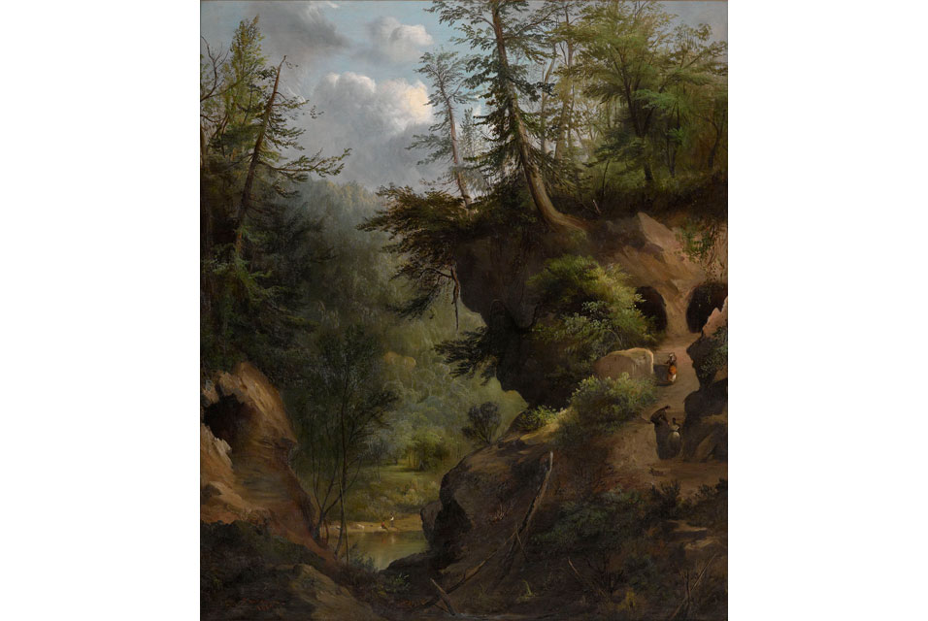

The Amon Carter Museum of American Art announced May 14, 2013 the acquisition of a major painting by 19th-century landscape artist Robert Seldon Duncanson (1821–1872), the first African-American artist to achieve international acclaim. The work, titled The Caves, painted in 1869, was originally owned by Cincinnati Abolitionist Richard Sutton Rust (1815–1906), and it remained in his family until the Amon Carter purchased it in late 2012. Because it has been in a private collection for nearly 150 years, the painting will be accessible to the public for the first time beginning May 4, when it is displayed in the Amon Carter’s galleries.

[*Read more*](http://www.artdaily.org/index.asp?int_sec=11&int_new=62279#.UY0iYJWXG9s)*…*

**Dallas Center for Architecture Landmarks Show**

2013 marks the 40th anniversary of the City of Dallas Landmarks program. An exhibition celebrating the rich architectural legacy of Dallas includes the process of designating a landmark, how that process has evolved over four decades and how the Dallas program fits into the context of the national preservation movement. The Dallas Center for Architecture is open from 9:00 a.m. to 6:00 p.m. Monday through Thursday and 9:00 a.m.-1:00 p.m. on Friday.

[*Read more…*](http://www.dallascfa.com/events/exhibition-dallas-landmarks.html)

**Current Exhibitions**

[***Cindy Sherman***](http://dma.org/View/CurrentExhibitions/index.htm)**at DMA** through June 09

[***Selections from the Permanent Collection***](http://www.themodern.org)**at the Fort Worth Modern**

[***Sharon Louden***](http://www.hollyjohnsongallery.com/html/home.asp)**at Holly Johnson Gallery** through June 22

[***SCENE OF THE CRIME II***](http://www.pdnbgallery.com/Site/HOME.html)**at PDNB Gallery** through June 22

[***Impressions of Europe: Nineteenth-Century Vistas by Martín Rico***](http://smu.edu/meadowsmuseum)**at the Meadows** through July 07

[***Loren Mozley: Structural Integrity***](http://dma.org/View/CurrentExhibitions/index.htm)**at the DMA** through June 30

[***Nathan Mabry***](http://www.nashersculturecenter.org)**at Nasher** through July 07

[***Ed Ruscha: Made in California***](http://www.cartermuseum.org/exhibitions)**at the Amon Carter** through July 21

[***Dan Rees***](http://www.gossmichaelfoundation.org/)**at Goss-Michael Foundation** through July 27

[***Tenth Anniversary Acquisitions***](http://www.themodern.org/exhibitions/upcoming)**at the Fort Worth Modern** through Aug 11

[***Walter Van Beirendonck***](http://dallascontemporary.org/)**at the Dallas Contemporary** through Aug 18

[***John Pomara***](http://dallascontemporary.org/)**at the Dallas Contemporary** through Aug 18

[***Taking Shape: Fresh Perspectives on Asian Bronzes***](http://crowcollection.org/)**at the Crow Collection** rhrough Sept 01

[***Gold on Black: Japanese Lacquer from the Jacqueline Avant Collection***](http://crowcollection.org/)**at the Crow Collection** through Sep 15

[***Chics Who Click***](http://arlingtonmuseum.org/)**at the Arlington Museum of Art** through Sep 30

[***Texas Regionalism***](http://www.cartermuseum.org/)**at the Amon Carter** through 2014

[***SHINE! Vintage Photographs & Shoe Shine Boxes***](http://www.pdnbgallery.com/Site/HOME.html)**at PDNB Gallery**

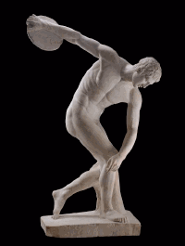

*Robert Seldon Duncanson (1821–1872), The Caves, 1869. Oil on canvas. Amon Carter Museum of American Art, Fort Worth.*



**CLOSING SOON**

[***Night: Prints and Drawings from the Collection***](http://www.cartermuseum.org/)**at the Amon Carter CLOSES** May 19

[***Photographs from the Collection***](http://www.cartermuseum.org/)**at the Amon Carter CLOSES** May 19

[***modzone: Works by Bill Parker***](http://www.banksfineart.com/)**at Banks Fine CLOSES** May 23

[***Keri Oldham***](http://www.kirkhopperfineart.com/) **at Kirk Hopper Fine Art** **CLOSES** May 25

[***Henry Finkelstein: Paintings***](http://www.valleyhouse.com/)**at Valley House Gallery CLOSES** May 25

[***Diane Walker-Gladney, Austin A. James***](http://www.norwoodflynngallery.com/)**Norwood Flynn Gallery CLOSES** May 25

[***Chagall: Beyond Color***](http://dma.org/View/CurrentExhibitions/index.htm)**at the DMA CLOSES** May 26

[***Marie Cosindas: Instant Color***](http://www.cartermuseum.org/)**at the Amon Carter CLOSES** May 26

[***Spanish Colonial Art***](http://www.arlingtonmuseum.org)**Arlington Museum of Art CLOSES** May 26

[***Marie Cosindas: Instant Color***](http://www.cartermuseum.org/exhibitions)**at the Amon Carter CLOSES** May 26

[***Texas Impressionism: Branding with Brushstroke and Color, 1885-1935***](http://www.tylermuseum.org/)**at Tyler Museum of Art CLOSES** May 26

[***The Haiti Series: Photographs by Terry Cockerham***](http://www.dallasartdealers.org/locations/irving-arts-center/)**at Irving Arts Center CLOSES** May 26

[***Spring Art Festival***](http://www.utdallas.edu/ah/events/index.php)**at UTD Art Gallery CLOSES** May 31

[***Communication Design Seniors Show***](http://gallery.unt.edu/)**at UNT Lightwell Gallery CLOSES** May 31

[***Sam Reveles - Aran: New Paintings and Drawings***](http://www.talleydunn.com/)**at Talley Dunn Gallery CLOSES** Jun 01

[***Jasper Johns - Circles and Squares***](http://www.talleydunn.com/)**at Talley Dunn Gallery CLOSES** Jun 01

[***FOCUS: Barry McGee***](http://www.themodern.org/exhibitions/upcoming)**at the Fort Worth Modern** **CLOSES** Jun 02

[***Retro & Vintage: French Modernist Charles Levier***](http://www.dallasartdealers.org/events/modzone-works-by-bill-parker/) **Banks Fine Art CLOSES** June 14

[***Danville Chadbourne***](http://artspace111.com/)**Artspace 111 CLOSES** June 15

# The Kimbell Acquires Maya Censer Stands

On April 12, 2013, the Kimbell Art Museum announced the acquisition of two rare Maya Palenque-style ceramic censer stands. Typical of the Maya late Classic period (A.D. 600–900) and dated to about A.D. 690–720, *Censer Stand with the Head of the Jaguar God of the Underworld* and *Censer Stand with the Head of a Supernatural Being with a Kan Cross* will be on view in the Museum’s north galleries on Sunday, April 21st. Admission is always free to view works in the Kimbell’s permanent collection.

Palenque-style ceramic censer stands (*incensarios*) are among the largest and most sophisticated freestanding sculptures created by Maya artists. There are very few in either public or private collections in the U.S. Measuring nearly four feet tall, the Kimbell censer stands are exceptional for their remarkable condition and superb quality of execution.

“The sculptures’ monumental scale and wealth of symbolic detail command the viewer’s attention,” commented Eric M. Lee, director of the Kimbell Art Museum. “I foresee these works quickly becoming hallmarks of our already choice collection of Maya art.”  Since their documented importation into the U.S. from Mexico on August 6, 1968, the two censers have been in private collections in Europe and the U.S. From 1985 to 1999, they were on view in the galleries of the Detroit Institute of Arts, as a long-term loan.

The sophistication and craftsmanship demonstrated in these stands are indicative of Palenque, a major Maya city-state located in current-day Chiapas, Mexico, that flourished in the seventh century. Ceramic censers were an important component of ritual paraphernalia and ceremonial life at Palenque. Censers were used both to represent and venerate divine beings, primarily the deities of the Palenque Triad. Though not necessarily conceived as a pair, both censers were undoubtedly made by the same highly skilled court artist.

*Captions:  
Censer Stand with the Head of the Jaguar God of the Underworld*, c. A.D. 690–720.  
Mexico, Usumacinta region, Chiapas, Palenque, Maya culture  
Late Classic period, A.D. 600–900  
Ceramic with traces of pigments  
44 x 22 x 12 1/4 in. (111.8 x 55.9 x 31.1 cm)  
Kimbell Art Museum, Fort Worth

*Censer Stand with the Head of a Supernatural Being with a Kan Cross*, c. A.D. 690–720  
Mexico, Usumacinta region, Chiapas, Palenque, Maya culture   
Late Classic period, A.D. 600–900  
Ceramic with traces of pigments  
44 7/8 x 21 1/2 x 11 1/2 in. (114 x 54.6 x 29.2 cm)  
Kimbell Art Museum, Fort Worth



**Upcoming Films**

[***The Kings of Summer***](http://themodern.org/films/category/Movies-That-Matter/298) **at the Fort Worth Modern**

May 14

[***Life of Pi***](http://www.nashersculpturecenter.org/) **at the Nasher**

May 17, Late Nights

[***From Up on Poppy Hill***](http://themodern.org/films/category/Movies-That-Matter/298) **at the Fort Worth Modern**

May 17 - May 19

[***The Private Life of a Masterpiece: Edgar Degas, The Little Dancer Aged 14***](https://www.kimbellart.org/learn/films) **at the Kimbell**

May 19

2:00 pm

[***At Any Price***](http://themodern.org/films/category/Movies-That-Matter/298) **at the Fort Worth Modern**

May 24 - May 26

[***In the House***](http://themodern.org/films/category/Movies-That-Matter/298) **at the Fort Worth Modern**

May 31 - Jun 02

[***A Class Apart and The Barber of Birmingham: Foot Soldier of the Civil Rights Movement***](http://themodern.org/films/category/Movies-That-Matter/298)  **at the Fort Worth Modern**

June 07

[***Love Is All You Need***](http://themodern.org/films/category/Movies-That-Matter/298) **at the Fort Worth Modern**

June 07 - June 09

[***The Private Life of a Masterpiece: Auguste Rodin, The Kiss***](https://www.kimbellart.org/learn/films) **at the Kimbell**

June 09

2:00 pm

[***National Theatre Live - This House***](http://www.themodern.org/performances)**at the Fort Worth Modern** June 19

[***Moonrise Kingdom***](http://www.nashersculpturecenter.org/) **at the Nasher**

June 21

Late Nights

[***The Motorcycle Diaries***](https://www.kimbellart.org/learn/films) **at the Kimbell**

June 30

2:00 pm

[***Ausangate***](https://www.kimbellart.org/learn/films) **at the Kimbell**

July 14

2:00 pm

[***Aguirre: The Wrath of God***](https://www.kimbellart.org/learn/films) **at the Kimbell**

July 28

2:00 pm

[***Peruvian Weaving***](https://www.kimbellart.org/learn/films) **at the Kimbell**

August 11

2:00 pm

[***Dancing with the Incas***](https://www.kimbellart.org/learn/films) **at the Kimbell**

August 11

2:00 pm

[***Only Angels Have Wings***](https://www.kimbellart.org/learn/films) **at the Kimbell**

August 25

2:00 pm

[***National Theatre Live - The Audience***](http://www.themodern.org/performances)**at the Fort Worth Modern**

August 28

**Upcoming Musical Performances**

[***Klyde Warren Park Jazz Series***](http://www.klydewarrenpark.org/Things-To-Do/events/live-on-the-lawn-jazz-at-klyde-warren-park.html)**at Klyde Warren Park**

May 16

[***Gérard Grisey's Le Noir de l'Etoile***](http://www.nashersculpturecenter.org/Events-Calendar/Soundings--New-Music-at-the-Nasher/Performances)**at the Nasher**

May 29, 8 & 11 PM

[***Betty Buckley "The Vixens of Broadway"***](http://www.themodern.org/performances)**Fort Worth Modern**

June 13; June 15



**New Amon Carter Library Hours**

Wednesday: 11 a.m.–4 p.m.  
Thursday: 11 a.m.–7 p.m.  
Friday: 11 a.m.–4 p.m.  
Saturday: 11 a.m.–4 p.m., September through May

*Other times by appointment*

Starting March 2 the Amon Carter Museum of American Art research library will offer Saturday hours, 11 a.m.-4 p.m., September through May.

Photocopies, digital scanning, public computers, and Wi-Fi available. Library materials may not be checked out.

Don't Miss...

**Dan Rees, Gravel Master**

At The Goss-Michael Foundation

[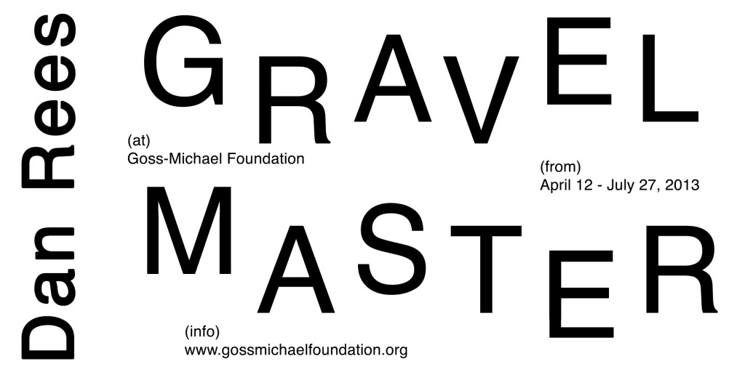](http://www.gossmichaelfoundation.org/upcoming-exhibitions/dan-rees-2/)  
[Watch an interview](http://artthisweek.com/) with Painter Dan Rees about his show, *Gravel Master*, on view through July 27, 2013