Slick - responsive Carousel Slider
Slick carousel slider by Ken Wheeler. Fully responsive. Scales with its container. Separate settings per breakpoint. Swipe, desktop mouse dragging, infinite looping among others. Slick is ready-for-use with the organiser and tt_news.



Version: 2.2.7, 2016-01-15
Extension Key: slick
Language: en
Keywords: slick, jquery, carousel, slider
Copyright 2014-2016, Dirk Wildt - Die Netzmacher, <http://wildt.at.die-netzmacher.de>

This document is published under the Open Content License available from http://www.opencontent.org/opl.shtml
The content of this document is related to TYPO3 a GNU/GPL CMS/Framework available from www.typo3.org
Table of Contents
Slick - responsive Carousel Slider 1
Screen Shots 3
Frontend 3
Slick Samples 4
Introduction 5
What does it do? 5
What do you need? 5
Install 6
image_crop 6
jQuery 6
Add a Folder for your Slick Items 6
Add some Content Elements to this folder 6
Place the Slick Carousel 6
Please add the TypoScript templates 6
Slick Carousel 7
Properties 7
Slick Item 8
Samples 8
Default TYPO3 content element 8
Slick Banner 8
Links 11
Slick Gallery 12
Sample 12
Same Ratio for all images 13
Slick Carousel with tt_news 14
Sample in the frontend 14
Slick Caroussel in localised context 16
TypoScript Template 16
Configuration 17
Reference 18
Constant Editor 19
CAROUSEL CSS CLASS 19
CAROUSEL CSS COLORS 19
CAROUSEL CSS FILES 19
CAROUSEL CSS HEADER 19
CAROUSEL CSS MARGINS 19
CAROUSEL CSS POSITION 19
CAROUSEL CSS TEXT 20
CAROUSEL JAVASCRIPT FILE 20
CAROUSEL JAVASCRIPT PROPERTIES 20
CAROUSEL JAVASCRIPT RESPONSIVE 21
What's new? 22
Version 2.x 22
Known bugs 23
Bugs 23
Introduction Package 23
Credits 24
Ken Wheeler 24
Benjamin Kott 24
Further Information 25
Feature Requests and Suggestions 25
Bugtracker 25
SVN Repository 25
Professional Support 25
Other extensions published by Die Netzmacher 26
Illustration Index 27
Change log 28

Screen Shots

Frontend
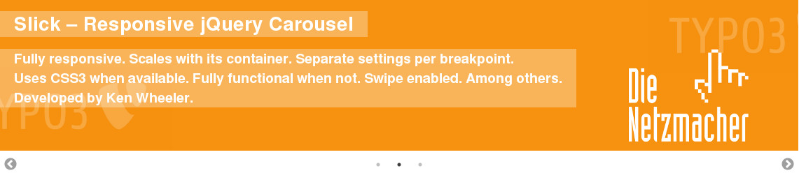Illustration 1: Slick Banner: header, text and background. All linkable. Ready to use.
Illustration 2: Slick content: an image ...
Illustration 3: ... is moving to ...
Illustration 4: an text element
Illustration 5: Slick sample with tt_news

Live
See an live example at http://geierwally.die-exen.de/

Slick Samples
Ken Wheeler, the developer of the Slick jquery library, provides samples, code snippets and the configuration of slick at
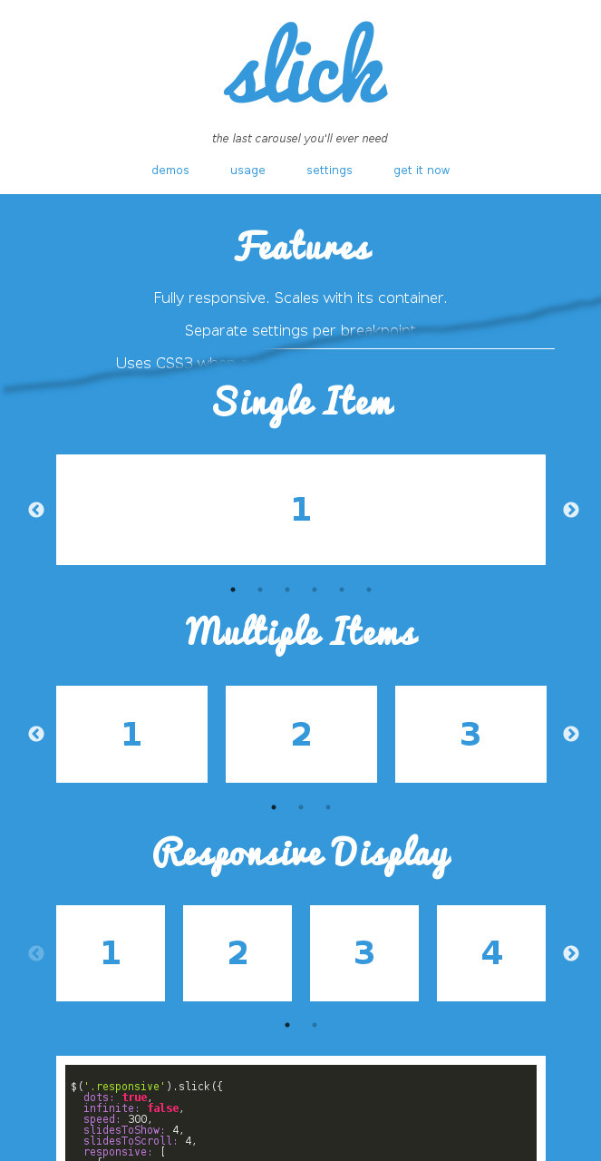Illustration 6: Slick online samples
- http://kenwheeler.github.io/slick/
See illustration on the right hand.

Introduction

What does it do?
TYPO3 Slick integrates the Slick Carousel of Ken Wheeler into TYPO3.
The Slick Carousel is
- Fully responsive
- Scales with its container
- Separate settings per breakpoint
- Uses CSS3 when available. Fully functional when not.
- Swipe enabled. Or disabled, if you prefer.
- Desktop mouse dragging.
- Infinite looping.
- Fully accessible with arrow key navigation.
- Add, remove, filter & unfilter slides.
- Autoplay, dots, arrows, callbacks, etc …
TYPO3 Slick
- provides the both content elements
  - Slick Carousel
  - Slick Item
- supports the single item slick ready-to-use.
- You can use every TYPO3 content element for your Slick Carousel.
- Images can crop.
Ready-for-use with
- the Organiser – TYPO3 for the lobby and the organisers – (organiser)
- News (tt_news)

What do you need?
- TYPO3 6.0 or higher.
- A jQuery library like t3jquery.
- If you like to use Slick ready-to-use, your page object must be called page (page = PAGE).
- You don't need to know anything about JavaScript and jQuery.
But if you want to use all features of the Slick Carousel you have to be familiar with JavaScript and jQuery.

Install
Install Slick.

image_crop
If you like to crop images, please install "cropping for tt_content images" (image_crop).

jQuery
You need a running jQuery library. I recommend t3jquery. If you are using t3jquery already, please compile the jQuery library again.

Add a Folder for your Slick Items
- Add a folder for your Slick items.
- Call the folder "Slick Items".
- Replace the default folder icon with the Slick icon:
  - Page properties of your folder
  - [Behaviour] > field "Contains Plugin": [Slick]

Add some Content Elements to this folder
- New record: Page content
- [General] > field "Type": [Slick Item]
- Enter
  - [General] Header: Header
  - [General] Text
  - [Images] Image (one only)
- If you like, please set links
  - [General] Header: Link
  - [General] Text (please use the link wizard)
  - [Images] Image Metadata: Link
If you need more properties for your carousel item in the frontend, please switch to another content element like "text & images".

Place the Slick Carousel
The Slick Carousel is a content element. You can place it everywhere on your website.
- New record: Page content
- [General] > field "Type": [Slick Carousel]
- Enter
  - Name (not visible in the frontend): Slick Carousel
  - Records
    - Please link to each record of the folder "Slick Items"

Please add the TypoScript templates
Your root page is recommended.
- Slick: Caroussel (slick)
- Slick: Item (slick)

Slick Carousel
The Slick Carousel can manage every content element, records of extensions like news and the slick item of course.
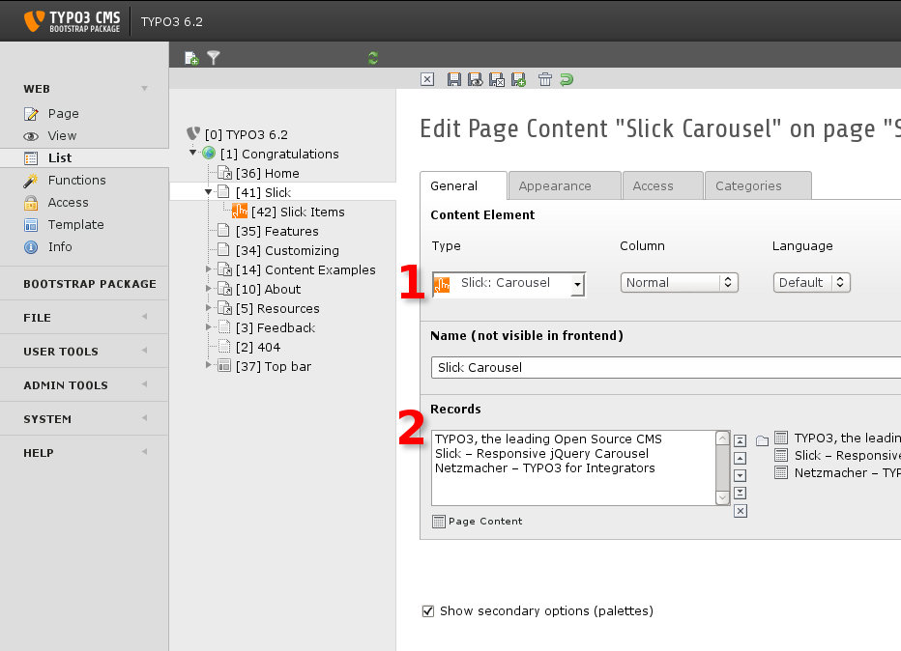Illustration 7: Slick Carousel – the TYPO3 backend form

Properties
The Slick Carousel has the properties:
- Name: The title of the carousel. Visible in the backend only.
- Records: Wizard for linking to content elements.

Slick Item

Samples
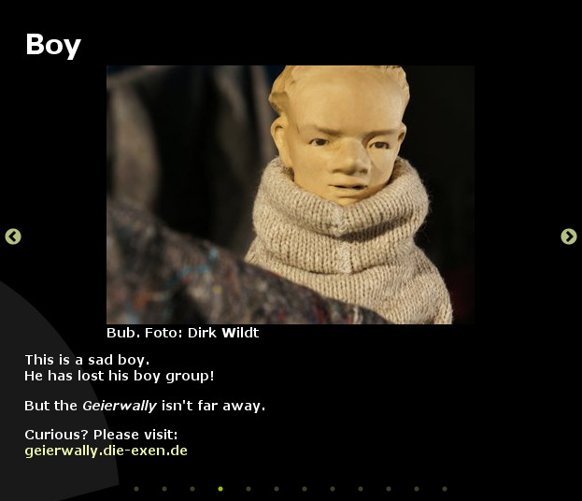Illustration 8: An text/image element
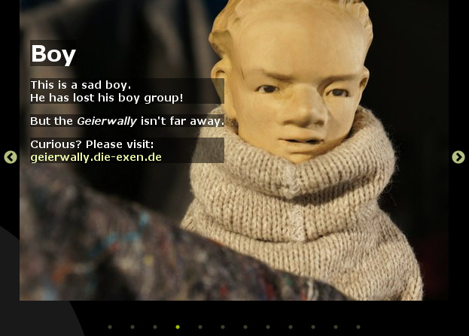Illustration 9: A Slick Banner
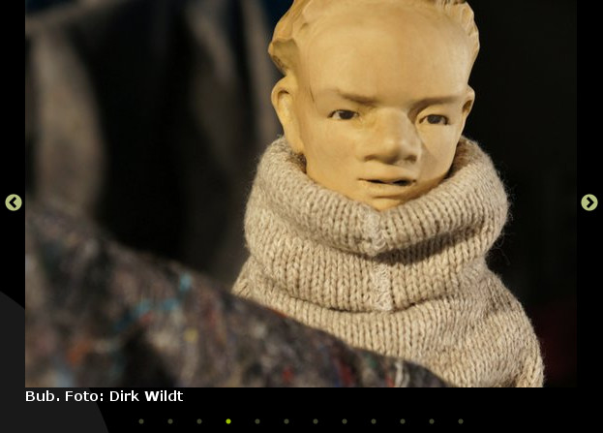Illustration 10: A Slick Gallery
The illustration above displays the same content element as
- an text/image element,
- a slick item with the section frame [slick banner] and
- a slick item with the section frame [slick gallery].

Default TYPO3 content element
There isn't any need to explain the usage of a TYPO3 content element. Use it!

Slick Banner

Default Design
A Slick Banner is an optimised content element. Title, text and background are linkable.
You can configure the design with the interface for TypoScript – the Constant Editor.
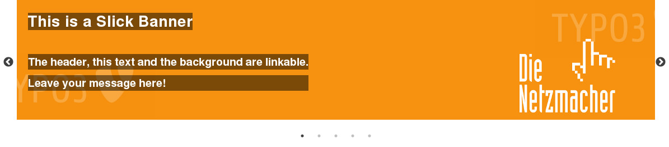Illustration 11: Slick Banner with default configuration

"Crazy Sample"
Illustration 12: Slick Banner "crazy sample"

Content Element
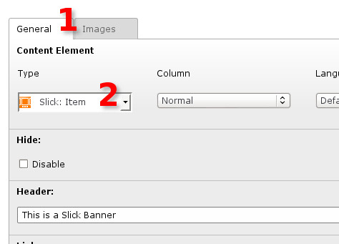Illustration 13: Content Element: Type [Slick: Item]
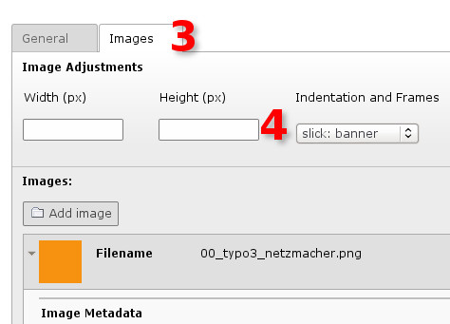Illustration 14: Content Element: Frame [Slick: Banner]

Constant Editor
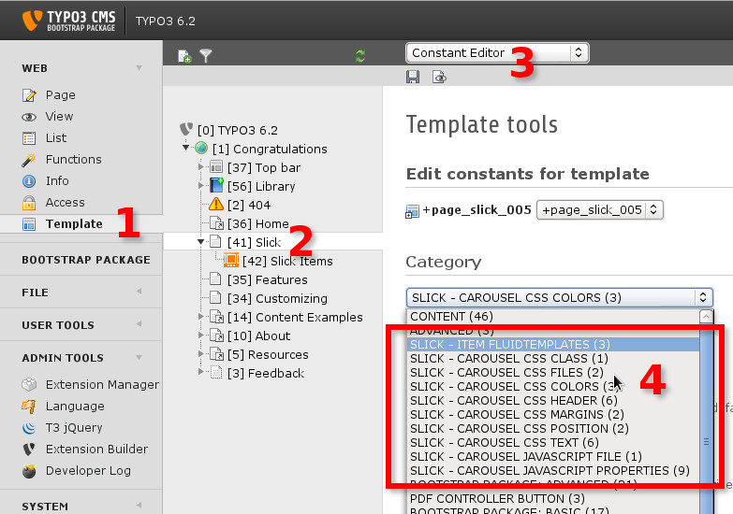Illustration 15: Slick Carousel properties in the TypoScript Constant Editor
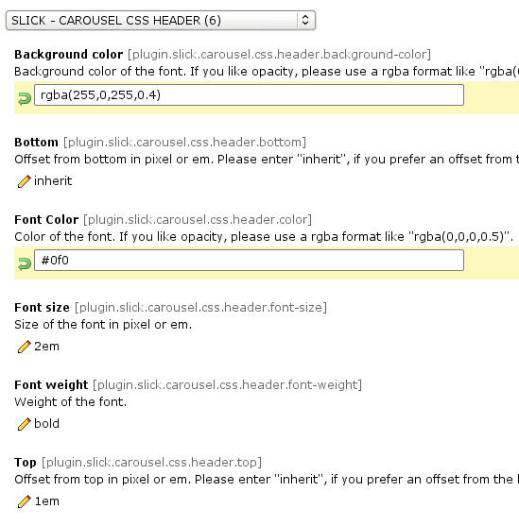Illustration 16: Slick Carousel CSS Header
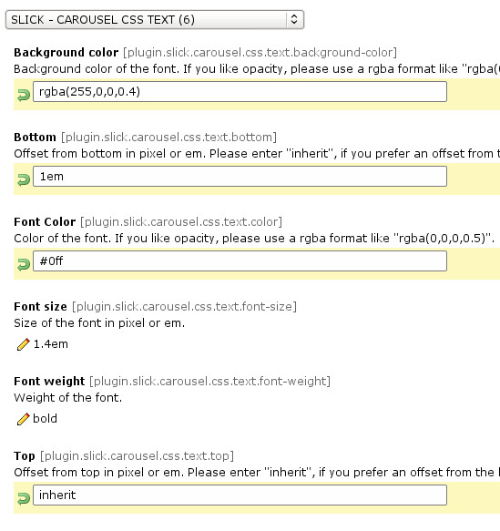Illustration 17: Slick Carousel CSS Text
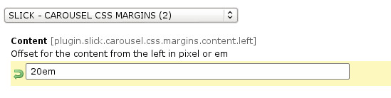Illustration 18: Slick Carousel CSS Margins
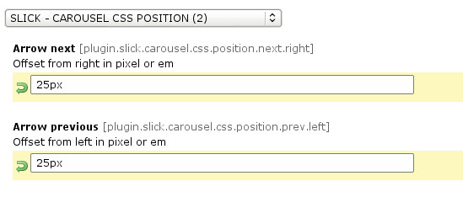Illustration 19: Slick Carousel CSS Position
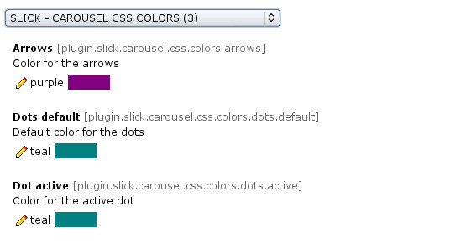Illustration 20: Slick Carousel Colors

Properties
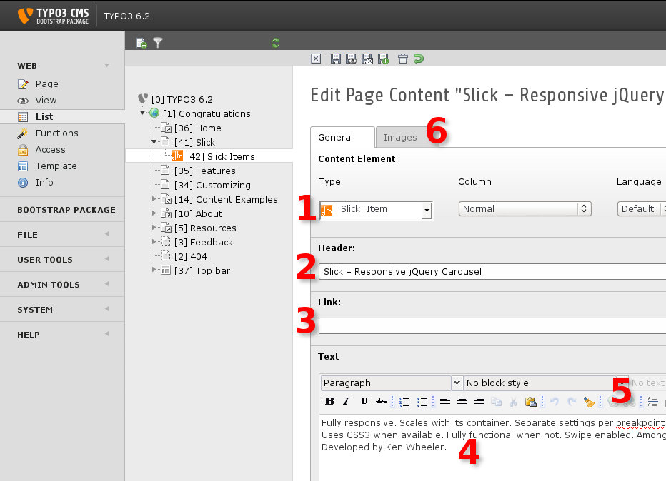Illustration 21: Slick Item – the TYPO3 backend form
A Slick Item (1) has the properties:
- header (2)
- text (4)
- image (6)

Links
You can link every property:
- header (3)
- text (5)
- image (6)

Internal Links
You can set a link to an internal page only in the current Slick version!
There is a workflow for external links. See the next section.

Workflow for External Links
If you need an external link, please add a page to your page tree. Set the page type to [Link to external URL].
Set the internal link of your Slickitem to this page.
Sorry for the trouble.

Slick Gallery
The especially skill of the Slick Item Gallery is, that you can manage all images for the gallery with one content element.
So you can define width and height for all images in this element.

Sample

Text & Images Content Element
Sample for a text & images content element which contains three images.
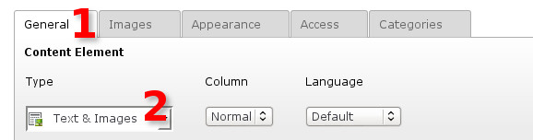Illustration 22: Content Element: Type [Text & Images]
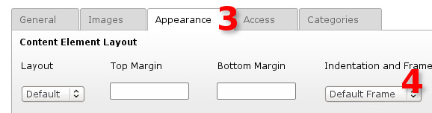Illustration 23: Content Element: Frame [Default Frame]
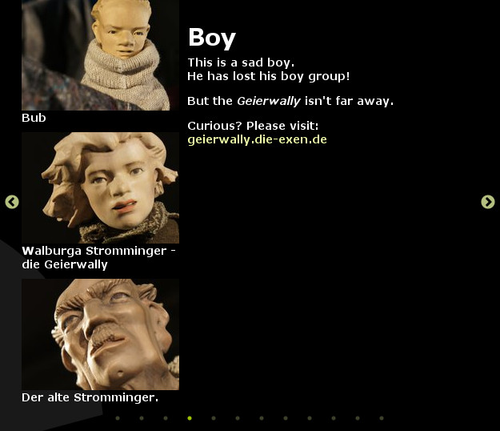Illustration 24: Text & images element in the frontend

Slick Gallery Content Element
Sample for the same content element configured as a Slick Item with the [Slick: Gallery] frame.
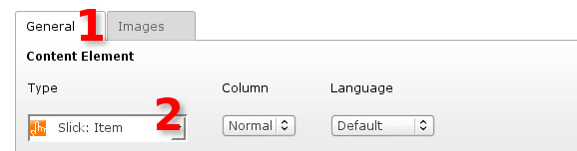Illustration 25: Content Element: Type [Slick: Item]
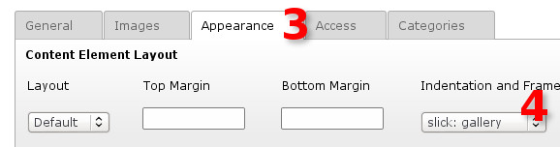Illustration 26: Content Element: Frame [Slick: Gallery]
Illustration 27: One of the three images

Same Ratio for all images
You can define the same ratio for all images.
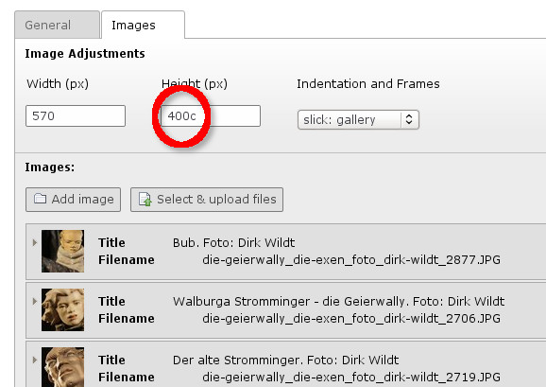Illustration 28: Same ratio for all images
In the illustration below the height isn't 400 but 400c. The "c" is a TYPO3 API property for images and means "cut".
570 x 400c effects: All images will displayed with a width of 570 pixel. If an image is higher as 400 pixel, it will cuted to 400 pixel height (centered).
By default the form for a content element accepts integers only. You can't enter 400c. It will moved to 400 automatically.
If you like the feature of an automatically cut, please install the extension
- TSconfig Pages and Users by extManager
http://typo3.org/extensions/repository/view/tsconf
The extension enhances the height and width of the TYPO3 content element, it will accept strings like 400c.
You configure the extension by the extension manager.

Slick Carousel with tt_news
Slick is ready-for-use with tt_news. It provides a template. All you need is a tt_news-plugin.

Sample in the frontend
Illustration 29: Slick sample with tt_news
Amount and size of items among others is configurable by the TypoScript constant editor.

Installation

Configure tt_news
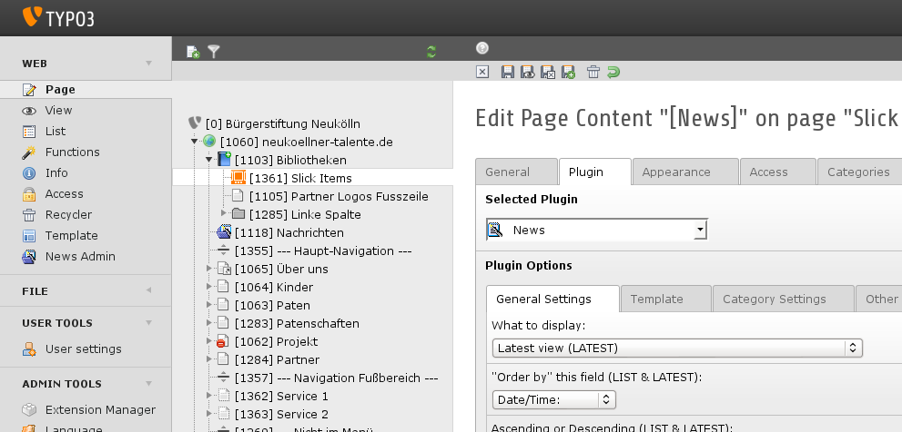Illustration 30: tt_news-plugin with latest view and ...
- Add a tt_news-plugin.
- Select [Plugin] > [General Settings] > "What do display": [Latest view (LATEST)].
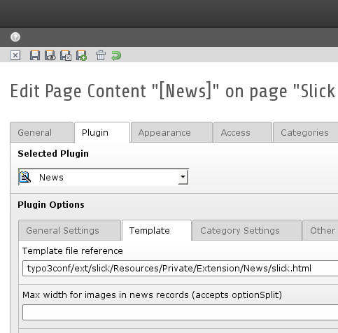Illustration 31: ... slick HTML template
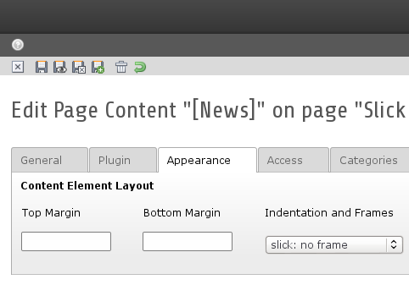Illustration 32: ... slick HTML template
- Select [Plugin] > [Template] > "Template file reference":
typo3conf/ext/slick/Resources/Private/Extension/News/slick.html
- Select [Appearance] > "Indentation and Frames": [slick: no Frame]

Configure Slick
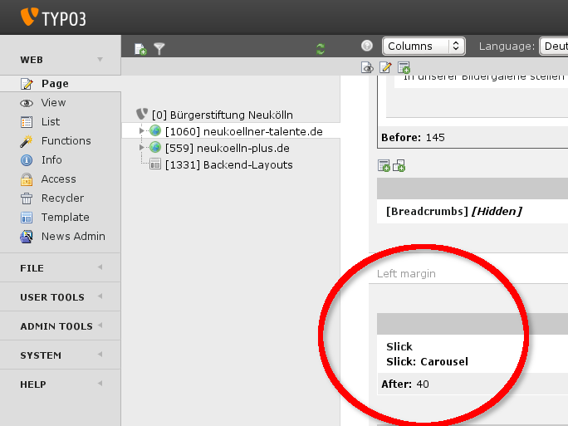Illustration 33: tt_news-plugin with latest view and ...
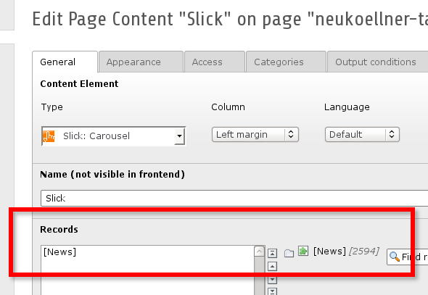Illustration 34: tt_news-plugin with latest view and ...
- Add the content element of Type [Slick: Carousel]. In the illustration above it is added to the root page.
- Link the Slick Carousel with the tt_news-plugin from above.

Slick Caroussel in localised context
In localised context all content elements get an HTML anchor.
This anchor causes an empty frame within the slick show.

TypoScript Template
To avoid this behaiviour please add the TypoSript template
- Slick: +Optimise Localisation
This template will remove all HTML anchors in localised context.

Configuration
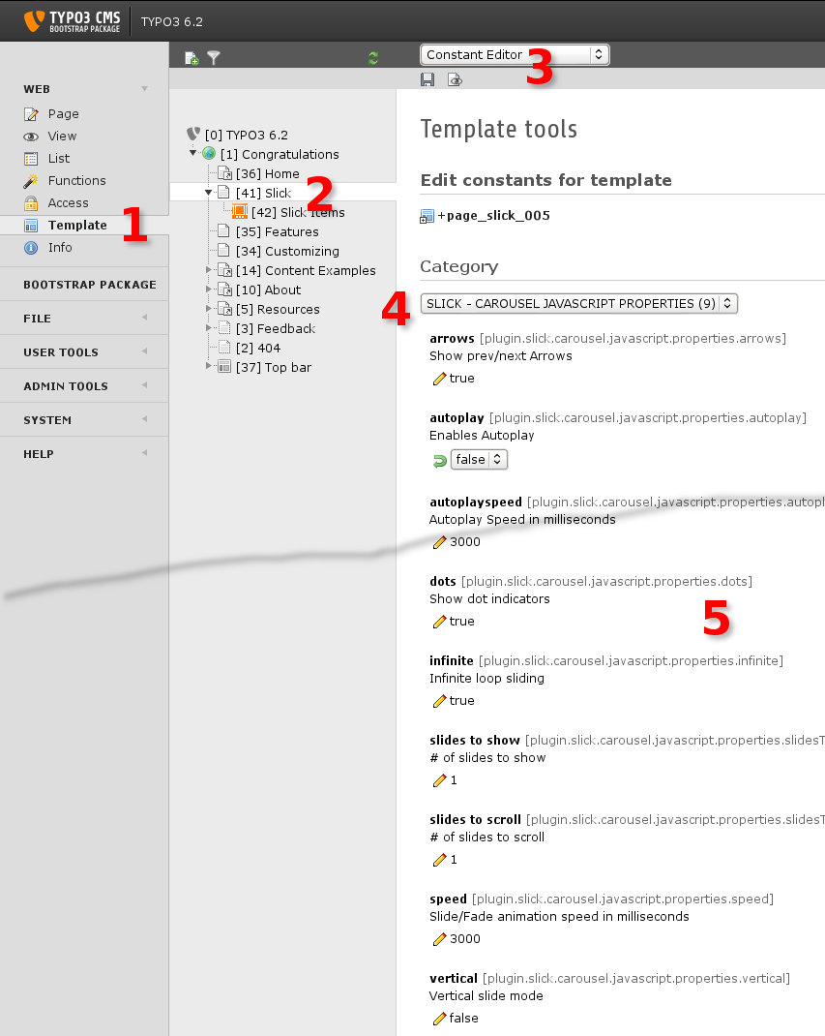Illustration 35: The TypoScript interface for some Slick properties
If you like to configure the Slick Carousel, please include the static template:
- Slick: Carousel (slick)
Configure Slick supported by the TypoScript interface – the Constant Editor:
- Modul > Web: Template (1)
- Page tree: Your page with the Slick Carousel (2)
- Edit area: [Constant Editor] (3)
  - Category: [SLICK CAROUSEL … ] (4)
See details in the section
- "Constant Editor" on page 19 below.

Reference
If you like to investigate the TypoScript setup, please refer to:

tt_content.slickitem = FLUIDTEMPLATE
tt_content.slickitem {
...
}
tt_content.slickcarousel < tt_content.shortcut
tt_content.slickcarousel {
...
}
page {
cssInline {
62478 = TEXT
62478 {
...
}
}
includeCSS {
slickLibrary = {$plugin.slick.carousel.css.file.library}
}
includeJSFooter {
slick = {$plugin.slick.carousel.javascript.file}
}
jsFooterInline {
60807 = TEXT
60807.value (
$(document).ready(function(){
$(\'.{$plugin.slick.carousel.css.class}\').slick({
arrows : {$plugin.slick.carousel.javascript.properties.arrows},
autoplay : {$plugin.slick.carousel.javascript.properties.autoplay},
autoplayspeed : {$plugin.slick.carousel.javascript.properties.autoplayspeed},
dots : {$plugin.slick.carousel.javascript.properties.dots},
infinite : {$plugin.slick.carousel.javascript.properties.infinite},
slidesToShow : {$plugin.slick.carousel.javascript.properties.slidesToShow},
slidesToScroll : {$plugin.slick.carousel.javascript.properties.slidesToScroll},
speed : {$plugin.slick.carousel.javascript.properties.speed},
vertical : {$plugin.slick.carousel.javascript.properties.vertical}
});
});
)
}
}

Values are controlled by the TypoScript interface – the Constant Editor. See details in the section
- "Constant Editor" on page 19 below.

Constant Editor
If you like to configure the Slick Carousel, please include the static template:
- Slick: Carousel (slick)
All properties have the prefix plugin.slick.
Example: carousel.javascript.properties.arrows is plugin.slick.carousel.javascript.properties.arrows.
Illustration is placed at
- "Slick Gallery" on page 12 above.

CAROUSEL CSS CLASS
Property | Type | Description | Default
carousel.css.class | string | Class: CSS class of the slick carousel | single-item

CAROUSEL CSS COLORS
Property | Type | Description | Default
carousel.css.colors.arrows | Color | Color for the arrows | #000
carousel.css.colors.dots.default | Color | Color for the dots | #000
carousel.css.colors.dots.active | Color | Color for the active dot | #000

CAROUSEL CSS FILES
Property | Type | Description | Default
carousel.css.file.extension | string | Extension: extension CSS file  Default: EXT:slick/Resources/Public/CSS/extension.css | See description
carousel.css.file.library | String | Library: slick library CSS file  Default: EXT:slick/Resources/Public/JavaScript/Slick/slick.css | See description

CAROUSEL CSS HEADER
Property | Type | Description | Default
carousel.css.header.background-color | String | Background color of the font. If you like opacity, please use a rgba format like "rgba(0,0,0,0.5)". | rgba(0,0,0,0.5)
carousel.css.header.bottom | String | Offset from bottom in pixel or em. Please enter "inherit", if you prefer an offset from the top. | inherit
carousel.css.header.color | String | Color of the font. If you like opacity, please use a rgba format like "rgba(0,0,0,0.5)". | #FFF
carousel.css.header.font-size | String | Size of the font in pixel or em. | 2em
carousel.css.header.font-weight | String | Weight of the font. | bold
carousel.css.header.top | String | Offset from top in pixel or em. Please enter "inherit", if you prefer an offset from the bottom. | 1em

CAROUSEL CSS MARGINS
Property | Type | Description | Default
carousel.css.margins.content.left | String | Content: Offset for the content from the left in pixel or em | 20px
carousel.css.margins.item | String | Item: Margin of an item. Arrows outside the item: 0. Arrows inside the item: 0 25px 0 25px. | 0

CAROUSEL CSS POSITION
Property | Type | Description | Default
carousel.css.position.next.right | String | Arrow next: Offset from right in pixel or em | -25px
carousel.css.position.prev.left | String | Arrow previous: Offset from left in pixel or em | -25px

CAROUSEL CSS TEXT
Property | Type | Description | Default
carousel.css.text.background-color | String | Background color of the font. If you like opacity, please use a rgba format like "rgba(0,0,0,0.5)". | rgba(0,0,0,0.5)
carousel.css.text.bottom | String | Offset from bottom in pixel or em. Please enter "inherit", if you prefer an offset from the top. | inherit
carousel.css.text.color | String | Color of the font. If you like opacity, please use a rgba format like "rgba(0,0,0,0.5)". | #FFF
carousel.css.text.font-size | String | Size of the font in pixel or em. | 1.4em
carousel.css.text.font-weight | String | Weight of the font. | bold
carousel.css.text.top | String | Offset from top in pixel or em. Please enter "inherit", if you prefer an offset from the bottom. | 7em

CAROUSEL JAVASCRIPT FILE
Property | Type | Description | Default
carousel.javascript.file | string | file: slick javascript library  Default: EXT:slick/Resources/Public/JavaScript/Slick/slick.js | See description

CAROUSEL JAVASCRIPT PROPERTIES
Slick Carousel has more properties than below.
If you like to configure properties, which aren't part of the list below, please add your own Slick javascript file. See

page.jsFooterInline.60807

Property | Type | Description | Default
carousel.javascript.properties.adaptiveHeight | string | adaptiveHeight: Enables adaptive height for single slide horizontal carousels. | false
carousel.javascript.properties.arrows | string | arrows: Show prev/next Arrows | true
carousel.javascript.properties.autoplay | boolean | autoplay: Enables Autoplay | true
carousel.javascript.properties.autoplayspeed | integer | autoplayspeed: Autoplay Speed in milliseconds | 3000
carousel.javascript.properties.cssEase | string | css ease: CSS3 Animation Easing. Has an effect only, if fade is true (see below).  Options:  - linear  - ease  - ease-in  - ease-out  - ease-in-out | ease
carousel.javascript.properties.dots | boolean | dots: Show dot indicators | true
carousel.javascript.properties.fade | boolean | fade: Fade your slick items. If it is enabled, slidesToShow and slidesToScroll should be 1 only (see both below). | false
carousel.javascript.properties.infinite | boolean | infinite: Infinite loop sliding | true
carousel.javascript.properties.initialSlide | integer | initial slide: 0 is the first slide. | 0
carousel.javascript.properties.rows | integer | rows: Setting this to more than 1 initializes grid mode. Use slidesPerRow to set how many slides should be in each row. | 1
carousel.javascript.properties.slidesPerRow | integer | slidesPerRow: With grid mode intialized via the rows option, this sets how many slides are in each grid row. | 1
carousel.javascript.properties.slidesToShow | integer | slides to show: # of slides to show | 1
carousel.javascript.properties.slidesToScroll | integer | slides to scroll: # of slides to scroll | 1
carousel.javascript.properties.speed | integer | speed: Speed in milliseconds | 3000
carousel.javascript.properties.vertical | boolean | vertical: Vertical slide mode | false

CAROUSEL JAVASCRIPT RESPONSIVE
Slick Carousel has more properties than below.
If you like to configure properties, which aren't part of the list below, please add your own Slick javascript file. See

page.jsFooterInline.60807

Property | Type | Description | Default
carousel.javascript.responsive.if | boolean | enabled: Enable responsive configuration | false
carousel.javascript.responsive.large.breakpoint | integer | large breakpoint: Breakpoint for large displays | 1024
carousel.javascript.responsive.large.settings.autoplaySpeed | integer | large autoplay speed: time in milliseconds upto the next slide for large displays | 3000
carousel.javascript.responsive.large.settings.slidesToShow | integer | large slides to show: Slides to show for large displays | 3
carousel.javascript.responsive.large.settings.slidesToScroll | integer | large slides to scroll: Slides to scroll for large displays | 3
carousel.javascript.responsive.medium.breakpoint | integer | medium breakpoint: Breakpoint for medium displays | 600
carousel.javascript.responsive.medium.settings.autoplaySpeed | integer | medium autoplay speed: time in milliseconds upto the next slide for medium displays | 3000
carousel.javascript.responsive.medium.settings.slidesToShow | integer | medium slides to show: Slides to show for medium displays | 2
carousel.javascript.responsive.medium.settings.slidesToScroll | integer | medium slides to scroll: Slides to scroll for medium displays | 2
carousel.javascript.responsive.small.breakpoint | integer | small breakpoint: Breakpoint for small displays | 480
carousel.javascript.responsive.small.settings.autoplaySpeed | integer | small autoplay speed: time in milliseconds upto the next slide for small displays | 3000
carousel.javascript.responsive.small.settings.slidesToShow | integer | small slides to show: Slides to show for small displays | 1
carousel.javascript.responsive.small.settings.slidesToScroll | integer | small slides to scroll: Slides to scroll for small displays | 1

What's new?

Version 2.x

Croping Images
[2.2.0]
Images can crop. You have to install the extension
- cropping for tt_content images (image_crop)

Localised Context
[2.2.7]
Template for localised context. See "Slick Caroussel in localised context" on page 16 above.

tt_news: ready-for-use
[2.1.0]
Slick is ready-for-use with News (tt_news). See
- "Slick Carousel with tt_news" on page 14 above.

Known bugs

Bugs
Latest bugs are published at
- https://forge.typo3.org/projects/extension-slick/issues

Introduction Package
The Introduction Package seem's to use a corrupt jQuery library. If you are using the Introduction Package, please remove the jQuery library and use for example t3jquery.

Credits
Credits to

Ken Wheeler
Who developes slick. See
- http://kenwheeler.github.io/slick/

Benjamin Kott
Who provides a sample for building custom content elements with extbase and fluid. The extension bk2k_content_elements was the base of TYPO3 slick. See
- https://speakerdeck.com/benjaminkott/typo3-content-elemente-mit-fluid
- https://github.com/benjaminkott/bk2k_content_elements

Further Information

Feature Requests and Suggestions
If you have helpful suggestions please send an e-mail to http://wildt.at.die-netzmacher.de

Bugtracker
https://forge.typo3.org/projects/extension-slick/issues

SVN Repository

Interface
https://tickets.die-netzmacher.de/projects/slick/repository

Checkout / Download / Update

Latest version / Specific version
your@server:/path/to/typo3conf/ext# svn co http://die-netzmacher.de/svn/slick/tag/x.x.x slick

Developer version - not recommended!
your@server:/path/to/typo3conf/ext# svn co http://die-netzmacher.de/svn/slick/trunk slick

Update
your@server:/path/to/typo3conf/ext/slick# svn update

Professional Support
If you need professional support, please refer to
- Call me: http://wildt.at.die-netzmacher.de
- Send a request form: http://die-netzmacher.de/kontakt

Other extensions published by Die Netzmacher
- +AOE Linkhandler Configurator: Configure the AOE linkhandler supported by userinterfaces. Out-of-the-box templates for cal, org, tt_news and tt_products. Don't edit page TSconfig any longer.
http://typo3.org/extensions/repository/view/linkhandlerconf/
- autositemap: A smart site-map optimised for the footer. It groups menus in columns. Great menus will get two columns. Configuration is based on TypoScript HMENU.
http://typo3.org/extensions/repository/view/autositemap/
- Browser – TYPO3 without PHP. Develop your TYPO3 extension 8 times faster! You need one line TypoScript for a result list with a search form, a record browser and an index browser. Images are wrapped self-acting. SEO, Search Engine Optimization, is integrated. http://typo3-browser.de/
- Caddy – the TYPO3 shopping cart. You can use it for your own needs. You need a database with products or any other items only. You can install Caddy out of the box with one mouse click – see Quick Shop below.
http://typo3-caddy.de/
- Deal! – TYPO3 Quick Shop interface for the marketplace ebay. Manage all items with TYPO3 and publish it on ebay. Amazon is under construction.
http://typo3-deal.de/
- Duty – collection of helpful scheduler tasks. Here: remove deprecated files from directories.
http://typo3.org/extensions/repository/view/duty/
- Flip it! offers lovely and smooth page flip transitions. It enables you to run over pages in PDF documents like in a real magazine. It is based on flash. Flipt it! can convert PDF documents to swf files automatically.
http://typo3.org/extensions/repository/view/flipit/
- Jobmarket is a catalogue with job offers. Views, the a-z-browser, the page-browser, the search, social bookmarks and a lot of other stuff can configured by the Browser plugin with the mouse.
http://typo3-job-market.de/
- Organiser – TYPO3 for the lobby and the organisers. Handle news, events, staff, headquarters, locations, workshops and a calendar with one extension. Sell online tickets! Install the Organiser with one mouse click!
http://typo3-organiser.de/
- Quick Shop – the fastest shop in the history of TYPO3. Install it with one mouse click! Quick Shop is based on the browser (see above) and powermail.
http://typo3-quick-shop.de/
- PDF Controller: Offer a TYPO3 page for PDF download. Individual layout with background PDF file. TYPO3 sessions are supported. Handling of responsive backend layouts and grid elements possible. PDF engine is TCPDF. http://typo3-pdfcontroller.de/
- Radial Search (Umkreissuche) – Enable the browsing through your data by geo location. 'Your data must have a latitude and a longitude. Address data can geocoded automatically by the Browser - TYPO3 without PHP.
http://typo3.org/extensions/repository/view/radialsearch/
- Route – Publish your routes with GoogleMaps or OpenStreetMap. Routes have points of interest (POI). You can categorise and filter both: routes and POI. Address data can geocoded automatically.
http://typo3-route.de/
- seo_dynamic_tag: Search Engine Optimization for the title tag, the canonical tag and the meta tags author, description and keywords. Configuration by a user interface.
http://typo3.org/extensions/repository/view/seo_dynamic_tag/
- Slick - jQuery Carousel: Fully responsive. Scales with its container. Separate settings per breakpoint. Uses CSS3 when available. Swipe enabled. Desktop mouse dragging. Infinite looping. Fully accessible.
http://typo3-slick.de/
- Start extends TYPO3 with the responsive framework Foundation (Zurb). Provides a dozen ready-to-use backend layouts and some grid-layouts. Template is included for a responsive newsletter. Based on the responsive framework Foundation (Zurb). http://start-typo3-responsive.de/
- TSconfig Pages and Users by extManager (extkey: tsconf): Configure the the eight most commonly used TSconfig porperties with the mouse - like page tree uids, activated extended view, activated clipboard, ...
http://typo3.org/extensions/repository/view/tsconf/

Illustration Index
Illustration 1: Slick Banner: header, text and background. All linkable. Ready to use. 3
Illustration 2: Slick content: an image ... 3
Illustration 3: ... is moving to ... 3
Illustration 4: an text element 3
Illustration 5: Slick sample with tt_news 3
Illustration 6: Slick online samples 4
Illustration 7: Slick Carousel – the TYPO3 backend form 7
Illustration 8: An text/image element 8
Illustration 9: A Slick Banner 8
Illustration 10: A Slick Gallery 8
Illustration 11: Slick Banner with default configuration 8
Illustration 12: Slick Banner "crazy sample" 9
Illustration 13: Content Element: Type [Slick: Item] 9
Illustration 14: Content Element: Frame [Slick: Banner] 9
Illustration 15: Slick Carousel properties in the TypoScript Constant Editor 9
Illustration 16: Slick Carousel CSS Header 10
Illustration 17: Slick Carousel CSS Text 10
Illustration 18: Slick Carousel CSS Margins 10
Illustration 19: Slick Carousel CSS Position 10
Illustration 20: Slick Carousel Colors 10
Illustration 21: Slick Item – the TYPO3 backend form 11
Illustration 22: Content Element: Type [Text & Images] 12
Illustration 23: Content Element: Frame [Default Frame] 12
Illustration 24: Text & images element in the frontend 12
Illustration 25: Content Element: Type [Slick: Item] 12
Illustration 26: Content Element: Frame [Slick: Gallery] 12
Illustration 27: One of the three images 12
Illustration 28: Same ratio for all images 13
Illustration 29: Slick sample with tt_news 14
Illustration 30: tt_news-plugin with latest view and ... 14
Illustration 31: ... slick HTML template 14
Illustration 32: ... slick HTML template 14
Illustration 33: tt_news-plugin with latest view and ... 15
Illustration 34: tt_news-plugin with latest view and ... 15
Illustration 35: The TypoScript interface for some Slick properties 17

Change log

2.2.7 Improvement
* #i0014: New TypoScript template for removing html anchors in localised context
2.2.6 Improvement
* #71039: Use jQuery instead of $ for compatibility
Thanks to Philipp Winterle for the suggestion
2.2.5 Bugfix
* #70635: Missing brace in item constants
2.2.4 Improvement
* #i0023: favicon
2.2.3 Bugfix
* #i0022: Default values for constants
* plugin.slick.carousel.javascript.properties.adaptiveHeight
* plugin.slick.carousel.javascript.properties.autoplaySpeed
* plugin.slick.carousel.javascript.properties.initialSlide
* plugin.slick.carousel.javascript.properties.rows
* plugin.slick.carousel.javascript.properties.slidesPerRow
* plugin.slick.carousel.javascript.responsive.large.breakpoint
* plugin.slick.carousel.javascript.responsive.large.settings.autoplaySpeed
* plugin.slick.carousel.javascript.responsive.large.settings.slidesToShow
* plugin.slick.carousel.javascript.responsive.large.settings.slidesToScroll
* plugin.slick.carousel.javascript.responsive.medium.breakpoint
* plugin.slick.carousel.javascript.responsive.medium.settings.autoplaySpeed
* plugin.slick.carousel.javascript.responsive.medium.settings.slidesToShow
* plugin.slick.carousel.javascript.responsive.medium.settings.slidesToScroll
* plugin.slick.carousel.javascript.responsive.small.breakpoint
* plugin.slick.carousel.javascript.responsive.small.settings.autoplaySpeed
* plugin.slick.carousel.javascript.responsive.small.settings.slidesToShow
* plugin.slick.carousel.javascript.responsive.small.settings.slidesToScroll
2.2.2 Bugfix * #i0021: Default value for constant plugin.slick.carousel.html.id
2.2.1 New Feature
* #i0020: header tag of a slick item is configureable by the Constant Editor
2.2.0 New Feature
* #69589: Cropping Images
2.1.1 Improvement
* #i0019: Manual
2.1.0 New Feature
* #69419: Template for tt_news
2.0.2 Improvement
* #i0018: Wrong order of constant editors properties
2.0.1 Bugfix
* #i0017: TypoScript: An end brace is in excess
2.0.0 Major Feature
* #i0016: New content element [Slick: Slide Show]
Feature
* #i0017: Configurable HTML slick id
1.1.2 Improvement
* #i0015: Slick gallery got an a tag. This is removed.
1.1.1 Feature
* #i0014: New properties: adaptiveHeight, fade, initial slide, rows, slidesPerRow
1.1.0 Improvement
* #i0013: JavaScript properties for slick responsive by Constant Editor
* #i0012: new frame "Slick: no frame"
* #i0011: Slick default theme css can disabled by Constant Editor
See Constant Editor:
* SLICK - CAROUSEL CSS FILES > plugin.slick.carousel.css.file.theme.if
* #i0010: Update slick from 1.3.6 to 1.5.0
1.0.2 Feature
* #i0009: CSS dots bottom by Constant Editor
1.0.1 Improvement
* #i0007: move state from alpha to beta
Bugfix
* #i0008: Manual had wrong SVN sample code
1.0.0 Features
* #62478: Configurabale CSS
* Removed: Resources/Public/CSS/extension.css
* New TypoScript property: page.cssInline.62478
* #62474: Use image field for carroussel / gallery
* #62473: Make responsive display configurable
* #62472: SVN Repository
Improvement
* #i0006: slick.js: includeJSFooterlibs is moved to includeJSFooter
0.1.0 Improvement
* #60807: ID for the inline JSS
* #i0005: Screenshots for the manual
0.0.3 Improvement
* #i0004: Extension CSS
* #i0003: Manual
0.0.2 Improvement
* #i0002: Manual
0.0.1 14-08-04
Initial release
* Dirk Wildt (Die Netzmacher) http://wildt.at.die-netzmacher.de

See: http://kenwheeler.github.io/slick/
You may select every type, but the type "Slick Item" is optimised for the Slick Carousel
You may link to each content element everywhere on you website.
See: https://tickets.die-netzmacher.de/projects/slick/repository/show/tags

