CARDTRACK

Technical Documentation
Architecture, schema, security model, validation, and maintenance reference
GitHub-only Option A | Version 3.0 | July 2026
Manual AI research -> validated JSON -> secure GitHub commit -> automatic Pages deployment

Contents
1. Executive summary
2. Architecture
3. Repository and deployment
4. Unified data model
5. Promotion classification
6. Import validation and merge behavior
7. Card lifecycle and archive design
8. GitHub publishing implementation
9. Security and threat model
10. Testing and quality assurance
11. Maintenance and extension points

1. Executive summary
CardTrack Option A is a dependency-free static web application deployed with GitHub Pages. It removes automated Gemini API search and Cloudflare. Current-offer research is completed manually in ChatGPT or Gemini, while CardTrack performs deterministic schema validation and writes one unified JSON database to GitHub through the Repository Contents API.
Component | Responsibility
GitHub Pages | Hosts the static site folder.
GitHub Actions | Validates data, runs unit tests, uploads the Pages artifact, and deploys.
ChatGPT / Gemini consumer app | Performs current web research using the dynamically generated prompt.
Browser Admin Publisher | Validates, previews, stages, archives/restores, and publishes changes.
Fine-grained PAT | Authorizes read/write access to the single repository contents file.
site/data/cardtrack.json | Single source of truth for cards, archived state, and offers.

2. Architecture
ChatGPT or Gemini live research
| JSON
v
CardTrack Admin Publisher (browser)
- schema validation
- offer merge / replace
- add / archive / restore cards
| GitHub Contents API + fine-grained PAT
v
site/data/cardtrack.json -> Git commit -> GitHub Actions -> GitHub Pages
The application is intentionally static. No server process or third-party backend is required. The only credential is entered interactively by the repository owner and is never included in the deployed artifact.
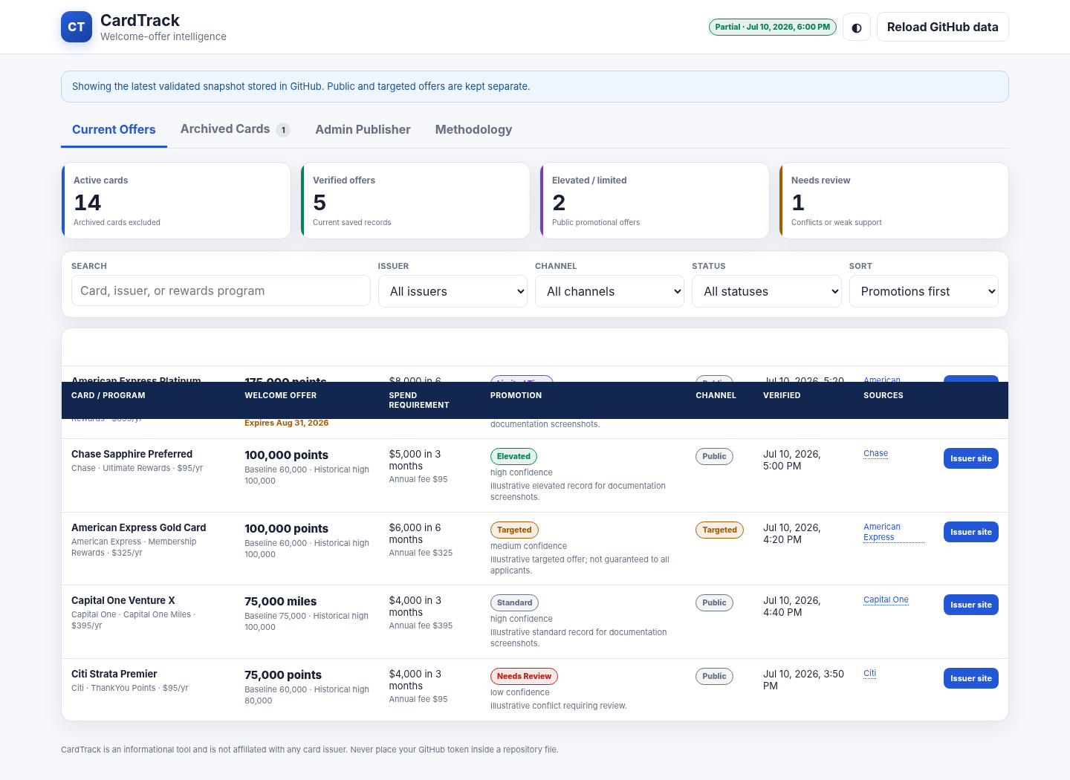
Figure 1. Main dashboard with illustrative documentation data; promotion flags are derived deterministically from the saved data.

3. Repository and deployment
.github/workflows/deploy-pages.yml
site/index.html
site/styles.css
site/app.js
site/lib/schema.mjs
site/lib/github.mjs
site/data/cardtrack.json
scripts/validate-data.mjs
tests/run-tests.mjs
The workflow triggers on pushes to main and on manual dispatch. It uses read-only repository permission plus Pages and OIDC deployment permissions. It does not require a GitHub Actions secret and it does not invoke an AI API.
- Node validates the database before upload.
- The unit suite runs before deployment.
- The entire site directory is uploaded as the Pages artifact.
- Deployment is blocked when validation or tests fail.

4. Unified data model
The unified database avoids multi-file partial updates. Cards, archived state, and offers are committed atomically through a single GitHub Contents API update.
{
"schemaVersion": 3,
"generatedAt": "ISO timestamp or null",
"dataStatus": "seed | live | partial",
"updatedBy": "source label",
"cards": [...],
"offers": [...]
}

4.1 Card object
Field | Type / rule
id | Unique lowercase slug; immutable research key.
name, issuer, program | Required text.
annualFee | Non-negative number.
baselineOffer | Used to determine Elevated status.
historicalHigh | Reference only; number or null.
bonusUnit | Default unit used in prompt and card setup.
applyUrl | HTTPS issuer URL.
isArchived | Boolean controlling display and prompt inclusion.
archivedAt | ISO timestamp or null.
createdAt / updatedAt | ISO timestamps.

4.2 Offer object
Field | Type / rule
cardId | Must match a catalog card.
bonusAmount | Non-negative number; no commas/currency symbols in JSON.
bonusUnit | points, miles, cash, or free-night certificate points.
channel | public, targeted, referral, branch, or mailer.
spendRequirement | Number or null.
spendPeriodMonths | Positive number or null.
annualFee | Non-negative number.
status | standard, elevated, limited, targeted, or review.
expirationDate | YYYY-MM-DD or null; expired imports are rejected.
lastVerifiedAt | ISO timestamp.
confidence | high, medium, or low.
note | Required, maximum 500 characters.
sources | At least one approved HTTPS source.

5. Promotion classification
Effective status | Rule
Limited time | Saved status is limited and the offer is not expired.
Elevated | Public bonusAmount is greater than the card baselineOffer, unless limited or review.
Targeted | Any non-public channel, unless review.
Standard | Public offer at or below baseline and not limited/review.
Needs review | Explicit research conflict or ambiguity.
Expired | expirationDate is earlier than the current date; imports are blocked, but existing stale data is visibly marked.
Expiration dates are displayed only when supplied by the researched record. The prompt explicitly tells the research model not to infer or guess dates.

6. Import validation and merge behavior
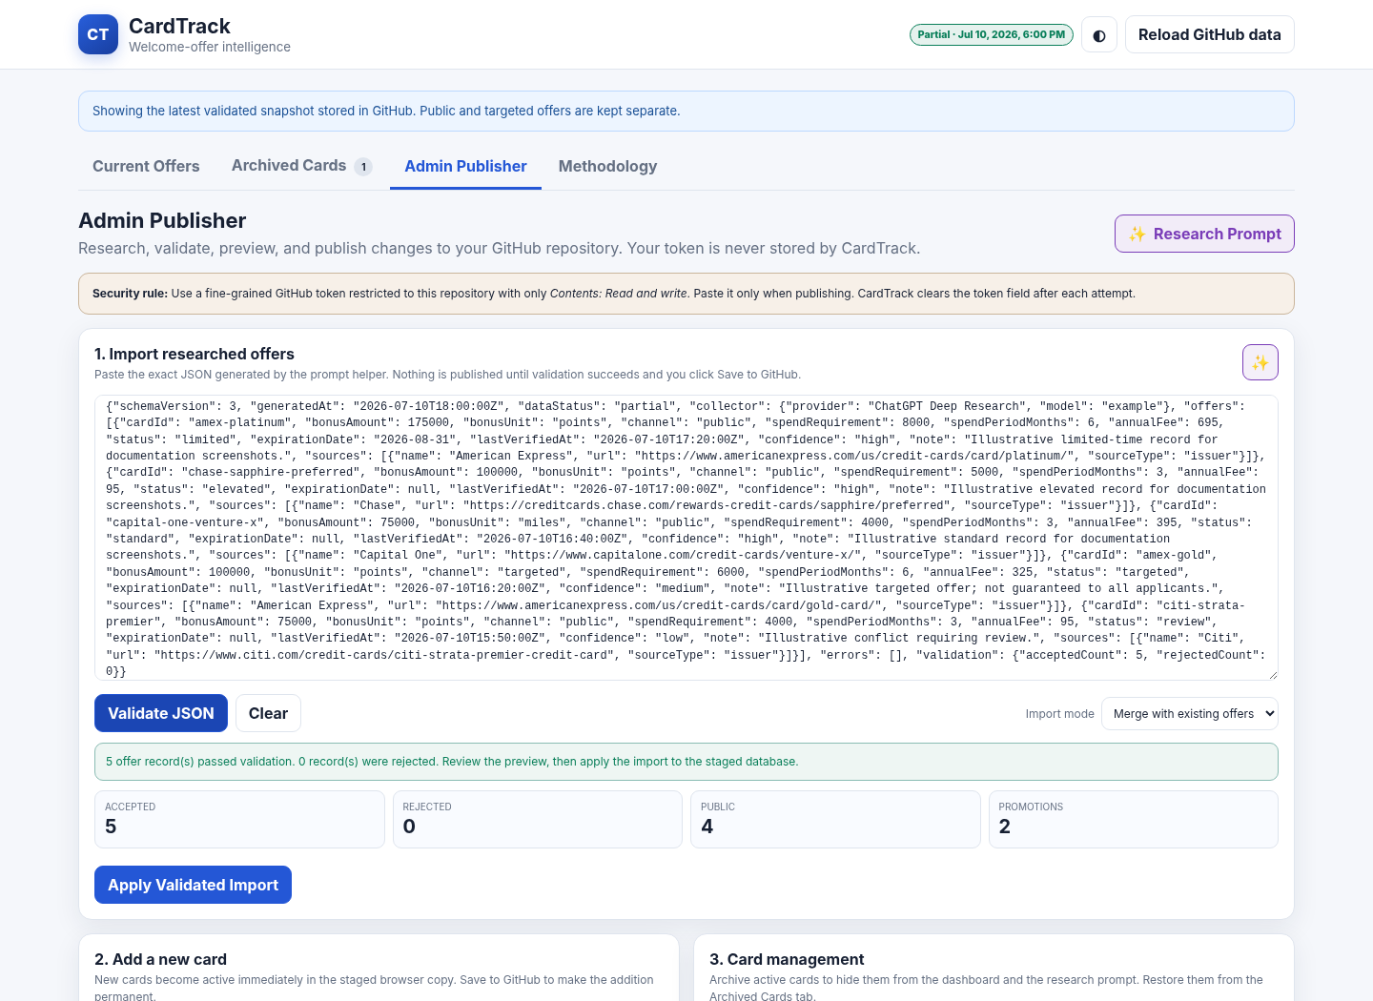
Figure 2. Browser validation preview showing accepted, rejected, public, and promotional counts.
- Accepts a JSON object with an offers array or a bare offer array.
- Removes optional Markdown fences before parsing.
- Requires schemaVersion 3 for structured imports.
- Rejects unknown cards, duplicate card/channel keys, expired offers, unapproved sources, malformed dates, and invalid numeric fields.
- Checks acceptedCount when the research response provides it.
- Rejects dataStatus live unless every active card has a public offer.
- Blocks an import when zero offers pass validation.

6.1 Merge mode
Merge replaces records with the same cardId + channel key and preserves other existing records. This is the normal update mode.

6.2 Replace mode
Replace discards all saved offers and uses only the accepted import records. It should be used only when the research result is intentionally complete.

7. Card lifecycle and archive design
Cards are never deleted through the normal UI. Hide / Archive sets isArchived=true and timestamps archivedAt. Archived cards are excluded from Current Offers, KPI counts, filters, and the generated research prompt. Restore reverses these fields. This reduces accidental catalog loss and supports later reactivation.
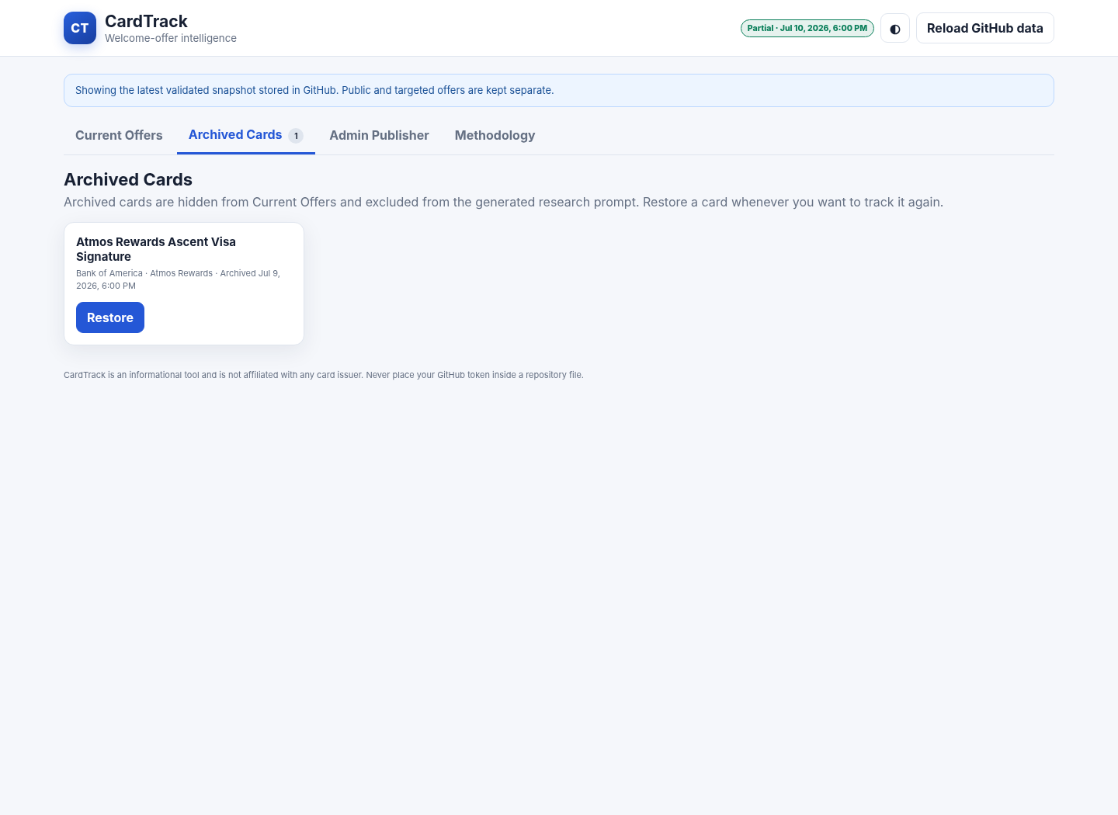
Figure 3. Archived cards remain available for restoration.

8. GitHub publishing implementation
The browser uses two GitHub REST calls: GET the existing file to obtain its SHA, then PUT the replacement content with the SHA, branch, and commit message. GitHub requires the SHA when updating an existing file. The fine-grained token must have Contents write permission for the selected repository.
GET /repos/{owner}/{repo}/contents/site/data/cardtrack.json?ref=main
PUT /repos/{owner}/{repo}/contents/site/data/cardtrack.json
Authorization: Bearer <fine-grained token>
Accept: application/vnd.github+json
X-GitHub-Api-Version: 2026-03-10
The JSON is UTF-8 encoded and Base64-encoded for the Contents API request. The token field is cleared in a finally block after test or save, whether the request succeeds or fails.
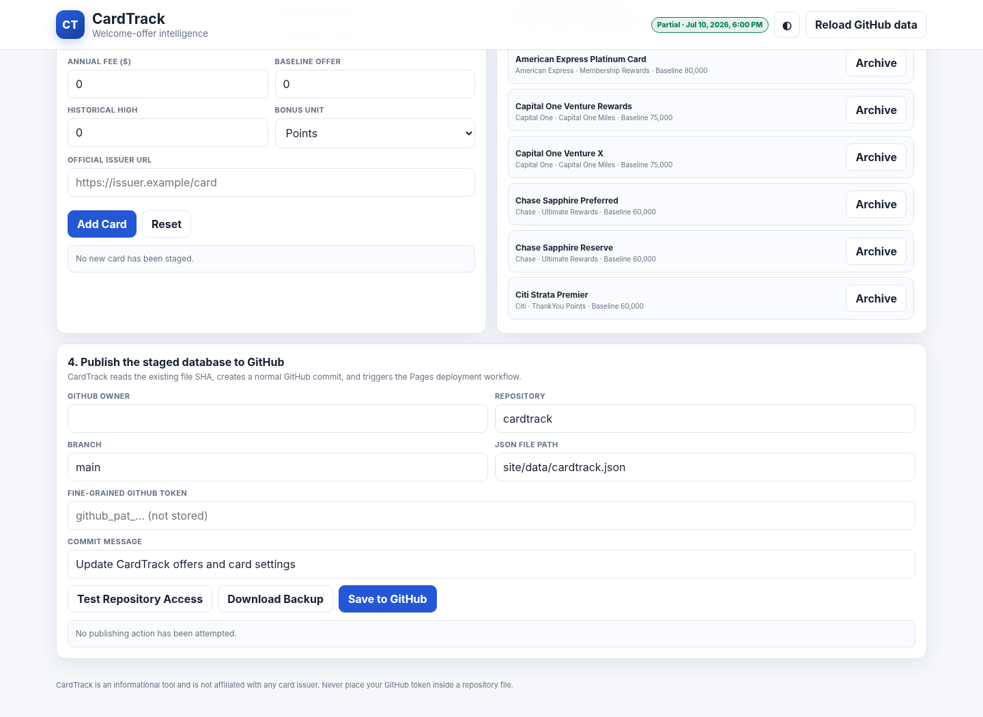
Figure 4. Publishing UI and repository configuration fields.

9. Security and threat model
Risk | Mitigation
Token committed to source | No token constants, config files, or repository secrets are required.
Token stored in browser | Token is not written to localStorage, sessionStorage, or cookies; it is cleared after each attempt.
Over-broad credential | Documentation requires one repository and Contents read/write only.
Malicious imported link | Sources are restricted to HTTPS and an approved domain list.
Malicious imported HTML | UI renders imported values using text nodes, not raw HTML.
Empty or corrupt overwrite | Zero-offer imports are blocked; final database validation runs before PUT.
Concurrent edit | GitHub file SHA is fetched immediately before update; a conflict returns 409 and the user must reload.
Lost device | Use separate expiring device-specific tokens and revoke the affected token.
Public admin UI | Without an authorized token, GitHub rejects writes. The UI itself contains no credential.
Design boundary A browser-entered personal access token is suitable for the owner’s private publishing workflow, but a multi-user or commercial system should use a GitHub App or server-side authorization.

10. Testing and quality assurance
Test area | Result
Database validation | Passed
Node syntax | Passed
Unit tests | 16 passed
Browser integration | Passed with mocked GitHub REST API
Prompt modal and active catalog | Passed
Import validation and merge | Passed
Promotion badges and dates | Passed
Add card | Passed
Archive and restore | Passed
Token clearing | Passed
GitHub PUT workflow | Passed with mocked response
Run the package tests with:
node scripts/validate-data.mjs
node tests/run-tests.mjs
A live repository commit was not performed during package creation because it requires the user’s private token. The GitHub Actions workflow repeats deterministic validation before every deployment.

11. Maintenance and extension points
- Update ALLOWED_SOURCE_DOMAINS in site/lib/schema.mjs when adding a trusted source.
- Change the catalog seed in site/data/cardtrack.json; preserve card IDs after research begins.
- Add new validation rules in validateOffer and corresponding tests.
- Keep the workflow dependency-free unless a build tool is genuinely needed.
- Review GitHub REST API versioning and action versions periodically.
- Regenerate screenshots and documentation after substantial UI changes.

Official references
GitHub: Fine-grained personal access tokens
GitHub: Create or update file contents
GitHub: Custom Pages workflows
GitHub: CORS and cross-origin REST requests
OpenAI: Deep research in ChatGPT
Google: Deep Research in Gemini Apps

