CARDTRACK

User Setup Guide
Beginner instructions for a new GitHub repository, manual research, and one-click publishing
GitHub-only Option A | Version 3.0 | July 2026
Manual AI research -> validated JSON -> secure GitHub commit -> automatic Pages deployment

Contents
1. What you are building
2. Package upload and GitHub Pages deployment
3. Create the fine-grained GitHub token
4. Research and import current offers
5. Add, hide, archive, and restore cards
6. Publish from CardTrack
7. Multiple devices and routine operation
8. Troubleshooting and safety

1. What you are building
This version of CardTrack is a static GitHub Pages website. It does not use Cloudflare and it does not call the Gemini or ChatGPT API. You perform research manually in the consumer ChatGPT or Gemini website, then CardTrack validates and publishes the JSON to your GitHub repository.
- GitHub Pages hosts the website.
- The built-in prompt prepares the exact research instructions and active-card catalog.
- ChatGPT or Gemini performs current web research.
- CardTrack validates the returned JSON before it can be applied.
- A restricted GitHub token authorizes CardTrack to update only the repository file.
- A GitHub Actions workflow validates the saved database and redeploys the site.
Important The token is not the Gemini API key. It is a separate GitHub credential. Do not paste it into ChatGPT, Gemini, this guide, or any repository file.

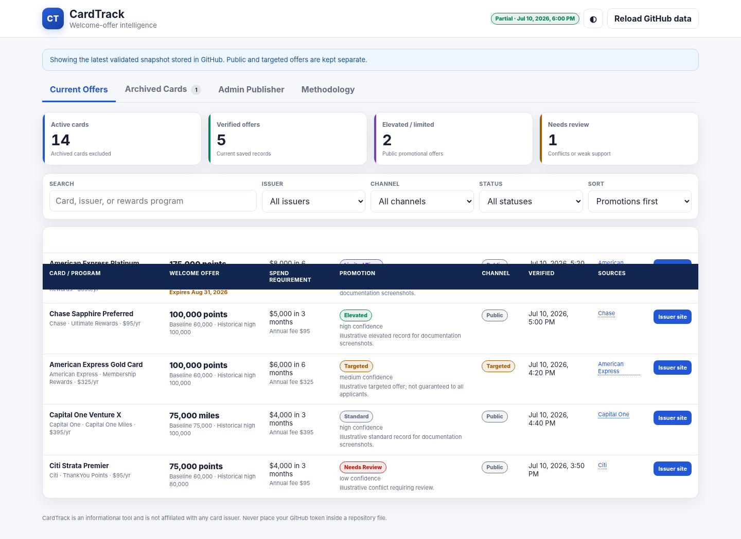
Figure 1. CardTrack dashboard with illustrative documentation data. Elevated and limited-time promotions are prominently flagged; this screenshot is not a statement of live offers.

2. Package upload and GitHub Pages deployment

2.1 Create a new repository
- Sign in to GitHub and select New repository.
- Name the repository cardtrack.
- Choose Public for the simplest GitHub Pages setup on a free account.
- Do not initialize the repository with a README, .gitignore, or license.
- Create the repository.

2.2 Extract and upload the package
Extract the ZIP on your computer. Open the extracted CardTrack folder and upload its contents to the root of the new repository. Do not upload the ZIP itself and do not add an extra outer folder.
.github/
site/
scripts/
tests/
docs/
README.md
WORKFLOW_COPY_PASTE.yml
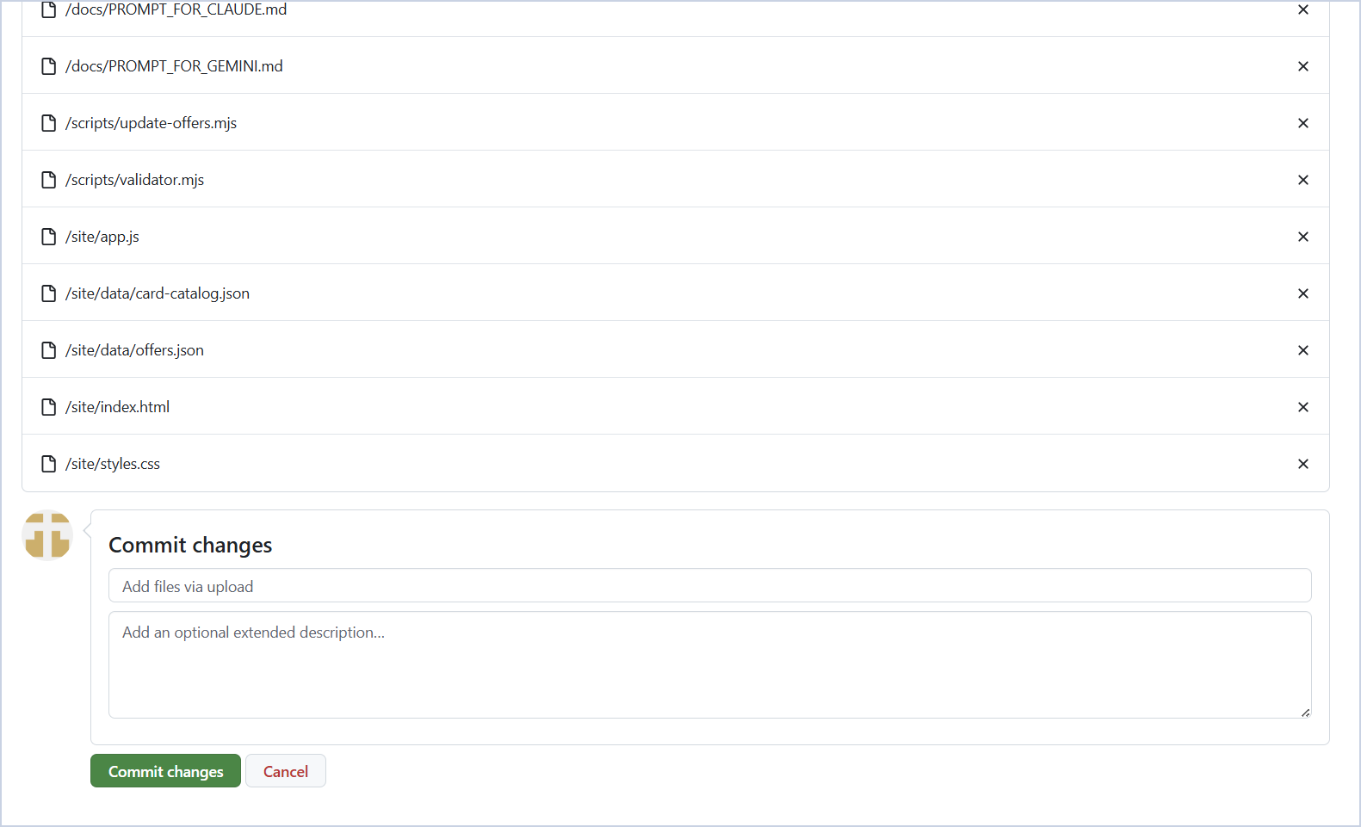
Figure 2. Your current GitHub upload-and-commit screen. Use a clear commit title such as “Initial CardTrack Option A deployment.”
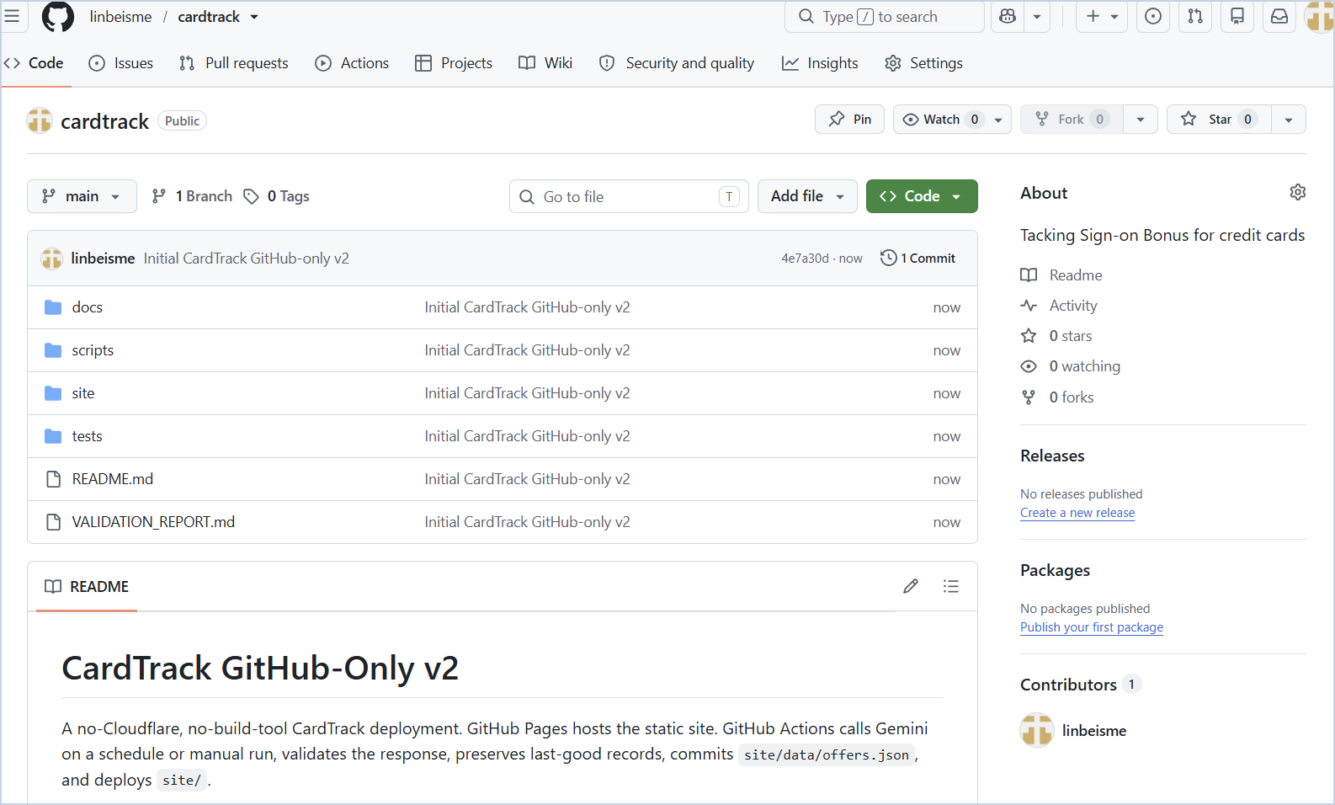
Figure 3. Example repository root after upload. The folders must sit directly at the repository root.
Hidden folder warning Windows or the GitHub web uploader may skip the .github folder. If the Actions tab says “Get started with GitHub Actions,” follow the next subsection.

2.3 If GitHub does not see the workflow
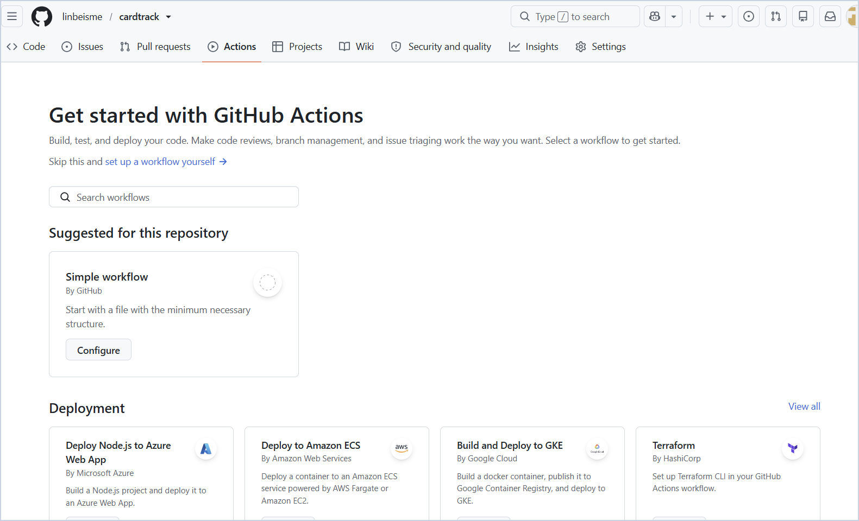
Figure 4. This screen means .github/workflows was not uploaded.
- Click “set up a workflow yourself.”
- Change the file name to deploy-pages.yml. GitHub automatically places it inside .github/workflows.
- Open WORKFLOW_COPY_PASTE.yml from the extracted package, copy all of its contents, and paste them into the editor.
- Commit directly to main with the message “Add CardTrack Pages workflow.”
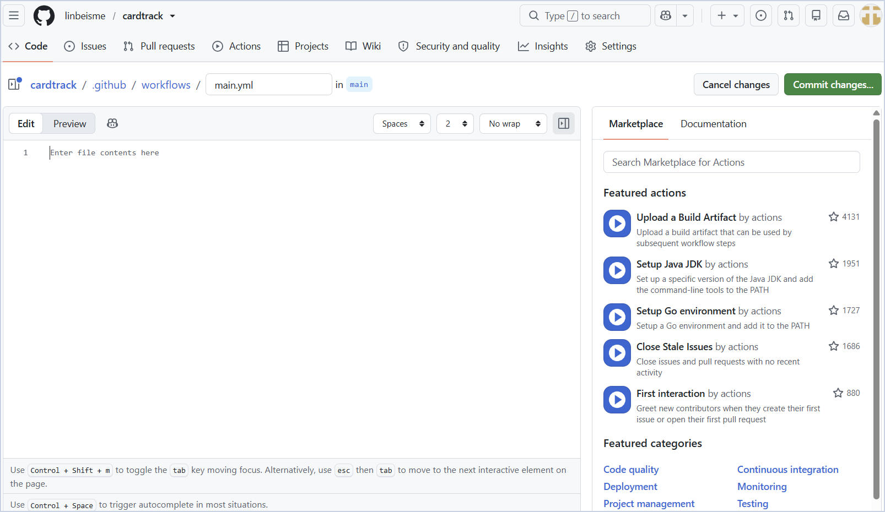
Figure 5. GitHub workflow editor. The final path must be .github/workflows/deploy-pages.yml.

2.4 Enable GitHub Pages
- Open repository Settings.
- Select Pages in the left sidebar.
- Under Build and deployment, set Source to GitHub Actions.
- Do not select the Jekyll or Static HTML template; the package already contains its own workflow.
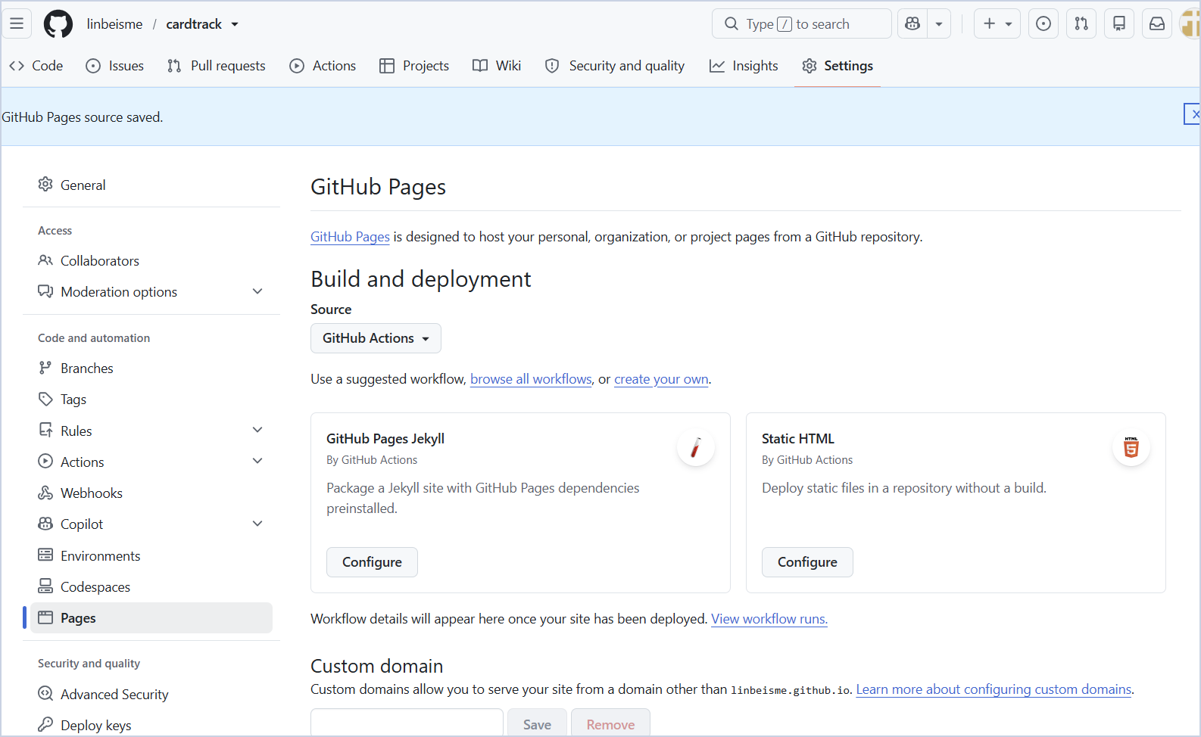
Figure 6. Correct Pages configuration: Source = GitHub Actions.

2.5 Confirm the first deployment
Open the Actions tab and select Validate and deploy CardTrack. The build and deploy jobs should finish with green check marks. The first deployment uses the starter catalog and may show zero current offers until you import research.
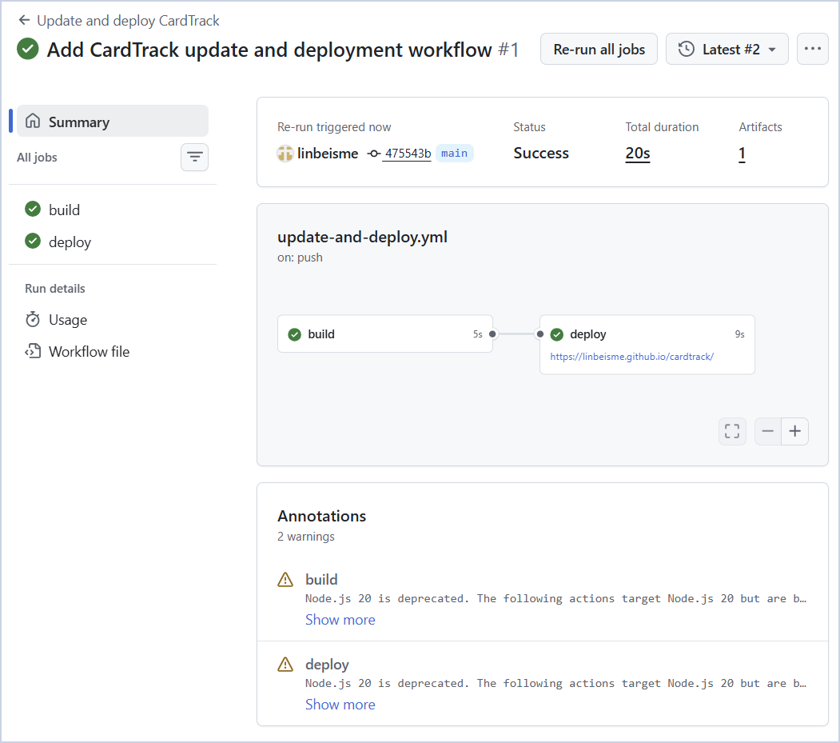
Figure 7. Successful GitHub Pages build and deployment.

3. Create the fine-grained GitHub token
The token is a restricted digital key that allows the Admin Publisher to update site/data/cardtrack.json. GitHub recommends fine-grained personal access tokens where possible, and the repository contents endpoint supports them with Contents write permission.
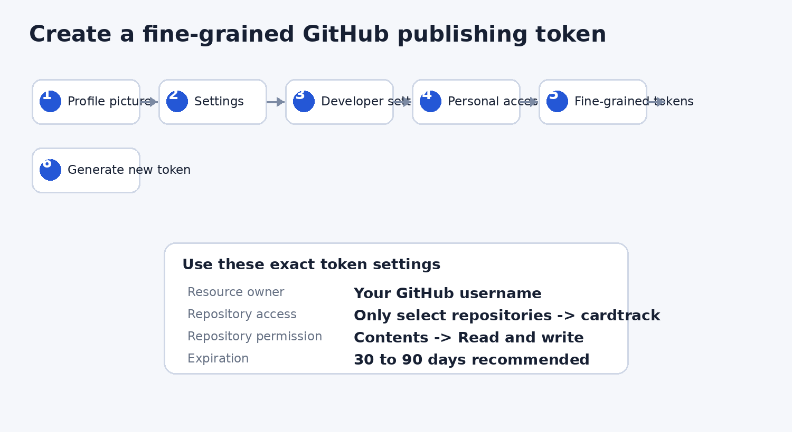
Figure 8. Illustrated path and minimum settings for the CardTrack publishing token.

3.1 Open the token page
- Click your GitHub profile picture.
- Select Settings.
- Scroll to Developer settings.
- Select Personal access tokens, then Fine-grained tokens.
- Choose Generate new token.
- Complete GitHub password or two-factor authentication if requested.

3.2 Use these exact settings
Field | Recommended setting
Token name | CardTrack Publisher - Desktop
Expiration | 30 to 90 days
Resource owner | Your GitHub username
Repository access | Only select repositories -> cardtrack
Repository permission | Contents -> Read and write
All other permissions | No access / default minimum
Generate the token and copy it immediately into a trusted password manager. GitHub will not show the full token again.
Never store the token Do not place the token in app.js, cardtrack.json, README, a GitHub issue, an email, or browser localStorage. CardTrack clears the field after every repository test or save attempt.

4. Research and import current offers

4.1 Open the prompt helper
- Open your published CardTrack site.
- Select Admin Publisher.
- Click the purple Research Prompt button or the sparkle icon beside the import section.
- The pop-up automatically includes every active, non-archived card.
- Click Copy Prompt.
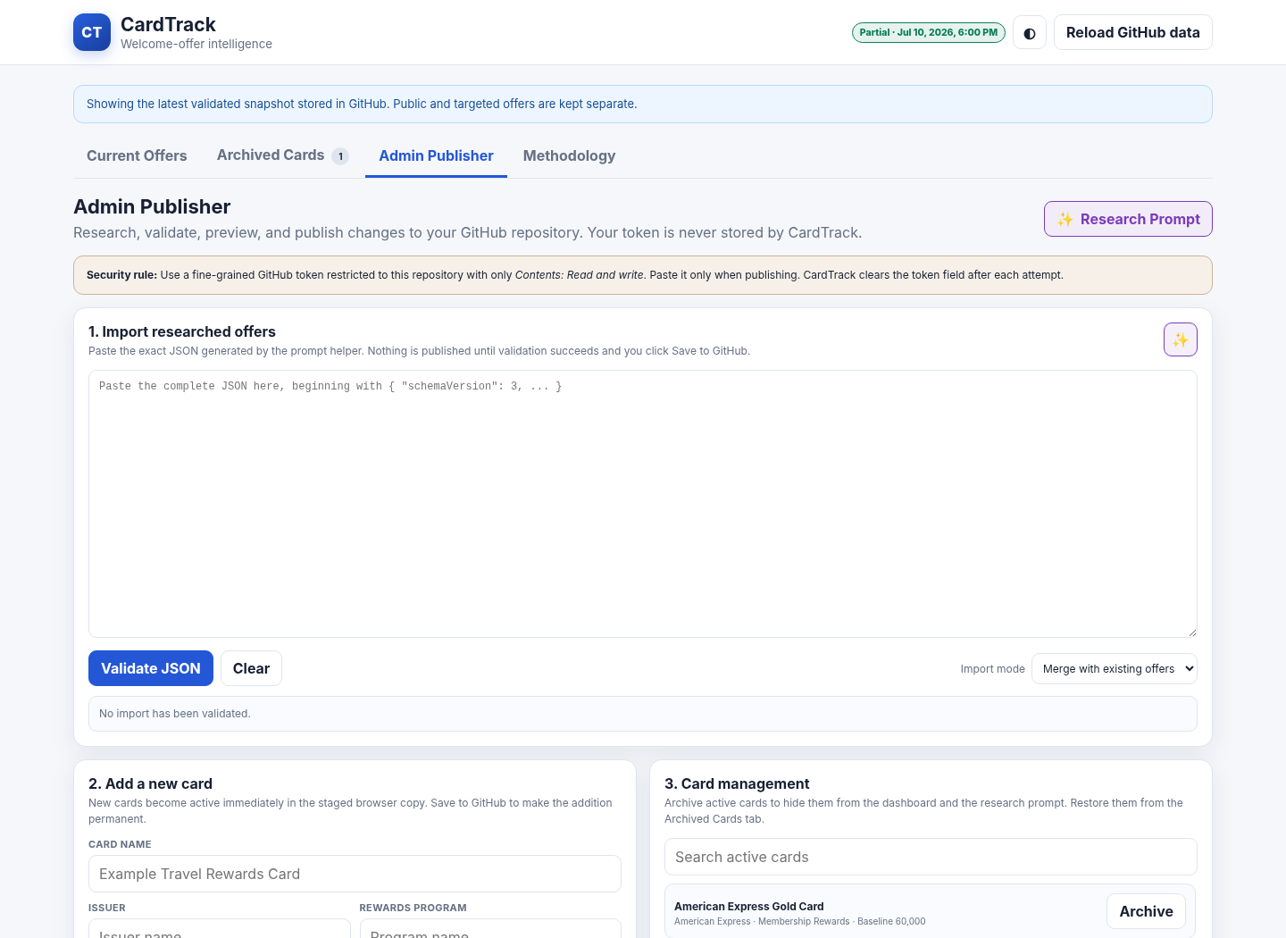
Figure 9. Admin Publisher with the Research Prompt button and JSON import area.
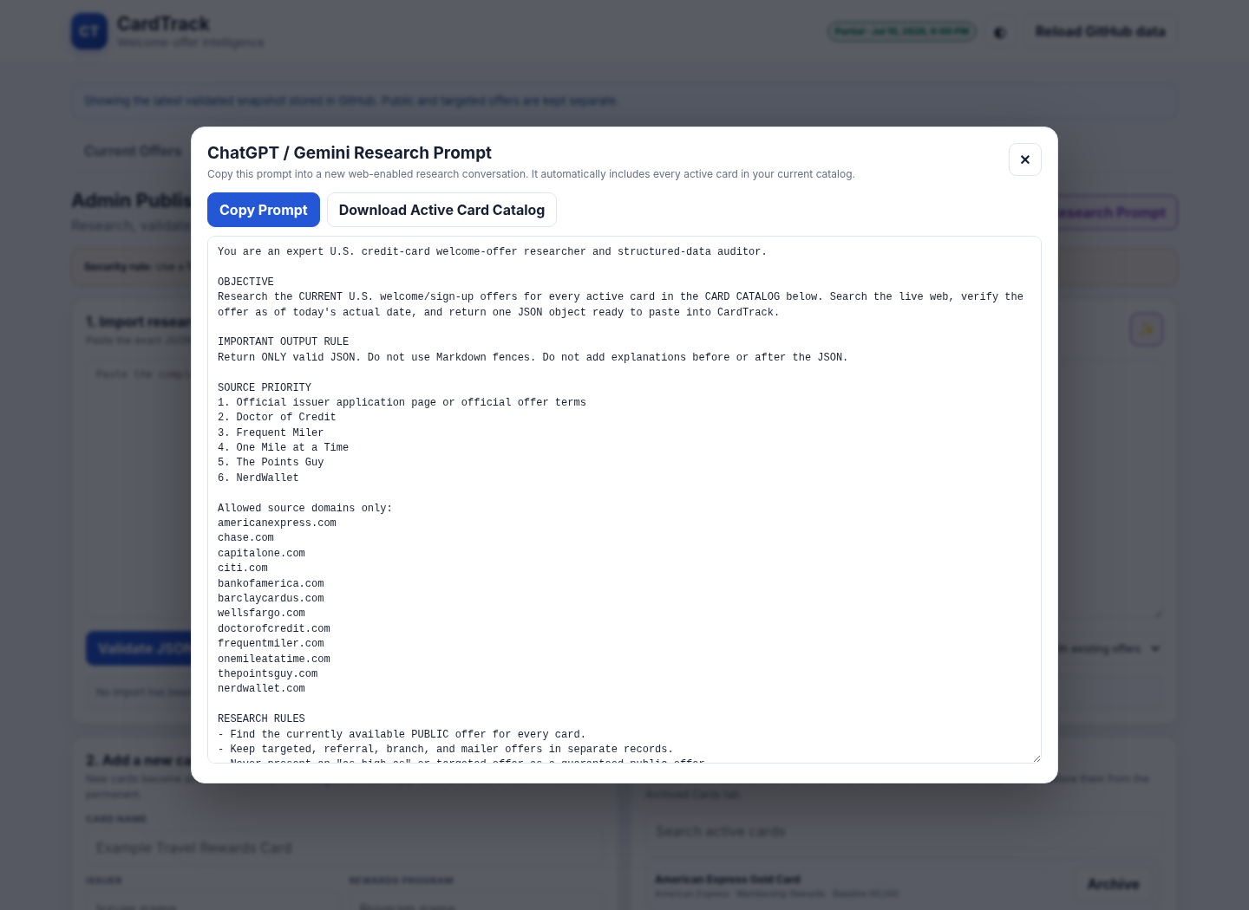
Figure 10. Prompt pop-up with Copy Prompt and Download Active Card Catalog controls.

4.2 Run the prompt in ChatGPT or Gemini
- Start a new web-enabled research conversation in ChatGPT or Gemini.
- Paste the copied prompt.
- Allow the service to research current public and targeted offers.
- Review the output. It must be one JSON object with no Markdown fences or commentary.
- Copy the complete JSON response.
Research accuracy The prompt prioritizes issuer pages and requires separate records for public and targeted offers. Still review unusual results before publishing.

4.3 Validate and apply the JSON
- Return to Admin Publisher.
- Paste the JSON into the import box.
- Choose Merge with existing offers for normal updates. Use Replace all offers only when the research result is a complete replacement.
- Click Validate JSON.
- Review Accepted, Rejected, Public, and Promotions counts.
- Click Apply Validated Import. This only stages the data in the browser; it does not save to GitHub yet.
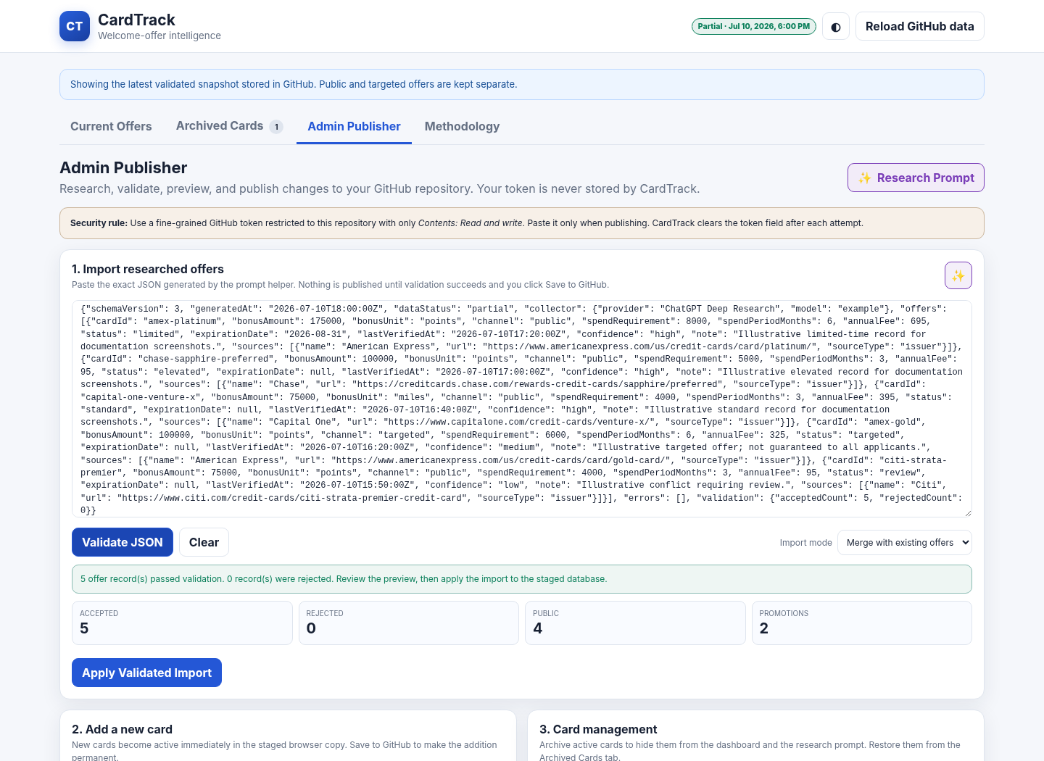
Figure 11. Validated import preview. The Apply Validated Import button appears only when at least one offer passes validation.
CardTrack blocks malformed JSON, unknown card IDs, duplicate card/channel records, unapproved source domains, expired offers, and a “live” status that does not cover every active card.

5. Add, hide, archive, and restore cards

5.1 Add a card
- Open Admin Publisher.
- Complete Card name, issuer, rewards program, annual fee, baseline offer, historical high, bonus unit, and official issuer URL.
- Click Add Card.
- The card becomes active in the staged browser database.
- Open the Research Prompt again so the new card appears in the next research request.
- Publish to GitHub to make the change permanent.

5.2 Hide and archive a card
- In Admin Publisher, locate the card under Card management.
- Click Hide / Archive.
- Confirm the action.
- The card disappears from Current Offers and from the research prompt.
- Publish to GitHub to save the archived state.

5.3 Restore an archived card
- Open the Archived Cards tab.
- Click Restore beside the card.
- The card becomes active in the staged database.
- Publish to GitHub to save the restore.
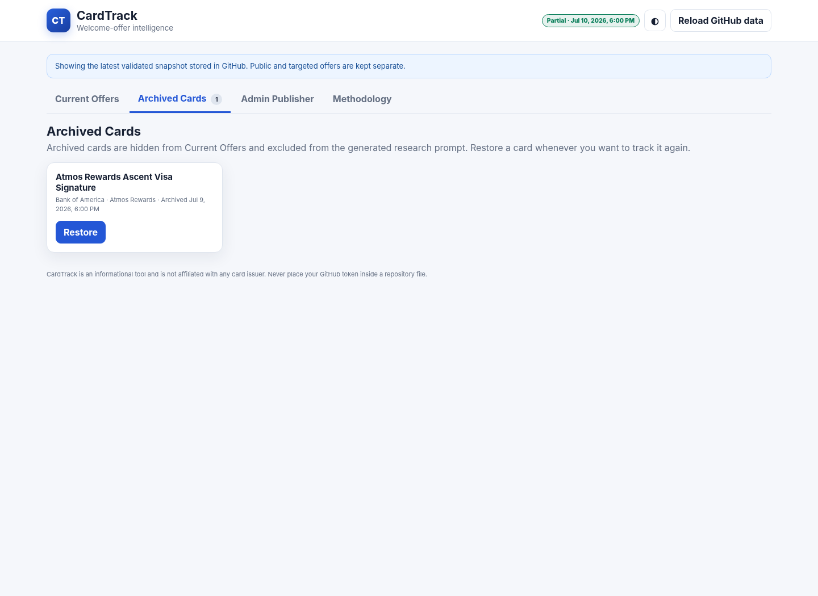
Figure 12. Archived Cards tab with a Restore button.

6. Publish from CardTrack
- Open Admin Publisher and scroll to Publish the staged database to GitHub.
- Confirm GitHub owner, repository, branch, and JSON file path. On the standard Pages URL, owner and repository are filled automatically.
- Paste the fine-grained token from your password manager.
- Optionally click Test Repository Access. CardTrack clears the token afterward, so paste it again before saving.
- Click Download Backup and keep the backup until deployment succeeds.
- Paste the token again and click Save to GitHub.
- CardTrack reads the current file SHA, creates a normal commit, clears the token field, and displays a commit link.
- Wait for the GitHub Actions deployment to complete, then click Reload GitHub data or refresh the website.
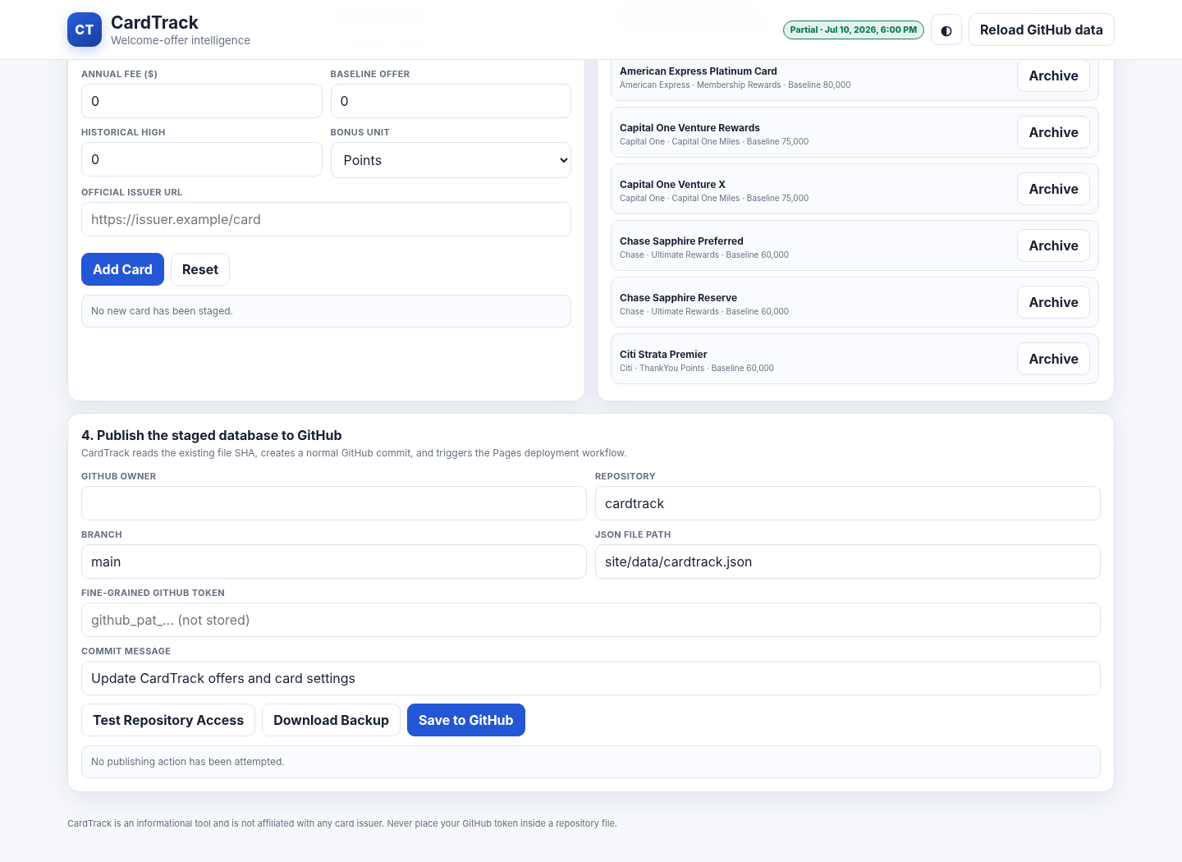
Figure 13. GitHub Publisher section. The token field is password-masked and is never stored.
Expected timing A GitHub commit is immediate. GitHub Pages deployment usually takes a short period; wait for green checks in Actions before judging the live website.

7. Multiple devices and routine operation
The public data is stored in GitHub, so every device sees the same offers and archive state after deployment. A personal access token is not tied to one device, but separate device-specific tokens are safer.
Situation | Recommendation
Desktop and laptop | Create one restricted token per device.
Lost device | Revoke only that device token in GitHub Developer settings.
Token expires | Generate a replacement token and use it on the next save.
Research update | Run the prompt, validate, merge, back up, and publish.
New card | Add the card first, then regenerate the prompt.
Temporary hide | Archive the card and publish; restore later from Archived Cards.

8. Troubleshooting and safety
Message / symptom | What to do
Actions shows no workflow | Create .github/workflows/deploy-pages.yml manually using WORKFLOW_COPY_PASTE.yml.
Pages configure step says Not Found | Confirm Settings -> Pages -> Source is GitHub Actions, then rerun all jobs.
401 from GitHub | Token is wrong, expired, or revoked. Generate or paste a valid token.
403 from GitHub | Token lacks Contents read/write or is not authorized for this repository.
404 from GitHub | Check owner, repository, branch, and site/data/cardtrack.json path.
409 conflict | Reload GitHub data, reapply the staged changes, and publish again.
JSON rejected | Read the first validation error, correct the research output, and validate again.
Unsaved changes banner | Publish or download a backup before reloading/closing the page.
Offer is targeted | Keep it in a separate targeted/referral/branch/mailer channel record.
Offer expiration unknown | Use null. Never guess an expiration date.

Official references
GitHub: Managing personal access tokens
GitHub: Repository contents API
GitHub: Custom workflows with Pages
ChatGPT: Deep research
Gemini: Use Deep Research

