✈
PointsBoard v11.3.2
Beginner Setup and Update Guide
Existing GitHub repository: flights • Existing Cloudflare Worker: flights
Guide item | Value
Release | 11.3.2 - recommendation presentation and deployment-alignment update
Guide date | July 24, 2026
Production URL | https://flights.benson-lin.workers.dev
Skill level | Beginner - use the numbered screenshots

Security rule
Never place the seats.aero or SerpApi keys in GitHub, source files, screenshots, or shared documents. Keep them as encrypted Cloudflare Worker secrets.

This guide incorporates the actual GitHub and Cloudflare screens encountered during the first deployment, including the missing hidden-file failure and the /api/health SPA-routing problem.

1. What is already deployed
PointsBoard is a full-stack React application. GitHub stores the source and runs verification. Cloudflare Workers Builds installs dependencies, builds the interface, deploys static assets, and runs protected /api routes that call seats.aero and SerpApi without exposing provider keys to the browser.
Part | Current value
GitHub repository | flights
Production branch | main
Cloudflare Worker | flights
Public URL | flights.benson-lin.workers.dev
Health endpoint | /api/health
Build command | npm run build
Deploy command | npx wrangler deploy

What a successful deployment must preserve
• Saved Routes and nearby-airport expansion.
• All original reward-program, cabin, time, stops, layover, duration, and connection-airport filters.
• Recommended Redemptions, Original Reward Results, Exact Same Flight, and Cash Fares.
• Original-currency taxes/fees and manual USD FX conversion.
• Strict Demo/Live separation and protected API keys.
Why Cloudflare Workers, not GitHub Pages alone
The app contains server-side /api/search, /api/cashfare, and /api/health routes. GitHub stores and verifies the source; Cloudflare hosts both the built interface and protected Worker logic.

2. What changed in v11.3.2
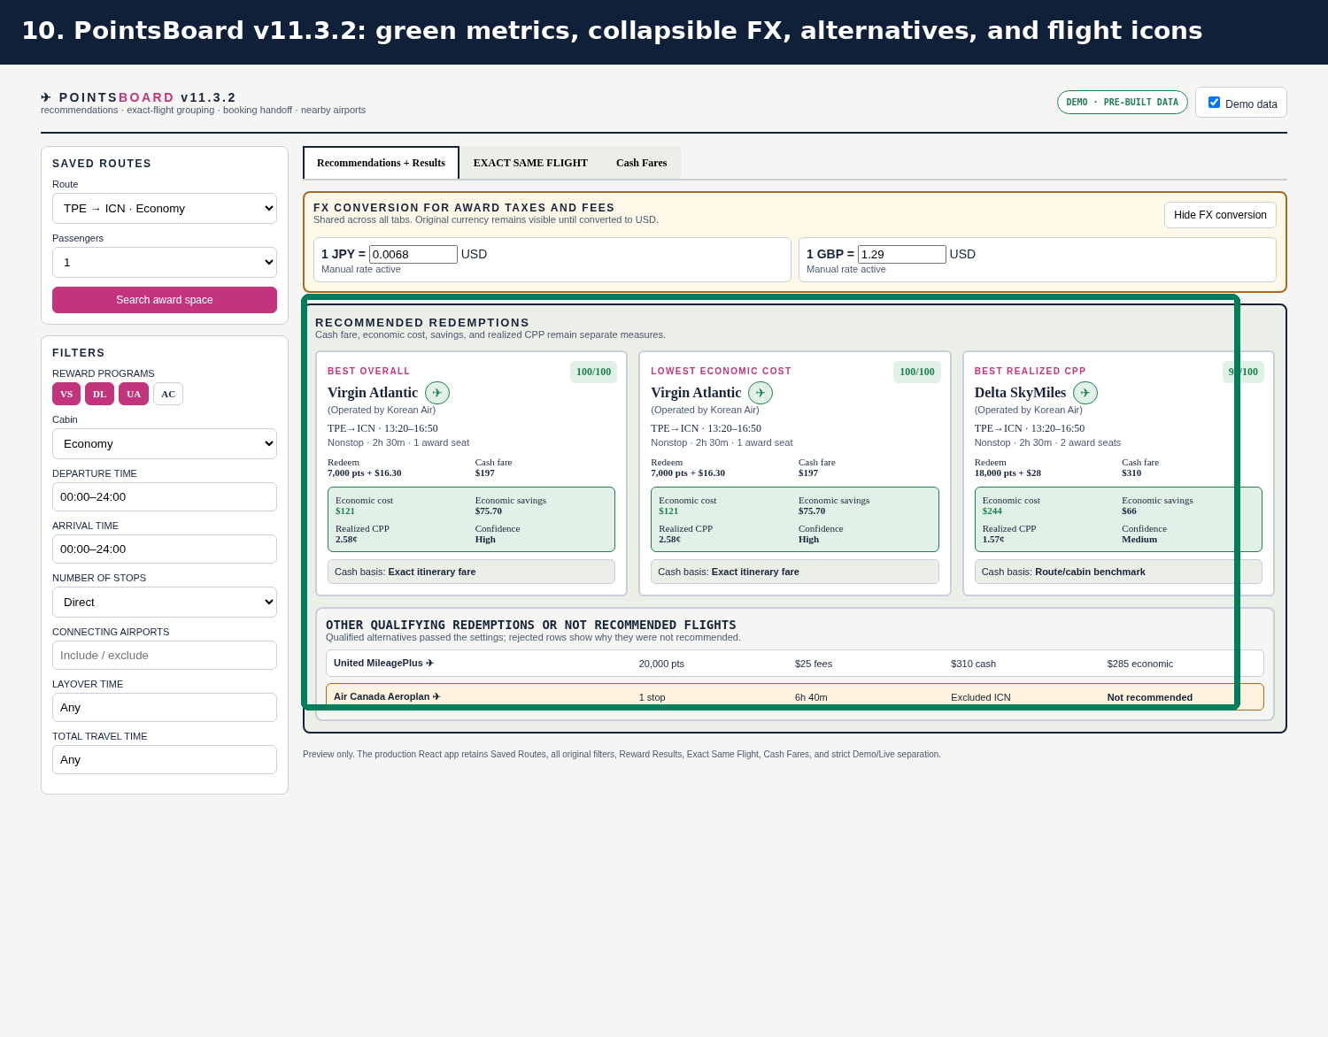
Figure 1. v11.3.2 preview with the retained original filters and new recommendation presentation.
Update | What it does
Light-green metric block | Groups economic cost, economic savings, realized CPP, and confidence without confusing them with cash fare.
Flight icon | Opens source-supplied flight number, departure/arrival, airline, seats, and check time.
Collapsible FX | Hides or shows the shared FX panel without deleting entered rates.
Other qualified flights | Shows alternatives that passed settings but did not win a featured category.
Not recommended | Shows up to five rows that failed preferences and explains why.

3. Download, extract, and confirm the package
Use the complete v11.3.2 ZIP for the safest update. The separate updated-files ZIP is available for advanced users who want to replace only changed files.
Required at repository root | Purpose
package.json and package-lock.json | Exact Node dependencies and test/build scripts.
wrangler.jsonc | Worker name, entry point, static assets, SPA fallback, and /api routing.
src/ | React interface and calculation modules.
worker/ and functions/ | Protected API routes and health endpoint.
public/ | CPP library, favicon, and security headers.
.github/workflows/verify.yml | GitHub Actions clean install, test, build, and dry-run verification.
.gitignore, .nvmrc, .dev.vars.example | Hidden files required for safe setup and deployment testing.

Do not upload generated or secret-bearing folders
Do not commit node_modules, dist, .dev.vars, .wrangler, or .wrangler-dry-run. Verify that .gitignore is present after upload.

Recommended backup
1. Download a ZIP backup of the current GitHub flights repository.
2. Keep a copy of the currently deployed v11.3.1 package.
3. Do not delete or recreate the Cloudflare Worker; update the existing flights Worker so its secrets and URL remain attached.

4. Update the existing GitHub repository named flights

Recommended method - GitHub Desktop or local Git
1. Clone the existing flights repository to your computer.
2. Extract the complete v11.3.2 package.
3. Copy the contents of the v11.3.2 project folder into the cloned repository folder.
4. Do not delete the cloned repository’s hidden .git folder.
5. Confirm .github, .gitignore, .nvmrc, package.json, package-lock.json, wrangler.jsonc, src, worker, functions, and public are visible.
6. Commit with the message: Update PointsBoard to v11.3.2.
7. Push the commit to main.

Alternative - changed-files patch
The updated-files ZIP preserves relative paths. Replace each file in the flights repository with the matching file from the patch. This method is faster but easier to perform incorrectly when nested or hidden files are involved.
Do not rename the project
The repository is flights and the Cloudflare Worker is flights. The included wrangler.jsonc uses name: flights so future builds continue updating the same Worker.

5. If the Actions tab shows “Get started with GitHub Actions”
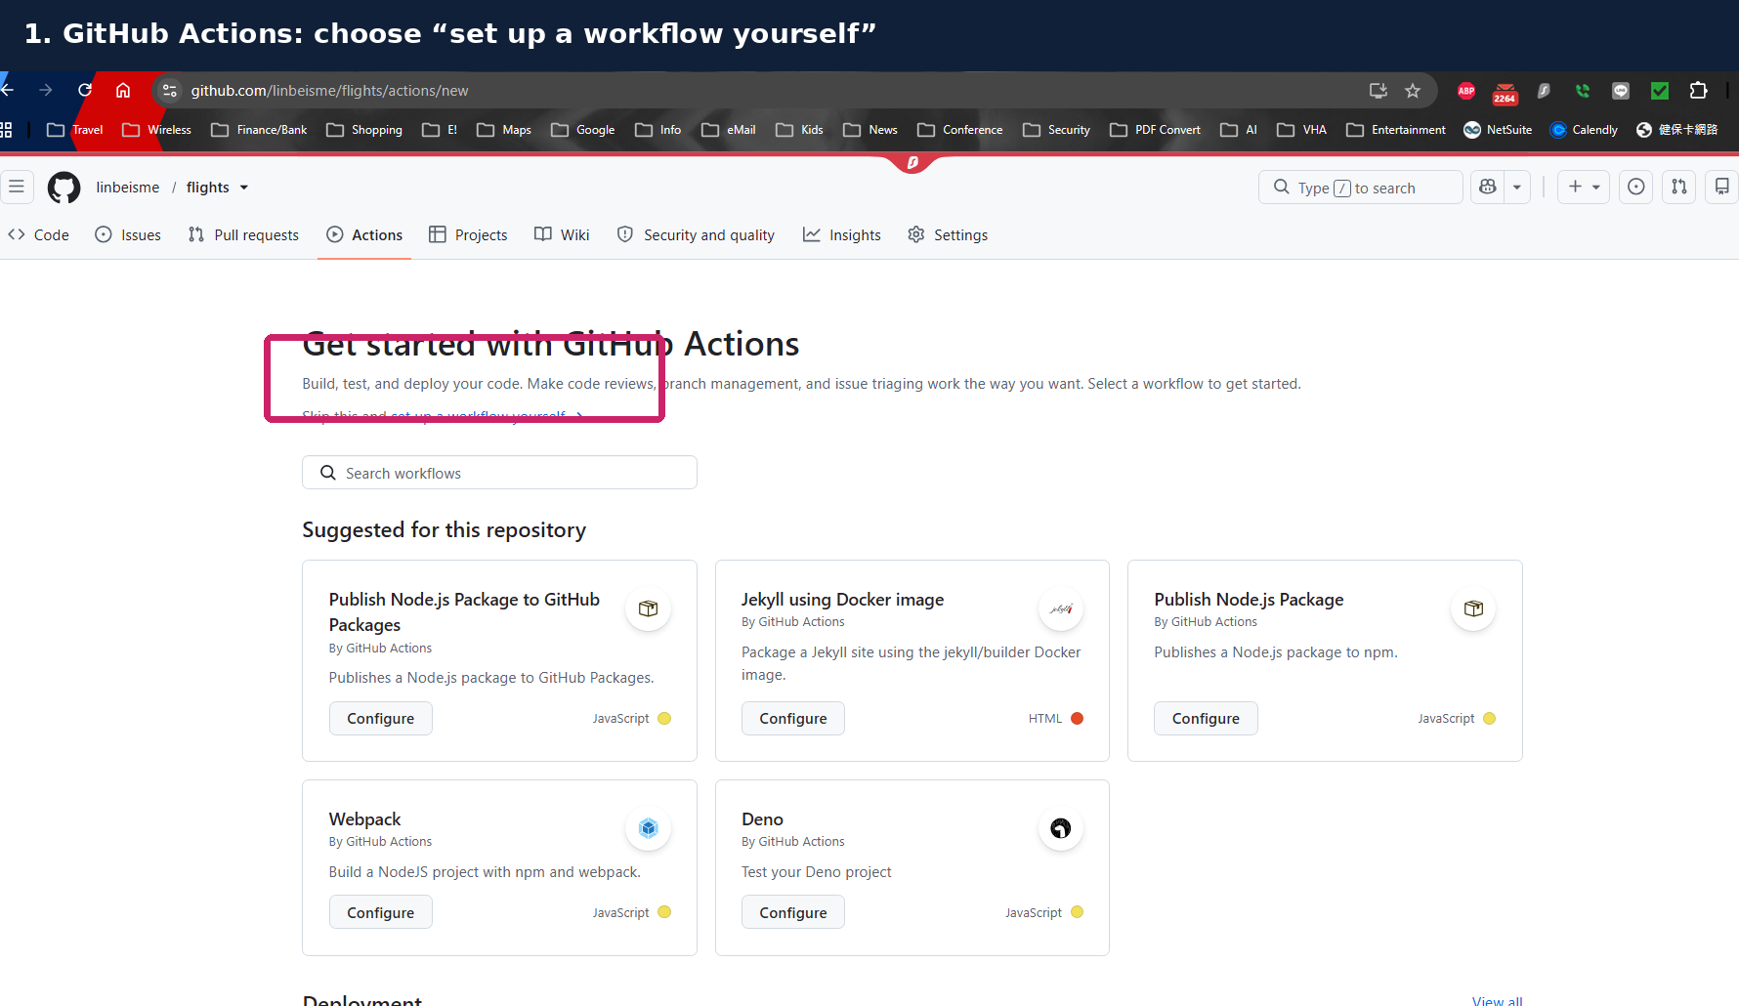
Figure 2. The actual GitHub screen encountered when the hidden .github workflow folder was not uploaded.
1. Do not choose the suggested Node, Jekyll, Webpack, or Deno templates.
2. Select set up a workflow yourself.
3. Name the file .github/workflows/verify.yml.
4. Use the verify.yml included in this v11.3.2 package.
5. Commit directly to main.
name: Verify PointsBoard
on:
push:
branches: [main]
pull_request:
workflow_dispatch:

The workflow_dispatch trigger creates a Run workflow button for manual verification.

6. How to read a failed GitHub Actions run
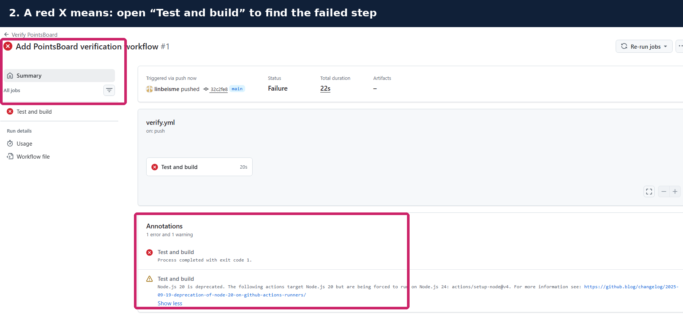
Figure 3. A red workflow summary does not identify the cause by itself; open the failed job and failed step.
1. Open Actions > Verify PointsBoard.
2. Select the newest failed run.
3. Select Test and build in the left panel.
4. Expand the step marked with a red X.
5. Read the final error lines; the yellow Node warning is not necessarily the cause.
Node warning versus actual failure
A Node.js deprecation warning can be non-blocking. Correct the first red step or explicit Error line rather than treating every yellow annotation as the failure.

7. The hidden .gitignore problem encountered during setup
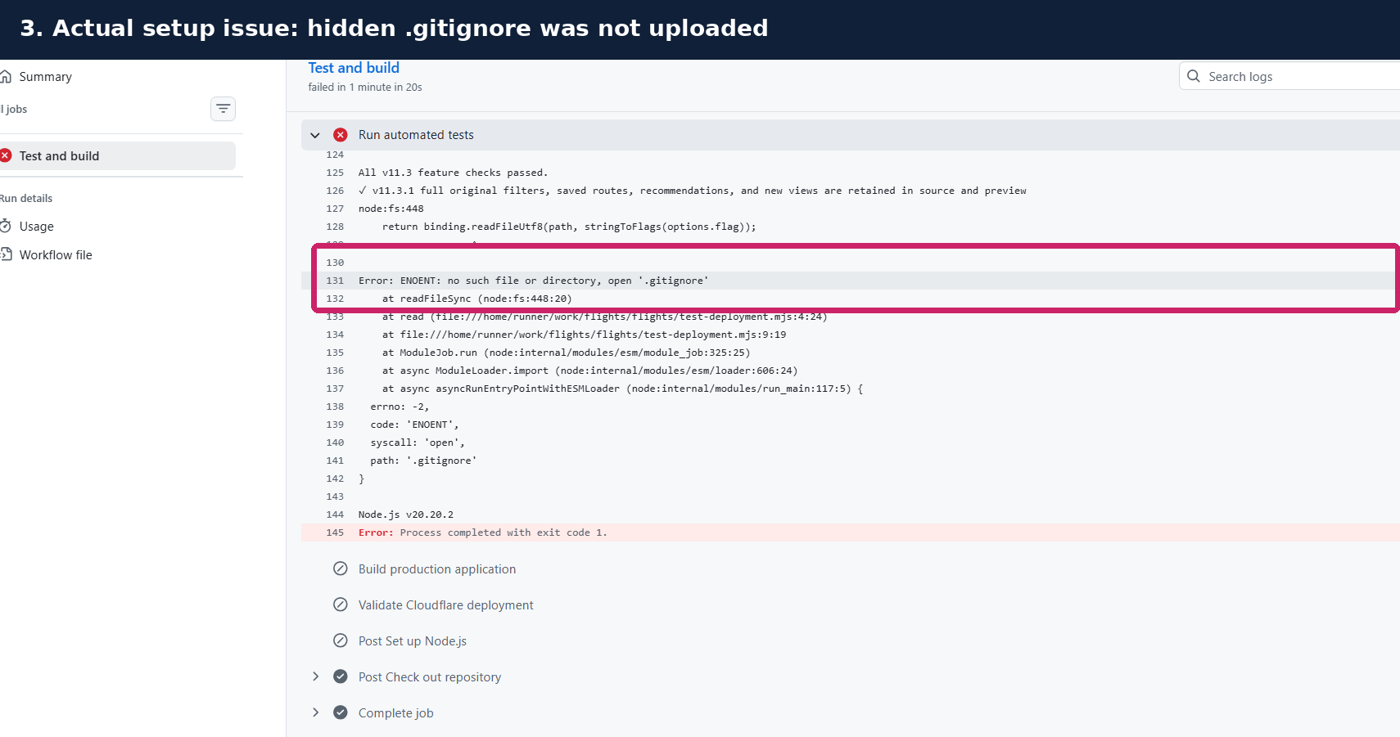
Figure 4. The actual failure: ENOENT because .gitignore was missing from the repository root.
Browser uploads and ZIP extraction workflows can overlook filenames beginning with a period. The deployment test intentionally checks for .gitignore because it protects secrets and generated folders.

Create these hidden files if missing
.gitignore
.nvmrc
.dev.vars.example
.github/workflows/verify.yml

Minimum .gitignore contents
node_modules/
dist/
.dev.vars
.wrangler/
.wrangler-dry-run/

After committing the missing file, use the new workflow run created by the commit; do not rely on the old failed run.

8. Expected GitHub verification
The included workflow uses Node 22 and performs the same production checks before Cloudflare deploys the code.
npm ci
npm test
npm run build
npm run deploy:dry

Step | Passing result | What a failure means
Install exact dependencies | Green | package-lock.json is present and npm is reachable.
Run audit tests | Green | Calculation, filter, currency, recommendation, Worker, and UI regressions passed.
Build production assets | Green | Vite compiled the React application.
Validate Cloudflare bundle | Green | Wrangler accepted the Worker and asset configuration without deploying.

Stop before Cloudflare if GitHub is red
Do not promote an update when npm test, npm run build, or the Wrangler dry run fails. Open the failed step and correct the repository before continuing.

9. Confirm the Cloudflare Workers Build
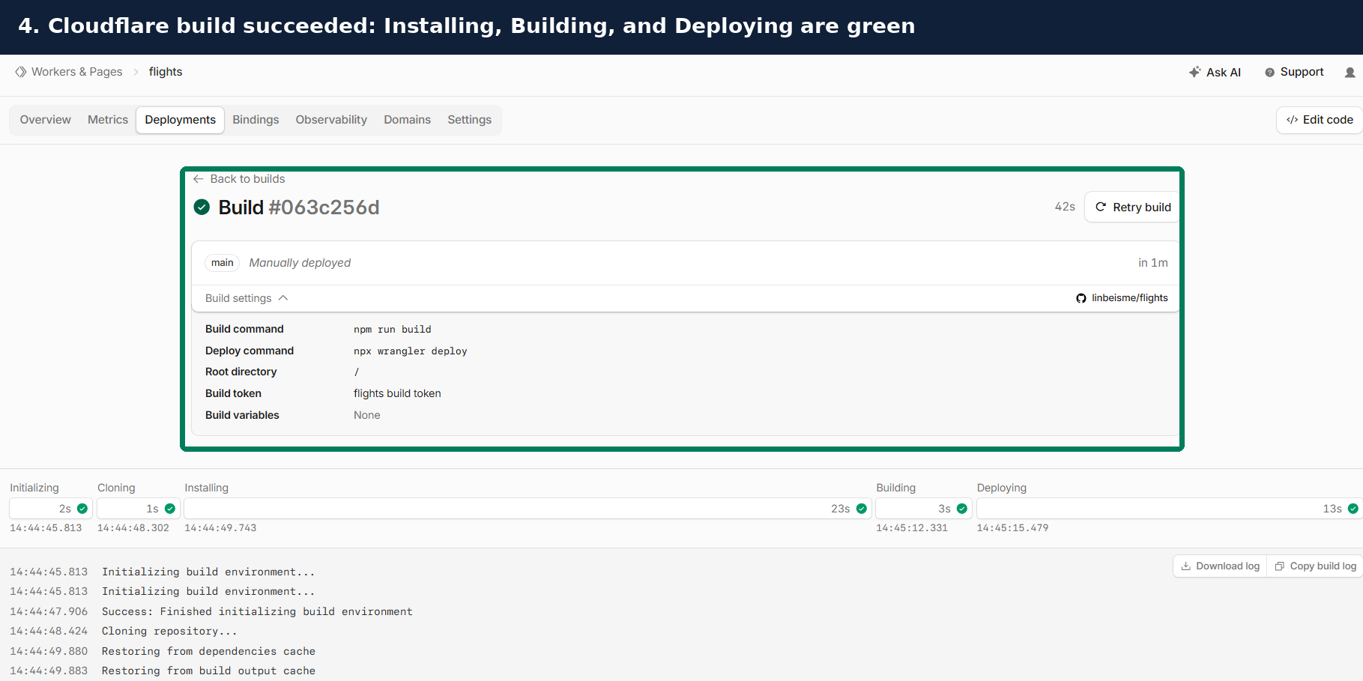
Figure 5. The actual successful Cloudflare build: Installing, Building, and Deploying all completed.
1. Open Cloudflare > Workers & Pages > flights > Deployments.
2. Open the newest build for main.
3. Confirm Build command is npm run build.
4. Confirm Deploy command is npx wrangler deploy.
5. Confirm Root directory is / or blank when package.json is at the repository root.
6. Wait for all build stages to turn green.
A normal push to main should trigger a new Workers Build automatically because the GitHub repository is already connected.

10. Enable and verify the Worker URL
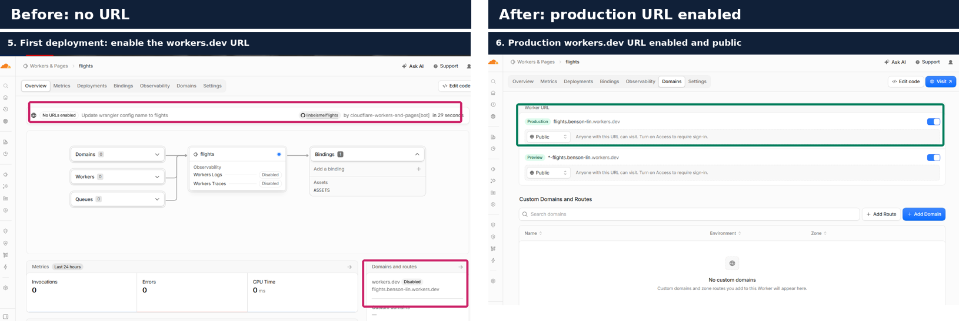
Figure 6. Before and after: the production workers.dev URL is enabled and public.
1. Open the Domains tab.
2. Enable the production Worker URL.
3. Keep access Public unless you deliberately configure Cloudflare Access.
4. Open https://flights.benson-lin.workers.dev.

11. Build secrets versus Worker runtime secrets
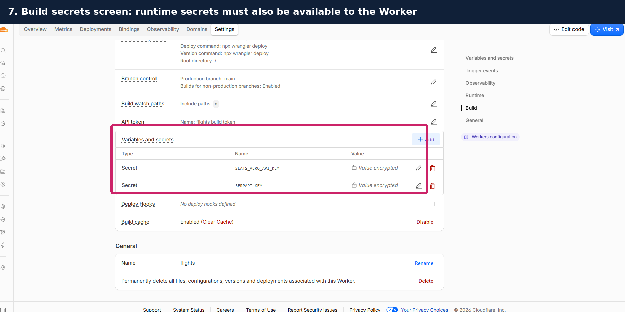
Figure 7. The actual Variables and secrets screen encountered during setup.
Cloudflare dashboard wording can vary. Build variables are available to the build process; the deployed Worker also needs the keys as encrypted runtime secrets. The practical verification is the /api/health response.
Secret name | Required for | Safe verification
SEATS_AERO_API_KEY | Live award search | liveAwardConfigured must be true.
SERPAPI_KEY | Live cash fares | liveCashConfigured must be true.

1. Open Workers configuration or the Worker’s runtime Variables and Secrets area.
2. Add each value as type Secret, not plaintext.
3. Deploy the secret changes.
4. Do not put either value in GitHub or .dev.vars.example.
Normal code updates do not normally require re-entering secrets
When the existing flights Worker is updated rather than recreated, encrypted runtime secrets should remain attached. Re-enter them only if /api/health reports false.

12. If /api/health opens the application instead of JSON
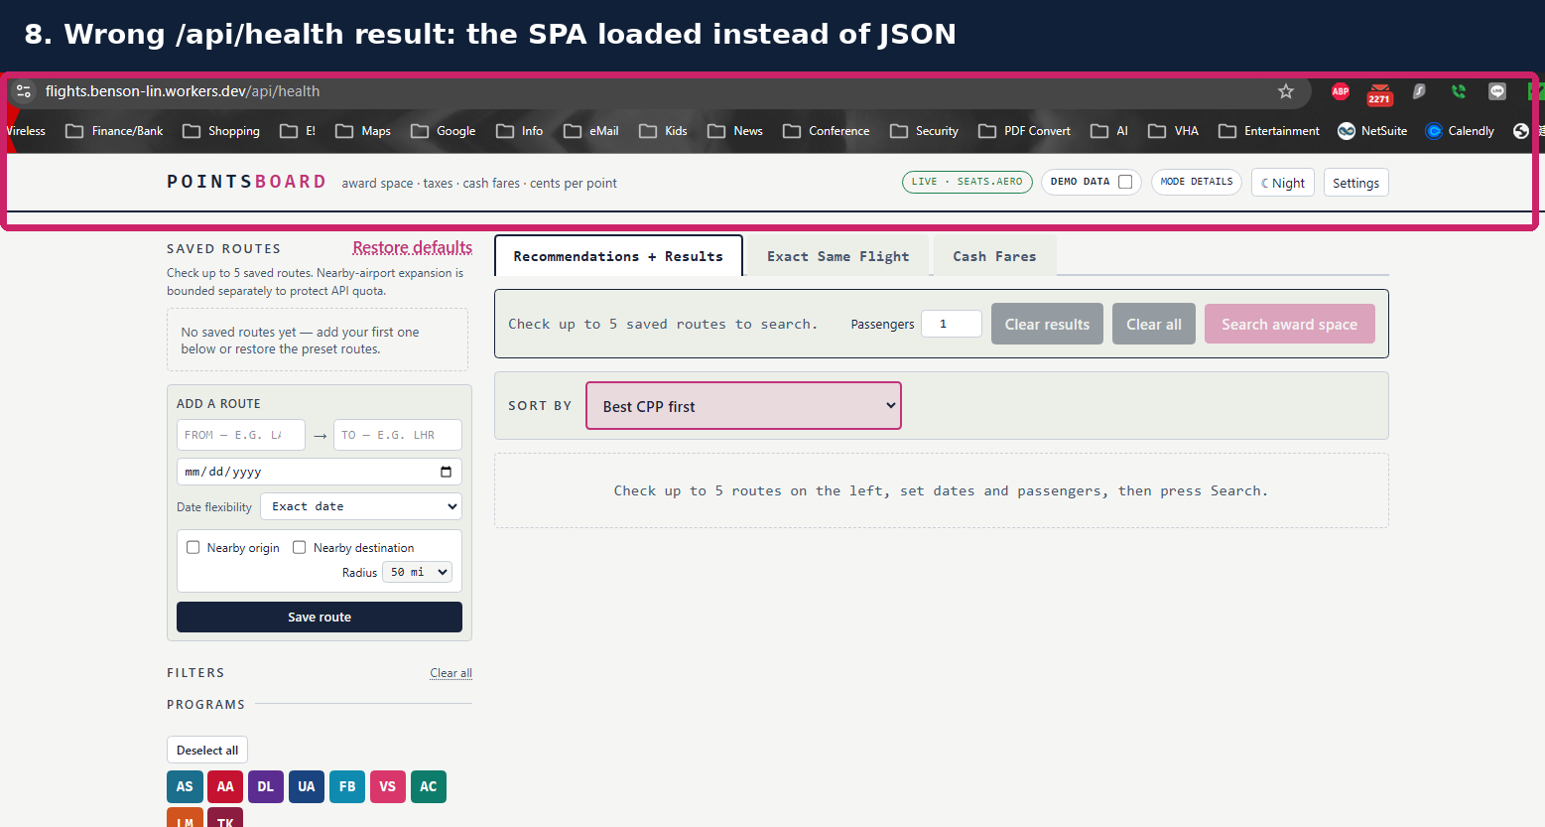
Figure 8. The actual incorrect result: the SPA shell appeared at /api/health.
This occurs when the static single-page-application fallback handles /api/health before the Worker API route. The fix is to run the Worker first for /api paths.

Required wrangler.jsonc routing
{
"name": "flights",
"main": "worker/index.js",
"compatibility_date": "2026-07-01",
"assets": {
"directory": "./dist",
"binding": "ASSETS",
"not_found_handling": "single-page-application",
"run_worker_first": ["/api/*"]
}
}

Commit the correction to main, wait for a new Cloudflare build, and hard-refresh /api/health.

13. Confirm the correct health response
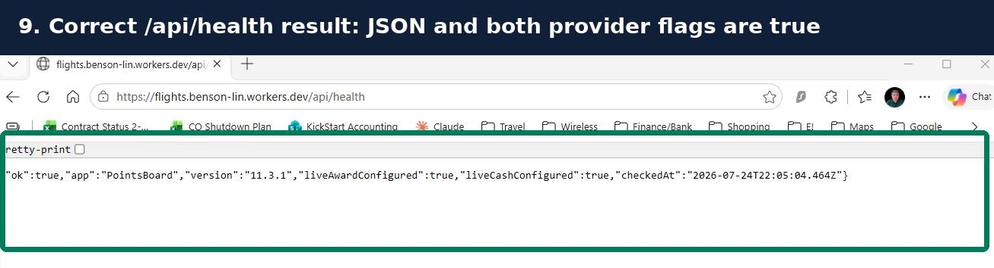
Figure 9. The correct live health response from the deployed flights Worker.
{
"ok": true,
"app": "PointsBoard",
"version": "11.3.2",
"liveAwardConfigured": true,
"liveCashConfigured": true
}

Value | Meaning
ok: true | Worker routing and health handler are operating.
version: 11.3.2 | The updated package is deployed.
liveAwardConfigured: true | The seats.aero runtime secret is available.
liveCashConfigured: true | The SerpApi runtime secret is available.

Stop if a provider flag is false
Correct the corresponding encrypted runtime secret and redeploy before relying on Live mode.

14. Verify the updated recommendation interface

Figure 10. v11.3.2 retains all original filters and adds the new recommendation presentation.
1. Leave Demo data enabled for the first test.
2. Run a pre-built route.
3. Confirm the four decision metrics are inside a light-green block.
4. Confirm the Other qualifying redemptions or not recommended flights section appears when applicable.
5. Apply a filter and confirm recommendations, alternatives, and Exact Same Flight update consistently.
6. Turn Demo off and confirm all Demo rows disappear before a Live search.

15. Use the flight popup and collapsible FX panel
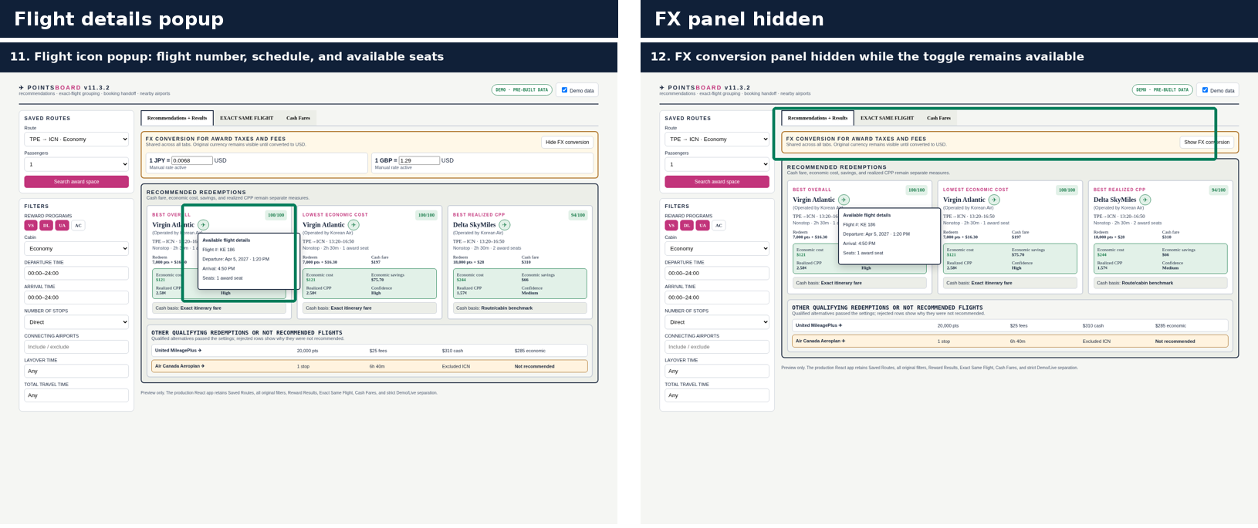
Figure 11. Flight details popup and the same page with the shared FX panel hidden.
The same FX rates apply across Recommendations + Results, Exact Same Flight, and Cash Fares. Original foreign-currency taxes remain visible, and cash-dependent calculations stay unavailable until a valid USD conversion rate is entered.

16. Production smoke test after every update

Demo test
[ ] Pre-built routes load.
[ ] Filters affect Recommendation and Exact Same Flight views.
[ ] Light-green metrics, flight popup, alternatives, and FX toggle work.
[ ] Turning Demo off removes every synthetic row.

Narrow Live test
[ ] Use one route, one date, one passenger, and nearby airports off.
[ ] Confirm results are not labeled Demo.
[ ] Confirm taxes/fees retain the source currency.
[ ] Confirm cash fare is exact, benchmark, or unavailable with provenance.
[ ] Confirm no synthetic cash fare is generated when the provider returns none.
[ ] Confirm booking links and copyable booking details remain available.

Rollback if needed
1. Open Cloudflare > flights > Deployments.
2. Select the prior known-good deployment or redeploy the previous Git commit.
3. Confirm /api/health and repeat the Demo smoke test.
4. Do not delete the Worker or secrets during rollback.

17. Troubleshooting and final checklist
Symptom | Corrective action
Actions page shows setup templates | Create .github/workflows/verify.yml using set up a workflow yourself.
npm test says .gitignore is missing | Create .gitignore at the repository root and commit it.
Cloudflare build cannot find package.json | Use root directory / or blank; package.json must be at repository root.
Worker name mismatch | Keep both Cloudflare and wrangler.jsonc name as flights.
/api/health opens the app | Keep assets.run_worker_first set to ["/api/*"].
Provider flag is false | Add/correct the encrypted runtime secret, then deploy.
FX calculations are blank | Open the FX panel and enter a valid USD rate for the original currency.
Flight popup says not supplied | The provider did not return that field; the app intentionally does not invent it.

Final update checklist
[ ] GitHub flights repository contains all project and hidden files.
[ ] Verify PointsBoard workflow is green.
[ ] Cloudflare flights build is green.
[ ] /api/health reports version 11.3.2 and both provider flags true.
[ ] Demo mode and strict Live mode both pass.
[ ] Recommendation green block, flight popup, FX toggle, and alternatives work.
[ ] One narrow Live search succeeds.

Official references checked July 24, 2026
GitHub - Workflows and .github/workflows
GitHub - Manually running workflow_dispatch workflows
Cloudflare Workers Builds
Cloudflare Workers Build configuration
Cloudflare Worker static-asset routing
Cloudflare Worker secrets

