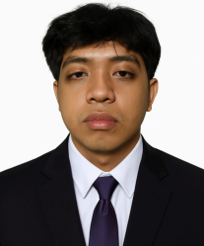

JOHN LLOYD J. MORALES
#117 Ilocos Sur St. Brgy, Ramon Magsaysay, Bago Bantay, Quezon City

OBJECTIVE
To contribute to the company's growth and development and become one of its asssets thru my hard work and determination.

CONTACT

09814690924
johnlloyd morales14@gmail.com

PERSONAL DETAILS

Age: 22 years old
Birthday: May 14, 2003
Birthplace: Oriental, Mindoro
Civil Status: Single
Religion: Roman Catholic
Nationality: Filipino
Height: 5'7
Weight: 56 kgs.

WORK EXPERIENCE

Service Crew
McDonald’s Munoz
(August 2023 - May 2025) Jollibee Bago Bantay
(July 2025 - Present)

Skills
Fast Learner Hardworking
Multi-tasking

EDUCATION

Elementary
Bago Bantay Elementary School
Bukid non St. Brgy. Ramon Magsaysay, Quezon City
2009 - 2015

HighSchool
San Francisco High School
Misamis St. Brgy. Sto. Cristo, Quezon City
2015 - 2019

Senior HighSchool
San Francisco High School
Misamis St. Brgy. Sto. Cristo, Quezon City
2019 - 2021
GAS - General Academic Strand

College
Bestlink College of The Philippines
Quirino Highway Novaliches, Quezon City
2022 - Present
BACHELOR OF SCIENCE IN INFORMATION TECHNOLOGY


I hereby certify that the above information are true and correct to the best of knowledge and belief.

JOHN LLOYD J. MORALES

