The TV-Anytime Forum

Specification Series: S-4
On:
Content Referencing
(Normative)

NOTICE
Use of the technologies described in this specification may infringe upon patents, copyrights or intellectual property rights of Members or non-Members of the TV-Anytime Forum.
Although the TV-Anytime Forum makes a reasonable effort to ascertain the ownership of intellectual property as an aid to the users of its specifications, it is entirely the responsibility of individual users of the specification to obtain all necessary licenses.
Neither the TV-Anytime Forum nor any of its Members accept any responsibility whatsoever for damages or liability, direct or consequential, which may result from use of this specification.

Document: SP004v12
Final Specification, Version 1.2
Date: 28 June 2002

Series Overview
This is the fourth in a series of five “S-series” documents produced by the TV-Anytime Forum. These documents establish the fundamental specifications for the services, systems and devices that will conform to the TV-Anytime standard, to a level of detail which is implementable for compliant products and services.
As is common practice in such standardization efforts, these specification documents were preceded by requirements documents (“R-series”), which define the requirements for the TV-Anytime services, systems, and devices.
Congruent with the structure defined in TV-Anytime’s Call for Contributions (TV014r3), these specifications are parsed into three major areas, each described in a separate document of the series: Metadata (S-3), Content Referencing (S-4) and Rights Management (S-5). See the Call for Contributions for more detail on the derivation and background of these categories and their respective roles in the TV-Anytime standardization process.
The other two documents in the S-series are intended to define the environment and system architecture in which the standards in S-3, S-4, and S-5 are to be implemented. The first document in the series (S-1) provides benchmark business models against which the TV-Anytime system architecture is evaluated to ensure that the TV-Anytime standard enables key business applications. The next document in the series (S-2) presents the TV-Anytime System Architecture. These two documents are placed ahead of the other three for their obvious introductory value; S-1 and S-2 are both informative.
Although each of the S-series documents is intended to stand alone, a complete and coherent sense of the TV-Anytime system standard can be gathered by reading all five of the specification documents in numerical order.
Content Referencing Specification S-4
Document Revision History

Version | Status | Date | Author | Comments
WD 126 | Working draft | 30 May to 1 June 2000 | Content Referencing Working Group | Drafted at the 6th TVAF meeting in New York City
TV050, r0 | First draft of specification | 26 - 28 July 2000 | Content Referencing Working Group | WD126 approved by final plenary as TV050r0 at 7th TVAF meeting in Geneva, Switzerland
TV050, r1 | First revision of specifications document | 29 July – 9 August 2000 | Alex Ashley, Content Referencing Group Editor (Philips) | Final editing by Content Referencing working group
TV050, r2 | Final draft of first revision of specifications document | 9 - 11 August 2000 | Kellie McKeown  (consultant) | Cosmetic editing and formatting
TV050, r3 | Changes to TV050r2 in response to comments. | 26 - 28 September 2000 | Alex Ashley (Philips), Content Referencing Group Editor | Alterations to specification by Content Referencing Working Group in response to comments to TV050r2
SP004 | Version 1 Content Referencing Specification. | 2 - 13 October 2000 | Nigel Earnshaw (BBC), Content Referencing Group Editor | Cosmetic editing and formatting
TV050r4 | Provisional version of V1.1 | 16 February, 2001 | Content Referencing Group | Provisional release V1.1
TV079 | Changes to TV050r4 in response to comments. | 27-30 March, 2001 | Nigel Earnshaw (BBC), Content Referencing Group Editor | Alterations to specification by Content Referencing Working Group in response to comments to TV050r4
SP004V1.1 | Final Version 1.1 Content Referencing Specification. | 2 - 14 April 2001 | Nigel Earnshaw (BBC), Content Referencing Group Editor | Cosmetic editing and formatting
WD459 | Draft version of V1.2 | 4 - 7 December 2001 | Content Referencing Group | Draft release V1.2
WD500 | Provisional version of v1.2 | 29 Jan - 1 Feb 2002 | Content Referencing Group | Provisional release V1.2
TV121 | Released version of Provisional version of v1.2 | 15 February 2002 | Nigel Earnshaw (BBC), Content Referencing Group Editor | Cosmetic editing and formatting
TV121r3 | Release of Second Provisional Version of v1.2 | 5 April 2002 | Nigel Earnshaw (BBC), Content Referencing Group Editor | Minor editing and formatting following group review of 16th meeting
wd574 | Final version of v1.2 | 14 June 2002 | Systems, Transport and Content Referencing Group | Removed RAR binary encoding  Updated XML Schema to match SP003 v1.2
TV121r4 | Final version of v1.2 | 21 June 2002 | Alex Ashley (Philips)  Systems, Transport and Content Referencing Group Joint Chair | Minor editing
SP004V12 | Final specification, v1.2 | 28 June 2002 | Skip Pizzi (Microsoft), TVAF Vice-chair & Supereditor | Minor editing

Table of Contents
Series Overview 2
About the TV-Anytime Forum 7
1. Scope 8
2. Glossary of Terms and Abbreviations 9
3. Conventions of Specification Syntax 11
4. Introduction 12
5. Key Concepts and Features 13
6. Location Resolution 15
7. The Authority 16
8. The CRID 17
9. Locators 18
10. Instance Metadata Identifiers 20
11. The Resolving Authority Record 23
11.1 Contents of Resolving Authority Record 23
12. Protocols for Location Resolution 25
12.1 Common Features and Interfaces 25
12.1.1 Resolution Handler 25
12.2 Location Resolution Over Unidirectional Networks 27
12.2.1 Guidance on use of Resolution Status Flags 29
12.3 Location Resolution Over Bi-directional Networks 30
12.3.1 Generic Bi-directional Resolution Server Discovery 30
12.3.2 Generic Bi-directional Request to Resolution Server 30
12.3.3 Generic Bi-directional Response From Resolution Server 31
12.3.4 Dynamic Behavior of PDR and Location Resolution Server 32
12.3.4.1 Requirements for PDR dynamic behavior 32
12.3.5 TCP/IP Based Resolution Server Discovery 34
12.3.5.1 Internet Service Discovery Query (RFC2782) 34
12.3.5.2 TV-Anytime Location Resolution Service Query 34
12.3.6 TCP/IP Based Request to Resolution Server 35
12.3.6.1 Further Requirements on a PDR HTTP Client. 36
12.3.7 TCP/IP Protocol for Response from Resolution Server 36
12.3.7.1 Case 1: Returning the Result of Resolving CRIDs 37
12.3.7.2 Case 2: Returning an HTTP Re-direct 37
12.3.7.3 Case 3: Returning a Resolving Authority Record. 37
12.3.7.4 Encoding Server Response 37
13. References 38
Appendix A : XML Schema for Content Referencing 39
A.1 Schema Definition 39
A.1.1 Location Resolution Schema 39
A.1.2 Resolving Authority Record Schema 41
A.2 Example Instance Documents 44
Appendix B : Example Dynamic Communication Behavior between a PDR and a Remote Location Resolution Server 46

Figures
Figure 5-1: Content Referencing Environment 13
Figure 8-1: Example of a Tree-Structured CRID 17
Figure 8-2: Examples of CRID 17
Figure 10-1: Examples of Instance Metadata Identifiers 21
Figure 10-2: Example of a resolved CRID 21
Figure 10-3: Example of the same resolved CRID after a change in location identified by “imi:def.com/1” 21
Figure 10-4: Example of an Instance Metadata Identifier with no name portion 21
Figure 10-5: Example of a more complex resolution table 22
Figure 11-1: An example Resolving Authority Record 24
Figure 12-1: CRID Resolution Architecture 25
Figure 12-2: Dynamic Behavior of Resolution Handler using Unidirectional Network 27
Figure 12-3: Example of Location Resolution Server Discovery 30
Figure 12-4: Stages of TCP/IP Based Resolution Server Discovery 34

Tables
Table 12-1: Location Resolution Message Format for Unidirectional System 28
Table 12-2: Interpretation of Status Flags 29
Table 12-3: PDR behavior in response to acquisition directive 29
Table 12-4: Submitted CRID Flag Description 31
Table 12-5: Result Flag Description 31
Table 12-6: Key definitions for HTTP URL encoding 35

About the TV-Anytime Forum
The global TV-Anytime Forum is an association of organizations which seeks to develop specifications to enable audio-visual and other services based on mass-market high volume digital storage in consumer platforms – simply referred to as personal media storage.
The TV-Anytime Forum was formed at an inaugural meeting held in Newport Beach, California, USA, on 27-29 September 1999. It has started work to develop open specifications designed to allow Consumer Electronics Manufacturers, Content Creators, Telcos, Broadcasters and Service Providers to exploit personal media storage.
As part of its formation, the TV-Anytime Forum has established four fundamental objectives for the organization, which are:
- The TV-Anytime Forum will define specifications that will enable applications to exploit persistent personal media storage in consumer electronics platforms.
- The TV-Anytime Forum is network independent with regard to the means for content delivery to consumer electronics equipment, including various DTV delivery mechanisms (e.g. ATSC, DVB, DBS and others) as well as the Internet and enhanced TV systems.
- The TV-Anytime Forum will develop specifications for interoperable and integrated systems, from content creators/providers, through service providers, to the consumers.
- The TV-Anytime Forum will specify the necessary security structures to protect the interests of all parties involved.
Member organizations from Europe, the USA, and Asia, are drawn from a wide variety of industries: Traditional Broadcasters, Internet Broadcasters, Content Owners, Service Providers, Telcos, Consumer Electronics Manufacturers, IT Industries, Professional Equipment Manufacturers, Component Manufacturers and Software Vendors.
The TV-Anytime Forum invites participation from all interested organizations. Membership is open to all who sign the TVAF Membership Agreement. Meetings are held approximately every two months in Europe, the USA, and Asia.
For more information or to get involved with the work of the TV-Anytime Forum, visit the TV-Anytime Forum (www.tv-anytime.org) or contact:

Chair: Simon Parnall (sparnall@ndsuk.com)
Vice-chairs: Wataru Kameyama (wataru@waseda.jp)
Skip Pizzi (skippiz@microsoft.com)
Treasurer: Christian Bertin (christian.bertin@rd.francetelecom.com)

Administrator: Dave Marples (dmarples@inventures.com)
(Tel: +1 925 275 6648)

Scope
The scope of this specification comprises the location independent identification of content, the location information, and the process of finding the location when an identifier is given. The content referencing process begins after a content item has been selected by a consumer through to, but not including, the actual acquisition of the desired content item.
Version 1.0 of the content referencing specification provides the mechanisms for location resolution in unidirectional network environments as defined in Business Model 1 of the TV-Anytime R-1 document. This version of the content referencing specification adds support for location resolution in a bi-directional environment to fulfill Business Models 2 and 3.

Glossary of Terms and Abbreviations

Terms
Acquisition | Retrieval of content
Authority | Organization that creates CRIDs
Capture | Storing the acquired content (e.g., to local storage)
Content | Anything the viewer would like to access (movies, games, TV programs, radio programs, etc.)
Content Creator | Producers of content
Content Provider | Entity that acts as the agent for and is the prime exploiter of the content
Content reference | Pointer to a specific content item
Instance Metadata Identifier | Identifier associated with a locator to bind to an instance metadata description.
Location Resolution | Process of establishing the address (location and time) of a specific content instance from its CRID
Locator | Time and place where a content item can be acquired
Metadata | Generally, data about content, such as the title, genre and summary of a television program. In the context of TV-Anytime, metadata also includes consumer profile and history data.
Resolution Handler | Functional unit that provides location resolution on a specific transport mechanism
Resolving Authority | Body which provides location resolution
Resolving Authority Record | Information needed for retrieving the location resolution data for the given authority
Service Provider | Aggregator and supplier of content which may include gateway and management roles

Abbreviations
CRID | Content Reference Identifier: identifier for content that is independent of its location
DVB | Digital Video Broadcasting: set of standards used for European digital TV broadcasting
DNS | Domain Naming System: system used on the Internet to register names that can then be mapped into IP addresses using a DNS server
EPG | Electronic Program Guide: means of presenting available content to the consumer, allowing selection of desired content
IP | Internet Protocol: generic name for the network protocols used on the Internet
IPR | Intellectual Property Rights
PDC | Program Delivery Control: European system used by some broadcasters to accurately indicate when programs start and stop
PDR | Personal Digital Recorder
SI | System Information: collection of information tables used in DVB
URI | Uniform Resource Identifier
URL | Uniform Resource Locator
UTC | Coordinated Universal Time

Conventions of Specification Syntax

Within this specification, syntax is defined for various textual items.
Items in bold are textual characters that must be used exactly as specified.
Items in <angle brackets and italics> are replaced by a suitable value, which is specified beside the syntax definition.
An item in square brackets ( ‘[ ‘ and ‘] ‘ ) denote optional items. The entire syntax definition within the square brackets can be omitted, subject to the rules specified.
For example a syntax specification of
Hello <name> how are you?
<name> is your name
The correct reading would be to take the text “Hello” and “how are you?” and insert your name between them.
Another example of a syntax specification is
Hello <name> [how are you?]
<name> is your name
The correct reading would be to take the text “Hello” and append your name after it, and then optionally append the text “how are you?”

Introduction
The purpose of content referencing is to allow acquisition of a specific instance of a specific item of content. For example, if a consumer sees an announcement on TV saying “there’ll be a new series of ‘The Agatha Christie Murder Mysteries’ next year,” he/she may want to instruct their Personal Digital Recorder (PDR) to record the whole series, but cannot since he/she does not know when the episodes are going to be broadcast. In fact, the broadcaster may not know yet either. Still the viewer will want to make sure at this point that he/she does not miss the opportunity to acquire the content.
To provide the capability desired by the consumer, the ability is needed to refer to content (in this example a series of programs) independent of its location, whether that location is on a particular broadcast channel on some date and time, or on a file server connected to Internet, or wherever.
In this example, the PDR system would be provided with a reference for the series. In due time, the body who assigned the reference would provide the information required to link this reference to the individual episodes, and subsequently to a specific date and time for each episode so that the PDR would be able to acquire all of them.
This example demonstrates the purpose of content referencing – to provide the ability to refer to content independent of its location, and the ability to subsequently resolve such a reference into one or more locations where the content can be obtained.
Of course, content can refer to many types of information. In addition to the television programs in the example above, it may include radio programs, audio tracks, MPEG-4 objects, scenes, images, music, etc.

Key Concepts and Features
The content referencing process begins after a content item has been selected by a consumer through to, but not including, the actual acquisition of the desired content item. In Figure 4-1 the scope of the content referencing process is shown. Some parts outside the scope of content referencing are included in Figure 4-1 to give it a global context.
Content searching, selection, etc.
Locator
Content
selection
CRID
Location
resolving
Content acquisition
CRID
Locator
Locator
Specific content
Some kind of input
Content Referencing
Locator
CRID
CRID
TV-Anytime application
Locator
Content
selection
CRID
Location
resolving
Content acquisition
Content acquisition
CRID
Locator
Locator
Specific content
Some kind of input
Content Referencing
Locator
CRID
CRID
TV-Anytime application
Content searching, selection, etc.
Content Consuming
Figure 5-1: Content Referencing Environment

In this model we can identify three areas of interest:
- The content selection process resulting in a Content Reference Identifier (CRID).
- The location resolving service – the core of content referencing – resulting in one or more pointers to instances of that content (locators) or one or more content reference identifiers.
- The retrieval process using one of these locators to subsequently acquire the content.
Before the process of content referencing can be employed, a selection process must supply a CRID. This CRID identifies a specific content item, but does not specify where that content item can be found. More detailed characteristics of the content, such as the price, the quality, the presence of commercials, etc., may not be known before the CRID is produced.
Given a CRID, there can still be numerous instances of the same desired content item (for example a broadcast may be repeated, a web site may be mirrored, the content item may be available from different content providers, via different networks, etc.) Some iteration may be required to narrow down the selection.
A content item that a CRID refers to might be a grouping of other content items, for example a CRID for referring to an entire series of programs.
The key concept of content referencing is the separation of the reference to a content item – the CRID – and information that is related to its retrieval.
The separation provided by the CRID enables a one-to-many mapping between content references and the locations of the deliverables.
Content is a general term. It is the context of a TV-Anytime service that determines what content will be delivered upon following a locator. In that sense a content instance is any deliverable that can be acquired (via a respective locator) by a consumer. New types of content delivery merely require new types of locators.
In the same way, it is the TV-Anytime location resolution service provider who declares what can be considered content items (e.g. programs, serials, etc.)
Content referencing, in conjunction with applications and additional metadata, may be able to deliver “first time” success, but may also involve some iteration enabling the overall system to deliver features including:
- Selection between alternatives
- Selection of sub-elements
- Selection between near matches
- Selection of time of delivery
- Selection ahead of time of release
- Selection based on coding quality
- Selection based on cost of delivery chain
- Selection based on acceded rights
- A point of reference – not necessarily unique – for the content item and any associated metadata.
Content referencing is:
- a form of content identification data and a specification for a set of rules for resolving this data into content locations from where this content can be retrieved.
Content referencing is not:
- the selection or retrieval process (it is in between);
- the definition of metadata used in any inquiry.

Location Resolution
Location resolution is the process of translating a CRID into other CRIDs or locators. Location resolution involves mapping a location-independent content reference (the CRID) to its location in time (e.g. scheduled transmission time in a broadcast system) and space (e.g. TV channel, IP address). In the context of this specification, locations in time and space are referred to as “locators.”
The process of location resolution may happen inside the PDR device (for example in a broadcast only system) or using a physically remote server (e.g., a server on the Internet.)

The Authority
An authority, as defined in this specification, is the body that creates a CRID, which they guarantee to be unambiguous. An authority will also provide the ability for the CRID to be resolved into locators or other CRIDs.
The CRID shall ultimately be resolved either directly by the CRID authority or by another party. If another party is providing resolution, the ability to resolve the CRID requires the flow of some information from the authority to the resolution provider, in order to tie the CRID to its resolution.
In most PDR implementations, there will be multiple authorities that the PDR must be able to distinguish between. To distinguish between authorities, each authority has a unique name. This TV-Anytime specification uses the Domain Naming System (DNS) to provide unique names for each authority.
The syntax of an authority name is:
<DNS name><name_extension>

<DNS name> is a registered Internet domain name. (See RFC1591 for DNS name registration[[2]].) The <DNS name> is case insensitive and must be a fully qualified name according to the rules given by RFC 1591.
<name_extension> is an optional string (beginning with a ‘;’ character) to enable multiple authorities to use the same DNS name. All <name_extension> elements which share the same <DNS name> must be unique. The <name_extension> section is case insensitive.
Some example authority names are:
- www.broadcaster.com
- ISP.net
- www.commerce.com;electronics

The CRID
A CRID is the output of the search and selection process and is an unambiguous identifier that refers to a piece of content, however multiple CRIDs may refer to that same piece of content.
It is permissible for a CRID to resolve into one or more other CRIDs. This CRID to CRID functionality can be used for two purposes:
- A CRID can resolve into multiple CRIDs for grouping content items such as an entire series of programs.
- A CRID may also resolve into one or more CRIDs to allow one authority to refer to CRIDs of another authority.
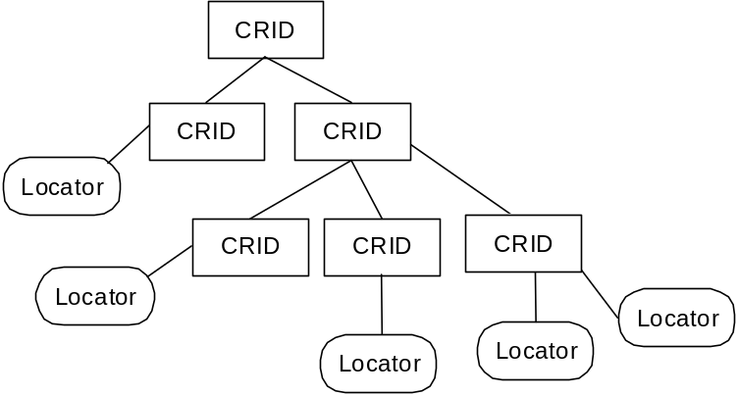
Figure 8-2: Example of a Tree-Structured CRID

The syntax of the CRID is:
CRID://<authority>/<data>

<authority> Uses the TV-Anytime authority naming rules given in section 7 to assure uniqueness.
<data> is a free format string that is Uniform Resource Identifier (URI) compliant, and is meaningful to the authority given by the <authority> field. The <data> portion of the CRID is case insensitive.
In its entirety, the CRID is URI compliant. (See RFC2396 for URI compliance specification [[1]].) As per RFC2396, the CRID:// part of the syntax is case insensitive.
Examples of syntactically valid CRIDs are:
CRID | Description
CRID://company.com/foobar | CRID created by “company.com” authority, with a data part of “foobar”
crid://broadcaster.co.jp;comedy/wibble | CRID created by “broadcaster.co.jp;comedy” authority, with a data part of “wibble”
Figure 8-3: Examples of CRID

Locators
An instance of content may be located on various media such as local storage, live broadcast stream, data broadcast stream, data file on the Internet and data stream via the Internet.
A locator specifies a location, and possibly time of availability, where a content item can be acquired. There will be many formats of locators as there are many different means by which a PDR can acquire content. It is a requirement of a locator to ensure that it is possible for the PDR to parse enough of the locator to be able to decide if it has the ability to use the relevant transport mechanism.
The locator will be parsed and used by media-dependent methods to identify the content location and to acquire the content using the media or transport specific protocol. For example, a DVB locator will contain location parameters for a DVB stream, such as transport stream ID, service ID, table ID and event ID.
The syntax for a locator is:
<transport mechanism>:<transport system specific>

<transport mechanism> shall be unique for each mechanism. The string “CRID” shall not be used as the name for a <transport mechanism>.
<transport system specific> will be defined by the creator of the <transport mechanism>.
In its entirety, the locator is URI compliant. (See RFC2396 for URI compliance specification [1].)
For each <transport mechanism>, there will be only one format for the syntax of the <transport system specific> section.
The <transport system specific> section shall provide the following information:
- Location – This provides the location where the content can be acquired. It is possible that a PDR can receive content from many different providers which all share the same <transport mechanism>. For this reason, it is a requirement of a TV Anytime locator that it is unambiguous between multiple providers using the same <transport mechanism>.
- Type of availability – It is possible that some schemes will be used for both schedule-based and on-demand acquired content. Content that is available at a specific time at a specific location (e.g., a broadcast TV program, a web–cast) is schedule based. Schedule-based content must be retrieved at the time given by the locator. Content that can be received at any time between two limits (e.g. content that is on a server for one month) is on-demand based. On-demand based content can be acquired at any time that it is available.
For schedule-based content:
- Start time – This provides information about when the content is scheduled to start. It is required that start time be unambiguous with respect to local time zone as a PDR may be able to receive content from many different time zones.
- Duration of content – The length in time of the content.
For on-demand content:
- Start of availability – This optional field, when present gives the first moment in time when the content is available. This time shall be unambiguous in terms of time zone as a PDR may be able to receive content from multiple time zones.
- End of availability – This optional field gives the first moment in time that the content will become unavailable. This time shall be unambiguous in terms of time zone as a PDR may be able to receive content from multiple time zones.
In defining a syntax for the <transport system specific> section of a locator associated with a <transport mechanism>, there is an assumption about the environment the PDR exists within. For each <transport mechanism> a PDR will need a certain amount of information in order to receive content from this system. This information may be provided within the transport mechanism, or by any other means appropriate to the target PDR.
As an example of the information within the environment, a PAL Western European locator might use the network and channel identifier within its syntax. The mapping of network and channel identifier to a physical channel uses information carried in the vertical blanking interval.
The transport mechanism may provide a more accurate timing system than the start time, which the PDR may decide to use for accurate content capture (e.g. PDC information, DVB event IDs.)

Instance Metadata Identifiers
The TV Anytime metadata specification SP003 v1.2 provides the ability to describe specific instances of content. Whilst TV Anytime created the CRID for location independent selection of content, it recognises that there will be occasions where the consumer may wish to acquire a location dependent version of a piece of content.
To enable this scenario, an optional identifier may be assigned to each locator, and may be signalled in the instance description metadata. When the location of the content changes the locator might change, but the instance metadata identifier will not change.
An instance metadata identifier is only guaranteed to be unique within the scope of the CRID to which it has been assigned. It is permissible to assign the same identifier to different CRIDs.
A PDR may use the instance metadata identifier to track changes in the location of an instance of a piece of content. A PDR will need to use both the CRID and the identifier to track changes (as opposed to just the identifier) because the identifier is only guaranteed to be unique within a given CRID.
The identifier can also be used to link the instance description metadata with the information retrieved by the location resolution process.
Each instance metadata identifier will need to be unique within the scope of a given CRID. In order to enable multiple parties to provide instance identifiers, it is a requirement for every instance metadata identifier to begin with a name that is guaranteed to be unique. To ensure that this name is unique, it must be a registered Internet domain name. (See RFC1591 for DNS name registration[[2]].) The name portion of an instance metadata identifier specifies the body that created the instance metadata identifier.
For a given instance identifier creator, there shall be only one instance metadata identifier per CRID – locator pair.
The syntax of an instance metadata identifier is:
imi:[<name>/]<data>

<name> is a registered Internet domain name. (See RFC1591 for DNS name registration[[2]].) The <name> is case insensitive and must be a fully qualified name according to the rules given by RFC 1591. If the <name> portion of an instance metadata identifier is the same as the authority name of the CRID, the name and the forward slash may be omitted.
<data> is a free format string (with the exception that the forward slash character is prohibited) that is Uniform Resource Identifier (URI) compliant, and is meaningful to the body specified by the <name> field. The <data> portion of the instance metadata identifier is case insensitive.
Examples of syntactically valid instance metadata identifiers are:
Instance Metadata Identifier | Description
imi:company.com/foobar | Instance metadata identifier created by “company.com” , with a data part of “foobar”
imi:broadcaster.co.jp/broodjeham | Instance metadata identifier created by “broadcaster.co.jp” , with a data part of “broodjeham”
imi:meaning | Instance metadata identifier created by the CRID authority (the <name> portion of the instance metadata identifier was omitted, therefore the CRID authority is used), with a data portion of “meaning”
Figure 10-4: Examples of Instance Metadata Identifiers
It is optional for location resolution information to contain instance metadata identifiers. Therefore a PDR shall not assume that these identifiers are always available in its acquisition procedures.
The following example demonstrates the use of an instance metadata identifier to track the change in location of a piece of content.

CRID | Locator | Identifier
crid://example.net/abc123 | dvb://123.5ac.3be;3e45@2001-12-07T12:00:00.00+01P02:10 | imi:def.com/1
crid://example.net/abc123 | ftp://example.net/mirror/def123.mov | imi:def.com/2
Figure 10-5: Example of a resolved CRID

CRID | Locator | Identifier
crid://example.net/abc123 | dvb://123.5ac.100;1e4a@2001-12-07T15:00:00.00+01P02:10 | imi:def.com/1
crid://example.net/abc123 | ftp://example.net/mirror/def123.mov | imi:def.com/2
Figure 10-6: Example of the same resolved CRID after a change in location identified by “imi:def.com/1”

In the following example the name portion has been omitted from the instance metadata identifier, because it is the same as the name of the CRID authority. In this example, the identifier “imi:1” is equivalent to writing “imi:example.net/1”.

CRID | Locator | Identifier
crid://example.net/abc123 | dvb://123.5ac.100;1e4a@2001-12-07T15:00:00.00+01P02:10 | imi:1
crid://example.net/abc123 | ftp://example.net/mirror/def123.mov | imi:2
Figure 10-7: Example of an Instance Metadata Identifier with no name portion

The following table shows a more complex set of permissible combinations of CRID and instance metadata identifier.

CRID | Locator | Identifier | Note
crid://example.net/abc123 | dvb://123.5ac.100;1e4a@2001-12-07T15:00:00.00+01P02:10 | imi:1 | 1
crid://example.net/abc123 | ftp://example.net/mirror/def123.mov | imi:2 | 1
crid://example.net/je98 | dvb://123.6ef.200;5e23@2002-01-31T14:20:00.00+01P00:30 | imi:mdprov.com/01 | 2
crid://example.net/je98 | dvb://123.6ef.200;1c24@2002-02-14T14:20:00.00+01P00:30 | imi:mdprov.com/02 | 2
crid://example.net/ja90 | dvb://2a3.faa.100;8ee9@2002-01-29T01:20:00.00+01P01:30 | imi:mdprov.com/01 | 3
crid://example.net/ja90 | dvb://c01.ad3.400;003c@2002-02-14T18:00:00.00+01P01:00 | imi:mdprov.com/02 | 3
crid://broadcaster.co.uk/0203 | dvb://c01.ad3.400;003c@2002-02-14T18:00:00.00+01P01:00 | imi:1 | 4
crid://broadcaster.co.uk/0203 | dvb://c01.ad3.400;003c@2002-02-14T18:00:00.00+01P01:00 | imi:mdprov.com/01 | 4
Figure 10-8: Example of a more complex resolution table
- Resolution for CRID “crid://example.net/abc123” with two instance metadata identifiers. No name is provided for the instance metadata identifier, therefore the CRID authority of “example.net” is used.
- Resolution for CRID “crid://example.net/je98” with two instance metadata identifiers. In this example an instance metadata identifier provider of “mdprov.com” has been specified.
- The same as the previous two examples, showing the resolution of a CRID to two locators with associated instance metadata identifiers. Note that this example uses the same instance identifiers as the previous example. The instance identifiers are disambiguated by the CRID.
- This example shows two different instance metadata identifiers being assigned to the same CRID and locator. This is only allowed because the identifiers are from different identifier providers.

The Resolving Authority Record
The resolving authority record (RAR) is an essential element in the location resolution process for both the unidirectional and bi-directional networks. It provides the information needed for retrieving the location resolution data for a given authority.
Each resolution authority will require one or more resolving authority records to exist in the PDR for location resolution to take place. Each resolving authority record will need to be placed inside some sort of transport specific container, which allows the PDR to know that this is a resolving authority record.
In the case of multiple records for the same authority, for each location resolution to be done, the PDR can choose to use any of them.

Contents of Resolving Authority Record

compliant authority record has the following structure:

This specification does not define a transmission format for the RAR in uni-directional networks. This specification does however define the information that must be carried by the encoded RAR. A transmission format is specified for the bi-directional content referencing process over TCP/IP, which is given in section 12.3
A TV Anytime compliant RAR shall contain at least the following items of information:
Resolution Provider -- The name of the body that is providing location resolution. It is possible that different bodies are providing location resolution for a single authority, for example a broadcaster might be providing a secondary resolution service for a content creator. These different location resolution providers need to be able to identify themselves for such purposes as updating their resolving authority records. The name of the resolution provider follows the naming rules given in section 7.
Authority name -- The name of the TV-Anytime CRID authority as described in Section 7.
Class -- The class field defines whether this authority record defines a resolution authority that can resolve all CRIDs for this authority name (class = primary) or only resolves some CRIDs for this authority name (class = secondary.) The reason for providing secondary resolving authority records is to allow one resolution provider to provide a partial resolving service for a content referencing authority. An example of this is a broadcaster providing partial resolution of another authority (such as the content creator) for the content they broadcast.
Version number -- A number that is incremented each time the resolution provider wishes to update its resolving authority records for a given authority name. The set of authority records the PDR should update is based on the combination of the authority name and the resolution provider. When a new version number is received for an authority by a resolution provider, all old resolving authority records for this authority name and resolution provider combination will be discarded by the PDR. When the version number reaches 2³²-1, the next version number shall be zero. Tables are considered equivalent if they have the same values of Resolution Provider, Authority name, version number and URL.
URL -- The location where resolution information can be found. The URL could point to a broadcast stream, or to a server on the Internet or any other place where location resolution information can be found. The syntax of the URL is that of the locator as given in section 9.
First valid date -- The first date when this authority can be used, in a form that is unambiguous with respect to timezone.
Last valid date -- The first date when this authority cannot be used, in a form that is unambiguous with respect to timezone.
The reason for providing start and end dates for resolution is so that resolution providers can move their resolution URLs and be sure all PDRs have switched to the new URL once the last valid date of the old resolution record has passed.
Weighting – The weighting field is used to give a hint to the PDR as to the order to try multiple records for an authority from the same resolution provider by providing the largest weighting number to the URL that should be tried first. The weighting field is only used to provide ordering between resolution provider records for the same combination of resolution provider and authority name and not for ordering one provider over another.

Field Name | Contents
Class | Secondary class
Weighting | 1
First valid date | 9:30am 26 September 2000
Last valid date | 6:00pm 28 November 2000
Resolution Provider | tva.resprov.com
Authority name | autnam.com
URL | http://www.resprov.com/lr/autnam
Figure 11-9: An example Resolving Authority Record

Protocols for Location Resolution

Common Features and Interfaces
This section defines the features common to location resolution using unidirectional or bi-directional networks. It is included here to provide a context for the details that follow in sections 12.2 and 12.3, and provides the descriptions of the terms that will be used in these sections.

Resolution Handler
In the TV-Anytime environment, content referencing services can be delivered through various delivery systems such as IP networks or broadcast TV. Figure 12-10 shows the concept of a modular resolution system, with multiple resolution handlers as required for specific location resolution transport mechanisms.

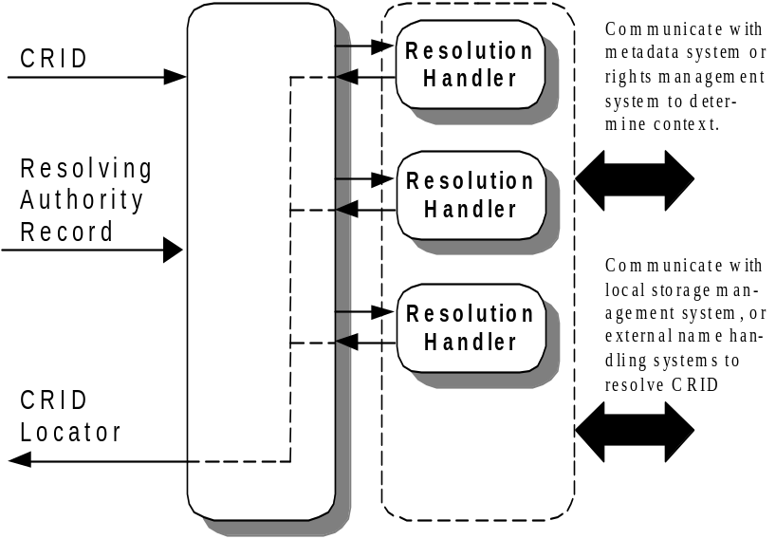
Figure 12-10: CRID Resolution Architecture
Figure 12-10 provides a network-transparent method for resolution, with multiple resolution handlers providing the network and protocol-dependent CRID resolution. For example, one resolution method is resolving CRIDs locally, by co-operating with the local storage management system to resolve the location of the locally stored content. Another resolution system might resolve a CRID using external name handling systems via a back channel or an Internet connection. Another system may refer to System Information (SI) tables, which contain mapping tables between CRIDs and locators and are transported in a digital broadcast stream.
It is envisaged that the resolution handler is an extensible resolution mechanism so that in the future when a new location resolution transportation method is developed, it is possible to extend the resolution process by implementing and plugging in a new resolution handler.
Steps in the content referencing process are now summarized.
- The CRID is used to decide which resolution handlers to invoke to resolve this CRID.
- The resolution request is forwarded to the appropriate resolution handlers.
- Each chosen resolution handler tries to resolve the CRID into locators or another set of CRIDs. The resolution process depends on the implementation of resolution handler. As part of this resolution process, the resolution handler may need to communicate with an external system. Some example processes between a resolution handler and an external system are:
  - Resolve the CRID using a mapping table located in the PDR. This method is appropriate for locally recorded contents or cached information from broadcast or IP networks.
  - Resolve the CRID using the broadcast stream.
  - Resolve the CRID via Internet or back channel.

Location Resolution Over Unidirectional Networks
This section of the specification defines the common features of resolution handlers that work with unidirectional networks. Each resolution handler using a unidirectional network will have a dynamic behavior similar to the one given in the flow chart Figure 12-11.

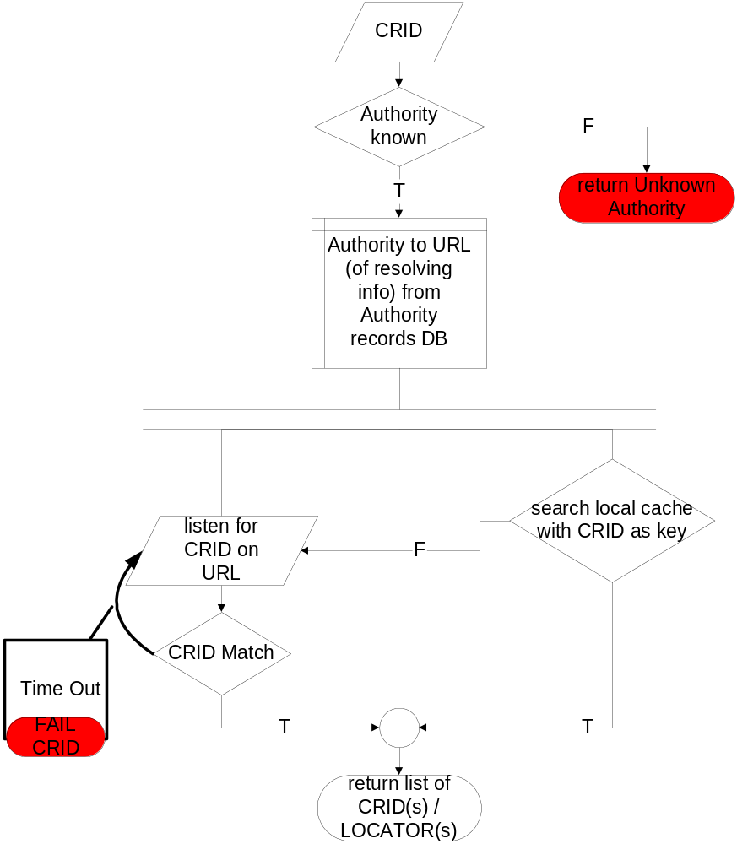
Figure 12-11: Dynamic Behavior of Resolution Handler using Unidirectional Network
The first step of location resolution in a unidirectional system is for the PDR to learn where it can receive location resolution information. This location is provided by the resolving authority record, which will need to be broadcast to the PDR at some known location. Failure to find any authority records for the given CRID’s authority will result in a failure to resolve CRIDs created by that authority.
Once this resolving authority record has been located, the PDR will know where to listen for location information for the given CRIDs’ authority (by using the URL field of the appropriate authority record.)
The PDR will have to choose one or more resolution handlers to use for resolving the desired CRID, as it will need to pick the resolution handlers that can understand the protocols used to carry the location resolution information. An example of this choice is the PDR choosing the DVB resolution handler if the resolution record says that resolution information is being sent on a DVB transport stream.
It is likely that a PDR implementation will also use the local resolution handler in case the content the CRID refers to is already available locally.
The information that will be sent in the unidirectional location resolution stream shall be in the form of a table that consists of CRID to message mappings. Each input CRID will output to a message that shall contain a status field. When the status field contains a value to indicate that the input CRID is valid, the message shall contain one or more CRIDs, or one or more locators.
A TV-Anytime compliant unidirectional location resolution stream shall contain a stream of matched pairs of:
CRID | Message

Each message shall at least contain:
Field | Description
Status | “CRID is resolved” (resolution list follows)  “discard CRID” (E.g. CRID is no longer valid)  “resolve after date <xxx>” (keep CRID, try later)
If Status = CRID is resolved:
Field | Description
Acquisition directive | “all” (all items of the following list must be acquired)  “any” (any item from the following list may be acquired as they are alternative locations for the same content)
A list of CRIDs or  a list of Locator(s) | CRIDs will conform to the syntax given in section 8  Locators will conform to the syntax given in section 9  Optionally, each locator can have an associated instance metadata identifier
Resolution complete | Is the list complete?  yes (CRID is completely resolved)  (e.g. This is the last episode of the series)  no (CRID might resolve into more items at a later date)
Re-resolution date | Date after which the PDR should attempt to re-resolve the CRID. This field is only meaningful when the Resolution Complete flag is set to “no”. This date shall be unambiguous with respect to timezone
If Status = ‘Resolve after date’
Field | Description
Date | The date and time on or after which the PDR should try to re-resolve the CRID. This field shall be unambiguous with respect to timezone.
Table 12-1: Location Resolution Message Format for Unidirectional System

The following table describes the acquisition behavior of a PDR in response to the status flags
Acquisition Directive | Resolution Complete | Description
All | No | Acquire all items in list and await further items.
All | Yes | Acquire all content items, after which acquisition of this CRID is complete.
Any | No | Select any of current item list (after which the acquisition is complete) or await additions to list.
Any | Yes | Select any one of the list items after which the acquisition is complete
Table 12-2: Interpretation of Status Flags

Guidance on use of Resolution Status Flags
CRIDs that when resolved translate into one or more CRIDs, with the acquisition directive of “all” and have the resolution complete flag set to “no” can be used for grouping of content that changes over time, for example a TV series. Such a group CRID may continue with its resolution complete flag set to “no” for a long period of time if the series has no planned end. It is permissible for a PDR to allow the user to view the content the PDR has acquired for this incomplete group CRID.
A CRID that resolves into one or more locators should not be used for an ongoing group (such as a series) as the PDR will assume that when the acquisition directive is set to “all” it must acquire all the parts of the content specified by the list of locators before that content is fully acquired, and hence viewable by the user.

Resolution type | Acquisition directive | Description of PDR behavior
CRID to CRID(s) | All | All result CRIDs should be acquired. Each result CRID can be considered either as its own content item or as part of the group.
CRID to CRID(s) | Any | Any of the result CRIDs can be acquired as they are considered equivalent by the authority that created this CRID.
CRID to Locators(s) | All | All items must be acquired before the content is complete. It is an implementation choice as to whether a PDR will allow viewing of incomplete content.
CRID to Locators(s) | Any | Select any one of the locators as they are considered equivalent by the authority that created this CRID.
Table 12-3: PDR behavior in response to acquisition directive

It is an implementer’s option as to whether the PDR will always go to the unidirectional stream for location resolution, or provide some local caching mechanism. This caching mechanism might be to cache resolved CRIDs, or to cache the unidirectional stream in case it is needed later. This cached information might be used by the resolution handler that handles the unidirectional stream or by creating another resolution handler that uses locally cached data.

Location Resolution Over Bi-directional Networks
In order for a PDR to use the location resolution services over bi-directional networks it is necessary to define a protocol to allow the PDR to initiate a connection and then transfer requested data between itself and a resolution service located at a remote server.
This section specifies how a PDR can discover the location of such a server on a bi-directional network and the TVA protocol to achieve the appropriate TV-Anytime data transfers over such a network.
This section does not specify how content is retrieved over a bi-directional network.

Generic Bi-directional Resolution Server Discovery
This discovery stage may not be required by all network implementations.
Given a CRID to resolve, the first step is to find a server that might be able to resolve this CRID. The process of server discovery is based on using the authority name from the CRID.
This specification makes the assumption that the CRID the PDR has been asked to resolve is from an authority completely new to the PDR, so that it has no prior knowledge of where to get this CRID resolved. In an actual implementation there may be some sort of caching of previous server discoveries, but the exact nature of this caching is implementation specific.
In the following example, an intermediate server is contacted to discover the address of the location resolution server.
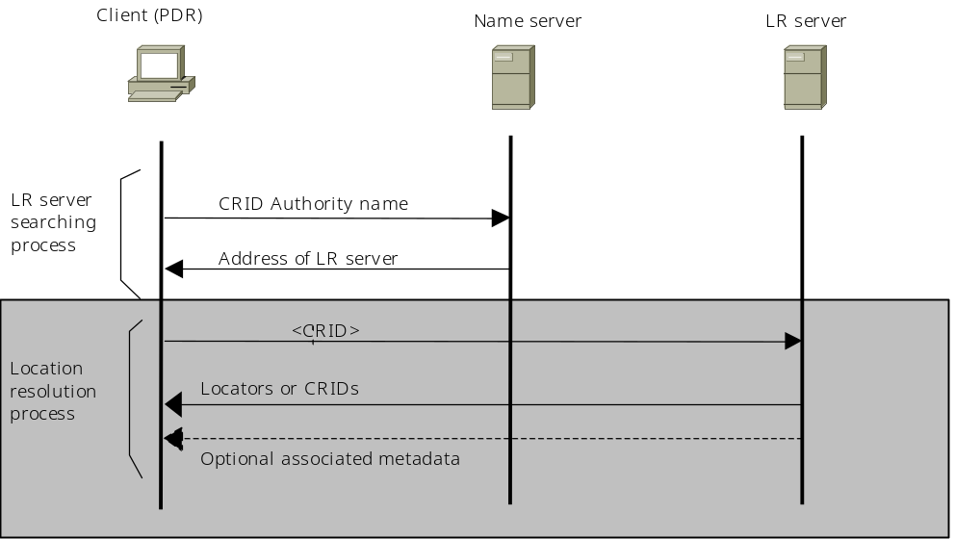
Figure 12-12: Example of Location Resolution Server Discovery

Generic Bi-directional Request to Resolution Server
Once the resolution server has been discovered, the next step is to communicate with this resolution server. The inputs to the server will be a list of one or more CRIDs to resolve, and optional flags to specify how the response should be created.
The TV Anytime defined optional flags are:
- SubmittedCRID
- Result

Value of SubmittedCRID flag | Description
0 | No descriptive metadata about the CRIDs being submitted shall be returned with the resolution information.
1 | Instances of the ProgramInformationTable or GroupInformationTable schemas shall be returned which describe the submitted CRIDs, if the location resolution server has this information.
All other values | Reserved
Table 12-4: Submitted CRID Flag Description

Value of Result flag | Description
0 | No descriptive metadata about the results from the location resolution shall be returned with the resolution information.
1 | If the submitted CRID resolves into further CRIDs, instances of the ProgramInformationTable or GroupInformationTable schemas shall be returned for each resolved CRID, if the location resolution server has this information.  If the submitted CRID resolves into locators, instances of the ProgramLocationTable schema shall be returned for each locator, if the location resolution server has this information.
All other values | Reserved
Table 12-5: Result Flag Description
If any of the optional flags are not present they are assumed to have a value of zero.

Generic Bi-directional Response From Resolution Server
The resolution server will respond with one of three possible types of information:
- The result from resolving the CRID. The response will contain instance(s) of XML schemas defined in the TV Anytime Metadata specification SP003 [[7]] and in Appendix A of this specification. The permitted response schemas are listed later in this section.
- A Resolving Authority Record (RAR). The PDR should store this RAR using the rules given in the unidirectional model, and then contact the server given by the URL field of the RAR
- A re-direct. The resolution server will return a message that gives the address of another location resolution server to contact.
In case (1) and case(3) where a PDR does not receive a RAR, the PDR shall assume the location resolution server is a primary class server, and follow the appropriate rules given in this specification for primary class resolution servers.
The permitted instantiated elements of the XML schemas defined in SP003 [[7]] and in Appendix A of this specification are:
- GroupInformationTable
- ProgramInformationTable
- ProgramLocationTable
- ContentReferencingTable

When an XML instance document is returned by the location resolution server, an instance of a ContentReferencingTable that contains CRIDResult or LocationsResult for each CRID submitted shall be returned. When indicated by the SubmittedCRID and Result flags, instances of GroupInformationTable, ProgramInformationTable and ProgramLocationTable may also be returned.
The results may be returned in any order the location resolution server desires and not necessarily the order in which the PDR specified in the request to the server.

Dynamic Behavior of PDR and Location Resolution Server
For the case where the PDR is connected to a bi-directional network there is a need to specify some aspects of the dynamic behavior of location resolution requests in a TV Anytime compliant PDR. This is required in order to avoid large numbers of PDRs all trying to contact the same location resolution server at the same moment in time.
As well as a PDR having a prescribed manner to avoid excess loading of a location resolution server, it is advisable that a location resolution provider takes certain steps in their implementation to aid the reduction of large instantaneous loads on their servers. When a server returns a response that indicates a CRID should be resolved again at a future date, it is advisable for the server not to return the same time and date information to all clients requesting this CRID, as they will then all try to contact the server at the same moment in time.
It should be noted that a PDR, in addition to receiving location information from a bi-directional network, might also be receiving information from one or more broadcast networks. When receiving information from a broadcast chain, there is the potential for many PDRs to all receive the same time and date for re-resolution.
In order to reduce the effect of instantaneous server loading, the PDR will need to implement a dynamic behavior that does not cause overloading of a location resolution server by frequent repeated access to the same server.

Requirements for PDR dynamic behavior
      - When the date and time for re-resolution arrives, the PDR shall wait a further random amount of time before contacting the location resolution server. This is required in order to reduce the chances of the location resolution server being swamped by many PDRs contacting it at the same moment in time.
      - If the location resolution server returns a re-resolution time and date that is in the past, the PDR shall wait a random amount of time before contacting the location resolution server again.
      - If the location resolution server is unavailable, the PDR shall assume the response for the CRIDs being resolved is “resolve again at a later date”. The date and time at which to re-resolve is based on the current date and time plus a random amount of time.
      - When a location resolution server returns information to specify that the CRID is unknown and this location resolution server is a secondary class server, and the PDR wishes to try this server again, the PDR shall wait a random amount of time before trying again.
      - When a location resolution server returns information to specify that the CRID is unknown and this location resolution server is a primary class server, the PDR should cease trying to resolve this CRID as it will never be resolvable.
      - The random time interval generator algorithm inside a given manufacturer’s PDR should not be configured in such a manner that all their PDRs have identical random time interval sequences. Testing compliance to this requirement is not specified in this document.
      - The standard deviation of the random time interval generator shall be at least 10 minutes. Testing compliance to this requirement is not specified in this document.
Appendix B describes a candidate for the dynamic behavior of the PDR when communicating with a remote location resolution server.

TCP/IP Based Resolution Server Discovery
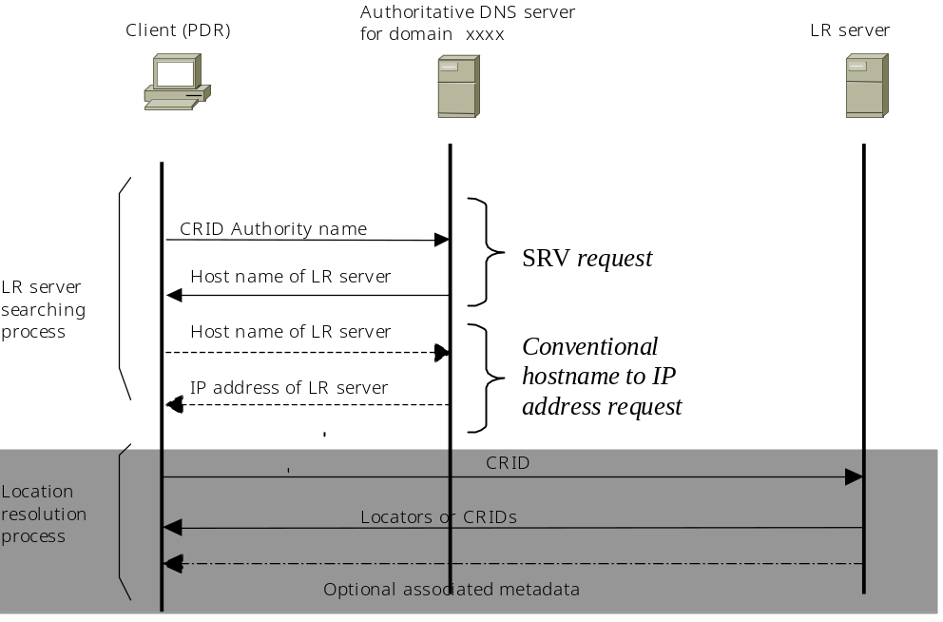As the <DNS name> part of the authority name is a name that is a registered Internet domain name, the mechanisms defined for DNS name lookup can be used as part of the server discovery phase.
Figure 12-13: Stages of TCP/IP Based Resolution Server Discovery

Internet Service Discovery Query (RFC2782)
RFC2782 [[5]] provides an expansion of the DNS [[2]] system that is used to allow Internet connected machines to find mail servers. In addition to being able to search for mail exchange (MX) records, it is also possible to search for service (SRV) records.
An RFC2782 compliant query is made up of several parts, namely:
_Service._Protocol.Name
For example a query for an HTTP server for example.com would be “_http._tcp.example.com”. The DNS server will respond with the host name and port number corresponding to the network location at which the requested service can be found. In the previous example, the return might be “webserver2.example.com on port 80”.

TV-Anytime Location Resolution Service Query
The name for the TV Anytime location resolution service is “lres” which is a shortened version of “location resolution”. The use of a shortened name is adopted, as there is a limit of 512 characters for a DNS response in some DNS client implementations.
The complete query name will look like:
_lres._tcp.<name_extension segment from CRID authority>.<DNS segment from CRID authority>

For example, given the CRID “crid://example.com;europe/9afc2”, the query string would be “_lres._tcp.europe.example.com” which would be sent to a DNS server that provides lookups for “example.com”.
Another example, this time without a name_extension segment in the authority name, would be: given the CRID “crid://example.co.uk/9afc2”, the query string would be “_lres._tcp.example.co.uk” which would be sent to a DNS server that provides lookups for “example.co.uk”.

TCP/IP Based Request to Resolution Server
The protocol for sending a request to the location resolution server is based on the HTTP protocol [1]. The format of the query string shall follow that generated by the submission of an HTML form using a GET request:
http://<Path_to_server_script>?[key=value]&[key=value]
where the key/value pair is repeated as required. The key is case sensitive and shall be represented using the exact case given for each key as specified in this section of the specification.
The precise specification for encoding the key-value pairs into the HTTP URL is given in section 17.13 of the HTML 4 specification [[6]]. It is the option of the location resolution service provider to implement this service using any server side technology they wish (CGI scripts, java servlets etc).
Each key shall be one of:
Key | Description | Allowable value
CRID | The CRID to resolve | A CRID inside quotes
SubmittedCRID | Used to specify whether metadata on the CRID being resolved is desired. See Section 12.3.2 for semantics of this flag. | A number. See Section 12.3.2 for allowed values.
Result | Used to specify whether metadata is required for each of the results from resolving this CRID. See Section 12.3.2 for semantics of this flag. | A number. See Section 12.3.2 for allowed values.
Table 12-6: Key definitions for HTTP URL encoding

It is permissible to resolve multiple CRIDs in one HTTP request by using multiple “CRID” keys in the URL, but the “SubmittedCRID” and “Result” keys may only be specified once in a request as they affect all CRIDs being resolved.
For the first connection to a location resolution server after the DNS based server location phase, the <path to server> is the hostname, a colon character, the textual representation of the port number followed by a slash. If the port number is 80, the colon and port number may be omitted.
For example, if the DNS server returned host name “computer2.example.com” on port 1234, the <path to server> would be
computer2.example.com:1234/
When a location resolution server provides a re-direct using an HTTP redirect, the <path to server> is the URL returned by the “Location” header of the HTTP redirect response.

For example, if the HTTP response was
Location http://redirect.example.com/tva/lr
The <path to server> would be
redirect.example.com/tva/lr
When a location resolution server provides a re-direct using the RAR, the <path to server> is the URL field from the RAR.
For example, if the URL field of the RAR contained the value
http://kaas.example.nl/scripts/resolution.cgi
the <path to server> would be
kaas.example.com/scripts/resolution.cgi

Examples of valid complete URLs are:
http://computer2.example.com:1234/?CRID=”crid://example.com/abc123”
http://broadcaster.com/?CRID=”crid://broadcaster.com/abc123”&CRID=”crid://broadcaster.com/def456”
http://kaas.example.com/scripts/resolution?CRID=”crid://example.com/abc123”&Result=1
http://redirected.example.com/tva/lr?CRID=”crid://example.com/abc123”&SubmittedCRID=1

Further Requirements on a PDR HTTP Client.
The PDR shall at least implement the HTTP v1.0 specification [[3]] for issuing a GET request to the server. In addition to the requirements of HTTP v1.0, the PDR shall also send the HTTP v1.1 header of “host” and the HTTP v1.0 header “user-agent”.
The HTTP client in the PDR shall support at least the following MIME type:
- text/xml

E.g. the HTTP client will need to send an accept command with at least the following components:
Accept: text/xml
In order to permit the secure transfer of resolution requests from the PDR to the location resolution server and secure results from the location resolution server, the PDR and location resolution server may negotiate the secure HTTP protocol as given in RFC2660 [[4]].
If the PDR supports decoding of an encoded response from the resolution server (e.g. decompressing a compressed response), the PDR shall indicate this by sending an HTTP “Accept-Encoding” header.
E.g. a HTTP client capable of decompression would send a header containing:
Accept-Encoding: x-compress; x-zip

TCP/IP Protocol for Response from Resolution Server
The response from the location resolution server will be based on the HTTP v1.0 specification [[3]].
The response from the server can be one of three possible types:
- The result of resolving the CRIDs sent to the server.
- An HTTP re-direct to allow the distribution of services amongst a number of machines.
- A standard Resolving Authority Record (RAR) to facilitate PDR caching, server load balancing, dynamic server administration and cross platform capability.
The use of a MIME type given by the “Content-Type” HTTP header shall be used to indicate which of the two possible server responses (type 1 or type 3) is being returned.

Case 1: Returning the Result of Resolving CRIDs
If the response from the location resolution server is the result of resolving the CRIDs requested by the PDR, one or more instances of the content referencing XML Schema as defined in this specification or in TV Anytime specification SP003 [[7]] shall be returned.
The MIME type returned by the location resolution server shall be text/xml.
E.g. one of the response lines from the HTTP server will be:
Content-Type: text/xml

Case 2: Returning an HTTP Re-direct
Use of the HTTP redirect commands (HTTP error codes 300 to 399) may be used by the location resolution server to indicate that the PDR should disconnect and connect to a different location resolution server. The reason for providing this functionality is so that a location resolution provider can redirect their resolution requests based on the CRID being resolved rather than just the authority name (which can be re-directed during the DNS lookup phase of CRID resolution).
The “location” response header shall be used to indicate where the PDR should contact.
E.g.
Location: http://www.example.com/tvaresolve

When the PDR has been re-directed from its initial location resolution server, it should provide a HTTP v1.0 “Referer” header containing the location of the server it has been redirected from, to the new server.

Case 3: Returning a Resolving Authority Record.
In the case returning a resolving authority record, the MIME type shall be text/xml and the response shall consist of an instance of a ResolvingAuthorityRecordTable conforming to the syntax specified in appendix A.1.2.

Encoding Server Response
It is permissible for the response from the server to be encoded, for example by compressing or encrypting the XML instance document. The “Content-Type” response header does not change, but rather the “Content-Encoding” gives the encoding that has been performed on the data. The exact form of encoding used is not specified in this specification and it is the responsibility of the HTTP client and server to negotiate commonly understood encoding systems.
E.g.
Content-Type: text/xml
Content-Encoding: x-zip

References

- RFC2396 – Uniform Resource Identifiers (URI): Generic Syntax
T. Berners-Lee, R. Fielding, L. Masinter.
http://www.ietf.org/rfc/rfc2396.txt
- RFC1591 – Domain Name System Structure and Delegation
J. Postel
http://www.ietf.org/rfc/rfc1591.txt

- RFC2068 – Hypertext Transfer Protocol -- HTTP/1.1
R. Fielding, J. Gettys, J. Mogul, H. Frystyk, T. Berners-Lee
http://www.ietf.org/rfc/rfc2068.txt

- RFC1945 – Hypertext Transfer Protocol -- HTTP/1.0
T. Berners-Lee, R. Fielding, H. Frystyk.
http://www.ietf.org/rfc/rfc1945.txt

- RFC2660 – The Secure HyperText Transfer Protocol
E. Rescorla, A. Schiffman.
http://www.ietf.org/rfc/rfc2660.txt

- RFC2782 – A DNS RR for Specifying the Location of Services (DNS SRV)
Gulbrandsen, P. Vixie, L. Esibov.
http://www.ietf.org/rfc/rfc2782.txt
- HTML 4.01 Specification
D. Ragget, A. LeHors, L. Jacobs.
http://www.w3.org/TR/html4

- TV-Anytime Specification SP003v1.2
The TV-Anytime Forum
http://www.tv-anytime.org

- : XML Schema for Content Referencing

  - Schema Definition
In this section, we define the normative content referencing schema. Instances of this schema are used during the location resolution process via bi-directional networks.
  - Location Resolution Schema

<?xml version="1.0" encoding="UTF-8"?>
<schema targetNamespace="http://www.tv-anytime.org/2002/06/ContentReferencing" xmlns:metadata="http://www.tv-anytime.org/2002/06/metadata" xmlns="http://www.w3.org/2001/XMLSchema" xmlns:CR="http://www.tv-anytime.org/2002/06/ContentReferencing">
<element name="ContentReferencingTable" type="CR:ContentReferencingTableType">
<annotation>
<documentation>A document conforming to the TV Anytime content referencing specification</documentation>
</annotation>
</element>
<complexType name="ContentReferencingTableType">
<sequence>
<element name="Result" type="CR:ResultType" minOccurs="0" maxOccurs="unbounded"/>
</sequence>
<attribute name="version" type="float" use="required"/>
</complexType>
<simpleType name="AcquisitionDirectiveType">
<restriction base="string">
<enumeration value="all"/>
<enumeration value="any"/>
</restriction>
</simpleType>
<simpleType name="ResolutionStatusType">
<restriction base="string">
<enumeration value="resolved"/>
<enumeration value="discard CRID"/>
<enumeration value="cannot yet resolve"/>
<enumeration value="unable to resolve"/>
</restriction>
</simpleType>
<complexType name="ResultType">
<choice>
<sequence>
<element name="CRIDResult" type="CR:CRIDResultType" minOccurs="0" maxOccurs="unbounded"/>
</sequence>
<sequence>
<element name="LocationsResult" type="CR:LocationsResultType" minOccurs="0" maxOccurs="unbounded"/>
</sequence>
</choice>
<attribute name="CRID" type="metadata:CRIDType" use="required"/>
<attribute name="complete" type="boolean" use="required"/>
<attribute name="acquire" type="CR:AcquisitionDirectiveType" use="required"/>
<attribute name="status" type="CR:ResolutionStatusType" use="required"/>
<attribute name="reresolveDate" type="dateTime" use="optional"/>
</complexType>
<complexType name="CRIDResultType">
<sequence>
<element name="Crid" type="metadata:CRIDType" maxOccurs="unbounded"/>
</sequence>
</complexType>
<complexType name="LocatorType">
<simpleContent>
<extension base="anyURI">
<attribute name="instanceMetadataId" type="metadata:InstanceMetadataType" use="optional"/>
</extension>
</simpleContent>
</complexType>
<complexType name="TimeAndURLType">
<simpleContent>
<extension base="anyURI">
<attribute name="start" type="dateTime" use="required"/>
<attribute name="duration" type="duration" use="optional"/>
<attribute name="end" type="dateTime" use="optional"/>
<attribute name="instanceMetadataId" type="metadata:InstanceMetadataType" use="optional"/>
</extension>
</simpleContent>
</complexType>
<complexType name="LocationsResultType">
<sequence maxOccurs="unbounded">
<choice>
<element name="Locator" type="CR:LocatorType"/>
<element name="DecomposedLocator" type="CR:TimeAndURLType"/>
</choice>
</sequence>
</complexType>
</schema>

Name | Definition
ContentReferencingTable | The top level element within which all content referencing results are instantiated.
ContentReferencingTableType | The syntax definition for the ContentReferencingTable element.
Result | The content referencing information for each CRID being resolved are contained within this element.
Version | The syntax version for this XML Schema. For instances conforming to the Schema defined in this specification, this field shall contain the value 1.0
ResultType | This type provides the container for all possible resolutions of a CRID.
CRID | The CRID that is being resolved
Complete | True if the resolution of this CRID is complete. If false, the CRID may resolve into further CRIDs or locators in the future.
Acquire | The grouping type for the list or CRIDs or Locators. This field is only meaningful when status equals resolved.
status | The status of resolving this CRID
reresolveDate | If status equals “cannot yet resolve”,  Or,  Complete equals false,  this field contains the date and time when re-resolution should next be attempted. This date and time shall be unambiguous with respect to timezone.
CRIDResult | An element for instantiating a result that represents a CRID resolving into one or more CRIDs.
LocationsResult | An element for instantiating a result that represents a CRID resolving into one or more locations.
CRIDResultType | When a CRID resolves into one or more CRIDs, an instance of CRIDResultType shall be used.
Crid | One of the “output” CRIDs.
LocatorType | This extension to the uriReference type holds the URL pointing to the content and has an optional attribute that contains the instance metadata identifier
instanceMetadataID | An attribute of Locator to provide a binding reference to the Instance Description Metadata (see Instance Metadata Identifiers)
TimeAndURLType | This extension to the uriReference type holds the URL pointing to the content and has attributes that contain the timing information required for acquisition.
start | If this is scheduled content, the date and time when the content will start. For on demand content, this is the time and date at which the content is first available.
duration | For scheduled content, this is the duration of the content. This element shall not be used for on demand content.
End | For scheduled content, this attribute shall not be used. For on demand content, this attribute contains the first time and date when the content is no longer available.
LocationsResultType | When a CRID resolves into one or more locators, an instance of LocationsResultType shall be used.
Locator | One of the “output” locators. This element is used when the locator contains the necessary timing information (such as start time, duration) as part of its syntax.
instanceMetadataID | An attribute of Locator to provide a binding reference to the Instance Description Metadata (see Instance Metadata Identifiers)
DecomposedLocator | One of the “output” locators. This element is used when the locator does not contain the necessary timing information (such as start time, duration) as part of its syntax.
AcquisitionDirectiveType | When a CRID resolves into a list of CRIDs or locators, the AcquisitionDirectiveType type describes what sort of group this list represents
All | All items in the list must be acquired. All items in the list combine to create the entire content assigned to the CRID being resolved.
Any | One of the items from the list should be acquired. All items in the list are equivalent.
ResolutionStatusType | Type indicating the result of a resolution request.
resolved | The CRID has been successfully resolved
discard CRID | The CRID should be discarded
cannot yet resolve | The CRID cannot be resolved yet, and should be resolved again at a later date
unable to resolve | The CRID cannot be resolved.

Instance Metadata Identifiers

  - Resolving Authority Record Schema

<?xml version="1.0" encoding="UTF-8"?>
<schema targetNamespace="http://www.tv-anytime.org/2002/06/ResolvingAuthority" xmlns="http://www.w3.org/2001/XMLSchema" xmlns:RAR="http://www.tv-anytime.org/2002/06/ResolvingAuthority" elementFormDefault="qualified">
<element name="ResolvingAuthorityRecordTable" type="RAR:ResolvingAuthorityRecordTableType">
<annotation>
<documentation>A document conforming to the TV Anytime content referencing specification</documentation>
</annotation>
</element>
<complexType name="ResolvingAuthorityRecordTableType">
<sequence>
<element name="ResolvingAuthorityRecord" type="RAR:ResolvingAuthorityRecordType" minOccurs="1" maxOccurs="unbounded"/>
</sequence>
</complexType>
<simpleType name="ProviderClassType">
<restriction base="string">
<enumeration value="primary"/>
<enumeration value="secondary"/>
</restriction>
</simpleType>
<complexType name="ResolvingAuthorityRecordType">
<sequence>
<element name="ResolutionProvider" type="string"/>
<element name="AuthorityName" type="string"/>
<element name="Class" type="RAR:ProviderClassType"/>
<element name="VersionNumber" type="unsignedLong"/>
<element name="URL" type="anyURI"/>
<element name="FirstValidDate" type="dateTime"/>
<element name="LastValidDate" type="dateTime"/>
<element name="Weighting" type="integer"/>
</sequence>
</complexType>
</schema>

Name | Definition
ResolvingAuthorityRecordTable | The top level element within which the RARs are instantiated.
ResolvingAuthorityRecord | The element within which the RAR information is instantiated.
ResolutionProvider | The string containing the name of the provider of this resolution service
AuthorityName | The string containing the name of the CRID authority that is being resolved by this resolution service
Class | The class of this resolution service (primary or secondary)
URL | The location from which resolution information is available.
FirstValidDate | The first time and date at which this RAR becomes valid.
LastValidDate | The first time and date at which this RAR becomes invalid.
Weighting | The weighting of this RAR record with respect to the other RAR records provided by this authority for the given CRID authority.
  - Example Instance Documents

The following is an example instance document conforming to the location resolution XML Schema specified in this specification.

<?xml version="1.0" encoding="UTF-8"?>
<ContentReferencingTable version="1.0" xmlns="http://www.tv-anytime.org/2002/06/ContentReferencing">
<!-- Example of a CRID resolving to other CRIDs -->
<Result CRID="crid://broadcaster.co.uk/akdsjdlkjdf" status="resolved" complete="true" acquire="all">
<CRIDResult>
<Crid>CRID://example.com/greatstuff</Crid>
<Crid>CRID://nextcrid.com/lkjkj</Crid>
</CRIDResult>
</Result>
<!-- Example of a CRID that is no longer valid -->
<Result CRID="crid://isp.net/868457549845f" status="discard CRID" complete="true" acquire="all"/>
<!-- Example of a CRID resolving to other CRIDs and is incomplete -->
<Result CRID="crid://example.co.uk/wibble" status="resolved" complete="false" acquire="all">
<CRIDResult>
<Crid>CRID://example.com/stuff</Crid>
<Crid>CRID://nextcrid.com/brodje</Crid>
</CRIDResult>
</Result>
<!-- Example of a CRID resolving to locators -->
<Result CRID="crid://broadcaster.com/ajcnd" status="resolved" complete="true" acquire="all">
<LocationsResult>
<Locator instanceMetadataId="imi:1">dvb://1.4ee2.3f4;4f5@2001-03-27T18:00:00.00+01:00</Locator>
<DecomposedLocator instanceMetadataId="imi:metadataProv.com/2" start="2001-03-29T18:00:00.00">ftp://myserver.example.com/directory12/hello.mp3</DecomposedLocator>
<DecomposedLocator start="2001-03-29T18:00:00.00" end="2001-04-03T18:00:00.00">ftp://myserver.example.com/directory12-backup/hello.mp3</DecomposedLocator>
</LocationsResult>
</Result>
</ContentReferencingTable>

The following is an example instance document conforming to the RAR XML Schema specified in this specification.

<?xml version="1.0" encoding="UTF-8" ?>
<ResolvingAuthorityRecordTable xmlns="http://www.tv-anytime.org/2002/06/ResolvingAuthority">
<ResolvingAuthorityRecord>
<ResolutionProvider>autnam.com</ResolutionProvider>
<AuthorityName>autnam.com</AuthorityName>
<Class>primary</Class>
<VersionNumber>1000</VersionNumber>
<URL>http://www.autnam.com/lr/</URL>
<FirstValidDate>2000-09-06T09:30:00Z</FirstValidDate>
<LastValidDate>2000-09-28T18:00:00Z</LastValidDate>
<Weighting>1</Weighting>
</ResolvingAuthorityRecord>
<ResolvingAuthorityRecord>
<ResolutionProvider>tva.resprov.com</ResolutionProvider>
<AuthorityName>autnam.com</AuthorityName>
<Class>secondary</Class>
<VersionNumber>1000</VersionNumber>
<URL>http://www.resprov.com/lr/autnam</URL>
<FirstValidDate>2002-09-26T09:30:00Z</FirstValidDate>
<LastValidDate>2002-10-28T18:00:00Z</LastValidDate>
<Weighting>3</Weighting>
</ResolvingAuthorityRecord>
</ResolvingAuthorityRecordTable>

- : Example Dynamic Communication Behavior between a PDR and a Remote Location Resolution Server

The following is an informative description of how the dynamic communication behavior between a PDR and a remote Location Resolution Server may be implemented on the PDR.
If the response to location request is “resolve again after a given date and time”:
- If the date and/or time is in the future:
Wait until this date and time arrives. Wait for a further random amount of time before contacting the server.
- Else If the date and time has already past:
Wait for a random amount of time before contacting the server
If the result from contacting the server again is that the re-resolve date and time is still in the past, double the range of the random delay from its current range and try again.
When delay >= 1 day, the PDR can either:
- Try each day
- Continue doubling delay until delay >= one week, at which point the delay stays fixed at one week.
Else If the LR server is unavailable:
Wait a random amount of time and then try again. If server is still unavailable, double the range of random delay from its current range and try again.
When delay >= 1 day, the PDR can either:
- Try each day
- Continue doubling delay until delay >= one week, at which point the delay stays fixed at one week.
Else If response is “CRID is unknown” and server type = secondary:
Wait for a random amount of time before contacting the server. If the result from contacting the server again is that the crid is still unknown, double the range of the delay from its current range and try again.
When delay >= 1 day, the PDR can either:
- Try each day
- Continue doubling delay until delay >= one week, at which point the delay stays fixed at one week.
Else If response is “CRID is unknown” and server type = primary:
Either:
- Assume CRID is invalid (as if LR server returns CRID = invalid)
Or:
- Follow delay system above. After one day assume CRID is invalid.

The issues arising from the potential separation of the authority and the resolution provider are detailed in the Business Models specification SP001 from version 1.1 onwards

