**miRanda 与TargetScan预测结果比较**

1. **关系对名字相同（值不同）**
2. **关系对出现**
3. **关系对消失**

**一步处理：miRNA与SM后变异UTR**

**D:\sSNP\Ei_Data\miRanda_targetScan_compare\priUTR\miRanda_targetScan_compare_priUTR.pl**

**D:\sSNP\Ei_Data\miRanda_targetScan_compare\priUTR\priUTR.txt**

**二步处理：SM后变异miRNA与UTR**

**D:\sSNP\Ei_Data\miRanda_targetScan_compare\priM_UTR\miRanda_targetScan_compare_priM_UTR.pl**

**D:\sSNP\Ei_Data\miRanda_targetScan_compare\priM_UTR\priM_UTR.txt**

**三步处理：****SM后变异miRNA与SM后变异UTR**

**D:\sSNP\Ei_Data\miRanda_targetScan_compare\priM_priUTR\miRanda_targetScan_compare_priM_priUTR.pl**

**D:\sSNP\Ei_Data\miRanda_targetScan_compare\priM_priUTR\priM_priUTR.txt**

**四步处理：miRNA与SM后变异lncRNA**

**D:\sSNP\Ei_Data\miRanda_targetScan_compare\prilncRNA\miRanda_targetScan_compare_prilncRNA.pl**

**D:\sSNP\Ei_Data\miRanda_targetScan_compare\prilncRNA\prilncRNA.txt**

**五步处理：SM后变异miRNA与lncRNA**

**D:\sSNP\Ei_Data\miRanda_targetScan_compare\priM_lncRNA\miRanda_targetScan_compare_priM_lncRNA.pl**

**D:\sSNP\Ei_Data\miRanda_targetScan_compare\priM_lncRNA\priM_lncRNA.txt**

**六步处理：SM后变异miRNA与SM后变异lncRNA**

**D:\sSNP\Ei_Data\miRanda_targetScan_compare\priM_prilncRNA\miRanda_targetScan_compare_priM_prilncRNA.pl**

**D:\sSNP\Ei_Data\miRanda_targetScan_compare\priM_prilncRNA\priM_prilncRNA.txt**

**七步处理：****由于SM导致miRNA-UTR结合有变化的关系对总数，TargetScan 和miRanda都预测到的变化对数**

**/pub4/xujuan/yangchangbo/Seve_Data/miRanda_targetScan_compare_mi_UTR.pl**

**/pub4/xujuan/yangchangbo/Seve_Data/miRanda_targetScan_compare_mi_UTR.o41443**

**七步处理：由于SM导致miRNA-lncRNA结合有变化的关系对总数，TargetScan 和miRanda都预测到的变化对数**

**/pub4/xujuan/yangchangbo/Seve_Data/miRanda_targetScan_compare_mi_lncRNA.pl**

**/pub4/xujuan/yangchangbo/Seve_Data/miRanda_targetScan_compare_mi_UTR.o41443**

**预测数据比较结果D:\sSNP\Ei_Data\Somatic_Mutation_effect.xlsx**

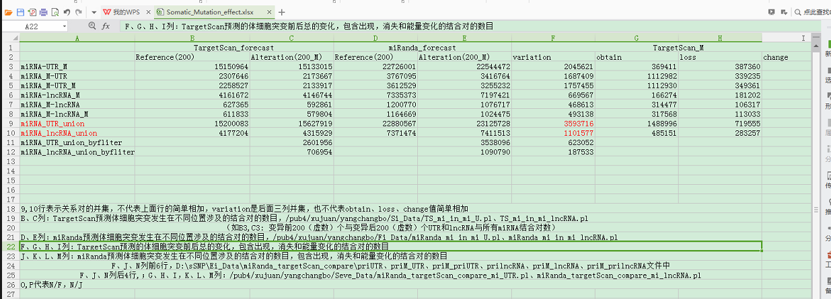

**统计所有关系对涉及的miRNA、基因（lncRNA、3’UTR）的数目**

**代码：**

**/pub4/xujuan/yangchangbo/Ei_Data/Variation_miR_Target_miR_lncRNA_UTR/Variation_miR_Target_miR_lncRNA_UTR.pl**

