LogicReader DOCX Fixture
This document exercises the DOCX pipeline: headings, paragraphs, a table and an image.

1 Claims and evidence
Attention replaces recurrence with direct pairwise interaction, which improves both accuracy and training throughput.
The proposed method reaches 28.4 BLEU on the English to German task.

1.1 Evidence table
Model | BLEU | Parallel
RNN baseline | 26.3 | no
Attention | 28.4 | yes

2 Figure
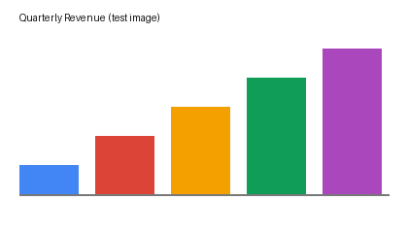
Figure 1: quarterly revenue by product line.

3 Conclusion
Attention mechanisms keep the model parallel while improving quality.

