Dear All My Friends:   
  
To get people's attention, I am offering cloud storage service for free!!  
Please, as a sign of support, register using button blow.  
Your basic info will be collect as a record.   
Then, you will be able to access to all your data from the anywhere on the earth!

However, to keep in mind, this is a free service and still under development.  
I do not take any responsibility of data loss or data security.   
Thus, please do not store any classified documents or important file in your storage.  
I will work during my personal free time to keep your data secured and to further develop this website.

Meanwhile, I am very interesting in talking to professional about web-design,   
IT services, system architecture or business.  
Thus, if you think we share the same view or you have excellent ideas, please feel free to contact me at lin.chu@yahoo.com.   
I will get back to you as soon as possible  
  
  
Say Hello to the World!  
Thanks,   
Chu Lin

Procedures:

1. register at <http://73.158.58.227>.
2. Wait for about 3-5 min for web to response.
3. Open your file explorer, right click on Network and choose map network drive..  
   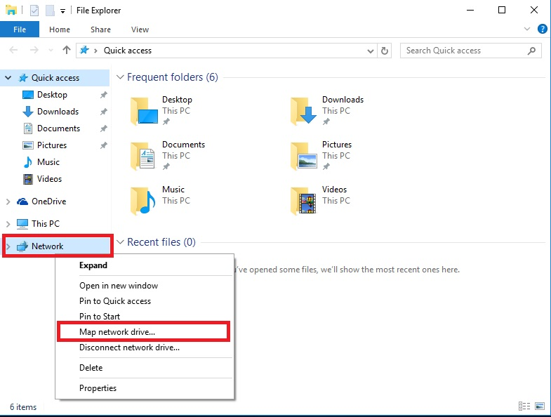
4. Navigate to Connect to a Web site that you can use to store your documents and picture  
   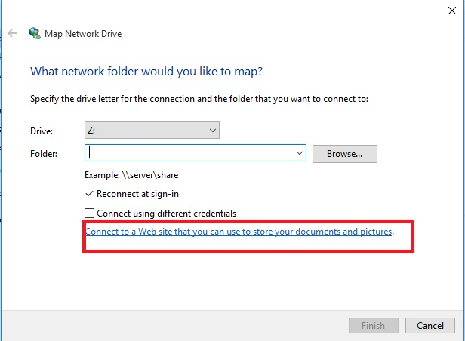
5. Follow the step and key in <ftp://73.158.58.227> into in Internet or network address.

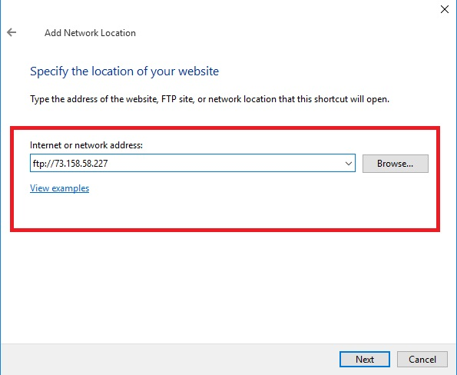

1. Uncheck the Log on anonymously and key in your username  
   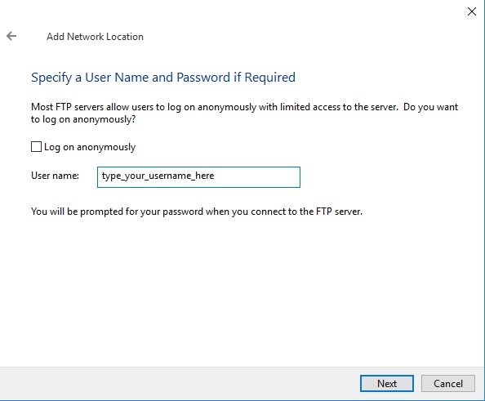
2. Key in your folder name (anything)  
   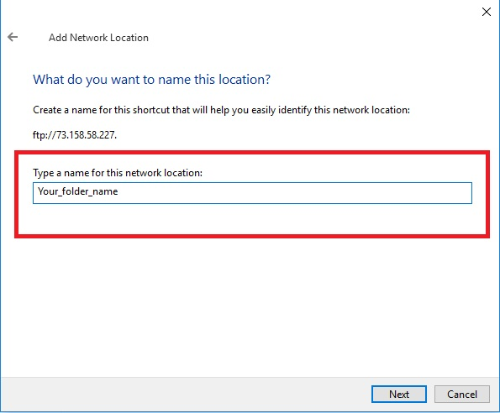
3. WaLa!! YOU ALL SET! NOW YOU CAN ACCESS YOUR FILE FROM ANY PC!!  
   