**Directions:** Using the four prompts below, identify how the FoodieLand app demonstrates good UX design.

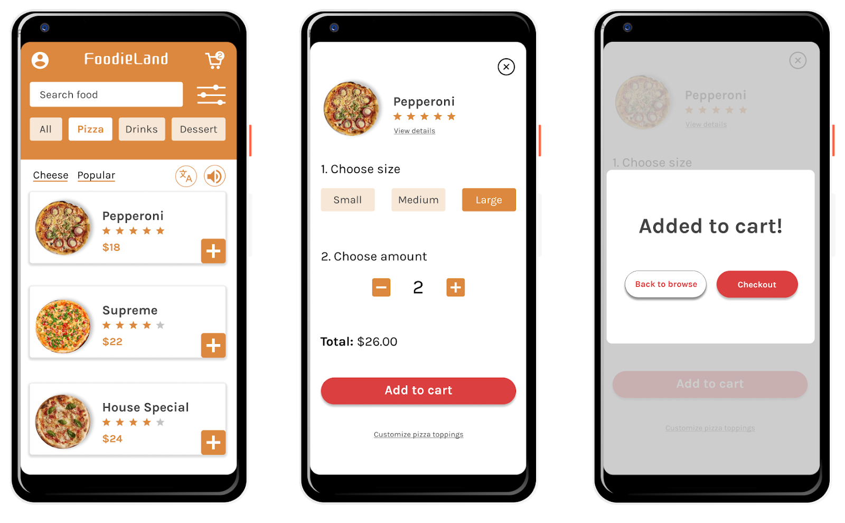

Prompt 1: Identify at least one aspect of the FoodieLand app that demonstrates usable design. Explain your reasoning in 1-2 sentences.

|  |
| --- |
| Hint: Is the app’s design, structure, and purpose clear? Does the app have any elements or features that make it easy to navigate? |

|  |  |
| --- | --- |
| **Usable** | Adding food to cart is simple as it has a plus button that easily demonstrate how to add items to your cart |

## 

## Prompt 2: Identify at least one aspect of the FoodieLand app that demonstrates equitable design. Explain your reasoning in 1-2 sentences.

|  |
| --- |
| Hint: Does the app address the needs of people with diverse abilities and backgrounds? |

|  |  |
| --- | --- |
| **Equitable** |  |

## 

## Prompt 3: Identify at least one aspect of the FoodieLand app that demonstrates enjoyable design. Explain your reasoning in 1-2 sentences.

|  |
| --- |
| Hint: Does the app inspire a positive reaction from the user by considering their thoughts and feelings? Does the app engage users and make them excited to keep using the app? |

|  |  |
| --- | --- |
| **Enjoyable** |  |

## 

## Prompt 4: Identify at least one aspect of the FoodieLand app that demonstrates useful design. Explain your reasoning in 1-2 sentences.

|  |
| --- |
| Hint: Does the app solve the problem of “how to help a busy person working from home select a meal to be delivered?” How does the app help solve this problem? |

|  |  |
| --- | --- |
| **Useful** |  |