Documentation and report of Astrophysics with Artificial Intelligence(Astropy and AstroML) – Astronomical Coordinates 1 with astropy

Donghun Kim

* **All the information is based on and originated from ‘astropy.org’, ‘atsroml.org’, and ‘wikipedia.org’**

<1> The fundamental knowledge to utilize astropy and astroML for astrophysics

1. Coordinates system.

There are some coordinate systems such as Cartesian coordinate system, cylindrical coordinate system, and spherical coordinate system. Those coordinates are related each other ones and also can be alternated to clarify the object position or calculate something which are changed depending on the coordinate system. Those coordinate systems have each own defined units and also each units can be converted along the process of alternation of coordinate system.

* The sort of the coordinate systems commonly utilized in astronomical community.

1. Horizontal system

This coordinate system is employing the observer’s local horizon as the fundamental plane to measure the location of the observed star. This coordinate system can be expressed with ‘Altitude’ and ‘Azimuth’. The altitude is the angle which is measured by observer from local horizon to observed celestial body, and the azimuth is the angle between the projected vector and the reference vector on the reference plane which is measured from observer’s point to interest point projected perpendicularly onto a reference plane. In addition to it, instead of the altitude, it is possible to utilize the zenith distance which is the angle comparable with the value which is subtracted the altitude (elevation) from the 90 degree.

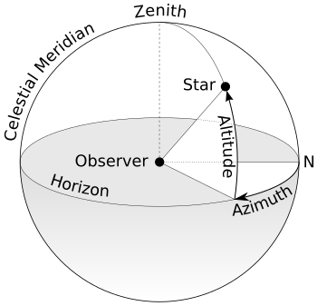

(Image from: https://en.wikipedia.org/wiki/Horizontal_coordinate_system)

1. Equatorial system.

This coordinate system can be implemented in spherical or rectangular coordinates and these ones are defined by the origin at the center of the Earth, the fundamental plane which is projected the Earth’s equator onto the celestial sphere, which is forming the celestial equator, primary direction toward the vernal equinox, and right-handed convention (anti-clockwise direction), which means that the coordinates increase along the northward and the eastward around the fundamental plane.

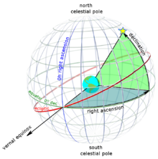

(Image from: <https://en.wikipedia.org/wiki/Equatorial_coordinate_system>)

1. Ecliptic system

This coordinate system is generally utilized in Solar System to represent the object’s apparent position, orbit, and pole orientation by employing the ecliptic and vernal equinox. This is because almost of the planets and small bodies in Solar system has orbits which are inclined to the ecliptic. The center of this coordinate can be set as one of Sun or Earth. This can be implemented in spherical or rectangular coordinates. However, the significant point is that the celestial equator and the ecliptic are slowly alternated because of the perturbing forces, which means that the primary direction is influenced, so this is not fixed. The slow motion of the Earth, known as axial precession, causes alternation of the coordinate system, which changes the coordinate system westward about the poles of the ecliptic slowly, but continuously. The completion of one circuit of this phenomenon is about 26,000 years. To consider the fixed position in space when the position is given in ecliptic coordinate system, this motion requires the specification of the equinox of a particular date, known as ‘epoch’. The most general methods are:

1. Mean equinox of a standard epoch

This is a fixed standard direction. This allows the various positions which are set at various dates to be compared.

1. Mean equinox of date

This utilizes the ecliptic of date and mean equator and those intersections. The ecliptic of date is the ecliptic in its position at date and the mean equator is rotating by precession to its position at date, but frees from the small sporadic oscillations of nutation.

1. True Equinox of date

Similar with the ‘Mean equinox of date’, this also employs the ecliptic of date and the equator, but this makes use of the true equator. In other words, in contrast with the Mean equinox of date, this equator includes the nutation. This is actual intersection of the two planes considered all motions and particular moment.

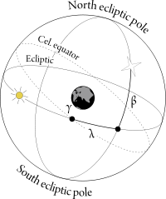

(Image from: <https://en.wikipedia.org/wiki/Ecliptic_coordinate_system>)

1. Galactic coordinate system

This coordinate system utilizes the two elements as the measurement elements, which are the ‘galactic longitude’ and ‘galactic latitude’ to find the target celestial body’s position. This system is generally employed to search the celestial body’s position and distribution. This also utilizes the degree, arcminute(arc-min), and arcsecond(arc-sec) to express the unit values of galactic longitude and latitude.

1. Galactic longitude

This measures the angular distance of the object eastward along the galactic equator from the galactic center.

1. Galactic latitude

This measures the angle of the object northward of the galactic equator.

This coordinate system also utilizes Sun as the center of the coordinate, the primary direction aligned with the approximate center of the Milky Way, and the fundamental plane parallel to an approximation of the galactic plane as the measure elements. Furthermore, this uses the right-handed convention, which means that it has positive value toward the north and east in the fundamental plane.

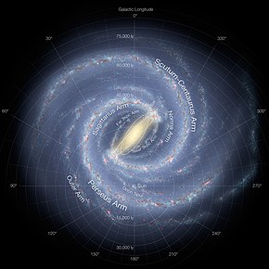

(Image from: https://en.wikipedia.org/wiki/Galactic_coordinate_system)

1. Super-galactic coordinate system

This coordinate system is the spherical coordinate system in the equator is the super-galactic plane. The characteristics of this are that the zero point of this coordinate system is where the super-galactic plane intersects with the galactic plane. Because of that the plane is observed from Earth, the plane passes Earth. Conventionally, super-galactic latitude is generally abbreviated SGB and longitude as SGL which analogies to ‘b’ and ‘l’ which are conventionally utilized in galactic coordinate system. Therefore, the zero point can be expressed SGB = 0°, SGL = 0°, lx = 137.37°, and bx = 0°. To be more specific, the north super-galactic pole (SGB = 90°) is laid at lz = 47.37° and bz = +6.32° at galactic coordinate system.

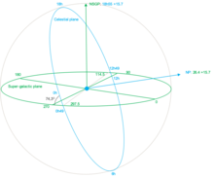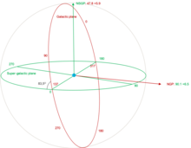

1. Conversion of the various coordinate systems.

To begin with, each coordinate system has different units to express and calculate the object’s position.

|  |  |  |
| --- | --- | --- |
| Coordinate system | Symbol | Mean |
| Horizontal coordinate system | A  h | azimuth  altitude |
| Equatorial coordinate system | α  δ  ω | right ascension  declination  hour angle |
| Ecliptic coordinate system | *λ*  *β* | ecliptic longitude  ecliptic latitude |
| Galactic coordinate system | *l*  *b* | galactic longitude  galactic latitude |
| Miscellaneous | *λ*o  *ϕ*o  *ε*  *θ*L  *θ*G | observer’s longitude  observer’s latitude  obliquity of the ecliptic(about  local sidereal time  Greenwich sidereal time |

1. Hour angle and right ascension

h = *θ*L – *α = θ*G + *λ*o – *α*

*α = θ*L – h = *θ*G + *λ*o – h

1. Equatorial and ecliptic

The classical equations of the longitudinal coordinate which are stemmed from Spherical trigonometry are

cos(β)sin(λ) = cos(δ)sin(α)cos(ε) + sin(δ)sin(ε)

cos(β)cos(λ) = cos(δ)cos(α)

sin(β) = sin(δ)cos(ε) – cos(δ)sin(ε)sin(α)

If divide the first equation with second one, the result equation is

tan(λ) =

However, this division is unclear because the period of tan is 180° (*π)*, but the ones of sin and cos are the 360° (2*π*).

The rotation matrix equivalent over above equations is that:

In addition to,

cos(δ)sin(α) = cos(β)sin(λ)cos(ε) – sin(β)sin(ε)

cos(δ)cos(α) = cos(β)cos(λ)

sin(δ) = sin(β)cos(ε) + cos(β)sin(ε)sin(λ)

tan(α) =

Likewise, the rotation matrix equivalent is

1. Equatorial and horizontal

The azimuth (A) is measured from the south point and alternated along the western. Zenith distance is the angular distance along the great circle from the zenith to a celestial object and complementary angle of the altitude which can be expressed as 90° - a.

cos(a)sin(A) = cos(δ)sin(h)

cos(a)cos(A) = cos(δ)cos(h)sin(*ϕ*o) – sin(δ)cos(*ϕ*o)

sin(a) = sin(*ϕ*o)sin(δ) + cos(*ϕ*o)cos(δ)cos(h)

Divide the first equation by second one.

tan(A) =

To evaluate the A, it is necessary to resolve the tan(A) and, in this process, it is needed to make use of the ‘two-argument arctangent’ to avoid the ambiguity of the arctangent. This calculates the arctangent of y /x and accounts for the quadrant which is computed. The azimuth is measured from south and opening positive to the west.

A = -arctan(x, y)

(x = -sin(*ϕ*o)cos(δ)cos(h) + cos(*ϕ*o)sin(δ),

y = cos(δ)sin(h) )