Homework 2
1, The application interface is given as following. And it can support multi-language display.
When Pictures(照片) is been chosen, the interface is:
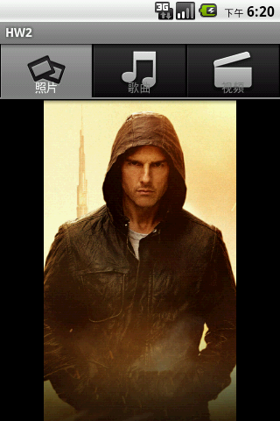
When Songs(歌曲) is been chosen, the interface is as following. When one item has been chosen, a Toast will show its content.
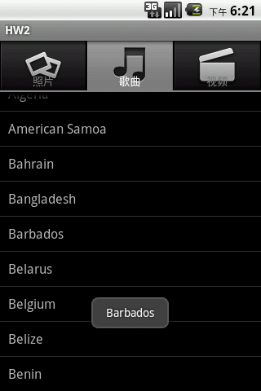
When Videos(视频) is been chosen, the interface is as following. It can support user to flip left or right.
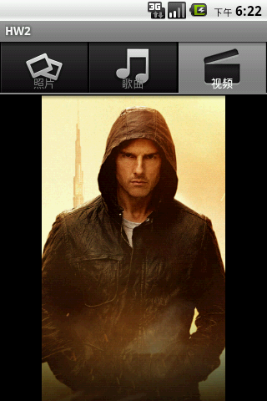
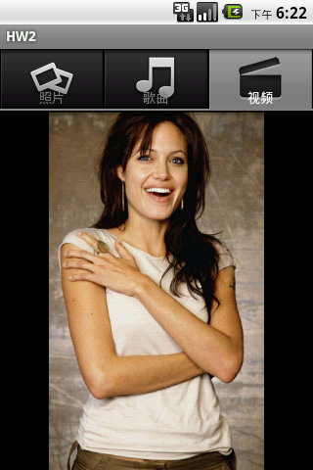
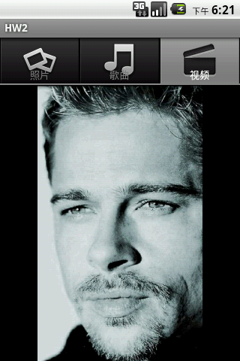
Submission guideline:
- Submit the project file to course website. You can find a submission link name as HW2 on Ispace.
- Submission deadline: 11:55pm, Mar 15th, 2013.
- All resources file could be found in the attached folder.

