WOODHOUSE BASECAMP
The cleaning app
A guide for cleaners. Five minutes to read, and then you have it.
The app does two things.
- What to clean today, and which one to do first.
- It tells the office when you are done, so nobody has to ring round and ask.
There is nothing to tick and nothing to hand in. Clean the building, then press one button.
The address for the app:

Ask the office if you do not have it.
OFFICE  0402 930 714 | MAINTENANCE  0437 316 386
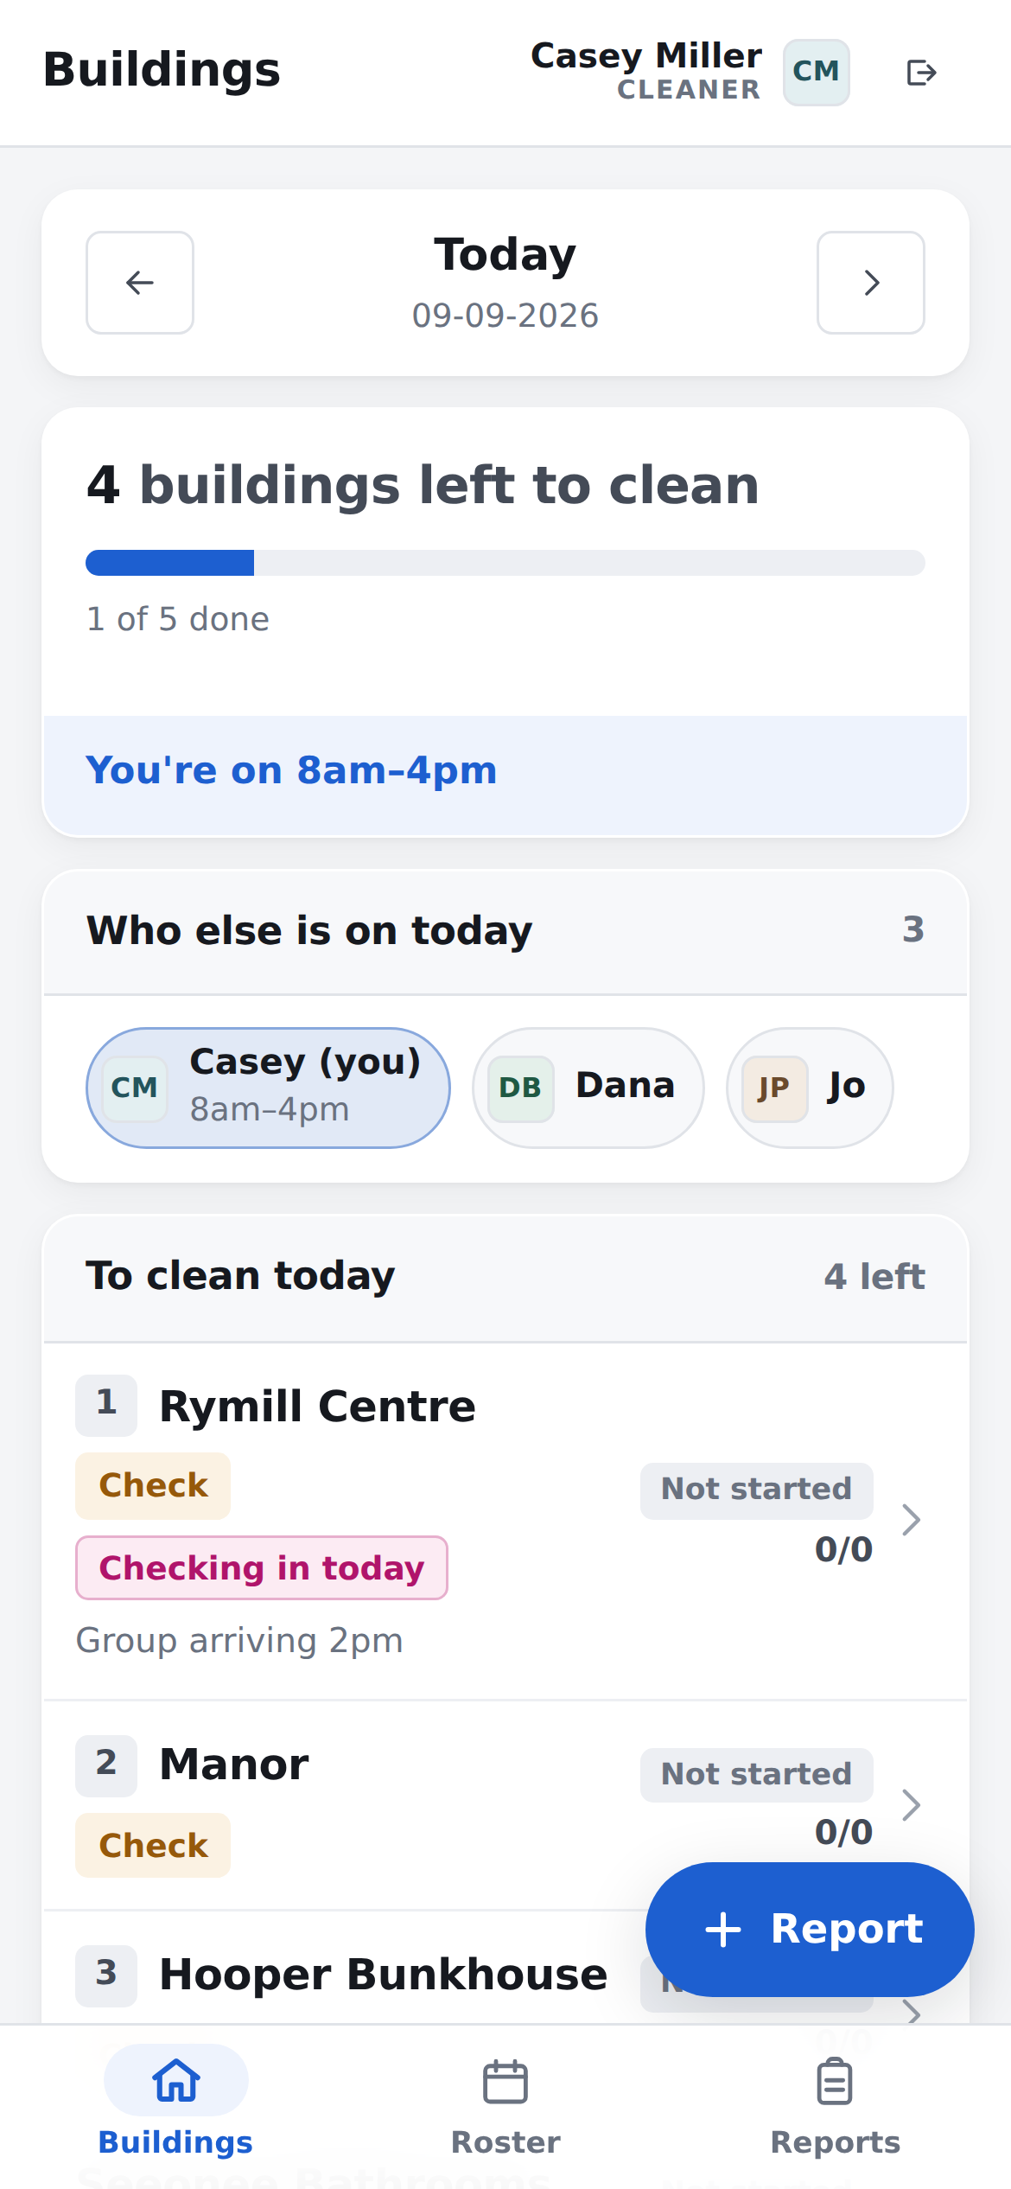
The screen a cleaner opens on.

THE SHORT VERSION

The whole job, in four steps
If you read nothing else, read this page.
- Sign in. Tap your name, then tap your PIN.
- Read today’s list. The buildings to clean are at the top, in order. Number 1 first.
- Clean the building. The app is not involved in this part.
- Open the building in the app and press the big blue button. That tells the office it is done.

Something broken, or something left behind?
Press Report. The office is told straight away, and you can carry on.

Two words you will see all day
Check | The quick walk round. Is it still clean, is it stocked, is anything broken.
Full Clean | The whole thing, top to bottom.
The office chooses which one, and the app tells you. You do not have to decide.

STEP 1 · YOU ONLY DO THIS ONCE

Put the app on your phone
It is a website, not an App Store app. Nothing to buy, nothing to update.
- Open the address in your phone’s browser. The office will send you the link. Write it on the front page of this guide.
- iPhone: tap the Share button at the bottom of the screen, scroll down, and tap Add to Home Screen.
- Android: tap Install on the bar under the names. If you do not see it, open the browser’s menu and tap Install app.

Why bother?
You get an icon on your home screen, it opens full screen with no address bar, and you never have to find the link again.
You can skip this and just use the browser. Everything works the same.
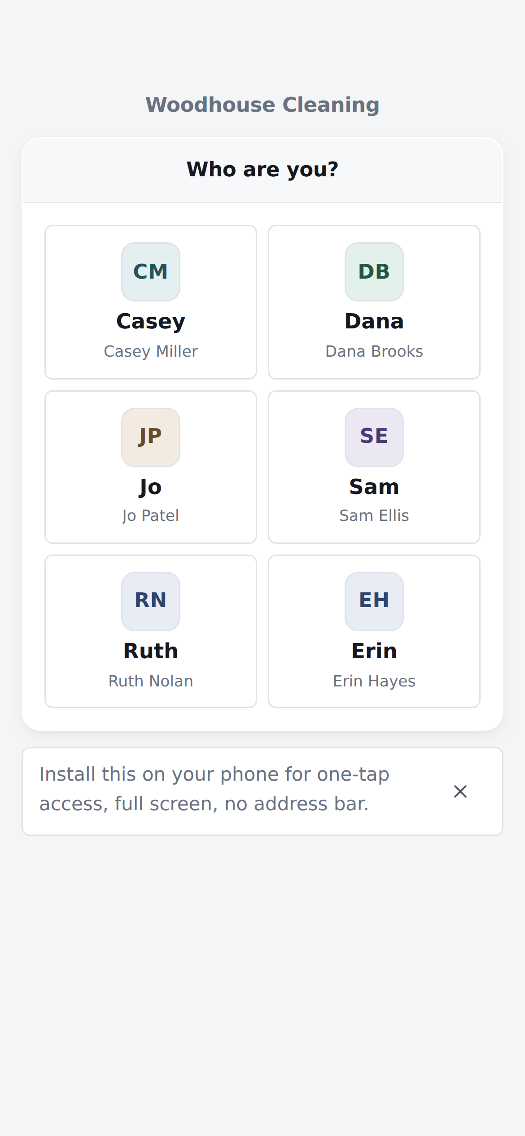
The bar under the names is the one to tap.

STEP 2

Sign in
Two taps and a PIN. No username, nothing to type.
Tap your name. | 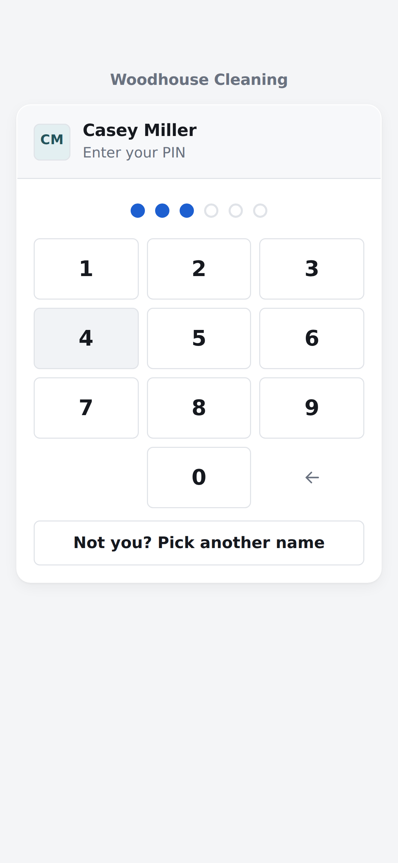  Tap your PIN.

- Tap your name. Yours is usually the first one.
- Tap your PIN. It signs you in on the last number, so there is no button to press afterwards.
It remembers you. On your own phone you will not be asked for your PIN again.
Handing the phone back? Tap the arrow in the top right corner to sign out.
Forgotten your PIN? The office can set you a new one. Nobody can look up the old one.
Tapped the wrong name?
Tap "Not you? Pick another name" at the bottom of the keypad, and start again.

STEP 3

Read today’s list
This is the screen you start on. It answers one question: what is left to clean today.
- Today’s date. The arrows look at other days. You can only tick off work on today, so come back to Today before you start.
- How many buildings are left. The bar fills up as they are signed off.
- Your hours today, if the office has rostered you on.
- The buildings to clean. They are in the order the office wants them done.
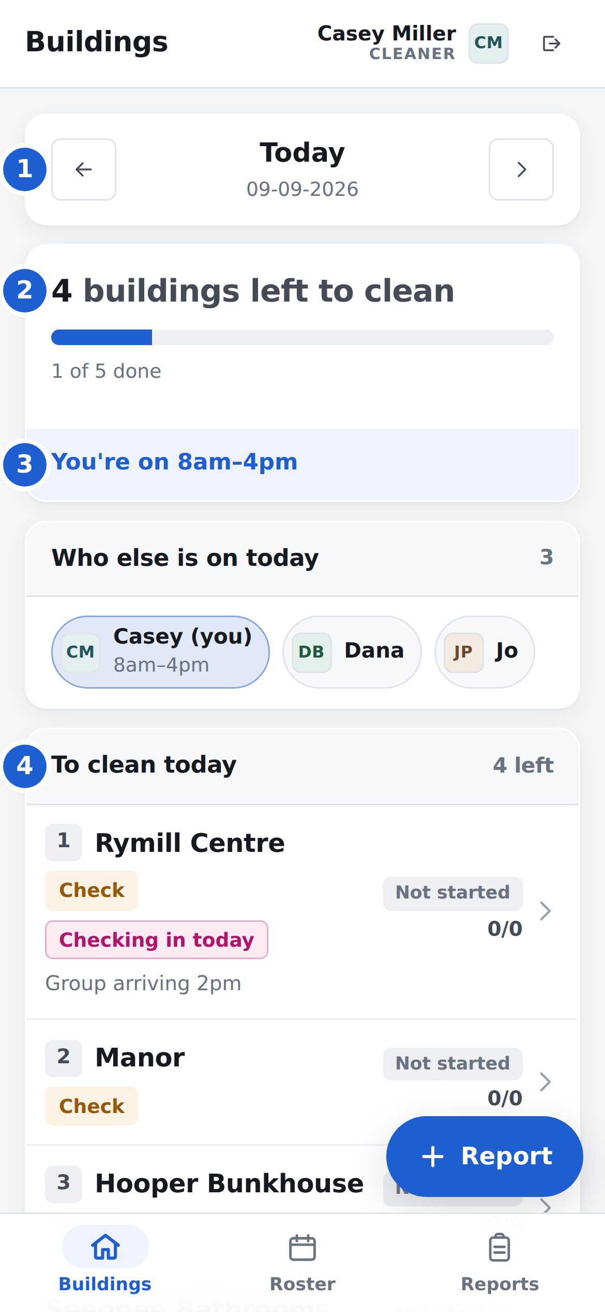
The numbers on this picture match the list above.
The same list for everyone
The plan says what needs cleaning, not who does it. Sort out between you who takes what, and the app keeps up.

STEP 3 · CONTINUED

What the labels mean
- The number and the name. Number 1 is the first job of the day. A building with no number is on today’s list too, it just does not have to be done in an order.
- Check or Full Clean. Which one the office asked for.
- A green "Done" and a time. Somebody has already finished that one. Leave it.

Checking in today | Guests arrive here today. Do this one first, whatever the numbers say.
Not started | Nobody has touched it yet.
Done 8:42 am | Finished, and the time it was signed off.
0/0 | The number of items ticked. Our buildings have no tick list, so this stays at 0/0. It is not a problem.
Group arriving 2pm | A note from the office about that building.
Other buildings | Everything not on today’s plan. Tap it to open the list if you need one of them.
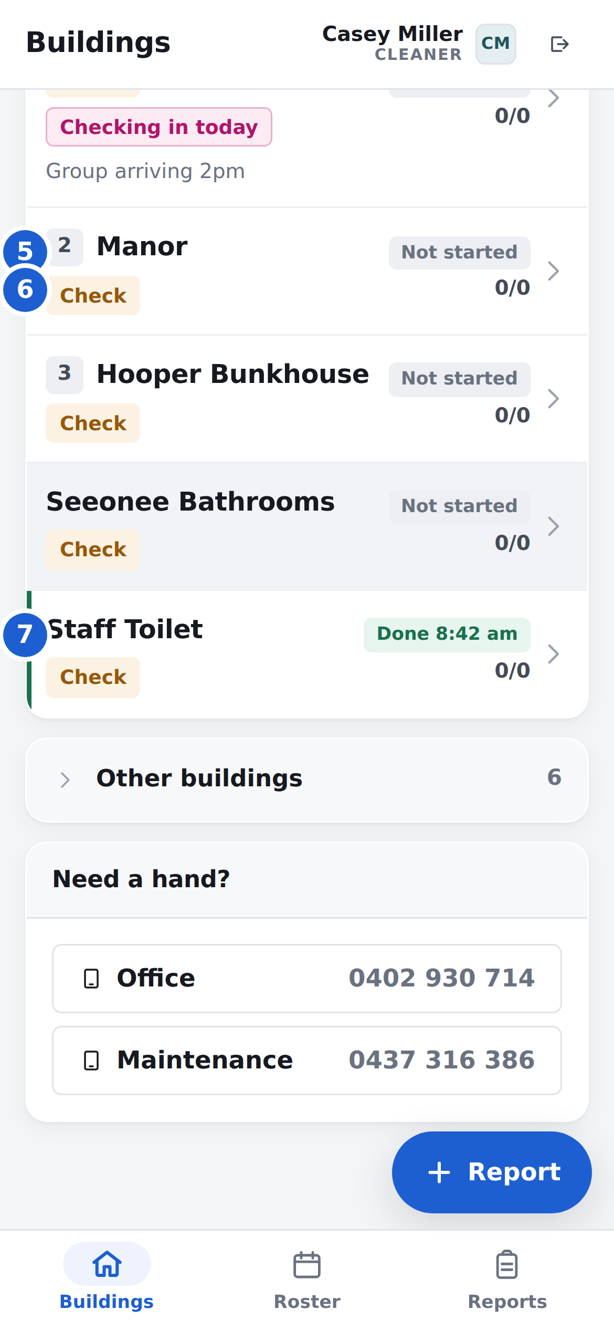
Further down the same list.

STEP 4 · THE IMPORTANT ONE

Mark the building done
Clean the building first. Then open it in the app and press the blue button.
- Tap the building on today’s list.
- Tap the blue button — "Mark check complete", or "Mark full clean complete".
- Tap "Yes, all done" when it asks.
The app takes you straight back to your list, and that building turns green.
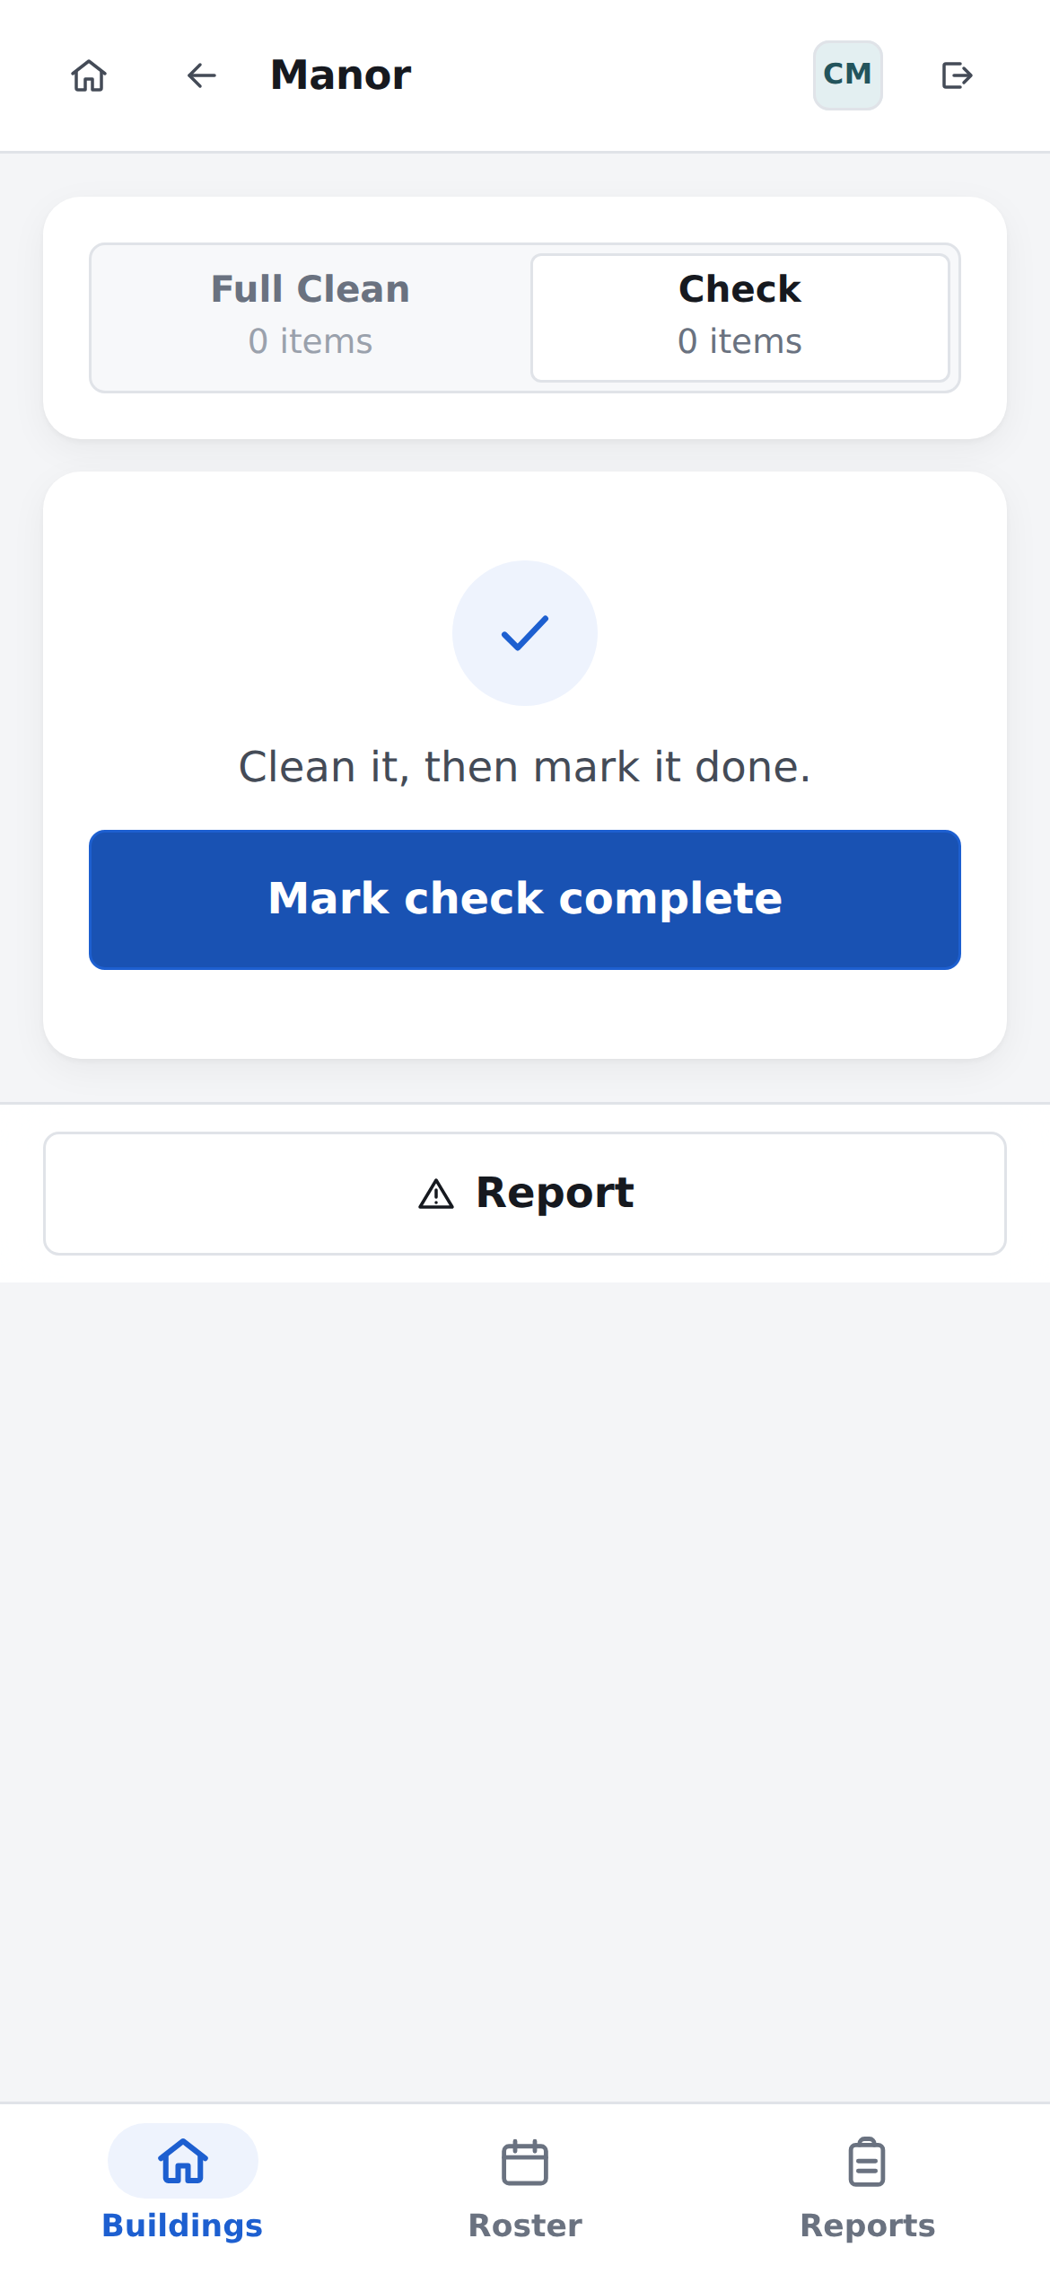  Tap the building on your list. | 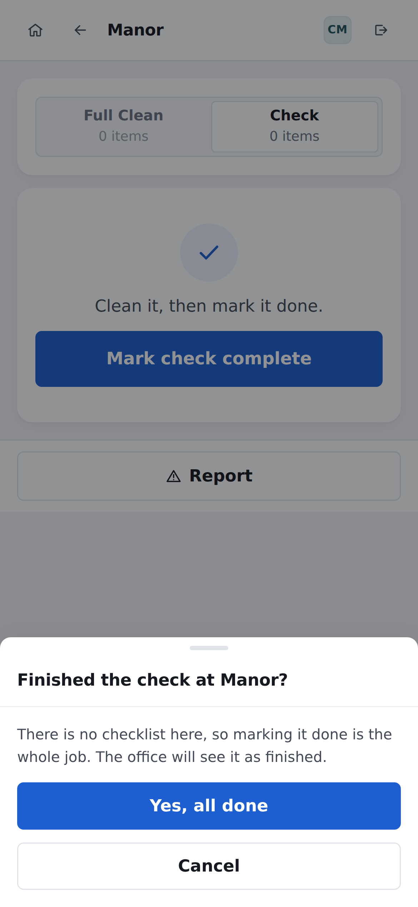  Then tap "Yes, all done".

Our buildings have no tick list
There is nothing to tick off room by room. One button is the whole job.

STEP 4 · CONTINUED

That’s it — the office can see it
The building now says Signed off, with your name and the time.
The office sees the same thing on their screen the moment you press the button. There is no need to ring in, write anything down, or hand anything over at the end of the day.
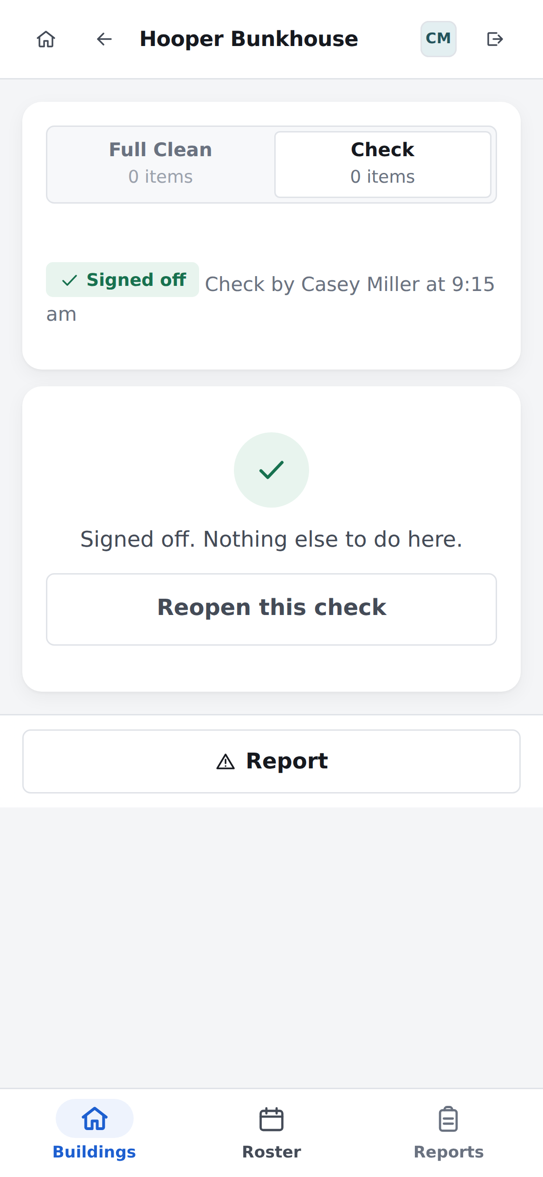
Green means done.

Pressed it by mistake?
Open the building again and tap "Reopen this check". It goes back to unfinished. Nothing is lost and nobody is in trouble.

Two of you in the same building?
That is fine. Whoever finishes last presses the button.

Cleaned something that was not on the list?
Open "Other buildings" at the bottom of your list, tap it, and mark it done the same way.
Only today can be ticked off
You can look at other days with the arrows at the top, but the button only works on today. If it is missing, check the top of the screen says Today.

WHEN SOMETHING IS WRONG

Report a problem
A broken tap, a blocked toilet, a light out, something left behind. Tell the office through the app.
- Tap Report. It is the blue button in the corner of your list, and it is also inside every building.
- Where — in your own words. "Kitchen near the door", "Room 3, upstairs". You can leave it empty.
- Details — what is wrong.
- Photo — optional, but it saves a lot of questions.
- Tap Send. The office gets it straight away.
Use it for lost property too
Anything worth telling the office about goes here. It does not have to be a fault.
You do not have to wait for an answer, and you do not have to stop cleaning. Send it and carry on.
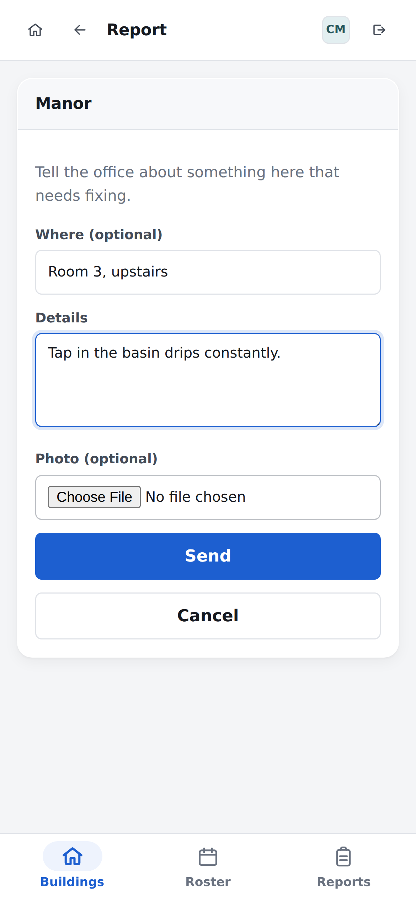  Where, what, and a photo if you have one. | 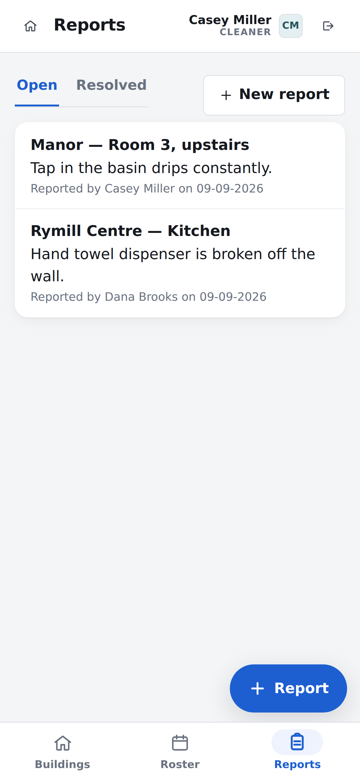  The Reports tab keeps every one of them.

GETTING AROUND

The three buttons at the bottom
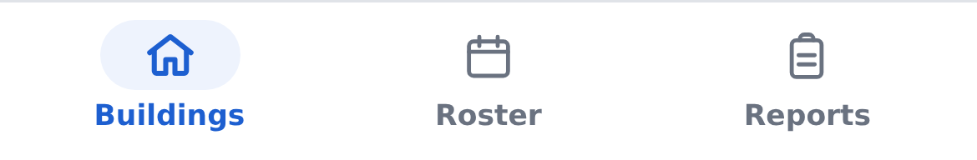

Buildings
Today’s work. This is where you spend the day.

Roster
Who is working this week, and when you are on. The office builds it; you read it.
The tab strip at the top also has "My availability", where you say which days you can work. Set it once, and change it when your week changes.
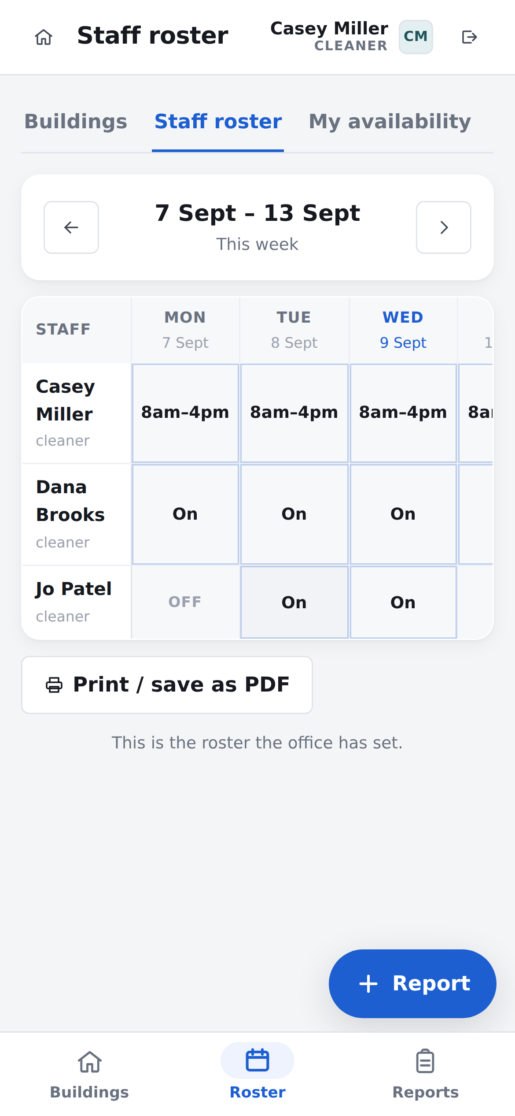
The Roster tab.

Reports
Everything that has been reported and not yet fixed. Worth a look before you ring the office about something — it may already be there.
Lost?
The house icon in the top left corner takes you back to today’s list from anywhere.

IF SOMETHING LOOKS WRONG

Questions people ask

My list is empty.
Check the top of the screen says Today. If it does, the office has not sent this week’s plan out yet — the screen will say so. You can still pick any building from "Other buildings" and get started.

It says I am not on today.
Nobody has put you on the roster for today. If that is wrong, ring the office. You can still use the app.

The building I cleaned already says Done.
Somebody else got there first. The name and time are on the building’s own screen.

I marked the wrong building.
Open it and tap "Reopen this check", then go and mark the right one.

There is no signal down there.
The app opens without signal, but it needs signal to load the day’s list and to save that a building is done. Walk back to where you have bars and press the button then. Nothing is lost.

It is stuck on "Loading".
Give it a few seconds — the first load of the morning is the slow one. If it stays there, it will offer you "Try again" and "Reset and reload". Try both, in that order.

Do I have to tick anything off?
No. Our buildings have no tick lists. Clean it, press the button.

I have a new phone.
Open the address again, tap your name, tap your PIN. Everything is there.
Still stuck?
Ring the office on 0402 930 714. Nothing in the app can be broken by pressing the wrong thing.

CUT THIS OUT

The short version, for the wall
Pin it up in the cleaning cupboard, or fold it into a pocket.
Woodhouse cleaning app — the whole job
- Tap your name, tap your PIN.
- Clean the buildings on today’s list, starting at number 1.
- Open each one and press the blue button when it is finished.
Something broken or left behind? Press Report.
OFFICE  0402 930 714 | MAINTENANCE  0437 316 386

