Lincoln Teo Ming Kern 3122215
AssignmentOne_3122215
FruitMachine
User Manual: When user starts the user will see a menu interface
To use the menu, the user simply just need to input the number as shown to execute the command for example, if user chose the Bahasa Melayu language just simple input 3 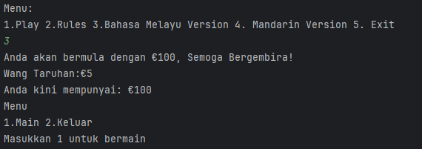
After that, to play the slot input 1 and to exit the game enter 2.
Rules:
The user starts with 100 credits and each bet is 5 credits there are 12 winning chances with different patterns.
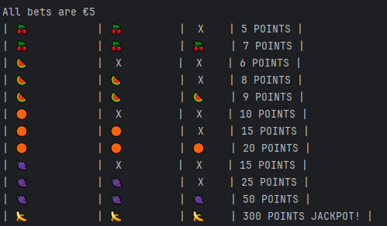
Best with IntelliJ compiler

