1. Problem Formulation

1.1 Physical Problem and Geometry
The problem considers a square plate of unit thickness, occupying a two-dimensional computational domain of (4 \times 4). The plate is maintained at a constant temperature of 200 K along all four external boundaries. A heat source at a prescribed temperature of 350 K is attached along a finite vertical line segment extending from ((1.5,2)) to ((1.5,3)).​
The internal heat source is located between the first and second columns of the nine specified interior grid points. Consequently, its position must be explicitly represented in the numerical model rather than approximated by shifting it to the nearest original grid point.​
The geometrical parameters are:​

Table 1.1 Geometrical and Physical Parameters of the Plate
Parameter | Value
Plate width | 4
Plate height | 4
Plate thickness | 1
External boundary temperature | 200K
Internal heat-source temperature | 350K
Heat-source location | (x=1.5, 2<=y<=3)
Number of required interior points | 9

The coordinate system follows the original problem statement, with the origin at the bottom-left corner of the plate.​

1.2 Governing Equation
The steady-state temperature distribution is governed by the two-dimensional Laplace equation provided in the assignment:​
$$\frac{∂^{2}T}{∂x^{2}}+\frac{∂^{2}T}{∂y^{2}}=0$$

where (T(x,y)) represents the temperature at position ((x,y)), measured in kelvin.​
This equation describes the temperature field in the plate away from the prescribed internal heat-source boundary. In the present study, the governing equation is taken directly from the problem statement.​
The computational domain is defined as​
$$Ω=\left(0,4\right)×\left(0,4\right)$$
The Laplace equation is therefore solved in the plate region excluding the internal prescribed-temperature segment:​
$$Ω^{'}=Ω\backslash Γ_{s}$$

1.3 Boundary Conditions and Modelling Assumptions
Two types of prescribed-temperature boundaries are considered:
External boundary condition​
The temperature is fixed at 200 K along all four sides of the plate:​
$$T\left(0,y\right)=T\left(4,y\right)=200 K$$
$$T(x, 0) = T(x, 4) = 200 K$$
Internal heat-source boundary condition​
The internal heat source is maintained at 350 K:​
$$T(1.5, y) =350 K, 2 ≤ y ≤ 3$$
Both conditions are implemented as Dirichlet boundary conditions.​ The following modelling assumptions are adopted:​
1.The internal source has a negligible width and is idealised as a zero-width isothermal line segment.
2.The material properties do not introduce additional volumetric heat generation (i.e., the Laplace equation holds).
3.The unit thickness is part of the physical geometry but does not explicitly enter the prescribed two-dimensional Laplace equation for Part A.​

1.4 Objectives and Required Outputs
The primary objective of Part A is to determine the steady-state temperatures at the nine specified interior locations:​
$$\left(x,y\right)∈\left\{1,2,3\right\}×\left\{1,2,3\right\}$$
These points are arranged in a regular (3×3) pattern.​ The temperatures are obtained via numerical solution, and the accuracy of the results is assessed through verification tests and grid refinement. In addition to the nine required temperatures, the complete temperature field is obtained to support the subsequent heat-flux calculations in Part B.

2. Numerical Method

2.1 Selection of Numerical Method
The finite difference method (FDM) was selected to solve the two-dimensional Laplace equation. This approach is based on the central finite difference formulas introduced in Chapter 5.5, which approximate derivatives using function values at neighbouring grid points.
FDM is suitable for the present problem because the plate has a regular square geometry and the required temperatures are located at specified grid points. By replacing the second-order partial derivatives with finite difference approximations, the governing equation can be converted into a system of linear algebraic equations.
A second-order central difference scheme was chosen for both spatial directions. Compared with first-order forward or backward difference formulas, central differences generally provide higher accuracy for sufficiently smooth temperature fields while maintaining a relatively simple computational structure.The resulting linear system was assembled in Python.

2.2 Central Finite Difference Discretisation
The governing equation for the steady-state temperature distribution is:
$$\frac{∂^{2}T}{∂x^{2}}+\frac{∂^{2}T}{∂y^{2}}=0$$
For a grid point (xᵢ, yⱼ), the second-order central finite difference approximations are:
$$\frac{∂^{2}T}{∂x^{2}}≈\frac{T_{i+1,j}-2T_{i,j}+T_{i-1,j}}{{\left(∆x\right)}^{2}}$$
$$\frac{∂^{2}T}{∂y^{2}}≈\frac{T_{i,j+1}-2T_{i,j}+T_{i,j-1}}{{\left(∆y\right)}^{2}}$$
where $T_{i,j}$ is the temperature at the current grid point, while the neighbouring terms represent the temperatures at adjacent grid points.
Substituting these expressions into the Laplace equation gives:
$$\frac{T_{i+1,j}-2T_{i,j}+T_{i-1,j}}{{\left(∆x\right)}^{2}}+\frac{T_{i,j+1}-2T_{i,j}+T_{i,j-1}}{{\left(∆y\right)}^{2}}=0$$
For a uniform grid with $∆x$ = $∆y$ = h, the equation simplifies to:
$$T_{i,j}=\frac{T_{i+1,j}+T_{i-1,j}{+T}_{i,j+1}+T_{i,j-1}}{4}$$
This is the five-point finite difference scheme. It expresses the temperature at an interior grid point as the average of its four neighbouring temperatures. For sufficiently smooth solutions, the second-order central difference approximations have a local truncation error of O(h²). But the overall convergence order of the numerical solution also depends on the regularity of the temperature field and the treatment of boundary conditions.

2.3 Treatment of the Internal Heat Source
To represent the source at its specified position, the computational grid was initially refined to a spacing of h = 0.5. This gives nine grid nodes along each coordinate direction, with coordinates ranging from 0 to 4 in increments of 0.5.
At this resolution, the internal heat source coincides with three grid nodes:(1.5, 2.0), (1.5, 2.5), (1.5, 3.0). These nodes were assigned a fixed temperature of 350 K, while all nodes on the four external boundaries were maintained at 200 K. The remaining interior temperatures were treated as unknowns.
The initial grid contains 81 nodes in total, including 32 external boundary nodes and 3 internal source nodes, leaving 46 unknown temperatures. The same representation was maintained during grid refinement. As the grid spacing decreased, additional nodes were introduced along the source segment while its physical position and prescribed temperature remained unchanged. Nevertheless, the source endpoints may affect the smoothness of the temperature field, so grid convergence needs to be examined separately to assess the resulting numerical behaviour.

2.4 Formulation and Solution of the Linear System
After discretisation, one finite difference equation was constructed for each unknown interior grid point. These equations were assembled into the matrix form:
$$AT=b$$
where A is the coefficient matrix, T is the vector of unknown nodal temperatures, and b contains contributions from the prescribed boundary and internal source temperatures.
For a uniform grid, the finite difference equation at an unknown node can be written as:
$$4T_{i,j}-T_{i+1,j}-T_{i-1,j}-T_{i,j+1}-T_{i,j-1}=0$$
When a neighbouring node has a prescribed temperature, its contribution is transferred to the right-hand side of the equation. For example, if the eastern neighbouring node belongs to the internal heat source and is fixed at 350 K, the corresponding equation becomes:
$$4T_{i,j}-T_{i+1,j}-T_{i-1,j}-T_{i,j+1}-T_{i,j-1}=350$$
The resulting system was solved using numerical linear algebra in Python. For the initial h = 0.5 grid, the system contains 46 unknown temperatures. For finer grids, the coefficient matrix becomes larger but remains sparse, since each unknown temperature is connected only to its neighbouring nodes. A sparse matrix representation was therefore used to reduce memory requirements and improve computational efficiency. The linear system was solved using SciPy's sparse direct solver. This changes the computational implementation of the matrix solution but does not alter the finite difference discretisation. The computed temperature field was subsequently used to extract the nine required nodal temperatures. The accuracy and reliability of the numerical solution were evaluated through analytical verification tests, algebraic residual checks and grid convergence analysis, as discussed in the following sections.

3. Numerical Implementation

3.1 Computational Grid and Node Classification
The numerical model was implemented in Python using NumPy and SciPy. A uniform Cartesian grid was generated over the 4 × 4 plate, with the initial grid spacing set to h = 0.5.At each node, the temperature was classified as either prescribed or unknown.The four external boundaries were assigned a temperature of 200 K, while nodes lying on the internal source segment were fixed at 350 K.
For the initial 9 × 9 grid, the classification resulted in 32 external boundary nodes, 3 internal source nodes and 46 unknown interior nodes. A Boolean mask was used to distinguish fixed-temperature nodes from unknown nodes, ensuring that the prescribed temperatures were retained during the solution process. The coordinates of the unknown nodes were stored in a consistent order, and each unknown was assigned a unique index for assembling the linear system.

3.2 Assembly of the Linear System
The coefficient matrix and right-hand-side vector were constructed by applying the five-point central difference equation to each unknown node.
For equal grid spacing in both directions, the discrete equation is:
$$4T_{i,j}-T_{i+1,j}-T_{i-1,j}-T_{i,j+1}-T_{i,j-1}=0$$
In the Python implementation, the coefficients were obtained directly from the central finite difference equation. The temperature at the current node appears in both the x- and y-direction terms, giving a diagonal coefficient of:
$$A_{k,k}=\frac{2}{{\left(∆x\right)}^{2}}+\frac{2}{{\left(∆y\right)}^{2}}$$
The neighbouring temperatures appear only once. Moving these terms to the left-hand side yields the off-diagonal coefficients: ${-1/\left(∆x\right)}^{2}$ for the left and right neighbours, and ${-1/\left(∆y\right)}^{2}$ for the upper and lower neighbours.
For neighbouring nodes with prescribed temperatures, their contributions were moved to the right-hand side. Applying this procedure to every unknown node produced the linear system:
$$AT=b$$
The matrix size depends on the number of unknown nodes. For the initial grid, A is a 46 × 46 matrix and T contains the 46 unknown temperatures.

3.3 Python Implementation and Numerical Solver
The initial implementation used NumPy to construct and solve the linear system. The function numpy.linalg.solve() was applied to obtain the unknown temperatures, which were then inserted into the full temperature grid.
For the subsequent grid convergence study, the same finite difference equations were retained, but the matrix was stored using SciPy's sparse matrix format. This was necessary because the number of unknown nodes increases rapidly as the grid spacing decreases, while each equation contains only a small number of non-zero coefficients.
The sparse coefficient matrix was initially assembled using the List of Lists (LIL) format and then converted to Compressed Sparse Row (CSR) format before being solved using scipy.sparse.linalg.spsolve().
The computational procedure therefore consisted of generating the grid, applying the prescribed temperatures, identifying the unknown nodes, assembling the coefficient matrix and right-hand-side vector, solving the linear system and reconstructing the complete temperature field.
The numerical solution was also checked by evaluating the algebraic residual:
$$r=AT-b$$
A normalised residual was calculated to compare the quality of the linear system solutions across different grid resolutions:
$$r_{rel}=\frac{\left\|AT-b\right\|∞}{(\left\|A\right\|∞\left\|T\right\|∞+\left\|b\right\|∞)}$$
This measure accounts for the scale of the coefficient matrix and solution vector. It was used to assess the algebraic solution quality, while the discretisation error was examined separately through grid refinement.

Table 31 Grid Resolution and Normalized Algebraic Residuals
h | Unknowns | Normalized residual
0.5 | 46 | 9.733e-17
0.25 | 220 | 1.733e-16
0.125 | 952 | 1.667e-16
0.0625 | 3952 | 2.359e-16
0.03125 | 16096 | 3.052e-16
0.015625 | 64960 | 4.644e-16

As shown in Table 1, the number of unknown temperatures increased from 46 to 64,960 as the grid spacing decreased from 0.5 to 0.015625. Despite the increasing system size, the normalized residuals remained on the order of 10⁻¹⁶ for all six grid resolutions. This indicates that the discretised linear systems were solved with very small algebraic residuals. Therefore, the differences observed between successive grid solutions are unlikely to be caused by insufficient convergence of the linear solver. The discretisation error is assessed separately through the grid refinement study in Section 6.

3.4 Extraction and Storage of Results
After solving the linear system, the complete temperature field was reconstructed by combining the calculated unknown temperatures with the prescribed boundary and source temperatures.
The nine temperatures required in Part A were extracted at the coordinates x, y = 1, 2, 3. Since these locations coincide with grid nodes at all selected resolutions, their temperatures could be obtained directly without interpolation.
The full temperature grids and the nine requested temperatures were exported as CSV files. Additional results from the grid convergence analysis, including inter-grid temperature changes, observed convergence orders and algebraic residuals, were also saved for subsequent evaluation.
The complete temperature field was retained because it provides the spatial temperature information needed for the heat-flux calculations in Part B. The final temperature distribution was also used to generate contour and heatmap visualisations, while the temperatures obtained at different grid resolutions were compared in a separate convergence plot.

4. Numerical Results

4.1 Steady-State Temperature Distribution
The steady-state temperature distribution was obtained using the central finite difference method. The computational grid was progressively refined, with the finest grid spacing of h = 0.015625 being used for the results presented in this section.
Figure 1 shows the temperature contour plot obtained from the finest-grid solution. The internal heat source is maintained at 350 K, while the four external boundaries remain at 200 K. The temperature decreases away from the source towards the outer boundaries, producing a non-uniform distribution across the plate.
The highest temperatures are concentrated around the internal source segment at x = 1.5 between y = 2 and y = 3. The temperature contours become more closely spaced near the source, indicating larger spatial temperature gradients in these regions. Further away from the source, the temperature distribution becomes smoother as it approaches the prescribed external boundary temperature.

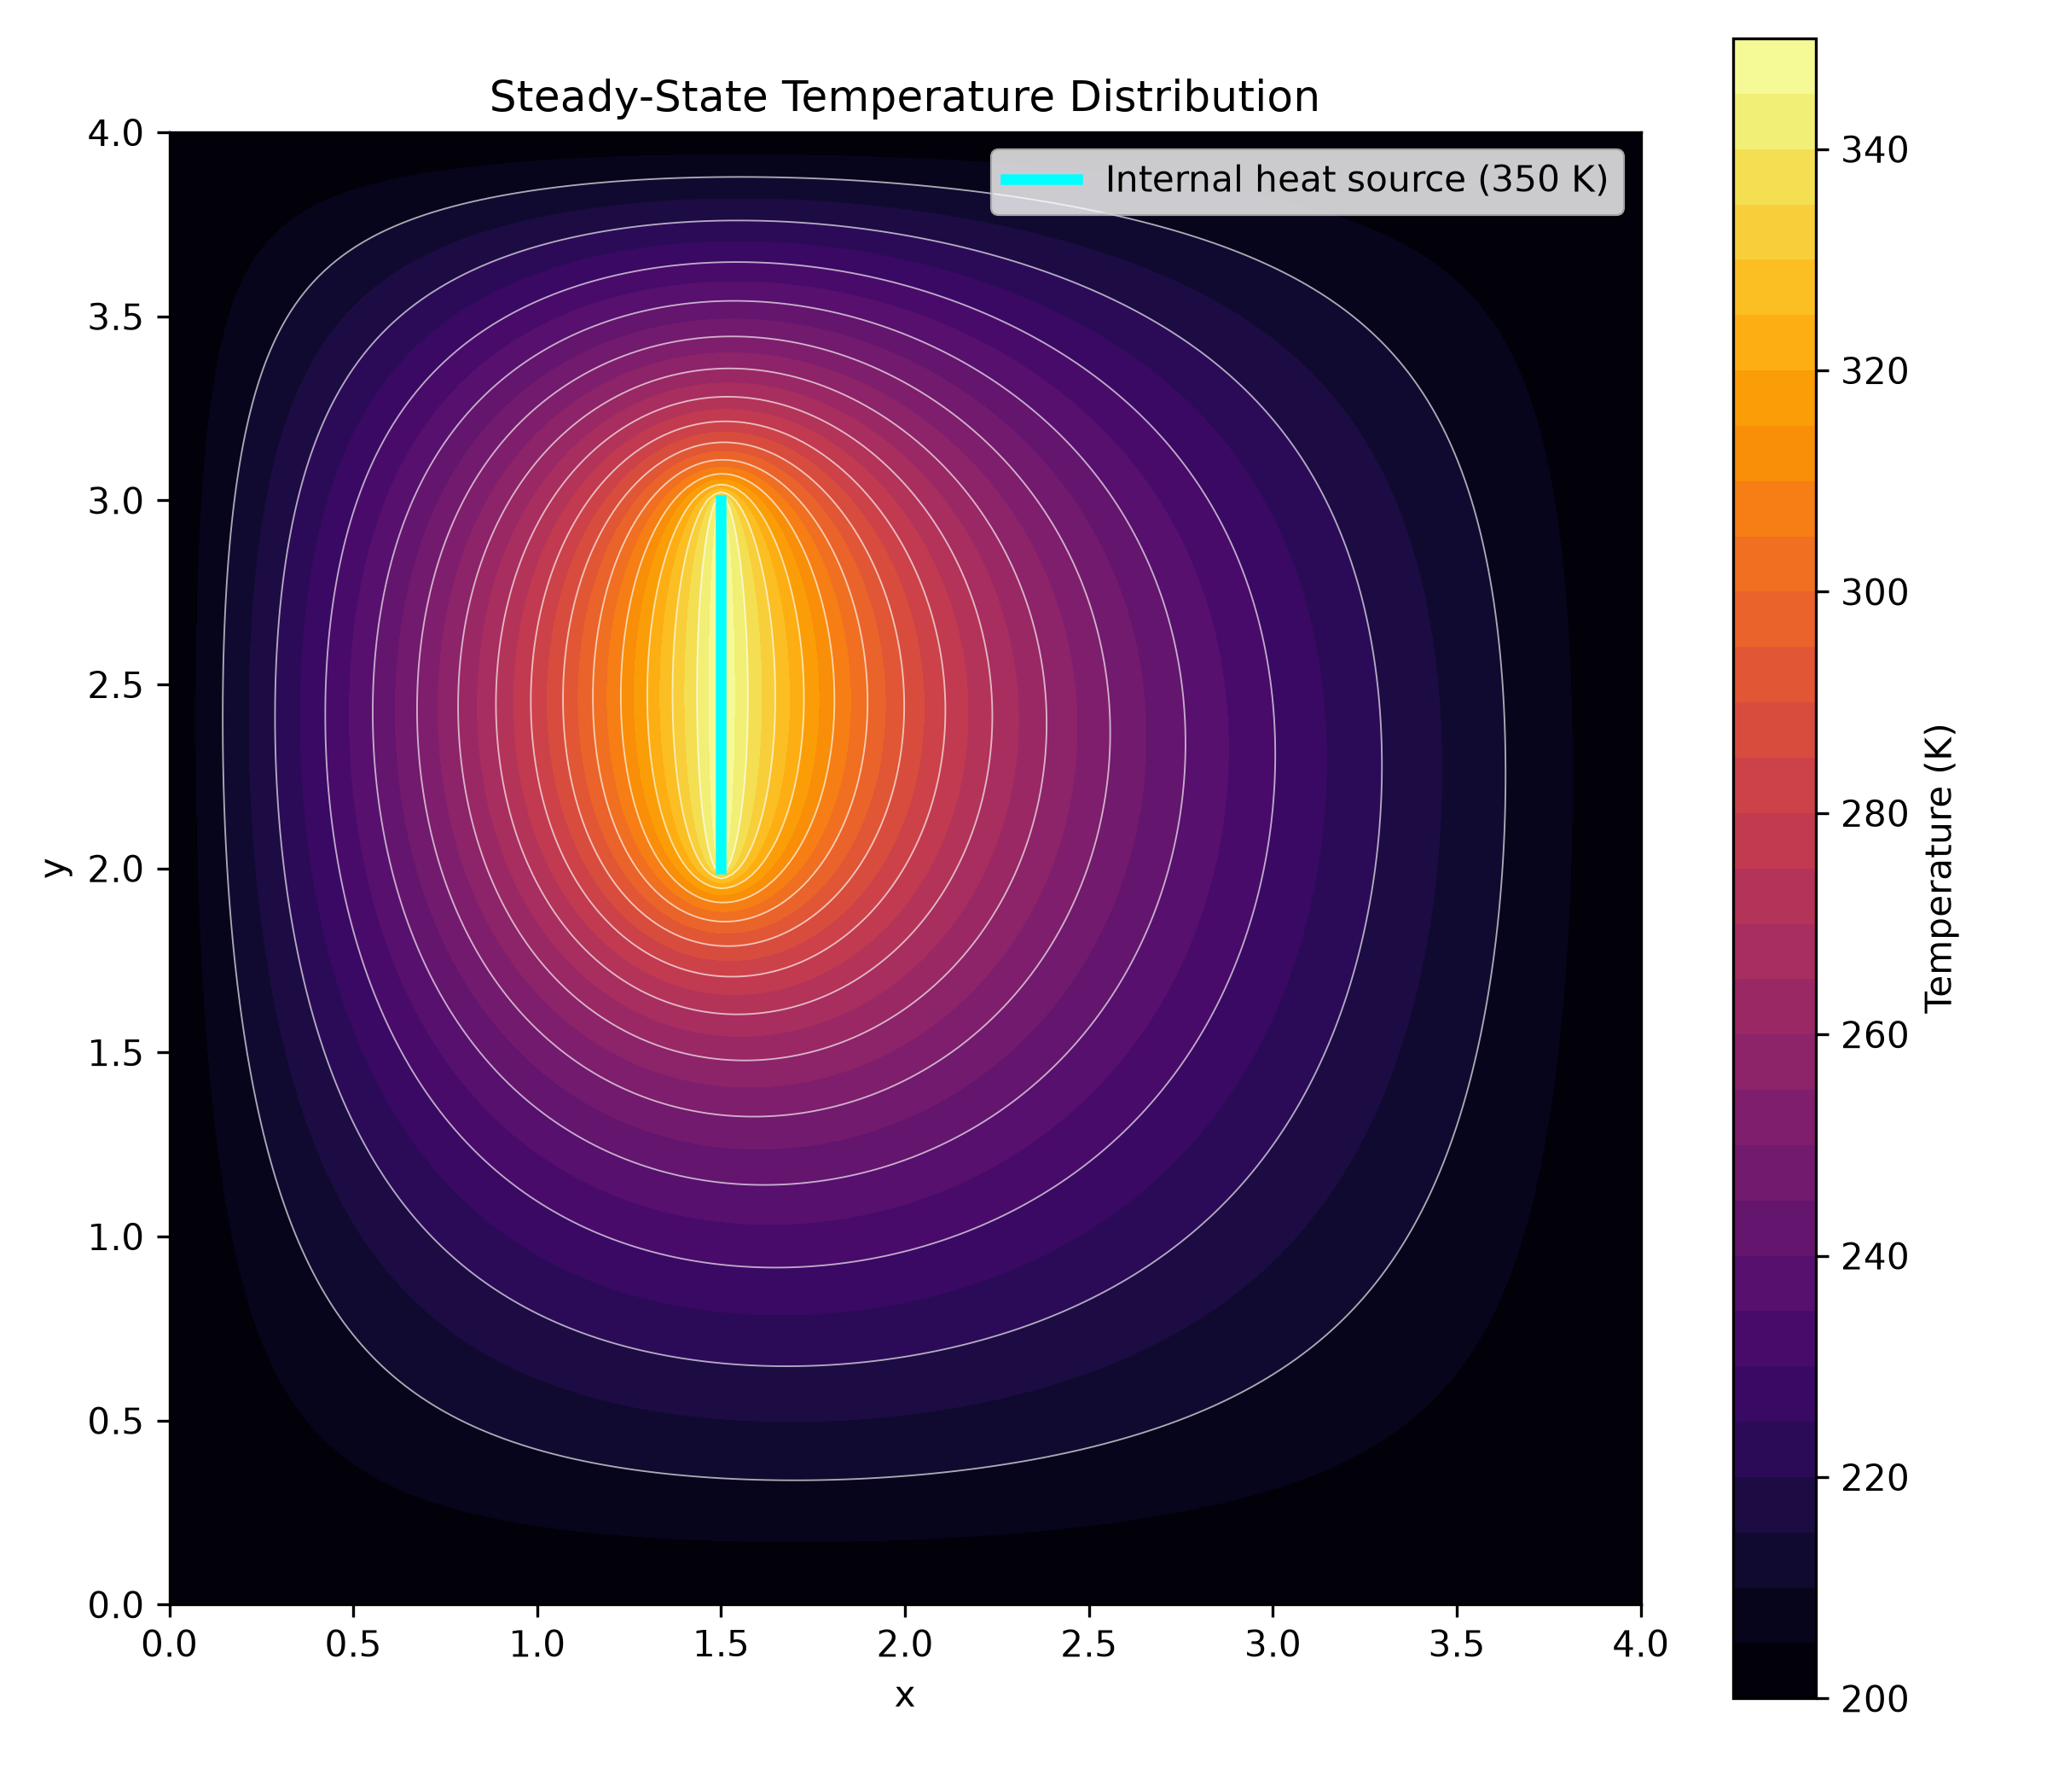
Figure 4.1 Steady-state temperature contour plot obtained using h = 0.015625

4.2 Temperatures at the Nine Required Nodes
The temperatures at the nine specified interior points were extracted directly from the finest-grid solution. Since all nine points coincide with computational grid nodes, no interpolation was required.

Table 4.2 Calculated temperatures at the nine required interior nodes (h = 0.015625)
x | y | Temperature (K)
1 | 1 | 226.6487
2 | 1 | 231.5347
3 | 1 | 216.0715
1 | 2 | 271.8111
2 | 2 | 279.7359
3 | 2 | 229.1359
1 | 3 | 266.4886
2 | 3 | 272.7308
3 | 3 | 224.2339

Among the nine required points, the highest temperature occurs at (2,2), with a calculated value of 279.7359 K. The lowest temperature is found at (3,1), where the temperature is 216.0715 K.
Figure 2 illustrates the positions of the nine required nodes and their corresponding temperatures within the complete temperature field.

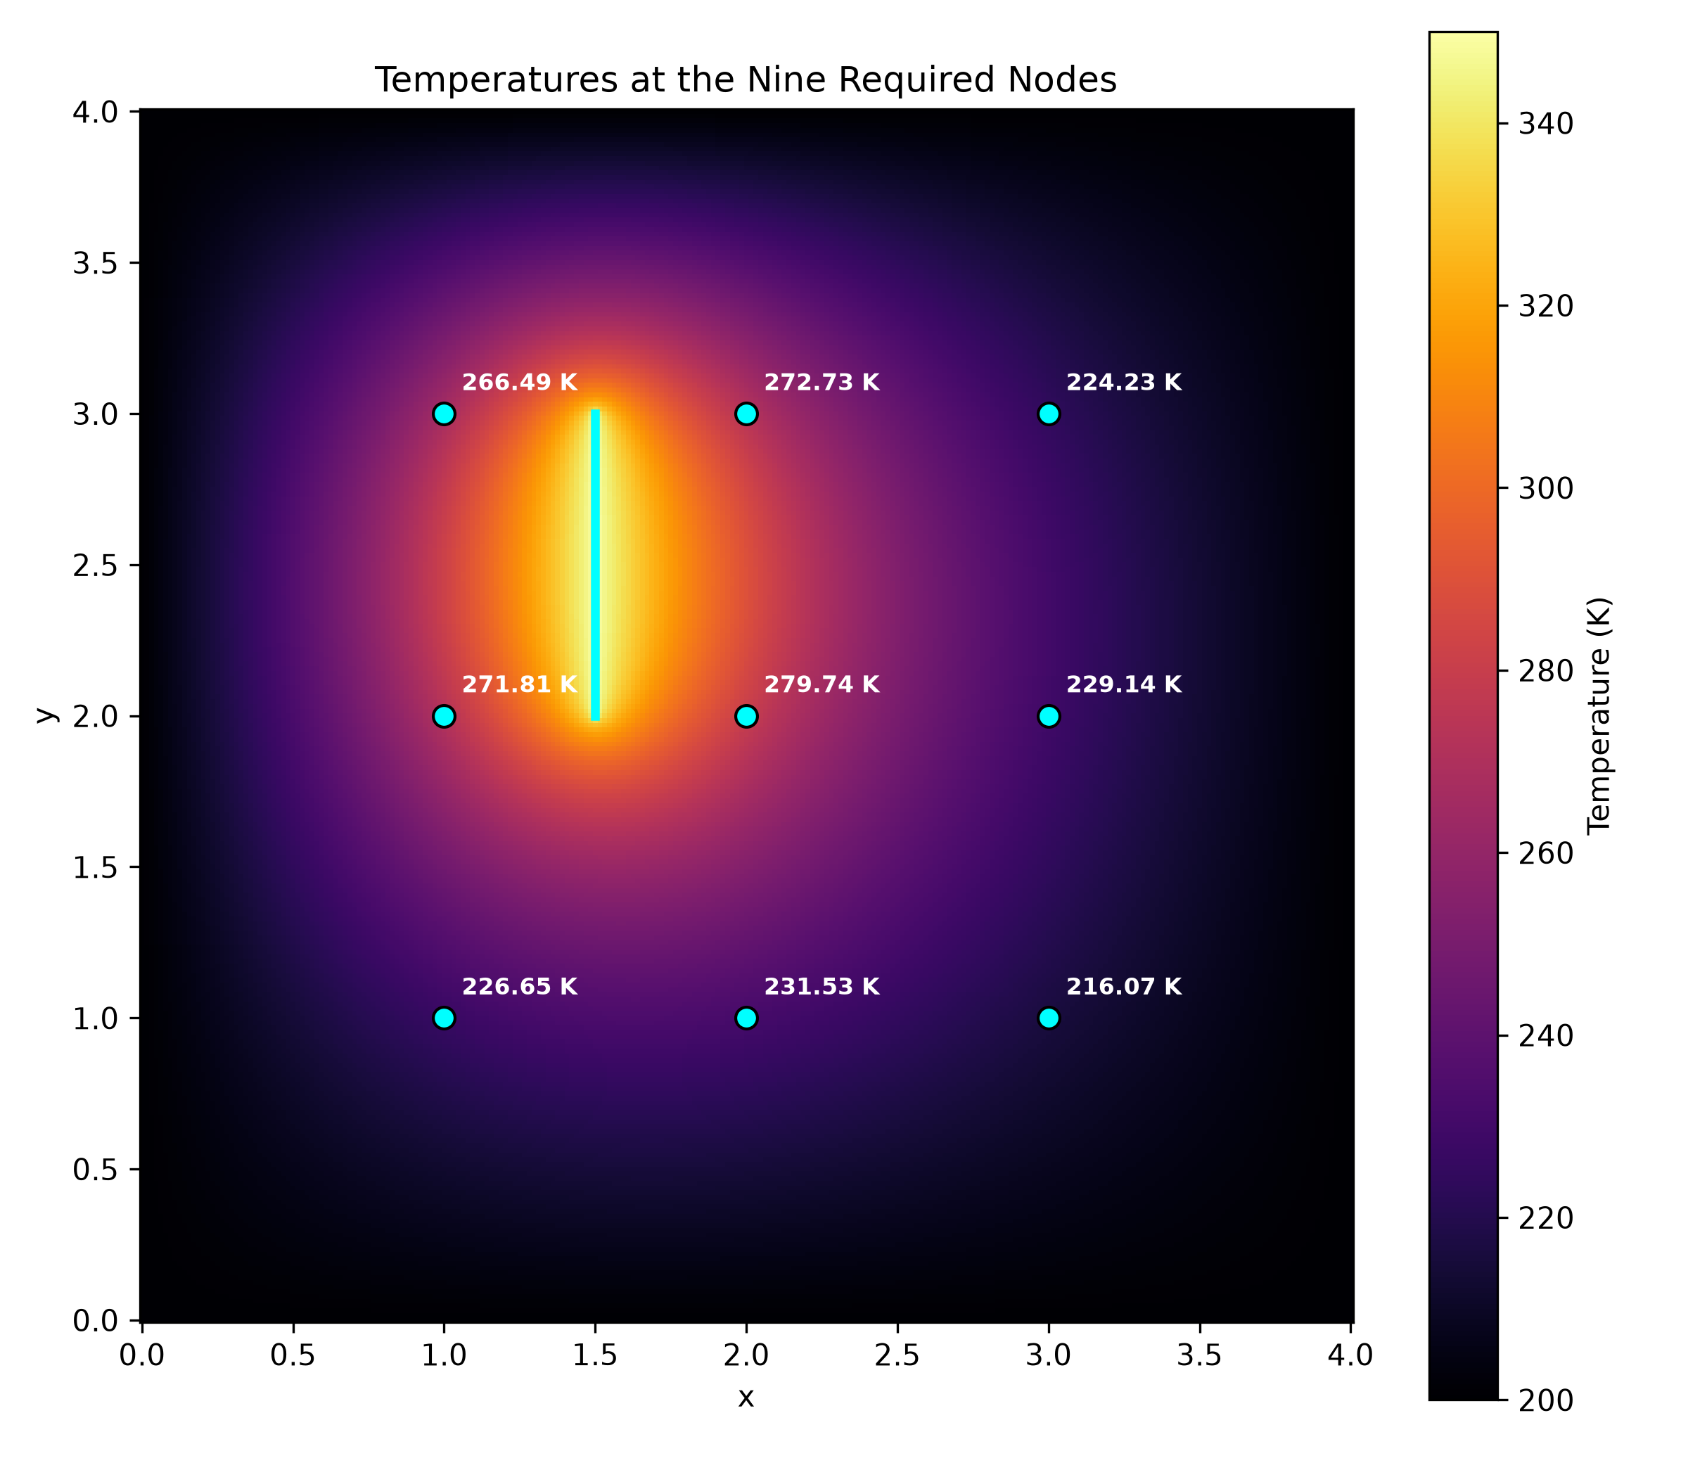
Figure 4.2 Temperature distribution with the nine required interior nodes labelled

4.3 Spatial Characteristics of the Temperature Field
The calculated temperatures show that the distribution is not symmetric about the centre of the plate, owing to the off-centre location of the internal heat source. Points closer to the source generally have higher temperatures, while those farther away tend towards the external boundary temperature of 200 K. For example, along y = 2, the calculated temperatures at x = 1, 2 and 3 are 271.8111 K, 279.7359 K and 229.1359 K, respectively. Although the points (1,2) and (2,2) are equally distant from the internal heat source, the temperature at (2,2) is higher. This difference is consistent with the influence of the external boundary conditions, as (1,2) is closer to the left boundary maintained at 200 K. The temperature distribution therefore depends not only on the distance from the heat source but also on the surrounding boundary conditions.
All computed temperatures lie between 200 K and 350 K, consistent with the maximum principle for Laplace's equation. In this model, the prescribed Dirichlet boundaries include both the external edges at 200 K and the internal heat-source segment at 350 K. The numerical solution therefore remains strictly within this specified range, providing a basic physical consistency check on the results.
The numerical results presented in this section correspond to the finest-grid FDM solution. Their sensitivity to grid resolution and the estimated limiting temperatures are examined separately in Sections 6 and 7.

5. Numerical Verification
To verify the accuracy of the numerical implementation, the finite difference solver was tested against several problems with known analytical solutions. These tests were performed independently of the original heat-source problem, allowing the numerical results to be compared directly with exact temperature values. Both the implementation of the finite difference equations and the treatment of prescribed-temperature boundaries were examined.

5.1 Verification Using Constant and Linear Temperature Fields
Two simple test cases were first considered to check the basic implementation of the solver.
For the constant temperature field,
$$T\left(x,y\right)=200$$
all four external boundaries were maintained at 200 K, with no internal heat source. Since both second-order derivatives are zero, this function satisfies Laplace's equation. The numerical solution reproduced the analytical temperature throughout the computational domain, with a maximum absolute error of 8.527 × 10⁻¹⁴ K.
The second test used a linearly varying temperature field:
$$T\left(x,y\right)=200+10x$$
The corresponding analytical temperatures were imposed along the external boundaries. This function also satisfies Laplace's equation, as its second-order derivatives with respect to both x and y are zero.
At the nine specified interior locations, the analytical temperatures are 210 K, 220 K and 230 K for x = 1, 2 and 3, respectively, regardless of y. The numerical solution reproduced these values, with a maximum absolute error of 5.684 × 10⁻¹⁴ K.
Both tests were performed using a grid spacing of h = 0.5. The maximum algebraic residual was 9.095 × 10⁻¹³ for each test, and the prescribed boundary temperatures were maintained exactly.
These results confirm that the basic matrix assembly, coordinate indexing and boundary-condition implementation reproduce constant and linear analytical temperature fields to approximately machine precision. However, because these functions are represented exactly by the central difference scheme, additional tests are needed to examine the convergence order for more general temperature distributions.

5.2 Verification Using a Smooth Analytical Solution
A non-linear analytical temperature field was subsequently introduced to assess the accuracy of the central finite difference scheme under grid refinement:
$$T\left(x,y\right)=200+\sin{x}\sinh{y}$$
The second derivatives are:
$$\frac{∂^{2}T}{∂x^{2}}=-\sin{x}\sinh{y}$$
$$\frac{∂^{2}T}{∂y^{2}}=\sin{x}\sinh{y}$$
Their sum is zero, confirming that the selected function satisfies the governing Laplace equation.
The analytical temperature values were prescribed along the four external boundaries, and the numerical solution was calculated using five grid spacings from h = 0.5 to h = 0.03125.
The numerical error was evaluated by comparing the computed temperature with the analytical solution at each unknown interior node. The maximum absolute error and root mean square error (RMSE) were calculated as:
$$E_{max}=max\left|T_{num}-T_{exact}\right|$$
$$RMSE=\sqrt{(\frac{1}{N})\sum{{{(T}_{num}-T_{exact})}^{2}}}$$
where N is the number of unknown interior nodes.

Table 5.1 Numerical errors for the smooth analytical solution
Grid spacing, h | Maximum absolute error (K) | RMSE (K)
0.5 | 0.21441449 | 0.10858568
0.25 | 0.05455294 | 0.02565634
0.125 | 0.01375443 | 0.00622538
0.0625 | 0.00344163 | 0.00153274
0.03125 | 0.00086101 | 0.00038024

The maximum absolute error decreased from approximately 0.2144 K to 0.000861 K as the grid was refined. The observed convergence order was calculated using:
$$p=\log_{2}[\frac{E\left(h\right)}{E\left(\frac{h}{2}\right)}]$$
For the final refinement from h = 0.0625 to h = 0.03125, the observed order based on the maximum absolute error was 1.99899, closely matching the theoretical second-order accuracy of the central finite difference scheme.
This result demonstrates that the numerical implementation achieves the expected second-order convergence for a sufficiently smooth analytical temperature field.

5.3 Verification of the Internal Boundary Treatment
To verify the treatment of the internal prescribed-temperature line segment, additional verification tests were conducted to examine whether the numerical implementation remained accurate when internal boundary nodes were introduced.
The following smooth analytical solution was used:
$$T\left(x,y\right)=350+\sin{(x-1.5)\sinh{y}}$$
This function satisfies Laplace's equation and gives:
$$T\left(1.5,y\right)=350K$$
Therefore, it allows a prescribed temperature of 350 K to be imposed along an internal vertical boundary while retaining an exact analytical solution for comparison. The external boundary temperatures in these verification tests were obtained from the analytical function, rather than fixed at 200 K as in the original problem.
Two internal boundary configurations were examined.
Full-length internal boundary
The first test considered a vertical internal boundary at x = 1.5 extending across the height of the plate. The numerical solution was compared with the analytical solution at five grid resolutions.
At h = 0.03125, the maximum absolute error was 0.00065672 K, and the observed convergence order approached 1.99948.
Finite-length internal boundary
The second test used a finite vertical segment at x = 1.5, extending from y = 2 to y = 3, matching the source geometry of the original problem.
The same analytical temperature field was used, and the internal segment was maintained at 350 K. At h = 0.03125, the maximum absolute error was 0.00066181 K, with an observed convergence order of 1.99904.

Table 5.1 Comparison of analytical verification tests involving internal boundaries
Internal boundary configuration | Maximum error at h = 0.03125 (K) | Latest observed order
Full-length vertical boundary | 0.00065672 | 1.99948
Finite-length vertical segment | 0.00066181 | 1.99904

Both tests maintained the prescribed internal boundary temperature with zero reported boundary error. The normalized algebraic residuals remained on the order of 10⁻¹⁶.
The results show that the finite difference implementation can retain second-order convergence for smooth analytical solutions even when internal prescribed-temperature boundaries are present. Therefore, the existence of an internal boundary or a finite-length segment does not necessarily reduce the convergence order to one.
However, these tests do not establish the convergence order of the original problem, where the external boundaries are fixed at 200 K and the internal segment is maintained at 350 K. The behaviour of that particular temperature field is examined through grid convergence analysis in Section 6.

5.4 Summary of Verification Results
The verification tests provide consistent evidence that the finite difference equations and the associated linear system solver have been implemented correctly for the analytical problems considered. The constant and linear temperature fields were reproduced to approximately machine precision. For the smooth non-linear analytical solution, the observed convergence order approached two, as expected from the central difference scheme. Similar second-order convergence was also obtained for the full-length and finite-length internal boundary tests.
Together, these results support the reliability of the numerical implementation. They also establish an important distinction between the theoretical accuracy of the finite difference scheme and the convergence behaviour observed for the original heat-source problem, which is discussed in the following section.

6. Grid Convergence Analysis

6.1 Grid Refinement and Temperature Changes
A grid convergence study was conducted to assess the sensitivity of the calculated temperatures to the spatial discretisation. Six uniform grid spacings were considered, ranging from h = 0.5 to h = 0.015625, with each successive grid having half the spacing of the previous one. The physical dimensions, external boundary temperatures and internal heat-source conditions were kept unchanged throughout the study.
For each grid resolution, the temperatures at the nine required interior points were extracted and compared with those obtained using the preceding grid. The maximum absolute temperature change between two successive grids was calculated as:
$$∆T_{max}=max\left|T_{i}(\frac{h}{2})-T_{i}(h)\right|$$
where the maximum is taken over the nine required points.

Table 6.1 Maximum temperature changes between successive grid refinements
Grid refinement | Maximum temperature change (K)
0.5 → 0.25 | 6.217783
0.25 → 0.125 | 3.131355
0.125 → 0.0625 | 1.448887
0.0625 → 0.03125 | 0.706350
0.03125 → 0.015625 | 0.350467
The maximum temperature change decreased consistently as the grid was refined, from 6.217783 K in the first refinement to 0.350467 K in the final refinement. This indicates that the computed temperatures are becoming less sensitive to the grid spacing.
Figure 4 shows the variation in temperature at all nine required points across the six grid resolutions. The curves gradually approach stable values as the grid spacing decreases, providing further evidence of numerical convergence.

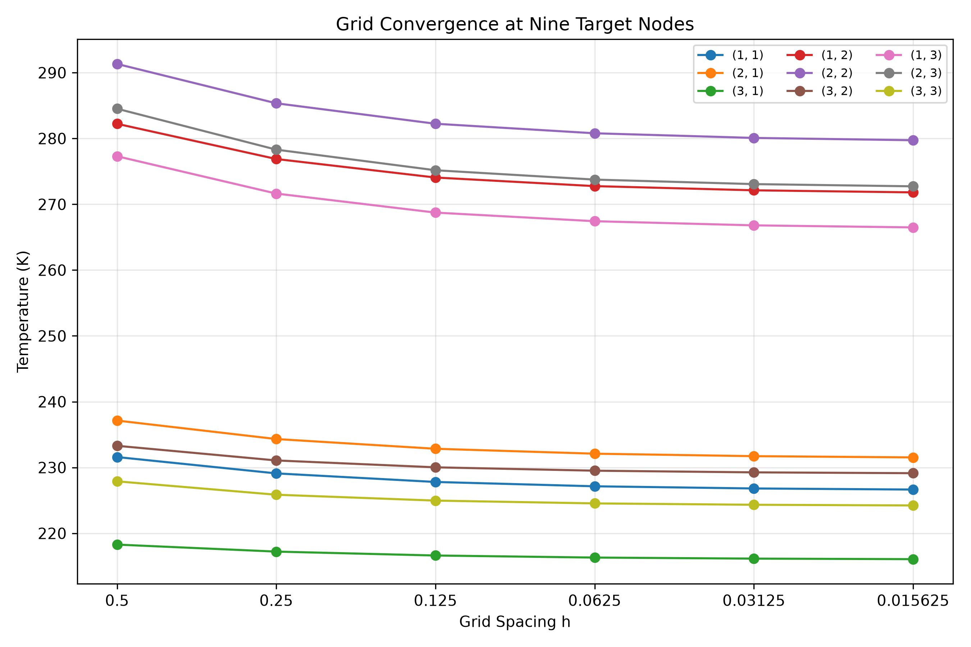
Figure 6.1 Nine target temperatures versus grid spacing across six uniform meshes

6.2 Observed Convergence Order
Although the central finite difference approximation has a theoretical truncation error of O(h²) for sufficiently smooth solutions, the observed convergence order of the numerical solution may differ depending on the properties of the problem.
The observed convergence order was estimated using the temperatures obtained from three consecutive grids:
$$p=\log_{2}(\frac{\left|T\left(h\right)-T\left(\frac{h}{2}\right)\right|}{\left|T\left(\frac{h}{2}\right)-T\left(\frac{h}{4}\right)\right|})$$
This expression assumes a refinement ratio of two and an approximately power-law error behaviour over the selected grid resolutions.
For the three finest grids, h = 0.0625, 0.03125 and 0.015625, the observed convergence orders at the nine required points ranged from 0.98307 to 1.01825, with a mean value of p̄ = 1.00647.
Despite the approximately first-order convergence observed in the original problem, the second-order central finite difference scheme remains a suitable choice for its numerical solution. The implications of this lower convergence order on the choice of numerical method are discussed in Section 8.1.

6.3 Assessment of Grid Independence
The final grid refinement, from h = 0.03125 to h = 0.015625, produced a maximum absolute temperature change of 0.350467 K among the nine required points.
To assess the relative magnitude of this change, the difference at each point was divided by the corresponding temperature from the finest grid:
$$ε_{grid}=\frac{\left|T\left(\frac{h}{2}\right)-T\left(h\right)\right|}{\left|T\left(\frac{h}{2}\right)\right|}×100\%$$
The maximum relative change across the nine points was:
$$ε_{grid,max}=0.12528\%$$
The systematic reduction in temperature changes and the stable observed convergence orders indicate that the numerical results are approaching limiting values.

7. Richardson Extrapolation

7.1 Principle of Richardson Extrapolation
Although the grid convergence study showed that the calculated temperatures approached stable values as the grid was refined, some differences remained between the solutions obtained using successive grid resolutions. Richardson extrapolation was therefore applied to estimate the limiting temperatures as the grid spacing approaches zero.
The method is based on an assumed asymptotic error model:
$$T\left(h\right)=T^{*}+Chᵖ$$
where $T\left(h\right)$is the numerical temperature, $T^{*}$is the estimated limiting temperature as $h$approaches zero, $C$is an error coefficient and $p$is the observed convergence order. The observed order $p$, previously evaluated in Section 6.2, was calculated independently at each target point.$)$
The estimated limiting temperature is then obtained from:
$$T^{*}=\frac{\left[2ᵖT\left(\frac{h}{2}\right)-T\left(h\right)\right]}{2ᵖ - 1}$$
For the original heat-source problem, the observed convergence order was approximately 1. Therefore, the extrapolation was based on the observed order at each target point rather than assuming the theoretical second-order accuracy of the central finite difference scheme.
The three finest grid resolutions, h = 0.0625, 0.03125 and 0.015625, were used for the final extrapolation. This choice reflects the convergence behaviour observed in the finer-grid solutions and avoids relying on the coarser results, which may be further from the asymptotic convergence region.

7.2 Extrapolated Temperature Results
The observed convergence order was calculated independently at each of the nine required points using the three finest grid solutions. The resulting order values ranged from 0.98307 to 1.01825, with a mean of approximately 1.00647.
Table 6 presents the extrapolated temperatures alongside the finest-grid values. As can be seen, the extrapolated values are consistently slightly lower than the numerical temperatures.

Table 7.1 Finest-grid temperatures and Richardson extrapolation estimates
Point (x,y) | Finest-grid temperature (K) | Observed order, p | Richardson estimate (K)
(1,1) | 226.6487 | 0.997896 | 226.4828
(2,1) | 231.5347 | 0.996778 | 231.3454
(3,1) | 216.0715 | 0.983072 | 215.9885
(1,2) | 271.8111 | 1.011235 | 271.5006
(2,2) | 279.7359 | 1.011105 | 279.3908
(3,2) | 229.1359 | 1.006469 | 229.0108
(1,3) | 266.4886 | 1.017960 | 266.1851
(2,3) | 272.7308 | 1.018250 | 272.4012
(3,3) | 224.2339 | 1.015435 | 224.1331
The extrapolated temperatures are consistently slightly lower than the corresponding finest-grid numerical values. This agrees with the observed trend in the grid convergence study, where the calculated temperatures decreased as the grid spacing was reduced.

7.3 Assessment of Extrapolation Corrections
The difference between the finest-grid numerical temperature and its Richardson estimate was used to assess the magnitude of the extrapolation correction:
$${∆T}_{R}=\left|T_{R}-T_{fine}\right|$$
The maximum absolute correction among the nine target points was 0.34513 K, while the mean absolute correction was 0.21699 K.
To express the correction relative to the prescribed temperature difference between the internal heat source and the external boundaries, a reference temperature difference of 150 K was used:
$$ε_{R}=\frac{\left|T_{R}-T_{fine}\right|}{350-200}×100\%$$
The maximum relative correction based on this reference temperature difference was approximately 0.2301%.
For comparison, the maximum correction relative to the absolute Richardson temperature was approximately 0.1235%. These percentages use different reference values and should therefore be interpreted accordingly.
The corrections indicate that the finest-grid temperatures are reasonably close to the estimated limiting values. However, Richardson extrapolation relies on the assumed asymptotic error model, and the extrapolated correction is not a rigorous upper bound on the true discretisation error.
Consequently, the finest-grid numerical solution remains the primary computed result, while the Richardson estimates provide supplementary reference values for assessing the remaining grid sensitivity.

8. Discussion and Limitations

8.1 Suitability of the Numerical Method
The second-order central finite difference method was selected because it provides a direct numerical approximation of the governing Laplace equation and is consistent with the numerical differentiation techniques covered in Chapter 5.5 of the course. The regular geometry of the plate also makes the use of a uniform Cartesian grid appropriate. The analytical verification results in Section 5 support this choice. The numerical implementation achieved approximately second-order convergence for smooth analytical temperature fields, including test cases with both full-length and finite-length internal prescribed-temperature boundaries. These results demonstrate that the selected discretisation can achieve its expected accuracy under suitable solution conditions.
Although the original problem exhibited approximately first-order convergence, this does not invalidate the use of the second-order central difference formulation. The observed behaviour indicates that the convergence of the complete numerical solution depends not only on the order of the finite difference formula but also on the characteristics of the temperature field and the boundary configuration. The method was therefore retained because it has a clear theoretical basis, was verified against analytical solutions and provides a systematic means of obtaining the required temperatures through grid refinement, without requiring an unnecessarily advanced numerical framework.

8.2 Explanation of Convergence Behaviour of the Original Problem
The original heat-source problem exhibited an average observed convergence order of approximately 1.0065 at the nine required points. This behaviour differs from the approximately second-order convergence obtained in the analytical verification tests. One possible explanation is the reduced smoothness of the temperature field near the two endpoints of the finite-length internal heat source, located at (1.5,2) and (1.5,3).
Despite this behaviour, all nine calculated temperatures changed consistently towards stable values as the grid was refined. The observed convergence order also became increasingly consistent across the nine points on the finer grids.

8.3 Accuracy and Reliability of the Results
The reliability of the numerical results was assessed using analytical verification, algebraic residual checks, grid refinement and Richardson extrapolation. The normalised algebraic residuals remained below 5 × 10⁻¹⁶ across all six grid resolutions, confirming that the linear systems were solved with machine-level accuracy. The prescribed external and internal boundary temperatures were also maintained exactly in the numerical implementation.
For the original problem, the maximum temperature difference between the two finest grids was 0.35047 K. The corresponding maximum relative inter-grid change, calculated using the finest-grid absolute temperatures, was approximately 0.1253%.
Richardson extrapolation provided additional estimates of the limiting temperatures. The maximum absolute correction relative to the finest-grid solution was 0.34513 K. When expressed relative to the prescribed 150 K temperature difference between the internal source and external boundaries, this correction was approximately 0.2301%. These results confirm that the finest-grid temperatures are sufficiently close to their estimated limiting values, providing a reliable primary dataset for Part A.

9. Conclusion
The steady-state temperature distribution of the square plate was successfully obtained using the second-order central finite difference method and a system of linear algebraic equations. The nine required interior temperatures were calculated using the finest grid spacing of h = 0.015625, with the complete temperature field also obtained for subsequent heat-transfer analysis.
Richardson extrapolation provided additional estimates of the limiting temperatures, with a maximum correction of 0.3451 K relative to the finest-grid solution. Overall, the finite difference approach provided a suitable and computationally practical solution for Part A, with its numerical limitations identified and assessed.

