Pressure Field Reconstruction and Numerical Validation from Sparse Sensor Data
  - Authors: [Full names of all members]
[University and department] ME5704 Course Project

Abstract
This study reconstructs a robotic hand pressure field from five irregularly spaced sensor measurements. A standardised minimum-norm quadratic, a thin-plate spline (TPS), a Hertz contact model and a ring-shaped Gaussian are compared. Five readings do not uniquely identify the true field: near-zero training error does not ensure correct damage or pain predictions. In this example, model assumptions and the computational domain affect the conclusions much more than rounding errors in the linear algebra.
Within the sensor convex hull, the quadratic has the global pressure range [2, 43], and numerical TPS searches give approximately the same range. Neither predicts zero pressure or threshold exceedance there. However, the largest-width ring solution predicts a peak of 65.20, above the threshold of 50. Four exact ring fits found by multistart search have peaks from 45.23 to 131.76. The available measurements therefore support conditional predictions rather than an unconditional conclusion about pain or safety.
Keywords: pressure reconstruction; sparse data; thin-plate spline; constrained optimisation; Monte Carlo analysis

1 Introduction and Problem Definition
Pressure sensing can support the assessment of contact conditions and abnormal regions in a robotic hand. Loss of sensor data makes reconstruction of a continuous field underdetermined. Interpolating a few measurements raises two distinct questions: whether the numerical programme is accurate, and whether its assumptions support predictions at unmeasured locations. This study compares four model families on a common domain, using leave-one-out checks, domain sensitivity and noise perturbations to distinguish numerical error from model uncertainty.

1.1 Tasks and Measurements
Table 1 Sensor coordinates and measured pressures
Sensor | x | y | Pressure
S1 | 0.0 | 0.5 | 2
S2 | 1.3 | 1.1 | 17
S3 | 1.9 | 0.1 | 43
S4 | 2.5 | 2.3 | 28
S5 | 0.7 | 1.8 | 36

The tasks are to (a) construct p(x,y), (b) determine all zero-pressure locations and identify negative-pressure regions, and (c) find the maximum pressure and its location, then compare it with 50. The assignment supplies no coordinate units, pressure units or hand boundary. Its numerical values are retained without assuming units such as kPa.

1.2 Computational Domain and Scope
The primary domain Ω is the closed convex hull S1–S3–S4–S5, with S2 inside it. This is a modelling convention intended to reduce extrapolation, not a known physical hand boundary. The bounding rectangle B=[0,2.5]×[0.1,2.3] is also considered to assess domain sensitivity. Every statement about the absence of predicted damage is conditional on the model and domain.
The quadratic is used as a working model because its extrema are analytically checkable. TPS provides a smooth interpolation comparison; Hertz tests a single concave contact surface; the ring model illustrates the consequences of non-unique fits. Physical context remains necessary for the group's final model choice.

1.3 Error Measures and Types of Evidence
Let the training residual be eᵢ=p̂(xᵢ,yᵢ)−pᵢ. Equations (1)–(3) define the error measures. Training residuals quantify agreement with the observations, leave-one-out errors assess predictions after removing a measurement, and known-answer tests assess implementation accuracy. These measures are not interchangeable.
$SSE = ∑{e_{i}}^{2}$ (1)
$RMSE = \sqrt{\frac{SSE}{n}}$ (2)
$MAE = \frac{1}{n}∑|e_{i}|$ (3)
Three types of evidence are distinguished: analytical or structural results, such as quadratic candidate enumeration and ring positivity; numerical findings within specified bounds and initialisations, such as TPS extrema and nonlinear fits; and engineering interpretations requiring additional assumptions, such as treating p≤0 as damage. The domain and limitations are stated for each.

2 Pressure Models and Fitting Methods

2.1 Standardised Minimum-Norm Quadratic
Define u=(x−1.28)/0.8772684880 and v=(y−1.16)/0.8089499366, with basis [1,u,v,u²,uv,v²]. Five observation equations contain six unknown coefficients. numpy.linalg.lstsq selects the exact solution with the smallest Euclidean norm of the standardised coefficients, following its minimum-norm convention. In the original coordinates, the fitted model is given by Equation (4).
$p_{Q}(x,y) = 3.32315329 + 23.47706372x − 12.07575398y$
$−0.11982143x^{2} − 18.30543443xy + 18.85889480y^{2}$ (4)
This additional criterion selects one solution without removing the uncertainty inherent in the data. Rescaling the basis or changing coordinate directions can change the minimum-norm solution. Standardisation is therefore part of the model definition, not merely a numerical preprocessing step.

2.1.1 Underdetermination and Additional Constraints
The five-by-six design matrix has rank five, leaving one coefficient direction undetermined. If b* is an exact solution and n a null-space vector, b*+tn fits all five observations for every t. Minimum norm selects t, but this criterion is not derived automatically from contact mechanics. Curvature and extrema between sensors therefore depend on modelling choices.

2.1.2 Numerical Use of the Model
Extrema are evaluated using full-precision coefficients; the eight decimal places in the displayed formula are for presentation. Truncation introduces small residuals that should not be mistaken for solver error. Each leave-one-out fold recomputes the mean and standard deviation from its training coordinates, preventing the held-out location from entering the fit transformation.

2.2 Thin-Plate Spline
TPS combines an affine term with radial basis functions. Equation (5) uses the thin-plate kernel and affine augmentation described in the RBF interpolation documentation.
$p_{TPS}(x,y) = a_{0} + a_{1}x + a_{2}y + ∑w_{i}φ(r_{i})$ (5)
Here φ(r)=r² ln r, with φ(0)=0; each row of P is [1,xᵢ,yᵢ]. The augmented linear system [K+λI, P; Pᵀ, 0][w; a]=[p; 0] determines the coefficients subject to Pᵀw=0. Setting λ=0 gives exact interpolation. Minimising bending energy is not equivalent to minimising prediction error.
The TPS comparison is recomputed with an independent implementation. For λ=0, a common translation, rotation and uniform change of length scale preserve predictions at corresponding physical locations. For λ>0, both length scale and smoothing must be specified; smoothing parameters under different normalisations are not directly comparable.

2.2.1 Smoothness and Parameter Interpretation
TPS retains affine behaviour while radial terms accommodate local curvature, without imposing elliptical or ring-shaped pressure. It can overshoot below zero and does not enforce positivity between sensors. Choosing λ=0 avoids selecting a smoothing strength but assumes that observations should be interpolated exactly; noisy measurements need not justify that assumption.

2.3 Hertz and Ring-Shaped Gaussian Models
Equations (6) and (7) define the Hertz and ring-shaped Gaussian models. Hertz pressure is truncated to zero outside the contact ellipse. Ring pressure decreases as a Gaussian function of distance from the crest circle.
$p_{H} = p_{0}\sqrt{max\{0, 1 − \frac{{(x − x_{0})}^{2}}{a^{2}} − \frac{{(y − y_{0})}^{2}}{b^{2}}\}}$ (6)
$p_{R} = A exp[\frac{−{(r − R)}^{2}}{2{σ_{r}}^{2}}]$ (7)
The radial distance is r=√[(x−x₀)²+(y−y₀)²]. The SciPy comparison uses bounded nonlinear least squares through least_squares.
Table 2 Fitting procedures and selection criteria
Model | Data fit | Fitting or selection rule
Quadratic | Exact interpolation | Minimum norm in standardised basis
TPS λ=0 | Exact interpolation | Minimum bending energy
Hertz | RMSE 9.135 | Bounded nonlinear least squares with penalty
Ring | Four exact fits found | Largest σr among solutions found

The fitted Hertz parameters (p₀, x₀, y₀, a, b) are approximately (35.059, 1.731, −5, 1.790, 22.380), with SSE=417.268. The selected ring parameters (A, x₀, y₀, R, σr) are (65.199, 0.472865, 0.451401, 1.994998, 0.575664). Here σr denotes ring width; σn later denotes measurement-noise standard deviation.

2.3.1 Sensor-Level Hertz Residuals
Table 3 Hertz predictions and residuals
Sensor | Measured | Hertz prediction | Residual
S1 | 2 | 2.193 | +0.193
S2 | 17 | 32.658 | +15.658
S3 | 43 | 33.976 | -9.024
S4 | 28 | 29.519 | +1.519
S5 | 36 | 26.602 | -9.398

The largest absolute residual, about 15.658, occurs at S2. The model also underpredicts S3 by 9.024 and S5 by 9.398. These errors are associated with the locally low pressure at S2 rather than being distributed uniformly. SSE=417.268 should not be attributed only to solver performance: the concavity argument in Section 8 also identifies a conflict between the assumed surface shape and the readings.

3 Surface Shape and Predictive Performance
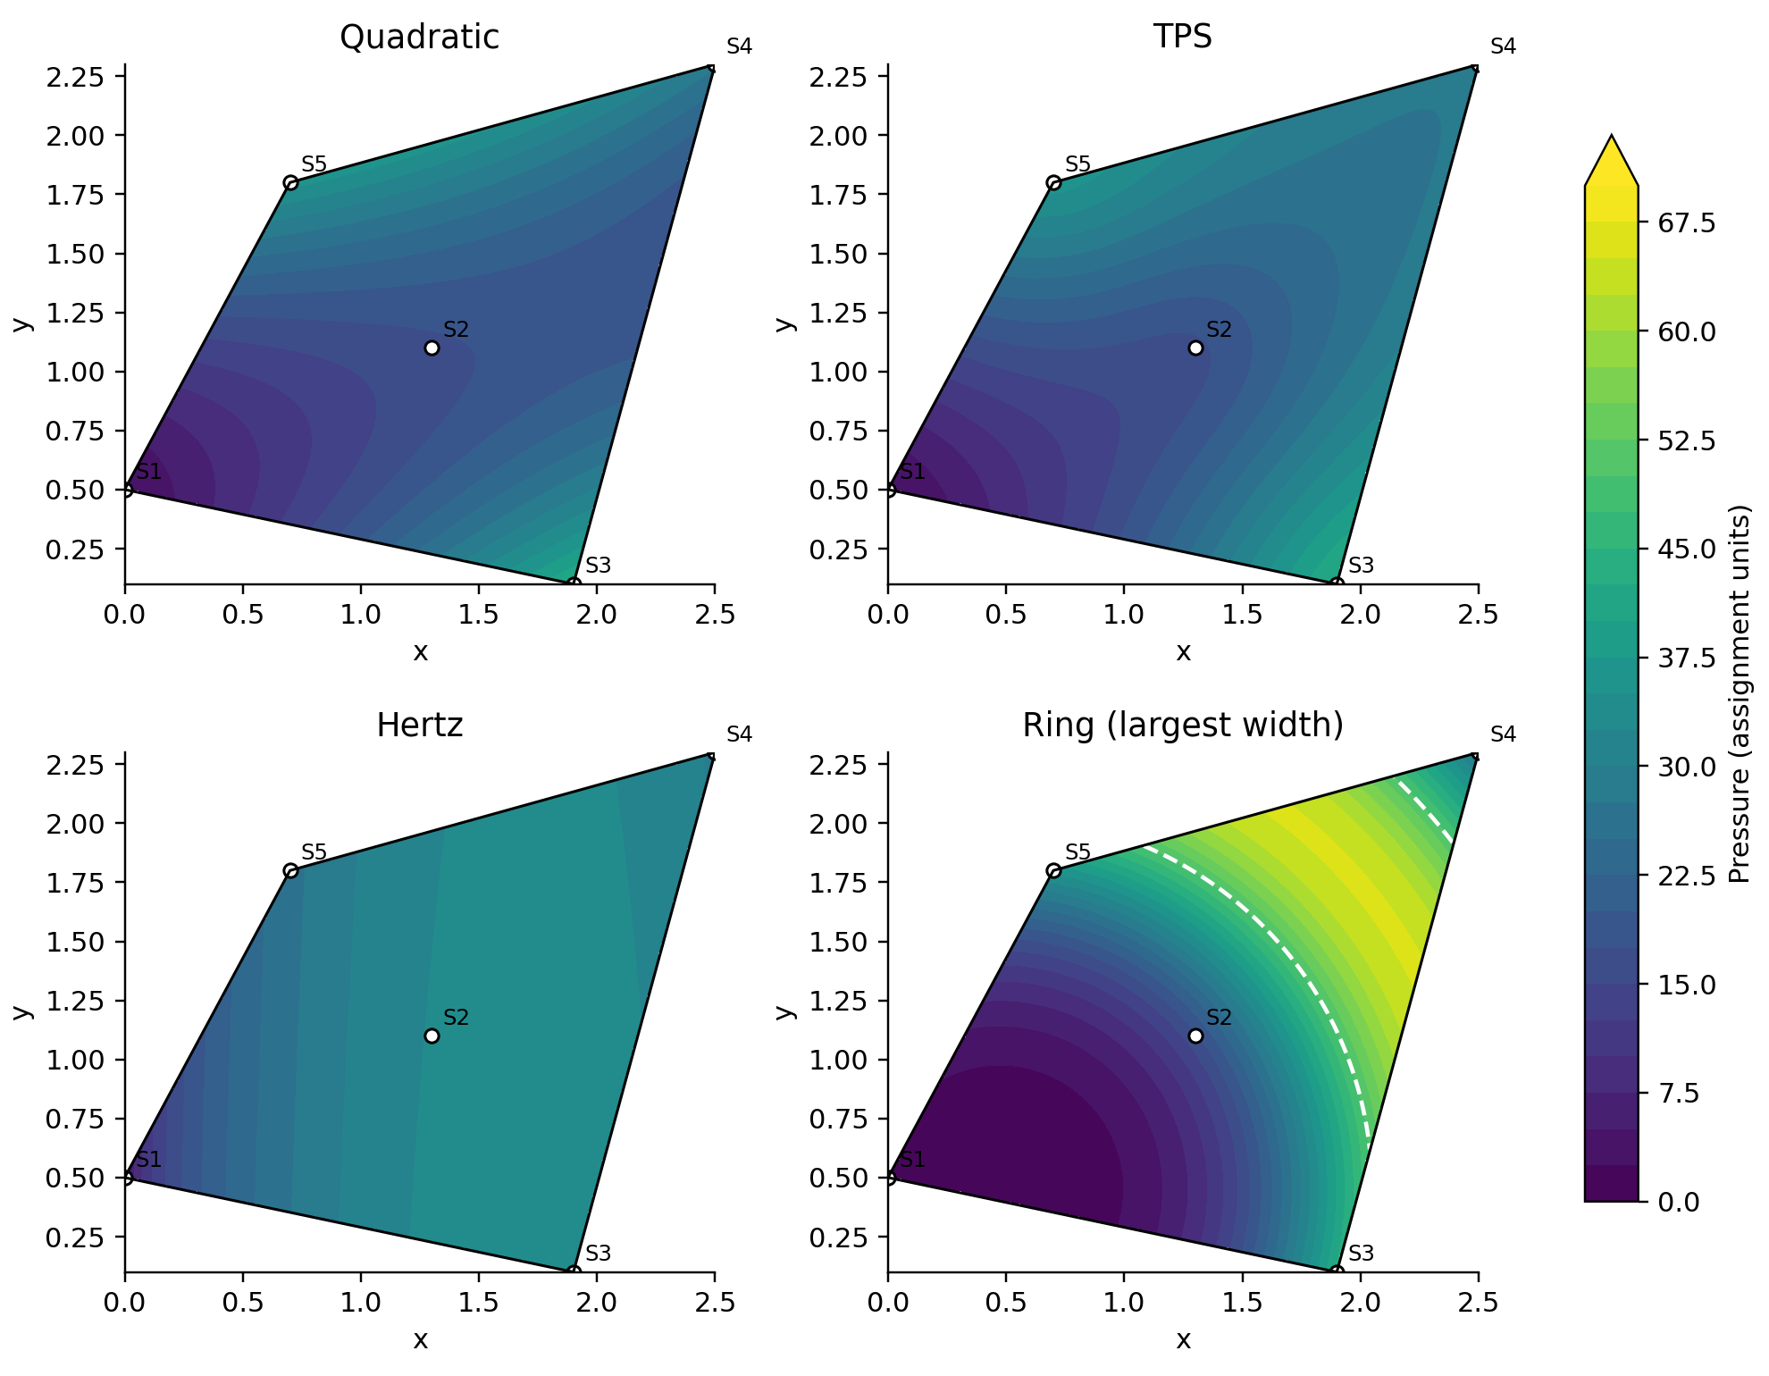
Figure 1 Pressure fields on the same sensor hull, with a common scale from 0 to 70. White dashed contours mark p=50; white dots indicate sensors.
Identical sensor readings can support substantially different internal curvature and peaks. Hertz cannot reproduce both the surrounding high readings and the low S2 reading. The ring model introduces a high-pressure crest between sensors that has not been directly measured.
Table 4 Interior hold-out and extrapolation errors
Model | S2 prediction | S2 absolute error | Four-fold extrapolation RMSE
Quadratic | 17.5737 | 0.5737 | 45.42
TPS | 36.597 | 19.597 | 44.05
Training mean | 27.250 | 10.250 | 19.56
Bounded ring | 32.968 | 15.968 | 249.93; bound-sensitive

Holding out S2 tests interpolation; holding out each of the other sensors tests extrapolation. Fits use only the retained observations. The quadratic performs best at the single interior hold-out location, but this is not fully independent validation if S2 was used to select the model or scaling. Both quadratic and TPS extrapolation errors exceed those of the training-mean baseline, indicating that reliable extrapolation is not supported by these data.

3.1 Sensor-Level Leave-One-Out Predictions
Table 5 Leave-one-out predictions at each sensor
Held-out sensor | Measured | Quadratic | TPS | Mean baseline
S1 | 2 | 77.040 | 40.433 | 31.000
S2 | 17 | 17.574 | 36.597 | 27.250
S3 | 43 | 19.987 | -13.708 | 20.750
S4 | 28 | 70.924 | 67.570 | 24.500
S5 | 36 | 20.225 | -2.766 | 22.500

3.1.1 Interpretation of the Interpolation Fold
S2 remains inside the hull of the other four sensors. Its quadratic prediction is 17.574, only 0.574 from the measured value of 17, whereas TPS predicts 36.597, an error of 19.597. This favours the chosen quadratic at that test location. However, one interior hold-out cannot establish an error distribution throughout the domain or guarantee more accurate peak prediction.

3.1.2 Interpretation of the Extrapolation Folds
When S1 is withheld, the quadratic predicts 77.040 instead of 2. TPS predicts −13.708 instead of 43 at withheld S3 and also predicts a negative value at withheld S5. These errors motivate restricting the primary conclusions to the sensor hull. The constant baseline has a four-fold RMSE of 19.56, lower than either spatial model, but lacks useful spatial structure. It diagnoses extrapolation risk rather than replacing pressure-field reconstruction.

4 Zero-Pressure Locations and Damage

4.1 Results Within the Convex Hull
The quadratic has a global minimum of 2 at S1 on Ω. This follows from checking all vertices, stationary points on every edge and interior stationary points, without relying on a finite grid. Consequently, {pQ=0}∩Ω and {pQ<0}∩Ω are both empty. Multistart constrained TPS searches with vertex checks also give a minimum near 2. This is numerical evidence, not a general proof of global TPS bounds.
All sensors lie strictly inside the fitted Hertz ellipse. Convexity of the ellipse places their entire hull inside it, so Hertz pressure is positive on Ω. For A>0 and σr>0, ring pressure is positive at every finite location. Its inability to represent negative pressure means that absence of predicted negative pressure cannot independently demonstrate absence of damage.

4.2 Zero Sets Outside the Convex Hull
Writing the quadratic as Ay²+B(x)y+C(x)=0 gives all its real zero locations through Equation (8).
$y = \frac{−B(x) ± \sqrt{Δ(x)}}{2A}, Δ(x) = {B(x)}^{2} − 4AC(x) ≥ 0$ (8)
Here A=18.85889480, B(x)=−12.07575398−18.30543443x, and C(x)=3.32315329+23.47706372x−0.11982143x². When A>0 and Δ>0, pressure is negative between the two roots. To apply the mathematical zero set to the hand, it must be intersected with the actual physical domain.
For Hertz, the zero set is the entire region q≥1, including the ellipse boundary and its exterior; reporting only q=1 omits infinitely many zero locations. The ring zero set is empty. TPS zero contours are traced numerically in a finite window, which cannot exhaust all zeros on the whole plane.
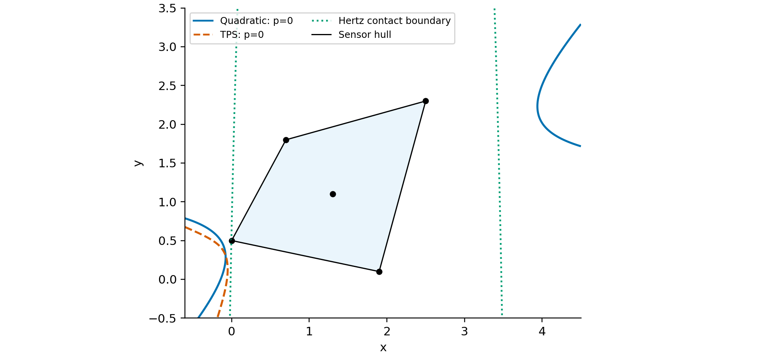
Figure 2 Exploratory zero contours outside the hull. The dotted green line marks the Hertz contact boundary; its exterior is also zero. Blue shading marks the sensor hull.
Figure 2 suggests a region to the left of S1 where additional readings would be informative. Extrapolated zero contours cannot be treated directly as physical damage boundaries. Hand geometry, contact conditions or new measurements are required for that interpretation.

4.3 Completeness and Physical Interpretation

4.3.1 Completeness for the Working Model
The quadratic is continuous on a closed bounded hull and must attain a minimum. A strictly positive global minimum rules out all zeros and negative values in that domain, avoiding an argument based only on unsuccessful line scans. The minimum of 2 leaves a margin of just 2 above zero, so noise sensitivity remains relevant.

4.3.2 Contact Conditions and Damage Criteria
Zero Hertz pressure outside the ellipse arises from contact truncation and may represent non-contact. The assignment treats zero pressure as a damage indicator, but non-contact and structural damage are physically different. Ring positivity excludes zero-pressure damage by construction. The mathematical zero set, the assignment's rule and the underlying physical cause must therefore be discussed separately.

5 Maximum Pressure and the Pain Threshold
Table 6 Maximum pressure within the hull
Model | Maximum in Ω | Location or set | Above 50
Quadratic | 43.000 | S3 (1.9,0.1) | No
TPS | ≈43.000 | S3 in numerical search | No
Hertz | ≈34.124 | ≈(1.738,0.134) | No
Selected ring | 65.199 | Crest r=R intersected with Ω | Yes

The interior quadratic stationary point is approximately (1.9308,1.2572), with p=18.397. Hessian eigenvalues of about −7.629 and 45.107 identify a saddle. Comparing the four edges and vertices gives the global maximum of 43. Solving only ∇p=0 would miss the constrained maximum.
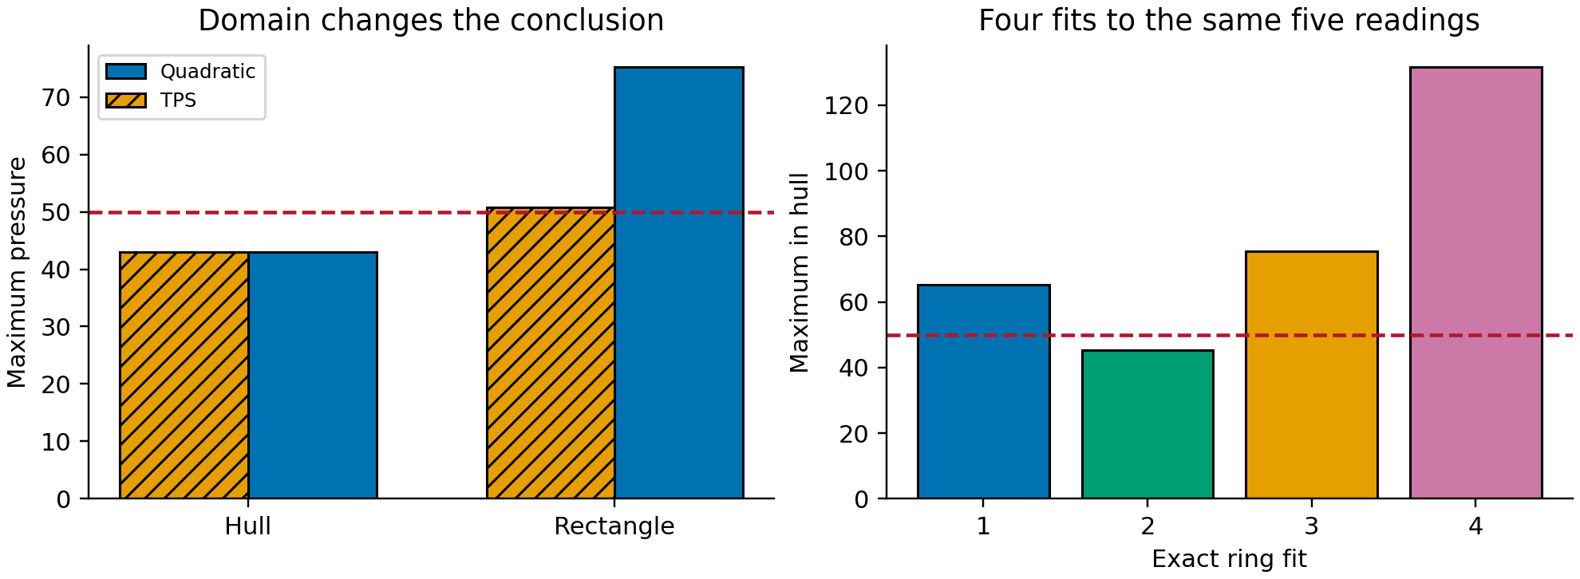
Figure 3 Left: hull versus bounding rectangle. Right: four exact ring fits. Red dashed lines mark the pressure threshold of 50.
On the bounding rectangle, the quadratic maximum becomes 75.312 at (0,2.3), and the numerical TPS maximum is 50.789 at (2.5,0.1). Both locations lie outside the sensor hull; these are extrapolation-sensitivity results rather than replacements for hull results. Without a bounded domain, the quadratic grows without bound in some directions and has no finite whole-plane maximum.
The four exact ring fits found have hull peaks of 65.199, 45.230, 75.381 and 131.761. Finding four solutions by random multistart search does not prove that exactly four exist. Three threshold exceedances among four unweighted fits do not constitute a 75% probability of pain.
In the stored ring Newton trials, four starts do not converge; the only endpoint reaching the crest lies outside the hull. Projected ascent and boundary searches find a peak within the hull. Since p≤A and the crest intersects Ω, the selected model's global hull maximum is directly established as A.

5.1 Boundary Searches and Multiple Solutions

5.1.1 Quadratic Boundary Candidates
Table 7 Quadratic maxima on the hull edges
Hull edge | Maximum on edge | Location
S1–S3 | 43.000 | S3
S3–S4 | 43.000 | S3
S4–S5 | 36.354 | ≈(1.00733,1.88537)
S5–S1 | 36.000 | S5

The local maximum on S4–S5 is below the global maximum of 43. A local projected-ascent method can stop at that boundary maximum. Multiple starts help reveal differing solutions, but complete boundary enumeration provides the direct global check for this quadratic. A stationary point found by parabolic interpolation must also be compared with endpoints before being called a constrained maximum.

5.1.2 Differences Between Exact Ring Fits
Table 8 Parameters and peaks of four exact ring fits
Fit | A and hull peak | R | σr | Peak minus 50
1 | 65.199 | 1.995 | 0.576 | +15.199
2 | 45.230 | 0.979 | 0.365 | -4.770
3 | 75.381 | 1.116 | 0.296 | +25.381
4 | 131.761 | 1.398 | 0.265 | +81.761

The widest-ring solution exceeds the threshold by 15.199, whereas the second solution is 4.770 below it. Selecting the largest width favours a broader ring but neither directly constrains peak height nor minimises prediction error. Both the selected result and the range of alternative fits must be reported.

6 Measurement Noise and Stability
Each measurement is perturbed independently by Gaussian noise εᵢ~N(0,σn²), where σn is 2%, 5% or 10% of the pressure range 41. Each level uses 1000 simulations. This is a sensitivity assumption, not an instrument calibration result. Reported intervals are the 2.5th and 97.5th percentiles of simulated outcomes, not confidence intervals for the true physical pressure.

6.1 Exact Quadratic Hull Extrema
Table 9 Noise sensitivity of the quadratic model
Noise | Damage frequency | Above 50 | 95% empirical peak interval
2% | 0.5% | 0.0% | [41.38, 44.60]
5% | 16.3% | 0.0% | [39.10, 47.05]
10% | 29.8% | 3.2% | [35.93, 50.74]

The previous 180×180 grid omitted key vertices and incorrectly returned the noise-free range [2.237,42.462], instead of [2,43]. Enumerating vertices and edge/interior stationary points changes the 10% noise damage frequency from 27.3% to 29.8%, threshold exceedance from 2.5% to 3.2%, and the upper endpoint of the maximum interval from 49.95 to 50.74. Grid discretisation can therefore change the threshold conclusion.

6.2 Continuation Fits for the Ring Model
Table 10 Noise sensitivity of ring continuation fits
Noise | Mean peak | 95% peak interval | Above 50 | Exact fits
2% | 66.35 | [60.54,74.00] | 100% | 99.6%
5% | 117.65 | [54.99,418.69] | 100% | 82.6%
10% | 173.36 | [47.59,516.22] | 95.1% | 69.8%

Ring fitting starts from the selected noise-free solution and follows a continuation procedure. Only the first 30 samples at each level receive an additional multistart check; the selected branch is retained in 30/30, 27/30 and 22/30 of those checks. At 5% and 10% noise, some fits cease to be exact, switch branches or yield very large peaks. The table includes inexact fits and is not a repeated exhaustive selection of the widest ring among all exact solutions.
The large ring exceedance frequencies describe this fitting workflow under the assumed noise; they are not physical pain probabilities. Further analysis should separate exact-fit successes from failures and report the frequency of active parameter bounds. Quadratic and ring simulations use different seeds and fitting procedures, so their tables are not paired sample-by-sample comparisons.
No exceedance in 1000 simulations does not imply a probability of exactly zero. Similarly, theoretical Gaussian lower bounds constrain population event probabilities; finite simulation frequencies can lie below them through sampling variation. Such a difference alone does not establish a programming error.

6.3 Statistical Interpretation of Simulation Frequencies

6.3.1 Event Counts and Sampling Error
Table 11 Quadratic simulation event counts
Noise | σn | Damage count | Exceedance count
2% | 0.82 | 5 / 1000 | 0 / 1000
5% | 2.05 | 163 / 1000 | 0 / 1000
10% | 4.10 | 298 / 1000 | 32 / 1000

Under an independent-trial binomial approximation, the standard error of a frequency is √[f(1−f)/1000]. At 10% noise, the 29.8% damage frequency has a standard error of about 1.45 percentage points; the 3.2% exceedance frequency has a standard error of about 0.56 points. These quantify finite-sample fluctuation only, excluding model-form error, incorrect noise assumptions and correlations between actual sensors.

6.3.2 Engineering Interpretation Near the Threshold
The noise-free quadratic peak of 43 is 7 below the threshold. At σn=4.10, that margin is only about 1.71 single-sensor noise standard deviations. Noise can therefore cause exceedance even with a fixed model form. The upper empirical interval endpoint of 50.74 and the 32 exceedance events consistently contradict an assertion of complete safety at 10% noise.
S1 has a baseline pressure of only 2, comparable with noise scales of 2.05 and 4.10. Its damage classification is consequently sensitive to perturbations. Additional low-pressure boundary measurements and sensor calibration are more informative than simply increasing plotting resolution.

7 Programme Validation and Numerical Methods
The integrated validation run passes 26 automated tests and 15 known-answer benchmark checks. Its central example is p=40−2(x−1)²−3(y−2)², whose maximum is 40 at (1,2) and whose roots on x=1 are 2±√(40/3). Six full-rank synthetic observations test quadratic reconstruction at unseen locations; TPS is tested on an affine field. Table 12 summarises measured errors. The complete exact/numerical values, tolerances, iteration counts and timings are exported by the validation system.
Table 12 Selected known-answer validation results
Check | Measured maximum error | Analytical reference or interpretation
Quadratic fit | 7.105e-14 | Six measurements; three unseen checks
TPS affine fit | 8.882e-16 | p=3+2x−4y at unseen locations
Bisection | 4.836e-13 | y=2−√(40/3); 43 iterations
Newton root | 8.882e-16 | y=2+√(40/3); 5 iterations
Newton maximum | 0.000e+00 | (x,y,p)=(1,2,40); 2 iterations
Quadratic hull | 1.421e-14 | Minimum 2, maximum 43; vertices included

7.1 Implementation Accuracy and Prediction Accuracy
All 100 corrected Hertz starts meet the hit criterion of a cost within 1% of the best result. This does not prove identical global optima in every run. Agreement with SciPy SSE is a cross-check, not an analytical proof. Ring fits likewise combine tiny training residuals with different peaks and extrapolation predictions. Successful numerical tests cannot replace independent physical measurements.
For a quadratic, edge enumeration covers all boundary candidates and is more interpretable than a dense grid. Bisection requires valid brackets, while sign-change scans can miss tangencies and close root pairs. Newton methods depend on initial conditions and derivative behaviour and do not guarantee discovery of every root. The new regression tests check both interval endpoints and explicitly demonstrate the two scan limitations.

7.2 Validation Scope and Boundary Cases
The existing LM implementation can still return converged=True after repeatedly rejected steps, so residual, feasibility and optimality checks remain necessary. A ring with R>0 is not smooth at r=0, and Hertz derivatives are nonsmooth at the contact boundary. Passing the available tests does not cover every such case. The harness tests the actual quadratic Monte Carlo functions and contact numerical library, rather than claiming every standalone project script has been independently verified.
TPS extrema remain numerical search results rather than certified global bounds. Further work should add refinement studies, systematic boundary searches and gradient-residual tables. A right-endpoint omission in the root scanner was corrected during integration. Off-grid tangencies and narrow root pairs remain documented limitations; zero-free conclusions must use additional arguments such as the quadratic global minimum.

7.3 Reproducibility and Result Checks

7.3.1 Sources and the Validation System
The stored 1000-sample contact study supplies the fitted, noise and optimisation results used here. The normal validation run retests its routines but does not regenerate that entire study; --full-contact enables regeneration. The corrected quadratic Monte Carlo programme is rerun directly. TPS and comparison figures use an independent implementation. Keeping these sources separate avoids describing partial reproduction as complete validation of all original scripts.

7.3.2 Residuals and Feasibility
The local validation report records analytical and numerical answers, maximum absolute errors, tolerances, convergence checks and execution times. Beyond a pass count, results must satisfy residual tolerances and domain constraints, flag iteration-limit failures correctly and agree with tables and figures. The Jacobian error, omitted vertices and non-converged stationary points illustrate why derivative checks, complete candidate sets and convergence diagnostics all matter.

8 Discussion

8.1 Model Assumptions and Strength of Evidence
If the five readings are treated as exact and the four surrounding points must be matched, concavity requires S2 pressure to be at least 19.5566, instead of 17. A model concave within the contact region, such as Hertz, cannot interpolate these readings exactly. This does not exclude every single-peak model or every convex contact region, nor does it reject a physical contact mechanism without accounting for measurement error.
Fixed-y₀ Hertz scans show increasing parameter scales and SSE approaching 416.261. This supports an interpretation of unstable parameter identification. A finite scan does not, by itself, prove that no better finite-parameter solution exists.

8.2 Ring Cross-Validation and Parameter Bounds
With S1 or S4 withheld, the fit reaches the artificial upper bound A=2000. Increasing that bound by a factor of 100 changes S1 prediction from 106.68 to 113.68 and S4 prediction from 513.97 to 843.55. These results show bound sensitivity, not a proof that no finite solution exists. S3 and S5 folds reach R=0, a Gaussian peak limit; no bound hit is detected for S2. Largest-width selection in each fold uses equality-constrained SLSQP.
Under the original bounds, four-fold extrapolation RMSE is 249.93. Excluding S1 and S4 produces RMSE=36.94 and MAE=36.61, but these describe only the S3/S5 subset. They are not an improvement in overall predictive performance and cannot be ranked directly against quadratic RMSE=45.42 or TPS RMSE=44.05 over four folds. Both the conditional four-fold result and the subset definition are needed.

8.3 Model Choice and Additional Measurements
The quadratic is a transparent working model with analytically checkable extrema; TPS supplies an independent smooth comparison. Equal hull extrema do not imply equal predictions at unknown locations. Ring fits should be retained as evidence of structural sensitivity, and Hertz as evidence of shape mismatch and parameter degeneration. None should be presented as an experimentally validated true pressure field.
Priorities for additional sensing are the low-pressure boundary near S1, interior locations with the largest model disagreement, and the selected ring crest within the hull. The actual hand boundary and instrument noise must be established before extending local predictions to whole-hand damage or pain assessments.

9 Conclusions

9.1 Choice of Pressure Distribution
Several different surfaces fit the five readings almost exactly. The standardised quadratic is a useful working model because its interior hold-out error is small, its expression is simple and its extrema can be checked completely. Its limitations are underdetermination and coordinate dependence. TPS supplies a different smoothness assumption, Hertz exposes shape mismatch and ring fits reveal non-unique peaks. Training RMSE alone is insufficient for model selection.

9.2 Zero Pressure and Damage
On the specified sensor hull, the quadratic working model has no zeros or negative values; TPS searches agree numerically. Extrapolated zero contours are leads for further measurements rather than established damage boundaries. Noise experiments show sensitivity at low pressure, so the noise-free absence of predicted damage should be presented together with simulated damage frequencies.

9.3 Maximum Pressure and Threshold Exceedance
The quadratic gives a hull maximum of 43 at S3, whereas the selected ring gives 65.199. The four exact ring fits found lie on both sides of the threshold. Expanding the domain also makes the quadratic and TPS maxima exceed 50. Pain assessment therefore depends on the chosen model and domain; the true maximum is not uniquely identified. The results support conditional predictions, not an unconditional safety guarantee.

Appendix A Reproducibility and Data Sources

A.1 Software and Source Versions
Numerical calculations use Python 3.12, NumPy 2.3.5, SciPy 1.16.3, Matplotlib 3.10.7 and pytest 8.3.5. The baseline quadratic Monte Carlo fix is commit 3214007 and the contact-model fix is 5ecc1de. validation/evidence/results.json records exact source-file hashes, versions and the validation timestamp for this integrated run.

A.2 Files and Execution
On Windows, double-click run_validation.cmd. Alternatively, run the command python validation/run_validation.py --open from the repository. The output folder contains index.html for browser viewing, benchmarks.csv for exact and numerical results, and results.json for provenance and simulation counts. Add --full-contact to regenerate the longer contact study. See validation/README.md for installation, output locations and coverage.
Contact-study inputs are physical_contact_models/results/*.csv and numbers.json. The corrected quadratic code is c/noise_robustness.py; the independent TPS is validation/tps.py. reports/make_figures.py recreates the colour figures; integrated_data.json retains the earlier comparative numerical analysis. The checked-in validation/evidence directory is a run snapshot, while validation/output is regenerated locally. Submit the scripts together with the report, fill in all full names and contributions, and export the completed report to PDF as required by the assignment.

Appendix B Member Contributions
All members should verify and complete this page. Contribution percentages must reflect actual work and total 100%. The roles below preserve the planned allocation and do not assert confirmed contributions.
Member | Full name | Main contribution | Percentage
A | [To be filled] | Pressure modelling and comparison | [Confirm]
B | [To be filled] | Zero-pressure and damage analysis | [Confirm]
C | [To be filled] | Peak pressure and optimisation | [Confirm]
D | [To be filled] | Validation, errors and integration | [Confirm]

