STAT 475 HOMEWORK 5 (due Tuesday, December 8)

Exercises for Handout 26 material: Explain the reason for selecting the correct answer, as well as
the reason for NOT selecting EACH of the wrong answers.

1) Quiz for Chapter 9 in the advanced programming certification guide: Questions 1-5

Ch 9 - Introducing Macro Variables
Q1 Ch9 Which of the following statements is false?
- A macro variable can be defined and referenced anywhere in a SAS program except within data lines.
- Macro variables are always user-defined, and their values remain constant until they are changed by the user.
- Macro variables are text strings that are independent of SAS data sets.
- The values of macro variables can be up to 65,534 characters long.
Answer b) is the correct answer - macro vars can be user defined, but there are some macro vars that are automatically defined.
Answer a) is not the correct answer because a macro variable can be define and reference anywhere in a SAS program except within the data section.
Answer c) is not the correct answer because macro variables are independent of SAS data operations and they are text strings.
Answer d) is not the correct answer because macro vars can be 65.534 K char in length, and the name of a macro var can be 32 chars long.

Q2 Ch9 Which of the following TITLE statements correctly references the macro variable month?
- title "Total Sales for '&month' ";
- title "Total Sales for 'month'";
- title "Total Sales for &month";
- title Total Sales for "&month";
Answer c) is correct because the entire phrase is enclosed by double quotes and month is preceded by an ampersand.
Answer a) is incorrect – when referencing a macro with an ampersand, must enclose this in double (NOT single) quotes.
Answer b) is incorrect – doesn't reference a macro variable – need to preference the name of a macro variable by an ampersand.
Answer d) is incorrect – the entire phrase needs to be enclose by doule quotes, not just the macro variable.

Q3 Ch9 Which of the following Title statements correctly references the macro variable month?
- options &month;
- %PUT &month;
- options symbolgen;
- %PUT the macro variable MONTH has the value &month.;
Option b) is correct and will write the value of the macro var &month to the output log.
Option a) is incorrect – options should be followed by something like SYMBOLGEN or NOSYMBOLGEN.
Answer c) is incorrect – options symbolgen simply turns on display of macro info for the session, but does not display the value of a specific variable.
Option d) is incorrect – the period is used to signify the end of a macro var, so if there is a period desired in the output, need to put two periods – e.g., %PUT the macro variable MONTH has the value &month..;

Q4 Ch9 Which statement will create a macro variable named location that has the value storage?
- &let location = storage;
- let &location = storage;
- %let location = "storage";
- %let location = storage;
Answer d) is correct – follows syntax of percent-let equals variableValue endingToken (here the end token is semicolon).
Answers a) and b) are incorrect – when setting a macro var, the syntax is %let (percent let), not ampersand let, or plain let.
Answer c) is incorrect – when using %let, the text string after the equls sign is the variable – so, here would be setting location to “storage” not storage.

Q5 Ch9 What value will these statements assign to the macro variable reptitle:
%let area = "Southeast";
%let reptitle = * Sales Report for &area Area *;
- Sales Report for Southeast Area
- SalesReport for "Southeast" Area
- *SalesReport for "Southeasf'Area*
- * SalesReport for "Southeast" Area *
Answer d) is correct – area was originally defined as a text string consisting of a double-quote, the string Southeast and then another double quote, so when the text string area is called, it comes in as the desired text surrounded by double quotes.
Answer a) is incorrect – Southeast was defined as being bracketed by double quotes and this answer has not quotes.
Answers a) and b) are incorrect as they are missig the asterisks bracketing the entire string.
Answer c) is incorrect because there should be spaces between the asterisk and the string – on both sides, and interior spaces are preserved when creating a macro text string.

2) Quiz for Chapter 10 in the advanced programming certification guide: Questions 1-3.

Ch 10 - Processing Macro Variables at Execution Time

Q1 Ch10 Which of the following is false?
a) a %LET statement causes the macro processor to create a macro variable before the program is compiled.
b) to create a macro variable that is based on data calculated by the DATA step, you use the SYMPUT function.
c) Macro functions are always processed during the execution of the DATA step.
d) Macro variable references in a DATA step are always resolved before DATA step execution
Answer c) is correct because most macro functions are handled by macro processor before SAS functions in DATA step are executed.
Answer a) is not the correct answer because assigning a value to a macro variable via %LET occurs befor the program is compiled.
Answer b) is not the correct answer because CALL SYMPUT(macName,put(macContents)) is the way to create a macro variable based on data calculated during DATA step.
Answer d) is not the correct answer because %LET is executed before the DATA step is even completely compiled, but CALL SYMPUT which is a DATA step call routine, and thus occurs during DATA step execution.

Q2 Ch10 Which of the following correctly creates a macro variable named region and assigns to it a value that is based on the value of the data set variable Location?
a) data new;
set sasuser.all;
if location='Boston' then do;
call symput('region', 'East');
end;
else do;
call symput('region', 'West');
end; run;
b) data new;
set sasuser.all;
if location='Boston' then do;
%let region=East;
end;
else
%let region=West;
end; run;
c) data new;
set sasuser.all;
if location='Boston' then do;
call symput(region, "East");
end;
else
call symput(region, "West");
end; run;
d) data new;
set sasuser.all;
if location='Boston' then do;
symput(region, East);
end;
else
symput(region, West);
end; run;
Answer a) is the correct answer – syntax is CALL SYMPUT('literal',.. followed by a literal string (again in single quotes).
Answer b) is incorrect because %LET is not the correct way to assign a macro variable inside of a DATA step – inside a DATA step need to use CALL SYMPUT.
Answer c) is incorrect because the macro variable name (region) needs to be enclosed in single quotes, as does the macro string.
Answer d) is incorrect because the literal string that is the name of the macro (region) must be enclosed in single quotes.

Q3 Ch10 The SYMPUT routine cannot
a) be used to assign a data set variable as a value to a macro variable.
b) create a series of macro variables in one DATA step.
c) automatically convert a numeric value to a character value when used to assign a value to a macro variable in a DATA step.
d) be used to assign a numeric value to a macro variable in an SCL program.
Answer d) is correct because SYMPUTN (not SYMPUT) is supposed to be used to assign a numeric value to a macro variable in an SCL program.
Answer a) is incorrect because CALL SYMPUT is the correct way to assign a dataset variale as a value to a macro variable.
Answer b) is incorrect because SYMPUT can be used to create a series of related macro variables in one DATA setp.
Answer c) is incorrect because all macro values are character strings, so CALL SYMPUT automatically takes a numeric value and converts it to character when it is the value given for the macro variable.

Exercise 1. Write a SAS code to compute 1+1. Your code must contain the following keywords:
- title
- assignment is completed by
- &sysday
- &sysdate
- &systime
- Your full name
- %scan to extract your last name
- %eval
- %let
- %put
- %macro
- %mend

Add Two Numbers
Calculating 1 + 1
Using a plain SYSEVALF: 2
SYSEVALF with an INTEGER option: 2
SYSEVALF using a BOOLEAN option: 1
SYSEVALF using a CEIL: 2, or FLOOR option: 2
SAS475 HW5, Exercise 1.
Assignment is completed by Crampton
SAS Session initiated on Wednesday, 25NOV2015, at 21:08 UTC.

/* compute sum of two numbers */
%let assignment= HW5;
%let myFullName= Lin Crampton;
%let myLastName= %scan(&myFullName,2);

title1 "Add Two Numbers";
footnote1 font=Arial height=8pt "SAS475 &assignment, Exercise 1.";
footnote2 font=Arial height=8pt "Assignment is completed by &myLastName";
footnote3 font=Arial height=8pt "SAS Session initiated on &sysday, &sysdate9, at &systime UTC.";

%macro addNums(a, b);
data _null_ ;
file print ;
%let y=%sysevalf(&a+&b);

/* values to logfile */
%put Calculating &a + &b;
%put Using a plain SYSEVALF: &y;
%put SYSEVALF with an INTEGER option: %sysevalf(&a +&b, integer);
%put SYSEVALF using a BOOLEAN option: %sysevalf(&a +&b, boolean);
%put SYSEVALF using a CEIL: %sysevalf(&a +&b, ceil), or FLOOR option: %sysevalf(&a +&b, floor);

/* printing values to output window */
put "Calculating &a + &b";
put +5 "Using a plain SYSEVALF: &y";
put +5 "SYSEVALF with an INTEGER option: %sysevalf(&a +&b, integer)";
put +5 "SYSEVALF using a BOOLEAN option: %sysevalf(&a +&b, boolean)";
put +5 "SYSEVALF using a CEIL: %sysevalf(&a +&b, ceil), or FLOOR option: %sysevalf(&a +&b, floor)";
stop;
run;
%mend addNums;
%addNums(1,1) /* add whatever numbers you want to add */

Exercise 2. Run a macro loop to illustrate the Law of Large Numbers. This is what you need to do:

(a) Generate 1, 2, 3, 4, 5, ..., n Bernoulli(p) random variables and compute the means of 1, 2, 3 ,4,5, ..., n variables. Generate the variables and do the computations within the same loop (cf. the code we studied in class).
(b) Plot the means to show that they converge to p.
(c) Create a macro loop which has n and p as arguments.

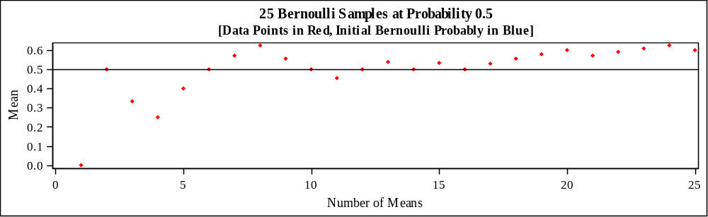

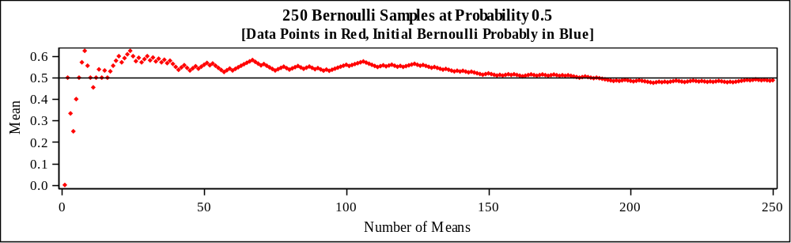

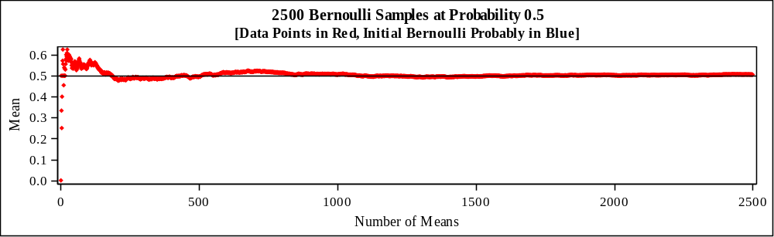

%let myfolder=%str(/folders/myfolders/HW5);
libname HW5 "&myfolder";

%macro proveLLN(p, n); /* prove law of large numbers */
proc iml;
/* vectorMean generates means through the vector - like dplyr in R */
start vectorMean(x); /* running vector mean - just like its done in R */
return( cusum(x)/(1:ncol(x)) );
finish;

/* generate a rowVector of randomMeans and a rowVector of 1...n */
call randseed(2016);
x = j(1,&n); /* initialize a vector of size [1,n] */
call randgen(x,"Ber", &p); /* fill with Bernoulli RV */
runMean = vectorMean(x); /* runMean now contains a vector of all the means */
Nvalue=1:&n; /* Nvalue is a vector of the counts of means */

/* plot the samples to demonstrate the Law of Large Numbers */
title1 "&n Bernoulli Samples at Probability &p";
title3 "[Data Points in Red, Initial Bernoulli Probably in Blue]";
ods graphics / width=600px height=250px; /* want 3 short/wide graphs on one page */
run Scatter(Nvalue, runMean)
option="markerattrs=(symbol=DiamondFilled color=red size=4)"
group=Origin
lineparm={0 &p 0} /* initial Bernoulli Probability */
label={"Number of Means" "Mean"}
yvalues=do(0,1,0.1) /* should generate an axis from 0-1 with ticks at .1 */
/*other="refline 0 1 / axis=y" /* add reference line */
procopt="noautolegend" /* PROC option */
;
quit;

%mend proveLLN;

options nonumber nodate;
ods rtf file = "&myfolder/ex2.rtf";
ods pdf file = "&myfolder/ex2.pdf";
%proveLLN(0.5,25)
%proveLLN(0.5,250)
%proveLLN(0.5,2500)
ods _all_ close;
Exercise 3. Consider the dataset in file Products.dat. The variables are Product Number, Product
Name, Manufacturer Number, Product Type and Retail Unit Cost. Do the following:
(a) Read instream data
(b) Use PROC SQL to insert a new row
(c) Use PROC SQL to modify the data to reflect a 20% price increase on all software products, and a 20% discount on all the other products.
(d) Use PROC SQL to add title, footnote, labels and modify formats (if necessary) to obtain the following output (Note that the footnote contains today’s date).

Product Information
Product Number Product Name
Manufacturer Numer Product Type Retail Unit Cost
5009 Dream Machine 500 Workstation $2560.00
4506 Business Machine 450 Workstation $2676.00
2101 Travel Laptop 400 Laptop $2208.00
2212 Analog Cell Phone 230 Phone $28.00
4509 Digital Cell Phone 245 Phone $140.00
5003 Office Phone 560 Phone $116.00
1110 Spreadsheet Software 134 Software $360.00
1200 Database Software 113 Software $958.80
3409 Statistical Software 243 Software $2278.80
2102 Wordprocessor Software 245 Software $414.00
2200 Graphics Software 246 Software $718.80
3480 Desktop Computer 780 Workstation
Updated on 30NOV15

/**** HW5, Ex3, SAS 475 - create table, modify columns, add row ****/

%let myfolder=%str(/folders/myfolders/HW5);
libname homework "&myfolder";

/*********** (a) Read instream data **************/
data products;
infile "&myfolder/products.dat" FIRSTOBS=3;
input prodnum 4. @8 prodname $23. manunum 6. @43 prodtype $11. @57 rtlcost dollar6.;
run;

proc sql;
create table prodtable as
select prodnum format=4.,
prodname format=$23.,
manunum format=4.,
prodtype format=$11.,
rtlcost format=comma8.2
from products
;
quit;

/************ b) Use PROC SQL to insert a new row *************/
proc sql;
insert into prodtable
set prodnum = 3480,
prodname ='Desktop Computer',
manunum = 780,
prodtype = 'Workstation',
rtlcost = 1799
;
quit;

/******* (c) Use PROC SQL to modify the data to reflect a 20% price increase on all software
products, and a 20% discount on all the other products. *******/
proc sql;
alter table prodtable
add newcost num format=dollar8.2 label="Retail Price"
;
quit;

proc sql;
update prodtable
set newcost=rtlcost*
case when prodtype like 'Software' then 1.20
else 0.8
end;
;
proc sql;
alter table prodtable
drop rtlcost;
select * from prodtable;
quit;

/****** (d) Use PROC SQL to add title, footnote, labels and modify formats *********/
Title1 "Product Information";
footnote "Updated On &sysdate";
options nodate nonumber;

proc sql;
alter table prodtable
modify prodnum label='Product Number'
modify prodname label='Product Name'
modify manunum label="Manufacturer's Number"
modify prodtype label="Product Type"
;
select* from prodtable;
quit;

title1; footnote1;

Product Information
Product Number | Product Name | Manufacturer's Number | Product Type | Retail Price
5009 | Dream Machine | 500 | Workstation | $2560.00
4506 | Business Machine | 450 | Workstation | $2676.00
2101 | Travel Laptop | 400 | Laptop | $2208.00
2212 | Analog Cell Phone | 230 | Phone | $28.00
4509 | Digital Cell Phone | 245 | Phone | $140.00
5003 | Office Phone | 560 | Phone | $116.00
1110 | Spreadsheet Software | 134 | Software | $360.00
1200 | Database Software | 113 | Software | $958.80
3409 | Statistical Software | 243 | Software | $2278.80
2102 | Wordprocessor Software | 245 | Software | $414.00
2200 | Graphics Software | 246 | Software | $718.80
3480 | Desktop Computer | 780 | Workstation | $1439.20
Updated On 01DEC15

