STAT 475 TAKE-HOME MIDTERM EXAM
(due Thursday, October 15, 2015, by 10pm, sent to okoroste at gmail dot com) *****************************************************************************
Exercises for Handout 10 material: Explain the reason for selecting the correct answer, as well as the reason for NOT selecting EACH of the wrong answers.

- Quiz for Chapter 8 in the textbook: Questions 1 – 6.
- A00-201 Practice Exam: Question 94 and 97.

And the following
Exercise 1. For the data in file ‘ExamEx1.xls’, produce a report identical to the one in file ‘Report_Ex1.html’.
HANDOUT 10 - Quiz for Chapter 8 in the textbook: Questions 1 – 6.
Ch8 Q1) The default statistics produced by the MEANS procedure are n-count, mean, minimum, maximum, and…
- median
- range
- standard deviation
- standard error of the mean.
Option C is correct because by default the MEANS procedure produces a count, min, max, mean and sd.
Option A, Option B and Option D are incorrect because if you want these, you have to a PROC MEANS with customized output – specify the statistic and then list all the variables (in the same order as they appear in the VAR statement). E.g., proc means n mean median std min max range data=test;

Ch8 Q2) Which statement will limit a PROC MEANS analysis to the variables Boarded, Transfer, and Deplane?
- by boarded transfer deplane;
- class boarded transfer deplane;
- output boarded transfer deplane;
- var boarded transfer deplane;
Option D is correct because specifying the PROC MEANS variables with a Var statement is the correct procedure. By default, SAS PROC MEANS provides descriptive statistics for all the numeric variables in the dataset.
Option A is incorrrect because the BY option produces statistics for subgroups, but does not limit the variable scope.
Option B is incorrect because PROC MEANS CLASS produces statistics for subdivisions of the variable set, 'classes', but does not limiti the variable scope.
Although CLASS is nice because the data do not need to be sorted, and produces one output table with separate statistics for each class.
Option C is incorrect because OUTPUT writes the statistics summary table to a file, with the caveats that the keyword for the statistic and the list of all of the variables must be specified, and the variables must be in their database order, or the order specified by a VAR statement.

Ch8 Q3) The data set Survey.Health includes the following variables. Which is a poor candidate for PROC MEANS analysis?
- IDnum
- Age
- Height
- Weight
Option A) is correct. Idnum conveys little info – doesn't make sense to statistically analyze IDnum.
Options B), C) and D) are incorrect because there could be valuable information gained by examining the statistical difference in Age, Height and Weight.

Ch8 Q4) Which of the following statements is true regarding BY group processing?
- BY variables must be either indexed or sorted.
- Summary statistics are computed for BY variables.
- BY group processing is preferred when you are categorizing data that contains few variables.
- BY group processing overwrites your data set with the newly grouped observations.
Option A) is correct because the problem with using By is that the variables must be pre-sorted or indexed – this is a big advantage to using CLASS, which doesn't require pre-sorting or indexing.
Option D) is incorrect because BY doesn't overwrite variables, it is the pre-BY step of sorting that can overwrite variables if you are not careful.

Ch8 Q5) The default statistics produced by the MEANS procedure are n-count, mean, minimum, maximum, and…
a) median
b) range
c) standard deviation
d) standard error of the mean.
Option C is correct because by default the MEANS procedure produces a count, min, max, mean and sd.
Option A, Option B and Option D are incorrect because if you want these, you have to a PROC MEANS with customized output – specify the statistic and then list all the variables (in the same order as they appear in the VAR statement). E.g., proc means n mean median std min max range data=test;

Ch8 Q6) Which statement will limit a PROC MEANS analysis to the variables Boarded, Transfer, and Deplane?
- by boarded transfer deplane;
- class boarded transfer deplane;
- output boarded transfer deplane;
- var boarded transfer deplane;
Option D is correct because specifying the PROC MEANS variables with a Var statement is the correct procedure. By default, SAS PROC MEANS provides descriptive statistics for all the numeric variables in the dataset.
Option A is incorrrect because the BY option produces statistics for subgroups, but does not limit the variable scope.
Option B is incorrect because PROC MEANS CLASS produces statistics for subdivisions of the variable set, 'classes', but does not limit the variable scope.
CLASS is nice because the data do not need to be sorted, and produces one output table with separate statistics for each class.
Option C is incorrect because OUTPUT writes the statistics summary table to a file, with the caveats that the keyword for the statistic and the list of all of the variables must be specified, and the variables must be in their database order, or the order specified by a VAR statement.
A00-201 Practice Exam: Question 94 and 97.

A00-201 Practice Exam: Question 94
Unless specified, which variables and data values are used to calculate statistics in
the MEANS procedure?
A. non-missing numeric variable values only
B. missing numeric variable values and non-missing numeric variable values only
C. non-missing character variables and non-missing numeric variable values only
D. missing character variables, non-missing character variables, missing numeric variable
values, and non-missing numeric variable values
Answer A) is correct because PROC MEANS excludes missing values before calculating statistics, and only computes for numerical variables.
Answer B) is incorrect because PROC MEANS only works on non-missing numerics. PROC MEANS does not know how to compute arithmetic statistics on “.”, so it excludes all missings.
Answers C) and D) are incorrect because PROC MEANS never works on non-numerics.

A00-201 Practice Exam: Question 97
The following SAS program is submitted:
proc means data = sasuser.houses std mean max;
varsqfeet;
run;
Which one of the following is needed to display the standard deviation with only two
decimal places?
A. Add the option MAXDEC = 2 to the MEANS procedure statement.
B. Add the statement MAXDEC = 7.2; in the MEANS procedure step.
C. Add the statement FORMAT STD = 7.2; in the MEANS procedure step.
D. Add the option FORMAT = 7.2 option to the MEANS procedure statement.
Answer A) is correct because SAS wants MAXDEC= on the PROC MEANS line.
Answers B) and D) are incorrect because MAXDEC wants an integer number of places after the decimal. Answers B) and C) are incorrect because MAXDEC is in PROC MEANS statement.

Exercise 1. For the data in file ‘ExamEx1.xls’, produce a report identical to the one in file ‘Report_Ex1.html’.
The SAS System
The MEANS Procedure
Group | N Obs | Variable | Label | N | Mean | Median | Std Dev | Minimum | Maximum | Range
Cx | 10 | Age  Visit 1  Visit 2  Visit 3  Visit 4 | Age  Visit 1  Visit 2  Visit 3  Visit 4 | 10  10  10  8  10 | 47.60  15.58  15.20  13.86  14.25 | 47.00  15.38  13.25  13.90  13.65 | 16.22  4.00  3.10  3.47  2.22 | 20.00  10.00  12.35  9.45  11.60 | 75.00  23.50  20.00  18.45  17.20 | 55.00  13.50  7.65  9.00  5.60
Tx | 10 | Age  Visit 1  Visit 2  Visit 3  Visit 4 | Age  Visit 1  Visit 2  Visit 3  Visit 4 | 10  10  7  9  9 | 43.80  17.73  15.31  15.03  14.41 | 42.50  16.38  14.90  14.35  14.55 | 12.37  3.98  2.15  3.45  1.66 | 25.00  14.00  13.00  10.50  12.20 | 62.00  26.00  19.60  22.50  17.43 | 37.00  12.00  6.60  12.00  5.23
Stats 475 - CSULB - Prof. Korosteleva
Lin Crampton 11OCT2015 23:13
Exercise 1 Fall 2015 Midterm

/**** Midterm ****/
/* For the data set in file ‘Exam_Ex1.xls’, produce a report identical (data-wise) to the one stored in file ‘Report_Ex1.html’. */
/* */

libname midterm '/folders/myfolders/midterm/'; /* helps to remember where stuff saved */
options validvarname=any;

/** must use proc import (rather than libfilename) because on a linux system **/
proc import
datafile="/folders/myfolders/midterm/Exam_Ex1.xls"
out=midterm.ex1
dbms=xls
replace;
getnames=yes; /* headers */
run;

/*****************************/
/****** Blue & Gold *******/
/******** Template ********/
proc template;
define table base.template.table;
cellstyle mod(_row_, 2) and
^(_style_ like '%Header') as {backgroundcolor=verylightblue},
^(mod(_row_, 2)) and
^(_style_ like '%Header') as {backgroundcolor=yellow};
end;
run;

/**************************/
/***** Proc Means *****/
/**************************/
options nonumber nodate;
title1 height=6pt "The SAS System";
footnote1 font=arial height=8pt color=blue "Stats 475 - CSULB - Prof. Korosteleva";
footnote2 font=arial height=8pt color=blue "Lin Crampton &sysdate9 &systime";
footnote3 font=arial height=8pt color=blue "Exercise 1 Fall 2015 Midterm";

ods listing close;
ods html body='/folders/myfolders/midterm/crampton_ex1.html';

proc means n mean median std min max range data=midterm.ex1 maxdec=2;
class Group;
run;
ods html close;
ods listing;
proc contents data=midterm.ex1 ;
run;

Exercises for Handout 11 material: Explain the reason for selecting the correct answer, as well as the reason for NOT selecting EACH of the wrong answers.
****** Quiz for Chapter 8 in the textbook: Questions 7 – 10.

Ch8 Q7 - By default, PROC FREQ creates a table of frequencies and percentages for which data set variables?
a. character variables
b. numeric variables
c. both character and numeric variables
d. none: variables must always be specified
Option C) is correct because by PROC FREQ creates a table for all variable, unless otherwise specified.
Options A) and B) are not the most correct because PROC FREQ generates frequencies for all variables, both character and numeric.
Option D) is incorrect because by default PROC FREQ generates a one-way frequency table for every variable in the dataset.

Ch8 Q8 - Frequency distributions work best with variables that contain
a) continuous values.
b) numeric values.
c) categorical values.
d) unique values.
Option C) is correct because frequency tables only make sense when there are a small number of categorical values to subset.
Option A) is incorrect because it doesn't make sense to subset continuous values – there would be a subset for every unique value.
Option B) is not the best choice because only if there are a small amount of unique numeric values do frequency distributions make sense.
Option D) is not the best choice because creating frequency distributions with unique values only works well if there is a very small number of unique values.

Ch8 Q9) Which PROC FREQ step produced this two-way table?
A proc freq data=clinic.diabetes;
tables height weight;
format height htfmt. weight wtfmt.; run;
B proc freq data=clinic.diabetes;
tables weight height;
format weight wtfmt. height htfmt.; run;
C proc freq data=clinic.diabetes;
tables height*weight;
format height htfmt. weight wtfmt. run;
D proc freq data=clinic.diabetes;
tables weight*height;
format weight wtfmt. height htfmt.;run;
Option D) is correct because the tables are subdivided first by weight and then by height (variables from top-left down). The asterisk is important because this is how SAS knows to make a 2-way table.
Options A) and B) are incorrect because the variables need to have an asterisk between them when using TABLES to tell SAS to create a frequency table using these variables.
Options A) and C) are incorrect because the variable on the left hand side of the asterisk is the rows, while the right hand side is the columns – and this doesn't match the output.

Ch8 Q10) Which PROC FREQ step produced this table
Figure 8.28: PROC FREQ Table
a) proc freq data=clinic.diabetes;
tables sex weight / list;
format weight wtfmt.; run;
b) proc freq data=clinic.diabetes;
tables sex*weight / nocol;
format weight wtfmt.; run;
c) proc freq data=clinic.diabetes;
tables sex weight / norow nocol;
format weight wtfmt.; run;
d) proc freq data=clinic.diabetes;
tables sex*weight / nofreq norow nocol;
format weight wtfmt.; run;
Option D) is correct because the table is subdivided by sex and then weight, which matches “tables sex*weight”. The asterisk is how SAS understands that we want a 2-way table. The “nofreq norow nocol” is important because there are no cell frequencies in this table (nofreq), there are no row percentages inthis table (norow) and there are no column percentages in this table (nocol).
Option A), Option B), and Option C) are all incorrect because they need all of the 'nofreq norow nocol' in order to generate the desire output.
Option A) and Option C) are incorrect because they need an asterisk between the variables that are set out in the table (here sex*weight), and they only have a space.

******* A00-201 Practice Exam: Questions 95 and 101.

Q95 - A00-201 Practice Exam
Exhibit: Output of a FREQ procedure.
The variable STYLE has a permanent label of "Style of homes" and the variable BEDROOMS has a permanent label of "Number of bedrooms". Which one of the following SAS programs produced the output shown in the exhibit?
A. proc freq data = sasuser.houses;
tables style and bedrooms; run;
B. proc freq data = sasuser.houses;
tables style * bedrooms; run;
C. proc freq data = sasuser.houses;
tables style , bedrooms; run;
D. proc freq data = sasuser.houses;
tables style;
tables bedrooms; run;
Answer D) is correct because frequency data is produced in two different tables, one broken down by STYLE and one broken down by BEDROOMS.
Answer A) is incorrect because SAS sees the variable STYLE, and then sees the 'and' as a variable AND, but there is no variable AND in this dataset – so would generate error.
Answer B) is incorrect because it would make one table with STYLE as rows and BEDROOMS as columns.
Answer C) is incorrect because the comma will generate an error. SAS is expecting variables or semicolon, or quotes, but comma is inappropriate in this location.

Q101 - A00-201 Practice Exam
The following SAS program is submitted:
proc freq data=sales;
…..
run:
Which one of the following statements completes the program and produces the output?
A. tables region product;
B. tables region* product;
C. tables product region;
D. tables product region*;
Answer B) is correct because it has an asterisk separating the two variables and the variables are in the correct order (from top left on down and over).
Answers A) and C) are incorrect because they need an asterisk between the variables.
Answers C) and D) are incorrect because the variables are in the wrong order.

S******* A00-211 Practice Exam: Questions 16 and 57.

Q16 - A00-211 Practice Exam
The following SAS program is submitted:
proc freq data = sales;
<insert TABLES statement here>
run;

The following output is created by the FREQUENCY procedure:
Which TABLES statement(s) completed the program and produced the output?
A. tables region * product;
B. tables product; tables region;
C. tables region product;
D. tables product * region;
Answer A) is correct because “region * product” produces a “Table of region by product”.
Answer B) is incorrect because it would produce two tables, one broken down by product and one broken down by region.
Answer C) is incorrect because “tables region product” doesn't result in Region broken down by Product.
Answer D is incorrect because it would produce a “Table of Product by Region”.

A00-211 Practice Exam: Questions 57
The following SAS program is submitted:
proc freq data = sashelp.class;
tables gender * age / <insert option here> ; run;

Table of Sex by Age
Sex | Age | Frequency | Row  Percent
F | 12 | 0 | 0.00
 | 13 | 1 | 100.00
 | 14 | 0 | 0.00
 | 15 | 0 | 0.00
 | Total | 1 | 100.00
M | 12 | 1 | 33.33
 | 13 | 0 | 0.00
 | 14 | 1 | 33.33
 | 15 | 1 | 33.33
 | Total | 3 | 100.00
proc freq data = sashelp.class;
data class2;
set sashelp.class;
if ( upcase(substr(name,1,1)) = "R" | upcase(substr(name,1,1)) = "A") ;
run;
proc freq data=class2;
tables sex * age / crosslist missing nocol nopercent totpct; run;

Which option correctly completes the program and creates the report?
A. CROSSLIST B. LIST C. NOCOLS D. NOCROSSTAB

Answer A) is correct because with the CROSSLIST option, SAS displays crosstabulation tables in the standard Output Delivery System (ODS) column format.
Answer B) is incorrect because he LIST option cannot be used when the TABLES statement requests statistical tests or measures of association to be included in the ouput.
Answer C) is incorrect because NOCOLS supresses printing of column percentages of a crosstab.
Answer D) is incorrect because NOCROSSTAB is a bogus option. When requesting omission of CROSSTAB info, the following options are appropriate: NOCOL (suppresses printing of column percentages of a crosstab), NOROW (suppresses printing of row percentages of a crosstab.),
NOPERCENT (suppresses printing of cell percentages of a crosstab.)

******* Exercise 2. Information on presence or absence (yes or no) of two features, A and B, is available for several individuals. The data are stored in file ‘ExamEx2.dat’. Compute the number of individuals who have:
(a) characteristic A 9
(b) characteristic B 13
(c) only characteristic A 2
(d) only characteristic B 6
(e) both characteristics 7
(f) neither characteristic 5
(g) either characteristic 15

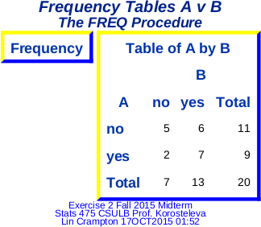

libname midterm '/folders/myfolders/midterm'; /* data lives here*/
/* yellow and blue template */
proc template;
define style Styles.yellowNblueborder;
parent = Styles.Default;
style Table from Output /
cellpadding = 5
borderspacing = 2
bordercolordark = blue
bordercolorlight = yellow
borderwidth = 4;
end;
run;

/* read in data and validate */
data midterm.ex2;
infile "/folders/myfolders/midterm/Exam_Ex2.dat" FIRSTOBS=2;
input @1 ID $3. typeA $4. typeB$;
ID=ID;
run;
proc print data=midterm.ex2 noobs;
title1 'just the data';
run;

/* format for output */
title1 'Frequency Tables A v B';
footnote1 font=arial height=8pt color=blue "Exercise 2 Fall 2015 Midterm";
footnote2 font=arial height=8pt color=blue "Stats 475 CSULB Prof. Korosteleva";
footnote3 font=arial height=8pt color=blue "Lin Crampton &sysdate9 &systime";

/* write to both hmtl and rtf */
ods html file='/folders/myfolders/midterm/Exam_Ex2.html' style=yellowNblueborder;
ods rtf file='/folders/myfolders/midterm/Exam_Ex2.rtf' style=yellowNblueborder;

/*****************************************************************************/
/********* frequency tables necessary to answer midterm questions *********/
proc freq data=midterm.ex2;
tables typeB*typeA / out=xlistAvB crosslist;
run;
proc print data=xlistAvB noobs;
title1 'TypeA vs TypeB Freq Table';
run;
/****** end frequency tables necessary to answer midterm questions *********/
/******************************************************************************/

/* housekeeping */
ods html close;
ods rtf close;
title1;
footnote1;
Exercises for Handout 12 material: Explain the reason for selecting the correct answer, as well as the reason for NOT selecting EACH of the wrong answers.

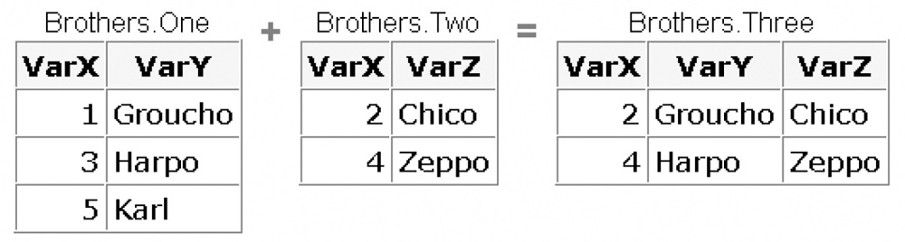
Ch12 Q1 Which program will combine Brothers.One and Brothers.Two to produce Brothers.Three?

a) data brothers.three;
set brothers.one;
set brothers.two; run;
b) data brothers.three;
set brothers.one brothers.two; run;
c) data brothers.three;
set brothers.one brothers.two;
by varx; run;
d) data brothers.three;
merge brothers.one brothers.two; by varx;run;
Answer A) is correct because datasets were pasted together, as a result of multiple set lines in a data statement.
Answer B) is incorrect because a SET statement followed by multiple datasets on the same line results in a vertical concatenation, rather than a horizontal paste of the data.
Answers C) and D) are incorrect because BY varx would join them on similar varx values, and since all of the varx values are unique, the output dataset would be empty.

CH 12 Q2 Which program will combine Actors.Props1 and Actors.Props2 to produce Actors.Props3?

Actors.Props1 | + | Actors.Props2 | = | Actors.Props3
  Actor | Prop
  Curly | Anvil
  Larry | Ladder
  Moe | Poker
  Actor | Prop
  Curly | Ladder
  Moe | Pliers
  Actor | Prop
  Curly | Anvil
  Curly | Ladder
  Larry | Ladder
  Moe | Poker
  Moe | Pliers

a. data actors.props3;
set actors.props1;
set actors.props2; run;
b. data actors.props3;
set actors.props1 actors.props2; run;
c. data actors.props3;
set actors.props1 actors.props2;by actor; run;
d. data actors.props3;
merge actors.props1 actors.props2; by actor; run;
Answer C) is correct because the dataset resulted from interleaving the first two datasets on the Actor field.
Answer A) is incorrect because multiple SET statements would result in horizontally pasted data.
Answer B) is incorrect because the resulting dataset is interleaved by actor – All of the Curly's go first, then all the Larry's then all the Moes.
Answer D) is incorrect because the merge would result in actors.prop2 overwriting the values for the actors in actors.prop1.

Ch12 Q3 If you submit the following program, which new data set is created?

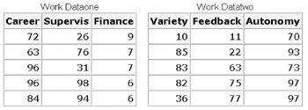

a.
Career | Supervis | Finance | Variety | Feedback | Autonomy
72 | 26 | 9 | . | . | .
63 | 76 | 7 | . | . | .
96 | 31 | 7 | . | . | .
96 | 98 | 6 | . | . | .
84 | 94 | 6 | . | . | .
. | . | . | 10 | 11 | 70
. | . | . | 85 | 22 | 93
. | . | . | 83 | 63 | 73
. | . | . | 82 | 75 | 97
. | . | . | 36 | 77 | 97

Option A) is correct because a SET statement followed by datasets results in vertically concatenated output.
Option B is incorrect because only multiple SET statements (one SET statement for each dataset) results in horizontally pasted data.
Option C) is incorrect because the data are interleaved, not vertically merged.
Option D) is incorrect because the data are merged incorrectly.

Ch 12 Q4 If you concatenate the data sets below in the order shown, what is the value of Sale in observation 2 of the new data set?
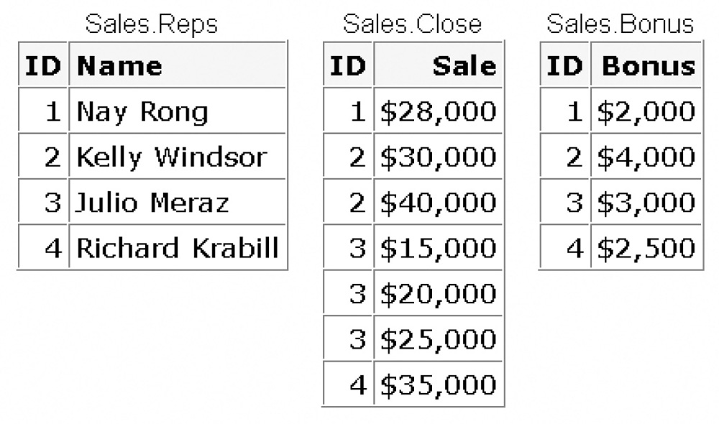
a) Missing statement.
b) $30,000
c) $40,000
d) you cannot concatenate these data sets
Option A) is correct because the datasets are read in sequentially in the same order setout in the SET statement, and the second observation in te first dataset read in (Sales.Reps) reflecting a missing value for Sale.
Option B) is incorrect because the datasets are concatenated, not merged.
Option C) Is incorrect and would be incorrect even if merged (would be 30K then).
Option D) is incorrect because datasets can always be concatenated.

Ch 12 Q5 What happens if you merge the following data sets by the variable SSN?

1st |  | 2nd
  SSN | Age
  029-46-9261 | 39
  074-53-9892 | 34
  228-88-9649 | 32
  442-21-8075 | 12
  446-93-2122 | 36
  776-84-5391 | 28
  929-75-0218 | 27
  SSN | Age | Date
  029-46-9261 | 37 | 02/15/95
  074-53-9892 | 32 | 05/22/97
  228-88-9649 | 30 | 03/04/96
  442-21-8075 | 10 | 11/22/95
  446-93-2122 | 34 | 07/08/96
  776-84-5391 | 26 | 12/15/96
  929-75-0218 | 25 | 04/30/97

a)The values of Age in the 1st data set overwrite the values of Age in the 2nd data set.
b) The values of Age in the 2nd data set overwrite the values of Age in the 1stA00-201 Practice Exam data set.
c) The DATA step fails because the two data sets contain same-named variables that have different values.
d) The values of Age in the 2nd data set are set to missing.
Answer b) is correct because when variables have the same name in multiple datasets, the last read value is the value in the output dataset.
Answer a) is incorrect because datasets are read in left->right order.
Answer c) and d) are incorrect because dealing with datasets with conflicting values in multiple datasets is differentiates SAS from a cut/paste/sort system

Ch12 Q6) Suppose you merge data sets Health.Set1 and Health.Set2 below:

Health.Set1 |  | Health.Set2
  ID | Sex | Age
  1129 | F | 48
  1274 | F | 50
  1387 | F | 57
  2304 | F | 16
  2486 | F | 63
  4425 | F | 48
  4759 | F | 60
  5438 | F | 42
  6488 | F | 59
  9012 | F | 39
  9125 | F | 56
  ID | Height | Weight
  1129 | 61 | 137
  1387 | 64 | 142
  2304 | 61 | 102
  5438 | 62 | 168
  6488 | 64 | 154
  9012 | 63 | 157
  9125 | 64
Which output does the following program create?
data work.merged;
merge health.set1(in=in1) health.set2(in=in2);
by id;
if in1 and in2;
run;
proc print data=work.merged;
run;
c)
Obs | ID | Sex | Age | Height | Weight
1 | 1129 | F | 48 | 61 | 137
2 | 1387 | F | 57 | 64 | 142
3 | 2304 | F | 16 | 61 | 102
4 | 5438 | F | 42 | 62 | 168
5 | 6488 | F | 59 | 64 | 154
6 | 9012 | F | 39 | 63 | 157
7 | 9125 | F | 56 | 64 | 159

Option C) is correct because it only has those observations that occur in both datasets – 'if in1 and in2' excluded anything that didn't have an observation in both datasets.
Answers A) and B) are incorrect because they both have observations for which there is not data for both in both datasets – 'if in1 and in2' combined with the merge health.set1(in=in1) health.set2(in=in2);
Option D) (none of the above) is incorrect because Option C) works.

Ch12 Q6) If you concatenate the data sets below in the order shown, what is the value of Sale in observation 2 of the new data set?

- Missingstatement.
- $30,000
- $40,000
- you cannot concatenate these data sets

Option A) is correct because the datasets are read in sequentially in the same order setout in the SET statement, and the second observation in te first dataset read in (Sales.Reps) reflecting a missing value for Sale. Option B) is incorrect because the datasets are concatenated, not merged.
Option C) Is incorrect and would be incorrect even if merged (would be 30K then).
Option D) is incorrect because datasets can always be concatenated.

Ch12 Q7 The data sets Ensemble.Spring and Ensemble.Sum both contain a variable named Blue. How do you prevent the values of the variable Blue from being overwritten when you merge the two data sets?
- data ensemble.merged;
merge ensemble.spring(in=blue)
ensemble.summer;
by fabric;
run;
- data ensemble.merged;
merge ensemble.spring(out=blue)
ensemble.summer;
by fabric;
run;
- data ensemble.merged;
merge ensemble.spring(blue=navy)
ensemble.summer;
by fabric;
run;
- data ensemble.merged;
merge ensemble.spring(rename=(blue=navy))
ensemble.summer;
by fabric;
run;
Answer D) is correct because RENAME is used to prevent overwriting when two datasets have the same name for a value which should not be merged.
Answer A) is incorrect because the IN= is a flag that identifies which database contributed the value.
Answer B) is incorrect because OUT= names the output file.
Answer C) is incorrect because (blue=navy) is nonsensical and would generate an error.
Ch12 Q9 If you merge Company.Staff1 and Company.Staff2 below by ID, how many observations does the new data set contain?

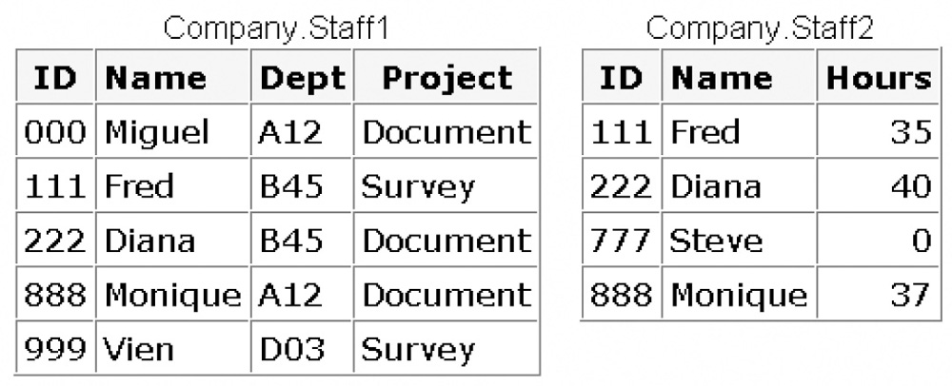

- 4
- 5
- 6
- 9
Answer C) is correct because the output dataset would contain the five entires from Staff1, plus an entry for the observation in Staff2 not included in Staff1 (Steve).
Answer A) is not correct because the resulting dataset would have entries for all unique IDs.
Answer B) is not correct (see above).. Answer B) would be correct if all entries in Staff2 were also included in Staff1.
Answer D) is not correct, as this is a merge, not a concatenation.

Ch12 Q10 If you merge data sets Sales.Reps, Sales.Close, and Sales.Bonus by ID, what is the value of Bonus in the third observation in the new data set?

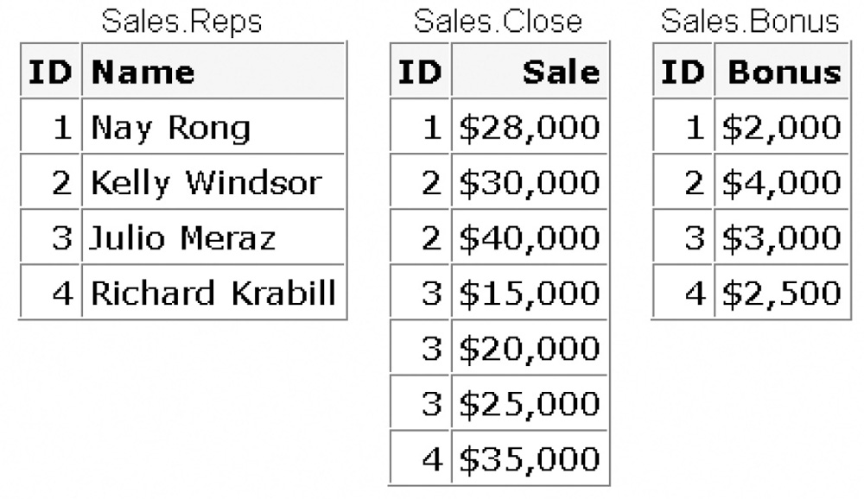
a) $4,000
b) $3,000
c) missing
d) can't tell from the information given
Answer A) is correct because Kelly#2 has two entries in the Sales Close dataset, so the third observation is the second observation for Kelly.; the bonus for Kelly#2 is 4K.
Answer B) is not correct because Kelly#2 has two entries in SalesClose. Answer B) would be correct if Kelly#2 had ony one sale in SalesClose.
Answer C) is incorrect because the value is not missing.
Answer D) is incorrect because it is clear from the info that Kelly#2 is Obs3.
****** A00-201 Practice Exam: Questions 1, 17, 18, 19, 20, 62, and 63.

Q1 - A-201 Practice Exam
In the following SAS program, the input data files are sorted by the NAMES variable:
libnametemp 'SAS-data-library';
data temp.sales;
merge temp.sales work.receipt;
by names;
run;
Which one of the following results occurs when this program is submitted?
A. The program executes successfully and a temporary SAS data set is created.
B. The program executes successfully and a permanent SAS data set is created.
C. The program fails execution because the same SAS data set is referenced for both read and write operations.
D. The program fails execution because the SAS data sets on the MERGE statement are in two different libraries.
Answer B) is correct because both input datasets (permanent temp.sales and temporary work.receipt) are sorted by Names and the result of the merge is written to the permanent temp.sales. No matter what it is called, when libname defines a library, it is a permanent library. If a temporary library is needed, use 'work.sales' or just 'sales'.
Answer A) is incorrect because cannot establish a temporary library by 'libname temp' – just makes a permanent library with name 'temp'.
Answer C) is incorrect because there is nothing wrong with using the same dataset for in and out.
Answer D) is incorrect because MERGE doesn't care if the merge files are from different libraries

Q17 - A-201 Practice Exam
The contents of two SAS data sets named EMPLOYEE and SALARY are listed below:
EMPLOYEE |  | SALARY
NAME | AGE | NAME | SALARY
Bruce | 30 | Bruce | 40000
Dan | 35 | Bruce | 35000
 |  | Dan | 37000
 |  | Dan | .
The following SAS program is submitted:
data work.empsalary;
merge work.employee (in = inemp)
work.salary(in = insal);
by name;
if inemp and insal; run;
How many observations will the data set WORK.EMPSALARY contain?
A. 2 B. 4 C. 5 D. 6
Answer B) is correct because each of the two observations in Employee will be matched twice to observations in Salary.
Answer A) is incorrect because the datasets are presorted, so all will appear in the output.
Answer C) is incorrect. It is hard to imagine how 5 observations could arise from this merge.
Answer D) is incorrect because the two employee observations will be matched to the corresponding Name entries in salary.

Q18 - A-201 Practice Exam
The SAS data sets WORK.EMPLOYEE and WORK.SALARY are listed below:
EMPLOYEE |  | SALARY
NAME | AGE | NAME | SALARY
Bruce | 30 | Bruce | 250000
Dan | 40 | Bruce | 35000
 |  | Dan | 25000

WORK.EMPLOYEE WORK.SALARY
fname age fname salary
Bruce 30 Bruce 25000
Dan 40 Bruce 35000
Dan 25000
The following SAS program is submitted:
data work.empdata;
merge work.employee work.salary;
by fname;
totsal+ salary;
run;
How many variables are output to the WORK.EMPDATA data set?
A. 3
B. 4
C. 5
D. No variables are output to the data set as the program fails to execute due to errors.
Answer: B

Q 19 - A-201 Practice Exam
The SAS data sets WORK.EMPLOYEE and WORK.SALARY are shown below:
WORK.EMPLOYEE WORK.SALARY
fname age name salary
Bruce 30 Bruce 25000
Dan 40 Bruce 35000
Dan 25000
The following SAS program is submitted:
data work.empdata;
<insert MERGE statement here>
by fname;
totsal+ salary;
run;
Which one of the following statements completes the merge of the two data sets by the FNAME variable?
A. merge work.employee work.salary (fname = name);
B. merge work.employee work.salary (name = fname);
C. merge work.employee work.salary (rename = (fname = name));
D. merge work.employee work.salary (rename = (name = fname));
Answer D) is correct because it renames the sort variable in a syntactically acceptable way '(rename=(oldname=newname))'.
Answers A) and C) are incorrect because the dataset merger is by fname, but A) and C) change the only fname to name.
Answes A) and B) are incorrect because this is not the correct to rename in a merge, and would create an additional variable – two copies of the same variable in a program often leads to problems.

Q20 - A-201 Practice Exam
The following SAS program is submitted:
proc sort data=work.employee;
by descending fname;
proc sort data=work.salary;
by descending fname;
data work.empdata;
merge work.employee work.salary;
by fname;
run;
Which one of the following statements explains why the program failed execution?
A. The SORT procedures contain invalid syntax.
B. The merged data sets are not permanent SAS data sets.
C. The data sets were not merged in the order by which they were sorted.
D. The RUN statements were omitted after each of the SORT procedures.
Answer C) is correct. Unless otherwise specified, must always merge datasets in ascending sorted (or indexed order). Here sort happened in descending order, and merge was attempted in ascending order. No bueno.
Answer A) is incorrect because sort procedures are syntactically correct, and would have worked if used by ascending fname.
Answer B) is incorrect because SORT doesn't require permanent datasets.
Answer D) is incorrect because RUN statements are not required after each DATA or PROC.

Q62 – A-201 Practice Exam
The following SAS program is submitted:
data work.company;
set work.dept1(keep = jobcode)
work.dept2(rename = (jcode = jobcode));
run;
Which one of the following is the result?
A. The variable JCODE is written to the output data set.
B. The variable JOBCODE is written to the output data set.
C. Neither variable JCODE nor JOBCODE is written to the output data set.
D. The program fails to execute due to errors.
Answer B is correct because keep specified jobcode. Using rename to set a pointer from jcode to jobcode doesn't impact the keep.
Answer A) is incorrect because jcode is a pointer to jobcode, which doesn't change that the keep is jobcode.
Answer C) is incorrect because jobcode is specified to be kept.
Answer D) is incorrect because there is nothing here to stop the program from executing.

Q63 -- A-201 Practice Exam
Which one of the following SAS statements renames two variables?
A. set work.dept1
work.dept2(rename = (jcode = jobcode) (sal = salary));
B. set work.dept1
work.dept2(rename = (jcode = jobcode sal = salary));
C. set work.dept1
work.dept2(rename = jcode = jobcode sal = salary);
D. set work.dept1
work.dept2(rename = (jcode jobcode) (sal salary));
Answer B) is correct – rename, followed by an equals sign, followed by pairs of rename candidates each enclosed in parentheses.
Answer A) is incorrect because all the rename pairs need to be enclosed in one large parenthesis.
Answer C) is incorrect because when using multiple renames within a SET statement, each rename needs to be enclosed in parentheses. If this were a proc rename oldname=newname, that would work, but “rename=(“ requires rename=(oldname=newname)).
Answer D) is incorrect because when renaming, must include an equals sign between the variables being renamed.

- *******A00-211 Practice Exam: Questions 7, 40, 53, 56 and 70.

Q7 - A00-211 Practice Exam
The following SAS program is submitted:
data work.empsalary;
set work.people (in = inemp)
work.money (in = insal);
if insal and inemp;
run;
The SAS data set WORK.PEOPLE has 5 observations, and the data set WORK.MONEY has 7 observations. How many observations will the data set WORK.EMPSALARY contain?
A. 0
B. 5
C. 12
D. 7
Answer A) is correct. 'if insal and inemp' requires both to be true, but inemp does not equal insal; therefore, always false and nothing written to data work.empsalary.
Answer B) is incorrect because nothing written. Would be correct if there were a merge and 5 observations in the dataset people matched 5 from money.
Answer C) is incorrect. It would be correct if it were 'if insal or inemp'.
Answer D) is incorrect. Could be correct if statement read 'if insal', but not the intersection of insal and inemp.

Q40 - A00-211 Practice Exam
Given the AIRPLANES data set:
AIRPLANES
TYPE MPG
------- --------
F-18 105
C-130 25
Harrier 75
A-6 10
The following SAS program is submitted:
data gt100;
set airplanes(keep = type mpg load);
load = mpg * 150;
run;
The program fails to execute due to syntax errors. What is the cause of the syntax error?
A. LOAD is not a variable in the data set AIRPLANES.
B. MPG is not a numeric variable.
C. LOAD must be defined prior to the SET statement.
D. LOAD is not a variable in the data set GT100.
Answer A) is correct. Dataset airplanes contains observations for two variables, type and mpg. Load is not not a variables in the datset airplanes (is in dataset gt100) and the data step does nothing to change that. Thus, cannot save load in dataset airplanes because it doesn't exist there.
Answer B) is incorrect because mpg is a numeric variable (no $). Even if mpg were char, it wouldn't cause a problem because SAS converts char to numeric when they are involved in arithmetic.
Answer C) is not the most correct answer. If load were defined in the original dataset along with type and mpg, there would be no problem.
Answer D) is incorrect because the keep refers to the set airplanes, not gt100. If the program had run (if e.g., there were no keep line), then load would be a variable in the temporary dataset gt100.

Q53 - A00-211 Practice Exam
Given the SAS data sets EMPLOYEE and SALARY:
EMPLOYEE SALARY
Fname age name salary
--------- ----- -------- --------
Bruce 30 Bruce 25000
Dan 40 Bruce 35000
Dan 25000
The following SAS program is submitted:
data work.empdata;
<insert MERGE statement here>
by fname;
totsal + salary;
run;
Which MERGE statement correctly completes the program?
A. merge employee salary rename(name = fname);
B. merge employee salary rename = fname = name;
C. merge employee salary (rename = (name = fname));
D. merge employee salary (rename = (fname = name));
Answer C) is correct because rename syntax requires 1) a paren set around rename and then a paren set within rename, and 2) oldname=newname (opposite syntax from most programming languages in terms of the equals). Since the datasets are being merged by fname and the rename is operating on salary, this is the correct syntax.
Answer A) is incorrect because it is missing the paren set outside of rename, and rename requires paren sets both inside and outside.
Answer B) is incorrect because the rename syntax requires two sets of parens (both inside and outside) and there are no parens here. Even with parens, this wouldn't work because rename syntax is oldname=newname and fname is not a variable in salary, nor is name the variable to be merged by.
Answer D) is incorrect because the ordering of fname and name is incorrect. Rename requires the syntax of oldname=newname. As written, this would bomb because there is no fname variable in salary, and the merge requires a fname.

Q56 - A00-211 Practice Exam
The following SAS program is submitted:
proc sort data = work.employee;
by descending fname;
proc sort data = work.salary;
by descending fname;
data work.empdata;
merge work.employee work.salary;
by fname;
run;
Why does the program fail to execute?
A. The data sets were not merged in the order by which they were sorted.
B. The RUN statement was omitted after each of the SORT procedures.
C. The SORT procedures contain invalid syntax.
D. The merged data sets are not permanent SAS data sets.
Answer A) is correct because SAS is unwielding on the requirement that datasets be presorted in the same order that they are merged.
Answer B) is incorrect because RUN statements are not necessary after each proc. When the program hits a RUN statement, it will run all these proc sorts.
Answer C) is incorrect because the sort commands are syntactically correct.
Answer D) is incorrect because there is no requirement that the merged datasets are permanent.

Q70 - A00-211 Practice Exam
The following SAS program is submitted:
libname temp 'SAS data library';
data temp.sales;
merge temp.sales work.receipt;
by names;
run;
The input data files are sorted by the NAMES variable: What is the result?
A. The program fails execution because the SAS data sets on the MERGE statement are in two different libraries.
B. The program fails execution because the same SAS data set is referenced for both read and write operations.
C. The program executes successfully and a temporary SAS data set is created.
D. The program executes successfully and a permanent SAS data set is created.
Answer D is correct because temp was previously defined in a libname statement and work library always exists.
Answer A is incorrect because the libraries are both properly defined and merge has no precondition re shared library space.
Answer B) is incorrect because SAS often writes to the input dataset; there is no prohibition against this.
Answer C) is incorrect because temp is a permanent library, defined by the libname statement.

*****************************************************************************
Exercises for Handout 13 material: Explain the reason for selecting the correct answer, as well as the reason for NOT selecting EACH of the wrong answers.

- Quiz for Chapter 14 in the textbook: Questions 1 – 10.
Ch 14 Q1 Which statement is false regarding the use of DO loops?
- They can contain conditional clauses.
- They can generate multiple observations.
- They can be used to combine DATA and PROC steps.
- They can be used to read data.
Answer c) is correct because DO loops are part of DATA steps. Cannot be part of a PROC step.
Answer a) is incorrect because DO loops often contain conditional clauses.
Answer b) is incorrect because generating multiple observations is what DO loops do.
Answer d) is incorrect because DO loops are often used to read data.4

Ch 14 Q 2 During each execution of the following DO loop, the value of Earned is calculated and is added to its previous value. How many times does this DO loop execute?
data finance.earnings;
Amount=1000;
Rate=.075/12;
do month=1 tos 12;
Earned+(amount+earned)*rate;
end;
- 0
- 1
- 12
- 13
Answer c) is correct because 'do month=1 to 12' would execute the loop 12 times.
Answer a) is incorrect because there is nothing to stop the loop from executing.
Answer b) is incorrect because a do loop executes multiple times.
Answer d) is incorrect, but would be correct if indexed from 0 (e.g., do month=0 to 12)

Ch 14 Q3 On January 1 of each year, $5000 is invested in an account. Complete the DATA step below to determine the value of the account after 15 years if a constant interest rate of ten percent is expected.
data work.invest;
…
Capital+5000;
capital+(capital*.10);
end; run;
- do count=1 to 15;
- do count=1 to 15 by 10%;
- do count=1 to capital;
- do count=capital to (capital*.10);

Answer a) is correct because this would cause the statements in the loop to be executed 15 times.
Answer b) is incorrect because do loops don't increment by percentage values.
Answer c) is incorrect because the value of Capital is incremented throughout the loop and this loop would go on infinitely, or until the computer ran out of resources.
Answer d) is incorrect because capital*.10 is less than capital, so the loop would not execute 15 times.

Ch14 Q4 In the data set Work.Invest, what would be the stored value for Year?
data work.invest;
do year=1990 to 2004;
Capital+5000;
capital+(capital*.10);
end; run;
- missing
- 1990
- 2004
- 2005
Answer d) is correct because the value of year is incremented at the bottom of the do statement, after execution of the do statements are over. The value of year is not checked until the system checks in the 'do year=x to y' at the top of the loop. Since there is no explicit output statement, the implicit output statement is executed, with the value of year=2005.
Answer a) is incorrect because even though work is a temporary dataset, this doesn't mean that variables are not assigned values.
Answer b) is incorrect because 1900 is the start point, not the end point, of the loop.
Answer c) is incorrect because the loop doesn't end until the value of the year is outside of the conditions 1990->2004.

Ch14 Q5 Which of the following statements is false regarding the program shown below?
data work.invest;
do year=1990 to 2004;
ata work.invest;
do year=1990 to 2004;
Capital+5000;
capital+(capital*.10);
output;
end; run;
- The OUTPUT statement writes current values to the data set immediately.
- The last value for Year in the new data set is 2005.
- The OUTPUT statement overrides the automatic output at the end of the DATA step.
- The DO loop performs 15 iterations.
Option b) is the best answer. Since there is an explicit output statement, SAS drops out after the value check. Even though the value of year has been incremented enough to fail the do loop check, SAS drops out immediately because of the explicit output statement-- so the latest value for the year in the dataset is 2004.
Option a) is not the best answert, because the function of the explicit output statement is to write the current values to the dataset immediately, rather than waiting for the loop to finish executing. This is why output is used to observe the steps within the loop.
Option c) is not the the correct answer because one of the side effects of the output statement is overriding of the automatic output at the end of the DATA step.
Option d) is not the correct answer because the implicit output statement is executed after the value of loop execeeds its predetermined value and drops out, which is 15 times through the loop.
Ch 14 Q6 - How many observations will the data set Work.Earn contain?
data work.earn;
Value=2000;
do year=1 to 20;
Interest=value*.075;
value+interest;
output;
end; run;
- 0
- 1
- 19
- 20
Answer d) is correct because the explicit output statementwrites an observation every time the loop executes (1-20).
Answer a) is not correct because there is nothing to stop the loop from executing.
Answer b) is not correct, but would be correct if there were no explicit output statement.
Answer c) is not correct because the loop executes 20 times before finishing the 'do year=1 to 20' condition.

Ch 14 Q7 Which of the following would you use to compare the result of investing $4,000 a year for five years in three different banks that compound interest monthly? Assume a fixed rate for the five-year period.
- DO WHILE statement
- nested DO loops
- DO UNTIL statement
- a DO group
Answer b) is the correct answer because by having two conditions (five years, three banks), it becomes a dimensional problem, and an ideal candidate for nested DO loops.
Answer d) is incorrect. It would be correct if is there were one group of statements that needed to be execute a fixed number of times – e.g., lose one of the conditions and make it five years at one bank.
Answers a) and c) are incorrect because it is not necessary to impose logical conditions on the execution of the loop.
Ch 14 Q8 Which statement is false regarding DO UNTIL statements?
- The condition is evaluated at the top of the loop, before the enclosed statements are executed.
- The enclosed statements are always executed at least once.
- SAS statements in the DO loop are executed until the specified condition is true.
- The DO loop must have a closing END statement
Option A) is the correct answer as DO UNTIL does its checking at the bottom of the loop.
Option B) is not the correct answer because statements are all executed at least once, since the checking is done at the bottom of the loop.
Option C) is incorrect because DO loop statements are executed until the specified condition is False.
Option D) is incorrect because the DO loop requires an END statement.

Ch 14 Q9 Select the DO WHILE statement that would generate the same result as the program below.
data work.invest;
capital=100000;
do until(Capital gt 500000);
Year+1;
capital+(capital*.10);
end;
run;
- do while(Capital ge 500000);
- do while(Capital=500000);
- do while(Capital le 500000);
- do while(Capital>500000);
Answer c) is correct because while is checked at the top and will go on as long as the logical condition is true; whereas, until is checked at the bottom and uses the logical condition as an ending point.
Answers a), b) and d) are incorrect because capital starts out as less that the starting condition, so will never execute.

Ch 14 Q10 In the following program, complete the statement so that the program stops generating observations when Distance reaches 250 miles or when 10 gallons of fuel have been used.
data work.go250;
set perm.cars;
do gallons=1 to 10 …;
Distance=gallons*mpg;
output;
end; run;
- while(Distance<250)
- when(Distance>250)
- over(Distance le 250)
- until(Distance=250
Answer A) - correct because the while loop checks at the top and stops when distance => 250.
Answer D) is incorrect because it is unlikely that distance will ever be exactly 250.
Answers A) and B) are incorrect because SAS has two conditional loops – WHILE and UNTIL. No OVER, no WHEN.

- A00-201 Practice Exam: Questions 5, 38, 84, 85, 86, 87, and 117.

Q5 - A00-201 Practice Exam
The following SAS program is submitted:
data work.sets;
do until (prod gt 6);
prod + 1;
end;
run;
Which one of the following is the value of the variable PROD in the output data set?
A. 5
B. 6
C. 7
D. 8
Answer C) is correct because the UNTIL gets checked at the end of the loop and as soon as it is greater than 6, will leave the loop.
Answer B) is incorrect because the loop executes until greater than 6, with this condition checked at the bottom of the loop.
Answers A) and D) are incorrect and I cannot fathom how anyone could think 5 is greater than 6, or how a loop that increments by 1 would drop out of a >6 routine with a value of 8.

Q38 - A00-201 Practice Exam
The SASDATA.BANKS data set has five observations when the following SAS program is submitted:
libnamesasdata 'SAS-date-library';
data allobs;
set sasdata.banks;
capital=0;
do year = 2000 to 2020 by 5;
capital + ((capital+2000) * rate);
output;
end;
How many observations will the ALLOBS data set contain?
A. 5
B. 15
C. 20
D. 25
Answer D) is correct as SASDATA.BANKS has 5 observations and the loop is repeated 5 times (2000, 2005,2010,2015,2020), so 5 sets of 5 observations=25.
Answer A) is incorrect. This is a 2d loop with 5 observations running 5 times. Answer B would be correct if SASDATA.BANKS only contained one observation.
Answers B) and C) are incorrect and I have no idea how someone would think 5 sets of 5 observations would result in 15 or 20 total observations.

Q84 - A00-201 Practice Exam
The following SAS program is submitted:
data work.sales;
do year = 1 to 5;
do month = 1 to 12;
x + 1;
end;
end; 1
run;
Which one of the following represents how many observations are written to the WORK.SALES data set?
A. 0
B. 1
C. 5
D. 60
The correct answer is B) because the only observation written is the last one.
Answer A) is incorrect because the loop does successfully execute.
Answer B) is incorrect because there is no intermediate output step.
Answer D) is incorrect. To write more than one observation, would need an output statement within a loop.

Q85 - A00-201 Practice Exam
The following SAS program is submitted:
data work.pieces;
do while (n lt 6);
n + 1;
end;
run;
Which one of the following is the value of the variable N in the output data set?
A. 4
B. 5
C. 6
D. 7
Answer C) is correct because SAS gives a default value of 0 to undefined used in aithmetic, so the while executes and increments n until n=6. At the top of the loop, the while checks the value of n and since it now fails the while condition, the loop exits.
Answers A) and B) are incorrect because the loop continues until n is incremented to less than 6, then incements once more.
Answer D) is incorrect because the 'n lt 6' checks at the top of the loop – the last time it passes this, n=5. N is then incremented inside of the loop and at the time the program ends, the value of n is 6.

Q86 - A00-201 Practice Exam
The following SAS program is submitted:
data work.clients;
calls = 6;
do while (calls le 6);
calls + 1;
end;
run;
Which one of the following is the value of the variable CALLS in the output data
set?
A. 4
B. 5
C. 6
D. 7
The correct answer is D) because the value of calls is 6 when entering the loop, so the 'calls +1' statement will execute once, so calls will contain a value of 7.
Answers A) and B) are incorrect and not sure how you can start with a value of 6 and increment it some number of times and end up with a number less than 6.
Answer C) is incorrect because the loop gets executed once.

Q87 - A00-201 Practice Exam
The SAS data set BANKS is listed below:
BANKS
name rate
FirstCapital 0.0718
DirectBank 0.0721
VirtualDirect 0.0728
The following SAS program is submitted:
data newbank;
do year = 1 to 3;
set banks;
capital + 5000;
end;
run;
Which one of the following represents how many observations and variables will exist in the SAS data set NEWBANK?
A. 0 observations and 0 variables
B. 1 observations and 4 variables
C. 3 observations and 3 variables
D. 9 observations and 2 variables
Answer B) is correct because input dataset Banks has three observations with 2 variables (name, rate) read in. There is no explicity OUTPUT statement, so only one observation. The loop creates two more variables (year, capital) for a total of four.

Q117 - A00-201 Practice Exam
The following SAS program is submitted:
data work.totalsales (keep=monthsales{12});
set work.monthlysales (keep=year product sales);
array monthsales {12};
do i=1 to 12;
monthsales{i}=sales;
end;
run;
The data set named WORK.MONTHLYSALES has one observation per month for each of five years for a total of 60 observations. Which one of the following is the result of the above program?
A. The program fails execution due to data errors.
B. The program fails execution due to syntax errors.
C. The program executes with warnings and creates the WORK.TOTALSALES data set.
D. The program executes without errors or warnings and creates the WORK.TOTALSALES data set.
The correct answer is B because 'keep=monthsales{12}' will throw an invalid value for KEEP option error.
Answer A) is incorrect because the system is failing due to syntax errors, not data errors.
Answers C) and D) are incorrect because the program will not run at all and will die with syntax error.

- A00-211 Practice Exam: Questions 9, 26, and 39.

Q9 - A00-211 Practice Exam
The following SAS program is submitted:
data work.sales;
do year = 1 to 5;
do month = 1 to 12;
x + 1;
output;
end;
end;
run;
How many observations are written to the WORK.SALES data set?
A. 60
B. 0
C. 1
D. 5
Answer A) is correct because the output within the inner loop writes 12 X for each year value (1-5). 12x5=60.
Answer B) is incorrect because the loop does execute and outputs each time the inner loop runs.
Answer C) is incorrect. If there were no output statement in the code, then this would be the correct answer.
Answer D) is incorrect. The output statement executes each time the inner loop is run. If the output were after the closing end for the month=1 to 12 statement, this would be correct.

Q26 - A00-211 Practice Exam
The following SAS program is submitted:
data work.sales;
do year = 1 to 5;
do month = 1 to 12;
x + 1;
end;
end;
run;
How many observations are written to the WORK.SALES data set?
A. 0
B. 1
C. 60
D. 5
Answer B) is correct. The loop successfully executes, and at the end, one implicit write occurs.
Answer A) is incorrect because the loop successfully executes.
Answers C) and D) are incorrect – there is no internal output statement to cause the loop to write multiple observations.

Q39 - A00-211 Practice Exam
The following SAS program is submitted:
data work.sets;
do until (prod gt 6);
prod + 1;
end;
run;
What is the value of the variable PROD in the output data set?
A. . (missing numeric)
B. 7
C. 6
D. 8
Answer B) is correct because the loop condition is prod > 6, and it is checked at the bottom of the loop. When prod>6, the loop exits.
Answer A is incorrect because prod starts out with a default value of 0, then is incremented 7 times.
Answer C) is incorrect because the loop doesn't end until prod > 6.
Answer D) is incorrect because the loop checks 'prod>6' at the bottom of the loop and exits without further incrementation.

Exercise 2.5. Use a DO loop to list all terms in the Fibonacci sequence that do not exceed 1,000. Hint: In the Fibonacci sequence, each consecutive number equals the sum of the two preceding it, e.g, 1, 1, 2, 3, 5, 8, …

Fibonacci Less Than 1K
n | Fibonacci
1 | 1
2 | 1
3 | 2
4 | 3
5 | 5
6 | 8
7 | 13
8 | 21
9 | 34
10 | 55
11 | 89
12 | 144
13 | 233
14 | 377
15 | 610
16 | 987
Stats 475 - CSULB - Prof. Korosteleva
Lin Crampton 11OCT2015 23:13
Exercise 2.5 Fall 2015 Midterm

libname midterm '/folders/myfolders/midterm';
/********* Fibonacci Calculations***********/
data fibonacci;
n = 0;
fibo = 0;
fiboWorking = 1;
do while (newFibo < 1000);
newFibo=fiboWorking + fibo;
fibo=fiboWorking;
fiboWorking=newFibo;
n=n+1;
output;
end;
run;

/************ format4print ******************/
title1 'Fibonacci Less Than 1K';
footnote1 font=arial height=8pt color=blue "Stats 475 - CSULB - Prof. Korosteleva";
footnote2 font=arial height=8pt color=blue "Lin Crampton &sysdate9 &systime";
footnote3 font=arial height=8pt color=blue "Exercise 2.5 Fall 2015 Midterm";

/************* printing ********************/
proc print data=fibonacci noobs label;
var n / style(header)={background=yellow};
var fibo / style(data)=[just=c] style(header)={background=yellow} ;
label fibo="Fibonacci";
run;
/************* housekeeping ****************/
title1;
footnote1;
Exercises for Handout 14 material: Explain the reason for selecting the correct answer, as well as the reason for NOT selecting EACH of the wrong answers.

- Quiz for Chapter 15 in the textbook: Questions 1 – 10.

Ch15 Q1 Which statement is false regarding an ARRAY statement?
- It is an executable statement.
- It can be used to create variables.
- It must contain either all numeric or all character elements.
- It must be used to define an array before the array name can be referenced.
Answer A) is correct because ARRAY processing is done during the compile phase.
Answer B) is not the correct answer because the purpose of ARRAY is to create variables.
Answer C) is not the correct answer because ARRAYs must be of singular type – either all numeric or all character.
Answer D) is not the correct answer because an ARRAY need to be defined before it is called.

Ch 15 Q2 What belongs within the braces of this ARRAY statement?
array contrib{?} qtr1-qtr4;
- quarter
- quarter*
- 1-4
- 4
Answer D) is correct because within the brackets/braces/parens must be either an asterisk or the number of elements.
Answers A) and B) not correct because either the number of array elements or an asterisk belongs here.
Answer C) is incorrect because this is the place to define the number of variables in the array, not to iterate them.

Ch 15 Q3 For the program below, select an iterative DO statement to process all elements in the contrib array.
data work.contrib;
array contrib{4} qtr1-qtr4;
…
contrib{i}=contrib{i}*1.25;
end;
run;
- do i=4;
- do i=1 to 4;
- do until i=4;
- do while i le 4;
Answer B) is correct because this is the syntax for a do-loop,.
Answers C) and D) are incorrect because there needs to be an initialization and an increment of the do-loop (which happens automatically in the 'do i=1 to 4'. If a statement initializing the counter variable before entering the loop, and then incrementing the counter variable within the loop, then Answer C) and Answer D) could work.
Answer A) is just wrong. The equality test is going to return True or False and the statement would read 'do 1' or 'do 0' – both of which would probably generate errors
Ch 15 Q4 What is the value of the index variable that references Jul in the statements below?
array quarter{4} Jan Apr Jul Oct;
do i=1 to 4;
yeargoal=quarter{i}*1.2;
end;
- 1
- 2
- 3
- 4
Answer C) is correct because 'Jul' is the third element in the array.
Answer A)-incorrect; 'Jan' corresponds to index element 1.
Answer B)-incorrect; 'Apr' corresponds to index element 2.
Answer D)-incorrect; 'Oct' corresponds to index element 4

Ch15 Q5 Which DO statement would not process all the elements in the factors array shown below?
array factors{*} age height weight bloodpr;
- do i=1 to dim(factors);
- do i=1 to dim(*);
- do i=1,2,3,4;
- do i=1 to 4;
Answer B) is the correct answer because an asterisk doesn't work here to define the number of elements. When initializing an array, can use an asterisk to represent the number of elements, but not here.
Answer A) would process all the elements of the array because it loops from 1 to the number of array elements.
Answers C) and D) would sequentially loop through all all four variables, so would process all elements of factor

Ch 15 Q6 Which statement below is false regarding the use of arrays to create variables?
- The variables are added to the program data vector during the compilation of the DATA step.
- You do not need to specify the array elements in the ARRAY statement.
- By default, all character variables are assigned a length of eight.
- Only character variables can be created.
Answer D) is correct because character arrays and numeric arrays can both be created. Arrays must be of sinular type – there is no mixing of character and numeric within an array.
Answer A) is incorrect because ARRAY works In the compilation phase.
Answer B) is incorrect because it is optional to specify the array elements in the array statement.
Answer C) is incorrect because all char array variables are of default length 8 – length can be increase by varName $ X

Ch 15 Q7 For the first observation, what is the value of diff{i} at the end of the second iteration of the DO loop?
Weight 1 | Weight 2 | Weight 3
192 | 200 | 215
137 | 130 | 125
220 | 210 | 213
array wt{*} weight1-weight10;
array diff{9};
do i=1 to 9;
diff{i}=wt{i+1}-wt{i};
end;
- 15
- 10
- 8
- -7
Answer a) is the correct answer because on the second iteration diff2 = 215-200.
Answer b) is not correct. Would be correct on 7th iteration for wt{i}-wt{i+1} = 220-210
Answer c) is not correct. Would be correct on the first iteration of the loop 200-192
Answer d) is not correct. Would be correct for the fourth iteration of the loop.

Ch15 Q8 Finish the ARRAY statement below to create temporary array elements that have initial values of 9000, 9300, 9600, and 9900.
array goal{4} …;
- _temporary_ (9000 9300 9600 9900)
- temporary (9000 9300 9600 9900)
- _temporary_ 9000 9300 9600 9900
- (temporary) 9000 9300 9600 9900
Answer a) is the correct answer because a temporary array needs a syntax of '_temporary_' followed by the elements enclosed in parens and separated by commas or spaces.
Answer b) is incorrect because temporary needs to have underscores on both sides.
Answer c) is not correct because the elements need to be enclosed in parentheses.
Answer d) is not correct because it need to be '_temporary_' not '(temporary)', plus the elements need to be enclosed in parentheses.

Ch15 Q9 Based on the ARRAY statement below, select the array reference for the array element q50.
array ques{3,25} q1-q75;
- ques{q50}
- ques{1,50}
- ques{2,25}
- ques{3,0}
Answer c) is correct because the 50th element resides at the end of the second row, row2, element25.
Answer a) is incorrect – q50 is an array element, not an array index.
Answer b) is incorrect – this would access the 50th element of the first row, but this array is (3x25)
Answer d) is incorrect – this would access element q51.

Ch 15 Q10 Select the ARRAY statement that defines the array in the following program.
data coat;
input category high1-high3 / low1-low3;
array compare{2,3} high1-high3 low1-low3;
do i=1 to 2;
do j=1 to 3;
compare{i,j}=round(compare{i,j}*1.12);
end;
end;
datalines;
5555 9 8 7 6
4 3 2 1
8888 21 12 34 64
13 14 15 16
; run;
- array compare{1,6} high1-high3 low1-low3;
- array compare{2,3} high1-high3 low1-low3;
- array compare{3,2} high1-high3 low1-low3;
- array compare{3,3} high1-high3 low1-low3;
Answer b) is correct because a do loop of size3 inside a do loop of size2 creates a 2x3 array.
Answer a) is not correct – there are 6 elements, but it is a nested do loop.
Answer c) is not correct. Would be correct if the do i= line were swapped with the do j= line.
Answer d) is not correct. Would create a 9-element array.

****** A00-201 Practice Exam: Questions 44, 45, 46, 47, and 116.

Q44 - A00-201 Practice Exam
The following SAS program is submitted:
data work.test;
set work.staff (keep = jansales febsales marsales);
array diff_sales{3} difsales1 - difsales3;
array monthly{3} jansales febsales marsales;
run;
Which one of the following represents the new variables that are created?
A. JANSALES, FEBSALES and MARSALES
B. MONTHLY1, MONTHLY2 and MONTHLY3
C. DIFSALES1, DIFSALES2 and DIFSALES3
D. DIFF_SALES1, DIFF_SALES2 and DIFF_SALES3
Answer C is correct because staff dataset already contained jansales febsales marsales, so difsales[1-3] are the only new variables created.
Answer A is incorrect because jansales febsales marsales already existed in staff dataset.
Answer B is incorrect because monthly is an array that exists for the duration of the data statement.
Answer D is incorrect bwcause difsales[1-3] is an array that exists for the duration of the data statement.

Q45 - A00-201 Practice Exam
The following SAS program is submitted:
data work.test;
array agent{4} $ 12 sales1 - sales4;
run;
Which one of the following represents the variables that are contained in the output data set?
A. SALES1, SALES2, SALES3, SALES4 y
B. AGENTS1, AGENTS2, AGENTS3, AGENTS4
C. None, the DATA step fails because the ARRAY statement can reference only numeric data.
D. None, the DATA step fails because the ARRAY statement can reference only pre-existing variables.
Answer A is correct because 'agent{4} $ 12 sales1-sales4' creates a temporary array named 'agents' and four character variables (sales1, sales2, sales3, sales4).
Answer B) is incorrect because the array statement names the four variables to be created in the output datase.
Answer C) is incorrect because arrays can create character elements by including the '$' (like they did here).
Answer D) is incorrect – arrays can reference pre-existing variables, or can create new variables.

Q46 - A00-201 Practice Exam
The following SAS program is submitted:
data stats;
set revenue;
array weekly{5} mon tue wed thus fri;
<insert DO statement here>
total = weekly{i} * .25;
Which one of the following DO statements completes the program and processes the
elements of the WEEKLY array?
A. do i = 1 to 5;
B. do weekly {i} = 1 to 5;
C. do i = mon tue wed thu fri;
D. A DO loop cannot be used because the variables referenced do not end in a digit.
Answer A) is correct because this would allow the do loop to increment sequentially through the control string, and access weekly1-weekly5.
Answer B) is incorrect because if this didn't throw an error, it would assign 1-5 to weekly(i}.
Answer C) is incorrect because it wouldn't work with the way the increment variable is used in the do loop. Weekly wants '1-5' not 'mon-fri' Weeklyfri does not exist.
Answer D is incorrect because do loops do not require that variables end in a digit.

Q 47 - A00-201 Practice Exam
Which one of the following statements is true regarding the name of a SAS array?
A. It is saved with the data set.
B. It can be used in procedures.
C. It exists only for the duration of the DATA step.
D. It can be the same as the name of a variable in the data set.
Answer C is correct because its transitory nature is the most salient feature of a SAS array. In SAS, an array is not a data structure, but is simply a way of temporary identifying a group of variables.
Answer A is incorrect because SAS arrays are transitory and exist only for the duration of the data step.
Answer B is incorrect – SAS arrays do not exist outside of the dataset that creates them.
Answer D is incorrect because SAS array names may not be the same as any of the variables in the array.

Q116 - A00-201 Practice Exam
The following SAS program is submitted:
data work.totalsales;
set work.monthlysales(keep=year product sales);
retrain monthsales {12};
array monthsales {12};
doi=1 to 12;
monthsales{i}=sales;
end;
ent+1;
monthsales{ent}=sales;
run;
The data set named WORK.MONTHLYSALES has one observation per month for each of five years for a total of 60 observations.
Which one of the following is the result of the above program?
A. The program fails execution due to data errors.
B. The program fails execution due to syntax errors.
C. The program runs with warnings and creates the WORK.TOTALSALES data set with 60 observations.
D. The program runs without errors or warnings and creates the WORK.TOTALSALES data set with 60 observations.
Answer B is correct because the retain statement cannot reference montnsales{12}; it would have to read 'array monthsales1-monthsales12', and this would be a compile-time (syntax) errore.
Answer A is incorrect – if it ever got there, mothsales{13} would bomb and this would be a run-time error (data error). But the program will die in the compile stage, so A) incorrect.
Answers C and D are incorrect because this program has two catastrophic errors.

****** A00-211 Practice Exam: Questions 4, 34, 47

Q4 - A00-211 Practice Exam
The following SAS program is submitted:
data work.totalsales (keep = monthsales{12});
set work.monthlysales (keep = year product sales);
array monthsales{12};
do i = 1 to 12;
monthsales{i} = sales;
end;
run;
The program fails execution due to syntax errors. What is the cause of the syntax error?
A. The KEEP= data set option should be the statement KEEP MONTHSALES{12}.
B. The variable MONTHSALES does not exist.
C. An array cannot be referenced on a KEEP data set option.
D. The KEEP= data set option should be (KEEP = MONTHSALES).
Answer C is correct because array names cannot be used in LABEL, LENGTH, FORMAT, DROP or KEEP statements (and available only at execution time). If mention the names of the variables created by the array, could keep that. But cannot use '(keep =monthsales{12});'.
Answer A is incorrect because the syntax on KEEP requires an equals sign, plus cannot reference an ARRAY NAME in a KEEP statement.
Answer D is incorrect because cannot reference an ARRAY NAME in a keep statement..
Answer B is incorrect because MONTHSALES does exist for the duration of the datastep, but an array name cannot go outside of its datastep.

Q34 - A00-211 Practice Exam
The following SAS program is submitted:
data work.test;
set work.staff (keep = jansales febsales marsales);
array diff_sales{3} difsales1 - difsales3;
array monthly{3} jansales febsales marsales;
run;
What new variables are created?
A. MONTHLY1, MONTHLY2 and MONTHLY3
B. DIFF_SALES1, DIFF_SALES2 and DIFF_SALES3
C. JANSALES, FEBSALES and MARSALES
D. DIFSALES1, DIFSALES2 and DIFSALES3
Answer D) is correct because difsales1-disales3 were created as part of this datastep.
Answer A) is incorrect because jansales febsales marsales existed before this datastep called.
Answer B) is incorrect. Diff_sales is the arrayname which has as its elements the variabes difsales1, difsales2, difsales3.
Answer C) is incorrect because jansales febsales marsales existed before entering this datastep.

Q47 - A00-211 Practice Exam
The following SAS program is submitted:
data work.test;
array items{3} _temporary_;
run;
What are the names of the variable(s) in the WORK.TEST data set?
A. ITEMS1, ITEMS2, ITEMS3
B. No variables are created because it is a temporary array.
C. ITEMS
D. The program fails to execute because there are no variables listed on the ARRAY statement.
Answer B) is correct because _temporary_ makes it a temporary array which exists for the duration of the data statement.
Answer A) is incorrect. Would be correct without the _temporary_.
Answer C) is incorrect because Items is not a variable, the elements of Items array exist.
Answer D) is incorrect. The program executes but doesn't do much.

and the following

Exercise 3. Patients underwent knee replacement surgeries for one or both knees. The data record patient id, the replaced knee number (1 or 2), and satisfaction scores pre-operatively, one day, one week, and one month after the surgery. The data are
Patient Knee Score Score at Score at Score at
ID Number Pre-op one day one week one month
01 1 0 5 7 10
02 1 0 10 15 15
02 2 3 5 8 10
03 1 0 3 3 3
03 2 0 6 9 9
04 1 0 4 10 10

(a) Use the ARRAY statement to create a data set containing satisfaction scores for knee 1. The data set should look like this
id visit score

01 1 0
01 2 5
01 3 7
01 4 10
02 1 0
02 2 10
02 3 15
02 4 15
03 1 0
03 2 3
03 3 3
03 4 3
04 1 0
04 2 4
04 3 10
04 4 10
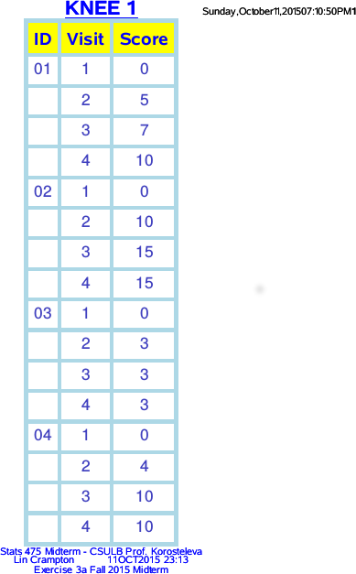

(b) Use the ARRAY statement to create a data set containing satisfaction scores for knee 2. The data set should look like this
id visit score

02 1 3
02 2 5
02 3 8
02 4 10
03 1 0
03 2 6
03 3 9
03 4 9
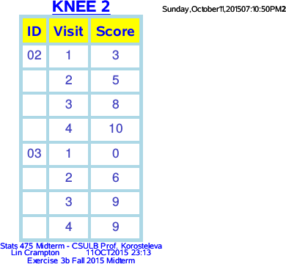

(c) Use the MERGE statement to create the merged file that looks like this

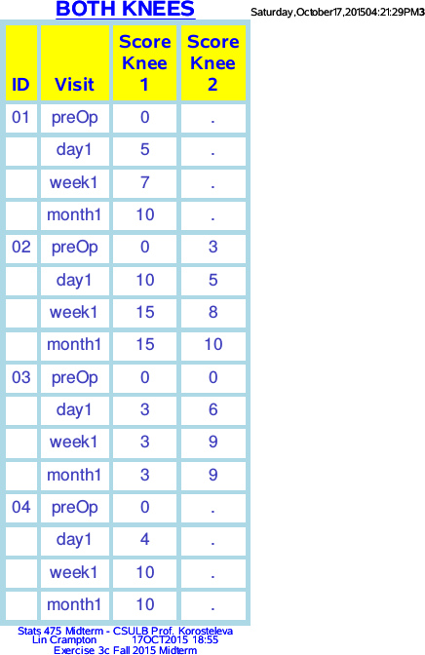
score_ score_
id visit knee1 knee2

01 pre_op 0 .
01 day 1 5 .
01 week 1 7 .
01 month 1 10 .
02 pre_op 0 3
02 day 1 10 5
02 week 1 15 8
02 month 1 15 10
03 pre_op 0 0
03 day 1 3 6
03 week 1 3 9
03 month 1 3 9
04 pre_op 0 .
04 day 1 4 .
04 week 1 10 .
04 month 1 10 .

(d) Turn in your SAS code as well as the output it produces.

libname midterm '/folders/myfolders/midterm'; /*where the code&data live */

/****** data input *******/
data knees_wide;
input ID$ 1-2 KneeNum$ 4 PreOp Day1 Week1 Month1;
datalines;
01 1 0 5 7 10
02 1 0 10 15 15
02 2 3 5 8 10
03 1 0 3 3 3
03 2 0 6 9 9
04 1 0 4 10 10
;
run;

/****** Exercise 3a *******/
data knee1 (keep=ID Visit Score);
set knees_wide;
array kneeScore{4}_numeric_;
if (kneeNum=1) then do Visit=1 to 4;
Score=kneeScore{Visit};
output;
by ID;
end;
run;

/****** Exercise 3b *******/
data knee2 (keep=ID Visit Score);
set knees_wide;
array kneeScore{4}_numeric_;
if (kneeNum=2) then do Visit=1 to 4;
Score=kneeScore{Visit};
output;
by ID;
end;
run;

/****** Exercise 3c *******/
data knee1;
set wide1;
if KneeNum=1;
run;
data knee2;
set wide1;
if KneeNum=2;
run;

/****** transpose *******/
proc transpose data=knee1 out=longKnee1;
by ID;
run;
proc transpose data=knee2 out=longKnee2;
by ID;
run;

/****** housekeeping ******/
data longKnee1;
set longKnee1 (rename=(col1=Score_Knee1));
Visit =_name_;
drop _name_;
run;
data longKnee2;
set longKnee2 (rename=(col1=Score_Knee2));
Visit =_name_;
drop _name_;
run;

/****** merge transposed knee datasets ******/
data mergedKnees;
merge longKnee1 longKnee2;
by ID;
run;
proc print data=mergedKnees noobs;
title1 'merged';
var ID Visit Score_Knee1 Score_Knee2;
run;title1;

/****** plain printing *******/
ods pdf file='/folders/myfolders/midterm/wipEx3plain.pdf';
ods rtf file='/folders/myfolders/midterm/wipEx3plain.rtf';
proc print data=knee1 noobs; title1 'Knee 1'; run;
proc print data=knee2 noobs; Title1 "Knee2"; run;
proc print data=mergedKnees noobs; title1 "Merged Knees"; run;
ods pdf close;
ods rtf close;

/********* Blue & Gold Report **********/
ods pdf file='/folders/myfolders/midterm/wipEx3.pdf';
ods rtf file='/folders/myfolders/midterm/wipEx3.rtf';
proc report data=knee1 nowd headline headskip /* Exercise 3a - Knee 1 */
style(report)=[cellspacing=5 borderwidth=6 bordercolor=lightblue]
style(header)=[/* color=blue */ foreground=blue background=yellow /*fontstyle=italic*/ fontsize=5]
style(column)=[color=moderate blue fontfamily=helvetica fontsize=4]
style(lines)=[color=white backgroundcolor=black fontweight=bold fontsize=5];

column ID Visit Score;
define ID / order order=internal 'ID';
define Visit /style=[just=center] 'Visit';
define Score/ style=[just=center]'Score';

title1 color=blue font=helvetica height=16pt color=blue bold underlin=3 "KNEE 1";
footnote1 font=arial height=8pt color=blue "Stats 475 Midterm - CSULB Prof. Korosteleva";
footnote2 font=arial height=8pt color=blue "Lin Crampton &sysdate9 &systime";
footnote3 font=arial height=8pt color=blue "Exercise 3a Fall 2015 Midterm";
/* arrange footnotes in this order so can change footnote3 without affecting footnote1 and footnote2 */

run;
proc report data=knee2 nowd headline headskip /* Exercise 3b - Knee 2 */
style(report)=[cellspacing=5 borderwidth=6 bordercolor=lightblue]
style(header)=[/* color=blue */ foreground=blue background=yellow /*fontstyle=italic*/ fontsize=5]
style(column)=[color=moderate blue fontfamily=helvetica fontsize=4]
style(lines)=[color=white backgroundcolor=black fontweight=bold fontsize=5];

column ID Visit Score;
define ID / order order=internal 'ID';
define Visit /style=[just=center] 'Visit';
define Score/ style=[just=center]'Score';

title1 color=blue font=helvetica height=16pt color=blue bold underlin=3 "KNEE 2";
footnote3 font=arial height=8pt color=blue "Exercise 3b Fall 2015 Midterm";

run;
proc report data=mergedKnees nowd headline headskip /* Exercise 3c - Merged Knee Dataset */
style(report)=[cellspacing=5 borderwidth=7 bordercolor=lightblue]
style(header)=[/* color=blue */ foreground=blue background=yellow /*fontstyle=italic*/ fontsize=5]
style(column)=[color=moderate blue fontfamily=helvetica fontsize=4]
style(lines)=[color=white backgroundcolor=black fontweight=bold fontsize=5];

column ID Visit Score_Knee1 Score_Knee2;
define ID / order order=internal '/ID';
define Visit /style=[just=center] '/Visit';
define Score_Knee1/ style=[just=center] "Score/Knee 1";
define Score_Knee2/ style=[just=center] 'Score/Knee 2';

title1 color=blue font=helvetica height=16pt color=blue bold underlin=3 "BOTH KNEES";
footnote3 font=arial height=8pt color=blue "Exercise 3c Fall 2015 Midterm";

run;
ods pdf close;
ods rtf close;
*****************************************************************************

