4.15

**select** *

**from** section **join** classroom **using** (building,room_number)

5.15

**create function** avg_salary(company_name **varchar**(20))

**returns integer**

**begin**

**declare** ans **integer**;

**select avg**(salary) **into** ans

**from** works

**where** works.company_name=company_name

**return** ans;

**end**

**select** company_name

**from** works

**where** avg_salary(company_name)>avg_salary(“First Bank”)

6.23

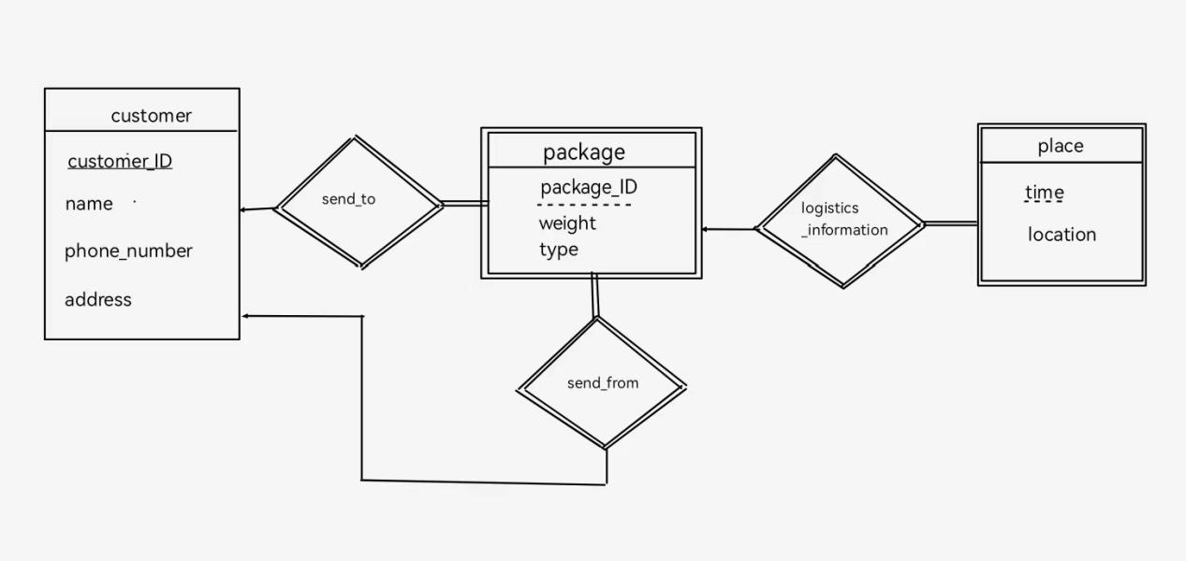

package(package_ID,sender_ID,receiver_ID,weight,type

**foreign key** sender_ID **references** customer

**foreign key** receiver_ID **references** customer)

place(package_ID,time,location

**foreign key** package_ID **references** package)

customer(customer_ID,package_ID,name,phone_number,address

**foreign key** package_ID **references** package)

send_to(package_ID,customer_ID)

send_from(package_ID,customer_ID)

logistics_information(time,package_ID)

7.26

r:(ID,name,phone_number),ID→name,phone_number→name,but ID not necessarily identifies phone_number,because a person can have more than one phone_number but only one ID.

|  |  |  |
| --- | --- | --- |
| ID | name | phone_number |
| 111111 | 何慧琳 | 13627344908 |
| 111111 | 何慧琳 | 15073419853 |

r关系

7.27

