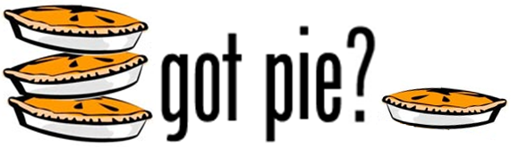

Support the Harrington PTA and take the stress out of baking this Thanksgiving!
Use the order portion at the bottom of this page & return it to your child’s teacher. Include a check or cash with your order**. Order your pies now! They are sure to go fast!
Orders due on Tuesday, November 16th
Pick up your orders at Harrington School lobby on Wednesday, November 24th, 8:30-9:00AM

If you have any questions, contact:
Anne Stevens, 781-862-7662 or anne@janescove.com

ORDER FORM

Pie Variety | Price per pie | Quantity | Total | Check Box if you wish to donate the pie to shut ins
Apple Hi-Pie | $12.00
Blueberry Hi-Pie | $13.00
Apple Raspberry Hi-Pie | $13.00
Strawberry Rhubarb | $11.00
Red Raspberry | $12.00
Mince | $11.00
Pumpkin (thaw and serve) | $11.00
Southern Pecan (thaw and serve) | $12.00
Lemon Meringue Pie | $13.00
Chocolate Cream Pie | $12.00
Boston Cream Pie | $12.00
 |  | Total #  of pies = | Total  amount owed =$

**Payment must accompany order form. Make checks payable to Harrington P.T.A.

Child’s Name: __________________________________
Parent’s Name: _________________________________
Phone Number: _________________________________
Email address: __________________________________
THANK YOU!

