HBLC Booking App User Guide

v 1.0

# Introduction

The booking app has two modes depending on the logged in user’s role. Users who register on the app have a client role while users who register through the artist onboarding process have an artist/admin role. Functions available in both modes are shown below.

|  |  |
| --- | --- |
| artist/admin mode | Client mode |
|  |  |

# Common app calendar functions

1. The HBLC calendar displays events in 3 colours – salmon pink for HBLC bookings, maximum blue for private events and indigo dye for events to be booked (DRAFTS). Today is highlighted in sky blue and the current time is highlighted in green. You can change between month, week and day view by clicking the view icons on the top right corner. Changing date range is by clicking on the top left icons. The most left icon brings the calendar to the current date. The second icon moves the calendar to earlier dates and the third icon moves the calendar to later dates. The range of date movement depends on the current view. DRAFT events can be modified by dragging (move to a different time), resizing (shorten or lengthen the booking) or clicking to open the edit popup box. To delete a DRAFT event, open the popup edit box and click DELETE.
2. An artificial private event between 8am to 6pm is created in the app calendar for each therapist OFF day to remind people not to book events on the OFF days. The example below shows the therapist is OFF work on every Sunday. The calendar ONLY fetches events of the current selected therapist from Google Calendar. If multiple therapists are required for a booking, their existing events on Google Calendar can be fetched in turn, one at a time.

# 

# Corporate Booking

1. Corporate Booking flow allows adding multiple events to one booking for one corporate. To start adding an event, select a therapist from the “Select therapist” drop-down list and a corporate from the “Select corporate” drop-down list and then click a blank slot on the calendar. Edit the DRAFT event as required. Continue to populate the calendar with events for all required therapists. When all required events are in place, click “SAVE ALL DRAFTS” to book.
2. The calendar may become too crowded with multiple therapists existing events during the process of booking. You can clear the existing events of a therapist from the calendar by clicking the “x” icon next to a therapist as shown in the figure below. Existing events are helpful to avoid conflicts when creating a new event. Once you have scheduled all the required events for a therapist, her/his existing events are no longer useful and they can be cleared to make it easier to check all DRAFT events are correctly scheduled.
3. The figure below shows 2 DRAFT events with warning signs. A warning sign indicates some details for the event are not specified. Open the event edit popup box to fill in the details and the warning sign will go away.
4. 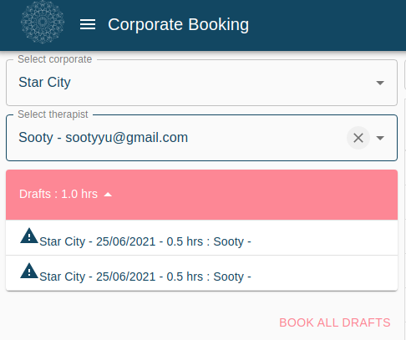

DRAFT events and all therapist existing events on the booking calendar can make the calendar quite crowded.

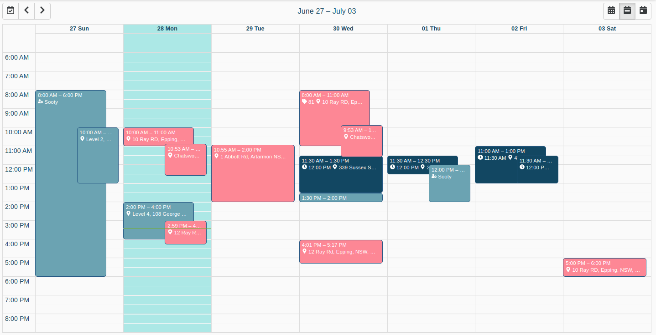DRAFT events with all therapist existing events cleared after pressing the x icon next to the therapist. It is much easier to check without the clutter. All DRAFT events include the travelling time. Client start time is indicated after the clock icon in each event card.

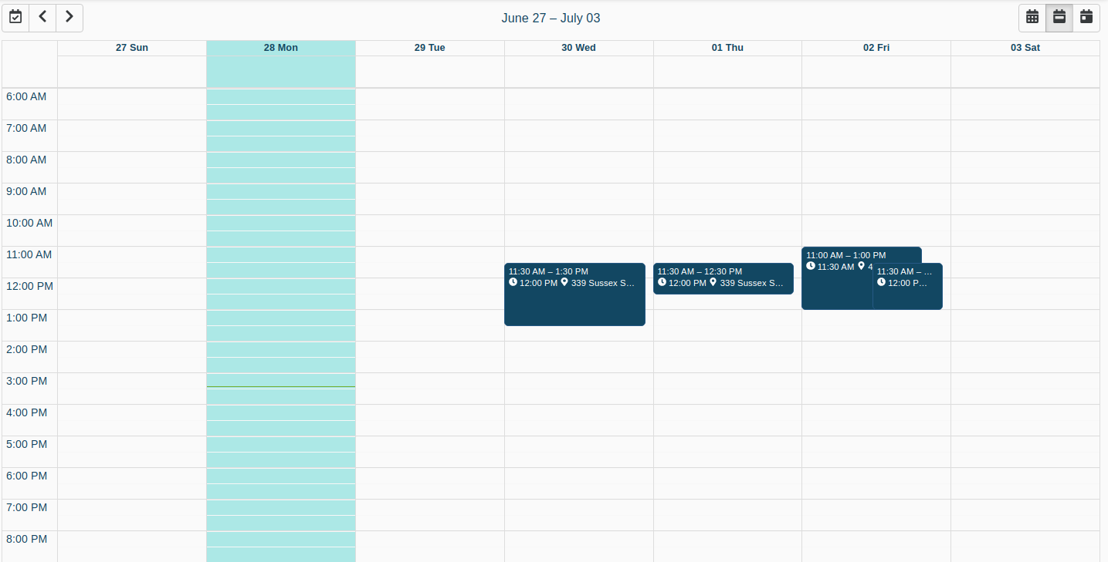

# Package Booking

1. Package Booking flow allows adding multiple events to one booking for one package item. To start booking, select a package, add a client and then a therapist. Adding a client can be done by typing the client’s name or email. Auto complete search function is built in so as soon as you start typing, some suggestions will show up. The client must register first before he or she can be found through the auto complete search.

# Therapist Booking

1. Therapist booking allows a therapist to book her client for itemised services. One booking can only contain one event. Any Therapist and Choose Therapist booking flows offer the same type of booking except they are completed by clients.
2. To start booking, add a client and service items. “Select therapist” is the therapist who is using the app by default. Event location is the client’s address by default. They can be overwritten. An estimated duration for the selected services are shown as below. Click a blank slot on the calendar to create an event. A ½ hour event is created first. You can then click on it to check all details.
3. Once all details are correct, click BOOK to book. A payment link is sent to the client’s email address to request a deposit payment. The booking will be deleted automatically if the client doesn’t pay the deposit in 12 hours.

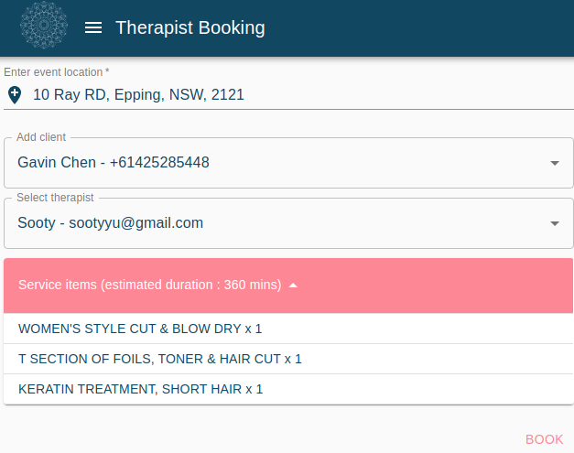

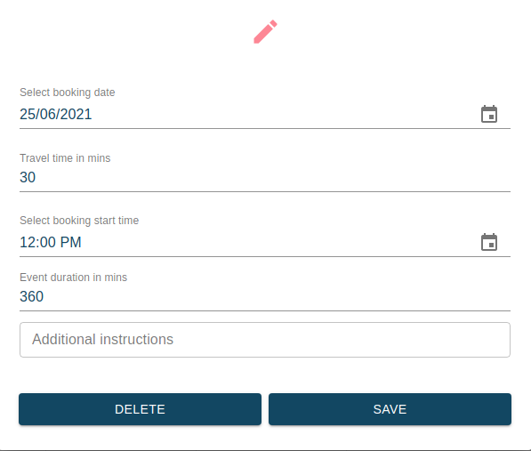

# Manage Bookings

1. The Manage Bookings function allows an admin or artist to modify or manage payment of an existing booking. By default the app will load up bookings of itemised services (aka therapist bookings) in the next 7 days when the app is launched. You can change the booking filter by clicking the search icon on the top right corner. Retrieved booking are displayed as booking cards with key booking information. The card below is a therapist booking. Booking time is shown on the title. Client’s details are shown in the top section while payment status, therapist name and booked services are shown in the bottom section. If the client provides any instructions for booking, it will be shown below the comment icon.
2. $97/326.00 in the example below represents $97 has been paid for a $326.00 booking. Therapist name is shown after the person/cogwheel icon. Booking number is shown after the tag icon.
3. There are 3 icons below the booking card. The pen icon takes you to the corresponding booking flow to perform the edit function (Therapist Booking in this example) where you can add/remove items, change therapist or time. If the booking is a package or corporate booking, it will take you to the Package or Corporate Booking flow. The icon in the middle takes you to a payment request popup. You can send a payment request to the client before the appointmenrt.
4. The last bin icon let you delete a booking. When a booking is deleted, deposit payment will be refunded to the client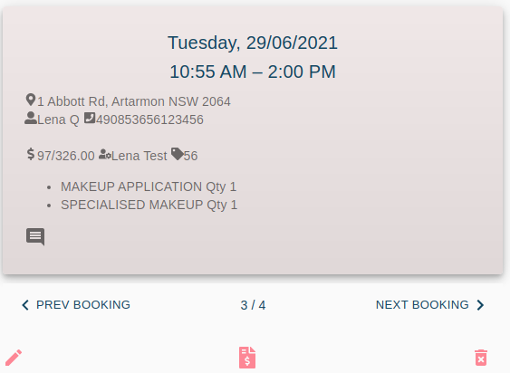 automatically.

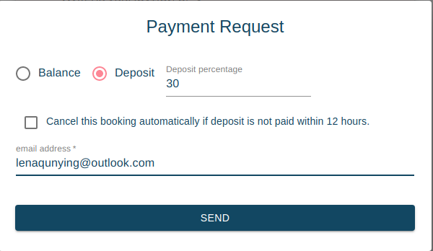

The pink flower icon below indicates the client has selected organic products. The pink bin icon indicates this booking has been deleted. All 3 icons below a deleted booking card are greyed out. A deleted booking is only displayed right after it is deleted for confirmation. When you change the booking search filter and reload bookings, deleted bookings will no longer be shown.

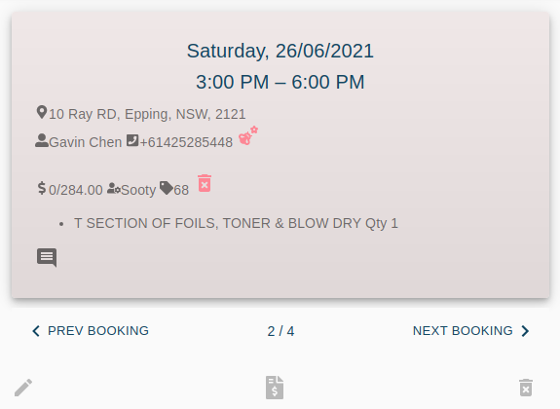

A corporate booking card example is shown below.

A package booking card example is shown below.

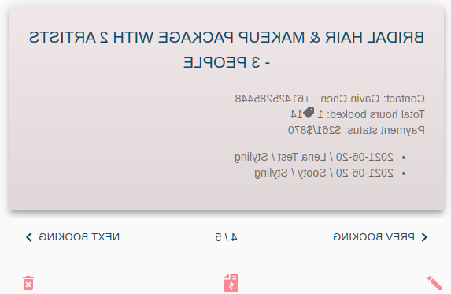

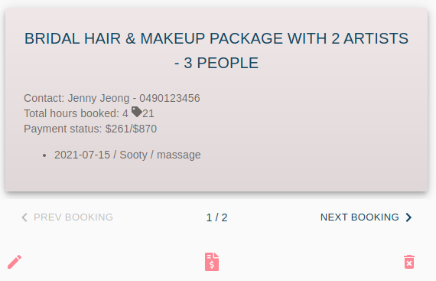

Therapists can use Manage Bookings function to check whether they have completed the CHECKOUT process for the services they completed in a period. The example below shows that therapist Sooty is searching for therapist bookings between 01/06/2021 and 15/06/2021.

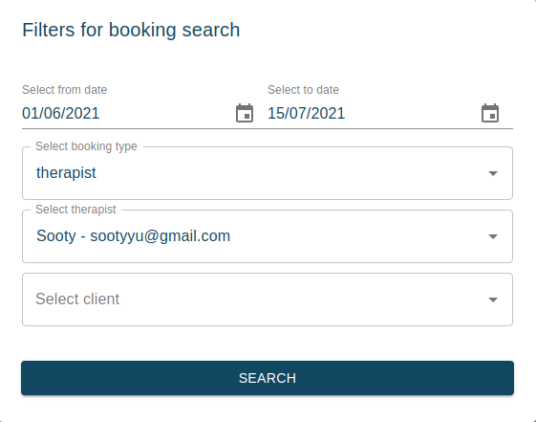The search returns the following 26 bookings. Sooty then scans through all bookings to make sure she has completed the CHECKOUT process for all 26 booking. A pink tick icon on the booking card indicates that the CHECKOUT process has been completed for the booking. A completed booking can no longer be modified. If she finds any booking without the pink tick icon, she can go to MyCalendar to complete the CHECKOUT process. Therapists only get PAID on completed bookings every fortnight. A completed appointment without the CHECKOUT process is viewed as an incomplete booking.

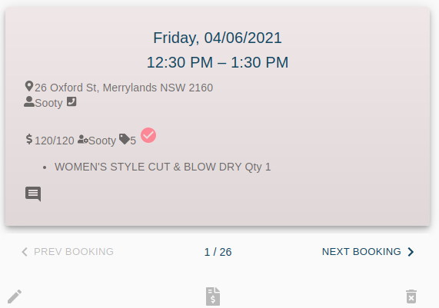

CHECKOUT for Package Bookings and Corporate Bookings is done on per event basis in My Calendar. When all events for a Package or Corporate booking are checkout, the booking is marked as completed.

# My Calendar

1. My Calendar function lets therapists track their daily schedule. HBLC bookings are shown in salmon pink. You can click on an event to show details of the event.

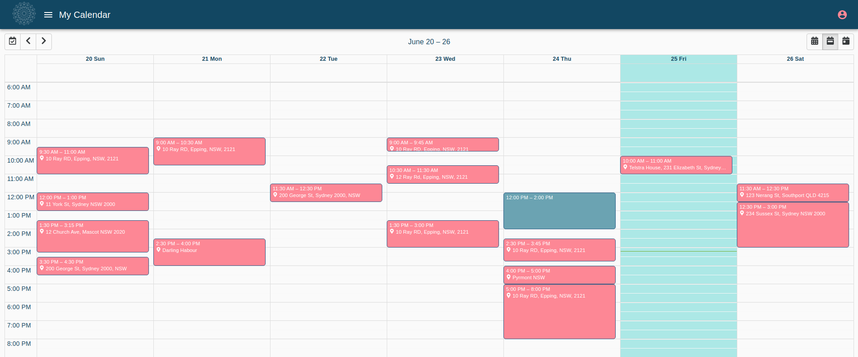A corporate booking event or package booking event is shown below. Therapists are required to checkout after an event is completed. The booked service start and end time are displayed and therapists can overwrite if they attend the event at a different time. It is especially important for corporate bookings because therapists are paid by the actual length of time they performed the services instead of the booked length of time. There is no payment required for corporate and package booking at checkout. Payment for corporate and package bookings should be administered at Manage Bookings. Once checkout is completed, the event can no longer be changed. Checkout function for future events are greyed out to prevent accidentally checkout an incompleted event.

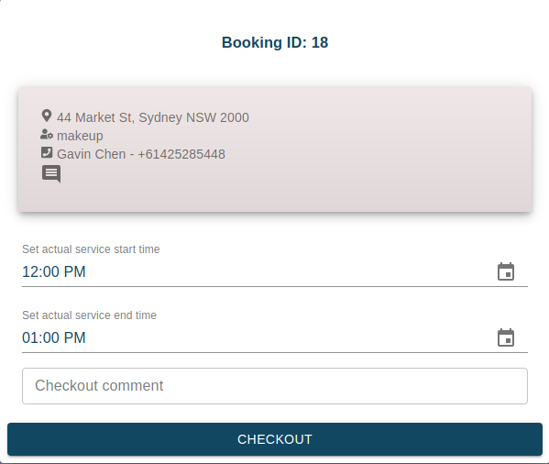

An example for therapist booking checkout is shown below. The left most CHECKOUT icon let therapists collect the balance payment from the client in cash or client’s credit card. The middle CHECKOUT icon sends a payment link to the client. The pen icon lets therapists add or remove service items. Once service items are updated, the balance payment will change. If any editing is required, it should be done before clicking the CHECKOUT icon.

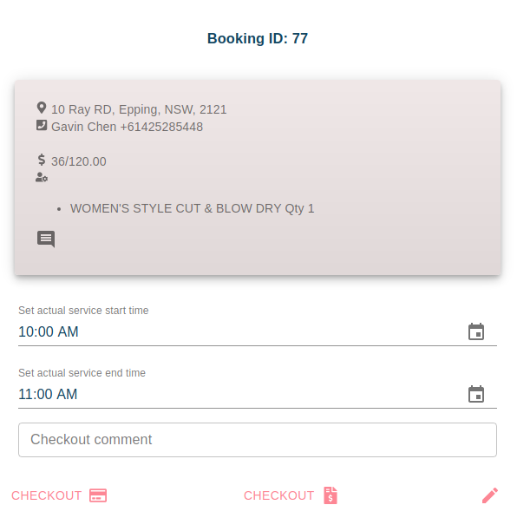

# Google Calendar settings

1. The booking app needs to read events from the therapist’s Google Calendar. Therapists MUST have the following setting in their Google Calendar in order to make the app work properly.

# Google sign in

The app uses Google API to read therapist Google Calendar. Therapists must sign in to Google after sign in to the app. Therapists can sign in to Google with any gmail account. Upon first Google sign in, Google will ask permission to read all your Google calendar event details. You have to give permission in order for the app to work properly. Clients are not required to do Google sign in.

# Client appointment SMS reminders

SMS appointment reminders will be sent to clients 48 hours before the appointment time. Reminders are sent based on per event. If there are multiple events for one booking, clients will receive a SMS reminder for each event. Clients who make an appointment within 48 hours will not receive a SMS reminder.

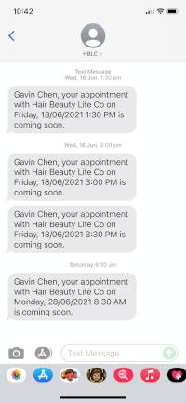

# Booking update best practice