Login-JWT

User login

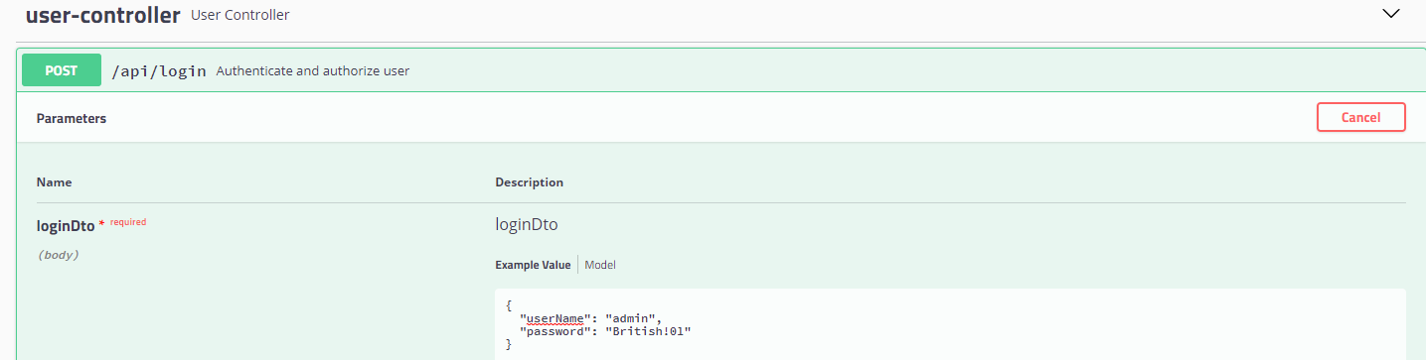

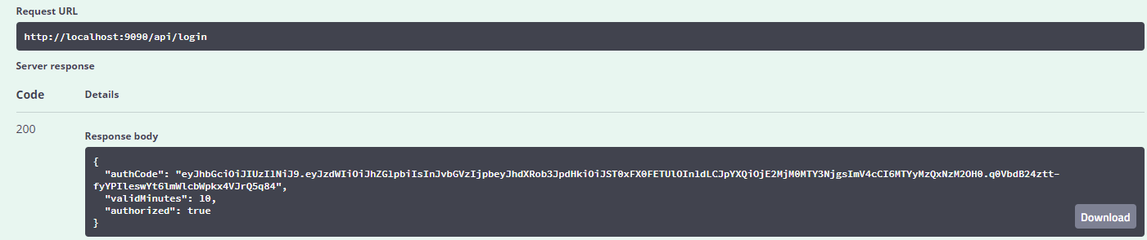

Get users

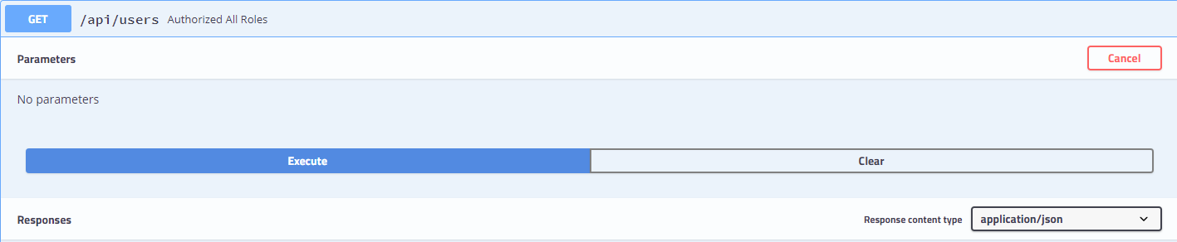

Response Body

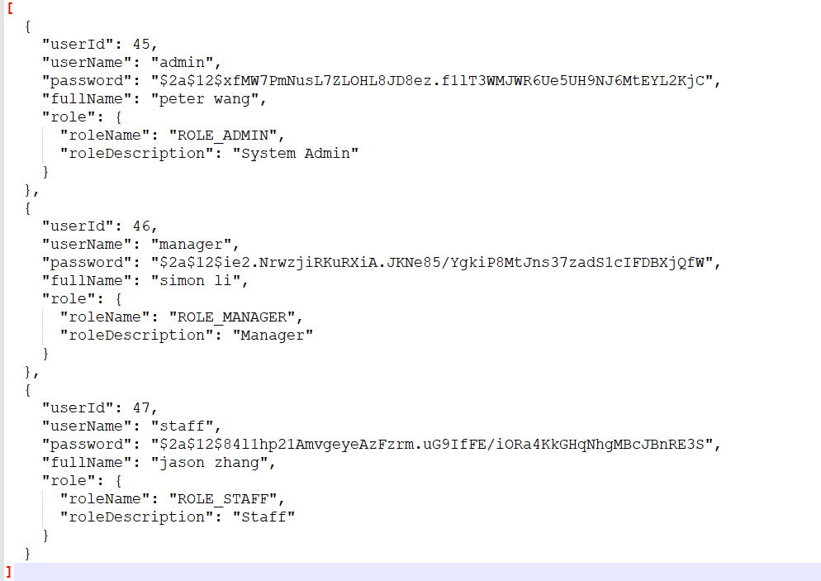

Circle CI Dashboard

