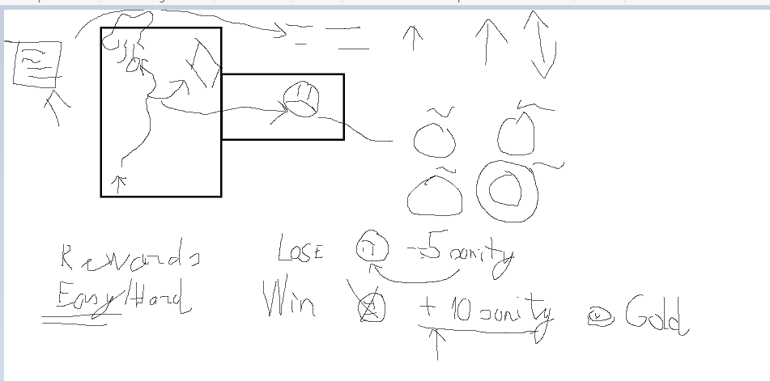
Each room has triggers(poem writing – choose words), enemy triggers(choose skill/mini game).
Chosen word increases attribute(strength, intelligence, neutrality, coordination), each word has it’s own attribute increase.
The higher the attribute – the more difficult the game is but the reward is better
Win outcome:
- Defeats the enemy
- Gain some sanity back
- Gain gold
Lose outcome:
- Enemy stays alive
- Lose sanity
Maze:
Win – Escape
Lose – Get caught by chasing enemy
Intelligence (has a certain step amount for each puzzle)
Win – Complete certain amount of puzzle. (e.g. <= 6/10 to win)
Lose – Don’t complete (e.g. > 6/10 to win)

Neutrality
Win – scales have to go down a certain distance
Lose – scales tip too much to one side.
Strength
Win – Defend most projectiles from enemy (e.g. 18/20)
Lose – Don’t defend most projectiles from enemy

Sanity
The lower the sanity – the harder the games are. If you reach very low sanity threshold, you get sent back to last checkpoint.
Maze – increases enemy amount.
Intelligence – at first some circles flash, then an imposter end appears;
Neutrality – more balls
Strength – sometimes cannot defend, projectiles get smarter

