**#Data category**

1. Police vehicle
2. Ambulance
3. Road
4. Car accident (crush)

**#Material**

Each category collect 10 mp3 file

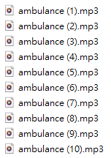

**#Method**

1. **STFT（Short-time Fourier Transform）**

Variable y_axis: ‘log’ : the spectrum is displayed on a log scale.

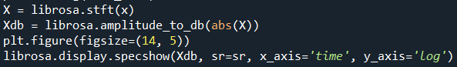



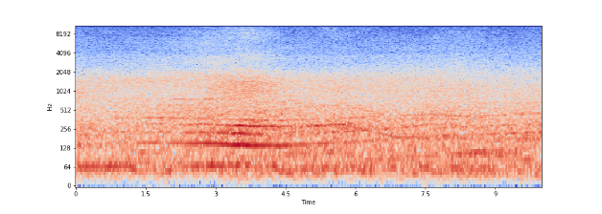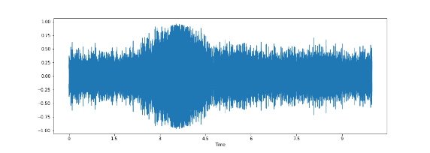

1. **data argumentation**

加上噪音

Noise addition using normal distribution with mean = 0 and std =1

Permissible noise factor value = x > 0.004



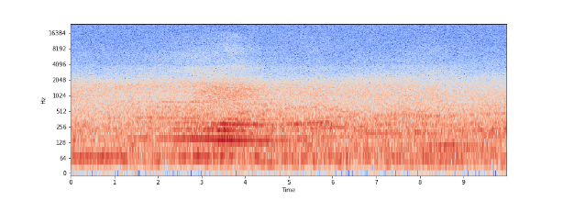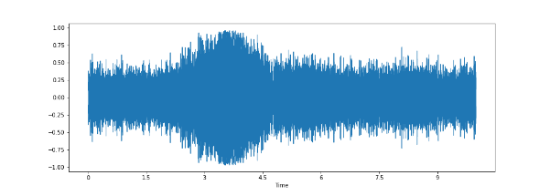

時間平移

Shifting the sound wave

Permissible factor values = sr/10



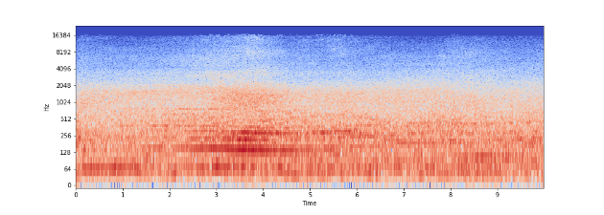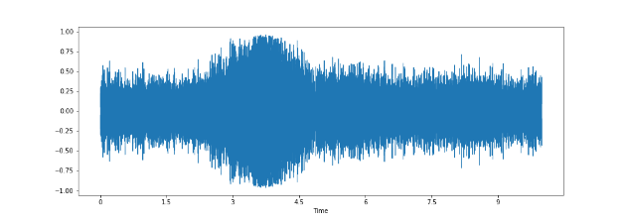

時間拉伸

Time-stretching the wave

Permissible factor values = 0 < x < 1.0

Variable factor: ‘0.4’ because this value has a small difference with original sample.



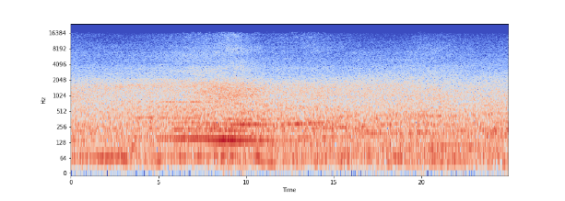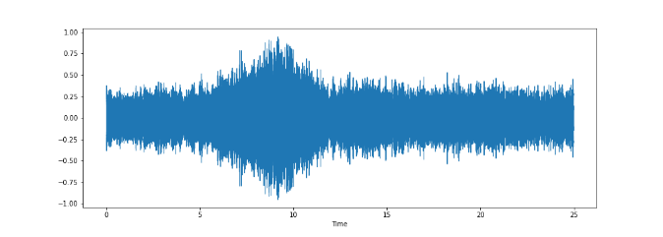

變調

pitch shifting of wav

Permissible factor values = -5 <= x <= 5

Variable n_steps: ‘-5’ sample rate and number of steps through which pitch must be shifted

