**HREC SUPPORTING DOCUMENT CHECKLIST & TEMPLATE**

**for submission via InfoHub**

This checklist and template is intended to aid your submission to the HREC for a full ethical review by providing you with a reminder of all the documents you *might* submit in one file. All supporting documents should be inserted into this document where indicated. **Please note that your submission cannot be reviewed without the relevant Information Sheet(s) and Consent/Assent Form(s).**

***Please tick the documents you have provided for review only***

|  |  |  |
| --- | --- | --- |
| 1 | Information Sheet for Participants | Yes |
| 2 | Information Sheet for Parents/Guardians | Yes |
| 3 | Information Sheet for Children | Yes |
| 4 | Consent form for Participants | Yes |
| 5 | Consent Form for Parents/Guardians | Yes |
| 6 | Assent Form for Children | Yes |
| 7 | Interview Schedule for Interviews/focus groups | Yes |
| 8 | Questionnaires/Surveys | Yes |
| 9 | Advertisement/Poster/flyers for recruitment of participants | Yes |
| 10 | Letter(s) of permission from external organization(s) granting access to their business/school/charity/database etc., | Yes |
| 11 | Any other relevant supporting documents specifically required for your study | Yes |
| 12 | Cover Letter Responding to Decision Points *(not required for a new submission but will be required for your response to the committee after the review)* | Yes |

***Insert all Information Sheets here*** *and ensure that they following the correct format – see Question12 in the HREC Application Form (HR1) – please confirm that you will print this document on your School Headed Paper*

## Information Sheet

**Title:** Emotional Response Language Education E-learning Platform

**Topic:** Second Language Acquisition, Computational Linguistics, Multimodal Communication

**Institution:**  UCD Computer Science

**Researcher:**  John Sloan

**What is this research about?**

ERLE is a language learning website which uses the emotions of an avatar to give feedback. I am interested in how users interact with the website and the avatar.

**這項研究是關於什麼的？**

ERLE是一個語言學習網站，它使用化身的情緒來提供反饋。 我對用戶如何與網站和頭像進行互動感興趣。

**Why are you doing this research?**

I believe facial expressions are a very important means of non-verbal communication. I want to understand how language learners feel about interacting with an avatar who displays different emotions when they make correct and incorrect sentences.

**你為什麼要做這項研究？**

我認為面部表情是非語言交流的一種非常重要的手段。我想了解語言學習者如何與根據句子表現出不同情緒的化身進行交互。

**Why have I been invited to take part?**

You are an intermediate English language learner who is over 18. Your teacher/professor has indicated that your English level is suitable for this project.

**為什麼我被邀請參加？**

您是一名18歲以上的中級英語學習者。 您的老師/教授表示您的英語水平適合此項目

**What will happen if I decide to take part in this research study?**

If you decide to participate, you will be able to practice your English with the avatar for 30 minutes in each class. You will be able to join classes for 12 weeks. You may choose to type or speak to input sentences. You will receive feedback from a native English speaker. This feedback will be shown in the facial expressions of the avatar. If you make mistakes, you will be able to see where the errors are and what the correction is.

**如果我決定參加這項研究，會發生什麼？**

如果您決定參加，您將能夠在每堂課中使用頭像練習英語30分鐘。你可以加入課程12週。您可以選擇輸入或說出輸入句子。您將收到母語為英語的人的反饋。該反饋將顯示在化身的面部表情中。如果您犯了錯誤，您將能夠看到錯誤的位置以及更正的內容。

**How will the data be used?**

The sentences you type and speak will be used to understand how you change your language pronunciation and production after receiving feedback. The recordings from the sentences you speak will be saved and used to train a pronunciation model.

**如何使用數據？**

您輸入和說出的句子將用於了解您在收到反饋後如何更改語言發音和製作。您所說句子的錄音將被保存並用於訓練發音模型。

**How will you protect my privacy?**

You will choose a username which has no connection to your real name. In the study you will be referred to only by the basic demographic information you provide: age, sex and nationality.

**您將如何保護我的隱私？**

您將選擇與您的真實姓名無關的用戶名。在研究中，您將僅通過您提供的基本人口統計信息來提及：年齡，性別和國籍。

**How is this research funded?**

This project is funded by UCD Computer Science.

**這項研究是如何資助的？**

該項目由UCD計算機科學資助

**What are the benefits of taking part in this research study?**

You will be able to practice your English. You may find it enjoyable to interact with an avatar who responds to your sentences.

**參加這項研究有什麼好處？**

你將能夠練習英語。您可能會發現與響應您的句子的頭像進行交互很有趣。

**What are the risks of taking part in this research study?**

If you see negative expressions from the avatar you may feel bad. When using the speech recognition, it may be frustrating to see a different result from what you expect. The sentences you input by speech or text may be identifiable.

**參加這項研究的風險是什麼？**

如果你看到化身的負面表達，你可能會感覺很糟糕。使用語音識別時，看到與預期不同的結果可能會令人沮喪。您通過語音輸入的句子可能是可識別的。

**Can I change my mind at any stage and withdraw from the study?**

Yes. You can change your mind anytime and withdraw with no disadvantage. If you wish to withdraw, you can send an email to [john.sloan.1@ucdconnect.ie](mailto:john.sloan.1@ucdconnect.ie) with the subject “withdraw from ERLE - <username>”. If you want a copy of your data, or wish your data to be deleted, you can state that in the email and we will follow your request.

**我可以在任何階段改變主意並退出研究嗎？**

是。 你可以隨時改變主意，並且毫無劣勢地退出。 如果您想退出，可以發送電子郵件至john.sloan.1@ucdconnect.ie，主題為“退出ERLE - 用戶名。 如果您需要數據副本或希望刪除數據，可以在電子郵件中說明，我們會按照您的要求提供。

**Has this research project received ethical approval?**

Yes.

**該研究項目是否獲得了道德批准？**

是。

**How will I find out what happens with this project?**

You can email - [john.sloan.1@ucdconnect.ie](mailto:john.sloan.1@ucdconnect.ie).

**我怎樣才能知道這個項目會發生什麼？**

您可以發送電子郵件 - john.sloan.1@ucdconnect.ie

***Insert all consent forms here*** *– the format can vary as researchers may want to itemize everything that they need a participant to consent to involved in the current study and may anticipate further research such as future publications, archiving or re-using the de-identified data at a later stage. Please confirm that you will print this document on your School Headed Paper*

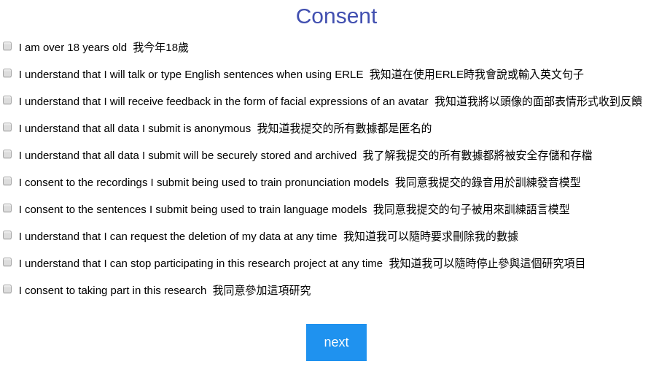

*Insert* ***Children’s Assent Form****, if applicable here*

*Insert* ***Interview schedule*** *and any instructions for interviewing here*

*Insert* ***Questionnaires/Surveys/scales*** *and any associated evaluation document here*

*Insert* ***Recruitment Advertisement/Poster or flyers here*** *– if the document is not in Word please insert the text only*

*Insert* ***External Letters of Permissions here*** *– such as letters from School Principals, Company CEOs, Charity Directors, Copyright permission for use of questionnaire if applicable*

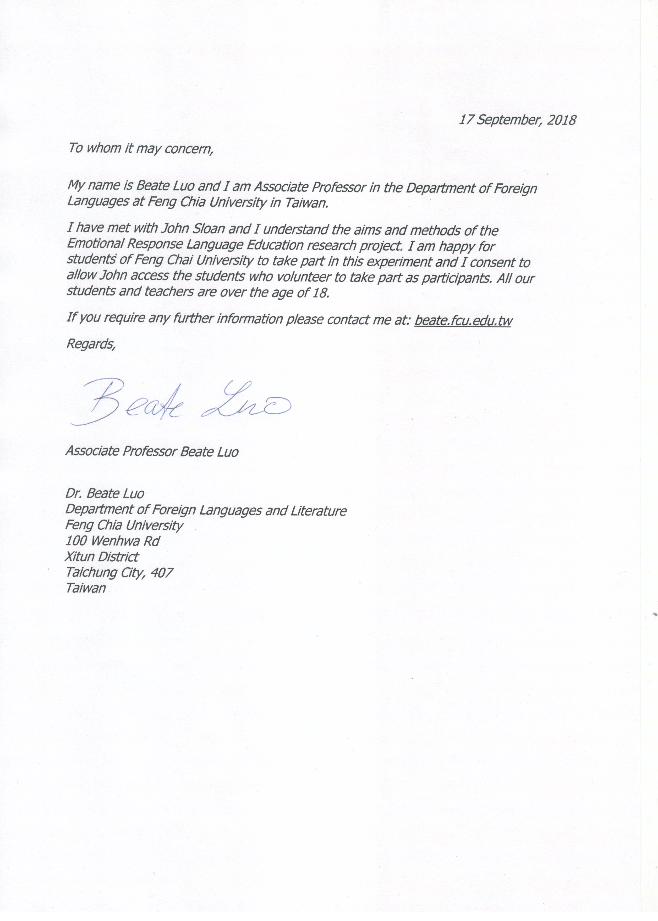

*Insert* ***Local Research Ethics Approval******Letters or Letters of Permissions to access databases****– such as letters from Hospitals, Nursing Homes, HSE Health Boards, Prisons, or any other body or organization that has a Research Ethics Committee)*

*Insert any other supporting documentation that is not listed above here but is relevant to your study: For Example: a listing of support groups, a training programme for researchers, a debriefing doc, or a protocol for dealing with stressed participants*

**Cover Letter Responding to Decision Points** *(not required for a new submission)*

**Should there be approval sought from the university where these students are based (ie from someone other than Professor Luo)?**

Professor Luo has stated that no further approval needs to be sought from the university for the students to participate. She added, *“Joining this class, students have given their permission. They voluntarily joined this class that I set up just for the purpose to communicate about Erle.”*

Application:

**• Q7 v: Please provide more detail on composition of the sample;**

*The sample will be made up of male and female university students from Feng Chai University. Professor Beate Luo will introduce the research project to her classes and invite students who wish to take part to sign up. It is not possible to know the exact composition of the sample now, as any student who chooses to take part will be allowed access. The number of participants is not strictly set, i.e. if there are 35 students who wish to take part in the main phase then they will be accepted.*

**• Q10a): Please outline what steps will be taken to ensure that Professor Luo’s role in the study does not create any pressure for her students to take part or any undue expectation that they will do so;**

*She (Prof. Luo) will ~~select~~ introduce the research project to students from the classes of students she teaches at Feng Chia University and invite participation from those who express interest. Professor Luo has set up a virtual space on the app ‘Remind’ which she uses in her classes. Students will be free to join (and drop out of) the ERLE project by clicking the project icon on Remind. Professor Luo will make it clear that participation is voluntary and will not create any pressure for students to join.*

**• Q10: Specifically, how will the students from Taiwan be informed about the project and be recruited? Will it be made clear to the students that they are under no obligation to participate?**

Professor Luo has already introduced the website to the students and directed them to watch the talk and ‘how to’ video on the main page of the website. She has asked that any students who are interested in taking part to sign up on the application which they use for their class (similar to Blackboard/Moodle). Professor Luo has made it clear that participation will be completely voluntary.

• **Q11: Professor Luo “will assign her own students to this experiment. She will choose those who she judges as most suited ...” Please clarify. Participants cannot be “assigned” to take part in research, merely invited to do so;**

*The ERLE platform has been used by Prof. Beate Luo who will ~~assign~~ introduce it to her own students during class. She will ~~choose those who she judges as most suited to this form of learning~~ inquire into the interest of students from classes which she judges to be at a level most suited to this form of learning. Students who volunteer to take part will be invited to join a group on the app ‘Remind’, which the class use for their assignments. Then, each student, in addition to reading the information sheet, will be required to watch the ‘How To’ video and check a box indicating they have done so. When choosing a username, they will be asked to choose one from which they could not be identified.*

**• Q12: It is stated that participants can withdraw, but there is no explanation of the protocol for handling data for withdrawn participants;**

On the information sheet:

*If you wish to withdraw, you can send an email to john.sloan.1@ucdconnect.ie with the subject “withdraw from ERLE - <username>”. If you want a copy of your data, or wish your data to be deleted, you can state that in the email and we will follow your request.*

**• Q13a): Please review the consent process and clarify whether Q13 a) should be “yes” rather than ”no” (a consent form is included in the supporting documentation);**

The consent form is online and cannot be ‘written’, as stated in the question. Consent boxes will be checked by clicking with a mouse.

**• Q15: “Only the PI, Professor Beate Luo and the participant will have knowledge of the link between username and participant.” How will the PI and Professor Luo know what this link is? Why is it necessary that they should know this?**

This has been changed so that neither the PI or Professor Luo will be able to identify participants (unless the participant voluntarily shares their username and data). Thus keeping all data anonymous.

*All data gathered will be linked only to the username. ~~Only the PI, Prof Beate Luo and the participant will have knowledge of the link between username and participant.~~ The PI will not know the real name of the participants. Prof Beate Luo will not know the participants usernames.*

**• Q20: Is the idea that the data gathered from the study will be made available publicly for research purposes? If so, there is no objection to this, if it is suitable de-identified, but this should be stated in the submission.**

*The data will be maintained in the database for use in training pronunciation and grammatical error detection models. It will not be made publicly available.*

Documents

**• Information Sheet: Why have I been invited to take part? Please change “chosen” to “suggested”, “recommendation” or something of that nature;**

This has been changed and can be seen in the information sheet in this document in red.

**• Please include more detail in the information leaflet, so that the prospective participant is *properly informed before making his or her decision.***

More information has been added, visible in red in the attached sheet.

**• The information and consent forms are only in English, a translation into the native language should also be provided;**

A translation has been provided for each sentence in the information sheet and consent form. This translation will be checked by an assistant of Professor Luo before students sign up.

**• Consent Form: Please check for and correct errors (e.g. “trian” instead of “train”).**

Fixed.

**• Please include more detail in the methods section on what the participants will be doing in and also supplementary information e.g. to what questions or prompts are they responding and what will a typical session look like?**

Additional explanation has been added, e.g.:

*If you decide to participate, you will be able to practice your English with the avatar for 30 minutes in each class. You will be able to join classes for 12 weeks. You may choose to type or speak to input sentences. You will receive feedback from a native English speaker. This feedback will be shown in the facial expressions of the avatar. If you make mistakes, you will be able to see where the errors are and what the correction is.*

The how-to video on the main page of the site gives a full and comprehensive picture of what is involved in a typical session. It has been designed specifically for L2 learners, and the first check box potential participants must click confirms that they have watched this video. In their first session, the avatar also reminds participants of the video and a link is given in the navigation bar.

**• Consent Form: Please consider asking for the participant specific consent to the data being archived.**

Added:

*I understand that all data I submit will be securely stored and archived*